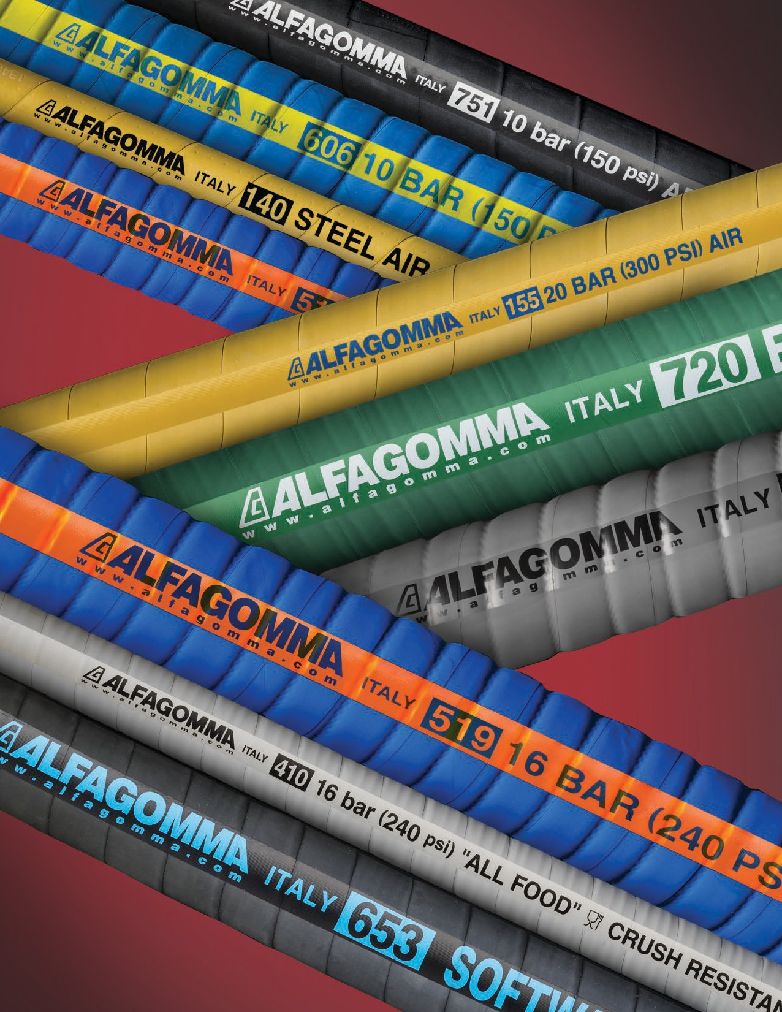

Industrial Rubber Hoses by Kuriyama

Alfagomma
ISO 9001
ISO 14000
THE ASSOCIATION FOR HOSEAND ACCESSORIES DISTRIBUTION
EDITION 0618

Throughout the world, the name Alfagomma is synonymous with quality, a reputation based on first class hose products, a commitment to research and development and ongoing capital investment. Alfagomma’s development and product engineering continues to produce fluid transfer and material handling product innovations that assure excellent performance and cost savings for customers.
Establishing a
Legacy
Alfagomma rubber hoses are manufactured in their facility located in Teramo, Italy. This factory has earned registration under ISO 9001, a quality assurance model against which a plant’s quality systems are audited. The standard represents an international consensus on good management practices, and sets out the requirements for an organization whose business processes range all the way from design and development to production. This commitment to quality is the primary reason behind Alfagomma’s 60-years of success.

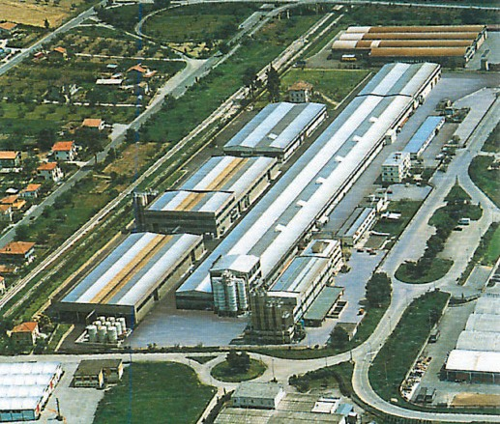

Alfagomma headquarters-Vimercate, Italy
Alfagomma Rubber Industrial Hose Manufacturing facility-Teramo, Italy

Kuriyama of America, Inc. – North American headquarters and main warehouse (shown below), is located at 360 East State Parkway, Schaumburg, IL. Kuriyama is the exclusive U.S. distributor of Industrial Rubber Hose products manufactured by ALFAGOMMA S.p.A. KOA also has four additional warehouses throughout the U.S., where Alfagomma hose products are stocked.

ALFAGOMMA® Industrial Rubber Hose Index by Series Number

Series |  | Page | Series |  | Page | Series |  | Page
6C5AA | NEW | 54 | T352AA |  | 22-23 | T631AE | NEW | 62
CT601AA |  | 50 | T405LB |  | 29 | T650AH |  | 59
HWT763AA | NEW | 72 | T405LL |  | 28 | T653AA |  | 46-47
LT753AA |  | 64 | T410LB | NEW | 31 | T6D1AA |  | 48
ST6D2AA |  | 49 | T410LL |  | 30 | T704HA | NEW | 63
T140AK |  | 10 | T422LH | NEW | 32 | T714LG | NEW | 38
T142AK |  | 11 | T426LB | NEW | 33 | T720AA |  | 66
T146AK |  | 74 | T452LE |  | 35 | T720LG |  | 37
T155AK |  | 12 | T455LL |  | 34 | T737AA |  | 68
T202AA |  | 16 | T505OG |  | 40 | T740AA |  | 67
T204AA |  | 17 | T509OE |  | 41 | T750AA |  | 65
T253AA |  | 18 | T519OE | NEW | 42 | T750AG |  | 65
T254AA |  | 19 | T600AA |  | 44-45 | T757AA |  | 68
T340AA |  | 25 | T601AA |  | 51 | T758AA |  | 69
T340AH |  | 25 | T604AA |  | 52 | T758AE |  | 69
T341AA |  | 26 | T605AA |  | 53 | T760AA |  | 70
T341AH |  | 26 | T605AH |  | 55 | T760LE | NEW | 39
T343AH | NEW | 27 | T606AE |  | 56 | T763AA |  | 71
T350LH |  | 20 | T614AA |  | 60 | T766AA |  | 73
T350LL |  | 20 | T620AA |  | 57 | T902AA |  | 13
T351LG |  | 21 | T629AA |  | 58 | T903LE |  | 14
T351LL |  | 21 | T631AA |  | 61 | T957LL |  | 75

CODE LEGEND FOR AVAILABLE COLORS
(Refers to last two letters of the Series number.)
A = BLACK B = GREY | D = WINE RED E = BLUE  F = PURPLE | G = GREEN H = RED  I = ORANGE | J = TAN  K = YELLOW L = WHITE | M = SILVER  O = TRANSLUCENT

Note: The second to last letter refers to the hose tube color and the last letter refers to the hose cover color.

Alfagomma® hoses are produced using silicone free release agents.

Please call your local Kuriyama Warehouse for availability of products/sizes shown.

NOTE: Although every effort has been made to accurately show the color of the ALFAGOMMA hoses in the catalog, because of the limitation of four-color process printing, some of the colors shown herein may not be exact.
The “Alfagomma” trademark contained in this publication is a registered trademark of Alfagomma S.p.A.
The “Kuriyama-Couplings” and “Biofuel Friendly Products” trademarks are trademarks of Kuriyama of America, Inc.

APPLICATION GUIDE 6-9
PAGE
DESCRIPTION
TYPE
Index
CODE LEGEND FOR AVAILABLE COLORS 3
INDEX BY SERIES NUMBER 3
INTRODUCTION 2
INNOVATIVE TECHNOLOGY 2
CHEMICAL T505OG T509OE
NEW T519OE
Acid – Chemical S & D 240 PSI – XLPE 40
Acid – Chemical S & D 240 PSI – UHMWPE 41
Acid – Chemical S & D 240 PSI – UHMWPE – Corrugated 42
COMPRESSED AIR
T140AK T142AK

T155AK T902AA T903LE
Braided Steel Wire Air Hose 10
600 PSI High Temperature – Oil Resistant Steel
Braided Reinforced Air Hose 11
300 PSI Textile Cord “Air Drill” Hose 12
150 PSI High Quality Hot Air Blower Hose 13
150 PSI High Quality FDA Hot Air Blower Hose 14

FDA LIQUID FOOD TRANSFER
T405LB T405LL T408LL T410LL
NEW T410LB NEW T422LH NEW T426LB
T452LE T455LL
150 PSI Grey Food S & D Hose 29
150 PSI White Food S & D Hose 28
240 PSI Food & Beverage S & D Hose – Crush Resistant 29
240 PSI Food & Beverage S & D Hose – Crush Resistant 30
240 PSI Food & Beverage S & D Hose – Crush Resistant 31
150 PSI Liquid S&D Brewery Hose 32
150 PSI Grey Food S & D Hose – Corrugated 33
150 PSI Potable Water Hose 35
150 PSI Food Discharge Hose 34
FDA LIQUID COMPATIBILITY GUIDE 36

FDA DRY FOOD MATERIAL HANDLING
NEW

NEW
T714LG T720LG T760LE
75 PSI Corrugated Bulk Food S & D Hose – FDA 37
Bulk Food S & D Hose – FDA 36
75 PSI Dry Bulk Food Discharge Hose – FDA Grade 38

MATERIAL HANDLING
NEW HWT763AA
LT753AA
NEW T704HA
T720AA T740AA

T750AA – T750AG T757AA – T737AA T758AA – T758AE T760AA
T763AA T766AA
75 PSI Heavy Duty Dry Powder Delivery Hose 3/8" Tube 72
150 PSI 2-Ply Abrasive Material Blast Hose 64
150 PSI Industrial Sewer Vacuum Hose 63
Bulk Material S & D Hose 66
1275 PSI High Performance Steel-Reinforced
Concrete Pumping Hose 67
150 PSI 4-Ply Abrasive Material Blast Hose 65
600 PSI Plaster & Concrete Hose 68
800 PSI Plaster, Grout & Concrete Hose 69
75 PSI Light Weight Dry Powder Delivery Hose 70
75 PSI Heavy Weight Dry Powder Delivery Hose 71
150 PSI Heavy Weight Dry Powder Delivery Hose 73

TYPE
DESCRIPTION
Index
PAGE

PETROLEUM
NEW 6C5AA
CT601AA ST6D2AA T6D1AA T600AA T601AA T604AA T605AA T605AH T606AE T614AA T620AA T629AA T631AA
NEW T631AE
T650AH T653AA
150 PSI Corrugated Tank Truck Hose 54
150 PSI Corrugated Oil Rigger/Oil Field-Frack Tank Hose 50
400 PSI Oil Rigger / Frack Discharge Hose with SUPERTUFF Cover 49
400 PSI Oil Rigger / Frack Discharge Hose 48
Hard Wall Marine Exhaust Hose USCG/SAE J1527 B2 44-45
150 PSI Oil Rigger/Oil Field-Frack Tank Hose 51
Flexor – SAE 100 R4 Oil Return Hose 52
150 PSI Black Petroleum S & D Hose 53
150 PSI Red Petroleum S & D Hose 55
150 PSI Corrugated Petroleum S & D – Arctic Hose 56
150 PSI Hot Tar & Asphalt S & D Hose 60
300 PSI Black Fuel & Oil S & D Hose 57
150 PSI Black Biofuel Petroleum Suction Hose 58
300 PSI Hot Tar & Asphalt Applicator Delivery Hose 61
300 PSI Hydrocarbon Drain 62
150 PSI Oil Discharge Hose 59
Soft Wall Marine Exhaust Hose – SAE J2006 R1 46-47

SPECIALTY HOSES
T146AK T957LL
1000 PSI Braided MSHA Mine Spray Hose 74
150 PSI Furnace Door Coolant Hose 75

STEAM
Steam Hose Safety Facts 24
NEW
T340AH – T340AA T341AH – T341AA T343AH
HOT WATER
T350LL – T350LH
270 PSI EPDM Braided Steam Hose 25
270 PSI Chlorobutyl Braided Steam Hose 26
270 PSI Braided Refinery Steam Hose 27
T351LL – T351LG
T352AA
Premium White Cover Paper Mill Creamery Wash
Down Hose – No Nozzle 20
150 PSI Premium Paper Mill Creamery Wash
Down Hose with Tapered Nozzle 21
75 PSI Radiator Hose 22-23

WATER SUCTION & DISCHARGE
T202AA T204AA T253AA T254AA
150 PSI EPDM General Purpose Water S & D Hose 16
SBR Water S & D Hose 17
150 PSI EPDM Layflat Water Discharge Hose 18
150 PSI SBR Water Discharge Hose 19

CARE, MAINTENANCE AND STORAGE 76
TECHNICAL DATA 77
CHEMICAL GUIDE 78
CHEMICAL RESISTANCE CHART 79-87
CAUTIONARY STATEMENT & LIMITED WARRANTY 88
- Kuriyama of America, Inc. disclaims any liability for use of its products in applications other than those for which they were designed.
- Weights and dimensions are nominal.
- Pictures shown are for illustration purposes only. Actual hose construction may vary.

Chemical Application Guide
Application Guide
PRODUCT | PAGE | AGRICULTURAL FERTILIZERS | CHEMICAL SOLUTIONS | CHEMICAL/SOLVENT TRANSFER
T505OG | 40 | 4 | 4 | 4
T509OE | 41 | 4 | 4 | 4
T5190E | 42 | 4 | 4 | 4
* Working Pressure and vacuum ratings are based at ambient temperature of 68°F (20°C).
Compressed Air Application Guide
PRODUCT | PAGE | CONSTRUCTION AIR SERVICE | HEAVY DUTY | HIGH HEAT | HIGH PRESSURE AIR | HOT AIR BLOWER HOSE
T140AK | 10 | 4 | 4 |  | 4
T142AK | 11 | 4 | 4 | 4 | 4
T155AK | 12 | 4
T902AA | 13 |  |  | 4 |  | 4
T903LE | 14 |  |  | 4 |  | 4
* Working Pressure and vacuum ratings are based at ambient temperature of 68°F (20°C).
Food Transfer Application Guide – FDA Liquid
PRODUCT | PAGE | ABRASIVE MATERIAL SUCTION & DISCHARGE, WET/DRY | DRY BULK FOOD DISCHARGE | FDA | 3A | ALCOHOLIC BEVERAGE DISCHARGE
T405LB | 29 | 4 |  |  | 4 | 4
T405LL | 28 | 4 |  |  | 4 | 4
T410LB | 31 | 4 |  |  | 4 | 4
T410LL | 30 | 4 |  |  | 4 | 4
T422LH | 32 | 4 |  |  | 4 | 4
T426LB | 33 | 4 |  |  | 4 | 4
T452LE | 35 | 4
T455LL | 34 | 4 |  |  | 4 | 4
* Working Pressure and vacuum ratings are based at ambient temperature of 68°F (20°C).
Food Transfer Application Guide – FDA Material Handling
PRODUCT | PAGE | ABRASIVE MATERIAL SUCTION & DISCHARGE, WET/DRY | DRY BULK FOOD DISCHARGE | FDA | 3A | ALCOHOLIC BEVERAGE DISCHARGE
T714LG 38 4 4
T720LG 37 4 4 4
T760LE 39 4 4
* Working Pressure and vacuum ratings are based at ambient temperature of 20°C (68°F).
Material Handling Application Guide – Non FDA
PRODUCT | PAGE | ABRASIVE MATERIAL TRANSFER, WET/DRY | ABRASIVE SLURRY TRANSFER | CEMENT, WET PUMPING | CONCRETE PUMPING | DRY BULK FOOD DISCHARGE
HWT763AA | 72 | 4 | 4
LT753AA | 64
T704HA | 63 | 4
T720AA | 66 | 4 | 4
T737AA | 68 |  |  | 4 | 4
T740AA | 67 |  |  | 4 | 4
T750AA | 65
T750AG | 65
T757AA | 68 |  |  | 4 | 4
T758AA | 69 |  |  | 4 | 4
T758AE | 69 |  |  | 4 | 4
T760AA | 70 | 4
T763AA | 71 | 4 | 4
T766AA | 73 | 4 | 4
* Working Pressure and vacuum ratings are based at ambient temperature of 68°F (20°C).

Application Guide

TUBE COMPOUND | PSI RATING | 4 + 4 SP | TEMP | VACUUM HG (IN)
XLPE | 240 | 4 | -22°F TO 176°F | 4
UHMWPE | 240 | 4 | -22°F TO 200°F | 4
UHMWPE | 240 |  | -22°F TO 200°F | 4

MINES / QUARRIES | OIL RESISTANT | FDA | PSI RATING | STEEL BRAIDED WIRE | TEMP | VACUUM HG (IN)
4 |  |  | See Catalog | 4 | -22°F TO 176°F
4 | 4 |  | 600 | 4 | -40°F TO 242°F
4 |  |  | 300 |  | -22°F TO 176°F
 |  |  | 150 |  | -40°F TO 350°F | 4
 |  | 4 | 150 |  | -40°F TO 350°F | 4

ALCOHOLIC BEVERAGE S & D | OIL BASED FOOD SUCTION & DISCHARGE | OIL BASED FOOD DISCHARGE | POTABLE WATER | PSI RATING CONSTANT | TEMP | VACUUM HG (IN)
4 | 4 | 4 |  | 150 | -22°F TO 212°F | 4
4 | 4 | 4 |  | 150 | -22°F TO 212°F | 4
4 |  |  |  | 240 | -22°F TO 226°F | 4
4 |  |  |  | 240 | -22°F TO 226°F | 4
4 |  |  |  | 150 | -22°F TO 226°F
4 | 4 |  |  | 150 | -22°F TO 176°F | 4
 |  |  | 4 | 150 | -22°F TO 176°F
 |  | 4 |  | 150 | -22°F TO 176°F

ALCOHOLIC BEVERAGE S & D | OIL BASED FOOD SUCTION & DISCHARGE | OIL BASED FOOD DISCHARGE | POTABLE WATER | PSI RATING CONSTANT | TEMP | VACUUM HG (IN)
75 -22°F TO 176°F 4
See Catalog -22°F TO 176°F 4
75 -22°F TO 176°F

DRY POWDER DELIVERY, CEMENT/SAND | GROUT | PLASTER | SHOT & SAND BLAST, DRY ABRASIVE DELIVERY | PSI RATING | TEMP | VACUUM HG (IN)
 |  |  |  | 75 | -22°F TO 176°F
4 |  |  |  | See Catalog | -22°F TO 176°F | 4
 |  |  |  | 150 | -40°F TO 212°F | 4
 |  |  |  | See Catalog | -22°F TO 176°F
 |  |  |  | 600 | -22°F TO 176°F
 |  |  | 4 | 150 | -22°F TO 176°F
 |  |  | 4 | 150 | -22°F TO 176°F
 | 4 | 4 |  | 600 | -22°F TO 176°F
 | 4 | 4 |  | 800 | -22°F TO 176°F
 | 4 | 4 |  | 800 | -22°F TO 176°F
4 |  |  |  | 75 | -22°F TO 176°F
4 |  |  |  | 75 | -22°F TO 176°F
4 |  |  |  | 150 | -22°F TO 176°F
4 |  |  |  | 75 | -22°F TO 176°F

Petroleum Application Guide
Application Guide
PRODUCT | PAGE | AROMATIC CONTENT | BILGE PUMP | BIOFUELS (UP TO E98 AND B100) | CORRUGATED COVER | FUEL / OIL SUCTION & DISCHARGE | HOT TAR & ASPHALT SUCTION & DISCHARGE
6C5AA | 54 | 4 |  |  | 4 | 4
CT601AA | 50 | 4 |  |  | 4
ST6D2AA | 49
T6D1AA | 48
T600AA | 44-45
T601AA | 51 | 4
T604AA | 52
T605AA | 53 | 4 |  |  |  | 4
T605AH | 55 | 4 |  |  |  | 4
T606AE | 56 | 4 |  |  | 4 | 4
T614AA | 60 |  |  |  |  |  | 4
T620AA | 57 | 4 |  |  |  | 4
T629AA | 58 | 4 |  | 4 |  | 4
T631AA | 61 |  |  |  |  |  | 4
T631AE | 62
T650AH | 59
T653AA | 46-47 |  | 4
* Working Pressure and vacuum ratings are based at ambient temperature of 68°F (20°C).
Specialty Hoses Application Guide
PRODUCT | PAGE | FURNACE DOOR COOLANT | MSHA UNDERGROUND MINE COMPLIANT
T146AK | 74 |  | 4
T957LL | 75 | 4
* Working Pressure and vacuum ratings are based at ambient temperature of 68°F (20°C).
Steam & Hot Water Application Guide
PRODUCT | PAGE | STEAM CLEANER USE/ DETERGENTS OR OIL | HIGH TENSILE STEEL CORD REINFORCEMENT | RADIATOR | HOT WATER | PIN-PRICKED COVER | PSI RATING CONSTANT
T340AA | 25 | NO | 4 |  |  | 4 | 270
T340AH | 25 | NO | 4 |  |  | 4 | 270
T341AA | 26 | NO | 4 |  |  | 4 | 270
T341AH | 26 | NO | 4 |  |  | 4 | 270
T343AH | 27 | NO | 4 |  |  | 4 | 270
T350LH | 20 | NO |  |  | 4 |  | See Page 20
T350LL | 20 | NO |  |  | 4 |  | See Page 20
T351LL | 21 | NO |  |  | 4 |  | 150
T351LG | 21 | NO |  |  | 4 |  | 150
T352AA | 22-23 | NO |  | 4 | 4 |  | 75
* Working Pressure and vacuum ratings are based at ambient temperature of 68°F (20°C).
Water Suction And Discharge Application Guide
PRODUCT | PAGE | AGRICULTURAL FERTILIZERS | CHEMICAL SOLUTIONS | CONSTRUCTION | HEAVY DUTY | HIGH PRESSURE
T202AA | 16 | 4 | 4
T204AA | 17 |  | 4
T253AA | 18 |  | 4
T254AA | 19 |  | 4
* Working Pressure and vacuum ratings are based at ambient temperature of 68°F (20°C).

Application Guide

HYDRAULIC SUCTION / RETURN | MARINE EXHAUST  / FUEL FILL | OIL FIELD / FRACK DISCHARGE | OIL FIELD / FRACK TANK SUCTION | PETROLEUM DISCHARGE | PETROLEUM SUCTION / DISCHARGE | PSI | TEMP | VACUUM HG (IN)
 |  |  | 4 |  |  | 150 | -22°F TO 176°F | 4
 |  |  | 4 |  |  | 150 | -22°F TO 176°F | 4
 |  | 4 |  |  |  | 400 | -22°F TO 176°F
 |  | 4 |  |  |  | 400 | -22°F TO 176°F
 | 4 |  |  |  |  | 75 | - 4°F TO 212°F | 4
 |  |  | 4 |  |  | 150 | -22°F TO 176°F | 4
4 |  |  |  |  |  | See Catalog | -40°F TO 212°F | 4
 |  |  |  |  | 4 | 150 | -22°F TO 176°F | 4
 |  |  |  |  | 4 | 150 | -22°F TO 176°F | 4
 |  |  |  |  | 4 | 150 | -65°F TO 180°F
 |  |  |  |  |  | 150 | - 4°F TO 356°F | 4
 |  |  |  |  | 4 | 300 | -22°F TO 176°F | 4
 |  |  |  |  | 4 | 150 | -22°F TO 176°F | 4
 |  |  |  |  |  | 300 | -22°F TO 176°F
 |  |  |  | 4 |  | 300 | -22°F TO 356°F
 |  |  |  | 4 |  | 150 | -22°F TO 176°F
 |  |  |  |  |  | 75 | -22°F TO 176°F

PIN-PRICKED | PSI RATING | TEMP
4 | 1000 | -22°F to 200°F
 | 300 | Tube: -40°F to 248°F Cover: -40°F to 1000°F

SATURATED STEAM | SHIPYARDS & CHEMICAL PLANTS | REFINERY | SUPERHEATED STEAM | PAPER MILL WASH DOWN | FOOD & DAIRY WASHDOWN | TAPPERED NOZZLE | TEMP
4 |  |  |  |  |  |  | -40°F TO 430°F
4 |  |  |  |  |  |  | -40°F TO 430°F
4 | 4 |  | 4 |  |  |  | -40°F TO 430°F
4 | 4 |  | 4 |  |  |  | -40°F TO 430°F
4 |  | 4 | 4 |  |  |  | -40°F TO 430°F
 |  |  |  | 4 | 4 |  | See Page 20
4 |  |  |  | 4 | 4 |  | See Page 20
 |  |  |  | 4 | 4 | 4 | -40°F TO 248°F
 |  |  |  | 4 | 4 | 4 | -40°F TO 248°F
-40°F TO 248°F

IRRIGATION | LAYFLAT | MAX. REC. WP (PSI) | STEEL HELIX | WATER DISCHARGE | WATER SUCTION | TEMP | VACUUM HG (IN)
4 |  | 150 | 4 | 4 | 4 | -22°F TO 176°F | 4
4 |  | 75 | 4 | 4 | 4 | -22°F TO 176°F | 4
4 | 4 | 150 |  | 4 |  | -22°F TO 176°F
4 |  | 150 |  | 4 |  | -40°F TO 248°F

Applications:
High pressure air hose for heavy-duty use in mines, quarries, construction and industry.

Cover:
Yellow SBR – abrasion and ozone resistant – pin pricked.

Reinforcement:
High tensile steel wire braids.

Tube:
Black Extruded SBR – resistant to oil mist.

Working Pressure:
Constant Pressure –
40 Bar (600 PSI): 1/2", 3/4", 1", 1 1/4", 1 1/2", 2"
30 Bar (450 PSI): 2 1/2", 3", 4"

Temperature Range:
-22°F (-30°C) to 176°F (+80°C)

Branding:
ALFAGOMMA – ITALY – T140 STEEL AIR (embossed)

Standard Length:
50 or 100 feet

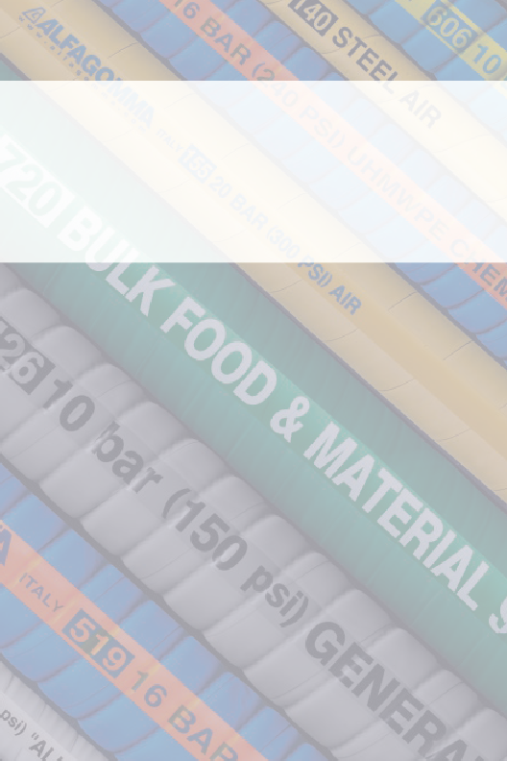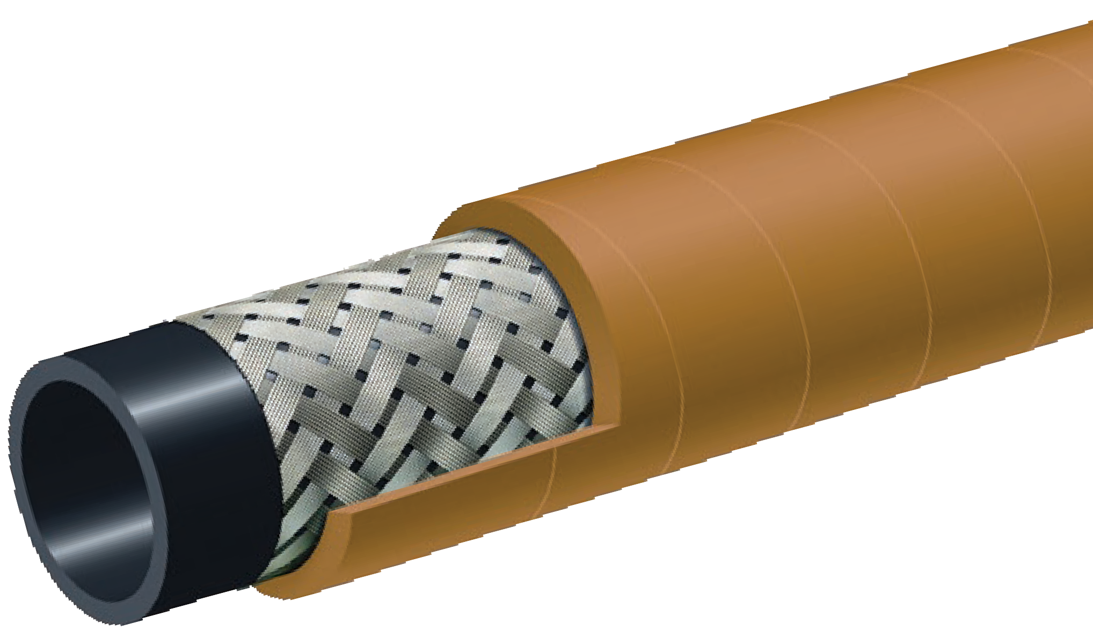
T140AK
Braided Steel Wire Air Hose
Compressed Air

Nominal Specifications
Series | ID  (in.) | ID  (mm) | OD  (in.) | OD  (mm) | Max Rec. WP (PSI) | Min. Bending Radius (in. @ 68°F) | Weight (lbs./ft.)
T140AK050 | 1/2 | 13 | 0.87 | 22 | 600 | 2 1/2 | 0.28
T140AK075 | 3/4 | 19 | 1.10 | 28 | 600 | 4 | 0. 37
T140AK100 | 1 | 25 | 1.34 | 34 | 600 | 5 | 0. 47
T140AK125 | 1 1/4 | 32 | 1.65 | 42 | 600 | 6 1/2 | 0. 72
T140AK150 | 1 1/2 | 38 | 1.89 | 48 | 600 | 7 1/2 | 0. 86
T140AK200 | 2 | 51 | 2.52 | 64 | 600 | 10 | 1.34
T140AK250 | 2 1/2 | 63 | 3.03 | 77 | 450 | 12 1/2 | 1.64
T140AK300 | 3 | 76 | 3.54 | 90 | 450 | 15 | 1.95
T140AK400 | 4 | 102 | 4.65 | 118 | 450 | 20 | 2.75

COUPLING SUGGESTIONS
Steel or malleable iron male insert NPT, female ground joint or washer type with spud, or universal quick-acting couplings attached with 2 or 4 bolt interlocking clamps or bands.

Applications:
High pressure air for mines and quarries. Designed for long lasting service and maximum safety in heavy duty applications where resistance to oil is required.

Cover:
Yellow SBR/NBR – abrasion, ozone, hydrocarbon and flame resistant – pin pricked.

Reinforcement:
High tensile steel wire braids.

Tube:
Black Extruded NBR (RMA Class A) – oil mist resistant.

Working Pressure:
40 Bar (600 PSI) 2"
30 Bar (450 PSI) 2 1/2", 3"

Temperature Range:
-40°F (-40°C) to 248°F (+120°C)

Branding:
ALFAGOMMA – ITALY T142 HIGH TEMP STEEL AIR –
OIL RESISTANT (embossed)

Standard Lengths:
100 feet: 2" through 3"
50 feet: 2" and 3"

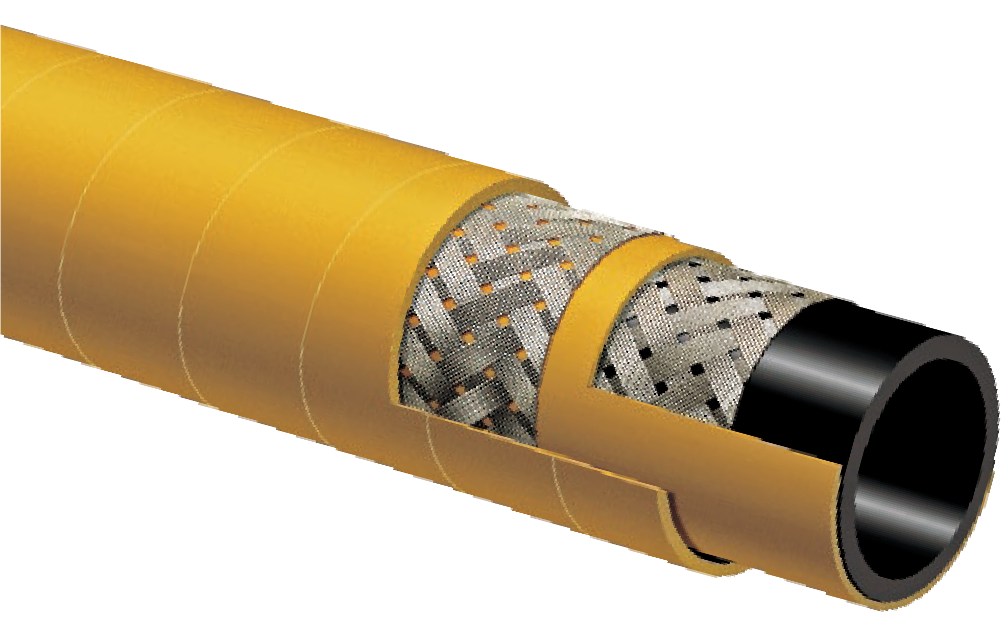

T142AK
High Temperature – Oil Resistant Steel Braided Reinforced Air Hose
Compressed Air

Nominal Specifications
Series | ID  (in.) | ID  (mm) | OD  (in.) | OD  (mm) | Max Rec. WP (PSI) | Min. Bending Radius (in. @ 68°F) | Weight (lbs./ft.)
T142AK200 | 2 | 51 | 2.52 | 64 | 600 | 10 | 1.16
T142AK250 | 2 1/2 | 63 | 3.03 | 77 | 450 | 12 1/2 | 1.93
T142AK300 | 3 | 76 | 3.54 | 90 | 450 | 15 | 1.91

COUPLING SUGGESTIONS
Steel or malleable iron male insert NPT, female ground joint or washer type with spud, or universal quick-acting couplings attached with 2 or 4 bolt interlocking clamps or bands.

Applications:
High quality air hose for mining and construction service.

Cover:
Yellow SBR – abrasion and ozone-resistant.

Reinforcement:
Spiraled, high tensile textile cords.

Tube:
Black SBR/NBR blend – oil mist resistant.

Working Pressure:
Constant Pressure – 20 Bar (300 PSI)

Temperature Range:
-22°F (-30°C) to 176°F (+80°C)

Branding:
ALFAGOMMA – ITALY – T155 20 BAR (300 PSI) AIR (in
blue letters)

Standard Length:
100 feet: 1/2" through 4"
50 feet: 1/2", 1" and 2" through 4"

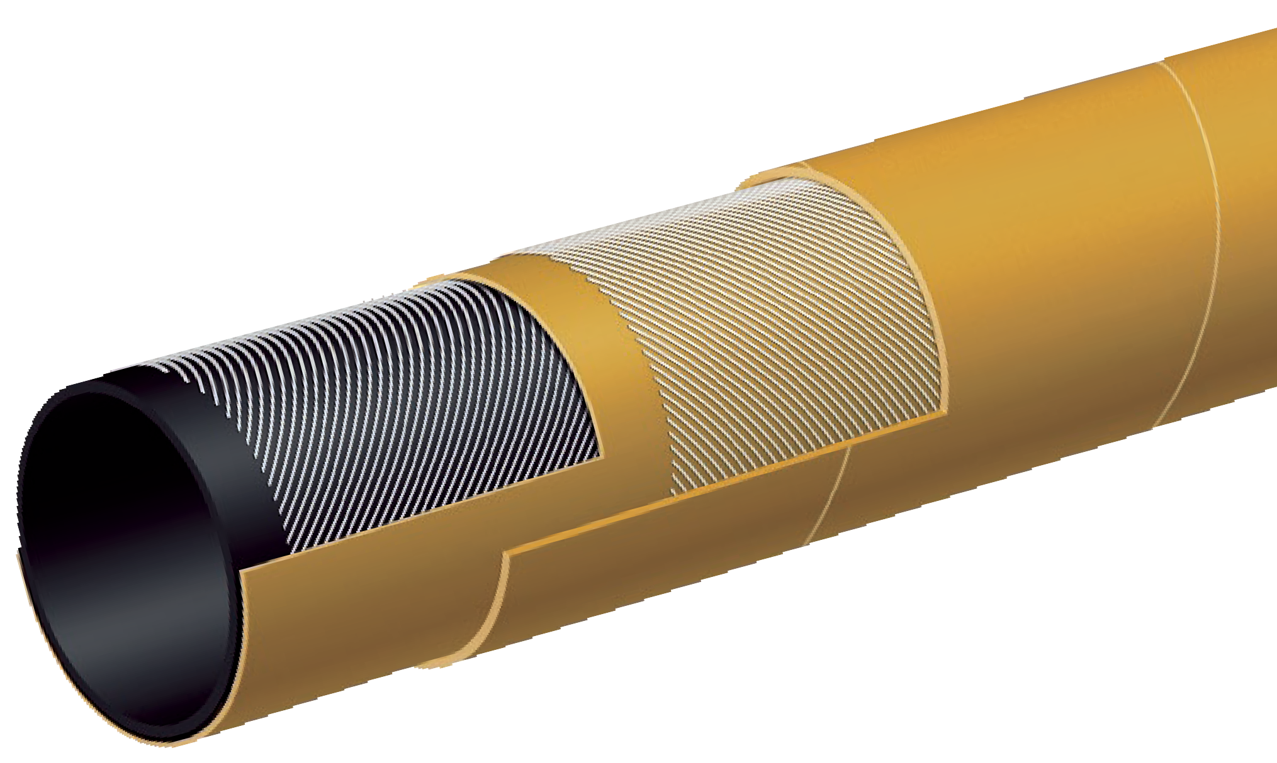

T155AK
300 PSI Textile Cord “Air Drill” Hose
Compressed Air

Nominal Specifications
Series | ID  (in.) | ID  (mm) | OD  (in.) | OD  (mm) | Max Rec. WP (PSI) | Weight (lbs./ft.)
T155AK050 | 1/2 | 13 | 0.83 | 21 | 300 | 0.22
T155AK075 | 3/4 | 19 | 1.14 | 29 | 300 | 0.38
T155AK100 | 1 | 25 | 1.38 | 35 | 300 | 0.48
T155AK125 | 1 1/4 | 32 | 1.73 | 44 | 300 | 0.60
T155AK150 | 1 1/2 | 38 | 1.97 | 50 | 300 | 0.70
T155AK200 | 2 | 51 | 2.56 | 65 | 300 | 1.12
T155AK250 | 2 1/2 | 63 | 3.11 | 79 | 300 | 1.55
T155AK300 | 3 | 76 | 3.62 | 92 | 300 | 1.89
T155AK400 | 4 | 102 | 4.65 | 118 | 300 | 2.47

COUPLING SUGGESTIONS
Steel or malleable iron male insert NPT, female ground joint or washer type with spud, attached with 2 or 4 bolt interlocking clamps or bands. Universal couplings may be used on sizes (1/2" – 2")

Applications:
Hot air transfer between the air compressor and dry bulk tank on bulk material carriers.

Cover:
Black EPDM – heat, abrasion and ozone resistant.

Reinforcement:
Spiraled high tensile textile cords with flexible steel helix wire.

Tube:
Black EPDM – heat-resistant.

Working Pressure:
Constant Pressure – 10 Bar (150 PSI)

Temperature Range:
-40°F (-40°C) to 356°F (+180°C)

Branding:
ALFAGOMMA – ITALY T902 10 BAR (150 PSI) – HOT AIR
SERVICE (in white letters)

Standard Length:
100 feet

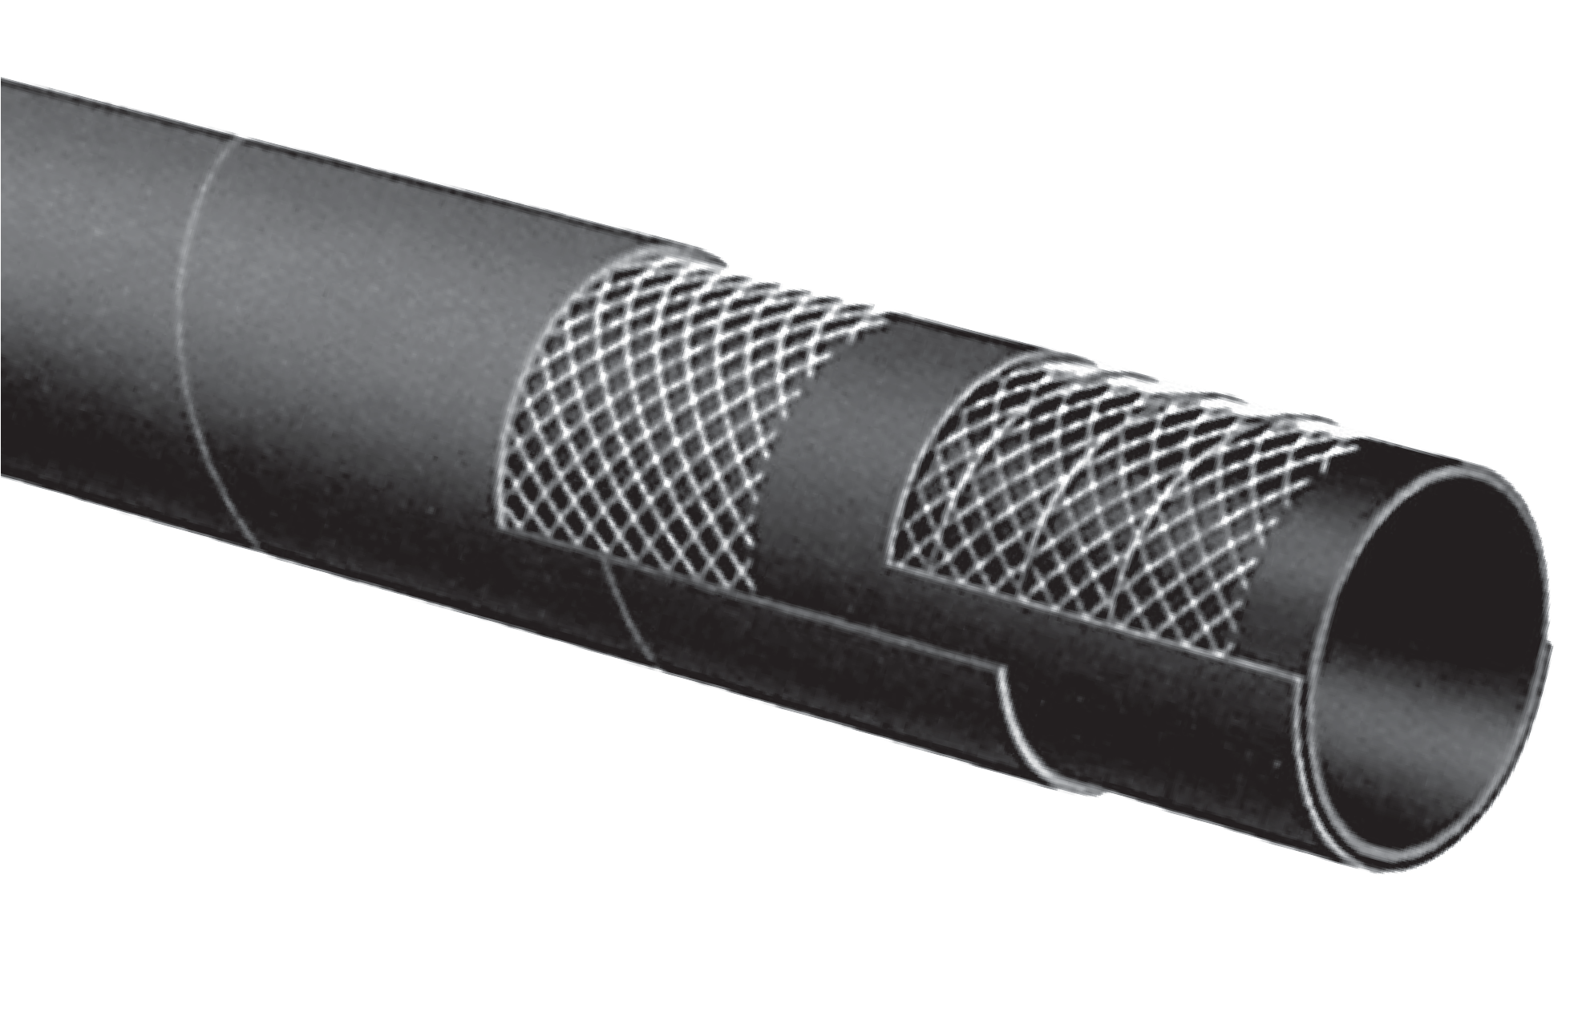

T902AA
150 PSI High Quality Hot Air Blower Hose
Compressed Air

Nominal Specifications
Series | ID  (in.) | ID  (mm) | OD  (in.) | OD  (mm) | Max Rec. WP (PSI) | Vacuum HG (in.) | Min. Bending Radius (in. @ 68°F) | Weight (lbs./ft.)
T902AA200 | 2 | 51 | 2.48 | 63 | 150 | 30 | 6 | 1.01
T902AA300 | 3 | 76 | 3.54 | 90 | 150 | 27 | 9 | 1.60
T902AA400 | 4 | 102 | 4.57 | 116 | 150 | 27 | 12 | 2.23

COUPLING SUGGESTIONS
Quick-Acting, pin lug, short shank couplings or combination nipples attached with single bolt, double bolt, wire or band type clamps.

Applications:
Hot air transfer between the air compressor and dry bulk tank on bulk material carriers.

Cover:
Blue EPDM – heat, abrasion and ozone resistant.

Reinforcement:
Spiraled high tensile textile cords with flexible steel helix wire.

Tube:
White EPDM – heat-resistant. Meets FDA requirements.

Working Pressure:
Constant Pressure – 10 Bar (150 PSI)

Temperature Range:
-40°F (-40°C) to 356°F (+180°C)

Branding:
ALFAGOMMA – ITALY T903 10 BAR (150 PSI) – HOT AIR
SERVICE – FDA (in white letters)

Standard Length:
100 feet

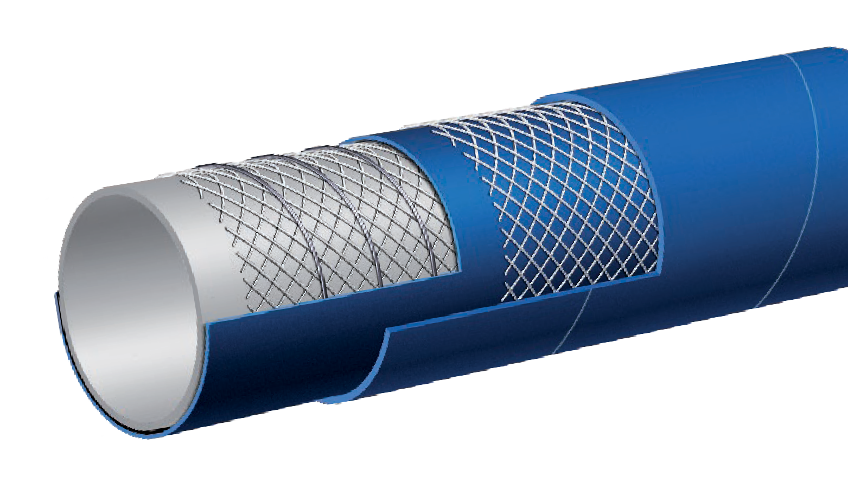

T903LE
150 PSI High Quality FDA Hot Air Blower Hose
Compressed Air

Nominal Specifications
Series | ID  (in.) | ID  (mm) | OD  (in.) | OD  (mm) | Max Rec. WP (PSI) | Vacuum HG (in.) | Min. Bending Radius (in. @ 68°F) | Weight (lbs./ft.)
T903LE300 | 3 | 76 | 3.54 | 90 | 150 | 27 | 9 | 1.65
T903LE400 | 4 | 102 | 4.57 | 116 | 150 | 27 | 12 | 2.26

Notes

Applications:
Suction and discharge of non-corrosive liquids for irrigation, construction, fertilizers and lasso acid solutions.

Cover:
Black EPDM – abrasion and ozone resistant.

Reinforcement:
Spiraled high tensile textile cords with flexible steel helix wire.

Tube:
Black EPDM.

Working Pressure:
Constant Pressure – 10 Bar (150 PSI)

Temperature Range:
-40°F (-40°C) to 212°F (+100°C)

Branding:
ALFAGOMMA – ITALY – T202 10 BAR (150 PSI)
GENERAL PURPOSE EPDM (in green letters)

Standard Length:
100 feet: 1" through 6"
20, 50 feet: 5" 20, 25 feet: 8"
20, 25, 50 feet: 6" 20 feet: 10" through 12"

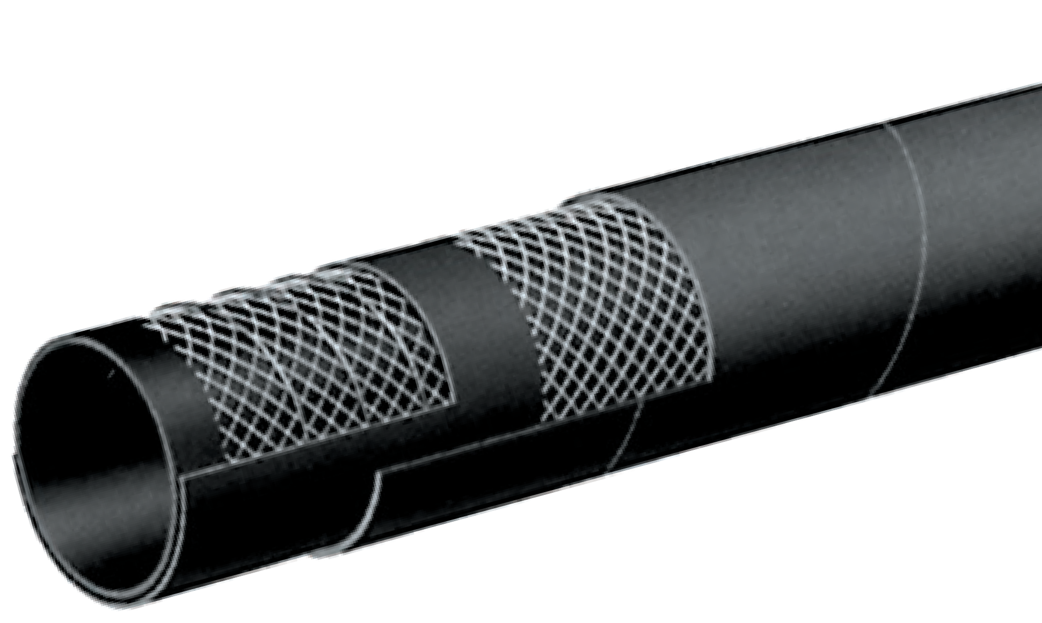

T202AA
150 PSI EPDM
General Purpose Water S & D Hose
Water Suction

FOR APPLICATIONS INVOLVING INDUSTRIAL ACID CHEMICALS AND ALCOHOLS, PLEASE REFER TO T505OG AND T509OE CHEMICAL HOSES
Nominal Specifications
Series | ID  (in.) | ID  (mm) | OD  (in.) | OD  (mm) | Max Rec. WP (PSI) | Vacuum HG (in.) | Min. Bending Radius (in. @ 68°F) | Weight (lbs./ft.)
T202AA100 | 1 | 25 | 1.38 | 35 | 150 | 30 | 4 | 0.47
T202AA125 | 1 1/4 | 32 | 1.65 | 42 | 150 | 30 | 5 | 0.56
T202AA150 | 1 1/2 | 38 | 1.89 | 48 | 150 | 30 | 6 | 0.64
T202AA200 | 2 | 51 | 2.40 | 61 | 150 | 30 | 8 | 0.84
T202AA250 | 2 1/2 | 63 | 2.95 | 75 | 150 | 27 | 10 | 1.20
T202AA300 | 3 | 76 | 3.46 | 88 | 150 | 27 | 12 | 1.44
T202AA350 | 3 1/2 | 90 | 4.02 | 102 | 150 | 27 | 14 | 1.82
T202AA400 | 4 | 102 | 4.49 | 114 | 150 | 27 | 16 | 2.03
T202AA500 | 5 | 127 | 5.55 | 141 | 150 | 24 | 25 | 3.18
T202AA600 | 6 | 152 | 6.54 | 166 | 150 | 24 | 30 | 4.01
T202AA800 | 8 | 203 | 8.70 | 221 | 150 | 21 | 40 | 6.59
T202AA1000 | 10 | 254 | 10.71 | 272 | 150 | 18 | 50 | 9.03
T202AA1200 | 12 | 305 | 12.87 | 327 | 150 | 18 | 61 | 12.54

Applications:
Suction and discharge of water for irrigation and construction.

Cover:
Black SBR – ozone and abrasion-resistant.

Reinforcement:
Spiraled high tensile textile cords with flexible steel helix wire.

Tube:
Black SBR.

Working Pressure:
Constant Pressure – 5 Bar (75 PSI)

Temperature Range:
-22°F (-30°C) to 176°F (+80°C)

Branding:
ALFAGOMMA– ITALY – T204 (embossed)

Standard Length:
20, 25, 50, 100 feet: 6"
20, 25, feet: 8"

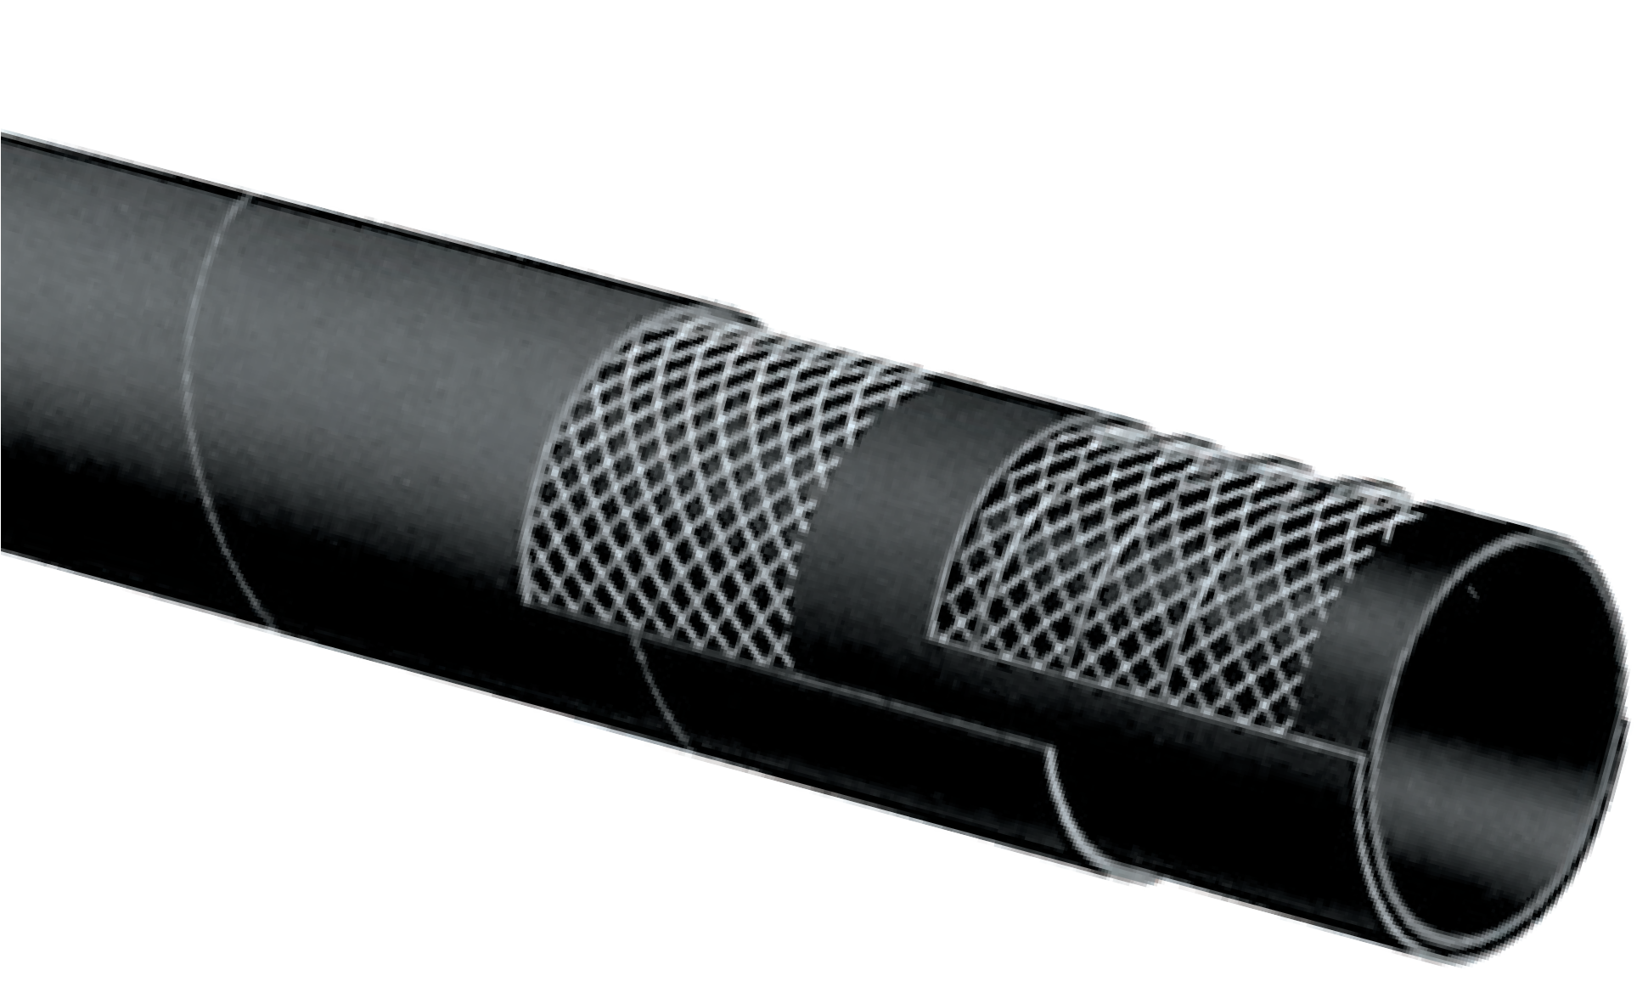

T204AA
75 PSI SBR Water S & D Hose
Water Suction

Nominal Specifications
Series | ID  (in.) | ID  (mm) | OD  (in.) | OD  (mm) | Max Rec. WP (PSI) | Vacuum HG (in.) | Min. Bending Radius (in. @ 68°F) | Weight (lbs./ft.)
T204AA600 | 6 | 152 | 6.54 | 166 | 75 | 24 | 30 | 4.13
T204AA800 | 8 | 203 | 8.70 | 221 | 75 | 21 | 40 | 7.06

Applications:
High pressure, 150 PSI lay flat type hose for general industrial construction and irrigation.

Cover:
Black EPDM – abrasion and ozone-resistant.

Reinforcement:
High tensile textile cords.

Tube:
Black EPDM.

Working Pressure:
Constant Pressure – 10 Bar (150 PSI)

Temperature Range:
-22°F (-30°C) to 176°F (+80°C)

Branding:
ALFAGOMMA – ITALY – T253 10 BAR (150 PSI) EPDM
WATER DISCHARGE (in green letters)

Standard Length:
100 feet: 1 1/2" through 10"
50 feet: 6", 6 5/8", 8", 10" & 12"

* 65/8" referred to as Elephant Trunk Hose – Ideal for “Irrigation Boots.”

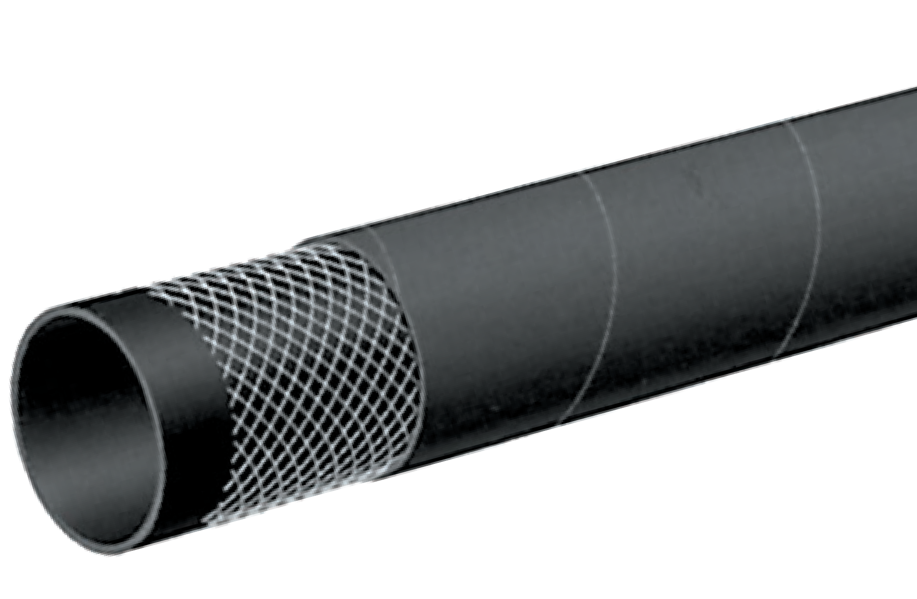

T253AA
150 PSI EPDM Layflat Water Discharge Hose
Water Discharge

FOR APPLICATIONS INVOLVING INDUSTRIAL ACID CHEMICALS AND ALCOHOLS, PLEASE REFER TO T505OG AND T509OE CHEMICAL HOSES

Nominal Specifications
Series | ID  (in.) | ID  (mm) | OD  (in.) | OD  (mm) | Max Rec. WP (PSI) | Weight (lbs./ft.)
T253AA150 | 1 1/2 | 38 | 1.81 | 46 | 150 | 0.37
T253AA200 | 2 | 51 | 2.32 | 59 | 150 | 0.50
T253AA250 | 2 1/2 | 63 | 2.80 | 71 | 150 | 0.60
T253AA300 | 3 | 76 | 3.31 | 84 | 150 | 0.86
T253AA400 | 4 | 102 | 4.33 | 110 | 150 | 1.19
T253AA600 | 6 | 152 | 6.38 | 162 | 150 | 2.00
T253AA662 | 6 5/8 | 168 | 7.01 | 178 | 150 | 2.17
T253AA800 | 8 | 203 | 8.46 | 215 | 150 | 2.82
T253AA1000 | 10 | 254 | 10.63 | 270 | 150 | 5.11
T253AA1200 | 12 | 305 | 12.56 | 319 | 150 | 5.93

Applications:
Water discharge hose for construction and irrigation.

Cover:
Black SBR – abrasion and ozone-resistant.

Reinforcement:
High tensile textile cords.

Tube:
Black SBR.

Working Pressure:
Constant Pressure – 10 Bar (150 PSI)

Temperature Range:
-22°F (-30°C) to 176°F (+80°C)

Standard Length:
100 feet: 1 1/2" through 8"
50 feet: 8"

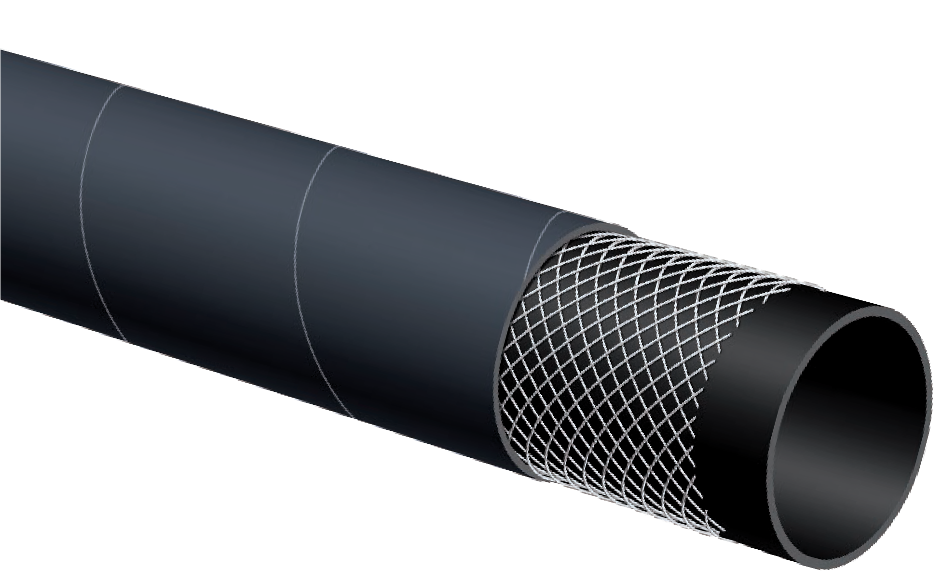

T254AA
150 PSI SBR Water
Discharge Hose
Water Discharge

Nominal Specifications
Series | ID  (in.) | ID  (mm) | OD  (in.) | OD  (mm) | Max Rec. WP (PSI) | Weight (lbs./ft.)
T254AA150 | 1 1/2 | 38 | 1.89 | 48 | 150 | 0.66
T254AA200 | 2 | 51 | 2.40 | 61 | 150 | 0.87
T254AA300 | 3 | 76 | 3.46 | 88 | 150 | 1.54
T254AA400 | 4 | 102 | 4.49 | 114 | 150 | 2.08
T254AA600 | 6 | 152 | 6.54 | 166 | 150 | 3.13
T254AA800 | 8 | 203 | 8.62 | 219 | 150 | 4.64

Applications:
For general wash down service, using hot water or low pressure saturated steam in processing plants and facilities and in food and dairy plants.

Cover:
Red EPDM – heat, abrasion and ozone resistant. White EPDM – heat, abrasion and ozone resistant.

Reinforcement:
High tensile textile cords.

Tube:
White EPDM. Meets FDA and 3A (18-03) requirements.

Working Pressure:
Constant Pressure – 15 Bar (225 PSI)

Steam Pressure:
Constant Pressure – 6 Bar (90 PSI)

Temperature Range:
Water -40°F (-40°C) to 248°F (+120°C) Steam 330°F to (+165°C)

Branding:
ALFAGOMMA – ITALY – T350 6 BAR (90 PSI) STEAM 15 BAR (225 PSI) HOT WATER (embossed)

Standard Length:
200 feet – eliminates bulky hookups

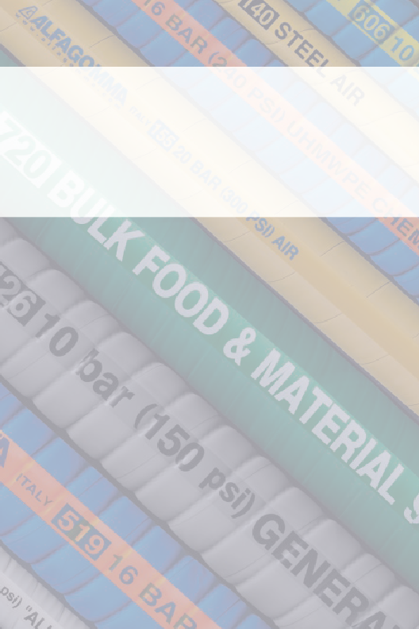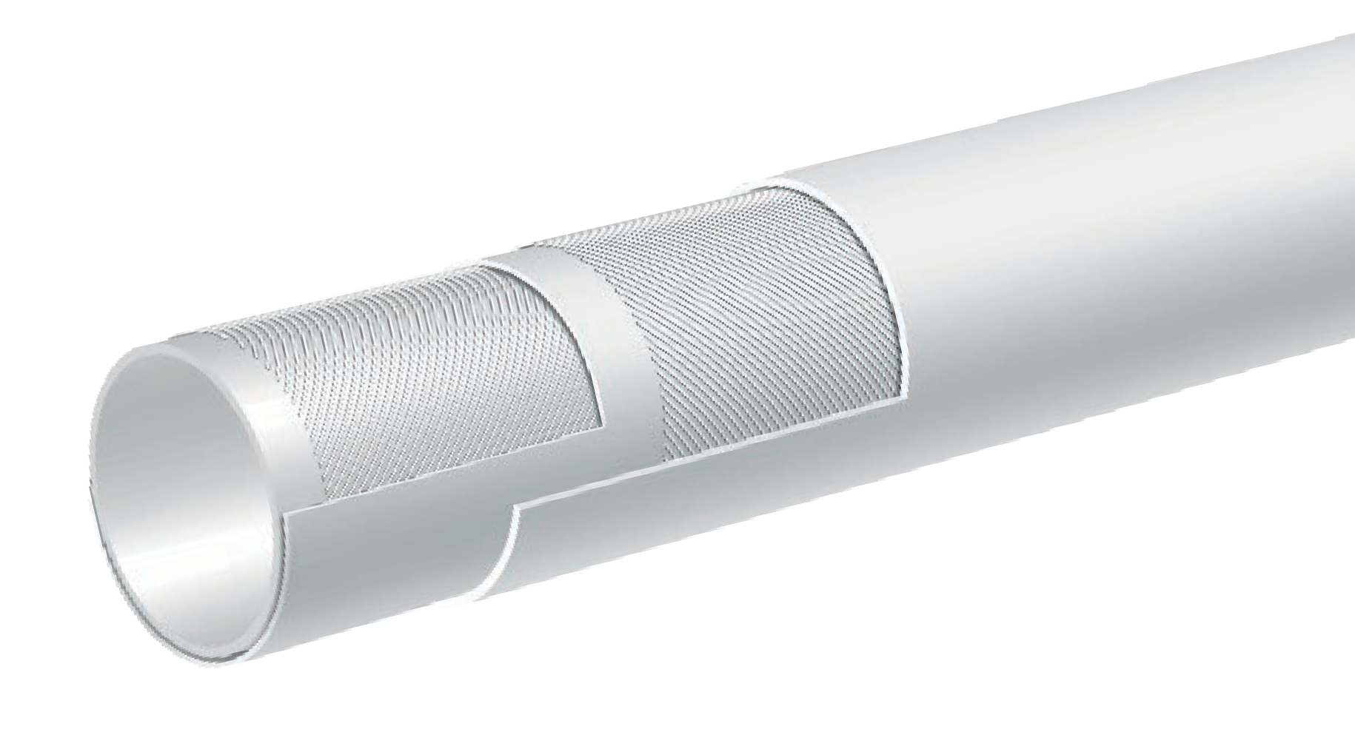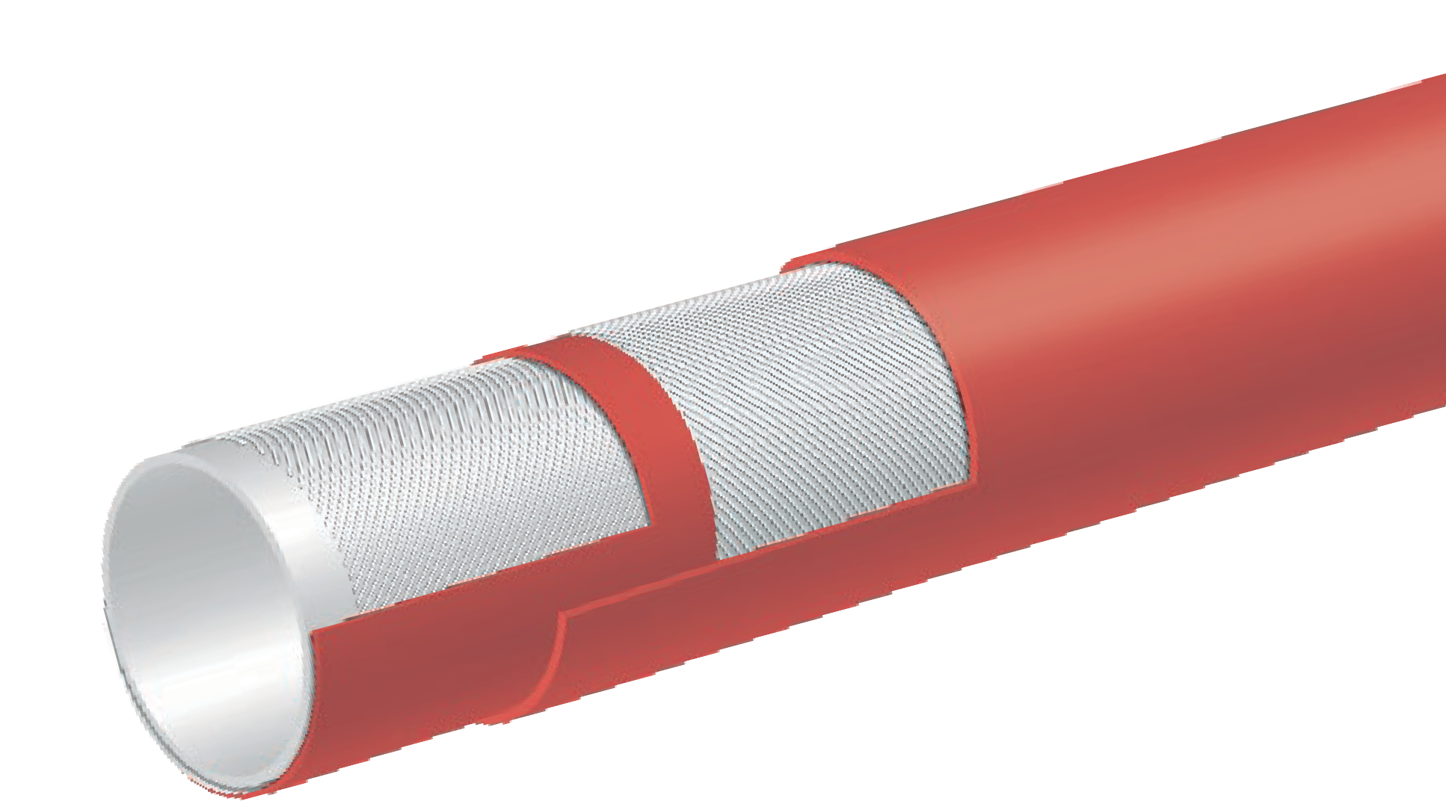
T350LL / T350LH
225 PSI Premium Paper Mill/Creamery Wash Down Hose – No Nozzle
T350LL
White Cover
COMPLIANT MATERIAL
T350LH
Red Cover
Hot Water

*T350 fully complies with the requirements listed in FDA CFR21.

Nominal Specifications
Series | ID  (in.) | ID  (mm) | OD  (in.) | OD  (mm) | Max Rec. WP (PSI) | Weight (lbs./ft.)
T350LL050 | 1/2 | 13 | 0.91 | 23 | 225 | 0.27
T350LL062 | 5/8 | 16 | 1.02 | 26 | 225 | 0.31
T350LL075 | 3/4 | 19 | 1.22 | 31 | 225 | 0.44
T350LL100 | 1 | 25 | 1.46 | 37 | 225 | 0.54
T350LL125 | 1 1/4 | 32 | 1.81 | 46 | 225 | 0.63
T350LL150 | 1 1/2 | 38 | 2.05 | 52 | 225 | 0.74
T350LL200 | 2 | 51 | 2.64 | 67 | 225 | 1.12
T350LH075 | 3/4 | 19 | 1.22 | 31 | 225 | 0.44
T350LH100 | 1 | 25 | 1.46 | 37 | 225 | 0.54
COUPLING SUGGESTIONS
Short shank, long shank couplings (NPT, GHT), barbed inserts attached with bands.

Applications:
For general wash down service, using hot and cold water in paper mills and in food and dairy plants.

Cover:
White or green EPDM – heat, abrasion and ozone resistant.

Reinforcement:
High tensile textile cords.

Tube:
White EPDM. Meets FDA and 3A (18-03) requirements.

Working Pressure:
Constant Pressure – 10 Bar (150 PSI)

Temperature Range:
-40°F (-40°C) to 248°F (+120°C)

Standard Length:
50 feet including 6" long built-in tapered nozzle*

*Tapered Nozzle Hole Size
3/4" and 1" ID 3/8"
1 1/4" ID 1/2"
1 1/2" ID 5/8"

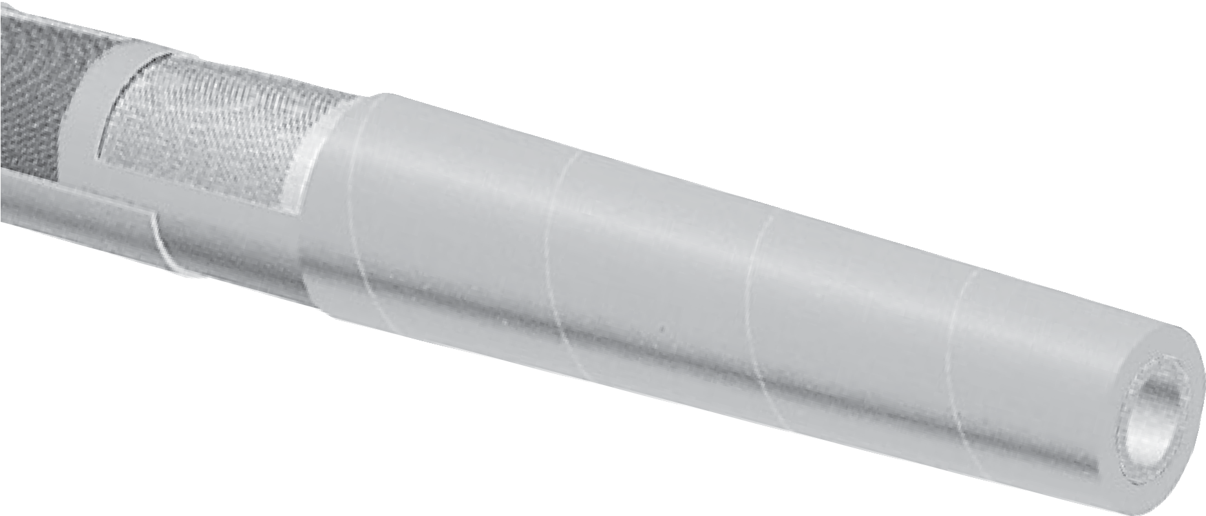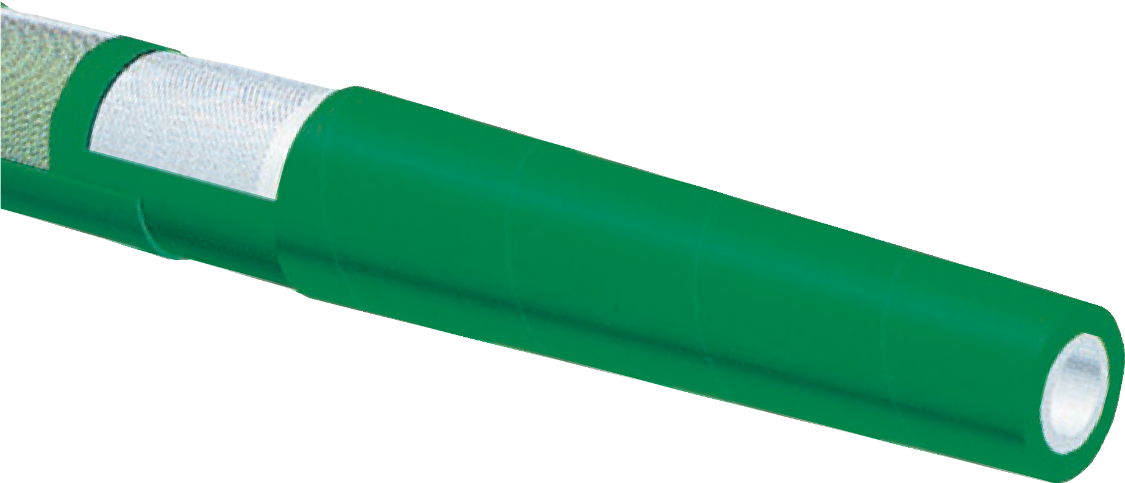
T351LL / T351LG
150 PSI Premium Paper Mill/ Creamery Wash Down Hose With Tapered Nozzle
T351LL
White Cover
T351LG
Green Cover
COMPLIANT MATERIAL
Hot Water
*T351 fully complies with the requirements listed in FDA CFR21.

Nominal Specifications
Series | ID  (in.) | ID  (mm) | OD  (in.) | OD  (mm) | Max Rec. WP (PSI) | Weight (lbs./ft.)
T351LL/LG075 | 3/4 | 19 | 1.22 | 31 | 150 | 0.44
T351LL/LG100 | 1 | 25 | 1.46 | 37 | 150 | 0.54
T351LL/LG125 | 1 1/4 | 32 | 1.81 | 46 | 150 | 0.78
T351LL/LG150 | 1 1/2 | 38 | 2.05 | 52 | 150 | 0.91

COUPLING SUGGESTIONS
Short shank, long shank couplings (NPT, GHT), barbed inserts attached with bands.

Applications:
Radiator hose.

Cover:
Black EPDM – heat, abrasion and ozone resistant.

Reinforcement:
High tensile textile cords.

Tube:
Black EPDM.

Working Pressure:
5 Bar (75 PSI)

Temperature Range:
-40°F (-40°C) to 248°F (+120°C)

Branding:
ALFAGOMMA – ITALY – T-352 RADIATOR – DIN 73411 –
dia mm / in. SAE 20R1-D2 (in yellow letters)

Standard Length:
12 1/2 foot and 200 foot coils for 1/2" to 2" ID sizes, 12 1/2 foot coils for 2 3/16" to 5" sizes

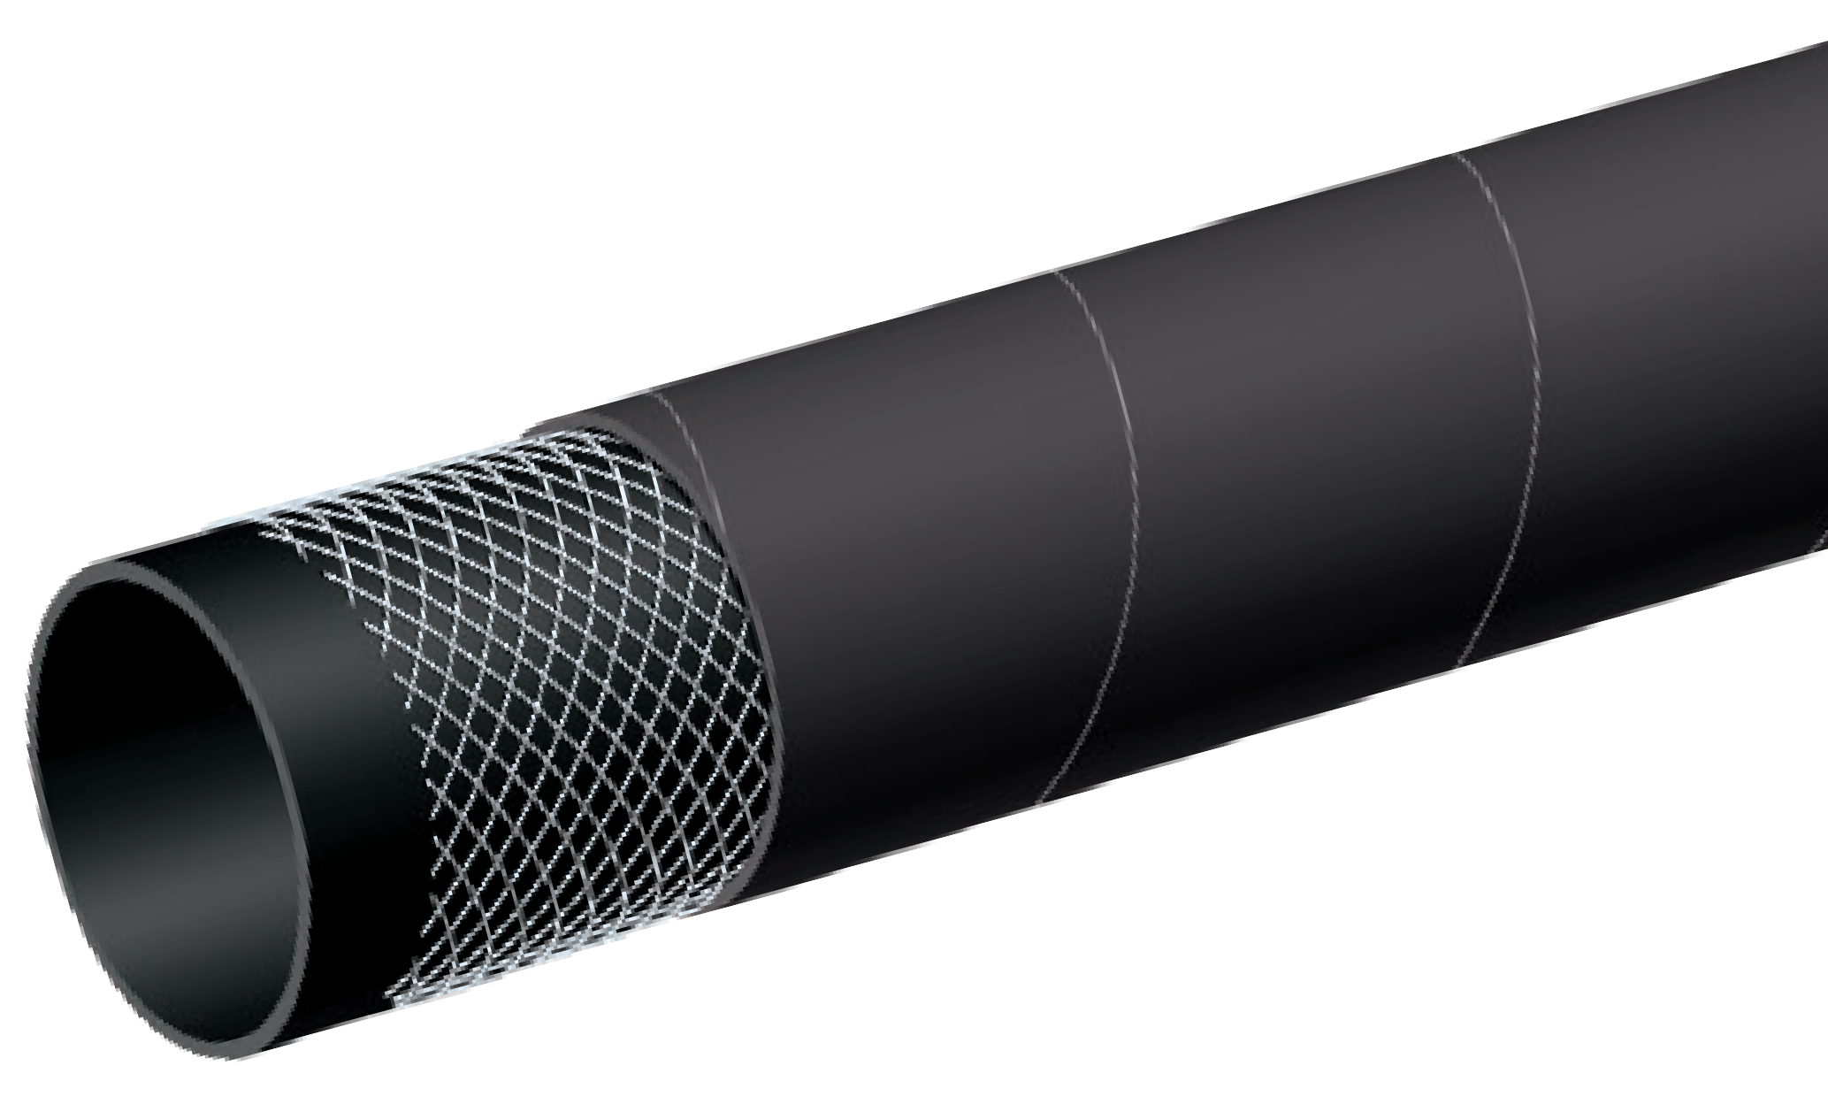
T352AA
75 PSI Radiator Hose
Hot Water

Nominal Specifications
Series | ID  (in.) | ID  (mm) | OD  (in.) | OD  (mm) | Max Rec. WP (PSI) | Available Length | Weight (lbs./ft.)
T352AA050X12.6 | 1/2 | 13 | 0.83 | 21 | 75 | 12'6" Coil | 0.19
T352AA050X200 | 1/2 | 13 | 0.83 | 21 | 75 | 200' Coil | 0.19
T352AA062X12.6 | 5/8 | 16 | 0.94 | 24 | 75 | 12'6" Coil | 0.22
T352AA071X12.6 | 11/16 | 18 | 1.02 | 26 | 75 | 12'6" Coil | 0.24
T352AA078X12.6 | 13/16 | 20 | 1.10 | 28 | 75 | 12'6" Coil | 0.26
T352AA087X12.6 | 7/8 | 22 | 1.18 | 30 | 75 | 12'6" Coil | 0.28
T352AA087X200 | 7/8 | 22 | 1.18 | 30 | 75 | 200' Coil | 0.28
T352AA100X12.6 | 1 | 25 | 1.30 | 33 | 75 | 12'6" Coil | 0.32
T352AA100X200 | 1 | 25 | 1.30 | 33 | 75 | 200' Coil | 0.32
T352AA112X12.6 | 1 1/8 | 28 | 1.42 | 36 | 75 | 12'6" Coil | 0.34
T352AA112X200 | 1 1/8 | 28 | 1.42 | 36 | 75 | 200' Coil | 0.34
T352AA118X12.6 | 1 3/16 | 30 | 1.50 | 38 | 75 | 12'6" Coil | 0.37
continued

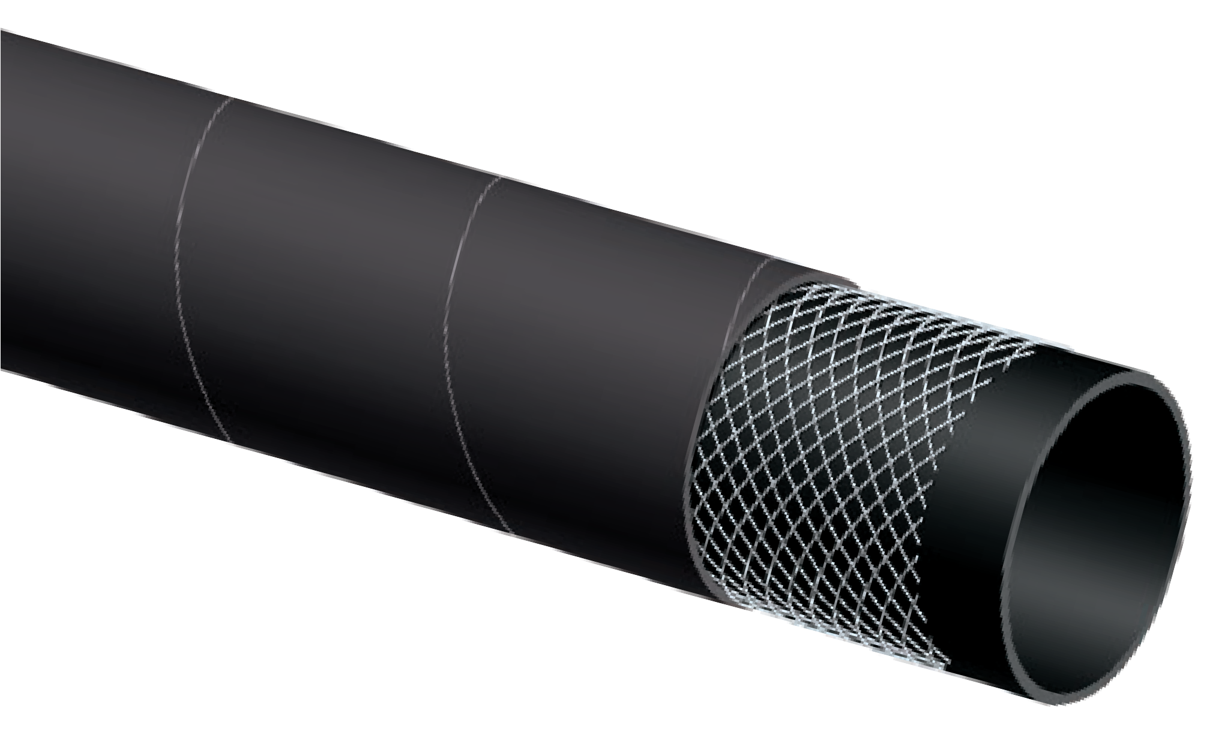
T352AA
75 PSI Radiator Hose
Hot Water

Nominal Specifications
Series | ID  (in.) | ID  (mm) | OD  (in.) | OD  (mm) | Max Rec. WP (PSI) | Available Length | Weight (lbs./ft.)
T352AA125X12.6 | 1 1/4 | 32 | 1.57 | 40 | 75 | 12'6" Coil | 0.39
T352AA125X200 | 1 1/4 | 32 | 1.57 | 40 | 75 | 200' Coil | 0.39
T352AA137X12.6 | 1 3/8 | 35 | 1.69 | 43 | 75 | 12'6" Coil | 0.42
T352AA150X12.6 | 1 1/2 | 38 | 1.89 | 48 | 75 | 12'6" Coil | 0.57
T352AA150X200 | 1 1/2 | 38 | 1.89 | 48 | 75 | 200' Coil | 0.57
T352AA157X12.6 | 1 9/16 | 40 | 1.97 | 50 | 75 | 12'6" Coil | 0.60
T352AA157X200 | 1 9/16 | 40 | 1.97 | 50 | 75 | 200' Coil | 0.60
T352AA162X12.6 | 1 5/8 | 42 | 2.05 | 52 | 75 | 12'6" Coil | 0.63
T352AA162X200 | 1 5/8 | 42 | 2.05 | 52 | 75 | 200' Coil | 0.63
T352AA175X12.6 | 1 3/4 | 45 | 2.17 | 55 | 75 | 12'6" Coil | 0.66
T352AA175X200 | 1 3/4 | 45 | 2.17 | 55 | 75 | 200' Coil | 0.66
T352AA189X12.6 | 1 7/8 | 48 | 2.28 | 58 | 75 | 12'6" Coil | 0.70
T352AA189X200 | 1 7/8 | 48 | 2.28 | 58 | 75 | 200' Coil | 0.70
T352AA200X12.6 | 2 | 51 | 2.40 | 61 | 75 | 12'6" Coil | 0.75
T352AA200X200 | 2 | 51 | 2.40 | 61 | 75 | 200' Coil | 0.75
T352AA218X12.6 | 2 3/16 | 55 | 2.56 | 65 | 75 | 12'6" Coil | 0.80
T352AA225X12.6 | 2 1/4 | 57 | 2.64 | 67 | 75 | 12'6" Coil | 0.82
T352AA238X12.6 | 2 3/8 | 60 | 2.76 | 70 | 75 | 12'6" Coil | 0.86
T352AA250X12.6 | 2 1/2 | 63 | 2.87 | 73 | 75 | 12'6" Coil | 0.90
T352AA275X12.6 | 2 3/4 | 70 | 3.15 | 80 | 75 | 12'6" Coil | 0.97
T352AA300X12.6 | 3 | 76 | 3.39 | 86 | 75 | 12'6" Coil | 1.04
T352AA315X12.6 | 3 1/8 | 80 | 3.54 | 90 | 75 | 12'6" Coil | 1.10
T352AA354X12.6 | 3 9/16 | 90 | 4.02 | 102 | 75 | 12'6" Coil | 1.36
T352AA400X12.6 | 4 | 102 | 4.49 | 114 | 75 | 12'6" Coil | 1.52
T352AA450X12.6 | 4 1/2 | 116 | 5.00 | 127 | 75 | 12'6" Coil | 1.69
T352AA500X12.6 | 5 | 127 | 5.55 | 141 | 75 | 12'6" Coil | 2.16

(Reprinted from RMA IP-11-1 Steam Hose)
Steam Hose Safety Facts

Handling steam is a very hazardous situation. Using care and some safety precaution can minimize or eliminate personal or property damage.

SELECTING AND USING STEAM HOSE
- Make sure steam hose is identified as a steam hose. It should be branded as such, stating working pressure and temperature rating.
- Make sure working pressure and temperature is not exceeded.
- Do not allow hose to remain under pressure when not in use.
- Avoid excess bending or flexing of hose near the coupling. Straight line operation is preferred. If bends are necessary as part of operation, spring guards may help.
- Be sure and use recommended steam hose couplings and clamps on hose.

MAINTENANCE OF STEAM HOSE
- Periodic inspection of hose should include looking for cover blisters and lumps.
- Check for kinked areas that could damage hose.
- Drain hose after each use to avoid tube damage before hose is put back in operation, to avoid “popcorning” of the tube.
- Check tightness of clamps bolts after each use.
- Check to see if clamps halves are touching. If they are, recouple hose with smaller clamps to insure proper tightness or grip around hose.
- Do not store hose over hooks.
- Steam hose lying on metal racks or installed around steel piping will dry out the hose, causing tube and cover cracking.
- For service in sub-zero application, use only T-341 chlorbutyl hose.

The chart represents the three forms of water when subjected to heat and pressure. Use only hoses specifically designed for the application.

Gauge Pressure (psi)
Temperature of Saturated Steam (°F)
10
25
50
75
100
125
150
175
200
225
250
239
267
298
320
338
353
366
377
388
397
406

SELECTING AND USING STEAM HOSE

Gauge Pressure |  | Temperature
psi | bar | °C | °F
25 | 1.73 | 130 | 267
30 | 2.07 | 134 | 274
35 | 2.42 | 138 | 281
40 | 2.76 | 141 | 287
45 | 3.11 | 144 | 292
50 | 3.45 | 148 | 298
60 | 4.14 | 153 | 307
70 | 4.83 | 158 | 316
80 | 5.52 | 162 | 324
90 | 6.21 | 166 | 330
100 | 6.90 | 170 | 338
120 | 8.28 | 177 | 350
140 | 9.66 | 182 | 361
160 | 11.04 | 188 | 371
180 | 12.42 | 193 | 379
200 | 13.80 | 198 | 388
225 | 15.53 | 203 | 397
250 | 17.25 | 208 | 406
275 | 18.98 | 212 | 414
300 | 20.70 | 216 | 422
325 | 22.43 | 221 | 429
350 | 24.15 | 225 | 437

CORROSIVE STEAM
When the water used to generate steam contains dissolved air, oxygen or carbon dioxide, then these gases end up as
contaminants in the steam. At high temperatures of steam both oxygen and carbon dioxide are extremely corrosive.

Carbon dioxide is acidic and therefore attacks metals whereas the oxygen corrodes metals and oxidizes rubbers. Corrosion of metals in the presence of both oxygen and acids is forty times faster than with either alone. Boiler water is therefore normally treated not only to remove the “hardness” which would cause “furring” of the boiler but also to remove dissolved oxygen and carbon dioxide and to ensure that the steam is not only not acidic but even slightly alkaline. Boiler water treatment is a specialised subject beyond
the scope of this technical sheet but correct steam generation is important.

DETERIORATION OF STEAM HOSE
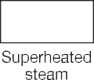
Like all rubber products steam hoses have a finite life and are subject to gradual deterioration with use. However, it sometimes happens that hoses which have been giving a good life suddenly start failing without apparent reason. In such cases it is often a change in the steam conditions causing a rapid acceleration of a normal failure mode. It is therefore useful to consider how steam hoses normally last and thus how the condition of the steam affects hose life.

Applications:
The transfer of saturated steam up to 270 PSI and 410°F (+210°C).
H Use with superheated steam will shorten hose life.
Proper draining of steam hose after each use will
increase service life.
H Not recommended for washdown applications where detergent or oils are present.
Cover:
Red or black EPDM – heat-resistant. Wrapped cover fabric impression. Pin-pricked cover to allow venting.

Reinforcement:
High tensile steel wire braids (1/2" ID – 1 wire braid, 3/4" and higher ID’s – 2 wire braids).

Tube:
Black extruded EPDM – heat-resistant.
Not for steam cleaner use.

Working Pressure:
Constant Pressure – 18 Bar (270 PSI)

Temperature Range:
-40°F (-40°C) to 410°F (+210°C)

Branding:
ALFAGOMMA – ITALY T340 18 BAR (270 PSI) STEAM – DRAIN AFTER USE – QTR/YEAR (embossed)

Standard Length:
50 or 100 feet
100 feet – 2 1/2" 200 feet – 3/4"

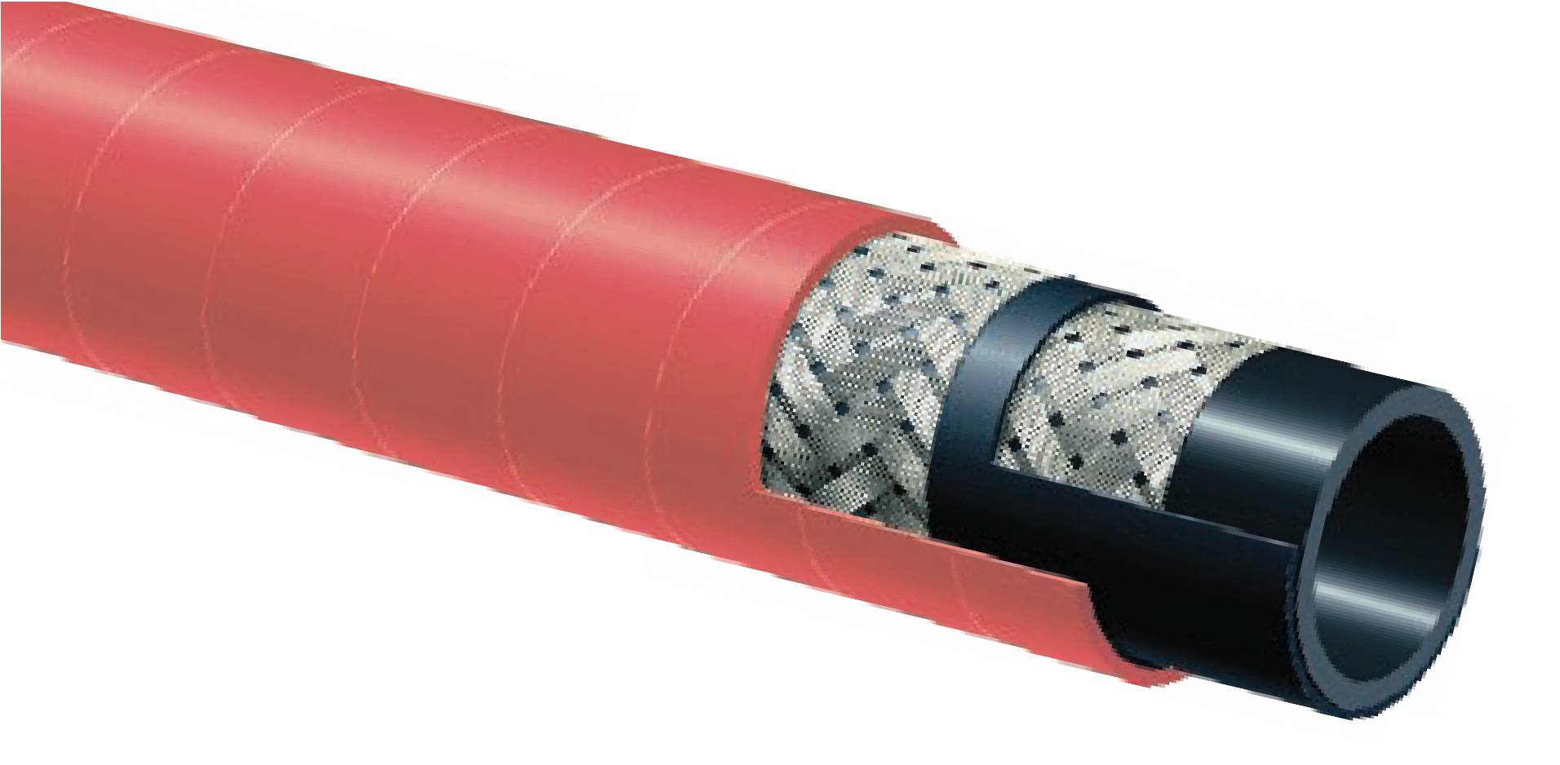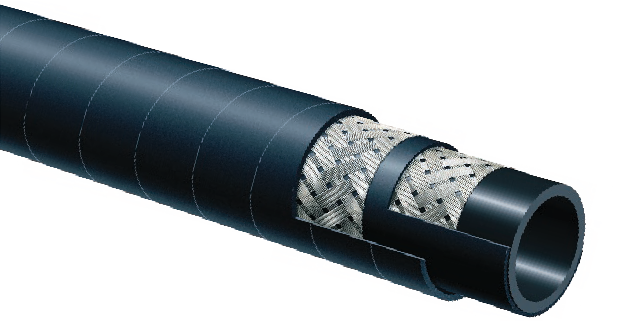
T340AH / T340AA
270 PSI EPDM
Braided Steam Hose
T340AH
Red Cover

T340AA
Black Cover
Steam
Warning
Handling steam is very hazardous. If it is not properly controlled it can cause property damage, injury or even death. Selection for the proper application, usage, and maintenance will not only increase hose life but will insure safe operation for the user.
Nominal Specifications
Series | ID  (in.) | ID  (mm) | OD  (in.) | OD  (mm) | Max Rec. WP (PSI) | Min. Bending Radius (in. @ 68°F) | Weight (lbs./ft.)
T340AH/AA050 | 1/2 | 13 | 0.91 | 23 | 270 | 5 | 0.28
T340AH/AA075 | 3/4 | 19 | 1.22 | 31 | 270 | 7 1/2 | 0.52
T340AH/AA100 | 1 | 25 | 1.50 | 38 | 270 | 10 | 0.60
T340AA200 | 2 | 51 | 2.64 | 67 | 270 | 20 | 1.38
T340AA250 | 2 1/2 | 63 | 3.19 | 81 | 270 | 25 | 1.99
T340AA300 | 3 | 76 | 3.70 | 94 | 270 | 30 | 2.50

Applications:
The transfer of saturated and superheated steam up to 270 PSI and max 410°F (+210°C) in shipyards, chemical plants and industrial applications.
H Proper draining of steam hose after each use will
increase service life.
H Not recommended for washdown applications where detergent or oils are present.
Cover:
Red or black EPDM – heat-resistant. Wrapped cover fabric impression. Pin-pricked cover to allow venting.

Reinforcement:
High tensile steel wire braids (1/2" ID – 1 wire braid, 3/4" and higher ID’s – 2 wire braids).

Tube:
Black extruded CIIR – heat-resistant.
Not for steam cleaner use.

Working Pressure:
Constant Pressure – 18 Bar (270 PSI)

Temperature Range:
-40°F (-40°C) to 410°F (+210°C)

Branding:
ALFAGOMMA – ITALY T341 18 BAR (270 PSI) STEAM – DRAIN AFTER USE – QTR/YEAR (embossed)

Standard Length:
50 or 100 feet

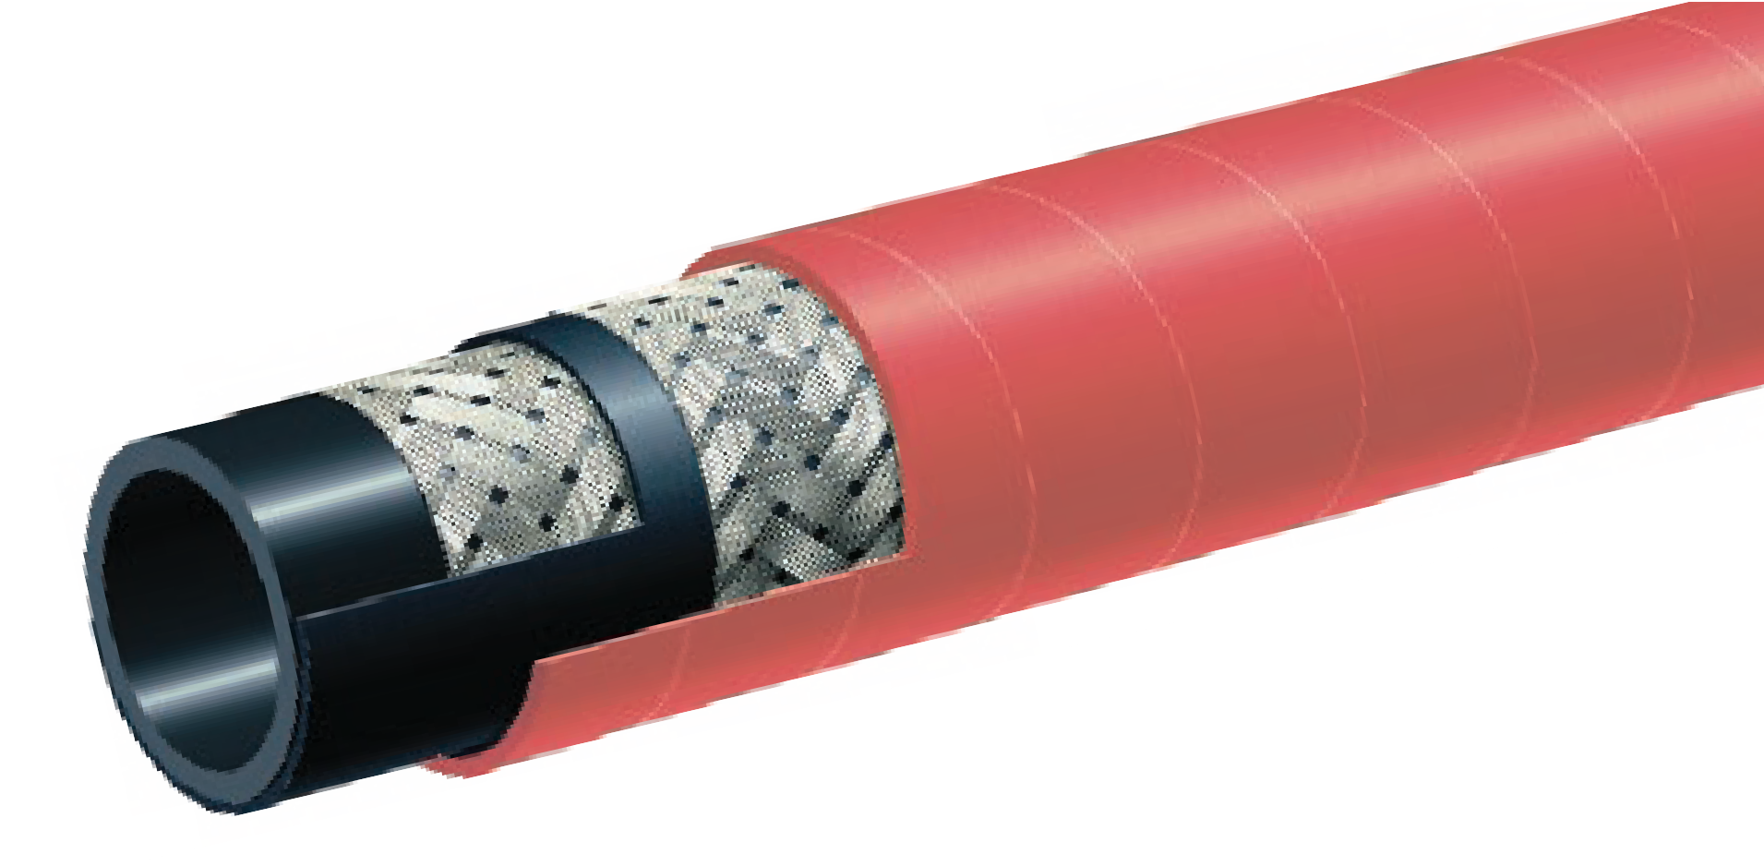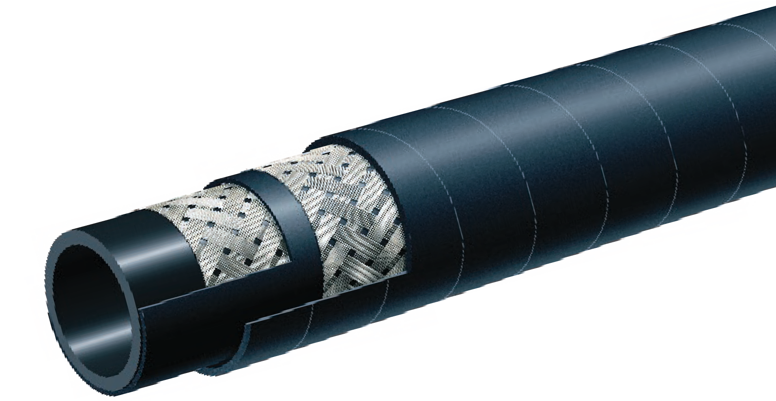
T341AH / T341AA
270 PSI Chlorobutyl Braided Steam Hose
T341AH
Red Cover

T341AA
Black Cover
Steam
Warning
Handling steam is very hazardous. If it is not properly controlled it can cause property damage, injury or even death. Selection for the proper application, usage, and maintenance will not only increase hose life but will insure safe operation for the user.
Nominal Specifications
Series | ID  (in.) | ID  (mm) | OD  (in.) | OD  (mm) | Max Rec. WP (PSI) | Min. Bending Radius (in. @ 68°F) | Weight (lbs./ft.)
T341AH/AA050 | 1/2 | 13 | 0.91 | 23 | 270 | 5 | 0.29
T341AH/AA075 | 3/4 | 19 | 1.22 | 31 | 270 | 7 1/2 | 0.53
T341AH/AA100 | 1 | 25 | 1.50 | 38 | 270 | 10 | 0.62
T341AH/AA125 | 1 1/4 | 32 | 1.81 | 46 | 270 | 12 1/2 | 0.89
T341AH/AA150 | 1 1/2 | 38 | 2.05 | 52 | 270 | 15 | 0.97
T341AH/AA200 | 2 | 51 | 2.64 | 67 | 270 | 20 | 1.44
*T341AA/AH 1 1/4", 1 1/2" & 2" not suitable for “Ship to Shore” service.

REFER TO STEAM HOSE SAFETY FACTS ON PAGE 24.
COUPLING SUGGESTIONS
Steel or malleable iron male insert NPT or female ground joint or washer type with spuds attached with 2 or 4 bolt interlocking clamps.
H Kuriyama offers a full line of ground joint couplings and clamps. Refer to current Kuriyama-Couplings™ and Accessories Catalog for type and pricing.
H Universal quick-acting couplings should not be used with steam hose.

Applications:
Saturated and superheated steam in applications where an oil resistant cover is needed.
H Use with superheated steam will shorten hose life.
Proper draining of steam hose after each use will
increase service life.
H Not recommended for washdown applications where detergent or oils are present.
Cover:
Red special compound - heat, oil-resistant, ozone and hydrocarbon resistant. Pin-pricked cover to allow venting.

Reinforcement:
High tensile steel wire braids.

Tube:
Black extruded EPDM – heat-resistant.
Not for steam cleaner use.

Working Pressure:
Constant Pressure – 18 Bar (270 PSI)

Temperature Range:
-40°F (-40°C) to 410°F (+210°C)

Branding:
Embossed brand ALFAGOMMA – ITALY T343 18 BAR (270 PSI) STEAM – DRAIN AFTER USE – QTR/YEAR

Standard Length:
50 or 100 feet

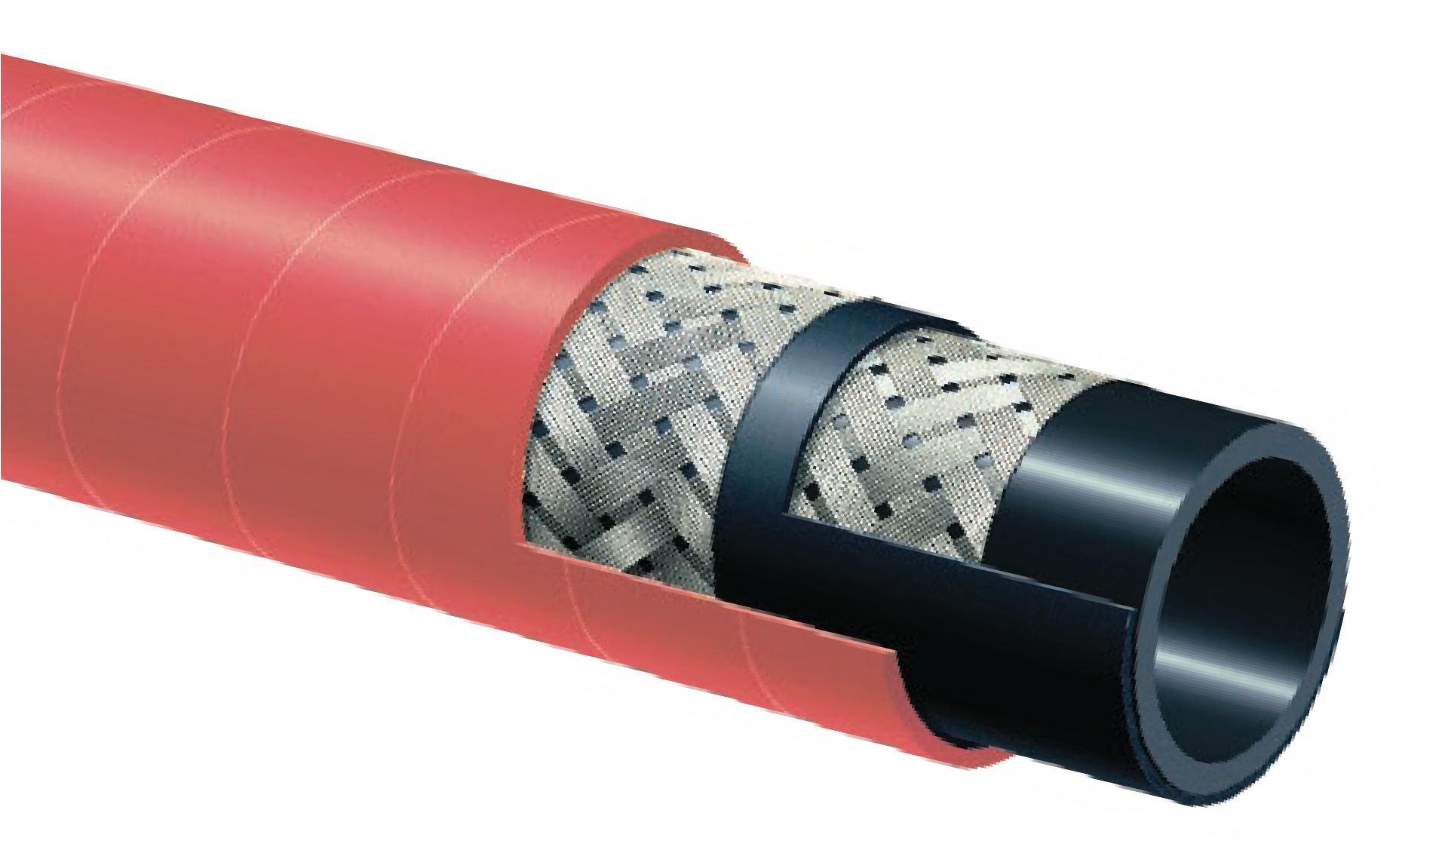
T343AH
270 PSI Braided Refinery Steam hose
NEW
PRODUCT
Steam
Warning
Handling steam is very hazardous. If it is not properly controlled it can cause property damage, injury or even death. Selection for the proper application, usage, and maintenance will not only increase hose life but will insure safe operation for the user.

Nominal Specifications
Series | ID  (in.) | ID  (mm) | OD  (in.) | OD  (mm) | Max Rec. WP (PSI) | Min. Bending Radius (in. @ 68°F) | Weight (lbs./ft.)
T343AH075 | 3/4 | 19 | 1.22 | 31 | 270 | 7 1/2 | 0.54
T343AH100 | 1 | 25 | 1.50 | 38 | 270 | 10 | 0.66

Applications:
Liquid, fatty, oily food and alcoholic beverage (max 75 proof) suction and discharge.
Hose may be sterilized with 5% soda solution.
H Not recommended for dry abrasive materials.
Cover:
White NBR/PVC – abrasion, ozone and oil resistant.

Reinforcement:
Spiraled high tensile textile cords with flexible steel helix wire.

Tube:
White NBR. Meets FDA and 3A (18-03) requirements.

Working Pressure:
Constant Pressure – 10 Bar (150 PSI)

Temperature Range:
-22°F (-30°C) to 212°F (+100°C)

Branding:
ALFAGOMMA – ITALY T405 10 BAR (150 PSI) – GENERAL PURPOSE FOOD QUALITY – S & D (black
letters)

Standard Length:
100 feet

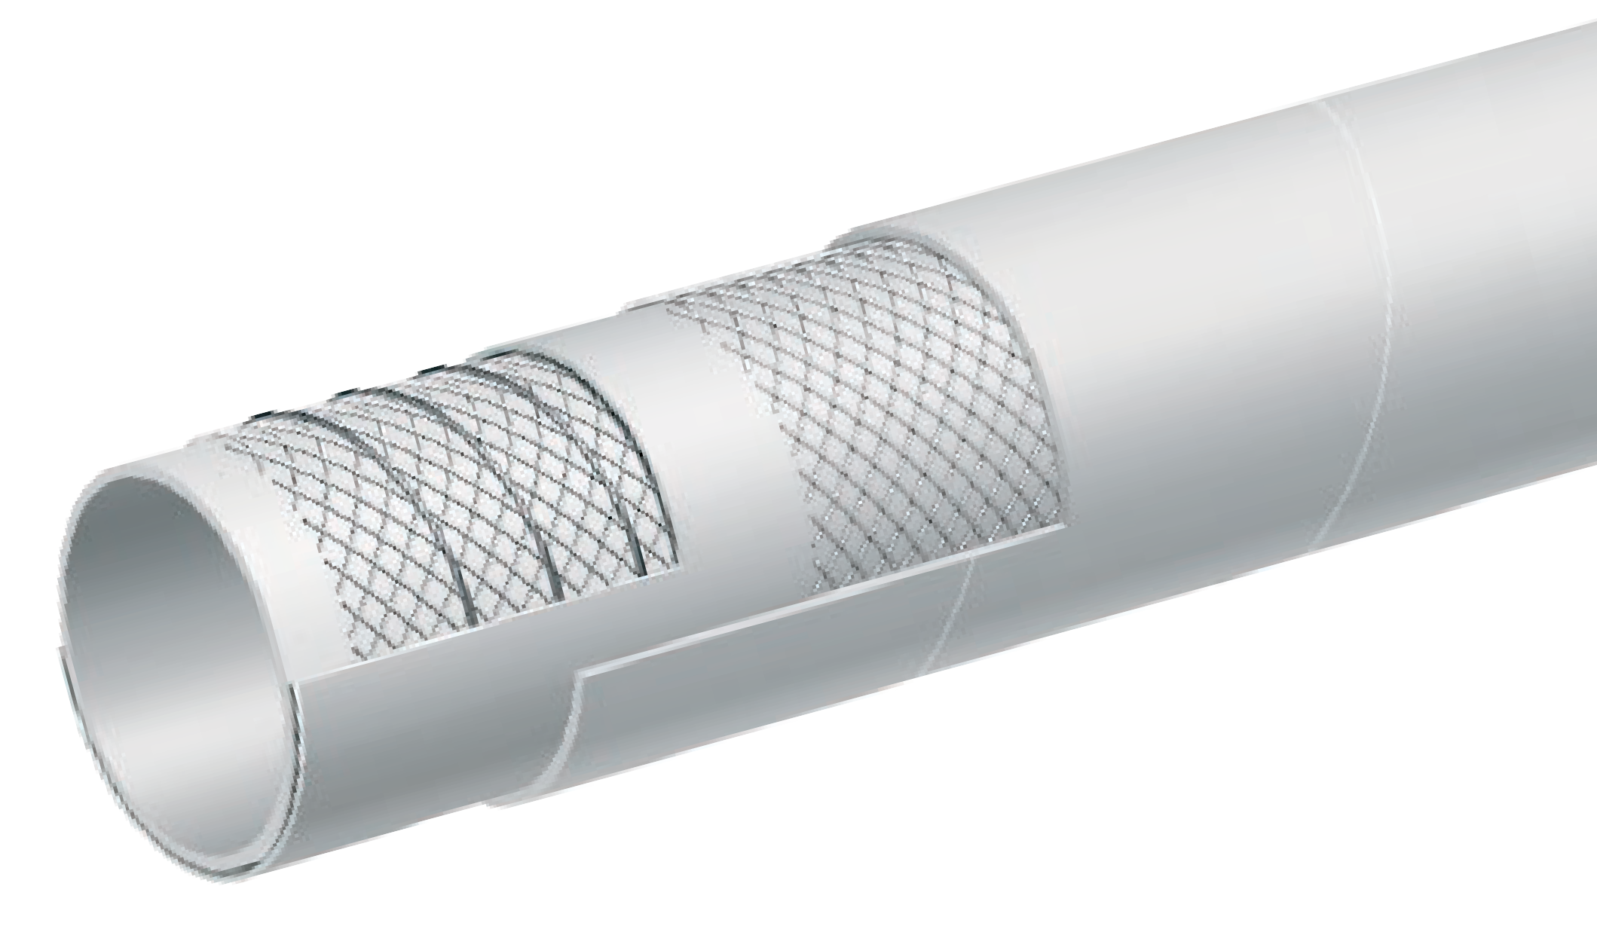
T405LL
150 PSI White Food S & D Hose
COMPLIANT MATERIAL
FDA Liquid Food Transfer

Nominal Specifications
Series | ID  (in.) | ID  (mm) | OD  (in.) | OD  (mm) | Max Rec. WP (PSI) | Vacuum HG (in.) | Min. Bending Radius (in. @ 68°F) | Weight (lbs./ft.)
T405LL100 | 1 | 25 | 1.46 | 37 | 150 | 30 | 3 | 0.61
T405LL150 | 1 1/2 | 38 | 1.97 | 50 | 150 | 30 | 4 1/2 | 0.84
T405LL200 | 2 | 51 | 2.48 | 63 | 150 | 30 | 6 | 1.08
T405LL300 | 3 | 76 | 3.46 | 88 | 150 | 27 | 9 | 1.71
T405LL400 | 4 | 102 | 4.57 | 116 | 150 | 27 | 12 | 2.36

CONSULT FOOD HOSE GUIDE FOR MATERIAL COMPATIBILITY ON PAGE 36.
COUPLING SUGGESTIONS
Quick-Acting or combination nipples attached with single bolt, double bolt, wire or band type clamps.

Applications:
Liquid, fatty, oily food and alcoholic beverage (max 75 proof) suction and discharge.
Hose may be sterilized with 5% soda solution.
H Not recommended for dry abrasive materials.
Cover:
Grey NBR/PVC – abrasion, ozone and oil resistant.

Reinforcement:
Spiraled high tensile textile cords with flexible steel helix wire.

Tube:
White NBR. Meets FDA and 3A (18-03) requirements.

Working Pressure:
Constant Pressure – 10 Bar (150 PSI)

Temperature Range:
-22°F (-30°C) to 212°F (+100°C)

Branding:
ALFAGOMMA – ITALY T405 10 BAR (150 PSI) – GENERAL PURPOSE FOOD QUALITY – S & D (black
letters)

Standard Length:
100 feet

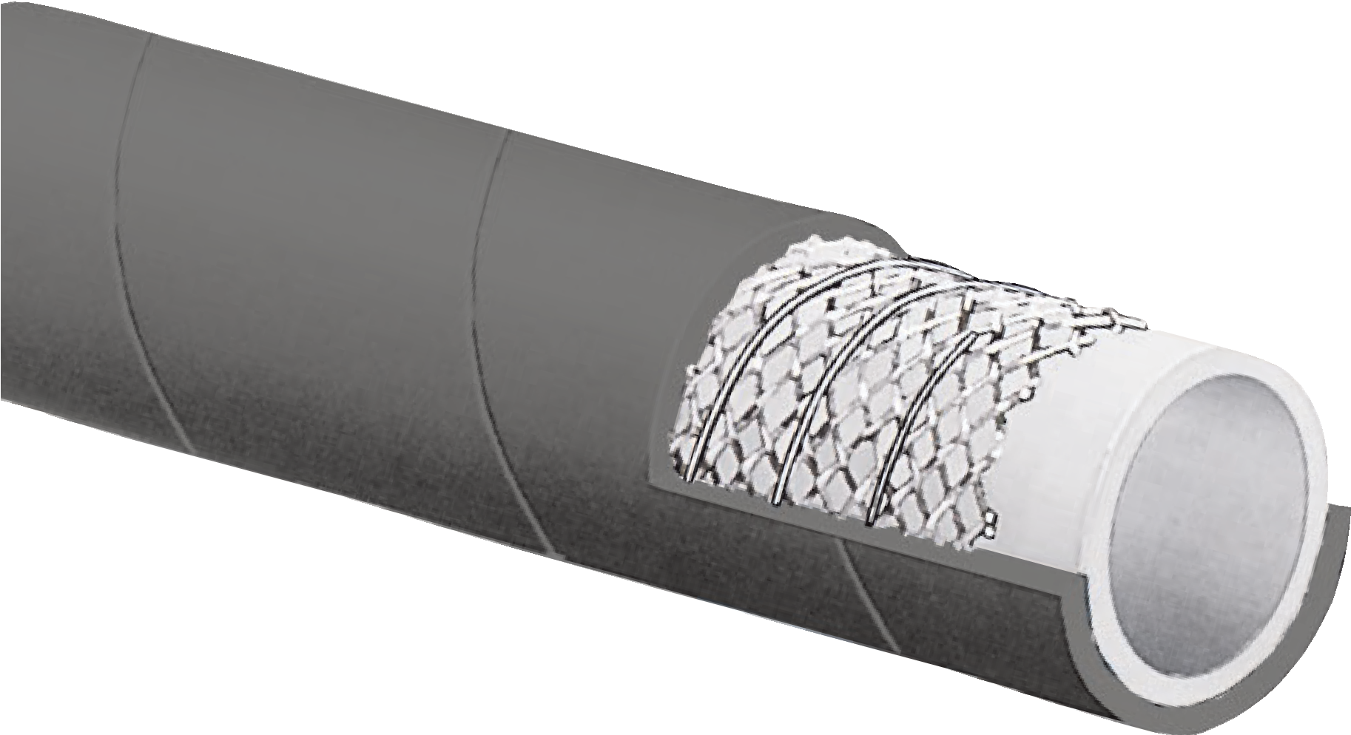
T405LB
150 PSI Grey Food S & D Hose
COMPLIANT MATERIAL
FDA Liquid Food Transfer

Nominal Specifications
Series | ID  (in.) | ID  (mm) | OD  (in.) | OD  (mm) | Max Rec. WP (PSI) | Vacuum HG (in.) | Min. Bending Radius (in. @ 68°F) | Weight (lbs./ft.)
T405LB150 | 1 1/2 | 38 | 1.97 | 50 | 150 | 30 | 4 1/2 | 0.84
T405LB200 | 2 | 51 | 2.48 | 63 | 150 | 30 | 6 | 1.08
T405LB300 | 3 | 76 | 3.46 | 88 | 150 | 27 | 9 | 1.71
T405LB400 | 4 | 102 | 4.57 | 116 | 150 | 27 | 12 | 2.36

CONSULT FOOD HOSE GUIDE FOR MATERIAL COMPATIBILITY ON PAGE 36.
COUPLING SUGGESTIONS
Quick-Acting or combination nipples attached with single bolt, double bolt, wire or band type clamps.

Applications:
Food and alcoholic beverage suction and discharge. Specially designed for wine, beer and spirits, up to 95 proof.
Hose may be sterilized with steam at 226°F (+130°C) for 30 minutes or with 5% soda solution.
H Not recommended for dry abrasive materials.
Cover:
White EPDM – abrasion and ozone resistant.

Reinforcement:
High tensile textile cords with embedded PET helix.

Tube:
White nontoxic CIIR. Meets FDA and 3A (18-03) requirements.

Working Pressure:
Constant Pressure – 16 Bar (240 PSI)

Temperature Range:
-22°F (-30°C) to 226°F (+108°C)

Branding:
ALFAGOMMA – ITALY T410 16 BAR (240 PSI) – FOOD SUCTION & DELIVERY – CRUSH RESISTANT (in black
letters)

Standard Length:
100 feet

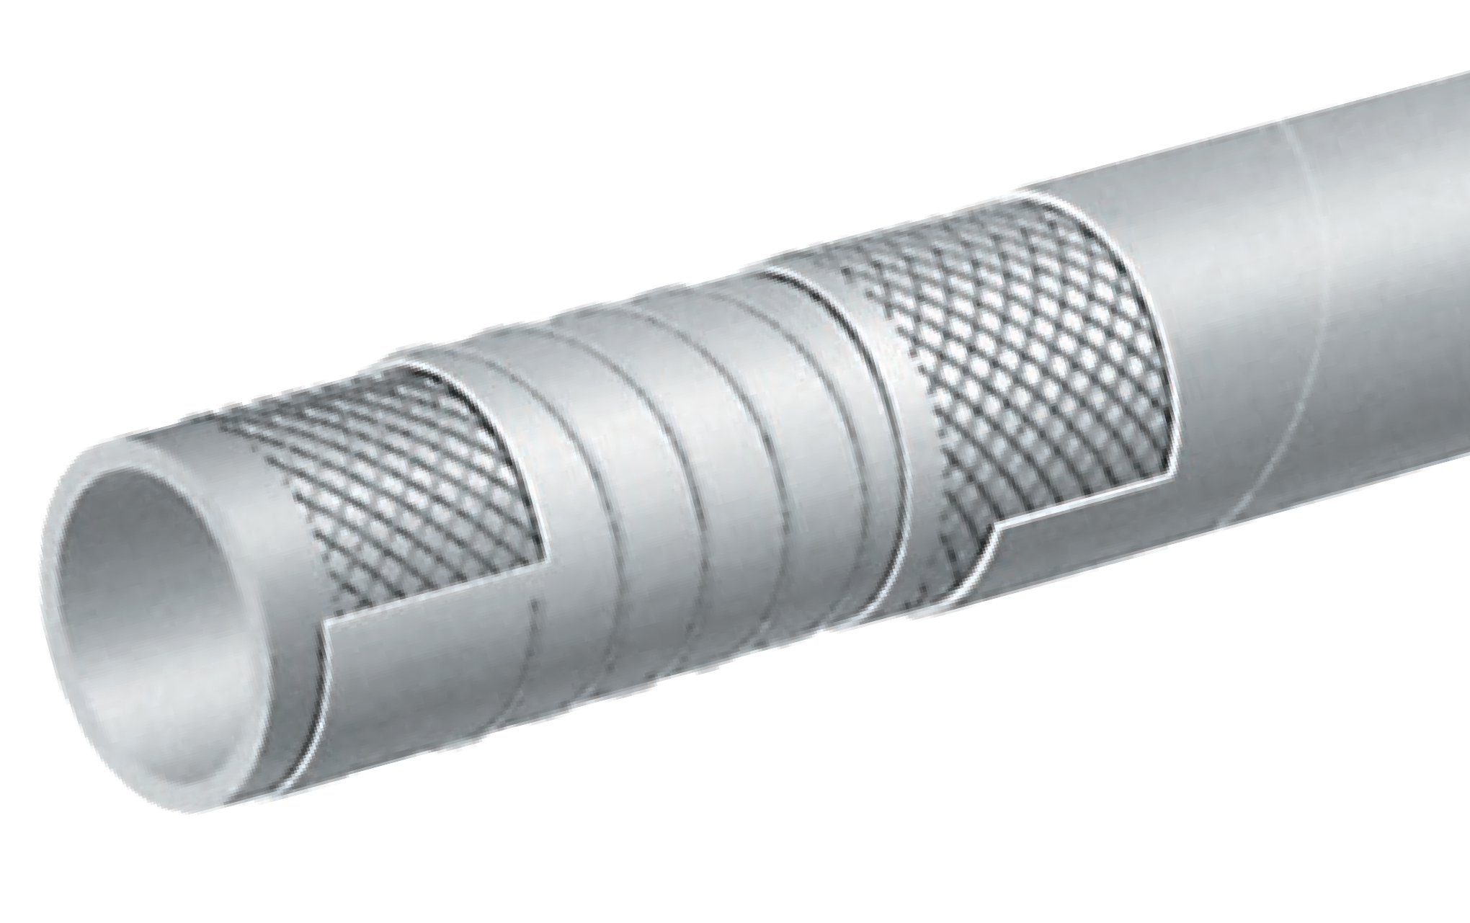
T410LL
240 PSI Food & Beverage S & D Hose – Crush Resistant
COMPLIANT MATERIAL
FDA Liquid Food Transfer
Nominal Specifications
Series | ID  (in.) | ID  (mm) | OD  (in.) | OD  (mm) | Max Rec. WP (PSI) | Vacuum HG (in.) | Min. Bending Radius (in. @ 68°F) | Weight (lbs./ft.)
T410LL100 | 1 | 25 | 1.46 | 37 | 240 | 30 | 4 | 0.60
T410LL150 | 1 1/2 | 38 | 2.05 | 52 | 240 | 30 | 6 | 1.00
T410LL200 | 2 | 51 | 2.56 | 65 | 240 | 30 | 8 | 1.29
T410LL300 | 3 | 76 | 3.62 | 92 | 240 | 30 | 12 | 2.23

CONSULT FOOD HOSE GUIDE FOR MATERIAL COMPATIBILITY ON PAGE 36.

COUPLING SUGGESTIONS
Quick-Acting couplings attached with bands.

Applications:
Food and alcoholic beverage suction and discharge. Specially designed for wine, beer and spirits, up to 95 proof.
Hose may be sterilized with steam at 226°F (+130°C) for 30 minutes or with 5% soda solution.
H Not recommended for dry abrasive materials.
Cover:
Grey EPDM – abrasion and ozone resistant.

Reinforcement:
High tensile textile cords with embedded PET helix.

Tube:
White nontoxic CIIR. Meets FDA and 3A (18-03) requirements.

Working Pressure:
Constant Pressure – 16 Bar (240 PSI)

Temperature Range:
-22°F (-30°C) to 226°F (+108°C)

Branding:
ALFAGOMMA – ITALY T410 16 BAR (240 PSI) – FOOD SUCTION & DELIVERY – CRUSH RESISTANT (in black
letters)

Standard Length:
100 feet

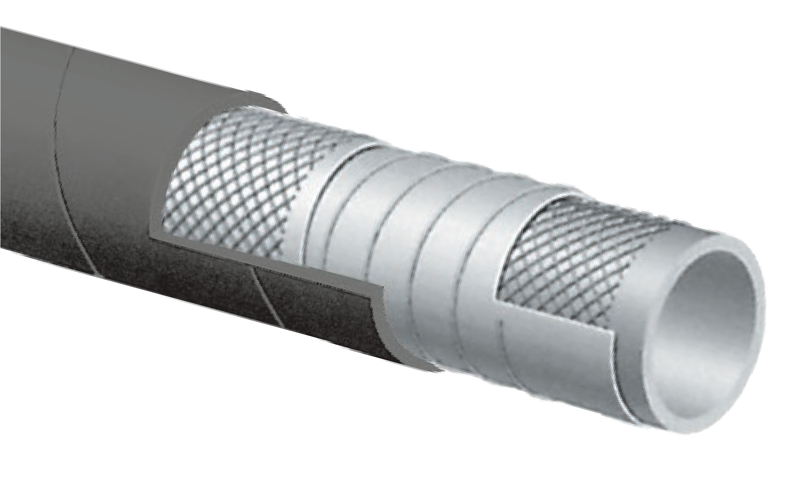
T410LB
240 PSI Food & Beverage S & D Hose – Crush Resistant
COMPLIANT MATERIAL
NEW
PRODUCT
FDA Liquid Food Transfer
Nominal Specifications
Series | ID  (in.) | ID  (mm) | OD  (in.) | OD  (mm) | Max Rec. WP (PSI) | Vacuum HG (in.) | Min. Bending Radius (in. @ 68°F) | Weight (lbs./ft.)
T410LB100 | 1 | 25 | 1.46 | 37 | 240 | 30 | 5 | 0.60
T410LB200 | 2 | 51 | 2.56 | 65 | 240 | 30 | 8 | 1.29
T410LB300 | 3 | 76 | 3.62 | 92 | 240 | 30 | 12 | 2.23

CONSULT FOOD HOSE GUIDE FOR MATERIAL COMPATIBILITY ON PAGE 36.

COUPLING SUGGESTIONS
Quick-Acting couplings attached with bands.

FDA Liquid Food Transfer

T422LH Series

Liquid S&D Brewery Hose

General Applications:
- Brewery suction and discharge.
NEW
PRODUCT

COMPLIANT MATERIAL

- Liquid food and alcoholic beverage suction and discharge (up to 95 proof).
- Versatile hose for applications requiring superb flexibility and light weight, while still maintaining high strength and durability.
Construction:
- Tube - White Chlorobutyl meeting 3A (18-03) and FDA requirements.
- Reinforcement - High tensile textile cords with specially designed embedded helix wires.
- Cover - Red smooth NR/EPDM blend for abrasion and ozone resistance.

Features and Advantages:

EXTREMELY FLEXIBLE!

Service Temperature Range:
-22°F (-30°C) to +226°F (+108°C)

Branding:
ALFAGOMMA ITALY 422 10 bar (150 psi)
BREWERY S&D (brewt logo) – extra flexible – FDA (white letters)

- 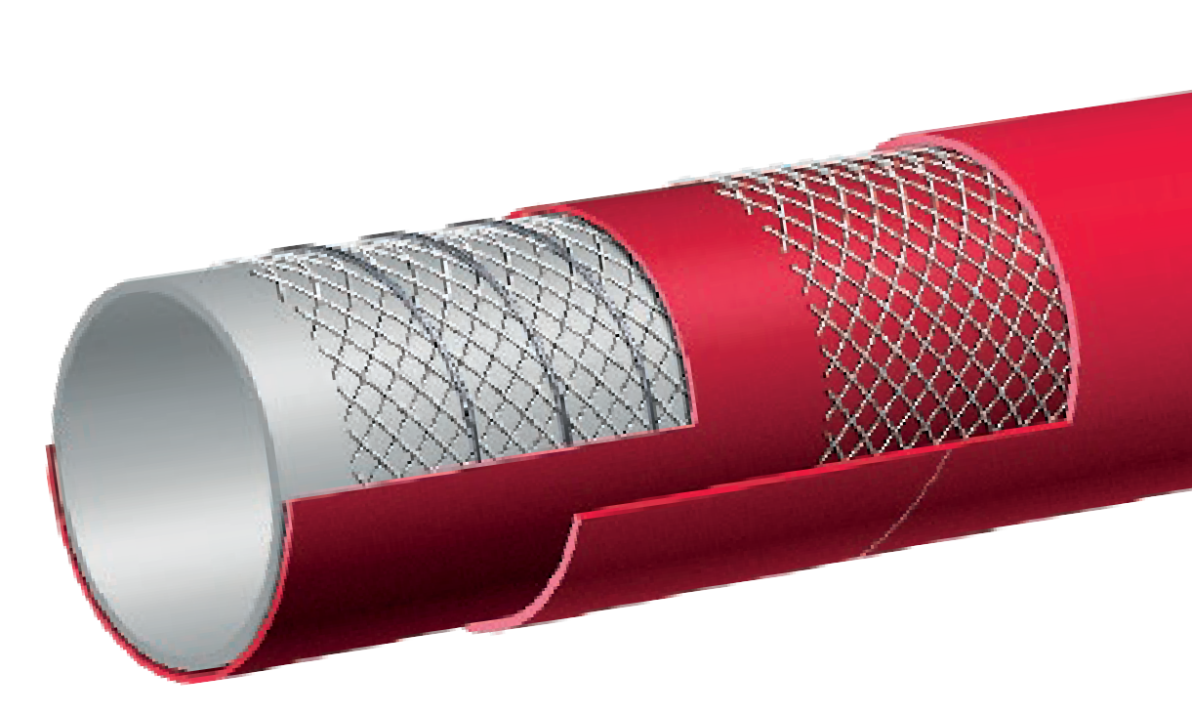Extreme Flexibility – Uniquely designed for maximum flexibility, bends easily around brewery equipment and works well in tight spaces.
- Lightweight – Up to 25% lighter weight than similar rubber hoses, while still maintaining 150 PSI working pressure.
- High Heat Resistance - Chlorobutyl tube capable of handling +226°F (+108°C) on a continuous basis. Allows for sterilization with +266°F (+130°C) steam for 30 minutes or with 5% soda solution.
- High Purity Tube - Will not impart odor or taste.
- Smooth Cover – Designed for easy cleaning, no gaps or crevices for dirt or bacteria to hide. Also provides a smooth surface for clamping.

Nominal Specifications
Series No. | ID |  | OD |  | Max. Rec. WP (PSI) | Vacuum HG (in.) | Min. Bend Radius  (in. @ 68°F) | Standard Length Coils (ft.) | Weight (lbs./ft.)
 | (in.) | (mm) | (in.) | (mm)
T422LH100 | 1 | 25 | 1.38 | 35 | 150 | 30 | 2 | 100 | 0.47
T422LH125 | 1 1/4 | 32 | 1.65 | 42 | 150 | 30 | 2 1/2 | 100 | 0.58
T422LH150 | 1 1/2 | 38 | 1.89 | 48 | 150 | 30 | 3 | 100 | 0.67
T422LH200 | 2 | 51 | 2.40 | 61 | 150 | 30 | 4 | 100 | 0.88
T422LH250 | 2 1/2 | 63 | 3.00 | 76 | 150 | 30 | 5 | 100 | 1.59
T422LH300 | 3 | 76 | 3.54 | 90 | 150 | 27 | 6 | 100 | 2.04
T422LH400 | 4 | 102 | 4.57 | 116 | 150 | 27 | 8 | 100 | 2.67

CONSULT FOOD HOSE GUIDE FOR MATERIAL COMPATIBILITY ON PAGE 36.

Applications:
Liquid, fatty, oily food and alcoholic beverage (max 75 proof) suction and discharge.
Hose may be sterilized with 5% soda solution.
H Not recommended for dry abrasive materials.
Cover:
Grey NBR/PVC – abrasion, ozone and oil resistant.
Reinforcement:
High tensile textile cords with flexible steel helix wire.

Tube:
White NBR. Meets FDA and 3A (18-03) requirements.

Working Pressure:
Constant Pressure – 10 Bar (150 PSI)

Temperature Range:
-22°F (-30°C) to 176°F (+80°C)

Branding:
ALFAGOMMA – ITALY T426 10 BAR (150 PSI) – GENERAL PURPOSE FOOD QUALITY – S & D (black
letters)

Standard Length:
100 feet

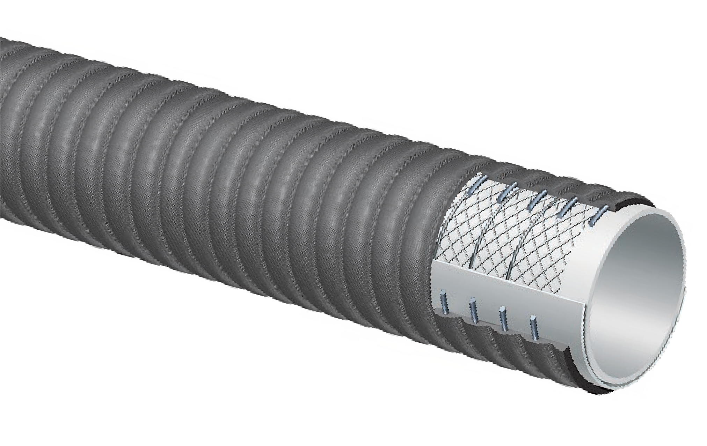
T426LB
150 PSI Grey Food S &D Hose
COMPLIANT MATERIAL
NEW
PRODUCT
FDA Liquid Food Transfer

Nominal Specifications
Series | ID  (in.) | ID  (mm) | OD  (in.) | OD  (mm) | Max Rec. WP (PSI) | Vacuum HG (in.) | Min. Bending Radius (in. @ 68°F) | Weight (lbs./ft.)
T426LB300 | 3 | 76 | 3.62 | 92 | 150 | 30 | 6 | 1.84
T426LB400 | 4 | 102 | 4.65 | 118 | 150 | 30 | 8 | 2.69

CONSULT FOOD HOSE GUIDE FOR MATERIAL COMPATIBILITY ON PAGE 36.
COUPLING SUGGESTIONS
Quick-Acting or combination nipples attached with single bolt, double bolt, wire or band type clamps.

Applications:
Discharge of liquid, fatty, oily foods and alcoholic beverages (max 75 proof).
Hose may be sterilized with 5% soda solution.
H Not recommended for dry abrasive materials.
Cover:
White NBR/PVC blend – abrasion, ozone and oil resistant.

Reinforcement:
High tensile textile cords.

Tube:
White NBR. Meets FDA and 3A (18-03) requirements.

Working Pressure:
Constant Pressure – 10 Bar (150 PSI)

Temperature Range:
-22°F (-30°C) to 176°F (+80°C)

Branding:
ALFAGOMMA – ITALY T455 10 BAR (150 PSI) – GENERAL PURPOSE FOOD TRANSFER (in black
letters)

Standard Length:
100 feet

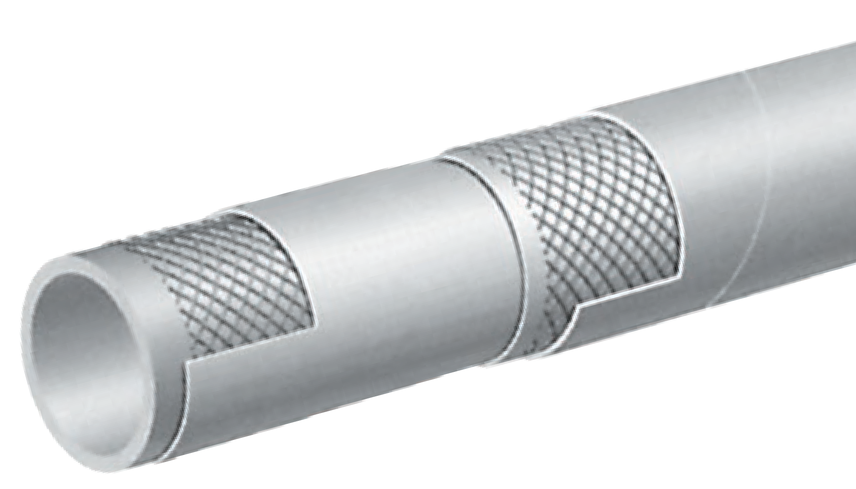
T455LL
150 PSI Food Discharge Hose
COMPLIANT MATERIAL
FDA Liquid Food Transfer

Nominal Specifications
Series | ID  (in.) | ID  (mm) | OD  (in.) | OD  (mm) | Max Rec. WP (PSI) | Weight (lbs./ft.)
T455LL150 | 1 1/2 | 38 | 1.89 | 48 | 150 | 0.60
T455LL200 | 2 | 51 | 2.48 | 63 | 150 | 0.95
T455LL300 | 3 | 76 | 3.46 | 88 | 150 | 1.38

CONSULT FOOD HOSE GUIDE FOR MATERIAL COMPATIBILITY ON PAGE 36.
COUPLING SUGGESTIONS
Quick-Acting couplings attached with bands.

H Kuriyama offers a full line of Quick-Acting couplings, pin lug shank couplings and combination nipples. Refer to current Kuriyama-Couplings™ and Accessories Catalog for type and pricing.

Applications:
Discharge of water used for drinking. Most often used for temporary water lines in construction and industrial applications.

Cover:
Blue SBR/EPDM blend – abrasion and ozone resistant.

Reinforcement:
High tensile textile cords.

Tube:
White NR. Meets FDA and 3A (18-03) requirements.

Working Pressure:
Constant Pressure – 10 Bar (150 PSI)

Temperature Range:
-22°F (-30°C) to 176°F (+80°C)

Branding:
ALFAGOMMA – ITALY T452 10 BAR POTABLE WATER
HOSE (150 PSI) WP (in white letters)

Standard Length:
100 feet

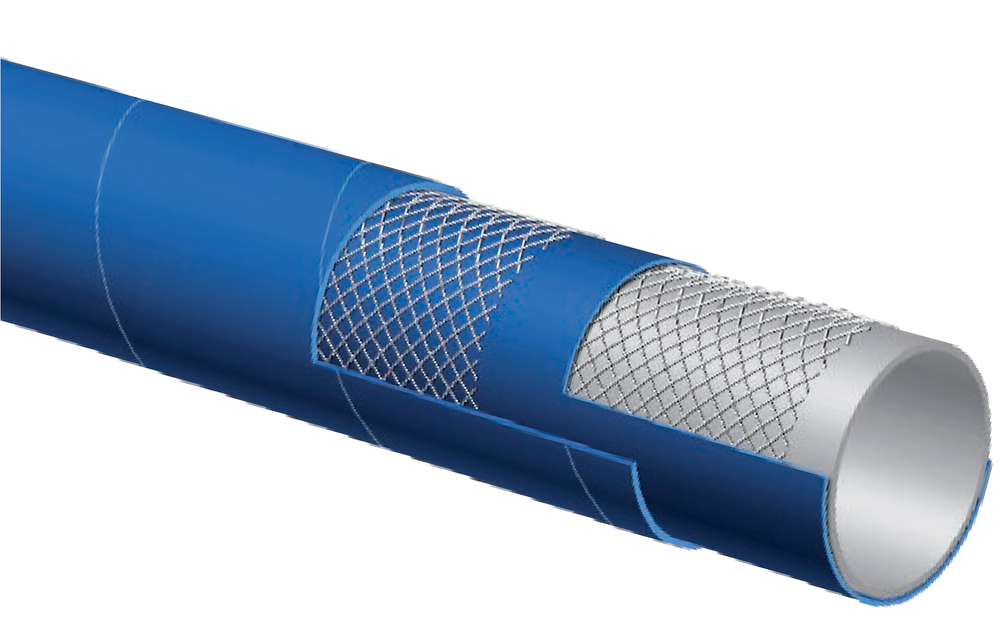
T452LE
150 PSI Potable Water Hose Hose is not NSF Approved
COMPLIANT MATERIAL
FDA Liquid Food Transfer

Nominal Specifications
Series | ID  (in.) | ID  (mm) | OD  (in.) | OD  (mm) | Max Rec. WP (PSI) | Weight (lbs./ft.)
T452LE150 | 1 1/2 | 38 | 1.97 | 50 | 150 | 0.73
T452LE200 | 2 | 51 | 2.56 | 65 | 150 | 1.13
T452LE300 | 3 | 76 | 3.62 | 92 | 150 | 1.88
T452LE400 | 4 | 102 | 4.65 | 118 | 150 | 2.51

CONSULT FOOD HOSE GUIDE FOR MATERIAL COMPATIBILITY ON PAGE 36.
COUPLING SUGGESTIONS
Quick-Acting couplings attached with bands.
H Kuriyama offers a full line of Quick-Acting couplings. Refer to current Kuriyama-Couplings™ and Accessories Catalog for type and pricing.

The following data is based on tests and believed to be reliable; however, we emphasize that the tabulation should be used as a guide only, since it does not take into consideration all variables such as elevated temperatures, fluid contamination, concentration, etc. that may be encountered in actual use. All critical applications should be tested. Contact ALFAGOMMA for recommendation and assistance.
FDA Liquid Compatibility Guide

KEY TO FDA LIQUID MATERIAL COMPATIBILITY CHART
Key to General Chemical Resistance Chart [all data based on 20°C (68°F) unless noted]:
E – Excellent; G – Good; F – Fair; C – Conditional; I – Insufficient Data; X – Not Recommended; Blank – No Data Alfagomma® hoses are produced using silicone free release agents.

FOOD | NATURAL RUBBER | CHLOROBUTYL | EPDM | NBR
BEER | F | G | E | E
BEET SUGAR, GRANULAR | E | X | G | E
BUTTERMILK | X | F | G | E
CANE SUGAR, GRANULAR | E | X | G | G
CASHEW NUT OIL | X | F | G
CASTOR OIL | X | F | G | E
CITRIC ACID | E | E | E | E
COCOA BUTTER | X | F | G | G
COCONUT OIL | X | F | G | E
CORN OIL | X | F | G | E
COTTONSEED OIL | X | F | G | E
ETHANOL (GRAIN ALCOHOL) | F | G | E | E
FISH MEAL
FLOUR | E | X | G
GRAPE JUICE | F | G | E | G
LACTIC ACID | F | F | G | E
LARD OIL | X | F | G | E
LINSEED OIL | X | F | G | E
LIQUOR (SPIRITS) | F | G | E | G
MILK | E | E | E | E
MINERAL OIL | X | X | X | E
MOLASSES | E | E | E | E
OLEIC ACID | X | F | G | F
OLIVE OIL | X | F | G | E
PALMITIC ACID | X | F | G | E
PARAFFINS | X | X | X | E
PEANUT OIL | X | F | G | E
POTATO FLOUR | E | X | G
SALT, GRANULAR | E | X | G | E
SOYBEAN OIL | X | F | G | E
SUCROSE, GRANULATED | E | X | G | G
SUGAR, GRANULATED | E | X | G | F
SUGAR SYRUP | E | E | E | F
TALLOW | X | X |  | E
TOMATO JUICE, PASTE & PUREE SAUCE | E | E | E | G
VEGETABLE OILS | X | F | G | E
VINEGAR | F | F | G | F
WATER, POTABLE | E | E | E | E
WHISKEY | F | G | E | E
WINES | F | G | E | E

Applications:
Suction and discharge of wet or dry abrasive materials. Designed for grains, flour and pellet transfer.
Cover:
Green SBR/EPDM blend – abrasion and ozone resistant.

Reinforcement:
Spiraled high tensile textile cords with flexible steel helix wire and static wire.

Tube:
3/16" white NR – abrasion resistant. Meets FDA requirements.

Working Pressure:
Constant Pressure –
10 Bar (150 PSI) for 2", 3", 4"
5 Bar (75 PSI) for 5", 6", 8"

Temperature Range:
-22°F (-30°C) to 176°F (+80°C)

Branding:
ALFAGOMMA – ITALY T720 – BULK FOOD & MATERIAL
– S & D (in white letters)

Standard Length:
100 feet: 2" through 4"
20 feet: 5", 6" and 8"
50 feet: 4", 5" and 6"

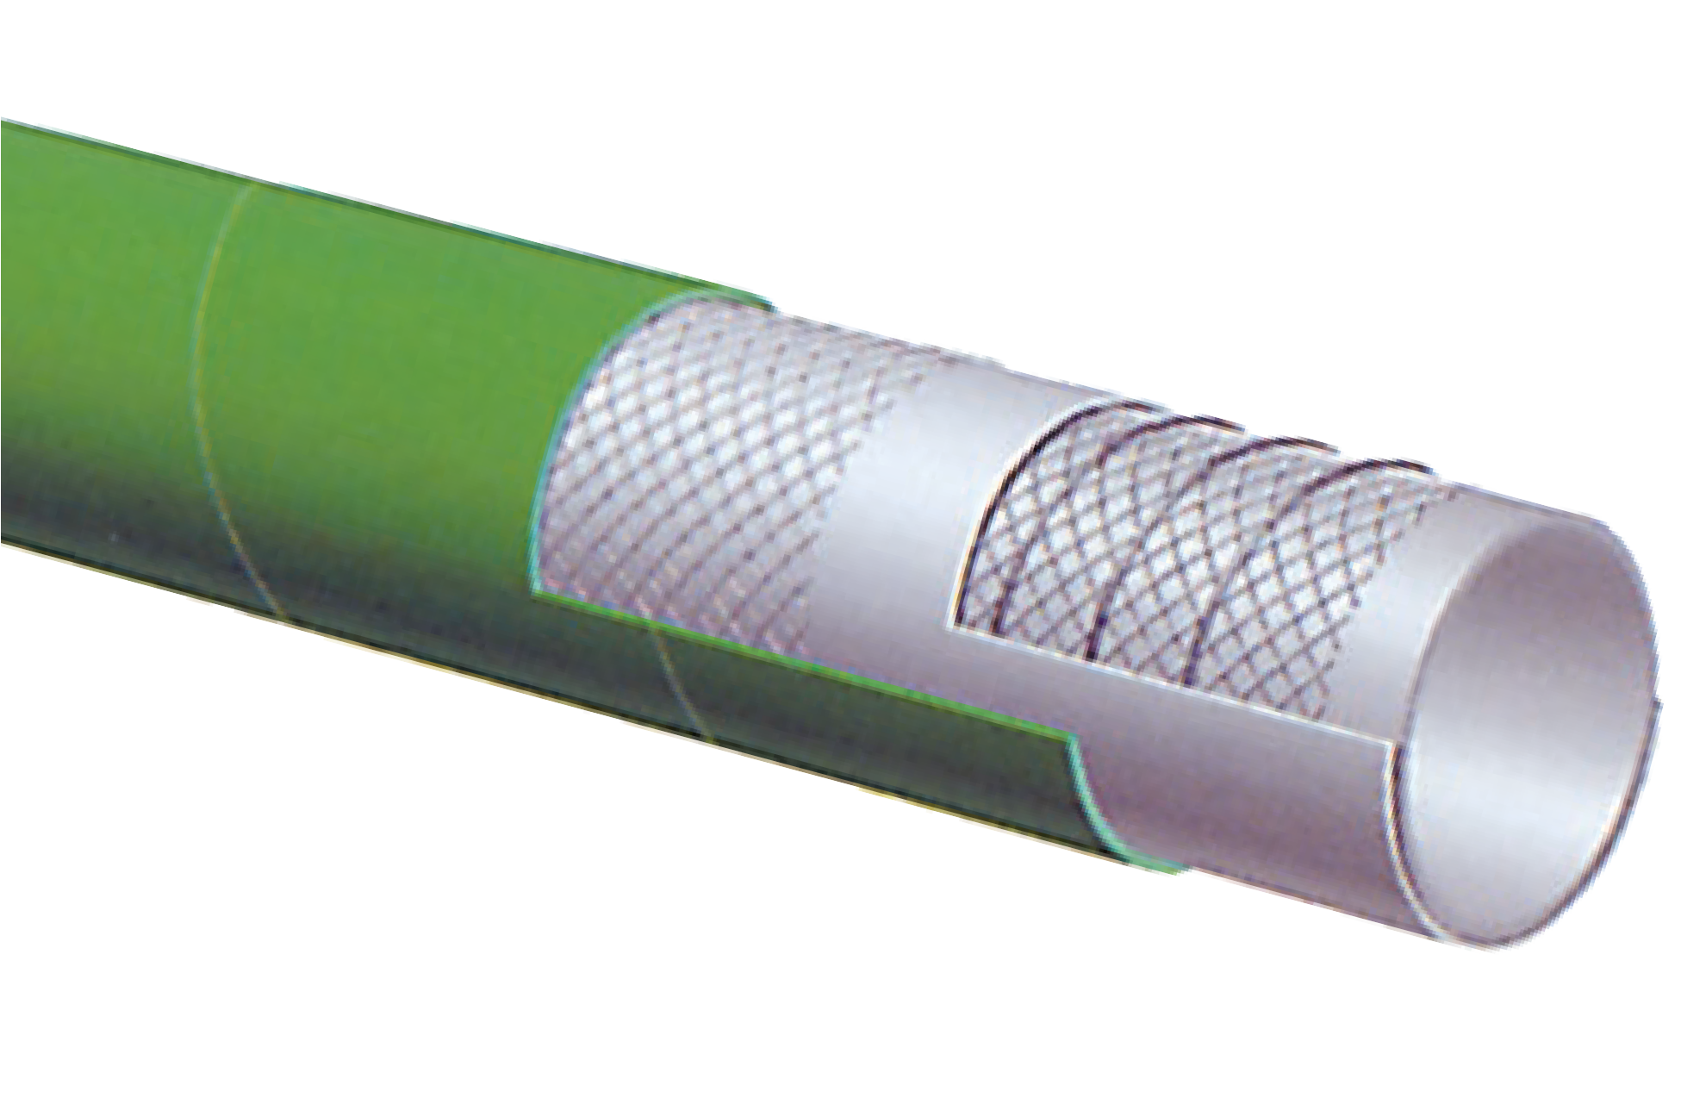
T720LG
Bulk Food S & D Hose
FDA Dry Food Material Handling
Nominal Specifications
Series | ID  (in.) | ID  (mm) | OD  (in.) | OD  (mm) | Max Rec. WP (PSI) | Vacuum HG (in.) | Min. Bending Radius (in. @ 68°F) | Weight (lbs./ft.)
T720LG200 | 2 | 51 | 2.64 | 67 | 150 | 30 | 6 | 1.23
T720LG300 | 3 | 76 | 3.62 | 92 | 150 | 27 | 9 | 1.91
T720LG400 | 4 | 102 | 4.65 | 118 | 150 | 27 | 12 | 2.63
T720LG500 | 5 | 127 | 5.71 | 145 | 75 | 24 | 20 | 3.81
T720LG600 | 6 | 152 | 6.69 | 170 | 75 | 24 | 24 | 4.72
T720LG800 | 8 | 203 | 8.78 | 223 | 75 | 21 | 32 | 7.01
H Please note: Proper grounding of static wire will prolong tube life.

CONSULT FOOD HOSE GUIDE FOR MATERIAL COMPATIBILITY ON PAGE 36.

COUPLING SUGGESTIONS
Quick-Acting, pin lug, short shank couplings or combination nipples attached with single bolt, double bolt, wire or band type clamps.

Applications:
For suction or discharge of wet or dry abrasive materials. Suitable for handling materials for human consumption.

Cover:
Green corrugated Nat/SBR blend rubber.

Reinforcement:
Spiraled high tensile textile cords with flexible steel helix wire and static wire.

Tube:
Natural white gum rubber 3/16" thick. Meets FDA requirements.

Working Pressure:
Constant Pressure – 5 Bar (75 PSI)

Temperature Range:
-22°F (-30°C) to 176°F (+80°C)

Branding:
ALFAGOMMA – ITALY T714 – 5 Bar (75 PSI) – BULK
FOOD & MATERIAL – S & D (in white letters)

Standard Length:
50 feet: 5” and 6”
20 feet: 5", 6" and 8”

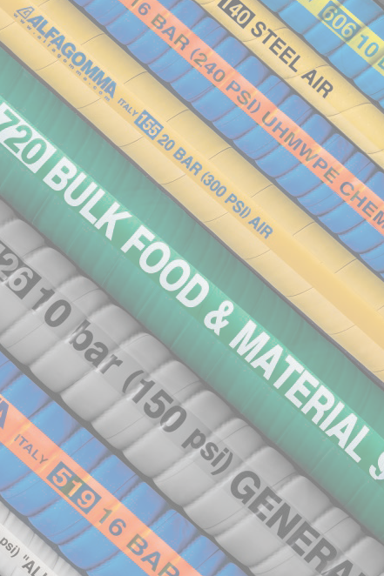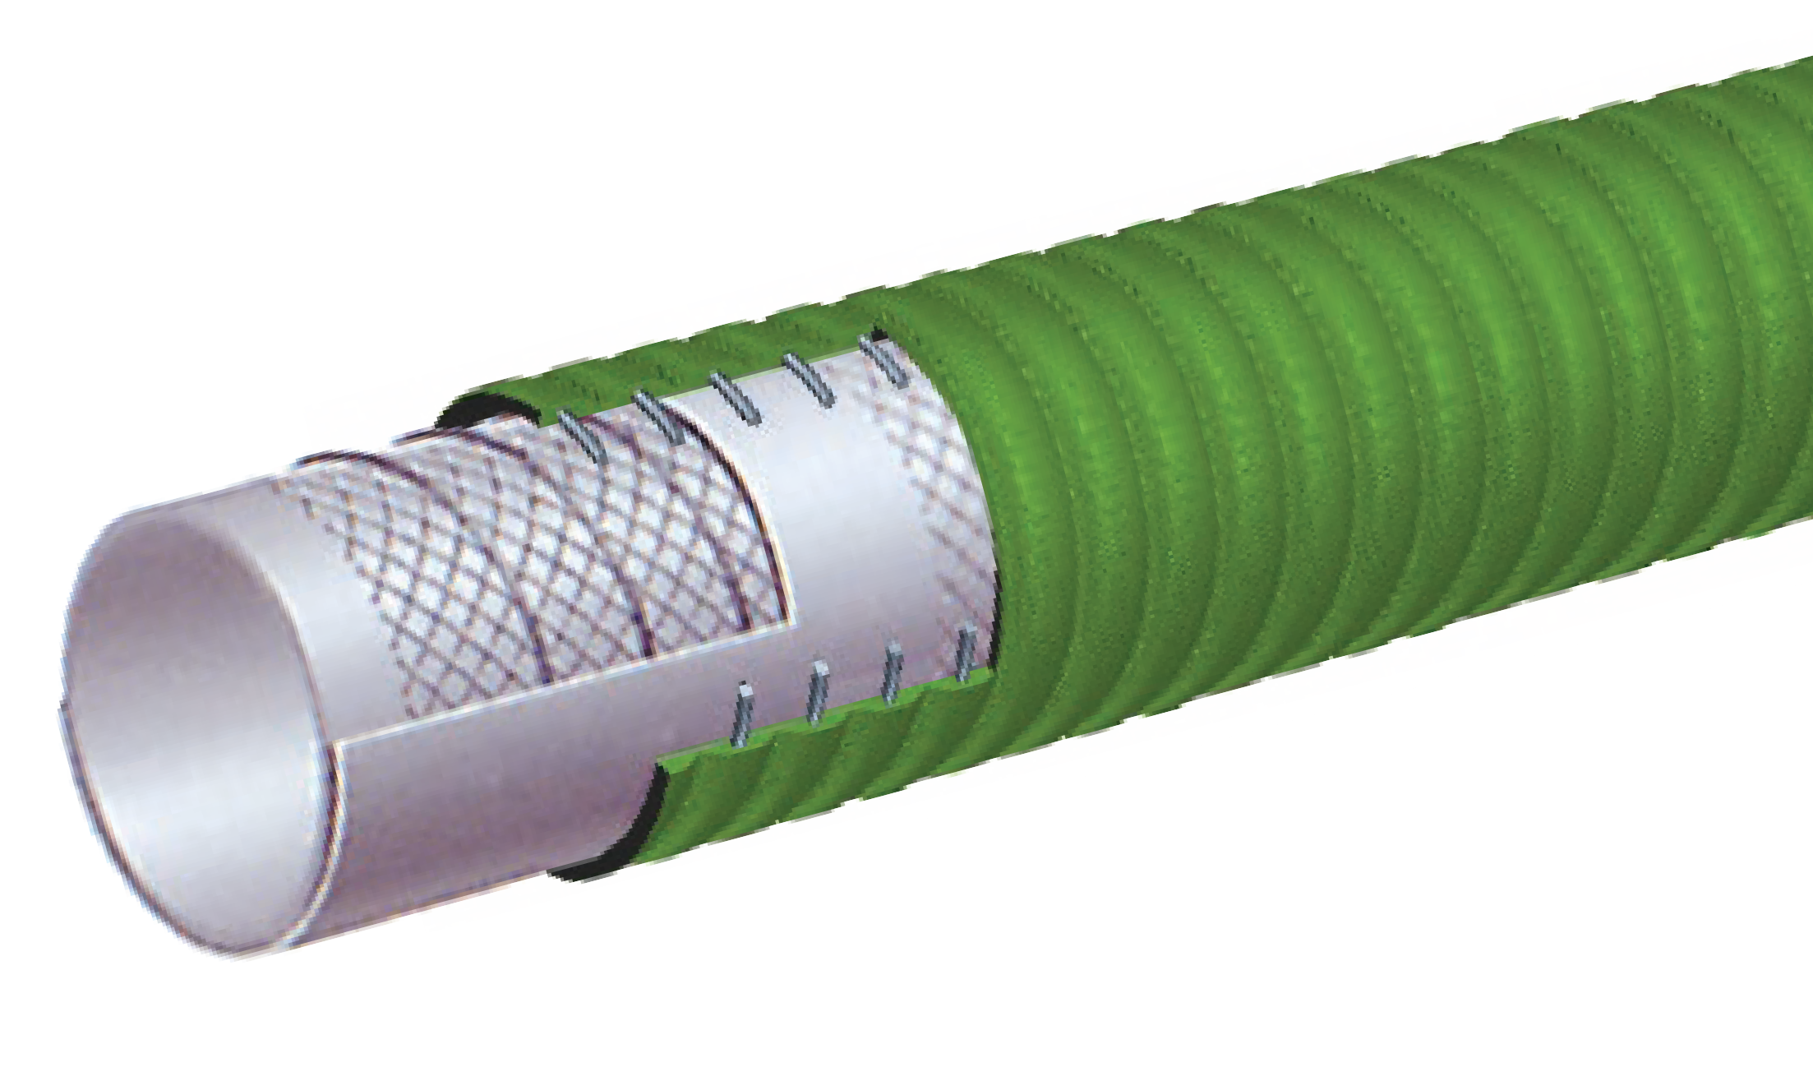
T714LG
Material Handling Hose FDA Grade
NEW
PRODUCT
FDA Dry Food Material Handling

Nominal Specifications
Series | ID  (in.) | ID  (mm) | OD  (in.) | OD  (mm) | Max Rec. WP (PSI) | Vacuum HG (in.) | Min. Bending Radius (in. @ 68°F) | Weight (lbs./ ft.)
T714LG500 | 5 | 127 | 5.63 | 143 | 75 | 24 | 12.5 | 3.8
T714LG600 | 6 | 152 | 6.85 | 174 | 75 | 24 | 24 | 4.75
T714LG800 | 8 | 203 | 8.94 | 227 | 75 | 21 | 32 | 7.01

H Please note: Proper grounding of static wire will prolong tube life.

CONSULT FOOD HOSE GUIDE FOR MATERIAL COMPATIBILITY ON PAGE 36.

COUPLING SUGGESTIONS
Quick-Acting, pin lug, short shank couplings or combination nipples attached with single bolt, double bolt, wire or band type clamps.

Applications:
Discharge or delivery of dry bulk food products.

Cover:
Blue SBR/EPDM – abrasion and ozone resistant.

Reinforcement:
Spiraled high tensile textile cords with static wire.

Tube:
3/16" white NR – abrasion resistant. Meets FDA requirements.

Working Pressure:
Constant Pressure – 5 Bar (75 PSI)

Temperature Range:
-22°F (-30°C) to 176°F (+80°C)

Branding:
ALFAGOMMA – ITALY T760 5 BAR (75 PSI) – BULK
FOOD & MATERIAL DELIVERY (in white letters)

Standard Length:
100 feet

T760LE
75 PSI Dry Bulk Food Discharge Hose
NEW
PRODUCT
FDA Dry Food Material Handling

Nominal Specifications
Series | ID  (in.) | ID  (mm) | OD  (in.) | OD  (mm) | Max Rec. WP (PSI) | Weight (lbs./ft.)
T760LE400 | 4 | 102 | 4.65 | 118 | 75 | 2.12
H Please note: Proper grounding of static wire will prolong tube life.

CONSULT FOOD HOSE GUIDE FOR MATERIAL COMPATIBILITY ON PAGE 36.

COUPLING SUGGESTIONS
Quick-Acting coupling attached with bands.

Applications:
Suction and transfer service for a variety of chemicals and solvents. Will handle 90% of existing chemicals. See Chemical Resistance Chart on pages 66 – 75.

Cover:
Green EPDM – abrasion and ozone resistant.

Reinforcement:
High tensile textile cords with flexible steel helix wire.

Tube:
Transparent XLPE (cross-linked polyethylene).

Working Pressure:
Constant Pressure – 16 Bar (240 PSI)

Temperature Range:
Normal recommended operating temperature is -22°F (-30°C) to 176°F (+80°C)

Branding:
ALFAGOMMA – ITALY T505 16 BAR (240 PSI) – XLPE
CHEMICAL – S & D (in orange letters)

Standard Length:
100 feet

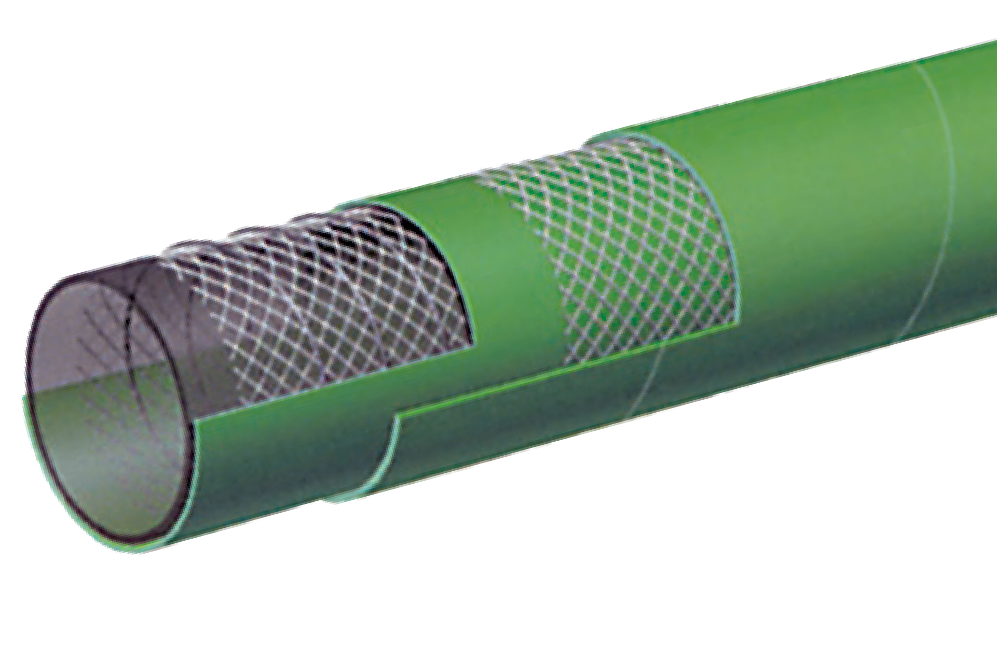

T505OG
Acid – Chemical S & D 240 PSI – XLPE
Chemical
Warning
Before using chemical hoses consult chemical resistance chart or consult factory.
IT IS ADVISABLE TO TEST THE TUBE MATERIAL UNDER ACTUAL SERVICE CONDITIONS PRIOR TO USE.
NOTE: FOR MAXIMUM SERVICE LIFE, WE RECOMMEND THAT T505 HOSE BE FLUSHED OUT AFTER EVERY USE.

Nominal Specifications
Series | ID  (in.) | ID  (mm) | OD  (in.) | OD  (mm) | Max Rec. WP (PSI) | Vacuum HG (in.) | Min. Bending Radius (in. @ 68°F) | Weight (lbs./ft.)
T505OG075 | 3/4 | 19 | 1.22 | 31 | 240 | 27 | 7 1/2 | 0.46
T505OG100 | 1 | 25 | 1.46 | 37 | 240 | 27 | 9 | 0.56
T505OG150 | 1 1/2 | 38 | 1.97 | 50 | 240 | 27 | 13 1/4 | 0.76
T505OG200 | 2 | 51 | 2.48 | 63 | 240 | 27 | 16 1/4 | 1.00
T505OG300 | 3 | 76 | 3.62 | 92 | 240 | 24 | 20 3/4 | 1.83
T505OG400 | 4 | 102 | 4.65 | 118 | 240 | 24 | 26 1/2 | 2.50

Applications:
Suction and transfer service for a variety of chemicals and acids. Will handle 98% of EXISTING CHEMICALS. See Chemical Resistance Chart on pages 66 – 75.

Cover:
Blue EPDM – abrasion and ozone resistant.

Reinforcement:
Synthetic textile cords with flexible steel helix wire.

Tube:
Transparent UHMWPE (Ultra High Molecular Weight Polyethylene).

Working Pressure:
Constant Pressure – 16 Bar (240 PSI)

Temperature Range:
Normal recommended operating temperature is -22°F (-30°C) to 200°F (+93°C)

Branding:
ALFAGOMMA – ITALY T509 16 BAR (240 PSI) –
UHMWPE CHEMICAL – S & D (in orange letters)

Standard Length:
100 feet
IT IS ADVISABLE TO TEST THE TUBE MATERIAL UNDER ACTUAL SERVICE CONDITIONS PRIOR TO USE.
NOTE: FOR MAXIMUM SERVICE LIFE, WE RECOMMEND THAT T509 HOSE BE FLUSHED OUT AFTER EVERY USE.

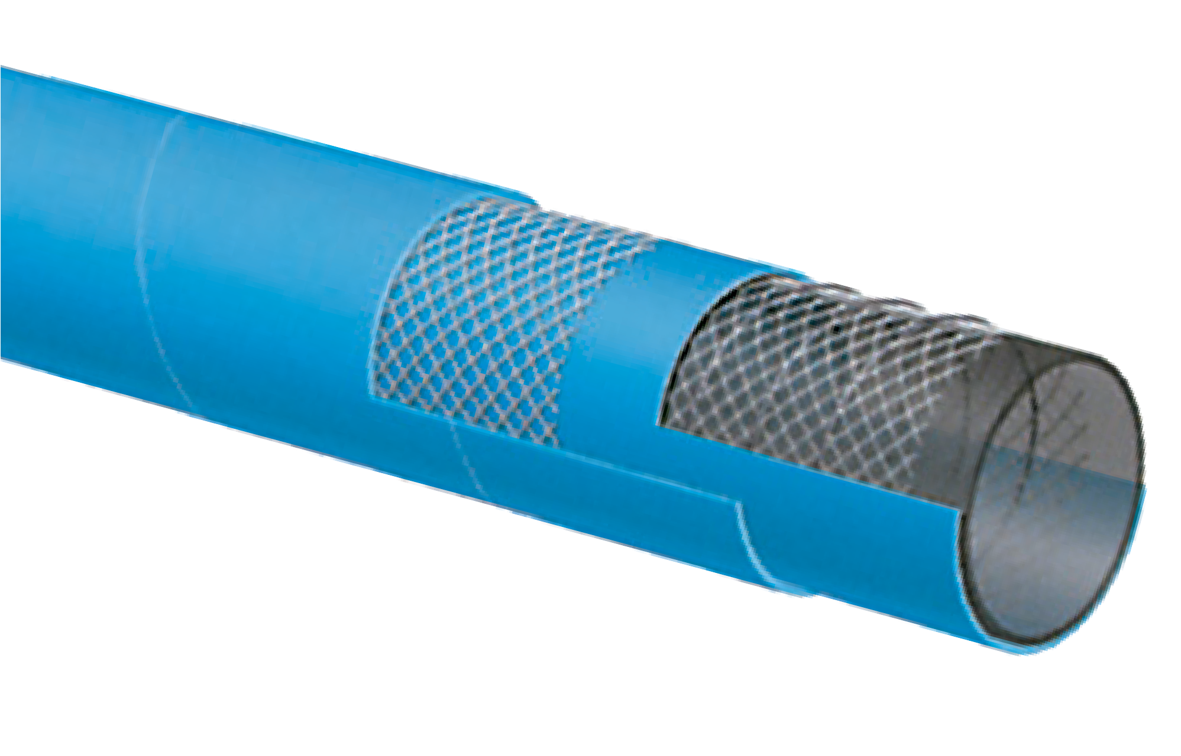

T509OE
Acid – Chemical S & D 240 PSI – UHMWPE
Meets FDA Requirements Suitable for use with DEF
Chemical
Warning
Before using chemical hoses consult chemical resistance chart or consult factory.

Nominal Specifications
Series | ID  (in.) | ID  (mm) | OD  (in.) | OD  (mm) | Max Rec. WP (PSI) | Vacuum HG (in.) | Min. Bending Radius (in. @ 68°F) | Weight (lbs./ft.)
T509OE075 | 3/4 | 19 | 1.22 | 31 | 240 | 27 | 7 1/2 | 0.41
T509OE100 | 1 | 25 | 1.46 | 37 | 240 | 27 | 9 | 0.50
T509OE125 | 1 1/4 | 32 | 1.73 | 44 | 240 | 27 | 10 1/4 | 0.60
T509OE150 | 1 1/2 | 38 | 1.97 | 50 | 240 | 27 | 13 1/4 | 0.68
T509OE200 | 2 | 51 | 2.48 | 63 | 240 | 27 | 16 1/4 | 0.91
T509OE250 | 2 1/2 | 63 | 3.03 | 77 | 240 | 27 | 17 1/2 | 1.40
T509OE300 | 3 | 76 | 3.62 | 92 | 240 | 24 | 20 3/4 | 1.91
T509OE400 | 4 | 102 | 4.65 | 118 | 240 | 24 | 26 1/2 | 2.61
T5090E600 | 6 | 152 | 6.77 | 172 | 240 | 24 | 40 | 5.28

COUPLING SUGGESTIONS
Quick-Acting and combination nipples, preferably stainless steel, attached with bands.

Applications:
Suction and transfer service for a variety of chemicals and acids. Will handle 98% of EXISTING CHEMICALS. See Chemical Resistance Chart on pages 66 – 75.

Cover:
Blue EPDM – abrasion and ozone resistant.

Reinforcement:
Synthetic textile cords with flexible steel helix wire.

Tube:
Transparent UHMWPE (Ultra High Molecular Weight Polyethylene).
IT IS ADVISABLE TO TEST THE TUBE MATERIAL UNDER ACTUAL SERVICE CONDITIONS PRIOR TO USE.
NOTE: FOR MAXIMUM SERVICE LIFE, WE RECOMMEND THAT T509 HOSE BE FLUSHED OUT AFTER EVERY USE.

Temperature Range:
Normal recommended operating temperature is -22°F (-30°C) to 200°F (+93°C)

Branding:
ALFAGOMMA – ITALY T519 16 BAR (240 PSI) –
UHMWPE CHEMICAL – S & D (in orange letters)

Standard Length:
100 feet

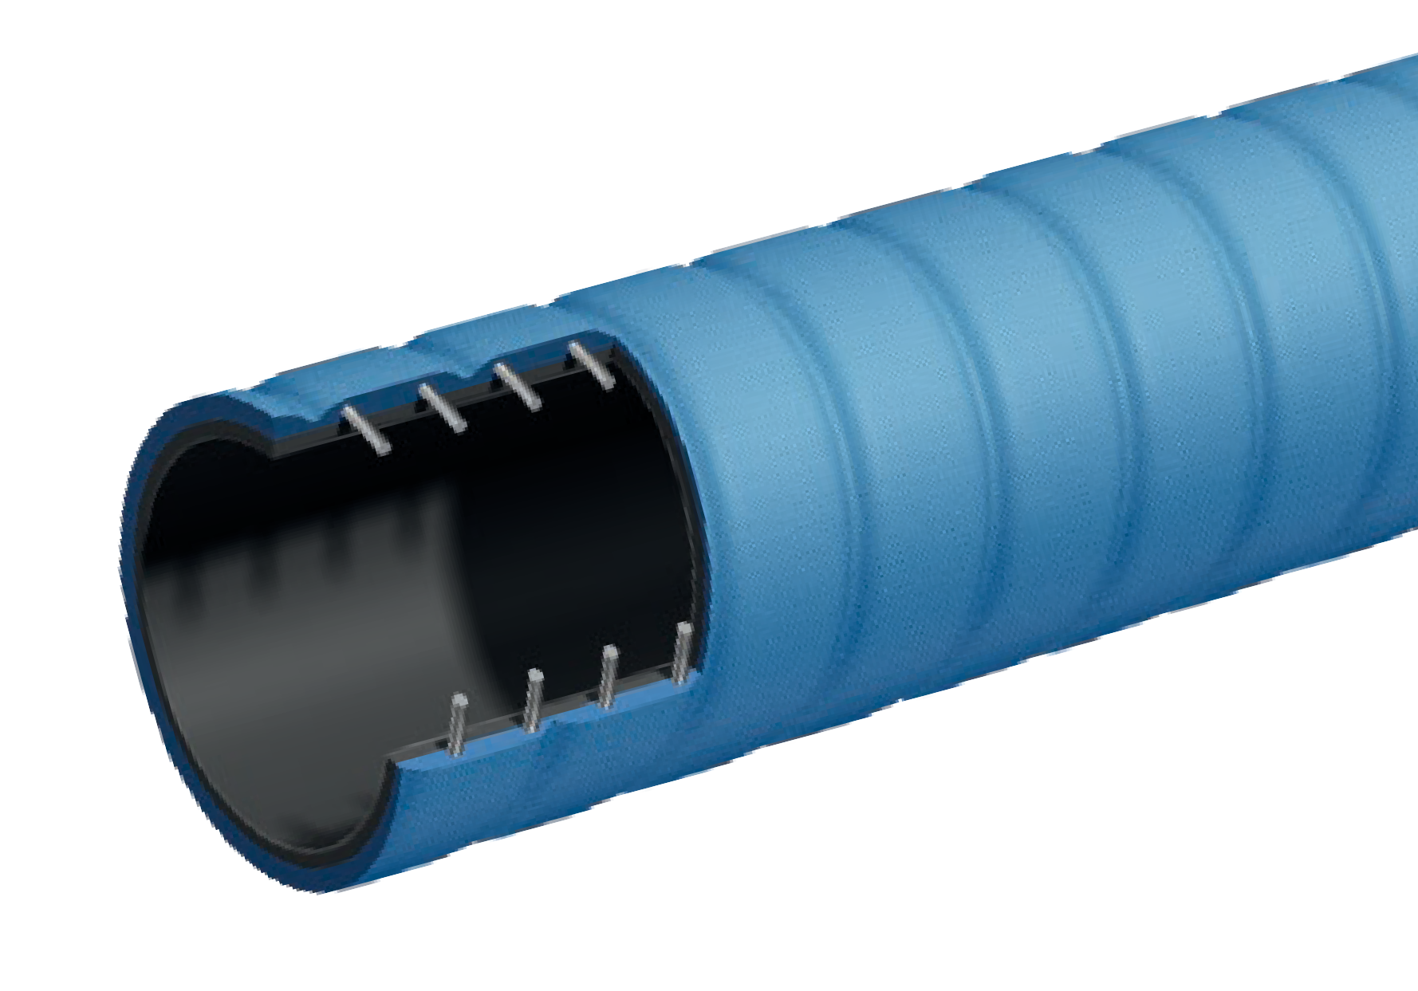
T519OE
Acid – Chemical S & D 240 PSI – UHMWPE –
Corrugated Suitable for use with DEF
NEW
PRODUCT
Chemical

Nominal Specifications
Series | ID  (in.) | ID  (mm) | OD  (in.) | OD  (mm) | Max Rec. WP (PSI) | Vacuum HG (in.) | Min. Bending Radius (in.) | Weight  (lbs./100 ft.)
T519OE200 | 2 | 51 | 2.48 | 63 | 240 | 27 | 6 | 94
T519OE300 | 3 | 76 | 3.54 | 90 | 240 | 27 | 9 | 169
T519OE400 | 4 | 102 | 4.57 | 116 | 240 | 27 | 12 | 275

Notes

Applications:
Fuel, oil and hydraulic fluids suction and discharge. Suitable for exhaust gas from water cooled stationary or marine diesel engines. Offers maximum flexibility.

Cover:
Black NBR/PVC blend – abrasion, ozone, hydrocarbon and fire resistant.

Reinforcement:
High tensile textile cords with flexible steel helix wire.

Tube:
Black NBR – exhaust gas, fuel and fire resistant.

Working Pressure:
Constant Pressure – 2 Bar (30 PSI)

Temperature Range:
-4°F (-20°C) to 212°F (+100°C)

Branding:
ALFAGOMMA – ITALY T600 MARINE EXHAUST/FUEL S & D – <SIZE> – USCG/SAE J1527 TYPE A2 (in red
letters)

Standard Length:
25 or 50 feet

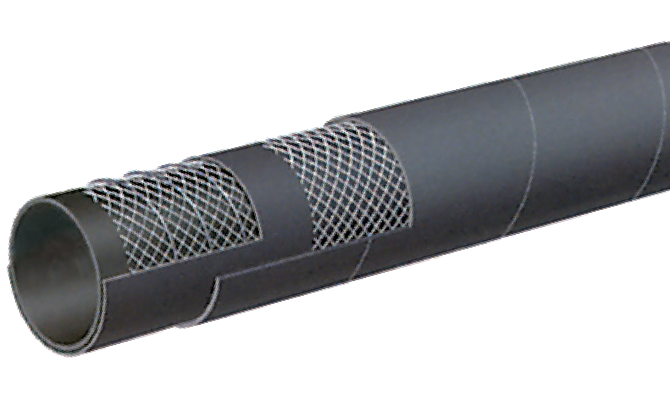

T600AA
Hard Wall Marine Exhaust Hose USCG/SAE J1527 A2/B2
Petroleum

Nominal Specifications
Series | ID  (in.) | ID  (mm) | OD  (in.) | OD  (mm) | Max Rec. WP (PSI) | Vacuum HG (in.) | Min. Bending Radius (in. @ 68°F) | Weight (lbs./ft.)
T600AA062 | 5/8 | 16 | 1.02 | 26 | 30 | 30 | 2 | 0.36
T600AA075 | 3/4 | 19 | 1.14 | 29 | 30 | 30 | 2 1/4 | 0.44
T600AA087 | 7/8 | 22 | 1.26 | 32 | 30 | 30 | 2 3/4 | 0.50
T600AA100 | 1 | 25 | 1.38 | 35 | 30 | 30 | 3 | 0.56
T600AA112 | 1 1/8 | 28 | 1.50 | 38 | 30 | 30 | 3 1/4 | 0.60
T600AA125 | 1 1/4 | 32 | 1.65 | 42 | 30 | 30 | 3 3/4 | 0.65
T600AA137 | 1 3/8 | 35 | 1.77 | 45 | 30 | 30 | 4 1/4 | 0.70
T600AA150 | 1 1/2 | 38 | 1.89 | 48 | 30 | 30 | 4 1/2 | 0.76
T600AA162 | 1 5/8 | 42 | 2.17 | 52 | 30 | 30 | 5 | 0.81
T600AA175 | 1 3/4 | 45 | 2.16 | 55 | 30 | 30 | 5 1/4 | 0.87
T600AA189 | 1 7/8 | 48 | 2.28 | 58 | 30 | 30 | 5 3/4 | 0.91
T600AA200 | 2 | 51 | 2.40 | 61 | 30 | 30 | 6 | 0.99
T600AA225 | 2 1/4 | 57 | 2.64 | 67 | 30 | 30 | 6 3/4 | 1.09
T600AA238 | 2 3/8 | 60 | 2.76 | 70 | 30 | 27 | 7 | 1.25
T600AA250 | 2 1/2 | 63 | 2.87 | 73 | 30 | 27 | 7 1/2 | 1.31

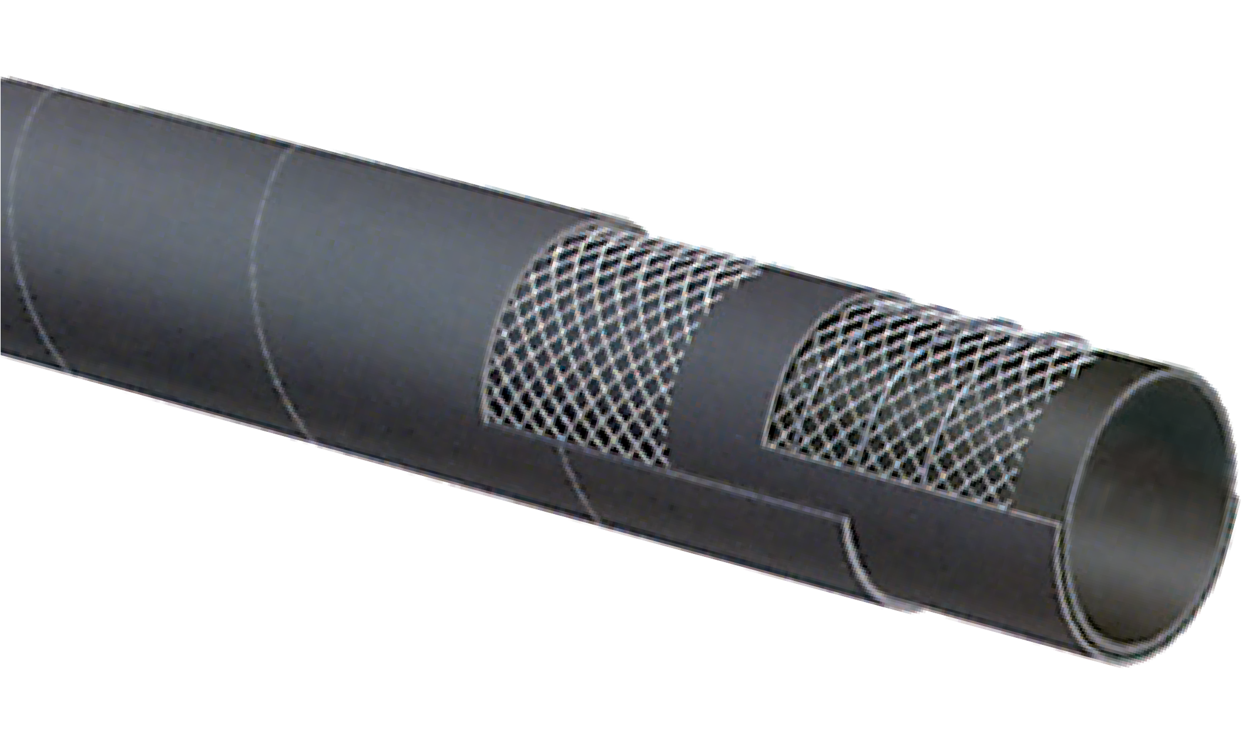
placeholder
Cover:
Applications: Working Pressure:
place
Tem
holder
perature R
ange:
placeholder
place
holder
placeholder
place
holder
Tube:
Reinforceme
nt:
Bran
ding:
Grounding Wi
placeholder
re:
Stan
place
dard Leng
holder
th:
placeholder

T600AA (continued)
Hard Wall Marine Exhaust Hose USCG/SAE J1527 A2/B2
Petroleum

Nominal Specifications
Series | ID  (in.) | ID  (mm) | OD  (in.) | OD  (mm) | Max Rec. WP (PSI) | Vacuum HG (in.) | Min. Bending Radius (in. @ 68°F) | Weight (lbs./ft.)
T600AA275 | 2 3/4 | 70 | 3.11 | 80 | 30 | 27 | 8 1/4 | 1.41
T600AA300 | 3 | 76 | 3.39 | 86 | 30 | 27 | 9 | 1.53
T600AA350 | 3 1/2 | 90 | 3.94 | 100 | 30 | 27 | 10 1/2 | 1.91
T600AA400 | 4 | 102 | 4.41 | 112 | 30 | 27 | 12 | 2.12
T600AA450 | 4 1/2 | 115 | 5.00 | 127 | 30 | 27 | 13 1/2 | 2.72
T600AA500 | 5 | 127 | 5.55 | 141 | 30 | 24 | 15 | 3.04

Applications:
Marine wet exhaust and bilge pump connections.

Cover:
Black Synthetic Rubber – abrasion, ozone and hydrocarbon resistant.

Reinforcement:
High tensile textile cords.

Tube:
Black Synthetic Rubber.

Working Pressure:
Constant Pressure – 5 Bar (75 PSI)

Temperature Range:
-22°F (-30°C) to 212°F (+100°C)

Branding:
ALFAGOMMA – ITALY – T653 SOFT WALL MARINE WET EXHAUST SAE J2006 R1 <SIZE> <YYYY MFG> (in blue
letters)

Standard Length:
12 1/2 feet in straight lengths

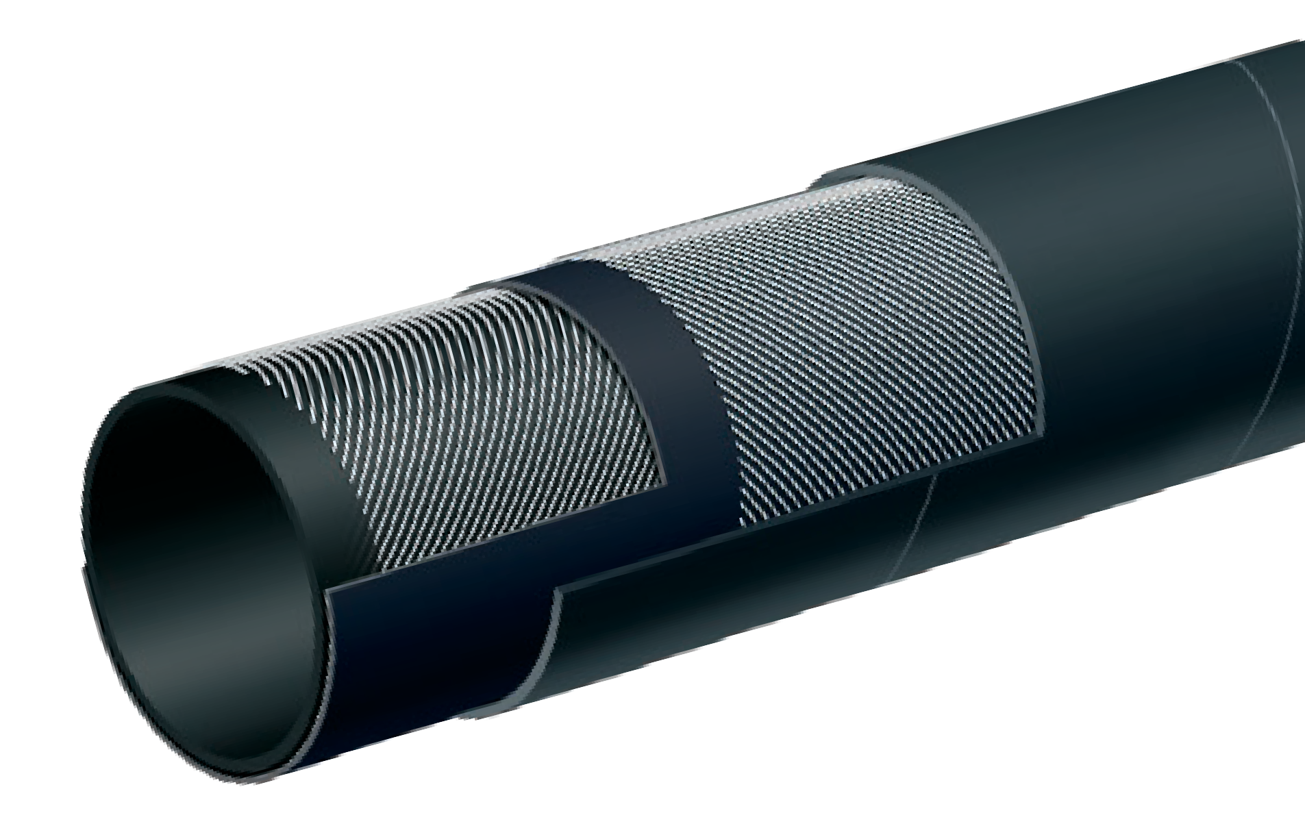

T653AA
Soft Wall Marine Exhaust Hose – SAE J2006 R1
Petroleum

Nominal Specifications
Series | ID  (in.) | ID  (mm) | OD  (in.) | OD  (mm) | Max Rec. WP (PSI) | Weight (lbs./ft.)
T653AA100 | 1 | 25 | 1.38 | 35 | 75 | 0.43
T653AA112 | 1 1/8 | 28 | 1.50 | 38 | 75 | 0.47
T653AA125 | 1 1/4 | 32 | 1.65 | 42 | 75 | 0.52
T653AA137 | 1 3/8 | 35 | 1.77 | 45 | 75 | 0.56
T653AA150 | 1 1/2 | 38 | 1.89 | 48 | 75 | 0.61
T653AA162 | 1 5/8 | 42 | 2.05 | 52 | 75 | 0.66
T653AA175 | 1 3/4 | 45 | 2.17 | 55 | 75 | 0.70
T653AA189 | 1 7/8 | 48 | 2.28 | 58 | 75 | 0.75
T653AA200 | 2 | 51 | 2.48 | 63 | 75 | 0.97
T653AA225 | 2 1/4 | 57 | 2.72 | 69 | 75 | 1.07
T653AA238 | 2 3/8 | 60 | 2.91 | 74 | 75 | 1.31
T653AA250 | 2 1/2 | 63 | 3.03 | 77 | 75 | 1.37
T653AA300 | 3 | 76 | 3.54 | 90 | 75 | 1.64
T653AA350 | 3 1/2 | 90 | 4.09 | 104 | 75 | 1.95
T653AA400 | 4 | 102 | 4.57 | 116 | 75 | 2.18

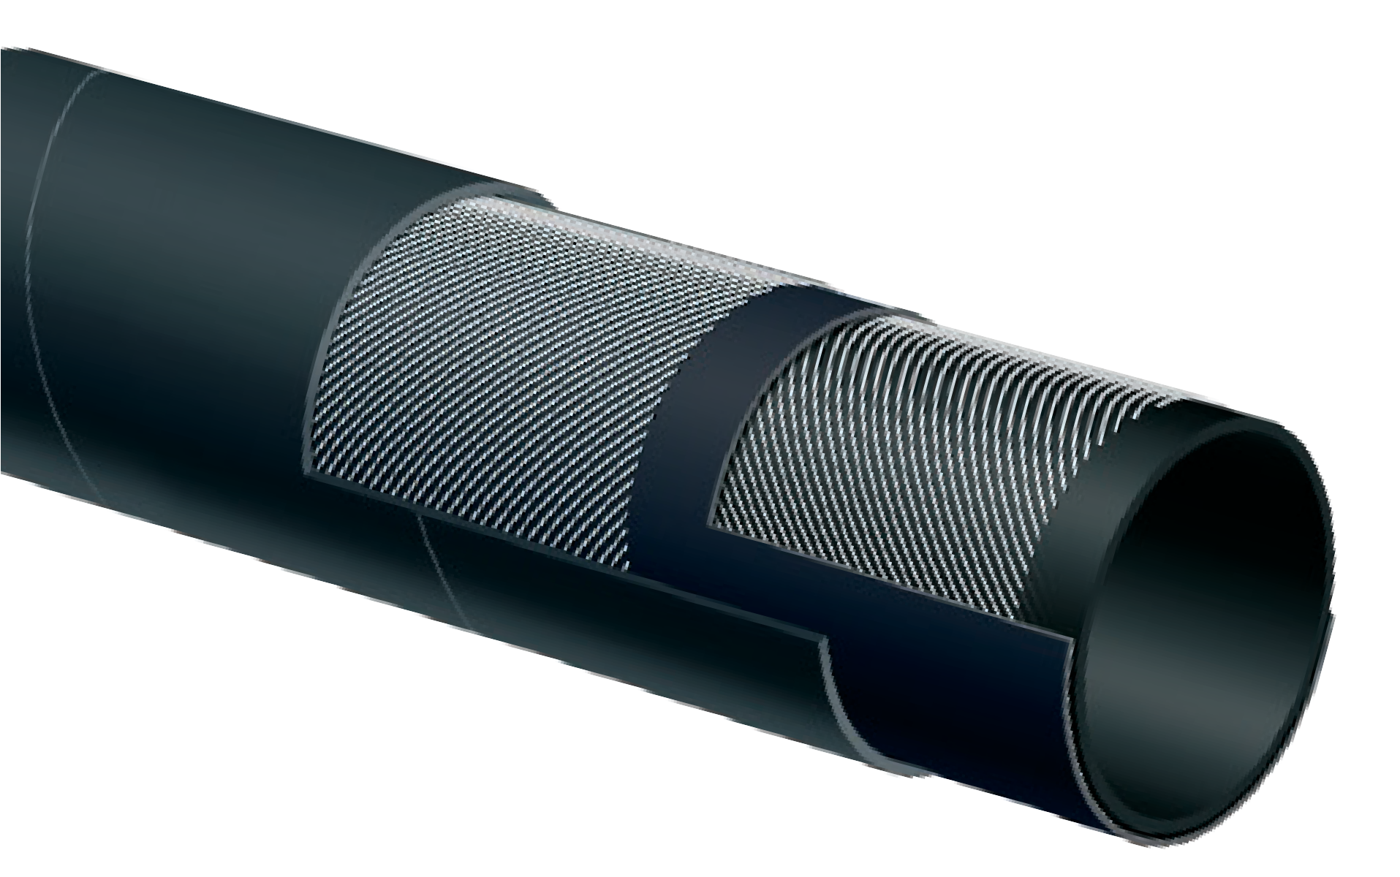

T653AA (continued)
Soft Wall Marine Exhaust Hose – SAE J2006 R1
Petroleum

Nominal Specifications
Series | ID  (in.) | ID  (mm) | OD  (in.) | OD  (mm) | Max Rec. WP (PSI) | Weight (lbs./ft.)
T653AA450 | 4 1/2 | 115 | 5.08 | 129 | 75 | 2.43
T653AA500 | 5 | 127 | 5.55 | 141 | 75 | 2.68
T653AA600 | 6 | 152 | 6.61 | 168 | 75 | 3.26
T653AA662 | 6 5/8 | 168 | 7.24 | 184 | 75 | 3.57
T653AA800 | 8 | 203 | 8.70 | 221 | 75 | 4.96

Applications:
Fracking fluids, liquid mud and crude oil delivery in oil field and gas exploration.

Cover:
Black synthetic elastomer – abrasion, oil and ozone resistant.

Reinforcement:
High tensile textile cords.

Tube:
Black synthetic elastomer.

Working Pressure:
Constant Pressure – 27 Bar (400 PSI)

Temperature Range:
-22°F (-30°C) to 176°F (+80°C)

Branding:
ALFAGOMMA – ITALY OIL RIGGER – FRACK 27 BAR
(400 PSI) (in blue letters)

Standard Length:
100 feet

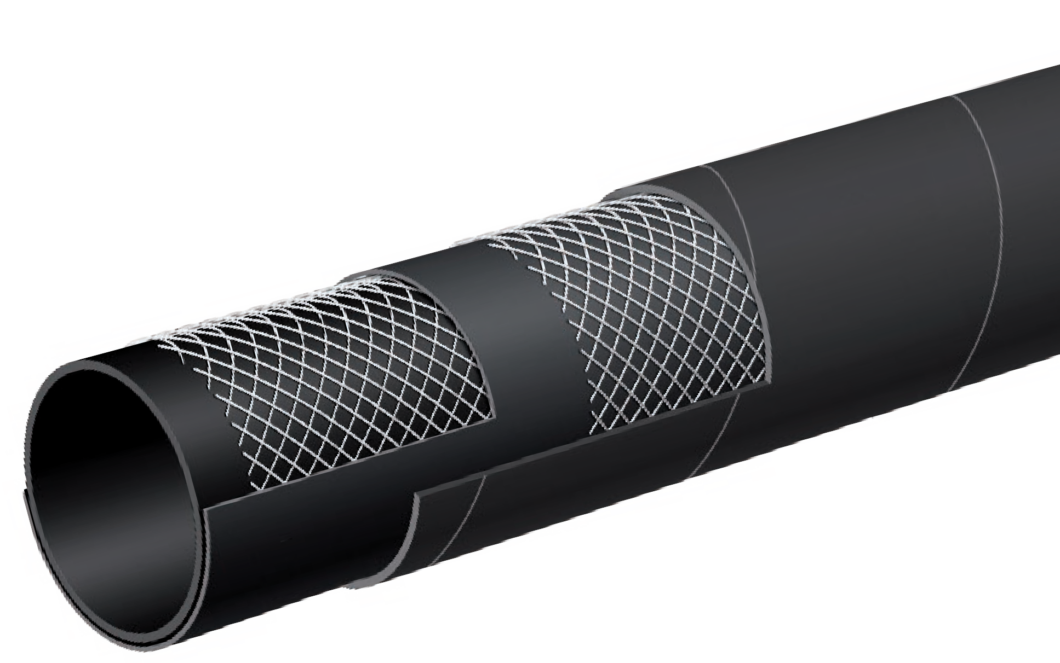

T6D1AA
400 PSI Oil Rigger / Frack Discharge Hose
Petroleum

Nominal Specifications
Series | ID  (in.) | ID  (mm) | OD  (in.) | OD  (mm) | Max Rec. WP (PSI) | Weight (lbs./ft.)
T6D1AA400 | 4 | 102 | 4.72 | 120 | 400 | 2.89

COUPLING SUGGESTIONS
H Kuriyama offers a full line of Quick-Acting couplings, pin lug shank couplings and combination nipples. Refer to current Kuriyama-Couplings™ and Accessories Catalog for type and pricing.

Applications:
Fracking fluids, liquid mud and crude oil delivery in heavy duty oil field and gas exploration.

Cover:
Black SUPERTUFF cover – abrasion, oil and ozone resistant.

Reinforcement:
High tensile textile cords.

Tube:
Black synthetic elastomer.

Working Pressure:
Constant Pressure – 27 Bar (400 PSI)

Temperature Range:
-22°F (-30°C) to 176°F (+80°C)

Branding:
ALFAGOMMA – ITALY OIL RIGGER – FRACK 27 BAR
(400 PSI) (in blue letters)

Standard Length:
100 feet

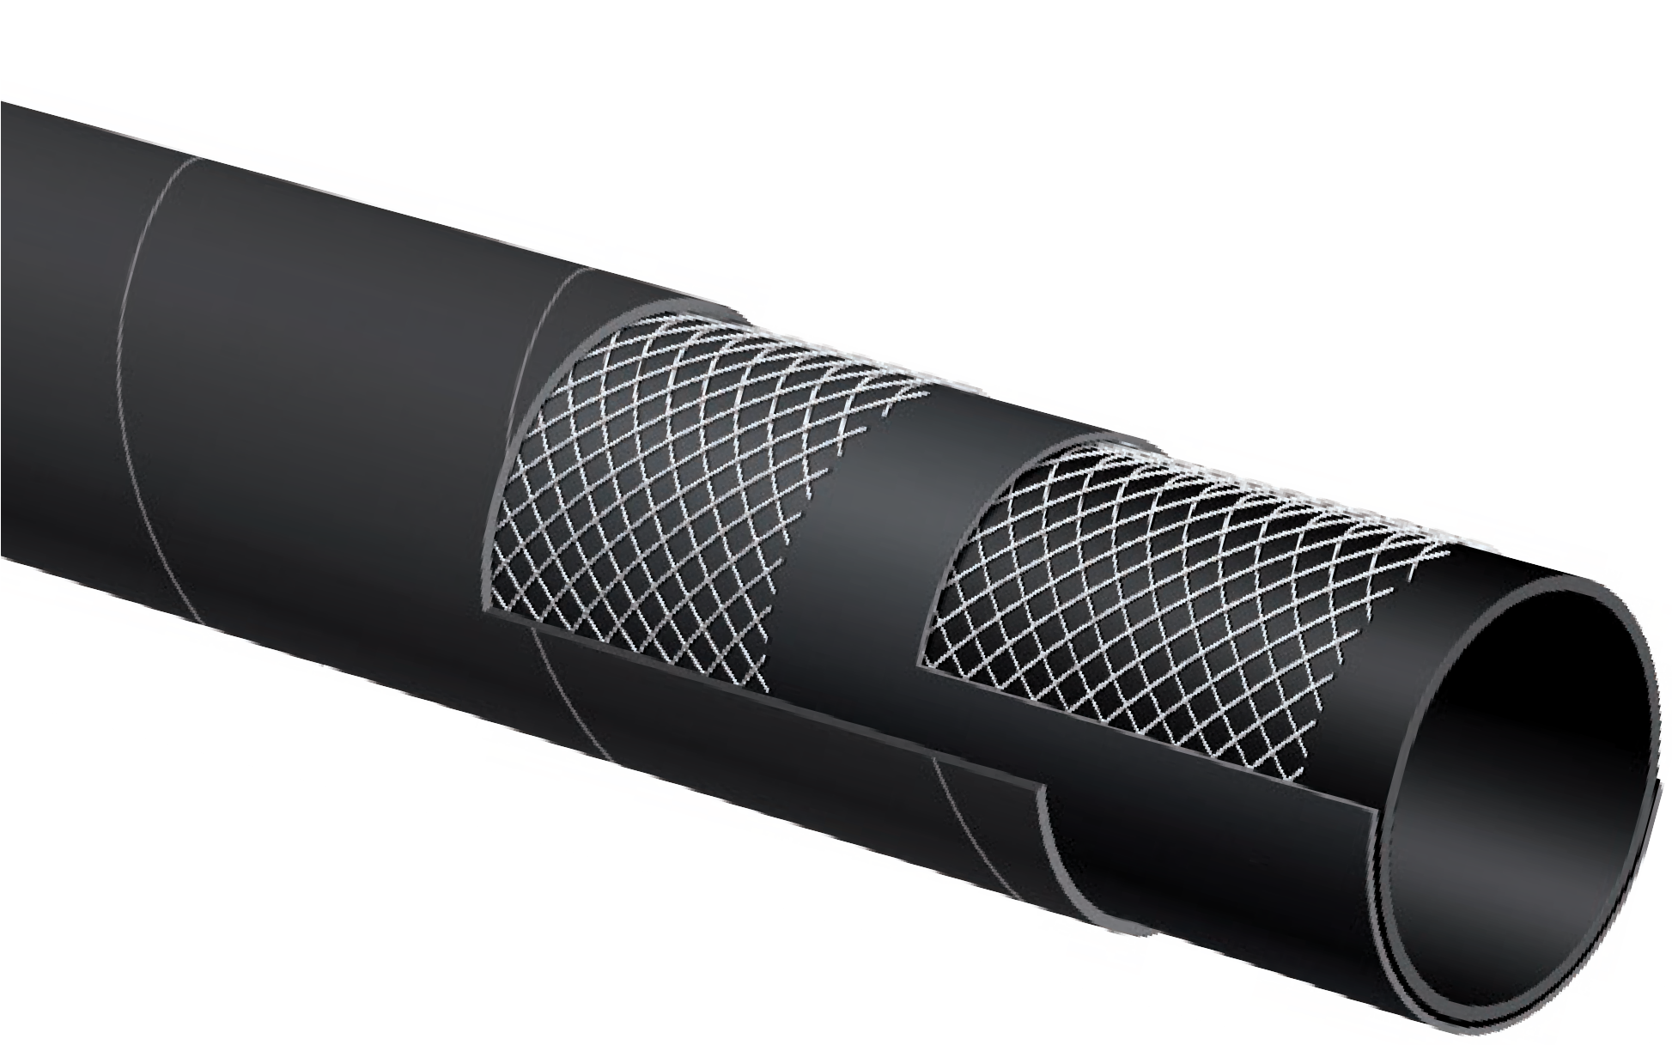

ST6D2AA
400 PSI Oil Rigger/Frack Discharge Hose with SUPERTUFF Cover
Petroleum

Nominal Specifications
Series | ID  (in.) | ID  (mm) | OD  (in.) | OD  (mm) | Max Rec. WP (PSI) | Weight (lbs./ft.)
ST6D2AA400 | 4 | 102 | 4.72 | 120 | 400 | 2.93

COUPLING SUGGESTIONS
H Kuriyama offers a full line of Quick-Acting couplings, pin lug shank couplings and combination nipples. Refer to current Kuriyama-Couplings™ and Accessories Catalog for type and pricing.

Applications:
Oil field vacuum tank service, for handling crude oil, frack solutions and slurries.
Note: For applications up to 35% aromatics. Not for use with refined petroleum products.
Cover:
Black corrugated SBR – abrasion, ozone, limited oil resistance.

Reinforcement:
High tensile textile cords with flexible steel helix wire.

Tube:
Black Nitrile – PVC blend, limited oil resistance, for oil field use.

Working Pressure:
Constant Pressure – 10 Bar (150 PSI)

Temperature Range:
-22°F (-30°C) to 176°F (+80°C)

Branding:
ALFAGOMMA – ITALY T6C1 10 BAR (150 PSI) OIL
FIELD-FRACK TANK S & D (in blue letters)

Standard Length:
100 feet: 2" through 4"

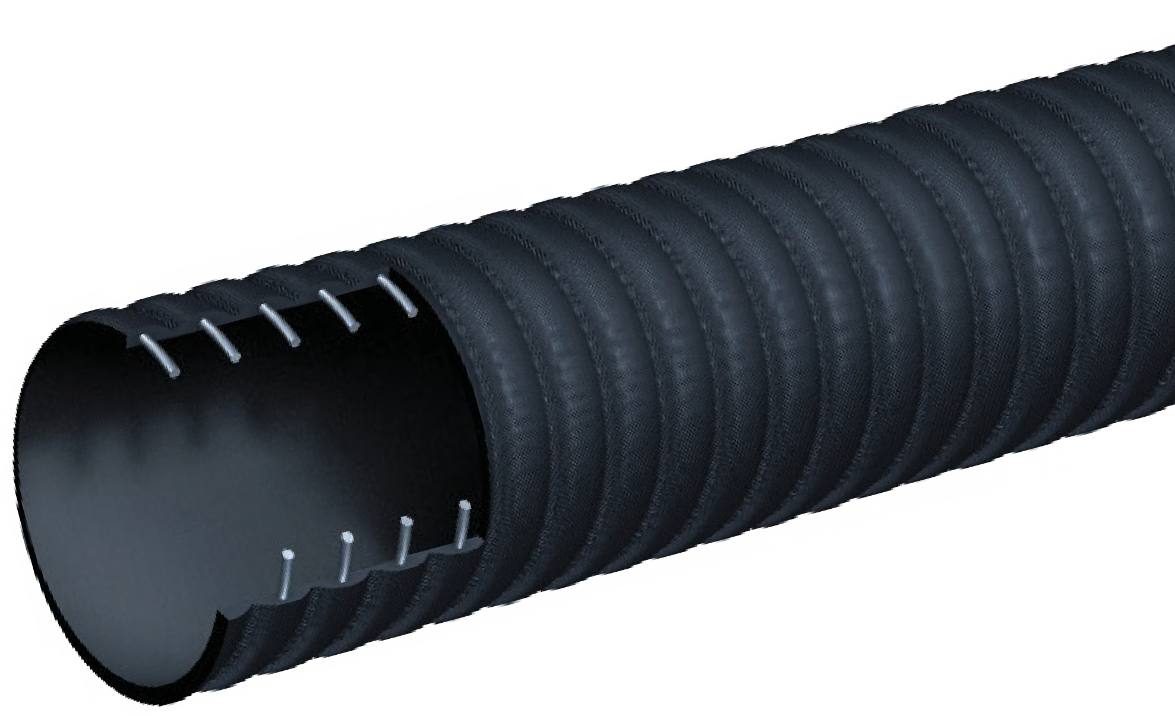

CT601AA
150 PSI Corrugated Oil Rigger/Oil Field-Frack Tank Hose
Petroleum
Nominal Specifications
Series | ID  (in.) | ID  (mm) | OD  (in.) | OD  (mm) | Max Rec. WP (PSI) | Vacuum HG (in.) | Min. Bending Radius (in. @ 68°F) | Weight (lbs./ft.)
CT601AA200 | 2 | 51 | 2.40 | 61 | 150 | 30 | 6 | 0.86
CT601AA300 | 3 | 76 | 3.46 | 88 | 150 | 27 | 9 | 1.61
CT601AA400 | 4 | 102 | 4.49 | 114 | 150 | 27 | 12 | 2.39

COUPLING SUGGESTIONS
Quick-Acting couplings or combination nipples attached with bands.

H Kuriyama offers a full line of Quick-Acting couplings, pin lug shank couplings and combination nipples. Refer to current Kuriyama-Couplings™ and Accessories Catalog for type and pricing.

Applications:
Oil field vacuum tank service, for handling crude oil, frack solutions and slurries.
Note: For applications up to 35% aromatics. Not for use with refined petroleum products.
Cover:
Black SBR – abrasion, ozone, limited oil resistance.

Reinforcement:
High tensile textile cords with flexible steel helix wire.

Tube:
Black Nitrile – PVC blend, limited oil resistance, for oil field use.

Working Pressure:
Constant Pressure – 10 Bar (150 PSI)

Temperature Range:
-22°F (-30°C) to 176°F (+80°C)

Branding:
ALFAGOMMA – ITALY T601 10 BAR (150 PSI) OIL
FIELD-FRACK TANK HOSE (in blue letters)

Standard Length:
100 feet: 2" through 6"
20 feet: 6"

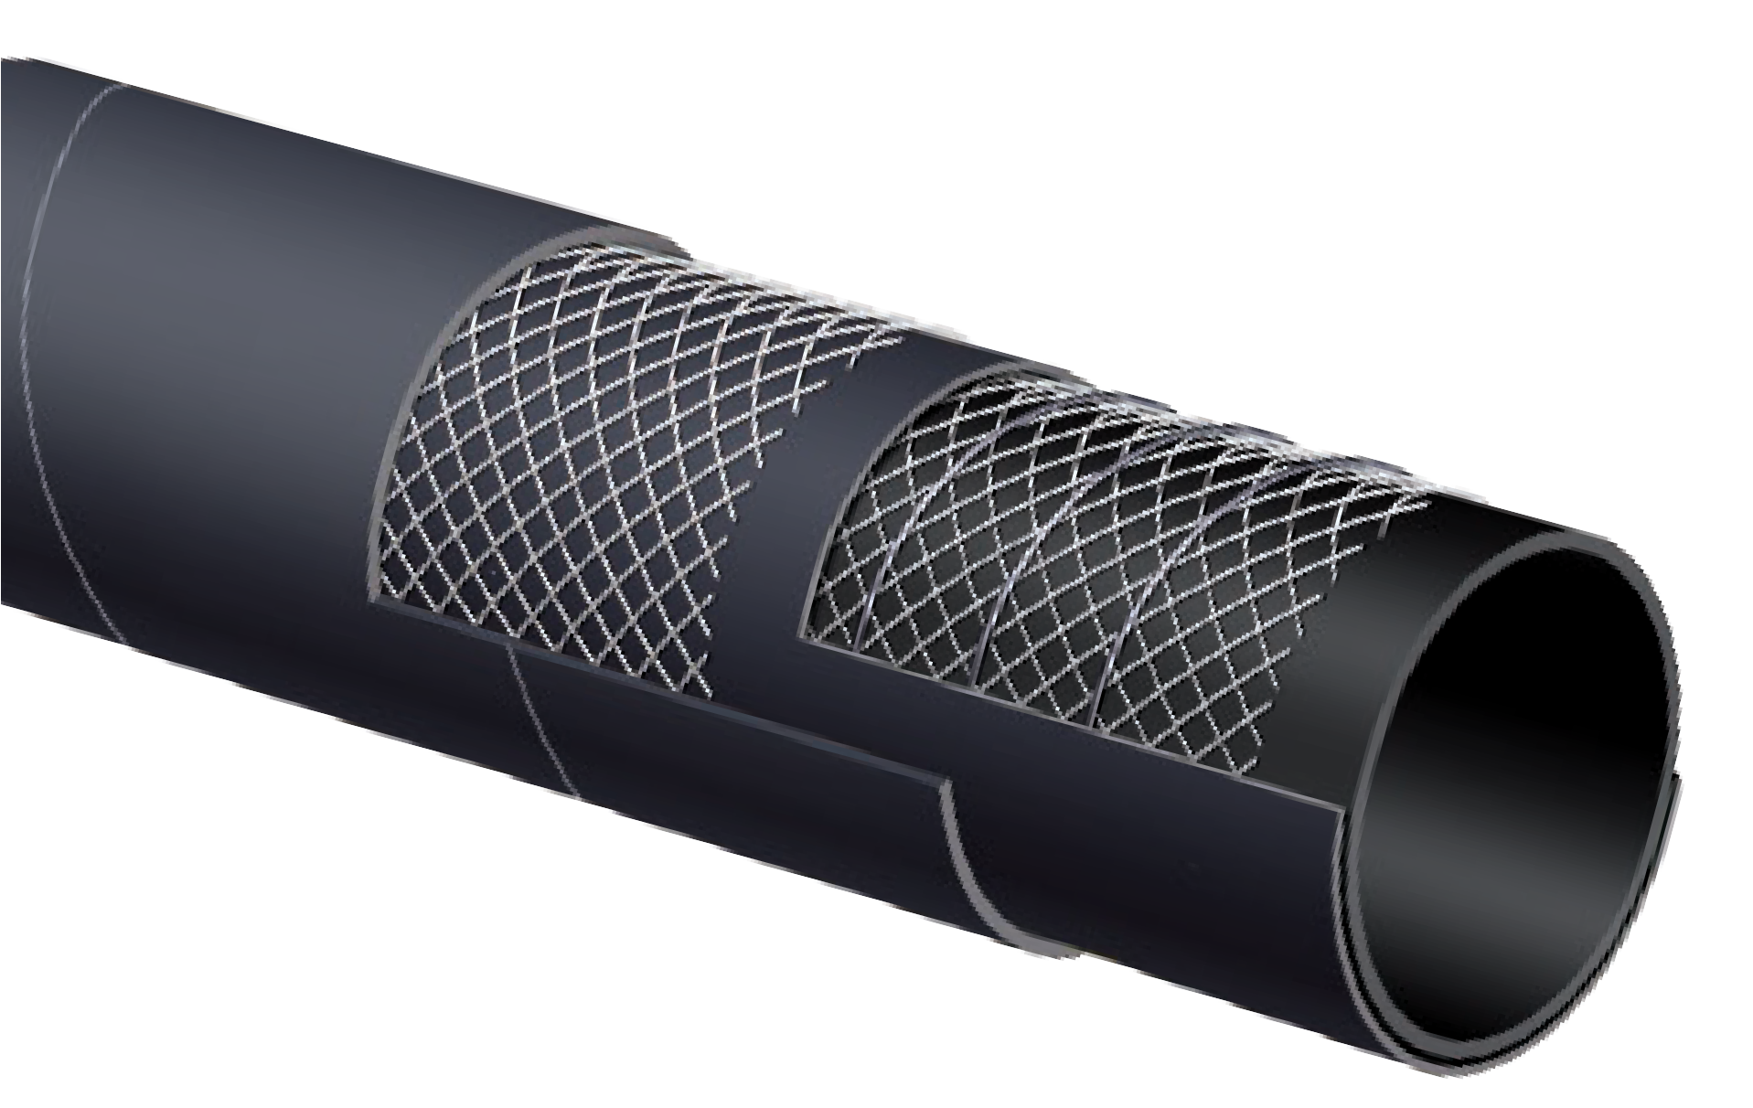

T601AA
150 PSI Oil Rigger/Oil Field- Frack Tank Hose
Petroleum

Nominal Specifications
Series | ID  (in.) | ID  (mm) | OD  (in.) | OD  (mm) | Max Rec. WP (PSI) | Vacuum HG (in.) | Min. Bending Radius (in. @ 68°F) | Weight (lbs./ft.)
T601AA200 | 2 | 51 | 2.40 | 61 | 150 | 30 | 10 | 0.93
T601AA300 | 3 | 76 | 3.46 | 88 | 150 | 27 | 15 | 1.73
T601AA400 | 4 | 102 | 4.57 | 116 | 150 | 27 | 20 | 2.40
T601AA600 | 6 | 152 | 6.61 | 168 | 150 | 24 | 30 | 4.59

COUPLING SUGGESTIONS
Quick-Acting couplings or combination nipples attached with bands.

Applications:
Low pressure return lines or suction lines with half the bend radius requirements of SAE J517 100 R4, service with petroleum based hydraulic fluids, water-glycol and water-fire resistant hydraulic fluids, oil, lubricants, crude oil, fuel oils and water.

Cover:
Black CR – oil, fuel, weather, ozone and abrasion- resistant.

Reinforcement:
High tensile textile cords with flexible steel helix wire.

Tube:
Black conductive NBR.

Working Pressure:
Constant Pressure – 20 Bar (300 PSI) 3/4" 17 Bar (250 PSI) 1" 14 Bar (200 PSI) 1 1/4"
10 Bar (150 PSI) 1 1/2" 7 Bar (100 PSI) 2"

Temperature Range:
-40° F (-40° C) to 212° F (+100° C) constant operation Maximum operating temperature: 257° F (+125° C).
Air maximum temperature: 175° F (80° C).
Note: Operating temperatures in excess of 212° F (+100° C) may materially reduce the life of the hose.
Branding:
ALFAGOMMA – ITALY – T604 (PSI) – SAE 100 R4 – (SIZE) –
Date (in white letters)

Standard Length:
100 feet

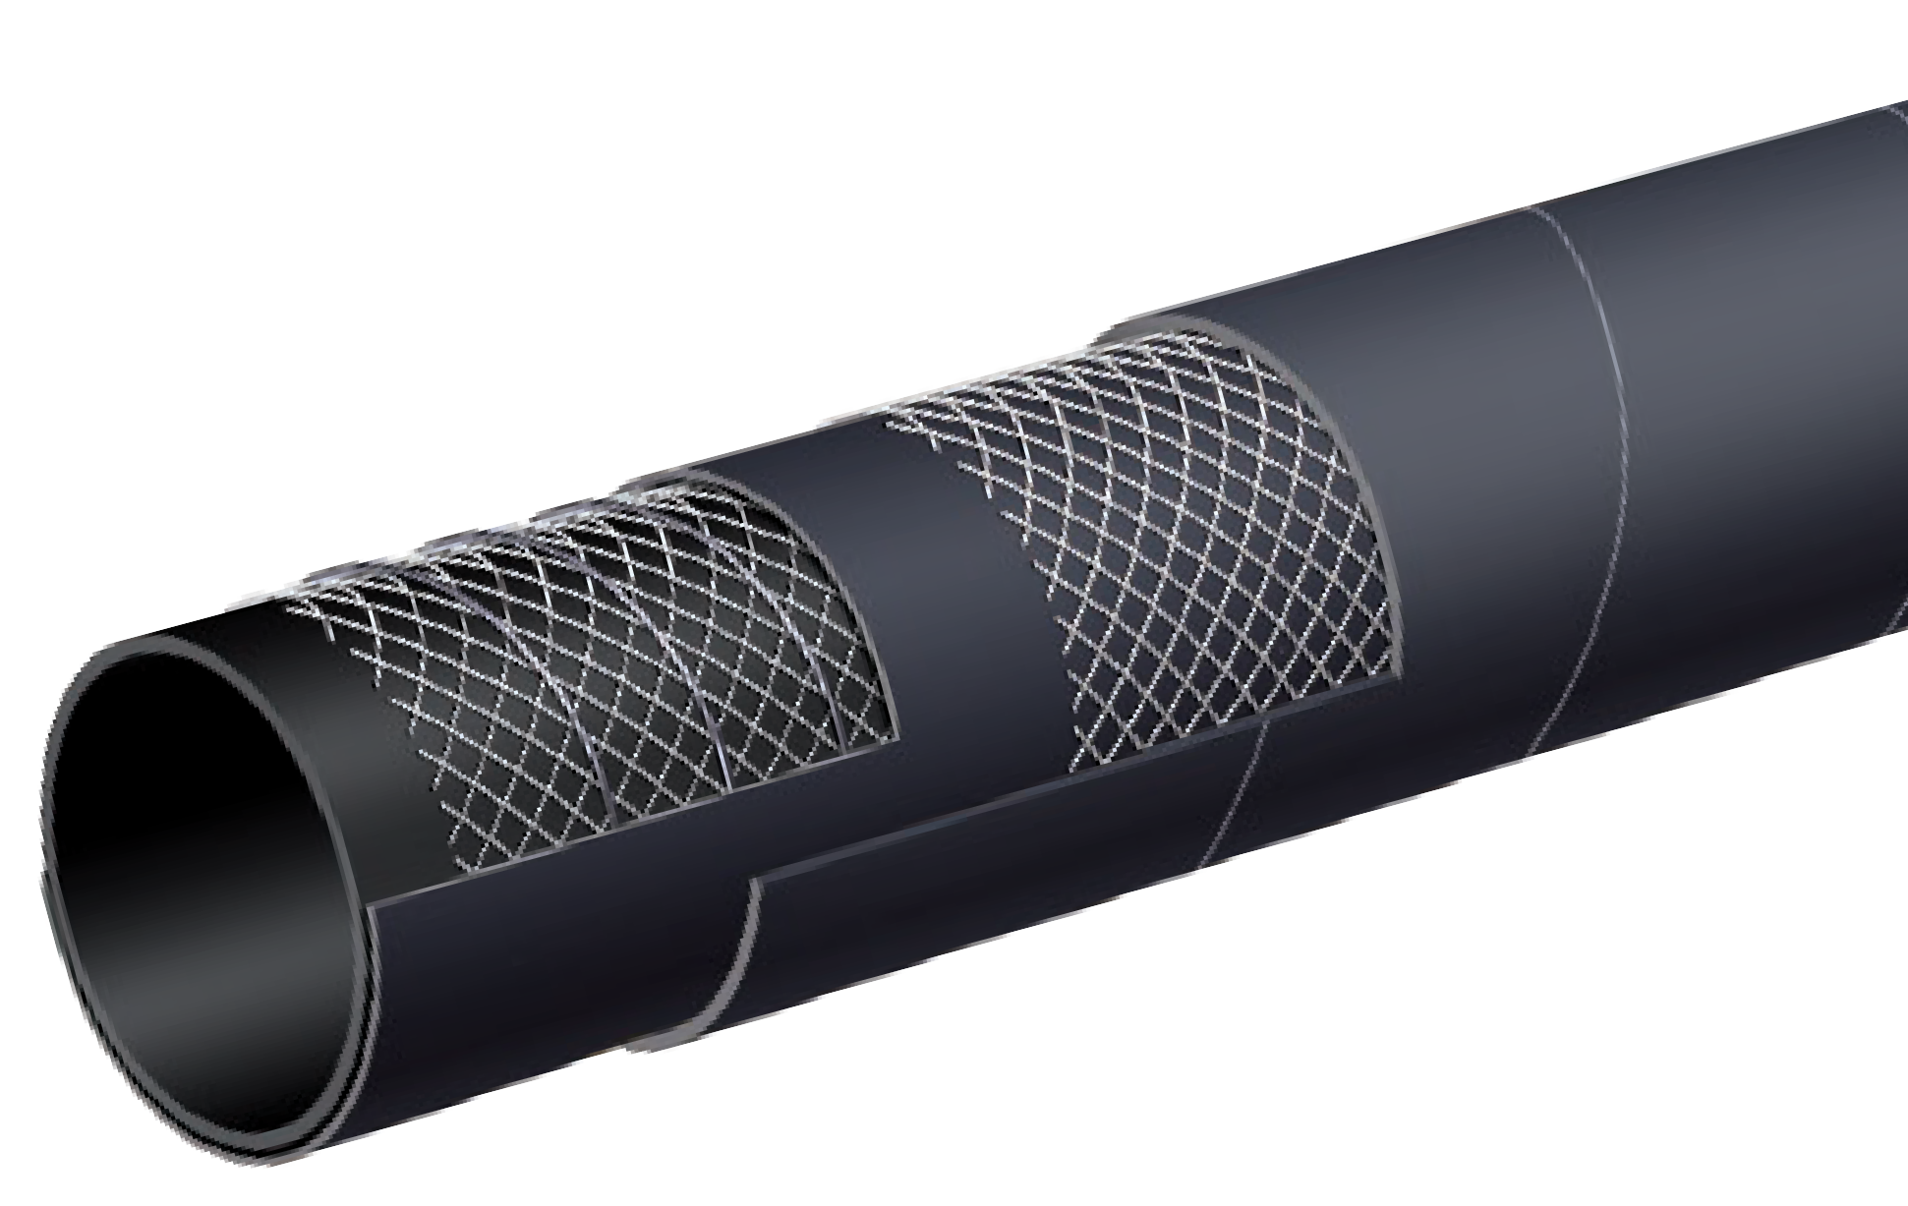

T604AA
Flexor – SAE 100 R4 Oil Return Hose
Petroleum

Nominal Specifications
Series | ID  (in.) | ID  (mm) | OD  (in.) | OD  (mm) | Max Rec. WP (PSI) | Vacuum HG (in.) | Min. Bending Radius (in. @ 68°F) | Weight (lbs./ft.)
T604AA075 | 3/4 | 19 | 1.14 | 29 | 300 | 30 | 2 1/4 | 0.41
T604AA100 | 1 | 25 | 1.38 | 35 | 250 | 30 | 3 | 0.52
T604AA125 | 1 1/4 | 32 | 1.65 | 42 | 200 | 30 | 3 3/4 | 0.61
T604AA150 | 1 1/2 | 38 | 1.89 | 48 | 150 | 30 | 4 1/2 | 0.70
T604AA200 | 2 | 51 | 2.40 | 61 | 100 | 30 | 6 | 0.90

COUPLING SUGGESTIONS
Crimp-on permanent type or combination nipples with bands.
Note: Hose cover does not need to be removed before attaching couplings.

H Kuriyama offers a full line of Quick-Acting couplings, pin lug shank couplings and combination nipples. Refer to current Kuriyama-Couplings™ and Accessories Catalog for type and pricing.

Applications:
For suction and discharge applications in truck and tank car transfer of gasoline, oil and other petroleum-based products with up to 50% aromatic content.

Cover:
Black CR – abrasion, ozone and hydrocarbon resistant.

Reinforcement:
High tensile textile cords with flexible steel helix wire.

Tube:
Black conductive NBR.

Working Pressure:
Constant Pressure – 10 Bar (150 PSI)

Temperature Range:
-22°F (-30°C) to 176°F (+80°C)

Branding:
ALFAGOMMA – ITALY T605 – 10 BAR (150 PSI)
PETROLEUM – S & D Ω - SAE 100R4 (in red letters)

Standard Length:
100 feet: 3/4" through 6"
20 feet: 6", 8"

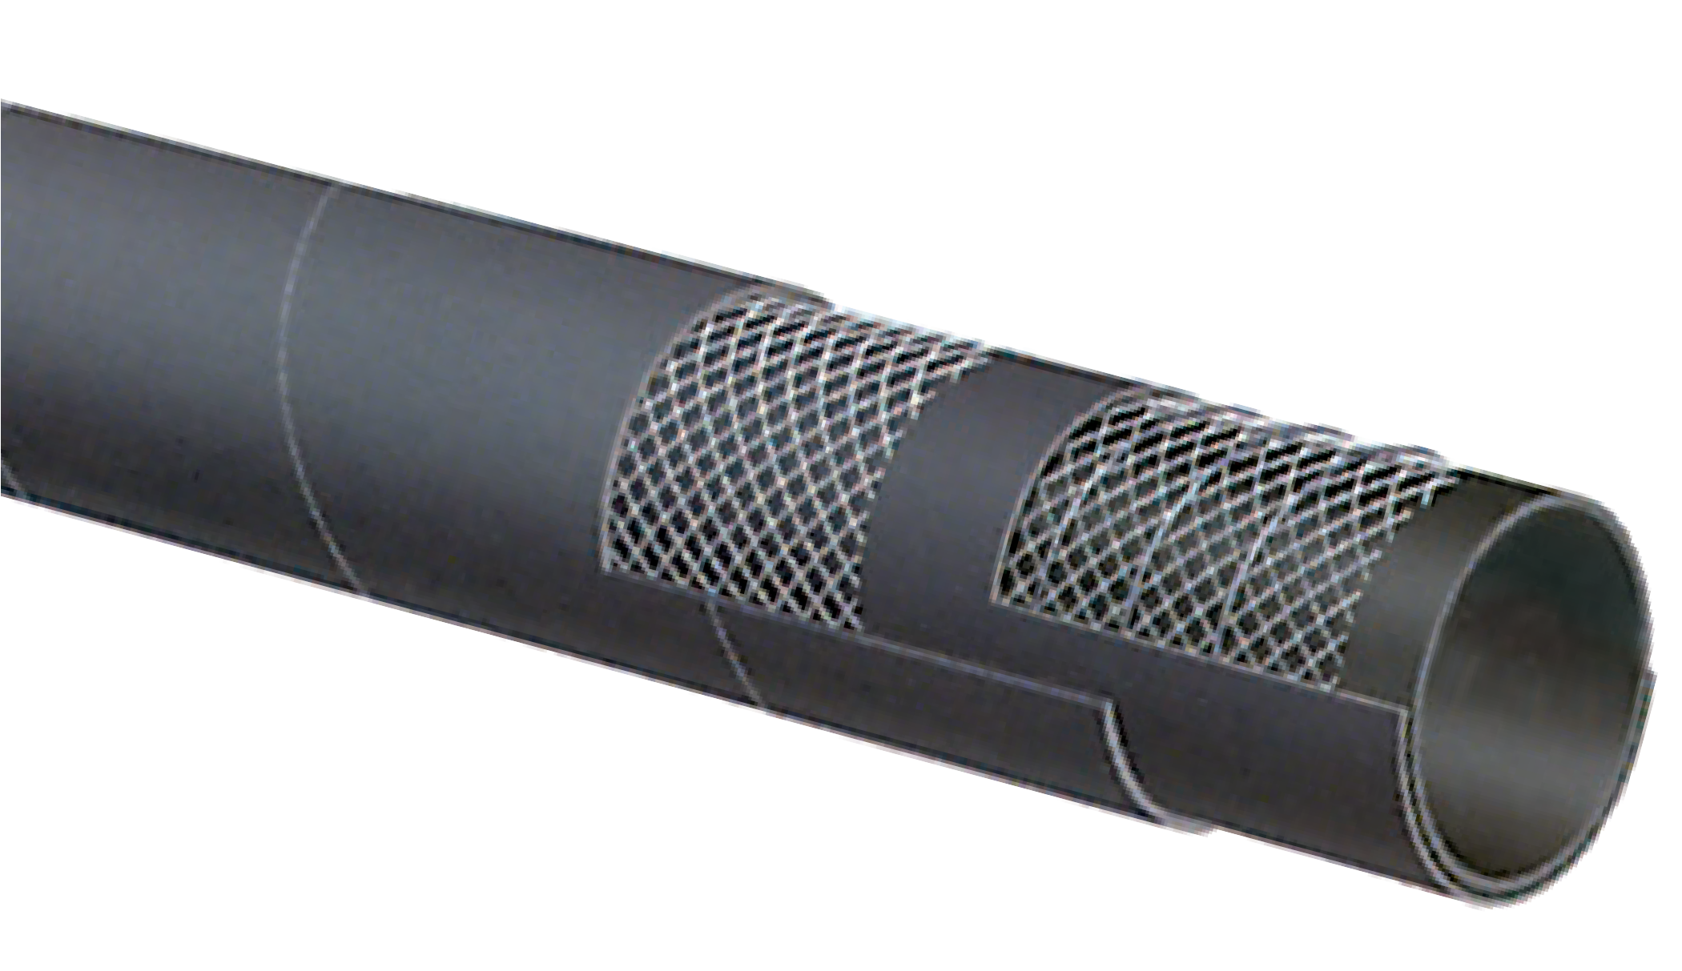

T605AA
150 PSI Black Petroleum S & D Hose
Petroleum
T605 IS NOT RECOMMENDED FOR USE ON A REEL.

Nominal Specifications
Series | ID  (in.) | ID  (mm) | OD  (in.) | OD  (mm) | Max Rec. WP (PSI) | Vacuum HG (in.) | Min. Bending Radius (in. @ 68°F) | Weight (lbs./ft.)
T605AA075 | 3/4 | 19 | 1.14 | 29 | 150 | 30 | 3 | 0.41
T605AA100 | 1 | 25 | 1.38 | 35 | 150 | 30 | 4 | 0.52
T605AA125 | 1 1/4 | 32 | 1.65 | 42 | 150 | 30 | 5 | 0.61
T605AA150 | 1 1/2 | 38 | 1.89 | 48 | 150 | 30 | 6 | 0.71
T605AA200 | 2 | 51 | 2.40 | 61 | 150 | 30 | 8 | 0.91
T605AA250 | 2 1/2 | 63 | 2.95 | 75 | 150 | 27 | 10 | 1.42
T605AA300 | 3 | 76 | 3.54 | 90 | 150 | 27 | 12 | 1.75
T605AA400 | 4 | 102 | 4.65 | 118 | 150 | 27 | 16 | 2.56
T605AA600 | 6 | 152 | 6.69 | 170 | 150 | 24 | 24 | 4.95
T605AA800 | 8 | 203 | 8.86 | 225 | 150 | 21 | 32 | 7.87

Applications:
For suction and discharge applications in truck and tank car transfer of gasoline, oil and other petroleum-based products with up to 50% aromatic content.

Cover:
Black corrugated CR – abrasion, ozone, and hydrocarbon resistant.

Reinforcement:
High tensile textile cords with flexible steel helix wire.

Tube:
Black Conductive NBR.

Working Pressure:
Constant Pressure – 10 Bar (150 PSI)

Temperature Range:
-22°F (-30°C) to 176°F (+80°C)

Branding:
ALFAGOMMA – ITALY T6C5 10 BAR (150 PSI)
PETROLEUM TANK TRUCK (in red letters)

Standard Length:
100 feet: 2" through 4"
20 feet: 6"

6C5AA
150 PSI Corrugated Tank Truck Hose
NEW
PRODUCT
Petroleum

Nominal Specifications
Series | ID  (in.) | ID  (mm) | OD  (in.) | OD  (mm) | Max Rec. WP (PSI) | Vacuum HG (in.) | Min. Bending Radius (in. @ 68°F) | Weight (lbs./ft.)
6C5AA200 | 2 | 51 | 2.48 | 63 | 150 | 30 | 4 | 0.85
6C5AA300 | 3 | 76 | 3.44 | 90 | 150 | 27 | 6 | 1.57
6C5AA400 | 4 | 102 | 4.57 | 116 | 150 | 27 | 8 | 2.21
6C5AA600 | 6 | 152 | 6.54 | 166 | 150 | 27 | 12 | 3.59

COUPLING SUGGESTIONS
Quick-Acting couplings or combination nipples attached with bands.

Applications:
For suction and discharge applications in truck and tank car transfer of gasoline, oil and other petroleum-based products with up to 50% aromatic content.

Cover:
Red CR – abrasion, ozone and hydrocarbon resistant.

Reinforcement:
High tensile textile cords with flexible steel helix wire.

Tube:
Black conductive NBR.

Working Pressure:
Constant Pressure – 10 Bar (150 PSI)

Temperature Range:
-22°F (-30°C) to 176°F (+80°C)

Branding:
ALFAGOMMA – ITALY T605 – 10 BAR (150 PSI)
PETROLEUM – S & D (in yellow letters)

Standard Length:
100 feet

T605 IS NOT RECOMMENDED FOR USE ON A REEL.

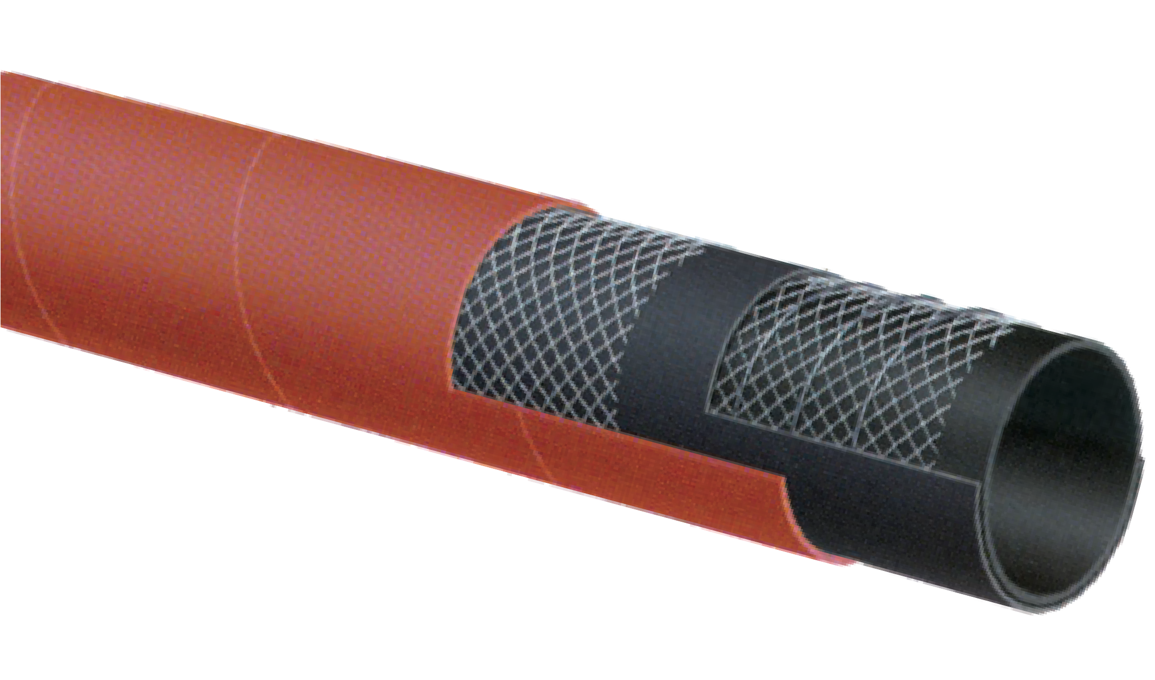

T605AH
150 PSI Red Petroleum S & D Hose
Petroleum

Nominal Specifications
Series | ID  (in.) | ID  (mm) | OD  (in.) | OD  (mm) | Max Rec. WP (PSI) | Vacuum HG (in.) | Min. Bending Radius (in. @ 68°F) | Weight (lbs./ft.)
T605AH150 | 1 1/2 | 38 | 1.89 | 48 | 150 | 30 | 6 | 0.73
T605AH200 | 2 | 51 | 2.40 | 61 | 150 | 30 | 8 | 0.94
T605AH300 | 3 | 76 | 3.46 | 88 | 150 | 27 | 12 | 1.74
T605AH400 | 4 | 102 | 4.57 | 116 | 150 | 27 | 16 | 2.41

Applications:
For suction and discharge applications in truck and tank car transfer of gasoline, oil and other petroleum-based products with up to 50% aromatic content. Where extreme flexibility is needed in low temperature.

Cover:
Blue corrugated – abrasion, ozone and hydrocarbon resistant.

Reinforcement:
High tensile textile cords with flexible steel helix wire.

Tube:
Black conductive NBR.

Working Pressure:
Constant Pressure – 150 PSI

Temperature Range:
-65°F (-54°C) to 180°F (+82°C)

Branding:
ALFAGOMMA – ITALY T606 – 10 BAR (150 PSI)
PETROLEUM – S & D Arctic (in blue letters on yellow layline)

Standard Length:
100 feet

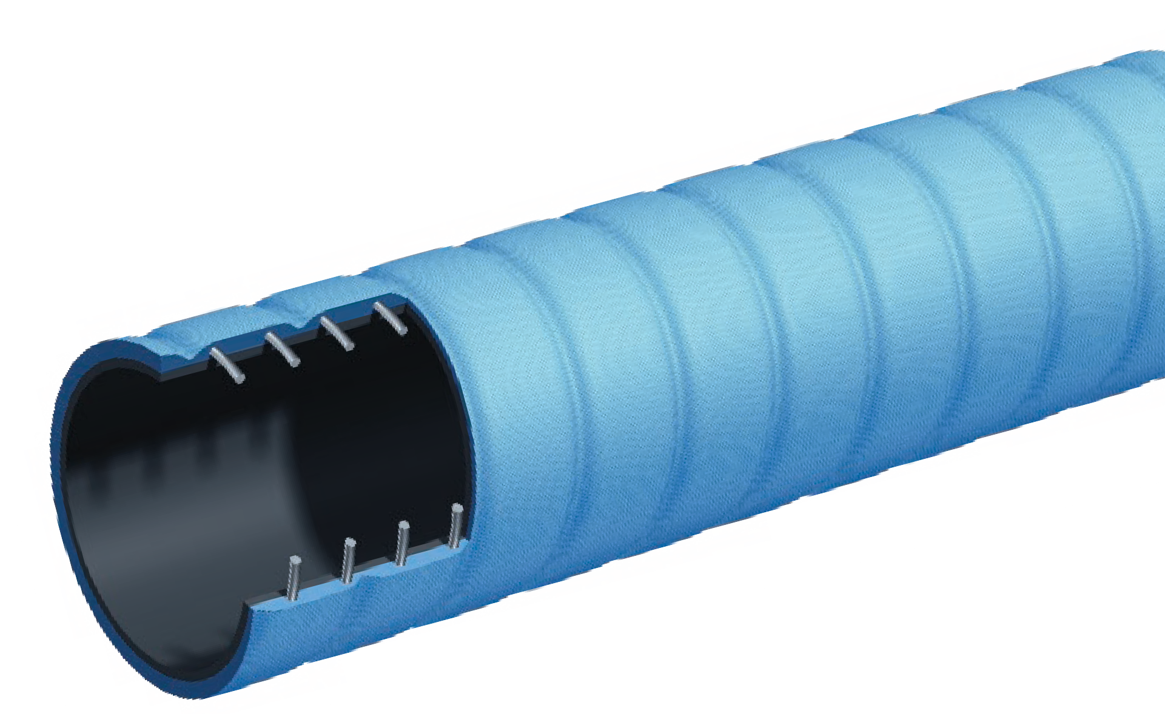

T606AE
150 PSI Corrugated Petroleum S & D – Arctic Hose
Petroleum

Nominal Specifications
Series | ID  (in.) | ID  (mm) | OD  (in.) | OD  (mm) | Max Rec. WP (PSI) | Vacuum HG (in.) | Min. Bending Radius (in. @ 68°F) | Weight (lbs./ft.)
T606AE200 | 2 | 51 | 2.48 | 63 | 150 | 30 | 3 | 1.06
T606AE300 | 3 | 76 | 3.54 | 90 | 150 | 30 | 4 1/2 | 1.84
T606AE400 | 4 | 102 | 4.57 | 116 | 150 | 30 | 6 | 2.67

COUPLING SUGGESTIONS
Quick-Acting, combination nipples attached with bands or internally expanded brass couplings with gasket seal attached with ferrules.

Applications:
Fuel and oil suction and discharge for up to 50% aromatic content. Designed for heavy duty applications.

Cover:
Black conductive CR – abrasion, ozone and hydrocarbon resistant.

Reinforcement:
High tensile textile cords with steel helix wire and static wire.

Tube:
Black conductive NBR.

Working Pressure:
Constant Pressure – 20 Bar (300 PSI)

Temperature Range:
-22°F (-30°C) to 176°F (+80°C)

Branding:
ALFAGOMMA – ITALY T620 – 20 BAR (300 PSI)
PETROLEUM – S & D Ω (in red letters)

Standard Length:
100 feet: 2" through 6"
20 feet: 6", 8"

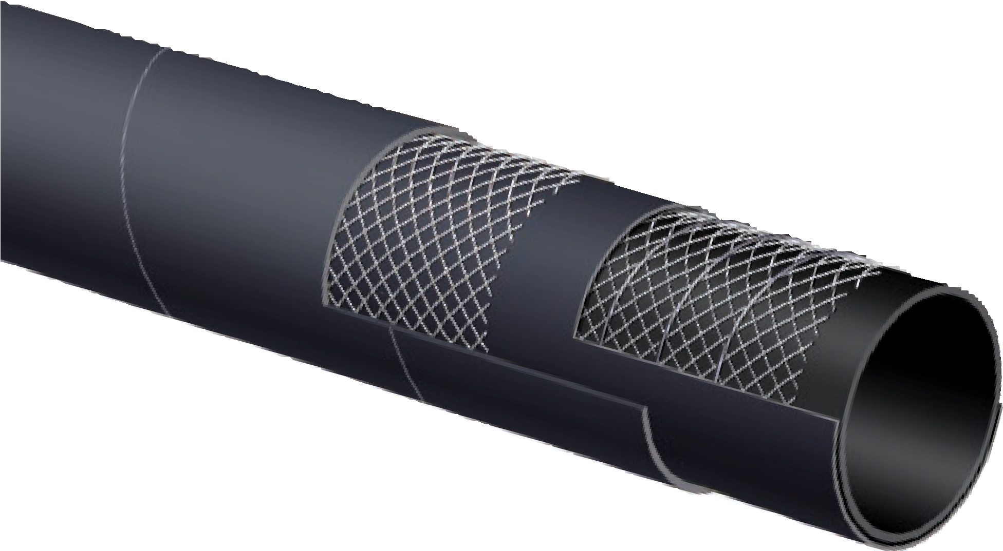

T620AA
300 PSI Black Fuel & Oil S & D Hose
Petroleum

Nominal Specifications
Series | ID  (in.) | ID  (mm) | OD  (in.) | OD  (mm) | Max Rec. WP (PSI) | Vacuum HG (in.) | Min. Bending Radius (in. @ 68°F) | Weight (lbs./ft.)
T620AA200 | 2 | 51 | 2.48 | 63 | 300 | 30 | 8 | 1.10
T620AA300 | 3 | 76 | 3.54 | 90 | 300 | 27 | 12 | 1.77
T620AA400 | 4 | 102 | 4.57 | 116 | 300 | 27 | 16 | 2.43
T620AA600 | 6 | 152 | 6.69 | 170 | 300 | 24 | 24 | 5.60
T620AA800 | 8 | 203 | 8.86 | 225 | 300 | 21 | 32 | 9.24

TM

Applications:
For suction and discharge applications in truck and tank car transfer of gasoline, oil and Biofuels – up to E98
and B100* with up to 60% aromatic content at ambient temperature.

Cover:
Black specially-blended neoprene – added resistance against abrasion, ozone and hydrocarbons.

Reinforcement:
High tensile textile cords with steel helix wire.

Tube:
Black conductive synthetic rubber.

Working Pressure:
Constant Pressure – 10 Bar (150 PSI)

Temperature Range:
-22°F (-30°C) to 176°F (+80°C)

Branding:
ALFAGOMMA – ITALY T629 – 10 BAR (150 PSI)
BIOFUEL Ω (in green letters)

Standard Length:
100 feet: 3/4" through 4"
H T629 is not recommended for use on a reel.
*Applies to Biodiesels which meet the ASTM D6751 criteria.

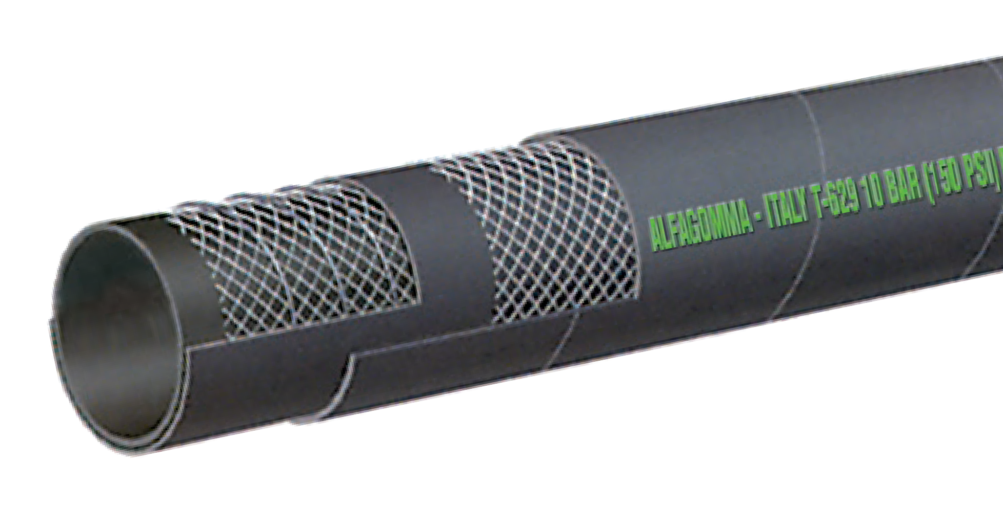

T629AA
150 PSI Black Biofuel Petroleum S & D Hose
Petroleum

Nominal Specifications
Series | ID  (in.) | ID  (mm) | OD  (in.) | OD  (mm) | Max Rec. WP (PSI) | Vacuum HG (in.) | Min. Bending Radius (in. @ 68°F) | Weight (lbs./ft.)
T629AA075 | 3/4 | 19 | 1.14 | 29 | 150 | 30 | 3 | 0.41
T629AA100 | 1 | 25 | 1.38 | 35 | 150 | 30 | 4 | 0.51
T629AA150 | 1 1/2 | 38 | 1.89 | 48 | 150 | 30 | 6 | 0.71
T629AA200 | 2 | 51 | 2.40 | 61 | 150 | 30 | 8 | 0.91
T629AA250 | 2 1/2 | 63 | 2.95 | 75 | 150 | 27 | 10 | 1.42
T629AA300 | 3 | 76 | 3.46 | 88 | 150 | 27 | 12 | 1.71
T629AA400 | 4 | 102 | 4.57 | 116 | 150 | 27 | 16 | 2.38

COUPLING SUGGESTIONS
Quick-Acting or combination nipples attached with bands.

Applications:
Oil discharge hose designed for use on trucks, docks or barges where a soft wall hose is required.

Cover:
Red CR – abrasion, ozone and hydrocarbon resistant.

Reinforcement:
Spiraled high tensile textile cords with embedded static wire.

Tube:
Black conductive NBR.

Working Pressure:
Constant Pressure – 10 Bar (150 PSI)

Temperature Range:
-22°F (-30°C) to 176°F (+80°C)

Branding:
ALFAGOMMA – ITALY T650 10 BAR (150 PSI) –
PETROLEUM DELIVERY (in yellow letters)

Standard Length:
100 feet

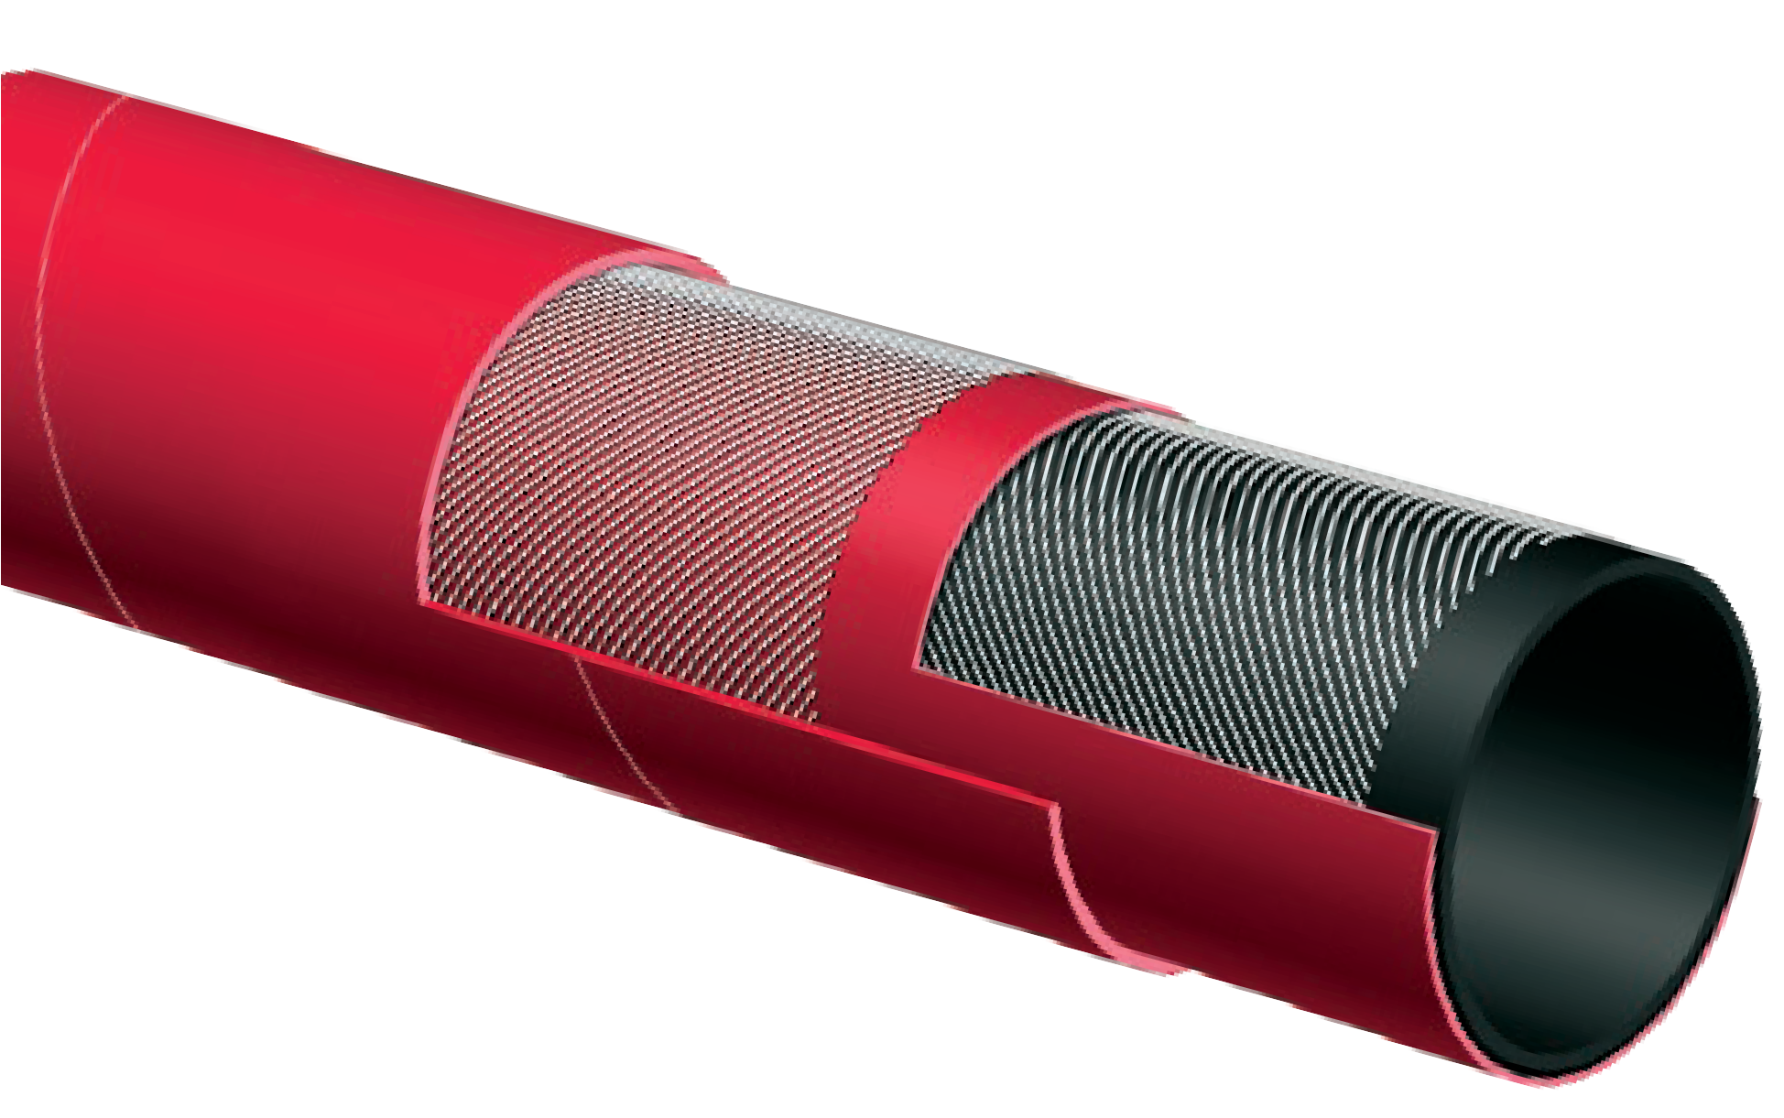

T650AH
150 PSI Oil Discharge Hose
Petroleum

Nominal Specifications
Series | ID  (in.) | ID  (mm) | OD  (in.) | OD  (mm) | Max Rec. WP (PSI) | Weight (lbs./ft.)
T650AH150 | 1 1/2 | 38 | 1.97 | 50 | 150 | 0.77
T650AH200 | 2 | 51 | 2.40 | 61 | 150 | 0.82
T650AH300 | 3 | 76 | 3.46 | 88 | 150 | 1.42
T650AH400 | 4 | 102 | 4.49 | 114 | 150 | 1.92

COUPLING SUGGESTIONS
Quick-Acting or combination nipples attached with bands.

Applications:
Hot tar and asphalt suction and discharge service.

Cover:
Black CSM – abrasion, ozone and hot tar resistant.

Reinforcement:
High tensile textile cords with steel helix wire.

Tube:
Black NBR – hot tar and asphalt resistant.

Working Pressure:
10 Bar (150 PSI)

Temperature Range:
-4°F (-20°C) to 356°F (+180°C)

Branding:
ALFAGOMMA – ITALY T614 10 BAR (150 PSI) HOT TAR
AND ASPHALT (on red stripe)

Standard Length:
100 feet

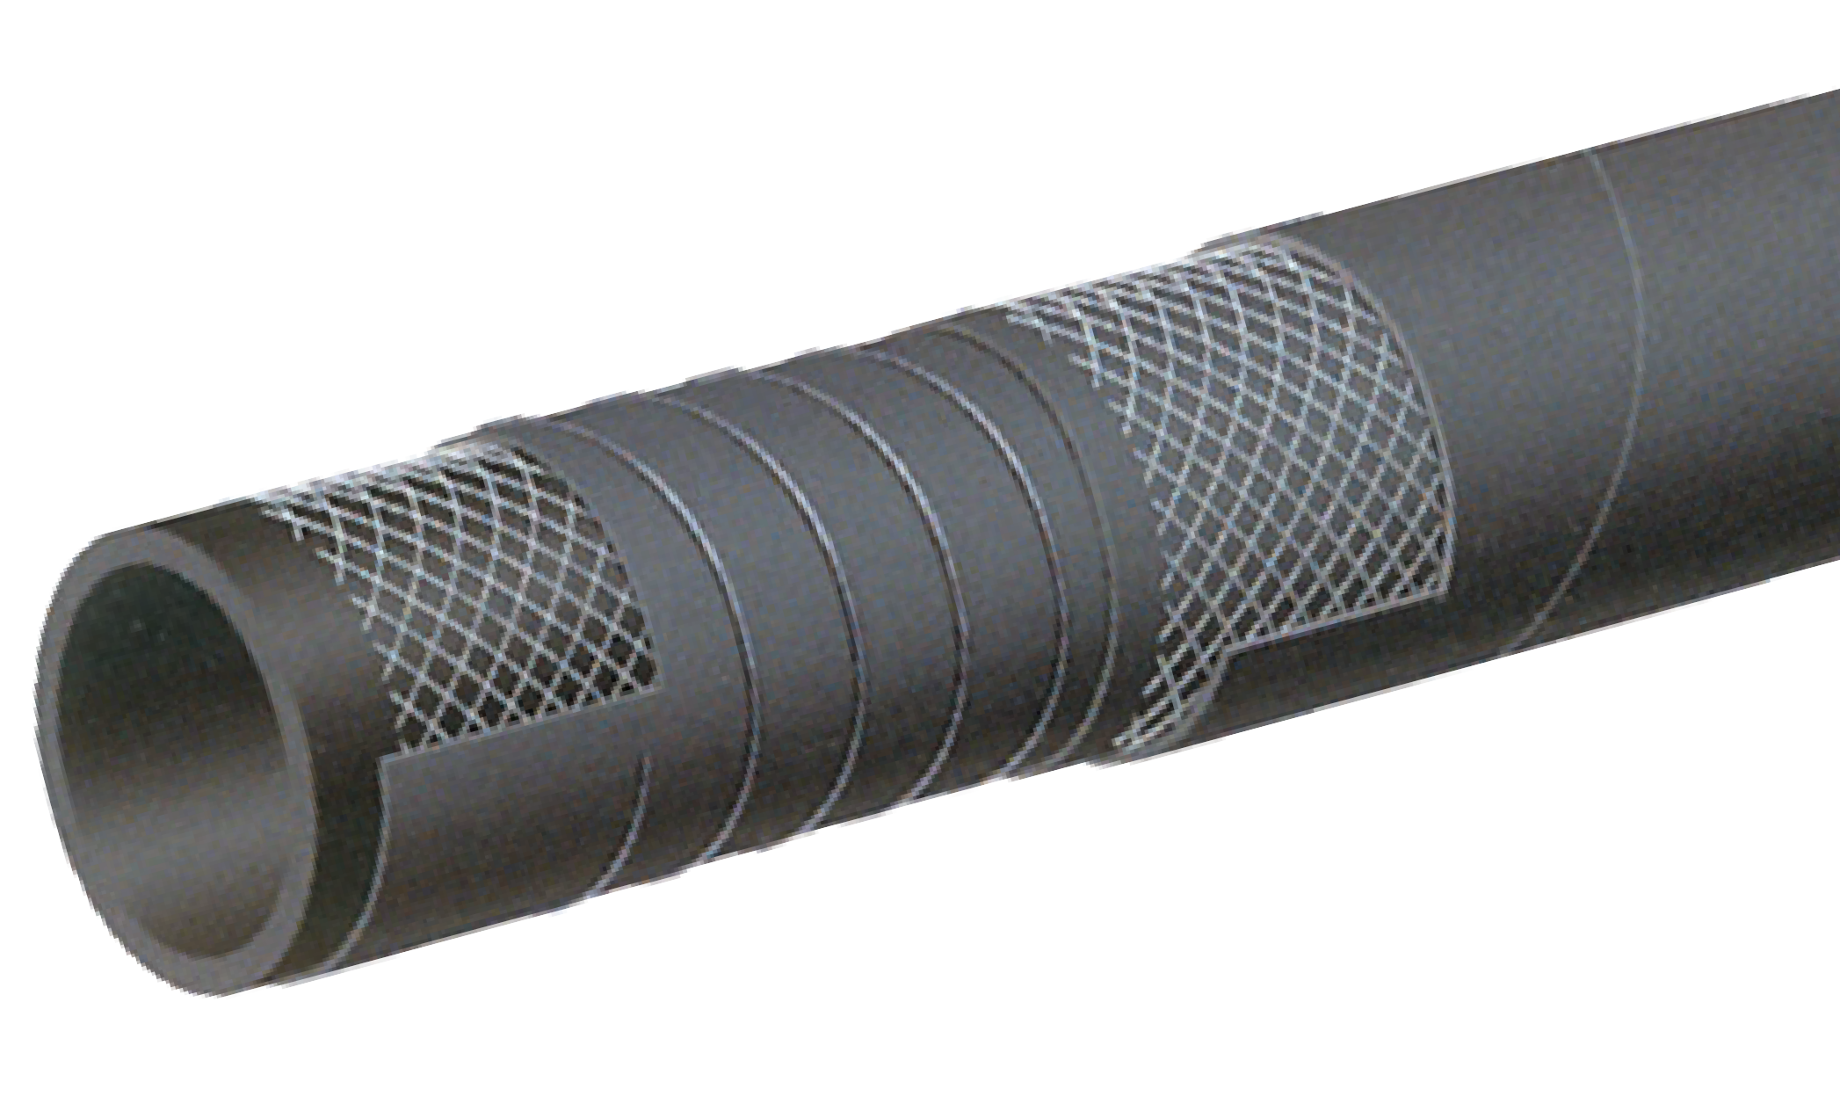

T614AA
150 PSI Hot Tar & Asphalt S & D Hose
Petroleum

Nominal Specifications
Series | ID  (in.) | ID  (mm) | OD  (in.) | OD  (mm) | Wall Thickness (mm) | Max Rec. WP (PSI) | Vacuum HG (in.) | Min. Bending Radius (in.) | Weight (lbs./ft.)
T614AA200 | 2 | 51 | 2.72 | 69 | 9 | 150 | 30 | 10 | 1.64
T614AA300 | 3 | 76 | 3.78 | 96 | 10 | 150 | 27 | 15 | 2.69
T614AA400 | 4 | 102 | 4.80 | 122 | 10 | 150 | 27 | 20 | 3.57

COUPLING SUGGESTIONS
Permanently attached couplings are suggested for assemblies.

Applications:
Hot tar and asphalt delivery service.

Cover:
Black CR – abrasion, ozone, hydrocarbon and fire resistant.

Reinforcement:
High tensile steel wire braids.

Tube:
Black NBR – hot tar and asphalt resistant.

Safety Factor:
10:1

Working Pressure:
20 Bar (300 PSI)

Temperature Range:
-22°F (-30°C) to 356°F (+180°C)

Branding:
ALFAGOMMA – ITALY T631 20 BAR (300 PSI) HOT TAR
AND ASPHALT (embossed)

Standard Length:
100 feet

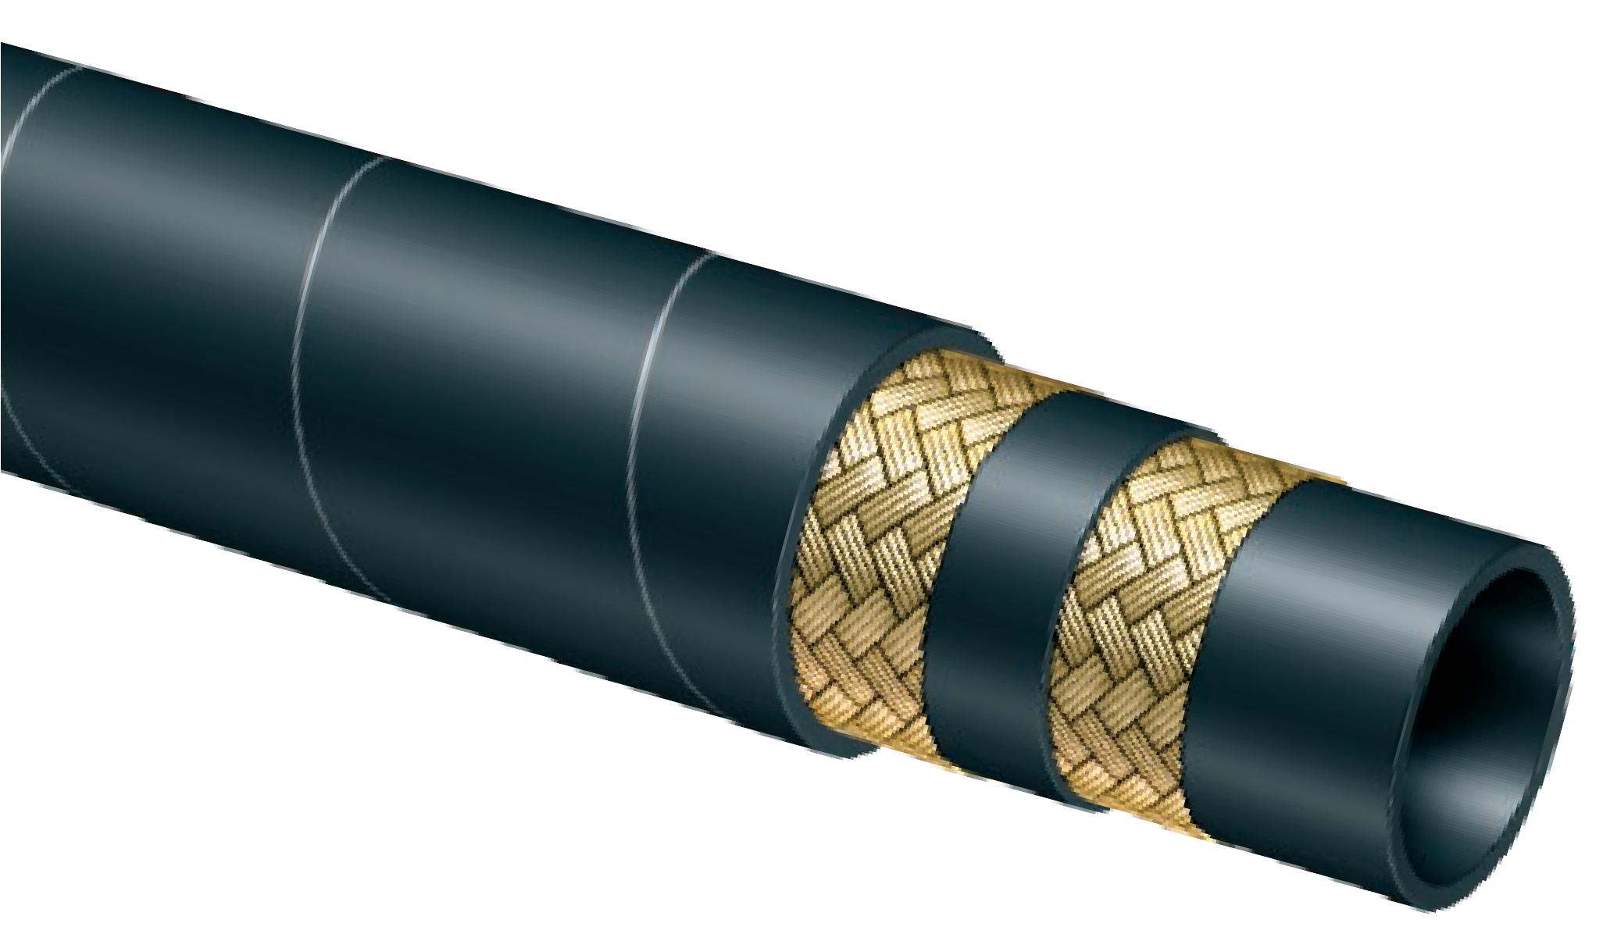

T631AA
300 PSI Hot Tar & Asphalt Applicator Delivery Hose
Petroleum

Nominal Specifications
Series | ID  (in.) | ID  (mm) | OD  (in.) | OD  (mm) | Wall Thickness (mm) | Max Rec. WP (PSI) | Min. Bending Radius (in.) | Weight (lbs./ft.)
T631AA075 | 3/4 | 19 | 1.26 | 32 | 6 | 300 | 3 | 0.50
T631AA100 | 1 | 25 | 1.50 | 38 | 6 | 300 | 3 | 0.77

COUPLING SUGGESTIONS
Permanently attached couplings are suggested for assemblies.

Applications:
Drain hose for residue from cleaning storage tanks and refining hydrocarbons.

Cover:
Blue CR – abrasion and hydrocarbon resistant.

Reinforcement:
High tensile steel wire braids.

Tube:
Black NBR-hydrocarbon resistant.

Working Pressure:
20Bar (300 PSI)

Temperature Range:
-22°F (-30°C) to 356°F (+180°C)

Branding:
ALFAGOMMA-HYDROCARBON DRAIN HOSE-300PSI

Standard Length:
100 Feet

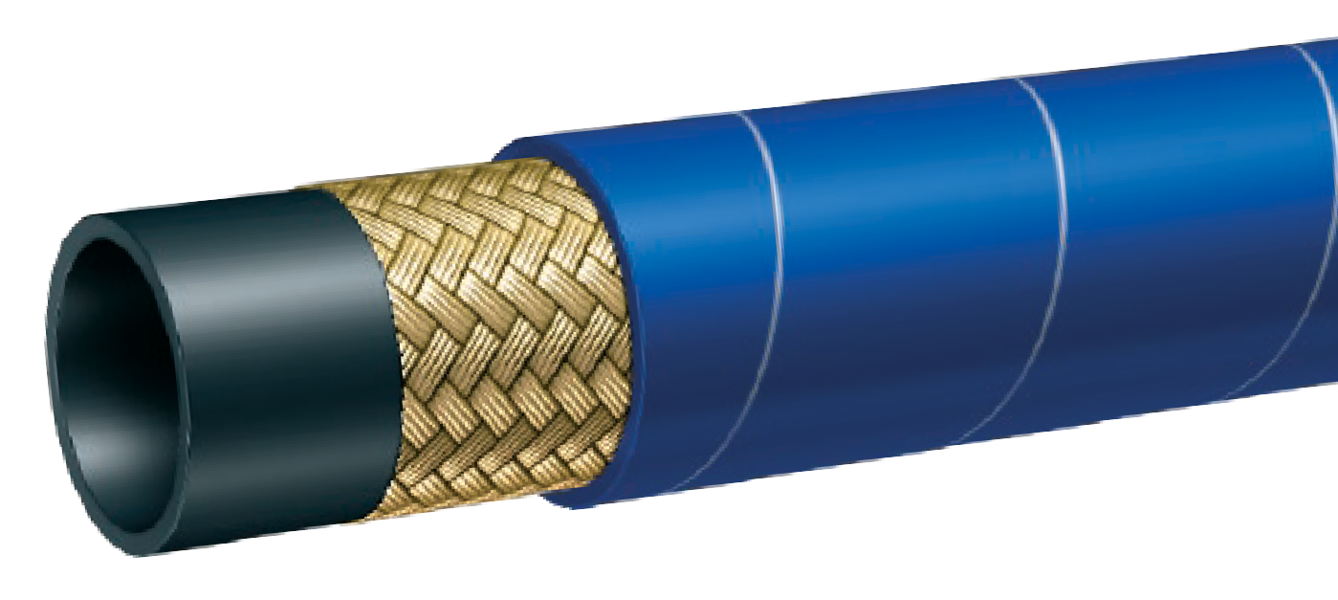
T631AE
300 PSI Hydrocarbon Drain Hose
NEW
PRODUCT
Petroleum

Nominal Specifications
Series | ID  (in.) | ID  (mm) | OD  (in.) | OD  (mm) | Wall Thickness (mm) | Max Rec. WP (PSI) | Min. Bending Radius (in.) | Approx. Weight (lbs./ft.)
T631AE075 | 3/4 | 19 | 1.26 | 32 | 6 | 300 | 3 | 0.50

Service Temperature Range:
-40°F (-40°C) to +212°F (+100°C)

Branding:
ALFAGOMMA ITALY 10 bar (150 psi) HEAVY DUTY INDUSTRIAL VACUUM S&D
Features and Advantages:
Construction:
- Tube - 1/4" thick red gum rubber tube for abrasion- resistance.
- Cover - Corrugated black conductive SBR/NR blend cover for abrasion and ozone-resistance.
- Reinforcement - High tensile textile fabric with embedded steel helical wire.

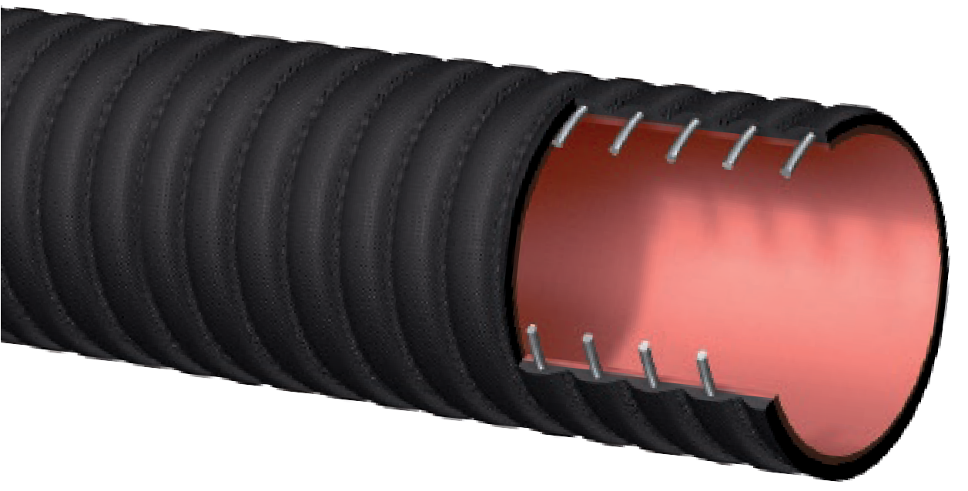Abrasion Resistant Tube – 1/4" gum rubber tube designed for wet or dry applications where severe abrasion is a factor. Provides for long hose service life.
NEW
PRODUCT
THE BOOMER™
T704HA Series
Industrial Sewer Vacuum Hose
General Applications:
- Material handling suction/discharge.
- Industrial vacuum equipment applications.
- Great hose for dry or wet abrasive materials.
- Popular hose for vacuum truck industry where a rugged and durable hose product is needed.
- Drill cutting suction hose in mobile drilling rigs.
Material Handling
Heavy Duty Construction – Thick tube and cover, high tensile strength fabric and durable steel helix wire designed for high pressure and vacuum application. All sizes rated to full vacuum, and PSI safety factor 3:1 (2”-8”) and 2.5:1 (10”).
Grounding Wire – Steel wire helps prevent the build-up of static electricity and to help keep material flowing smoothly.†
Corrugated Outer Cover – Provides increased hose flexibility.
“Cold-Flex” Materials – Hose remains flexible in sub-zero temperatures.
Cuffed Ends Available – Available with soft cuffed ends for easy installation and clamping.

Nominal Specifications
Series | ID  (in.) | ID  (mm) | OD  (in.) | OD  (mm) | Max Rec. WP (PSI) | Vacuum HG (in.) | Min. Bend Radius  (in. @ 68°F) | Standard Length Coils (ft.) | Weight (lbs./ft.)
T704HA200 | 2 | 51 | 2.87 | 69 | 150 | 30 | 6 | 100 | 1.41
T704HA300 | 3 | 76 | 3.69 | 96 | 150 | 30 | 9 | 100 | 2.40
T704HA400 | 4 | 102 | 5.03 | 122 | 150 | 30 | 12 | 100 | 3.39
T704HA500 | 5 | 127 | 6.22 | 149 | 150 | 30 | 15 | 100 | 4.31
T704HA600 | 6 | 152 | 7.04 | 174 | 150 | 30 | 24 | 100/50 | 5.13
T704HA800 | 8 | 203 | 9.00 | 227 | 150 | 30 | 32 | 100/50/35 | 9.26
T704HA1000 | 10 | 254 | 11.22 | 283 | 150 | 30 | 40 | 35 | 13.82
† Caution: This product is desgined to help dissipate static electricity when the netal wire is properly connected to ground, through the fitting or other means.
COUPLING SUGGESTIONS
Quick-Acting, pin lug, short shank couplings or combination nipples attached with single bolt, double bolt, wire or band type clamps.

H Kuriyama offers a full line of Quick-Acting couplings, pin lug shank couplings and combination nipples. Refer to current Kuriyama-Couplings™ and Accessories Catalog for type and pricing.

Applications:
Designed to convey abrasives, sand and shot blast material.

Cover:
Black conductive SBR/NR blend – abrasion and ozone resistant – pin pricked.

Reinforcement:
High tensile textile cords – 2-ply construction.

Tube:
Black static conducting NR – offering excellent abrasion resistance.

Working Pressure:
Constant Pressure – 10 Bar (150 PSI)

Temperature Range:
-22°F (-30°C) to 176°F (+80°C)

Branding:
ALFAGOMMA – ITALY T750 ABRASIVE MATERIAL
BLAST – 10 BAR (150 PSI) Ω (in white letters)

Standard Length:
50 or 100 feet

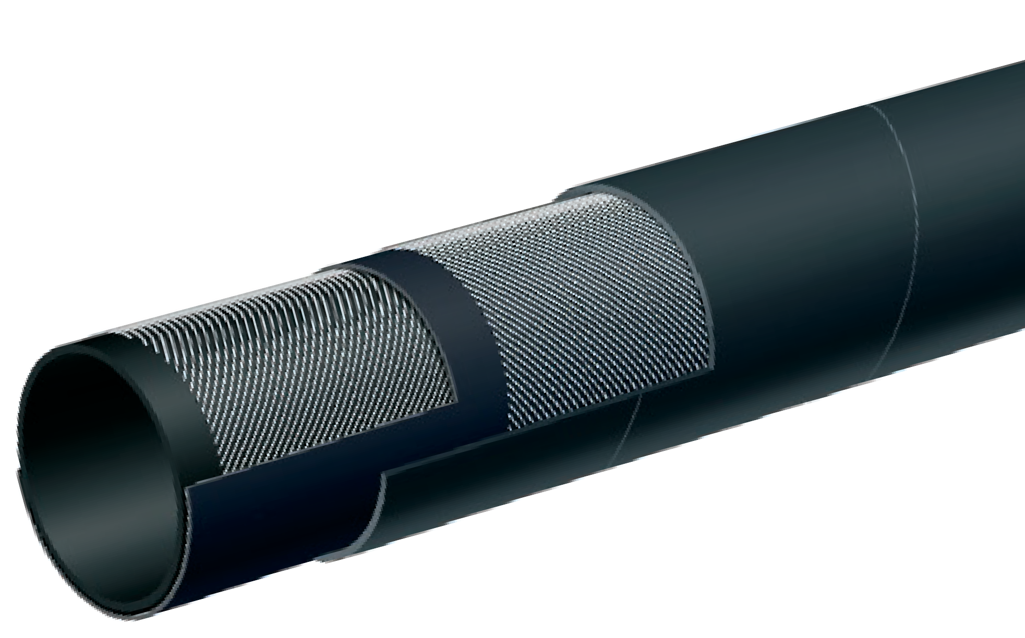

LT753AA
150 PSI 2-Ply Abrasive Material Blast Hose
Material Handling

Nominal Specifications
Series | ID  (in.) | ID  (mm) | OD  (in.) | OD  (mm) | Tube Thickness (mm) | Max Rec. WP (PSI) | Weight (lbs./ft.)
LT753AA050 | 1/2 | 13 | 1.06 | 27 | 0.212 | 150 | 0.34
LT753AA125 | 1 1/4 | 32 | 1.89 | 48 | 0.240 | 150 | 0.77
NOTE: Tolerances according to RMA Class 311-A

Blasting Data Guide
Premature hose wear can be prevented if the proper nozzle size is used for the corresponding hose ID size. (See chart below)
Blasting Data Guide
Series | UB8 | UB7 | UB6 | UB5 | UB4
NOZZLE SIZE | 1/2 | 7/16 | 3/8 | 5/16 | 1/4
CFM @ 100 PSI | 350 | 260 | 200 | 150 | 90
AIR HOSE | 2 | 1 1/2 | 1 1/2 | 1 1/4 | 1 1/4
S.B. HOSE SIZE | 1 1/2 | 1 1/2 | 1 1/4 | 1 1/4 | 1
MAT. LB/HR | 2250 | 1750 | 1260 | 900 | 540

Applications:
Designed to convey abrasives, sand and shot blast material.

Cover:
Black or green, conductive SBR/NR blend – abrasion and ozone resistant – pin pricked.

Reinforcement:
High tensile textile cords – 4-ply construction.

Tube:
Black static conducting natural rubber – offering excellent abrasion resistance.

Working Pressure:
Constant Pressure – 10 Bar (150 PSI)

Temperature Range:
-22°F (-30°C) to 176°F (+80°C)

Branding:
ALFAGOMMA – ITALY T750 ABRASIVE MATERIAL BLAST –
10 BAR (150 PSI) Ω (in white letters)

Standard Length:
50 or 100 feet

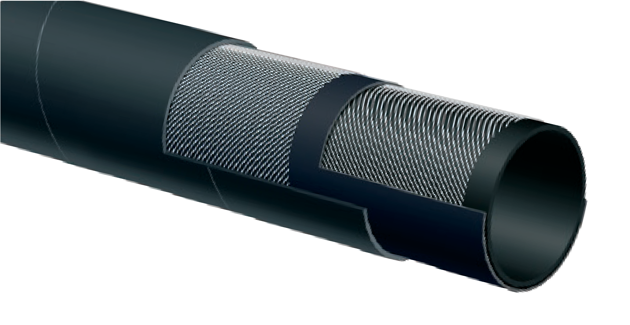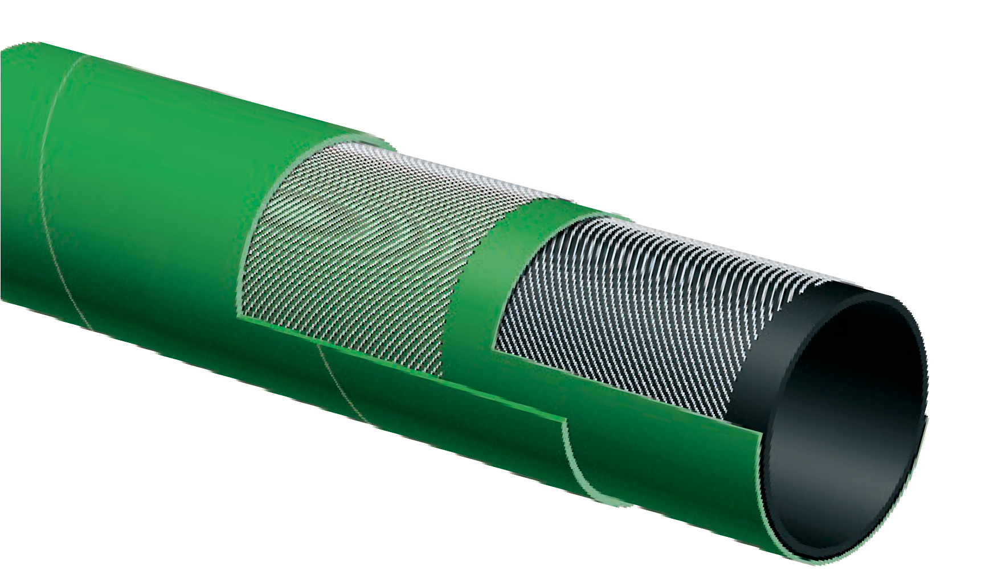
T750AA / T750AG
150 PSI 4-Ply Abrasive Material Blast Hose
T750AA
Black Cover

T750AG
Green Cover
Material Handling
Nominal Specifications
Series | ID  (in.) | ID  (mm) | OD  (in.) | OD  (mm) | Tube Thickness (mm) | Max Rec. WP (PSI) | Weight (lbs./ft.)
T750AA/AG075 | 3/4 | 19 | 1.50 | 38 | 0.236 | 150 | 0.68
T750AA/AG100 | 1 | 25 | 1.89 | 48 | 0.283 | 150 | 1.04
T750AA/AG125 | 1 1/4 | 32 | 2.17 | 55 | 0.283 | 150 | 1.23
T750AA/AG150 | 1 1/2 | 38 | 2.36 | 60 | 0.260 | 150 | 1.40
T750AA200 | 2 | 51 | 2.87 | 73 | 0.260 | 150 | 1.77
NOTE: Tolerances according to RMA Class 311-A

HOSE ID (in.) | HOSE ENDS | NOZZLE HOLDERS | THREADED FEMALE ADAPTER | GASKETS
3/4 | Q-1AL, Q-1BR, Q-1PI | NH-1AL, NH-1BR | – | SBG
1 | Q-2AL, Q-2BR, Q-2PI | NH-2AL, NH-2BR | – | SBG
1 1/4 | Q-3AL, Q-3BR, Q-3PI | NH-3AL, NH-3BR | SB-1AL, SB-1BR | SBG
1 1/2 | Q-4AL, Q-4BR, Q-4PI | NH-4AL, NH-4BR | SB-2AL, SB-2BR | SBG

COUPLING SUGGESTIONS
Sandblast couplings and nozzle holders attached with screws. See next column for coupling part numbers.
H Kuriyama offers a full line of sandblast couplings. Refer to current Kuriyama-Couplings™ and Accessories Catalog.

Applications:
Suction and discharge of wet or dry abrasive materials. Designed for grains and dry cement.

Cover:
Black conductive SBR/NR blend – abrasion and ozone resistant.

Reinforcement:
Spiraled high tensile textile cords with flexible steel helix wire.

Tube:
3/16" black conductive NR – abrasion resistant.

Working Pressure:
Constant Pressure –
10 Bar (150 PSI) for 2", 3", 4"
5 Bar (75 PSI) for 5", 6", 8"

Temperature Range:
-22°F (-30°C) to 176°F (+80°C)

Branding:
ALFAGOMMA – ITALY T720 – BULK MATERIAL – S & D
(in white letters)

Standard Length:
100 feet: 2" through 4"
20 feet: 5", 6" and 8"
50 feet: 4", 5" and 6"

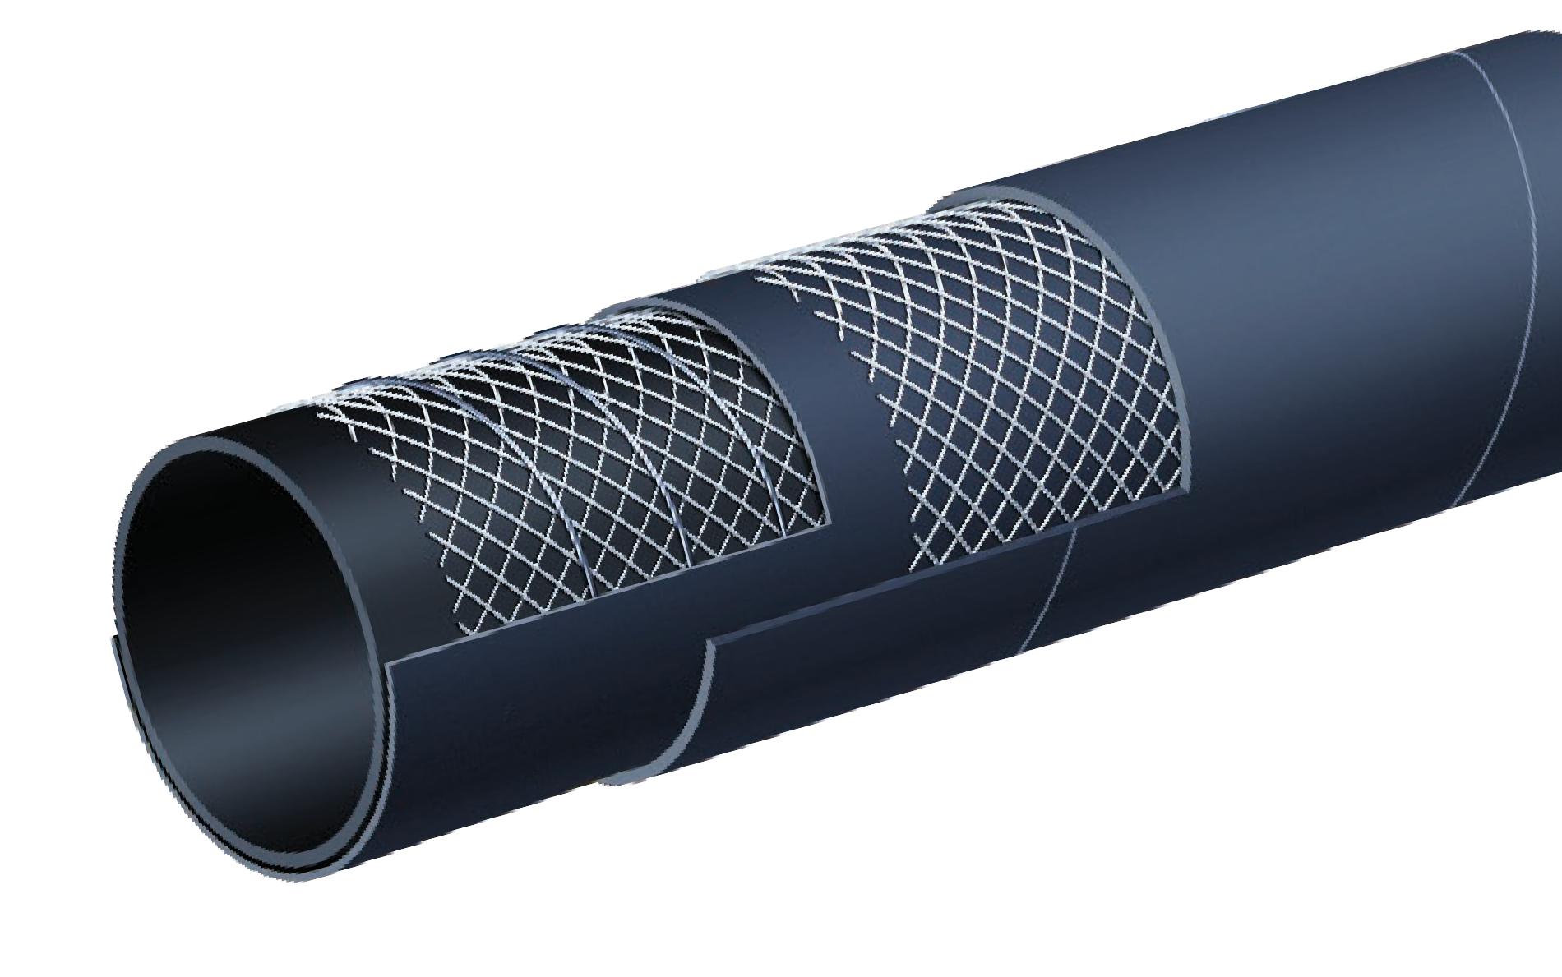

T720AA
Bulk Material S & D Hose
Material Handling
Nominal Specifications
Series | ID  (in.) | ID  (mm) | OD  (in.) | OD  (mm) | Max Rec. WP (PSI) | Vacuum HG (in.) | Min. Bending Radius (in. @ 68°F) | Weight (lbs./ft.)
T720AA200 | 2 | 51 | 2.56 | 65 | 150 | 30 | 6 | 0.97
T720AA300 | 3 | 76 | 3.54 | 90 | 150 | 27 | 9 | 1.54
T720AA400 | 4 | 102 | 4.57 | 116 | 150 | 27 | 12 | 2.15
T720AA500 | 5 | 127 | 5.63 | 143 | 75 | 24 | 20 | 3.20
T720AA600 | 6 | 152 | 6.61 | 168 | 75 | 24 | 24 | 4.01
T720AA800 | 8 | 203 | 8.70 | 221 | 75 | 21 | 32 | 6.05

COUPLING SUGGESTIONS
Quick-Acting, pin lug, short shank couplings or combination nipples attached with single bolt, double bolt, wire or band type clamps.

H Kuriyama offers a full line of Quick-Acting couplings, pin lug shank couplings and combination nipples. Refer to current Kuriyama-Couplings™ and Accessories Catalog for type and pricing.

Applications:
Steel-reinforced concrete pumping hose – Special easy- handling construction for concrete placement at casting site.

Cover:
Black conductive SBR/NR blend – abrasion and ozone resistant.

Reinforcement:
High tensile steel cords.

Tube:
Black conductive NR – abrasion resistant.

Working Pressure:
Working Pressure – 85 Bar (1275 PSI)

Temperature Range:
-22°F (-30°C) to 176°F (+80°C)

Branding:
ALFAGOMMA – ITALY T740 85 BAR (1275 PSI) W. P.
HEAVY DUTY CONCRETE PUMPING (in white letters)

Standard Length:
100 feet 2" through 4"
50 feet 2" through 5"

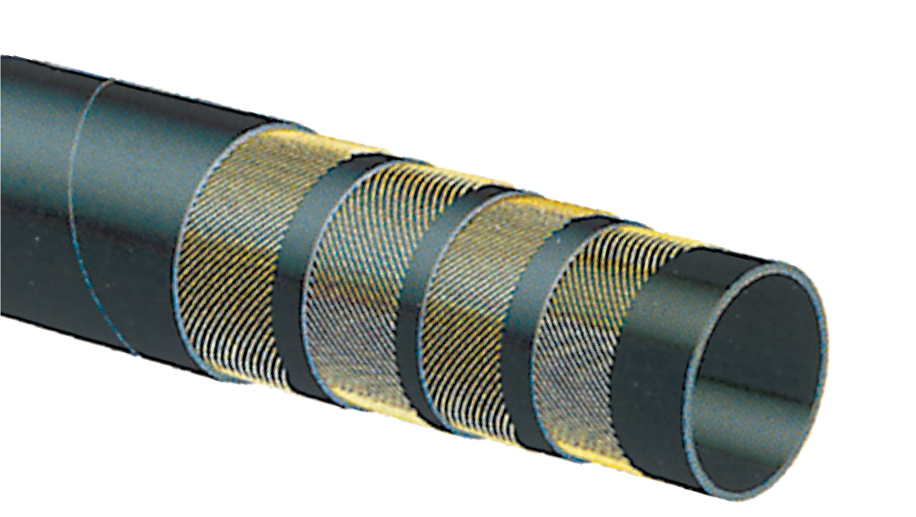

T740AA
1275 PSI High Performance Steel - Reinforced Concrete Pumping Hose
Material Handling

Nominal Specifications
Series | ID  (in.) | ID  (mm) | OD  (in.) | OD  (mm) | Wall Thickness (mm) | Max Rec. WP (PSI) | Min. Bending Radius (in.) | Weight (lbs./ft.)
T740AA200 | 2 | 51 | 2.72 | 69 | 9 | 1275 | 10 | 1.44
T740AA250 | 2 1/2 | 63 | 3.35 | 85 | 11 | 1275 | 10 1/2 | 2.25
T740AA300 | 3 | 76 | 3.94 | 100 | 12 | 1275 | 15 | 3.06
T740AA400 | 4 | 102 | 5.04 | 128 | 13 | 1275 | 20 | 4.72
T740AA500 | 5 | 127 | 6.10 | 155 | 14 | 1275 | 25 | 6.95

COUPLING SUGGESTIONS
Tubular steel full flow male permanently swaged or internally expanded with ferrule to provide maximum hose coupling compatibility.

Applications:
Designed for pumping plaster, grout, and wet cement to placement sites.

Cover:
Black conductive SBR/NR – abrasion and ozone resistant.

Reinforcement:
High tensile textile cords.

Tube:
Black conductive NR – abrasion resistant.

Working Pressure:
Constant Pressure – 40 Bar (600 PSI)

Temperature Range:
-22°F (-30°C) to 176°F (+80°C)

Branding:
ALFAGOMMA – ITALY T757 – 40 BAR (600 PSI)
PLASTER & CONCRETE (in white letters) and ALFAGOMMA – ITALY T737 – 40 BAR (600 PSI)
PLASTER & CONCRETE (in white letters)

Standard Length:
100 feet

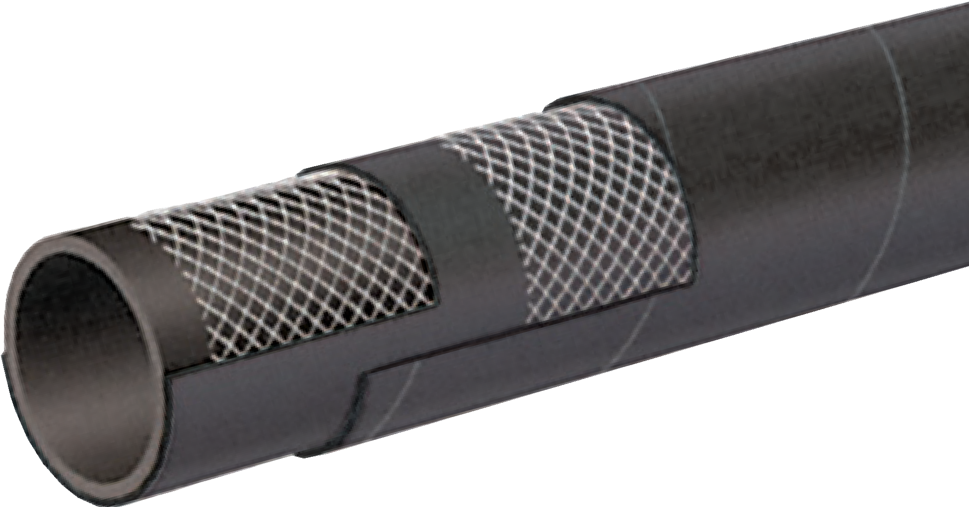

T757AA / T737AA
600 PSI Plaster & Concrete Hose
(Series T737AA for 3" ID)
Material Handling

Nominal Specifications
Series | ID  (in.) | ID  (mm) | OD  (in.) | OD  (mm) | Max Rec. WP (PSI) | Weight (lbs./ft.)
T757AA150 | 1 1/2 | 38 | 2.13 | 54 | 600 | 0.82
T757AA200 | 2 | 51 | 2.64 | 67 | 600 | 1.09
T737AA300 | 3 | 76 | 4.09 | 104 | 600 | 2.96

COUPLING SUGGESTIONS
Tubular steel full flow male permanently swaged or internally expanded with ferrule to provide maximum hose coupling compatibility.

Applications:
Designed for pumping plaster, grout, wet cement to construction placement sites at rated pressures.

Cover:
Black SBR/NR. Blue SBR/EPDM.

Reinforcement:
Spiraled high tensile textile cords.

Tube:
Black conductive NR – abrasion-resistant.

Working Pressure:
Constant Pressure – 55 Bar (800 PSI)

Temperature Range:
-22°F (-30°C) to 176°F (+80°C)

Branding:
ALFAGOMMA – ITALY T758 – 55 BAR (800 PSI)
PLASTER & CONCRETE (in white letters)

Standard Length:
100 feet

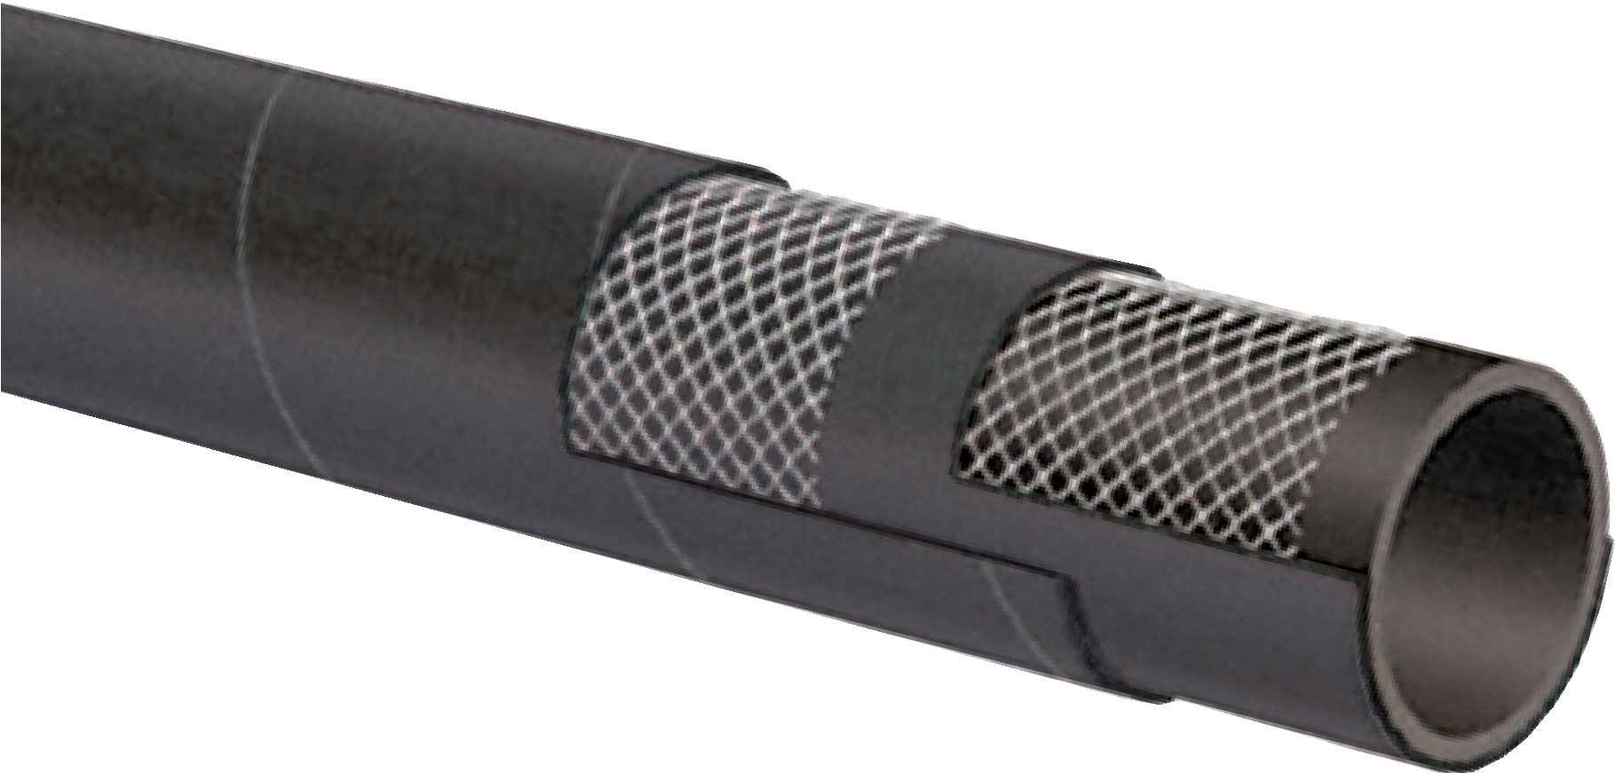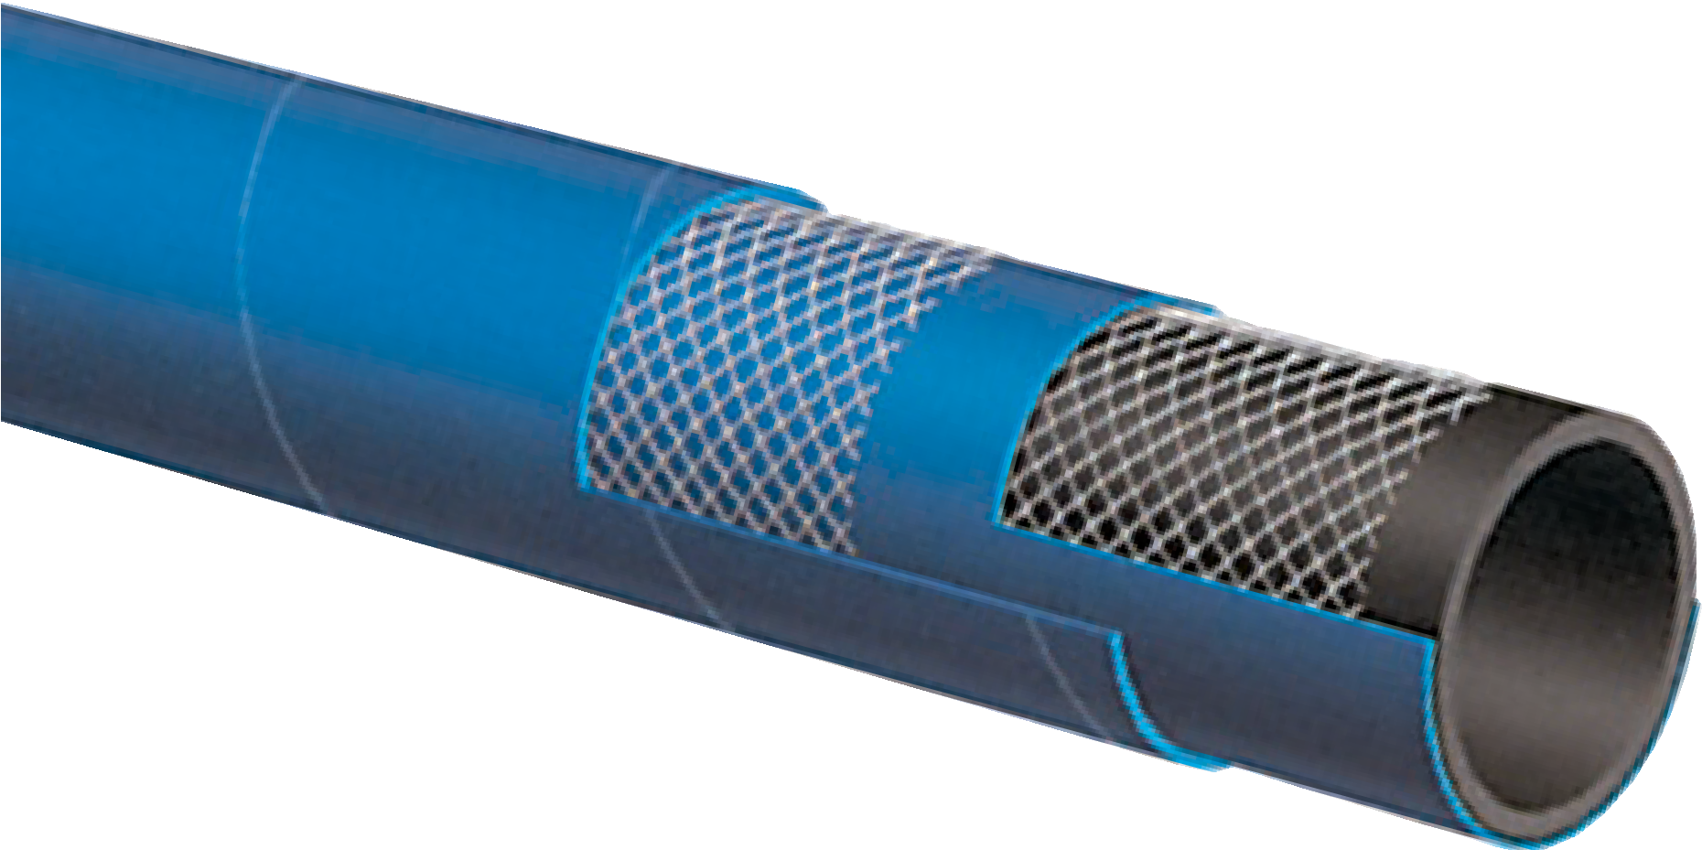
T758AA / T758AE
800 PSI Plaster, Grout & Concrete Hose
T758AA
Black Cover

T758AE
Blue Cover
Material Handling

Nominal Specifications
Series | ID  (in.) | ID  (mm) | OD  (in.) | OD  (mm) | Max Rec. WP (PSI) | Weight (lbs./ft.)
T758AA/AE100 | 1 | 25 | 1.57 | 40 | 800 | 0.60
T758AA/AE125 | 1 1/4 | 32 | 1.93 | 49 | 800 | 0.85
T758AA/AE150 | 1 1/2 | 38 | 2.28 | 58 | 800 | 1.15
T758AA/AE200 | 2 | 51 | 2.80 | 71 | 800 | 1.49

COUPLING SUGGESTIONS
Tubular steel full flow male permanently swaged or internally expanded with ferrule to provide maximum hose coupling compatibility.

Applications:
Discharge of dry powders under low pressure, such as dry cement, grains and animal feed transfer.

Cover:
Black conductive SBR/NR blend – abrasion and ozone resistant.

Reinforcement:
Spiraled high tensile textile cords.

Tube:
3/16" black static conducting NR – compounded to resist cutting by abrasive materials.

Working Pressure:
Constant Pressure – 5 Bar (75 PSI)

Temperature Range:
-22°F (-30°C) to 176°F (+80°C)

Branding:
ALFAGOMMA – ITALY T760 5 BAR (75 PSI) BULK
MATERIAL DELIVERY (in white letters)

Standard Length:
100 feet

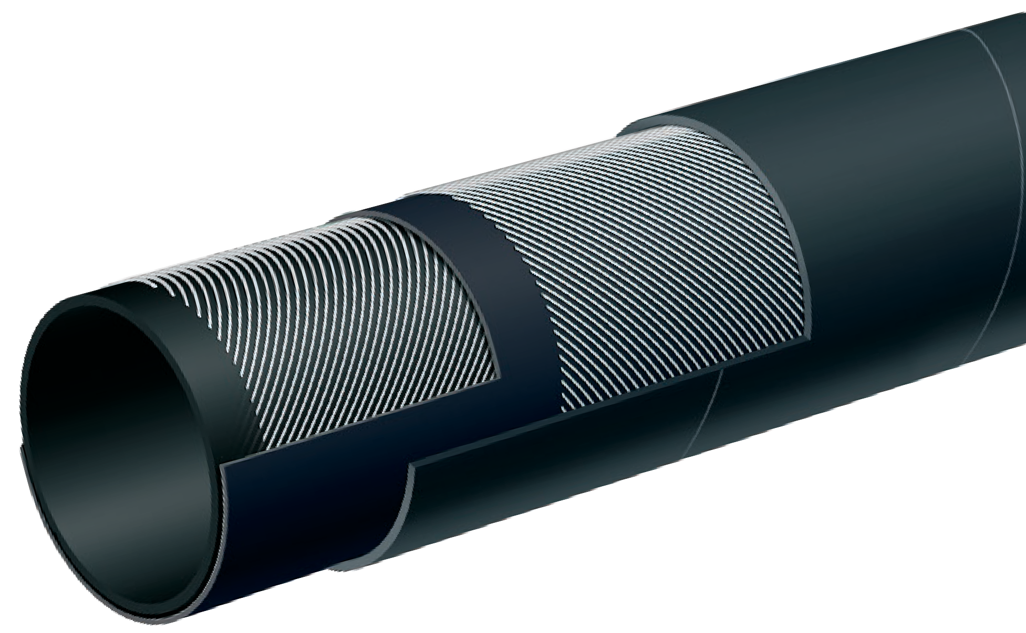

T760AA
75 PSI Light Weight Dry Powder Delivery Hose
Material Handling

Nominal Specifications
Series | ID  (in.) | ID  (mm) | OD  (in.) | OD  (mm) | Max Rec. WP (PSI) | Weight (lbs./ft.)
T760AA400 | 4 | 102 | 4.53 | 115 | 75 | 1.58
T760AA450 | 4 1/2 | 115 | 5.00 | 127 | 75 | 1.85
T760AA500 | 5 | 127 | 5.47 | 139 | 75 | 2.05
T760AA600 | 6 | 152 | 6.61 | 168 | 75 | 2.30
H Excessive bending during operation may cause premature wear.

Applications:
Discharge of dry powders under low pressure. Pneumatic transfer of dry materials and abrasive slurries.

Cover:
Black conductive SBR/NR blend – abrasion and ozone resistant.

Reinforcement:
Spiraled high tensile textile cords.

Tube:
1/4" black static conducting NR – compounded to resist cutting by abrasive materials.

Working Pressure:
Constant Pressure – 5 Bar (75 PSI)

Temperature Range:
-22°F (-30°C) to 176°F (+80°C)

Branding:
ALFAGOMMA – ITALY T763 5 BAR (75 PSI) BULK
MATERIAL DELIVERY (in green letters)

Standard Length:
100 feet

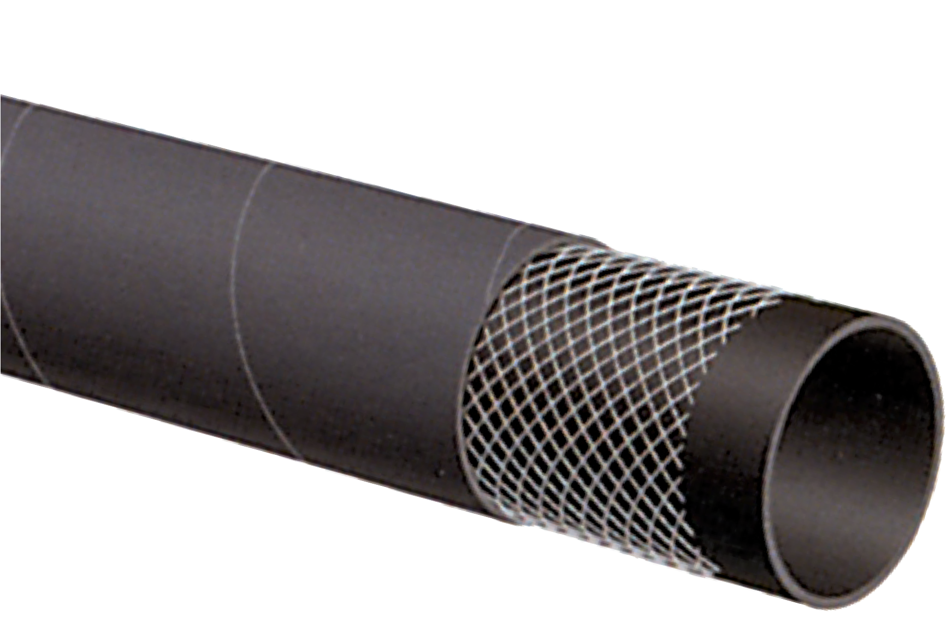

T763AA
75 PSI Heavy Weight Dry Powder Delivery Hose
Material Handling

Nominal Specifications
Series | ID  (in.) | ID  (mm) | OD  (in.) | OD  (mm) | Max Rec. WP (PSI) | Weight (lbs./ft.)
T763AA400 | 4 | 102 | 4.72 | 120 | 75 | 2.14
T763AA450 | 4 1/2 | 115 | 5.24 | 133 | 75 | 2.30
T763AA500 | 5 | 127 | 5.71 | 145 | 75 | 2.60
H Excessive bending during operation may cause premature wear.

Applications:
Discharge of dry powders under low pressure. Pneumatic transfer of dry materials and abrasive slurries.

Cover:
Black conductive SBR/NR blend – abrasion and ozone resistant.

Reinforcement:
Spiraled high tensile textile cords.

Tube:
3/8" black static conducting NR – compounded to resist cutting by abrasive materials.

Working Pressure:
Constant Pressure – 5 Bar (75 PSI)

Temperature Range:
-22°F (-30°C) to 176°F (+80°C)

Branding:
ALFAGOMMA – ITALY T763 5 BAR (75 PSI) HEAVY
DUTY BULK MATERIAL DELIVERY (in green letters)

Standard Length:
100 feet

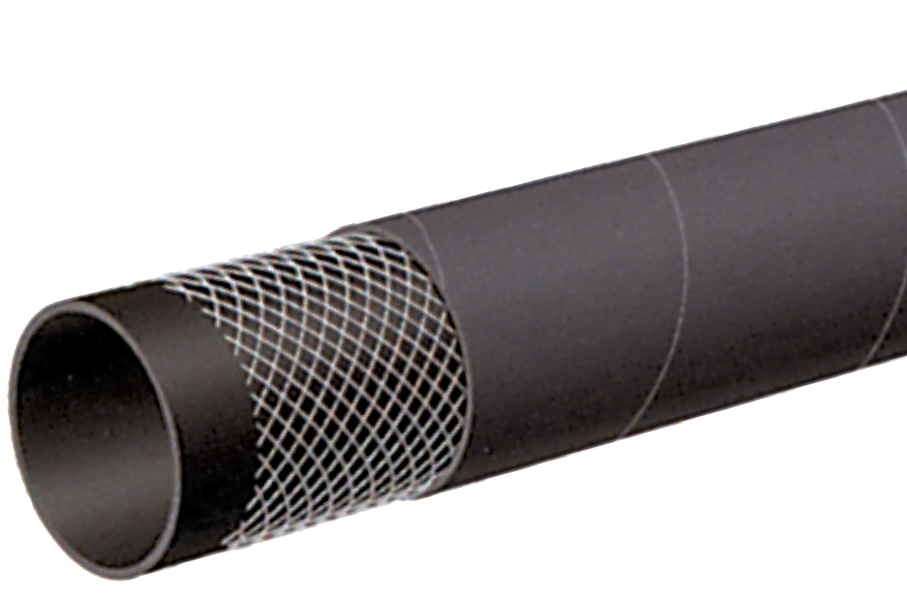
HWT763AA
75 PSI Heavy Duty Dry Powder Delivery Hose 3/8" Tube
NEW
PRODUCT
Material Handling

Nominal Specifications
Series | ID  (in.) | ID  (mm) | OD  (in.) | OD  (mm) | Max Rec. WP (PSI) | Weight (lbs./ft.)
HWT763AA400 | 4 | 102 | 4.96 | 126 | 75 | 2.56
H Excessive bending during operation may cause premature wear.

Applications:
Discharge of dry powders in heavy duty applications, such as dry cement, grains and animal feed transfer.

Cover:
Black conductive SBR/NR blend – abrasion and ozone resistant.

Reinforcement:
Spiraled high tensile textile cords.

Tube:
1/4" black static conducting NR – compounded to resist cutting by abrasive materials.

Working Pressure:
Constant Pressure – 10 Bar (150 PSI)

Temperature Range:
-22°F (-30°C) to 176°F (+80°C)

Branding:
ALFAGOMMA – ITALY T766 10 Bar (150 PSI) BULK
MATERIAL DELIVERY (in white letters)

Standard Length:
100 feet

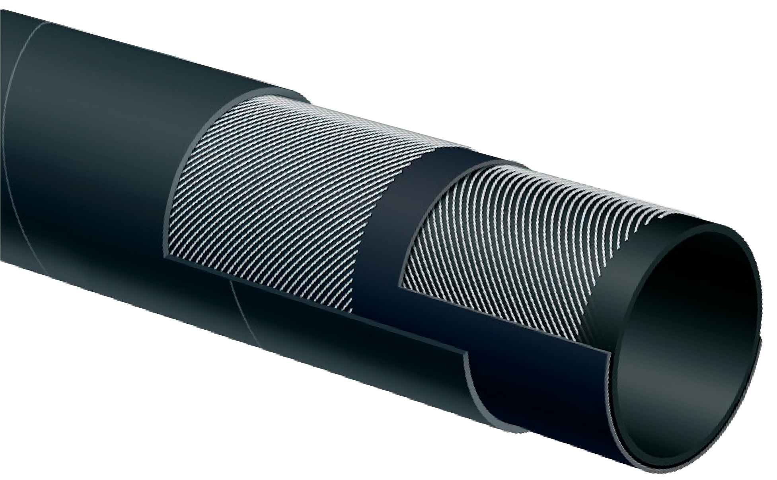

T766AA
150 PSI Heavy Duty Dry Powder Delivery Hose
Material Handling

Nominal Specifications
Series | ID  (in.) | ID  (mm) | OD  (in.) | OD  (mm) | Max Rec. WP (PSI) | Weight (lbs./ft.)
T766AA400 | 4 | 102 | 4.65 | 118 | 150 | 1.96
H Excessive bending during operation may cause premature wear.

Applications:
Underground mine water spray for dust control. Also usable on continuous mining machinery.

Cover:
Yellow SBR/NBR blend – abrasion, ozone, hydrocarbon and fire resistant – pin pricked.

Reinforcement:
High tensile steel wire braids.

Tube:
Black Extruded SBR/NBR blend – oil mist resistant.

Working Pressure:
Constant Pressure – 70 BAR (1000 PSI)

Temperature Range:
-22°F (-30°C) to 200°F (+90°C)

Branding:
ALFAGOMMA – ITALY – 70 BAR (1000 PSI) MINE SPRAY
MSHA IC – 152/6 (embossed)

Standard Length:
50 or 100 feet

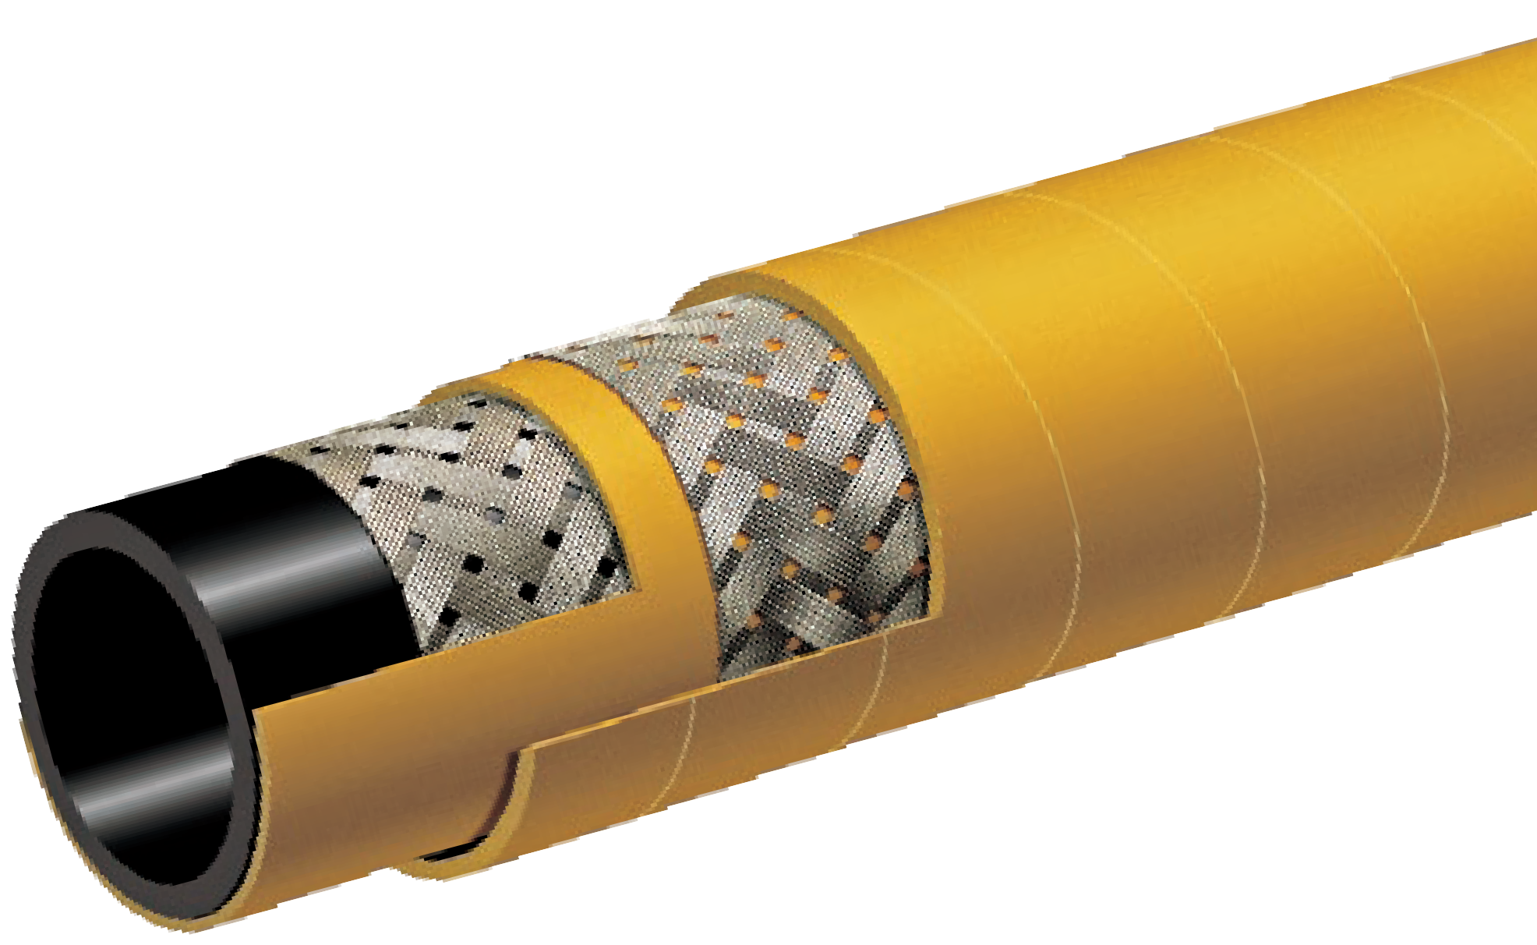

T146AK
1000 PSI Braided MSHA Mine Spray Hose
Specialty Hoses

Nominal Specifications
Series | ID  (in.) | ID  (mm) | OD  (in.) | OD  (mm) | Max Rec. WP (PSI) | Min. Bending Radius (in. @ 68°F) | Weight (lbs./ft.)
T146AK075 | 3/4 | 19 | 1.10 | 28 | 1000 | 3 3/4 | 0.45
T146AK100 | 1 | 25 | 1.34 | 34 | 1000 | 5 | 0.58
T146AK125 | 1 1/4 | 32 | 1.61 | 41 | 1000 | 6 1/4 | 0.75
T146AK150 | 1 1/2 | 38 | 1.93 | 49 | 1000 | 7 1/2 | 1.08
T146AK200 | 2 | 51 | 2.48 | 63 | 1000 | 10 | 1.47

COUPLING SUGGESTIONS
Permanently attached crimped hydraulic couplings.

Applications:
To convey cooling water to furnace doors in steel mills, glass plants, foundries, or where the hose is subjected to high temperatures and splashes of white-hot molten metals or glass.

Cover:
Beige EPDM – heat resistant, non-conductive resin- coated dust-free fiberglass cover.

Reinforcement:
High tensile textile cords.

Tube:
White EPDM.

Working Pressure:
Constant Pressure – 20 BAR (300 PSI)

Temperature Range:
Tube: -40°F (-40°C) to 248°F (+120°C)
Cover: -40°F (-40°C) to 1000°F (up to +540°C)

Standard Length:
100 feet

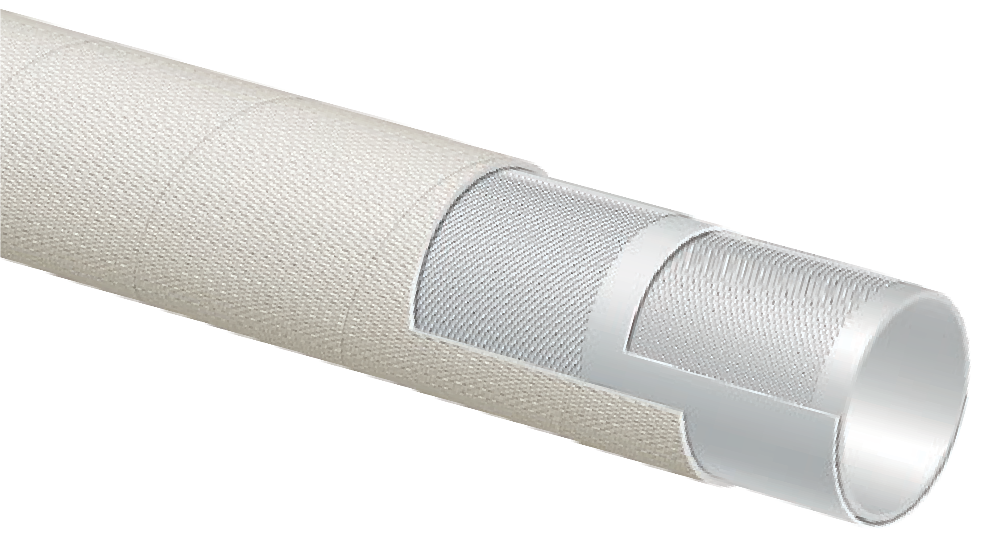

T957LL
300 PSI Furnace Door Coolant Hose
Specialty Hoses

Nominal Specifications
Series | ID  (in.) | ID  (mm) | OD  (in.) | OD  (mm) | Max Rec. WP (PSI) | Weight (lbs./ft.)
T957LL050 | 1/2 | 13 | 0.98 | 25 | 300 | 0.30
T957LL075 | 3/4 | 19 | 1.22 | 31 | 300 | 0.46
T957LL100 | 1 | 25 | 1.46 | 37 | 300 | 0.56
T957LL125 | 1 1/4 | 32 | 1.81 | 46 | 300 | 0.82
T957LL150 | 1 1/2 | 38 | 2.13 | 54 | 300 | 0.98
T957LL200 | 2 | 51 | 2.64 | 67 | 300 | 1.26
T957LL250 | 2 1/2 | 63 | 3.19 | 81 | 300 | 1.55
T957LL300 | 3 | 76 | 3.78 | 96 | 300 | 2.15
H Special order, minimums required. Contact your nearest KOA warehouse location for more information.

(Reprinted from RMA Hose Handbook 1 P-2 - Fourth Edition)
Care, Maintenance & Storage

Hose has a limited life and the user must be alert to signs of impending failure, particularly when the
conditions of service include high working pressures and/or the conveyance or containment of hazardous materials,
GENERAL CARE AND MAINTENANCE OF HOSE
Hose should not be subjected to any form of abuse in service. It should be handled with reasonable care.
Hoses should not be dragged over sharp or abrasive surfaces unless specifically designed for such service. Care should be taken to protect hose from severe end loads for which the hose or hose assembly were not designed. Hose should be used at or below its rated working pressure; any changes in pressure should
be made gradually so as to not subject the hose to excessive surge pressures. Hose should not be kinked or be run over by equipment. In handling large size hose, dollies should be used whenever possible; slings or handling rigs, properly placed, should be used to support heavy hose used in oil suction and discharge service.
STORAGE
Rubber hose products in storage can be affected adversely by temperature, humidity, ozone, sunlight, oils, solvents, corrosive liquids and fumes, insects, rodents and radioactive materials.
The appropriate method for storing hose depends to a great extent on its size (diameter and length), the quantity to be stored, and the way in which it is packaged. Hose should not be piled or stacked to such an extent that the weight of the stack creates
distortions on the lengths stored at the bottom. Since hose products vary considerably in size, weight,
and length, it is not practical to establish definite recommendations on this point. Hose having a very light wall will not support as much load as could a hose having a heavier wall or hose having a wire reinforcement. Hose which is shipped in coils or bales should be stored so that the coils are in a horizontal plane.
Whenever feasible, rubber hose products should be stored in their original shipping containers, especially when such containers are wooden crates or cardboard cartons which provide some protection against the deteriorating effects of oils, solvents, and corrosive liquids; shipping containers also afford some protection against ozone and sunlight.
Certain rodents and insects will damage rubber hose products, and adequate protection from them should be provided.
The ideal temperature for the storage of rubber products ranges from 50° to 70°F (10-20°C) with a maximum limit of 100°F (38°C). If stored below 32°F (0°C), some rubber products become stiff and would require warming before being placed in service. Rubber products should not be stored near sources of heat, such as radiators, base heaters, etc., nor should they be stored under conditions of high or low humidity.
To avoid the adverse effects of high ozone concentration, rubber hose products should not be stored near electrical equipment that may
generate ozone or be stored for any lengthy period in geographical areas of known high ozone concentration. Exposure to direct or reflected sunlight – even through windows – should also be avoided. Uncovered hose should not be stored under fluorescent or mercury lamps which generate light waves harmful to rubber.
Storage areas should be relatively cool and dark, and free of dampness and mildew. Items should be stored on a first-in, first-out basis, since even under the best conditions, an unusually long shelf life could deteriorate certain rubber products.

Flexibility & Bend Radius
Technical Data
Flexibility and minimum bend radius are important factors in hose design and selection if it is known that the hose will be subjected to sharp curvatures in normal use. When bent at too sharp an angle, hose may kink or flatten in the cross-section. The
reinforcement may also be unduly stressed or distorted and the hose life thereby shortened.
Adequate flexibility means the hose should be able to conform to the smallest anticipated bend radius without over stress. The minimum bend radius is generally specified for each hose in this catalog. This
is the radius to which the hose can be bent in service without damage or appreciably shortening its life. The radius is measured to the inside of the curvature.
Formula to determine minimum hose length given bend radius and degree of bend required:
Where:
L = Minimum length of hose to make bend (Bend must be made equally along this portion of hose length).
A = Angle of bend
B = Given bend radius of hose
= 3.14
Example: To make a 60° bend at the hoses’s rated minimum bend radius of 15 cm:
Thus, the bend must be made over approximately 16 cm of hose length. The bend radius used must be equal to or greater than the rated minimum bend
radius. Bending the hose to a smaller bend radius than minimum may kink the hose and the result in damage and early failure.
Oil Resistance
The definition of Oil Resistance is currently related to Tensile Retention % and Volume Swell % of the
tested material after immersion in ASTM No. 3 Oil and in ASTM Fuel B for 70 hours at 100°C (212°F). The hose industry is currently classifying the materials as follows:

Safety Features
Air hose – 4:1 Safety factor. Burst vs Working pressure
Water hose – 3:1 Safety factor. Burst vs Working pressure
Steam hose – 10:1 Safety factor. Burst vs Working pressure

The Chemical Guides in this section are offered as a general indication of the compatibility of the various materials used in ALFAGOMMA® hose with the chemicals and fluids listed. The basis for the ratings in this guide include actual service experience, the advice of various polymer suppliers, and the considered opinion of our rubber chemists. When in doubt, a sample of the compound should always be tested with the particular chemical it is to handle. Some of the variables that come into play in the resistance of a compound to chemical attack are:
Chemical Guide
- Temperature of the Material Transmitted:
Higher temperatures increase the effect of chemicals on rubber compounds. The increase varies with the polymer and the chemical. A compound quite suitable at room temperature might fail very quickly at higher temperatures.
- Service Conditions:
A rubber compound usually swells when exposed to a chemical. With a given percent of swell, the hose tube may function satisfactorily if the hose is in a static condition, but fail quickly if the hose is subject to flexing.
- The Grade or Blend of the Rubber Compound:
Basic rubber polymers are sometimes mixed or blended together to enhance a particular property for a specific service. The reaction to a particular chemical blend of polymers may, therefore, be somewhat different from the reaction to the single ones. When in doubt, a sample of the compound should always be tested with the particular chemical it is to handle.
- Alfagomma® hoses are produced using silicone free release agents.

KEY TO GENERAL CHEMICAL RESISTANCE CHART
Note: All data based on 20°C (68°F) unless otherwise noted.
Blank = No Data | G | = Good | C | = Conditional | X | = Unsatisfactory
E = Excellent | F | = Fair | I | = Insufficient Data

GENERAL CHEMICAL RESISTANCE OF ALFAGOMMA® HOSE COMPOUNDS

ASTM  Designation D1418-93 | Common Name | Composition | General Properties
CIIR | Chlorobutyl | Chloro-Isobutene-Isoprene | Excellent resistance to high heat steam. Very good weathering resistance, low permeability to air. Good physical properties. Poor resistance to petroleum-based fluids.
CR | Neoprene | Chloroprene | Excellent weathering resistance. Flame retarding. Good oil resistance. Good physical properties.
CSM | Hypalon® | Chloro-sulfonated polyethylene | Excellent ozone, weathering and acid resistance. Good abrasion and heat resistance. Can be compounded for good oil resistance.
EPDM | EPM or EPDM | Ethylene-propylene-diene-terpolymer | Good general purpose polymer. Excellent heat, ozone and weather resistance. Not oil resistant.
NBR | BUNA-N or Nitrile | Nitrile-Butadiene | Excellent oil resistance. Good physical properties.
NR | Natural | Isoprene Rubber (Natural) | Excellent physical properties, including abrasion resistance. Not oil resistant.
SBR | SBR | Styrene-Butadiene Rubber | Good physical properties, including abrasion resistance. Not oil resistant.
UHMWPE | UHMWPE | Ultra-High Molecular Weight Polyethylene | Excellent resistance to a majority of existing chemicals. Meets FDA requirements for food and beverages.
XLPE | Cross Linked Polyethylene | Cross Linked Polyethylene | Excellent resistance to most solvents, oils and chemicals. Do not confuse with chemical properties of standard  polyethylene.
 | Synthetic Rubber | Synthetic Rubber | Black conductive synthetic rubber, excellent resistance to Biofuel based fluids.

Key to General Chemical Resistance Chart [all data based on 20°C (68°F) unless noted]:
Chemical Resistance Chart
E – Excellent; G – Good; F – Fair; C – Conditional; I – Insufficient Data; X – Not Recommended; Blank – No Data
COMPOUND COMPOUND
Chemical or Material Conveyed | CIIR | CR | CSM | EPDM | NBR | NR | SBR | XLPE | UHMWPE | T629AA | Chemical or Material Conveyed |  | CIIR | CR | CSM | EPDM | NBR | NR | SBR | XLPE | UHMWPE | T629AA
ACETALDEHYDE | E | C | F | E | X | F | X | E | E | X |  | ANETHOLE | X | X | X | X | X | X |  |  |  | X
ACETIC ACID, GLACIAL | G | F | C | G | X | C | X | E | E | X |  | ANILINE | E | X | C | C | X | X | X | E | E | X
ACETIC ACID, 10% | G | E | E | E | E | G | F | E | E | E |  | ANILINE DYES | G | C | G | C | X | C | G | E | E | X
ACETIC ACID, 50% | G | F | E | E | F | X | F | E | E | F |  | ANILINE OIL | G | X | C | C | X | X | X | E | E | X
ACETIC ANHYDRIDE | C | G | E | G | X | F | X | E | E | X |  | ANIMAL FATS | C | C | F | C | E | X | X | E | E | E
ACETIC OXIDE (Acetic anhydride) | G | G | E | G | X | F | X | E | E | X |  | ANTIMONY PENTACHLORIDE |  | C | X | C | X | X |  | E | E | X
ACETONE | E | C | X | E | X | C | C | E | E | X |  | AQUA REGIA | C | X | C | C | X | X | X | X | X | X
ACETONE CYANOHYDRIN | E | G | F | E | X | F |  |  |  | X |  | ARGON | G | G | X | E | E | X | C |  |  | E
ACETONITRILE | E | E | G | E | X | G |  |  |  | X |  | ARSENIC ACID | E | E | E | E | E | E | E | E | E | E
ACETOPHENONE | G | X | X | E | X | C | X | E | E | X |  | ASPHALT | X | C | F | X | C | X | X | E | E | C
ACETYL ACETONE | E | X | X | E | X | X | X |  |  | X |  | ASTM FUEL A | X | C | C | X | E | X | X |  |  | E
ACETYL CHLORIDE | X | X | C | X | X | X | X |  |  | X |  | ASTM FUEL B | X | X | X | X | C | X | X |  |  | C
ACETYL OXIDE (Acetic anhydride) | G | G | E | G | X | F |  | E | E | X |  | ASTM FUEL C | X | X | X | X | C | X | X |  |  | C
ACETYLENE | E | E | C | E | E | C | F | E | E | E |  | ASTM OIL NO.1 | X | E | C | X | E | X | X | E | E | E
ACETYLENE DICHLORIDE | F | X | X | C | X | X | X |  |  | X |  | ASTM OIL NO.2 | X | C | X | X | E | X | X | E | E | E
ACETYLENE TERACHLORIDE | X | C | X | C | X | X |  |  |  | X |  | ASTM OIL NO.3 | X | C | C | X | E | X | X | E | E | E
ACROLEIN | E | G | G | E | F | G | F |  |  | F |  | ASTM OIL NO.4 | X | X | X | X | C | X | X |  |  | C
ACRYLONITRILE | X | X | C | E | X | C | F | E | E | X |  | AUTOMATIC TRASMISSION FLUID | X | C | C | X | E | X | X |  |  | E
ACRYLIC ACID |  | X | G | X | X | X |  |  |  | X |  | BANANA OIL | C | X | C | C | X | X |  |  |  | X
ADIPIC ACID | X | E | G | C | E | E |  | E | E | E |  | BARIUM CHLORIDE | E | E | E | E | E | E | E | E | E | E
AIR, +300°F | G | G | G | G | G | X | X |  |  | G |  | BARIUM HYDROXIDE | E | E | E | E | E | E | E | E | E | E
ALK-TRI | X | X | X | X | X | X |  |  |  | X |  | BARIUM SULPHIDE | E | E | E | E | E | E | G | E | E | E
ALLYL ALCOHOL | E | E | E | E | E | E |  | E | E | E |  | BEER | E | E | E | E | E | E | E | E | E | E
ALLYL BROMIDE | X | X | X | X | X | X |  |  |  | X |  | BEET SUGAR LIQUORS | E | C | E | E | E | E | E | E | E | E
ALLYL CHLORIDE | C | X | X | X | G | X | E | E | F | G |  | BENZAL CHLORIDE | G |  |  |  | X |  |  |  |  | X
ALUM (Aluminium potassium sulfate) | E | E | E | G | C | E |  | E | E | C |  | BENZALDEHYDE | G | X | X | E | X | X | X | E | E | X
ALUMINIUM ACETATE | G | C | F | E | C | E | X |  |  | C |  | BENZENE | X | C | C | C | X | X | X | E | F | X
ALUMINIUM CHLORIDE | E | E | E | E | E | E | E | E | E | E |  | BENZENE CARBOXYLIC ACID | E | E | C | C | X | X |  |  |  | X
ALUMINIUM FLUORIDE | E | E | E | E | E | E | E | E | E | E |  | BENZINE (Gasoline) | X | C | C | X | E |  | X | E | E | E
ALUMINIUM FORMATE | G | E | X | E | X | X |  |  |  | X |  | BENZOIC ACID | C | E | C | C | X | X | X |  |  | X
ALUMINIUM HYDROXIDE | E | E | E | E | E | E | G | E | E | E |  | BENZOL (Benzene) | X | C | C | C | X | X | X | E | F | X
ALUMINIUM NITRATE | E | E | E | E | E | E | E |  |  | E |  | BENZOTRICHLORIDE |  | X | X | E | X | X |  |  |  | X
ALUMINIUM SULFATE | A | G | E | E | E | E | G | E | E | E |  | BENZYL ACETATE | E | E | G | E | X | X |  |  |  | X
ALUMUS-NH3-CR-K |  |  |  |  |  |  |  |  |  |  |  | BENZYL ALCOHOL | E | C | C | C | X | X | X |  |  | X
AMINES-MIXED |  | C | X | G | X | C | G |  |  | X |  | BENZYL CHLORIDE | X | X | X | X | X | X | X |  |  | X
AMINOBENZENE (Aniline) | E | X | C | C | X | X | X | E | E | X |  | BENZYL ETHER (Dibenzyl Ether) | G | X | X | C | X | X | X |  |  | X
AMINODIMETHILBENZENE | G | X | F | C | C | X |  |  |  | C |  | BIODIESEL (BD100 O B100) |  |  |  |  |  |  |  |  |  | E
AMINOETHANE (Ethylamine) | G | C | F | E | C | C | X | E | E | C |  | BIODIESEL (BD20 O B20) |  |  |  |  |  |  |  |  |  | E
AMINOXYLENE | G | X | X | E | C | X |  |  |  | C |  | BIOETHANOL (E85) |  |  |  |  |  |  |  |  |  | E
AMMONIUM CARBONATE | E | E | C | E | C | E | E |  |  | C |  | BIS (2-CLOROETHYL) ETHER
AMMONIUM CHLORIDE | E | E | E | E | G | E | E | E | E | G |  | BLACK SULFATE LIQUOR | G | G | G | G | G | G | G | E | E | G
AMMONIUM HYDROXIDE | G | E | E | E | C | G | X | E | E | C |  | BLEACH | E | C | E | E | X | C | X | G | F | X
AMMONIUM NITRATE | E | E | E | E | E | E | E | E | E | E |  | BORAX SOLUTION | E | E | E | E | C | C | G | E | E | C
AMMONIUM PHOSPHATE, DIBASIC | E | E | E | E | E | E | E | E | E | E |  | BORIC ACID | E | E | E | E | E | E | E | E | E | E
AMMONIUM SULFATE | E | E | E | E | E | E | G | E | E | E |  | BRAKE FLUID (HD-557)12 DAYS | E | C | C | E | C | X | E |  |  | C
AMMONIUM SULFIDE | E | E | E | E | C | E | G | E | E | C |  | BRINE | E | E | E | E | E | E |  | E | E | E
AMMONIUM THIOSULFATE | E | E | E | E | C | E |  |  |  | C |  | BROMACIL
AMYL ACETATE | G | X | X | C | X | C | X | E | E | X |  | BROMOBENZENE | X | X | X | X | X | X | X |  |  | X
AMYL ACETONE | G | X | X | G | X | X |  |  |  | X |  | BROMOCHLOROMETANE | C | X | X | G | X | X |  | F | F | X
AMYL ALCOHOL | E | C | E | E | C | C | G | E | E | C |  | BROMOETHANE (Ethyl bromide) | C | X | X | X | C | C | X | E | E | C
AMYL BROMIDE | X | X | X | C | X | X |  |  |  | X |  | BROMOTOLUENE | X |  | X |  | X | X |  |  |  | X
AMYL CHLORIDE | X | X | X | X | X | X | X | E | E | X |  | BUGDIOXANE
AMYL ETHER | X | X | F | X | C | X |  |  |  | C |  | BUNKER OIL | X | G | C | X | E | X | X |  |  | E
AMYLAMINE | G | C | F | X | F | F |  |  |  | F |  | BUTADIENE | X | X | G | X | X | X | X | E | E | X

Key to General Chemical Resistance Chart [all data based on 20°C (68°F) unless noted]:
Chemical Resistance Chart
E – Excellent; G – Good; F – Fair; C – Conditional; I – Insufficient Data; X – Not Recommended; Blank – No Data
COMPOUND COMPOUND
Chemical or Material Conveyed | CIIR | CR | CSM | EPDM | NBR | NR | SBR | XLPE | UHMWPE | T629AA | Chemical or Material Conveyed |  | CIIR | CR | CSM | EPDM | NBR | NR | SBR | XLPE | UHMWPE | T629AA
BUTANE | X | E | C | X | E | X | X | E | E | E |  | CHLORODANE (Chlordane) | X | C | C | X | C | X | X |  |  | C
BUTANOIC ACID | X | X | C | C | C | C |  |  |  | C |  | CHLOROETHYL BENZENE | X | X | X | X | C | X |  |  |  | C
BUTANOL (Butyl alcohol) | C | E | E | C | E | E | E | E | E | E |  | CHLOROFORM | X | X | X | X | X | X | X | F | F | X
BUTANONE | E | X | X | E | X | X | X | E | E | X |  | CHLOROPENTANE | X | X | X | X | X | X |  |  |  | X
BUTOXYETHANOL | C | X | G | E | C | X |  |  |  | C |  | CHLOROSULFONIC ACID | X | X | X | X | X | X | X | F | X | X
BUTYL ACETATE | C | X | X | C | X | X | X | E | E | X |  | CHLOROTOLUENE | X | X | X | X | X | X | X |  |  | X
BUTYL ACRYLATE | X | X | X | C | X | X | X | E | E | X |  | CHLOROX | C | C | C | G | C | X | X |  |  | C
BUTYL ALCOHOL | C | E | E | C | E | E | E | E | E | E |  | CHROME PLATING SOLUTIONS | C | X | X | C | X | X | X |  |  | X
BUTYL ALDEHYDE (Butyraldehyde) | C | X | X | C | X | X | X | E | E | X |  | CHROMIC ACID | C | X | E | C | X | C | X | E | E | X
BUTYL BENZYL PHTHALATE | E | E | X | E | X | X |  | E | E | X |  | CHROMIUM TRIOXIDE (Chromic oxide) | G | X | E | C | X | X | X |  |  | X
BUTYL CARBITOL | E | X | C | E | X | X | X |  |  | X |  | CINNAMENE (Vinylbenzene) | X | X | X | X | C | X | X |  |  | C
BUTYL CELLOSOLVE | C | X | G | C | C | X | X | E | E | C |  | CIS-9-OCTADECENOIC ACID (Oleic acid) | X | C | C | C | G | X | X | E | E | G
BUTYL CHLORIDE | F | X | X | X | X | X |  |  |  | X |  | CITRIC ACID | E | E | E | E | E | E | E | E | E | E
BUTYL ETHER | C | C | X | C | X | X | X | E | E | X |  | COAL TAR OIL (Coal oil) | X | G | F | X | E | X | X | E | E | E
BUTYL ETHER ACETALDEHYDE | G | X | X | X | X | X |  |  |  | X |  | COAL TAR | X | C | C | X | C | X | X | E | E | C
BUTYL ETHYL ETHER | X | X | C | F | G | X |  |  |  | G |  | COAL TAR NAPHTHA | X | X | X | X | X | X |  | E | E | X
BUTYL OLEATE | C | X | X | C | X | X | X |  |  | X |  | COCONUT OIL | C | C | C | C | E | X | X | E | E | E
BUTYL PHTHALATE | G | X | X | E | X | X | X | E | E | X |  | COKE OVEN GAS | C | X | C | X | X | C | X | E | E | X
BUTYL STEARATE | C | X | X | X | C | X | X | E | E | C |  | COOLANOL (Monsanto) | X | C | C | X | E | X | X |  |  | E
BUTYLENE | X | C | C | X | C | X | X |  |  | C |  | COPPER CHLORIDE | E | C | C | E | E | E | E | E | E | E
BUTYRALDEHYDE | C | X | X | C | X | X | X | E | E | X |  | COPPER CYANIDE | E | E | E | E | E | E | E | E | E | E
BUTYRIC ACID | X | X | C | C | C | C | X | E | E | C |  | COPPER HYDRATE | E |  | G |  | G | F |  |  |  | G
BUTYRIC ANHYDRIDE | F | G | G | E | C | F |  |  |  | C |  | COPPER HYDROXIDE (Copper hydrate) | E |  | G |  | G | F |  |  |  | G
CADMIUM ACETATE | E |  | E |  | X | X |  |  |  | X |  | COPPER SULFATE | C | E | E | E | E | C | G | E | E | E
CALCIUM ALUMINATE | E |  | E |  | E | E |  |  |  | E |  | CORN OIL | C | C | C | C | E | X | X | E | E | E
CALCIUM BICHROMATE | E | E | F | E | C |  |  |  |  | C |  | COTTONSEED OIL | C | C | C | C | E | X | X | E | E | E
CALCIUM BISULFIDE | X | E | F | E | C | X | G |  |  | C |  | CREOSOTE | X | C | X | X | C | X | X | E | E | C
CALCIUM CHLORIDE | E | E | E | E | E | E | E | E | E | E |  | CRESOLS | X | X | X | X | X | X | X | E | E | X
CALCIUM HYDROXIDE | E | E | E | E | E | E | E | E | E | E |  | CRESYLIC ACID | X | X | X | X | X | X | X | E | E | X
CALCIUM HYPOCHLORITE | E | C | E | E | C | C | X | E | E | C |  | CROTONALDEHYDE | E | X | X | E | X | X | F | E | E | X
CALCIUM NITRATE | E | E | E | E | E | E | E |  |  | E |  | CRUDE OIL | X | C | C | X | C | X | X | E | E | C
CALCIUM SULFIDE | E | E | E | E | E | C | X |  |  | E |  | CUMENE | X | X | X | X | X | X | X |  |  | X
CALCIUM ACETATE | E | C | C | E | C | E | X |  |  | C |  | CUPRIC CARBONATE
CAPRYLIC ACID | F |  | G |  | F | C |  |  |  | F |  | CUPRIC HYDROXIDE (Copper hydroxide) | E |  | G |  | G | F |  |  |  | G
CARBAMIDE (Urea) | E | G | E | E | G | E |  | E | E | G |  | CUPRIC NITRATE (Copper nitrate) | E | E | E | C | C | G |  | E | E | C
CARBITOL | C | C | C | C | C | C | E | E | E | C |  | CUPRIC SULFATE (Copper sulfate) | C | E | E | E | E | C | G | E | E | E
CARBOLIC ACID PHENOL | C |  | C |  |  | C |  |  |  |  |  | CUTTING OIL | X | C | C | X | E | C | X |  |  | E
CARBON DIOXIDE | E | G | E | G | E | G | G | E | E | E |  | CYCLOHEXANE | X | X | C | X | E | X | X | E | E | E
CARBON DISULFIDE (Carbon bisulfide) | X | X | X | X | X | X |  | C | C | X |  | CYCLOHEXANOL | X | C | C | X | G | C | X | E | E | G
CARBON MONOXIDE | E | C | C | E | E | C | G | E | E | E |  | CYCLOHEXANONE | C | X | X | C | X | X | X | E | E | X
CARBON TETRACHLORIDE | X | X | X | X | X | X |  | E | E | X |  | CYCLOPENTANE | X | C | X | X | G | X |  |  |  | G
CARBONIC ACID | E | E | E | E | C | E | G | E | E | C |  | CYCLOPENTANOL
CASTOR OIL | C | E | E | C | E | E | E | E | E | E |  | CYCLOPENTANONE | X |  | X |  | X | X |  |  |  | X
CAUSTIC SODA | E | G | E | G | C | E | E | E | E | C |  | CYCLOPENTIL ALCOHOL (Cyclopentanol) |  | F |  | C | X |  |  |  |  | X
CELLOSOLVE ACETATE | C | X | X | G | X | C | X | E | E | X |  | D-FURALDEHYDE (Furfural) | C | F | C | E | G | X |  |  |  | G
CELLUGUARD | E | E | E | E | E | E | E |  |  | E |  | DDT IN KEROSENE | X | C | C | X | E | X | X |  |  | E
CETYLIC ACID (Palmitic acid) | C | G | C | C | E | C | G | E | E | E |  | DECAHYDRONAPHTHALENE (Decalin) | X | X | X | X | X | X | E | E | E | X
CHINA WOOD OIL (Tung oil) | C | C | C | X | E | X | X | E | E | E |  | DECAHYDROXYNHAPHTHALENE
CHLORINATED SOLVENTS | X | X | X | X | X | X | X | E | E | X |  | DECALIN | X | X | X | X | X | X | E | E | E | X
CHLORO-2-PROPANONE | C |  | X |  |  | X |  |  |  |  |  | DECYL ALCOHOL (Decanol) | X | X | C | X | E | X |  |  |  | E
CHLOROACETIC ACID | C | X | G | C | X | X | X | E | E | X |  | DECYL ALDEHYDE | F |  | X | X | X | X |  |  |  | X
CHLOROACETONE | C | X | X | E | X | X | X | E | E | X |  | DECYL BUTYL PHTHALATE | E |  | X |  | X | X |  |  |  | X
CHLOROBENZENE | X | X | X | X | X | X | X | E | E | X |  | DECIL CARBINOL
CHLOROBUTANE | F | X | X | X | X | X |  |  |  | X |  | DETERGENT, WATER SOLUTION | E | C | C | E | E | E | G | E | E | E

Key to General Chemical Resistance Chart [all data based on 20°C (68°F) unless noted]:
Chemical Resistance Chart
E – Excellent; G – Good; F – Fair; C – Conditional; I – Insufficient Data; X – Not Recommended; Blank – No Data
COMPOUND COMPOUND
Chemical or Material Conveyed | CIIR | CR | CSM | EPDM | NBR | NR | SBR | XLPE | UHMWPE | T629AA | Chemical or Material Conveyed |  | CIIR | CR | CSM | EPDM | NBR | NR | SBR | XLPE | UHMWPE | T629AA
DEVELOPING FLUID (PHOTO) | C | E | E | C | E | E | G |  |  | E |  | DIETHYLTRIAMINE
DEXTRON | X | C | X | X | E | X | X |  |  | E |  | DIHYDROXY SUCCINIC ACID | G | G | E | G | G | E |  |  |  | G
DI (2ETHYLHEXYL) ADIPATE  (Dioctyl adipate) | E | X | X | G | X | X |  | G | G | X |  | DIHYDROXYDIETHYL ETHER  (Diethylene glycol) | E | E | E | E | E | E |  | E | E | E
DI (2ETHYLHEXYL) PHTHALATE  (Dioctyl phthalate) | C | X | X | C | X | X | X | E | E | X |  | DIISOBUTYL KETONE | G | X | X | E | X | X | X | E | E | X
 |  |  |  |  |  |  |  |  |  |  |  | DIISODECYL PHTHALATE | E | X | X | E | X | X |  | E | E | X
DI-ISO-BUTYLENE | X | C | X | X | C | X | X | E |  | C |  | DIISOOCTYL ADIPATE | E | X | X | E | X | X |  |  |  | X
DI-ISO-DECYL PHTHALATE | E | X | X | E | X | X |  |  |  | X |  | DIISOOCTYL PHTHALATE | E | X | X | G | X | X |  | E | E | X
DI-ISO-PROPANOLAMINE | E | G | F | E | G | G |  |  |  | G |  | DIMETHYL CARBINOL | E | G | E | E | C | E |  | E | E | C
DI-ISO-PROPYL ETHER | X | C | C | X | G | X |  | E | E | G |  | DIMETHYL KETONE | E | C | X | E | X | C | F | E | E | X
DI-ISO-PROPYL KETONE | E | X | X | E | X | X | X | E |  | X |  | DIMETHYL PHTHALATE | C | X | X | C | X | X | X | E | E | X
DI-P-MENTHA-1,8-DIENE (Cinene) | X | X | X | X | C | X |  |  |  | C |  | DIMETHYL SULFATE | G | X | X | X | X | X |  | E | E | X
DIACETONE ALCOHOL | E | F | C | E | X | X | X | E | E | X |  | DIMETHYL SULFIDE | F | X | X | X | X | X |  |  |  | X
DIACETYLMETHANE (Acetylacetone) | E | X | X | E | X |  | X |  |  | X |  | DIMETHYL-3-PENTANONE
DIALLYLPHTHALATE (Diallyl phthalate) |  |  |  |  |  |  |  |  |  |  |  | DIMETHYL-4-HEPTANONE
DIAMMONIUM ORTHOPHOSPHATE |  | E |  | E | E |  |  |  |  | E |  | DIMETHYLAMINE | G | X | X | E | F | G | X | E | E | F
DIAMYL NAPHTHALENE | E |  | X |  |  | X |  | E | E |  |  | DIMETHYLANILINE | G | X | X | E | X | X | X |  |  | X
DIAMYLAMINE | E | C | C | E | G | G | X |  |  | G |  | DIMETHYLBENZENE | X | X | X | X | X | X | X |  |  | X
DIAMYLENE | X | X | X | X |  | X |  |  |  |  |  | DIMETHYLBUTANE (iso-Pentane) | X |  | X |  |  | X
DIAMYLPHENOL | X |  | X |  | X | X |  | E | E | X |  | DIOCTYL ADIPATE | E | X | X | G | X | X |  |  |  | X
DIBENZYL ETHER | C | X | X | C | X | X | X |  |  | X |  | DIOCTYL PHTHALATE | C | X | X | C | X | X | X | E | E | X
DIBROMOBENZENE | X | X | X | X | X | X |  |  |  | X |  | DIOXALANE |  |  |  |  |  |  | X
DIBROMOMETHANE (Methylene bromide) | X | X | X | C | X | X |  |  |  | X |  | DIOXANE | C | X | X | C | X | X | X | E | E | X
DIBUTYL ETHER | C | C | X | C | X | X | X | E | E | X |  | DIPENTENE | X | X | X | X | C | X | X |  |  | C
DIBUTYL PHTHALATE | C | X | X | C | X | X | X | E | E | X |  | DIPENTYLAMINE (Diamylamine) | E | C | C | E | G | G | X |  |  | G
DIBUTYL SEBACATE | C | X | X | C | X | X | X | E | E | X |  | DIPROPYLAMINEOLAMINE
DIBUTYLAMINE | X | C | C | F | X | X | X |  |  | X |  | DIPROPYLENE GLYCOL | E | E | E | E | E | E |  |  |  | E
DICALCIUM PHOSPHATE | E | E | E | E | E | E |  |  |  | E |  | DISODIUM PHOSPHATE | E | E | E | E | E | E |  |  |  | E
DICHLOROETHYLENE (1,2-Dichloroethene) | C | X | X | C | X | X |  | F | F | X |  | DIVINYL BENZENE | X | X | X | X | X | X | X |  |  | X
DICHLOROACETIC ACID | C | X | X | X | X | X | X | E | E | X |  | DOWELL INHIBITOR
DICHLOROBENZENE | X | X | X | X | X | X | X |  |  | X |  | DOWFAX 2A1 SOLVENT
DICHLOROBUTANE | X | X | X | X | C | X | X |  |  | C |  | DOWFAX 2A1 TA
DICHLORODIFLUOROMETHANE | C | C | C | C | C | C | E | E | G | C |  | DOWFAX 6A1 SOLVENT
DICHLOROETHANE | C | X | X | X | X | X | X | E | E | X |  | DOWFAX 6A1 TA
DICHLOROETHYL ETHER | X | X | X | X | X | X |  |  |  | X |  | DOWTHERMN, A AND E | X | X | C | X | X | X | X |  |  | X
DICHLOROHEXANE | X | X | X | X | X | X |  |  |  | X |  | DRY CLEANING FLUIDS | X | X | X | X | C | X | X |  |  | C
DICHLOROMETHANE | X | X | X | X | X | X | X |  |  | X |  | DUCGKIRIOEBAANE
DICHLOROPENTANE | X | X | X | X | X | X | X |  |  | X |  | DURD AW-16,31
DICHLOROPROPANE | X | X | X | X | F | X |  | G | G | F |  | DURO FR-HD
DICHLOROPROPENE | X | X | X | X | C | X |  | G | G | C |  | ETHANOIC ACID (Acetic acid) |  | C |  | C | C |  | G | E | E | C
DICHLOROTOLUENE |  |  |  |  |  |  |  |  |  |  |  | ETHANOL (Grain alcohol) | E | E | E | E | C | E | E | E | E | E
DIESEL OIL | X | C | C | X | E | X | X | E | E | E |  | ETHANOLAMINE | C | C | C | E | C | C | X |  |  | C
DIETHANOL AMINE | E | G | F | G | C | G | X |  |  | C |  | ETHERS | X | X | X | X | F | X | X | E | E | F
DIETHYLBENZENE | X |  | X |  |  | X | X |  |  |  |  | ETHYL ACETATE | C | X | X | C | X | X | X | E | E | X
DIETHYL ETHER | X | X | X | X | X | X | X | E | E | X |  | ETHYL ACETOACETATE | C | X | X | C | X | C | F |  |  | X
DIETHYL KETONE | G | X | X | G | X | X |  | E | E | X |  | ETHYL ACETONE (2-Pentanone) | G | X | X | G | X | X |  |  |  | X
DIETHYL OXALATE | X | X | X | X | X | F |  |  |  | X |  | ETHYL ACRYLATE | C | X | X | C | X | X | X |  |  | X
DIETHYL PHTHALATE | X | X | X | F | X | X |  | E | E | X |  | ETHYL ALCOHOL | E | E | E | E | C | E | E | E | E | E
DIETHYL SEBACATE | G | X | F | F | C | X | X |  |  | C |  | ETHYL ALDEHYDE | E | X | F | E | X | C |  | E | E | X
DIETHYL SULFATE | C | E | X | E | X | X | E |  |  | X |  | ETHYL ALUMINIUM DICHLORIDE | X |  | X |  | X | X |  |  |  | X
DIETHYL AMINE | C | C | C | C | C | C | G | E | E | C |  | ETHYL BENZENE | X | X | X | X | X | X | X | E | E | X
DIETHYLENE GLYCOL | E | E | E | E | E | E | E | E | E | E |  | ETHYL BROMIDE | X | X | X | X | C | C | X | E | E | C
DIETHYLENE OXIDE | X | X | X | E | X | X |  |  |  | X |  | ETHYL BUTYL ACETATE | E |  | G |  | X | X |  |  |  | X
DIETHYLENETRIAMINE | E | X | F | E | G | G | X |  |  | G |  | ETHYL BUTYL ALCOHOL (Ethylbutanol) | E |  | E |  |  | E

Key to General Chemical Resistance Chart [all data based on 20°C (68°F) unless noted]:
Chemical Resistance Chart
E – Excellent; G – Good; F – Fair; C – Conditional; I – Insufficient Data; X – Not Recommended; Blank – No Data
COMPOUND COMPOUND
Chemical or Material Conveyed | CIIR | CR | CSM | EPDM | NBR | NR | SBR | XLPE | UHMWPE | T629AA | Chemical or Material Conveyed |  | CIIR | CR | CSM | EPDM | NBR | NR | SBR | XLPE | UHMWPE | T629AA
ETHYL CELLULOSE | C | C | C | C | C | C | G | E | E | C |  | GLACIAL ACRYLIC ACID (Acrylic acid) | X | X | G | X | X | X |  |  |  | X
ETHYL CHLORIDE | E | X | C | C | E | C | G | E | E | E |  | GLUCONIC ACID | F | E | G | E | C | X |  |  |  | C
ETHYL DICHLORIDE | F | X | X | X | X | X | X | E | E | X |  | GLUCOSE | E | C | E | E | E | E | E | E | E | E
ETHYL DIISOBUTYLTHIO-CABARMATE |  |  |  |  |  |  |  |  |  |  |  | GLYCERINE | E | E | E | E | E | E | E | E | E | E
ETHYL ETHER | X | X | X | X | X | X | X | E | E | X |  | GLYCEROL | E | E | E | E | E | E | E | E | E | E
ETHYL FORMATE | C | C | C | C | X | X | X |  |  | X |  | GLYCOGENIC ACID (Gluconic acid) | F | E | G | E | F | X |  |  |  | F
ETHYL IODIDE | F | X | X | F | X | X |  | E | E | X |  | GLYCOLS | E | E | E | E | E | E | E | E | E | E
ETHYL OXALATE | X | X | X | E | X | E | X |  |  | X |  | GLYCONIC ACID (Gluconic acid) | F | E | G | E | F | X |  |  |  | F
ETHYL PHTHALATE | X | X | X | F | X | X |  | E | E | X |  | GLYCLYL ALCOHOL
ETHYL SILICATE | E | E | C | E | E | C | G |  |  | E |  | GREASE | X | F | C | X | E | X | X |  |  | E
ETHYL-N-BUTYL KETONE | G | X | X | G | X | X |  |  |  | X |  | GREEN SULPHATE LIQUOR | E | C | G | E | C | C | G |  |  | C
ETHYL-1-BUTANOL | E | E | E | E | E | E |  |  |  | E |  | HALON 1211
ETHYLAMINE | C | C | F | E | C | C | X |  |  | C |  | HELIUM | E | E | E | E | E | E | E |  |  | E
ETHYLENE CHLOROHYDRIN | C | C | C | C | X | C | G |  |  | X |  | HEPTALDEHYDE | C | C | X | C | E | X | X |  |  | E
ETHYLENE DIAMINE | E | E | C | E | C | C | G | E | E | C |  | HEPTANAL | C | C | X | C | E | X | X |  |  | E
ETHYLENE DIBROMIDE | C | X | X | C | X | X | X | F | F | X |  | HEPTANE | X | C | C | X | E | X | X |  | E | E
ETHYLENE DICHLORIDE | C | X | X | X | X | X | X | F | F | X |  | HEPTANE CARBOXYLIC ACID
ETHYLENE GLYCOL MONOETHYL ACETATE |  |  |  |  |  |  |  |  |  |  |  | HEPTANOIC ACID | X | C | C | X | E | X |  |  |  | E
ETHYLENE GLYCOL MONOBUTYL ETHER | E | X | C | E | F | X | X | E | E | F |  | HEPTANONE
ETHYLENE GLYCOL MONOETHYL ETHER  (Ethoxyethanol) | C | X | X | C | C | X |  | E | E | C |  | HEXADECANOIC ACID | G | X | X | G | E | E | G | E | E | E
 |  |  |  |  |  |  |  |  |  |  |  | HEXALDEHYDE | C | C | C | C | X | X | X | E | E | X
ETHYLENE GLYCOL MONOEHEXIL ETHER |  |  |  |  |  |  |  |  |  |  |  | HEXANE | X | C | C | X | E | X | X | E | E | E
ETHYLENE GLYCOL | E | E | E | E | E | E | E | E | E | E |  | HEXANOL | C | C | C | C | C | E | E | E | E | C
ETHYLENE OXIDE | C | X | X | C | X | X | X | E | E | X |  | HEXENE | X | C | C | X | C | X | X |  |  | C
FATTY ACIDS | C | C | C | X | C | X | X | E | G | C |  | HEXYL ALCOHOL | C | C | C | C | C | E | E | E | E | C
FERRIC BROMIDE | E |  | E |  | E | E |  |  |  | E |  | HEXYL METHYL KETONE  (Methyl hexyl ketone) | G | C | X | G | X | X |  |  |  | X
FERRIC CHLORIDE | E | C | C | E | E | E | E |  | E | E
FERRIC NITRATE | E | E | E | E | E | E | E |  | E | E |  | HEXYLAMINE | G | G | F | G | F | F |  |  |  | F
FERRIC SULFATE | E | E | E | E | E | E | E |  | E | E |  | HEXYLENE GLYCOL | E | E | E | F | C | E |  |  |  | C
FERROUS ACETATE | E | X | E | G | X | X |  |  |  | X |  | HISTOWAX (Paraffin Wax) | X |  | C |  |  | X
FERROUS CHLORIDE | E | E | E | E | E | E |  |  | E | E |  | HYDRAULIC & MOTOR OIL | C | C | C | C | C | X | X | E | E | C
FERROUS SULFATE | E | E | E | E | E | E | E |  | E | E |  | HYDRAZINE | C | C | C | E | C | C | G |  |  | C
FLUOROBORIC ACID | C | E | E | E | E | E | E | E | E | E |  | HYDROBROMIC ACID | E | C | E | E | X | E | X | E | E | X
FLUORINE | X | X | X | E | X | X |  | G | G | X |  | HYDROCLORIC ACID | C | C | C | C | C | C | X | C | C | C
FLUOROSILICIC ACID | E | E | E | E | E | E | G | E | E | E |  | HYDROCYANIC ACID | C | C | E | E | C | C | G |  |  | C
FORMALDEHYDE | C | C | C | C | C | C | G | E | E | C |  | HYDROFLUORIC ACID | C | C | E | C | C | C | X | E | E | C
FORMALIN (Formaldehyde) | C | G | C | E | G | C | G | E | E | G |  | HYDROFLUOSILICIC ACID | E | C | E | E | X | E | G | E | E | X
FORMIC ACID | E | C | E | E | C | C | E | E | E | C |  | HYDROGEN CHLORIDE ANHYDROUS | E | C | E | E | X | X | X |  |  | X
FREON SO2 |  |  |  |  |  |  |  |  |  |  |  | HYDROGEN DIOXIDE (10%)  (Hydrogen peroxide) | G | F | C | G | F | G |  |  |  | F
FREON 113 | X | E | C | X | E | C | G |  |  | E
FREON 12 | X | C | E | C | C | X | E | F | G | C |  | HYDROGEN GAS | E | E | E | E | E | C | G | E | E | E
FREON 22 | C | E | E | C | X | C | E | F | E | X |  | HYDROGEN PEROXIDE OVER 10% | C | X | C | C | X | C | X | C | F | X
FUEL A (ASTM) | X | C | C | X | E | X |  |  |  | E |  | HYDROGEN PEROXIDE 10% | G | F | C | G | F | G | X | E | E | F
FUEL B (ASTM) | X | X | X | X | C | X |  |  |  | C |  | HYDROGEN SULFIDE (WET) | E | E | G | E | X | X | X | E | E | X
FUEL OIL | X | C | C | X | E | X | X | E | E | E |  | HYDROXY BENZENE (Phenol) | C | X | C | C | X | C |  |  |  | X
FURAN (Furfuran) | X | X | X | X | X | X | X | E | E | X |  | HYDROXYISOBUTYRONIRILE  (Acetone cyanohydrin) | E | G | F | E | C | C |  |  |  | C
FURFURAL | C | X | C | C | X | X | X | E | E | X
FURFURAN (Furan) | X | X | X | X | X | X | X | E | E | X |  | HYDROXYTOLUENE (Benzyl alcohol) | C | C | C | C | X | X | X |  |  | X
FURFURYL ALCOHOL | C | X | X | C | X | X | X | E | E | X |  | HYVAR VXL
GALLIC ACID | C | C | C | C | C | E | G | E | E | C |  | IMINODI-2-PROPANOL  (Diisopropanolamine) | E | G | F | E | G | G |  |  |  | G
GALLOTANNIC ACID | G | E | E | E |  | E
GAS, COAL |  |  |  |  |  |  |  |  |  |  |  | IMINODIETHANOL (Diethanolamine) | C | G | F | G | C | C | X |  |  | C
GAS, HIGH OCTANE |  |  |  |  |  |  |  |  |  |  |  | IODINE | C | C | C | C | C | X | G | E | E | C
GASOLINE | C | X | C | X | E | C | X | E | E | E |  | IODINE PENTAFLUORIDE | X | X | X | X | X | X | X |  |  | X

Key to General Chemical Resistance Chart [all data based on 20°C (68°F) unless noted]:
Chemical Resistance Chart
E – Excellent; G – Good; F – Fair; C – Conditional; I – Insufficient Data; X – Not Recommended; Blank – No Data
COMPOUND COMPOUND
Chemical or Material Conveyed | CIIR | CR | CSM | EPDM | NBR | NR | SBR | XLPE | UHMWPE | T629AA | Chemical or Material Conveyed |  | CIIR | CR | CSM | EPDM | NBR | NR | SBR | XLPE | UHMWPE | T629AA
IODOFORM | X | X | X | E | E | X |  |  |  | E |  | METHOXYETHOXY ETHANOL
ISO-BUTANAL (Isobutyraldehyde) |  | F |  | G | X | X | G | E | E | X |  | METHOXYPROPENYL BENZENE
ISO-BUTYLAMINE | E | X | F | G | X | F |  |  |  | X |  | METHYL ACETATE | C | C | X | C | X | C | X |  |  | X
ISO-BUTYLBROMIDE | X | X | X | X | X | X |  |  |  | X |  | METHYL ACETOACETATE | C | X | X | C | X | X | X |  |  | X
ISO-BUTYLCARBINOL (Isoamyl alcohol) | E | E | E | E | E | X |  |  |  | E |  | METHYL ACETONE (Ethyl methyl ketone) | E | X | X | E | X | X | X | E | E | X
ISOCYANATES | G | X | F | G | C | F |  | E | E | C |  | METHYL ACETYLENE PROPADIENE
ISOOCTANE | X | C | C | X | E | X | X | E | E | E |  | METHYL ALLYL ALCOHOL
ISOPROPYL ACETATE | C | X | X | C | X | X | X | E | E | X |  | METHYL ALLYL CHLORIDE  (Methylallyl chloride) | X | X | X |  |  | X
ISOPROPYL ALCOHOL | E | C | E | E | C | E | E | E | E | C
ISOPROPYL ETHER | X | X | C | X | G | X | X | E | E | G |  | METHYL AMYL CARBINOL  (s-Heptyl alcohol) | G | G | E | E | E | G |  |  |  | E
JET FUELS | X | C | X | X | C | X | X | E | E | C
JP-4 OIL | X | X | X | X | E | X | X |  |  | E |  | METHYL BENZENE (Toluene) | X | X | X | X | X | X | X | F | F | X
KEROSENE | X | C | C | X | E | X | X | E | E | E |  | METHYL BROMIDE | C | X | X | X | C | X | X | F | F | C
KETONES | G | C | C | E | C | C | E | E | E | C |  | METHYL BUTANE (iso-Pentane) | X | X | X | X | E | X |  |  |  | E
LACQUER SOLVENTS | X | X | X | X | X | X |  | E | E | X |  | METHYL BUTYL ALCOHOL
LACTIC ACID - COLD | E | C | E | C | C | E | G | G | G | C |  | METHYL BUTYL KETONE | E | X | X | E | X | X | X | E | E | X
LACTIC ACID - HOT | E | C | E | C | C | E | X | G | G | C |  | METHYL CARBITOL  (Diethylene glycol monomethyl ether) |  | F |  | G | F |  |  |  |  | F
LARD | C | C | C | C | E | X | X | E | E | E
LAVENDER OIL | X | X | X | X | C | X | X |  |  | C |  | METHYL CELLOSOLVE | C | C | C | C | C | X | X | E | E | C
LEAD ACETATE | E | C | X | E | C | E | X | E | E | C |  | METHYL CHLORIDE | C | X | X | C | X | X | X | F | F | X
LEAD NITRATE | E | E | E | E | E | E | E |  |  | E |  | METHYL CYANIDE | E | E | G | E | C | G |  |  |  | C
LEAD SULFATE | E | E | E | E | E | E |  | E | E | E |  | METHYL ETHYL KETONE | E | X | X | E | X | X | X | E | E | X
LIME | E | G | G | E | G | E |  | E | E | G |  | METHYL HEXANOL | E | E | E | E | E | E |  |  |  | E
LIME BLEACH (Calcium hypochlorite) | E | C | E | E | C | C | E |  |  | C |  | METHYL METHACRILATE | X | X | X | X | X | X | X | E | E | X
LIME SULFUR | E | E | E | E | E | C | X | E | E | E |  | METHYL NORMAL AMYL KETONE |  | E | X | E | C | X |  |  |  | C
LIMONENE (Dipentene) | X | X | X | X | C | X |  |  |  | C |  | METHYL PROPYL ETHER | X | X | C | X | X | X |  |  |  | X
LINOLEIC ACID | X | C | X | X | C | X | X |  |  | C |  | METHYL SALYCILATE | C | X | X | C | X | X |  | E | E | X
LINSEED OIL | C | C | C | C | E | X | X | E | E | E |  | METHYL STYRENE ( p-Vinyltoluene) | X | X | X | X | X | X |  |  |  | X
LIQUID PETROLEUM GAS (LPG) | X | G | C | X | E | X | X | E | E | E |  | METHYL SULFIDE (Dimethyl sulfide) | F | X | X | X | X | X |  |  |  | X
LUBRICATING OIL | X | C | C | X | C | X | X | E | E | C |  | METHYL TERTIARY METYL ETHER
LYE SOLUTIONS (Caustic soda solution) | E | G | E | G | C | E | G |  |  | C |  | METHYL 1-2, 4-PENTANEDIOL
MEK | E | X | X | E | X | X | X | E | E | X |  | METHYL-ISO-AMYL-KETONE | G |  | X |  |  | X
MAGNESIUM ACETATE | E | X | E | G | X | X | X |  |  | X |  | METHYL-L-PROPANOL
MAGNESIUM CHLORIDE | E | E | E | E | E | E | E | E | E | E |  | METHYL-2-BUTANOL
MAGNESIUM HYDRATE  (Magnesium hydroxide) | E | C | E | E | C | C | G | E | E | C |  | METHYL-2-BUTANONE  (Methyl isopropyl ketone) | C | X | X | C | X | X | X |  |  | X
MAGNESIUM HYDROXYDE | E | C | E | E | C | C | G | E | E | C |  | METHYL-2-HEXANONE  (Methyl isoamyl ketone) | G |  | X |  |  | X
MAGNESIUM SULFATE | E | E | E | E | E | C | G | E | E | E
MALEIC ACID | X | X | X | C | X | X | X | E | E | X |  | METHYL-2-PENTANOL  (Methyl amyl alcohol) | E | G | E | E | G | G |  |  |  | G
MALEIC ANHYDRIDE | C | X | X | C | X | X | X |  |  | X
MALIC ACID | X | C | C | C | E | E | G | C | C | E |  | METHYL-2-PENTANONE  (Methyl isobutyl ketone) | C | X | X | C | X | X |  |  |  | X
MANGANOUS SULFATE | G | E | E | E | E | G |  |  |  | E
MAPP |  |  |  |  |  |  |  |  |  |  |  | METHYL-2-PROPEN-L-OL
MERCURY | E | E | E | E | E | E | E | E | E | E |  | METHYL-3-PENTEN-1-ONE
MERCURY VAPORS | E | G | E | E | E | G | E |  |  | E |  | METHYL-4-ISOPROPYL BENZENE (Cymene) | X | X | X | X | X | X |  |  |  | X
MESITYL OXIDE | F | X | X | C | X | X | X |  |  | X |  | METHYL AMYL ACETATE |  |  | X |  |  | X
METHALLYL ALCOHOL | E | E | E | E | E | E |  |  |  | E |  | METHYL AMYL ALCOHOL | E | G | E | E | G | G |  |  |  | G
METHALLYL CHLORIDE | X | X | X |  |  | X |  |  |  |  |  | METHYLCYCLOHEXANE | X | X | C | X | X | X |  |  |  | X
METHANE CARBOXYLIC ACID  *see Acetic Acid |  |  |  |  |  |  |  | E | E |  |  | METHYLENE BROMIDE | X | X | X | X | C | X |  | E | E | C
 |  |  |  |  |  |  |  |  |  |  |  | METHYLENE CHLORIDE | X | X | X | C | X | X | X | F | F | X
METHANOIC ACID (Formic acid) | E | E | E | E | G | C | E | E | E | G |  | METHYLETHYL KETONE | E | X | X | E | X | X | X |  |  | X
METHANOL (Methyl alcohol) | C | E | E | E | C | E | E | E | E | C |  | METHYL HEXYL KETONE | G | C | X | G | X | X |  | E |  | X
METHANOL (Wood alchol) | C | E | E | E | C | E | E | E | E | C |  | METHYL ISOBUTYL CARBINOL  (Methyl amyl alcohol) | E | X | E | C | X | G |  |  |  | X
METHOXY ETHANOL | E | E | E | E | C | E |  | E | E | C

Key to General Chemical Resistance Chart [all data based on 20°C (68°F) unless noted]:
Chemical Resistance Chart
E – Excellent; G – Good; F – Fair; C – Conditional; I – Insufficient Data; X – Not Recommended; Blank – No Data
COMPOUND COMPOUND
Chemical or Material Conveyed | CIIR | CR | CSM | EPDM | NBR | NR | SBR | XLPE | UHMWPE | T629AA | Chemical or Material Conveyed |  | CIIR | CR | CSM | EPDM | NBR | NR | SBR | XLPE | UHMWPE | T629AA
METHYLISOBUTYL KETONE | C | X | X | C | X | X | X | E | E | X |  | MINERAL OIL | C | C | C | X | E | X | X | E | E | E
METHYLISOPROPYL KETONE | C | X | X | C | X | X | X |  |  | X |  | MINERAL SPIRITS | X | C | G | X | C | X | X |  |  | C
METHYLLACTONITRILE  (Acetone cyanohydrin) | E | G | F | E | X | F |  |  |  | X |  | MOBILE HF A | X | C | X | X | E | X | X |  |  | E
 |  |  |  |  |  |  |  |  |  |  |  | MOLTEN SULFUR | G | E | E | E | G | G |  |  |  | G
M-ETHYLPHENOL |  |  |  |  |  |  |  |  |  |  |  | MONO-CHLOROACETIC ACID | G | C | G | G | X | C | X | E | E | X
METHYLPROPYL CARBINOL | E |  | E |  | E | E |  |  |  | E |  | MONOBUTYL ETHER | C | C | C | C | G | X | X |  |  | G
METHYLPROPYL KETONE | G | X | X | G | X | X |  | E | E | X |  | MONOCHLOROBENZENE | X | X | X | X | X | X | X | F | F | X
MIL-A-6091 | E | E | E | E | C | E |  |  |  | C |  | MONOCHLORODIFLUOROMETHANE  (Chlorodifluoromethane) | C | C | E | C | X | C | E | E | E | X
MIL-C-4339 | X | X | X | X | E | X |  |  |  | E
MIL-C-7024 | X | C | X | X | E | X |  |  |  | E |  | MONOETHANOL AMINE | C | G | C | C | G | C | G |  |  | G
MIL-E-9500 | E | E | E | E | E | E | E |  |  | E |  | MONOETHYL AMINE | C | C | F | E | C | C | F |  |  | C
MIL-F-16884 | X | C | C | X | E | X | X |  |  | E |  | MORPHOLINE | C | X | X | C | X | X |  |  |  | X
MIL-F-17111 | X | C | X | X | E | X | X |  |  | E |  | MOTOR OIL, 40W | X | C | C | X | E | X |  |  |  | E
MIL-F-25558 (RJ-1) | X | C | C | X | E | X | X |  |  | E |  | MTBE (Methyl tert-butyl ether) | G | X |  |  | X |  |  |  |  | X
MIL-G-10924 | X | C | C | X | E | X | X |  |  | E |  | MURIATIC ACID (Hydrogen chloride) | C | C | C | F | C | C | X |  |  | C
MIL-G-25013 | X | C | C | E | E | C | X |  |  | E |  | N-BUTANAL (Butyraldehyde) | C | X | X | C | X | X | X | E | E | X
MIL-G-25537 | X | C | C | X | E | X | X |  |  | E |  | N-BUTYLAMINE | C | X | X | C | C | X | X |  |  | C
MIL-G-3545 | X | C | C | X | E | X |  |  |  | E |  | N-BUTYLBENZENE | X | X | X | X | X | X |  |  |  | X
MIL-G-5572 | X | X | X | X | E | X | X |  |  | E |  | N-BUTYLBROMIDE | X | X | X | X | X | X |  |  |  | X
MIL-G-7711 | X | X | X | X | E | X | X |  |  | E |  | N-BUTYLBUTYRATE | E | X | X | E | X | X | X |  |  | X
MIL-H-05606 (HFA) | X | C | C | C | E | X |  |  |  | E |  | N-BUTYLCARBINOL (Pentyl alcohol) | E | E | E | E | E | E |  | E | E | E
MIL-H-13910 | G | E | G | E | E | E | E |  |  | E |  | N-NONYL ALCOHOL | E | E | E | E | E | E |  |  |  | E
MIL-H-19457 | E | X | X | C | X | X | X |  |  | X |  | N-OCTANE | X | G | X | X | C | X | X | E | E | C
MIL-H-22251 | E | C | C | E | C |  | G |  |  | C |  | N-SERV (75% XYLENE)
MIL-H-27601 | X | C | C | X | G | X |  |  |  | G |  | NA-K
MIL-H-5606 (J43) | X | C | C | C | E | X |  |  |  | E |  | NAPHTHA | X | X | C | X | C | X | X | E | E | C
MIL-H-6083 | X | E | C | X | E | C | X |  |  | E |  | NAPHTHALENE | X | X | X | X | X | X | X | E | E | X
MIL-H-8446 (MLO-8515) | X | E | C | X | G | X | X |  |  | G |  | NAPHTHENIC ACID | X | X | X | X | C | X | X |  |  | C
MIL-J-5161 | X | X | X | X | C | X | X |  |  | C |  | NATURAL GAS | X | E | E | X | E | C | F | E | E | E
MIL-J-5624 (JP-3,JP-4,JP-5) | X | X | X | X | E | X | X |  |  | E |  | NEOHEXANE | X | G | X | X | E | X |  |  |  | E
MIL-L-15016 | X |  | C |  |  | X | X |  |  |  |  | NEON GAS | E | E | E | E | E | E | E |  |  | E
MIL-L-17331 | X |  | G |  |  | X | X |  |  |  |  | NEU-TRI | X |  | X |  | X | X |  |  |  | X
MIL-L-2104 | X | C | C | X | E | X |  |  |  | E |  | NICKEL ACETATE | E | G | X | E | C | E | X |  |  | C
MIL-L-21260 | X | C | C | X | E | X | X |  |  | E |  | NICKEL CHLORIDE | E | C | E | E | E | E | E | E | E | E
MIL-L-23699 | X | C | C | X | C | X | X |  |  | C |  | NICKEL NITRATE | E | E | E | E | E | E |  | E | E | E
MIL-L-25681 | E | C | C | E | C | C | G |  |  | C |  | NICKEL SULFATE | E | E | E | E | E | C | G | E | E | E
MIL-L-3150 | X | C | C | X | E | X | X |  |  | E |  | NIETYLENE
MIL-L-4343 |  |  |  |  |  |  | X |  |  |  |  | NITRIC ACID, CONC (16N) | X | X | X | X | X | X |  |  |  | X
MIL-L-6082 |  |  |  |  |  |  | X |  |  |  |  | NITRIC ACID, RED FUMING | X | X | X | X | X | X | X | X | X | X
MIL-L-6085 | X | X | X | X | C | X | X |  |  | C |  | NITRIC ACID, 10% | E | G | E | E | X | X | X | E | E | X
MIL-L-7808 | X | X | X | X | G | X | X |  |  | G |  | NITRIC ACID, 13N |  | X |  |  | X | X |  |  |  | X
MIL-L-7870 | X | C | X | X | E | X | X |  |  | E |  | NITRIC ACID, 13N +5% |  | X |  |  | X | X |  |  |  | X
MIL-L-9000 | X | C | C | X | E | X | X |  |  | E |  | NITRIC ACID, 20% | G | X | E | E | X | X | X | E | E | X
MIL-L-9236 | X | X | X | X | C | X | X |  |  | C |  | NITRIC ACID, 30% | F | X | E | F | X | X | X | G | G | X
MIL-P-27402 | E | C | C | E | C |  | G |  |  | C |  | NITRIC ACID, 30% - 70% | F | X | C | X | X | X | X | F | F | X
MIL-R-25567 (RP-1) |  |  |  |  |  |  |  |  |  |  |  | NITRILOTRIETHANOL (Triethanolamine) | E | C | C | E | F | C | G | E | E | F
MIL-R-25576 (RP-1) | X |  | C |  |  | X |  |  |  |  |  | NITROBENZENE | F | X | X | C | X | X | X | E | E | X
MIL-S-3136 TYPE 1 FUEL | X | C | C | X | E | X | X |  |  | E |  | NITROETHANE | G | C | G | C | X | G | G |  |  | X
MIL-S-3136 TYPE 2 FUEL | X | X | X | X | C | X | X |  |  | C |  | NITROGEN | E | E | E | E | E | E | E | E | E | E
MIL-S-3136 TYPE 3 FUEL | X | X | X | X | G | X | X |  |  | G |  | NITROMETHANE | G | C | C | C | X | G | C |  |  | X
MIL-S-3136 TYPE 4 OIL, LOWSWELL | X | X | C | X | E | X | X |  |  | E |  | NITROUS OXIDE GAS |  | G |  | E | E |  |  |  |  | E
MIL-S-3136 TYPE 5 OIL, MEDSWELL | X | G | G | X | E | X | X |  |  | E |  | NONANOIC ACID | E |  | X |  | E | X |  | E | E | E
MIL-S-3136 TYPE 6 OIL, HI SWELL | X | X | C | X | E | X | X |  |  | E |  | NONANOL (Nonyl alcohol) | E | E | E | E | E | E |  |  |  | E
MIL-S-81087 | E | E | E | E | E | E | E |  |  | E |  | NUTO H

Key to General Chemical Resistance Chart [all data based on 20°C (68°F) unless noted]:
Chemical Resistance Chart
E – Excellent; G – Good; F – Fair; C – Conditional; I – Insufficient Data; X – Not Recommended; Blank – No Data
COMPOUND COMPOUND
Chemical or Material Conveyed | CIIR | CR | CSM | EPDM | NBR | NR | SBR | XLPE | UHMWPE | T629AA | Chemical or Material Conveyed |  | CIIR | CR | CSM | EPDM | NBR | NR | SBR | XLPE | UHMWPE | T629AA
NYVAC LIGHT |  |  |  |  |  |  |  |  |  |  |  | PHENYLAMINE (Aniline) | E | X | C | C | X | X |  | E | E | X
OCTANOIC ACID (n-Caprylic acid) | F |  | G |  | F | F |  |  |  | F |  | PHENYLBROMIDE (Bromobenzene) | X |  | X |  |  | X
OCTANOL (Octyl alcohol) | C | C | C | C | C | C | E |  |  | C |  | PHENYLBUTANE
OCTYL ACETATE | E | C | E | G | C | C | X | E | E | C |  | PHENYLCHLORIDE (Chlorobenzene) | X | X | X | X | X | X |  | E | E | X
OCTYL ALCOHOL | C | C | C | C | C | C | E |  |  | C |  | PHENYLETHYLENE (Styrene) | X | X | X | X | X | X | X |  |  | X
OCTYL ALDEHYDE | F |  | X |  | X | X |  | E | E | X |  | PHENYLMETHANE (Toluene) | X | X | X | X | X | X |  | E | E | X
OCTYL AMINE | E | G | F | G | F | F |  |  |  | F |  | PHENYLMETHANOL (Benzyl alcohol) | E | C | C | C | X | X |  |  |  | X
OCTYL CARBINOL | E | E | E | E | E | E |  |  |  | E |  | PHENYLMETHYL ACETATE (Acetic acid)
OCTYLENE GLYCOL | E | E | E | E | E | E |  |  |  | E |  | PHOSPHATE ESTERS | E | X | X | E | X | X | X |  |  | X
OIL-PETROLEUM |  |  |  |  |  |  | X | G | G |  |  | PHOSPHORIC ACID 10% | E | E | E | E | E | E | E | E | E | E
OLEIC ACID | X | F | C | X | G | X | X | E | E | G |  | PHOSFORIC ACID 10% - 85% | E | G | E | E | G | G | G | E | E | G
OLEUM (Fuming sulfuric acid) | X | X | X | X | X | X | X | X | X | X |  | PHOSPHORUS TRICHLORIDE | E | X | X | E | X | X | X | E | E | X
OLIVE OIL | C | G | C | G | E | X | X |  |  | E |  | PICRIC ACID, H20 SOLUTION | G | E | E | E | E | C | G |  |  | E
ORTHO-DICHLOROBENZENE | X | X | X | X | X | X | X |  |  | X |  | PINE OIL | X | X | X | X | E | X | X | E | E | E
ORTHO-DICHLOROBENZOL  (o-Dichlorobenzene) | X | X | X | X | X | X | X |  |  | X |  | PINENE | X | C | X | X | C | X | X |  |  | C
 |  |  |  |  |  |  |  |  |  |  |  | POLY CHLORINATED BIPHENOL
ORTHOXYLENE | X | X | X | X | X | X | X |  |  | X |  | POLYETHYLENE GLYCOL E-400 | E | G | E | E | C | E |  |  |  | C
OXALIC ACID | E | G | E | E | G | C | G | E | E | G |  | POLYOL ESTER |  | X |  | X | G |  |  |  |  | G
OXYDIETHANOL |  |  |  |  |  |  |  |  |  |  |  | POLYPROPYLENE GLYCOL | E | E | E |  | E | E |  | E | E | E
OZONE | G | F | G | E | X | X | X | E | E | X |  | POTASSIUM ACETATE | E | E | E | E | C | E | X |  |  | C
P-CYMENE | X | X | X | X | X | X |  |  |  | X |  | POTASSIUM BISULFATE | E | E | E | E | E | E | G |  |  | E
PAINT THINNER | X | X | X | X | X | X | X |  |  | X |  | POTASSIUM BISULFITE | E | E | E | E | E | E | G |  |  | E
PALMITIC ACID | C | G | C | C | E | C | G | E | E | E |  | POTASSIUM CARBONATE | E | E | E | E | E | E | E | E | E | E
PAPERMAKERS ALUM |  |  |  |  |  |  |  |  |  |  |  | POTASSIUM CHLORIDE | E | E | G | E | E | E | E | E | E | E
PARA-DICHLOROBENZENE | X | X | X | X | X | X | X |  |  | X |  | POTASSIUM CHROMATE | E | E | F | E | G | G | G |  |  | G
PARAFFIN WAX | X | G | E | X | E | X |  |  |  | E |  | POTASSIUM CYANIDE | E | E | E | E | E | E | E | E | E | E
PARALDEHYDE | E | G | X | E | C | F |  |  |  | C |  | POTASSIUM DICHROMATE | E | E | G | E | E | C | G | E | E | E
PARAXYLENE (p-Dimethylbenzene) | X | X | X | X | X | X |  |  |  | X |  | POTASSIUM HYDRATE  (Potassium hydroxide) | E |  | E |  |  | C | G | E | E
PCB
PELARGONIC ALCOHOL (Nonyl alcohol) | E | E | E | E | E | E |  | E | E | E |  | POTASSIUM HYDROXYDE | E | G | E | E | G | C | G | E | E | G
PENTACHLOROETHANE | X | X | X |  | X | X |  |  |  | X |  | POTASSIUM NITRATE | E | E | E | E | E | E | E | E | E | E
PENTADIONE |  |  |  |  |  |  |  |  |  |  |  | POTASSIUM PERMANGANATE, 5% | E | E | G | E | F | E | G | E | E | F
PENTAMETHYLENE (Cyclopentane) | X | C | X | X | G | X |  |  |  | G |  | POTASSIUM SILICATE | E | E | E | E | E | E | E |  |  | E
PENTANE | X | E | C | X | E | X | X | E | E | E |  | POTASSIUM SULFATE | E | E | E | E | E | C | G | E | E | E
PENTANOL (Pentyl alcohol) | E |  | E |  |  | E |  | E | E |  |  | POTASSIUM SULFIDE | E | E | E | E | C | G | G |  |  | C
PENTANONE | G | X | X | G | X | X |  |  |  | X |  | POTASSIUM SULFITE | E | E | C | E | E | C | G | E | E | E
PENTASOL (Pentachlorophenol) | E | G | E | G | C | X | G | E | E | C |  | PRESTONE ANTIFREEZE | E | E | E | E | E | E | E |  |  | E
PENTYL ACETATE (Amyl acetate) | X | X | X | C | X | C | X | E | E | X |  | PRODUCER GAS | X | G | C | X | E | X | X |  |  | E
PENTYL ALCOHOL (n-Amyl alcohol) | C | C | E | E | C | C | G | E | E | C |  | PROPANE | X | E | C | X | E | X | X | E | E | E
PENTYL BROMIDE (Amyl bromide) | X | X | X | C | X | X |  |  |  | X |  | PROPANEDIOL | E | G | E | E | E | E | E | E | E | E
PENTYL CHLORIDE (Amyl chloride) | X | X | X | X | X | X | X | E | E | X |  | PROPANETRIOL | E | E | E | E | E | E | E | E | E | E
PENTYL ETHER (Amyl ether) | X | X | F | X | C | X |  |  |  | C |  | PROPANOL | E | E | E | E | E | E | E | E | E | E
PENTYLAMINE (Amylamine) | G | F | F | X | F | F |  |  |  | F |  | PROPANOLAMINE
PERCHLORIC ACID | C | E | C | G | X | C | X | E | E | X |  | PROPANONE | E | X | C | E | X | C | G | E | E | X
PERCHLOROETHYLENE  (Tetrachloroethylene) | X | X | X | X | F | X | X | E | E | F |  | PROPENOL | E |  | E |  |  | E
 |  |  |  |  |  |  |  |  |  |  |  | PROPANEDIAMINE | E |  | F |  | G | G |  |  |  | G
PERCHLOROMETHANE  (Carbon tetrachloride) | X | X | X | X | X | X |  |  |  | X |  | PROPENE NITRILE | X | X |  |  | X | G |  | E | E | X
 |  |  |  |  |  |  |  |  |  |  |  | PROPENYL ALCOHOL (Allyl Alcohol) | E | E | E | E | E | E |  | E | E | E
PETROLEUM CRUDE | X | G | E | X | G | X | X | E | E | G |  | PROPENYL ANISOLE | X |  | X |  | X | X |  | E | E | X
PETROLEUM ETHER | X | X | C | X | E | X | X |  |  | E |  | PROPIONIC ACID | E | C | G | E | C | E | X |  |  | C
PETROLEUM OILS | X | G | G | X | X | X | X | E | E | X |  | PROPIONITRILE | E | C |  | C | E | E |  |  |  | E
PHENBO |  |  |  |  |  |  |  |  |  |  |  | PROPYL ACETATE | C | X | X | C | X | X | X | E | E | X
PHENOL | C | X | C | X | X | C | X | E | E | X |  | PROPYL ALCOHOL | E | E | E | E | E | E | E | E | E | E
PHENOLSULFONIC ACID | G | C | C | E | C | C | X |  |  | C |  | PROPYL ALDEHYDE | G | X | X | G | X | F |  |  |  | X

Key to General Chemical Resistance Chart [all data based on 20°C (68°F) unless noted]:
Chemical Resistance Chart
E – Excellent; G – Good; F – Fair; C – Conditional; I – Insufficient Data; X – Not Recommended; Blank – No Data
COMPOUND COMPOUND
Chemical or Material Conveyed | CIIR | CR | CSM | EPDM | NBR | NR | SBR | XLPE | UHMWPE | T629AA | Chemical or Material Conveyed |  | CIIR | CR | CSM | EPDM | NBR | NR | SBR | XLPE | UHMWPE | T629AA
PROPYL BENZENE | X | X | X |  |  | X |  |  |  |  |  | SODIUM SULFITE | E | E | E | E | E | G | G | E | E | E
PROPYL CHLORIDE | F | F | X | F | X | X |  |  |  | X |  | SODIUM THIOSULFATE | E | E | E | E | C | G |  | E | E | C
PROPYL ETHER |  |  |  |  |  |  |  |  |  |  |  | SOYBEAN OIL | G | E | G | C | E | X | X |  |  | E
PROPYL NITRATE | C | X | X | C | X | X | X |  |  | X |  | STANNIC CHLORIDE | E | G | E | E | E | E | E | E | E | E
PROPYLENE | X | X | X | X | X | X | X |  |  | X |  | STANNIC SULFIDE | E | E | E | E | E | E |  |  |  | E
PROPYLENE DIAMINE | E |  | F |  | G | G |  |  |  | G |  | STANNOUS CHLORIDE | E | E | E | G | E | E | E | E | E | E
PROPYLENE GLYCOL | E | E | E | E | E | E | E | E | E | E |  | STANNOUS SULFIDE | E | E | E | E | E | E |  |  |  | E
PYDRAUL, 'E' SERIES | C | X | X | C | X | X | X |  |  | X |  | STEAM, BELOW 350 DEG F | G | X | C | E | X | C | X | X | X | X
PYDRAULIC 'C' | X | X | X | X | X | X | X |  |  | X |  | STEARIC ACID | C | G | G | G | G | C | G | E | E | G
QUINTOLUBRIC 822 SERIES |  |  |  |  |  |  |  |  |  |  |  | STODDARD SOLVENT | X | G | X | X | E | X | X | E | E | E
RED OIL | X | F | C | F | E | X | X | E | E | E |  | STYRENE | X | X | X | X | X | X | X | F | F | X
REFRIGERANT 11 (Freon 11) | X |  | E |  |  | X | X | E | E |  |  | SULFAMIC ACID | E | G | E | E | C | G |  |  |  | C
REFRIGERANT 12 (Freon 12) | X |  | E |  |  | X | E | E | E |  |  | SULFUR | E | E | E | E | X | X | X | E | E | X
REFRIGERANT 22 (Freon 22) | X |  | E |  |  | C | E | E | E |  |  | SULFUR CHLORIDE | X | E |  | E | C | X | X |  |  | C
RESORCINOL | E | A | G | G | C | E | G |  |  | C |  | SULFUR DIOXIDE | C | C | C | E | X | C | G |  | G | X
SAE NO. 10 OIL | X | C | X | X | E | X | X |  |  | E |  | SULFUR TRIOXIDE, DRY | G | X | X | E | X | C | X | X | X | X
SAL AMMONIAC | E | E | E | E | E | E | E | E | E | E |  | SULFURIC ACID 60% (200°F) | E | X | G | E | G | X | X | X | X | G
SEA WATER | E | E | E | E | E | E | E | E | E | E |  | SULFURIC ACID, CONC. | X | X | X | X | X | X | X | F | F | X
SEWAGE | G | C | E | G | E | G | G | E | E | E |  | SULFURIC ACID, FUMING | X | X | X | X | X | X | X | X | X | X
SILICATE ESTERS | X | E | G | X | G | X | C |  |  | G |  | SULFURIC ACID, 25% | G | C | E | E | C | E | F | E | E | C
SILICATE OF SODA (Sodium silicate) | E | E | E | E | E | E | E |  |  | E |  | SULFURIC ACID, 25%-50% | G | X | G | E | C | G | F | E | E | C
SILICONE GREASE | E | E | E | E | E | E | E | E | E | E |  | SULFURIC ACID, 50%-96% | C | X | C | X | X | C | X | G | G | X
SILICONE OIL | E | E | E | E | E | E | E | E | E | E |  | SULFUROUS ACID, 10% | E | C | E | E | E | G | G | E | E | E
SILVER NITRATE | E | E | E | E | C | E | G | E | E | C |  | SULFUROUS ACID, 10%-75% | E | C | E | E | F | G | G | E | E | F
SKYDROL 500 TYPE 2 | G | X | X | E | X | X | X |  |  | X |  | SUTAN
SKYDROL 500B | G | X | X | E | X | X | X |  |  | X |  | T-BUTYL AMINE | C | X | X | C | C | X |  |  |  | C
SKYDROL 500C | G | X | X | E | X | X | X |  |  | X |  | TALL OIL | X | C | F | X | E | X | X |  |  | E
SKYDROL 7000 TYPE 2 | E | X | X | E | X | E | X |  |  | X |  | TALLOW | X | G | F | E | E | X | X | E | E | E
SOAP SOLUTIONS | E | G | E | E | E | F | X | E | E | E |  | TANNIC ACID | E | E | E | E | E | E | G | E | E | E
SODA ASH | E | E | E | E | E | E | X | E | E | E |  | TAR | X | X |  | X | X | X | X | X | F | X
SODA LIME | E | G | G | E | G | E |  |  |  | G |  | TAR BITUMINOUS | X | C | X | X | G | X | X |  |  | G
SODA NITER | E | G | E | E | E | G | G | E | E | E |  | TARTARIC ACID | G | E | E | G | E | E | G | E | E | E
SODIUM ACETATE | F | C | G | E | G | F | X | E | E | G |  | TELLONE 2 |  |  |  |  |  | C
SODIUM ALUMINATE | E | E | E | E | E | E | G |  |  | E |  | TERTIARY BUTYL ALCOHOL | C | C | C | C | C | C | G |  |  | C
SODIUM BICARBONATE | E | E | E | E | E | E | E | E | E | E |  | TERPINEOL | C |  | X |  |  | X | X
SODIUM BISULFATE | E | E | E | E | E | E | G | E | E | E |  | TERTIARY BUTYL AMINE | C | X | X | C | C | X |  |  |  | C
SODIUM BISULFITE | E | E | E | E | E | E | G | E | E | E |  | TERTIARY BUTYL MERCAPTAN | X | X | X | X | X | X | X |  |  | X
SODIUM BORATE | E | E | E | E | E | E | E | E | E | E |  | TEST ENTRY
SODIUM CARBONATE | E | E | E | E | E | E | E | E | E | E |  | TEST ENTRY 1
SODIUM CHLORIDE | E | E | E | E | E | E | E | E | E | E |  | TETRACHLOROBENZENE | X | X | X | X | X | X |  |  |  | X
SODIUM CYANIDE | E | E | E | E | E | E | E | E | E | E |  | TETRACHLOROETHANE | X | X | X | X | X | X | X | F | F | X
SODIUM DICHROMATE | E | F | G | E | E | X | G |  |  | E |  | TETRACHLOROETHYLENE | X | X | X | X | C | X | X | F | F | C
SODIUM HYDRATE (Sodium hydroxide) | E | G | C | E | X | E | G | E | E | X |  | TETRACHLOROMETHANE | X | X | X | X | X | X |  | E | E | X
SODIUM HYDROCHLORITE | G | F | E | G | F | F | G |  |  | F |  | TETRACHLORONAPHTHALENE | X | X | X | X | X | X |  | E | E | X
SODIUM HYDROXIDE (Caustic soda) | E | G | C | E | X | E | G | E | E | X |  | TETRAETHYLENE GLYCOL | E | E | E | E | E | E |  |  |  | E
SODIUM HYPOCHLORITE | C | C | G | E | C | X | F | E | E | C |  | TETRAETHYLORTHOSILICATE | E | E |  | E | E | X |  |  |  | E
SODIUM METAPHOSPHATE | G | E | C | E | E | E | E | E | E | E |  | TETRAHYDROFURAN (THF) | C | X | X | X | X | X | X |  |  | X
SODIUM NITRATE | E | G | E | E | C | G | G | E | E | C |  | TIN CHLORIDE | E | C | C | E | E | E |  | E | E | E
SODIUM PERBORATE | E | G | E | E | C | G | G |  |  | C |  | TITANIUM TETRACHLORIDE | X | C | X | X | C | X | X |  |  | C
SODIUM PEROXIDE | E | G | G | E | C | C | G | E | E | C |  | TOLUENE | X | X | X | X | X | X | X | E | E | X
SODIUM PHOSPHATE | E | G | E | E | E | E | E | E | E | E |  | TOLUIDINE | X | X | X | X | C | X |  | E | F | C
SODIUM SILICATE | E | E | E | E | E | E | E | E | E | E |  | TOLUOL (Toluene) | X | X | X | X | X | X | X | E | E | X
SODIUM SULFATE | E | E | E | E | E | C | G | E | E | E |  | TRANSFORMER OIL | X | C | C | X | C | X | X | E | E | C
SODIUM SULFIDE | E | E | E | E | E | G | G | E | E | E |  | TRANSMISSION 'A' OIL | X | C | C | X | E | X |  |  |  | E

Key to General Chemical Resistance Chart [all data based on 20°C (68°F) unless noted]:
Chemical Resistance Chart
E – Excellent; G – Good; F – Fair; C – Conditional; I – Insufficient Data; X – Not Recommended; Blank – No Data
COMPOUND COMPOUND
Chemical or Material Conveyed | CIIR | CR | CSM | EPDM | NBR | NR | SBR | XLPE | UHMWPE | T629AA | Chemical or Material Conveyed |  | CIIR | CR | CSM | EPDM | NBR | NR | SBR | XLPE | UHMWPE | T629AA
TRI(2-HYDROXYETHYL) AMINE  (Triethanolamine) | E | C | C | E | G | C |  |  |  | G |  | WOOD OIL | C | C | C | X | E | X | X | E | E | E
 |  |  |  |  |  |  |  |  |  |  |  | XENON | E | E | E | E | E | E | E |  |  | E
TRIBUTYL PHOSPHATE | G |  | X | G | F | C | X |  |  | F |  | XYLENE, XYLON | X | X | X | X | X | X | X | F | F | X
TRIBUTYLAMINE | E |  | F |  | G | G |  |  |  | G |  | XYLIDINE | G | X | X | G | C | X | X |  |  | C
TRICHLOROACETIC ACID | C | C | X | C | C | C | X |  |  | C |  | ZEOLITES | E | E | E | E | E | E | E |  |  | E
TRICHLOROBENZENE | X | X | X | X | C | X | X | F | F | C |  | ZINC ACETATE | E | C |  | E | G | E | X |  |  | G
TRICHLOROETHANE | X | X | X | X | X | X | X |  |  | X |  | ZINC CARBONATE | E | E | E | E | E | E |  |  |  | E
TRICHLOROETHYLENE | X | X | X | X | X | X | X | F | F | X |  | ZINC CHLORIDE | E | E | E | E | E | E | E | E | E | E
TRICHLOROMETHANE | X | X | X | X | X | X | X | F | F | X |  | ZINC CHROMATE | E | E | G | E | C | E |  |  |  | C
TRICHLOROTOLUENE (Benzotrichloride) |  | X | X | E | X | X |  |  |  | X |  | ZINC SULFATE | E | E | E | E | E | E | G | E | E | E
TRICRESYL PHOSPHATE | E | X | X | E | X | X | X |  |  | X |  | O-AMINOTOLUENE (o-Methylaniline) | C | X | X | C | X | X |  |  |  | X
TRIETHANOLAMINE | E | C | C | E | C | C | G | E | E | C |  | 1 UNDECANOL | E | E | E | E | E | E | E | E | G | E
TRIETHYLAMINE | G | G | E | E | E | G | X |  |  | E |  | 1-AMINO-2-PROPANOL  (Isopropanolamine) | E | E | F | E | C | G |  |  |  | C
TRIETHYLENE GLYCOL | E | E | E | E | C | E |  | E | E | C
TRIHYDROXYBENZOIC ACID | C | C | G | C | C | E |  |  |  | C |  | 1-AMINOBUTANE (Butylamine) | C | X | X | C | C | X | X |  |  | C
TRIMETHYL PENTANE (MIXED) | X | G | C | X | E | X | X |  |  | E |  | 1-AMINOPENTANE (Amylamine) | G | C | F | X | F | F |  |  |  | F
TRIMETHYL PENTENE |  |  |  |  |  |  |  |  |  |  |  | 1-BROMO-2-METHYL PROPANE  (Isobutyl bromide) | X | X | X | X | X | X |  |  |  | X
TRIMETHYLAMINE | E | E | E | C | C | E |  |  |  | C
TRISODIUM PHOSPHATE | E | E | E | E | E | E | E | E | E | E |  | 1-BROMO-3-METHYL BUTANE  (Isoamyl bromide) | X | X | X | X | X | X |  |  |  | X
TRITOYL PHOSPHATE | E | C | C | E | X | X | X |  |  | X
TUNG OIL | C | C | C | X | E | X | X | E | E | E |  | 1-BROMOBUTANE (n-Butyl bromide) | X | X | X | X | X | X |  |  |  | X
TUNG OIL (CHINA OIL) | C | C | C | X | E | X | X | E | E | E |  | 1-CHLORO-2-METHYL PROPANE  (Isobutyl chloride) | X | X | X | X | X | X |  |  |  | X
TURPENTINE | X | X | X | X | E | X | X | E | E | E
UNSYMETRICAL DIMETHYL HYDRAZINE (UDMH) | E | C | E | E | C | E | X |  |  | C |  | 1-CHLORO-3-METHYL BUTANE  (Isoamyl chloride) | X | X | X | X | X | X |  |  |  | X
UNDECYL ALCOHOL | E | E | E | E | E | E |  |  |  | E |  | 1-DECANOL | X | X | C | X | E | X |  | E | E | E
UREA (Carbammide) | E | G | E | E | G | E |  | E | E | G |  | 1-HENDECANOL (Undecanol) | E | E | E | E | E | E |  |  |  | E
URETHANE FORMULATIONS |  |  |  |  |  |  |  |  |  |  |  | 1,4-DIOXANE | C | X | X | C | X | X |  | E |  | X
URIC ACID | E | E | E | E | C | E |  |  |  | C |  | 2(2AMINOETHYLAMINO) ETHANOL  (N-(Aminoethyl)ethanolamine) | E |  | G |  |  | G
VARNISH | X | X | X | X | G | X | X | E | E | G
VEGETABLE OILS | C | C | G | F | E | X | X | E | E | E |  | 2(2ETHOXYETHOXY) ETHANOL  (Carbitol) | C | C | C | C | C | C | G |  |  | C
VERSILUBE F44 | E | E | E | E | E | E | E |  |  | E
VERSILUBE F55 | E | E | E | X | E | E | E |  |  | E |  | 2(2ETHOXYETHOXY) ETHYL ACETATE  (Carbitol acetate) | G | X | G | X | X | X | X |  |  | X
VINEGAR (Acetic acid) | E | G | E | E | G | G | G | E | E | G
VINEGAR ACID (Vinegar) | E |  | E |  |  | G |  | E | E |  |  | 2-AMINOETHANOL (Ethanolamine) | C | C | C | E | C | C | F |  |  | C
VINYL ACETATE | E | C | F | G | C | X | X | E | E | C |  | 2-CHLORO-1-HYDROXY-BENZENE  ( o-Chlorphenol) | X | X | X | X | X | X |  |  |  | X
VINYL BENZENE | X | X | X | X | C | X | X | F | F | C
VINYL CHLORIDE | X | X | X | C | X | X |  | E | E | X |  | 2-CHLOROPHENOL | X | X | X | X | X | X | X |  |  | X
VINYL CYANIDE | X | X | G | X | X | G | F | E | E | X |  | 2-CHLOROPROPANE | X | X | X | X | X | X | X |  |  | X
VINYL ETHER (Divinyl ether) | X |  | G |  | G | X |  |  |  | G |  | 2-ETHOXYETHANOL | C | X | X | C | C | X | X | E | E | C
VINYL STYRENE |  |  |  |  |  |  |  |  |  |  |  | 2-ETHOXYETHYL ACETATE | C | X | X | G | X | C |  | E | E | X
VINYL TOLUENE | X | X | X | X | X | X |  |  |  | X |  | 2-ETHYL(BUTYRALDEHYDE) | G |  | X |  | X | X |  |  |  | X
VINYL TRICHLORIDE (Trichloroethane) | X | X | X | X | X | X |  |  |  | X |  | 2-ETHYL-1-HEXANOL | C | C | C | C | C | G | G | E | E | C
VITAL, 4300,5310 |  |  |  |  |  |  |  |  |  |  |  | 2-ETHYLHEXANOIC ACID  (Ethylhexoic acid) | F |  | G |  | F | F |  |  |  | F
VM & NAPHTHA | X | F | X | X | G | X | X |  |  | G
WATER | E | G | E | E | E | E | C | E | E | E |  | 2-ETHYLHEXYL ACETATE | E |  | G |  | X | X |  | C | C | X
WATER, BOILING | E | G | E | E | G | E |  |  |  | G |  | 2-OCTANONE (Methyl hexyl ketone) | G | C |  | G | X | X |  |  |  | X
WATER, SODA |  |  |  |  |  |  |  | E | E |  |  | 2,4-DI-SEC--PENTYLPHENOL
WEMCO C | X | C | X | X | E | X | X |  |  | E |  | 3-BROMOPROPENE (Allyl bromide) | X | X | X | X | X | X |  |  |  | X
WHISKEY | E | E | E | E | E | E | E | E | E | E |  | 3-CHLORO-2-METHYL PROPANE
WHITE OIL | X | G | C | X | E | X | X | E | E | E |  | 3-CHLOROPROPENE | C | X | X | X | C | X | E | E | G | C
WHITE PINE OIL | X | X | X | X | C | X | X |  |  | C |  | 3-COAL OIL | X | G | F | X | E | X |  |  |  | E
WINES | E | E | E | E | E | E | E | E | E | E |  | 4-HYDROXY-4-METHYL-2-PENTANONE  (Diacetone alcohol) | E | F | C | E | X | X | X | E | E | X
WOOD ALCOHOL (Methanol) | C | E | E | E | C | E | E | E | E | C

Cautionary Statement
All Products sold and distributed by Kuriyama of America, Inc. are in the nature of commodities and they are sold by published specifications and not for particular purposes, uses or applications. Purchaser shall first determine their suitability for the intended purposes, uses or applications and shall either conduct its own engineering studies or tests, or retain qualified engineers, consultants or testing laboratories and consult with them before determining the proper use, suitability or propriety of the merchandise or Products for the intended purposes, uses or applications.
Kuriyama of America, Inc. (“Seller”) does not recommend the Products for any particular purpose, use or application, and the Purchaser or user thereof shall assume full responsibility for the suitability, propriety, use and application of the Products. Purchaser shall follow all instructions contained in Seller’s catalogs, brochures, technical bulletins and other documents regarding the Products. The Products, including but not limited to, hose, tubing or couplings, may fail due to the use or conveyance of substances at elevated or lowered temperatures or at excessive pressure, the conveyance of abrasive, injurious, flammable, explosive or damaging substances.
Hose or tubing used in bent configurations will be subjected to increased abrasion. Hose clamps or couplings may loosen after initial installation and all sections of hose and tubing including connections, couplings, clamps, conductivity and bonding should be inspected frequently, regularly and consistently, and should be replaced, adjusted or re-tightened for the avoidance of leakage, for the prevention of injuries or damages, and for general safety purposes. Except as indicated in its Limited Warranty, Seller shall not be liable or responsible for direct or indirect injuries or damages caused by or attributed to the failure or malfunction of any Products sold or distributed by it.
Purchasers or users of the Products should frequently and consistently undertake inspections and protective measures with respect to the use and application of Products, which should include the examination of tube and cover, conditions of the hose or tubing, and the identification, repair or replacement of sections showing cracking, blistering, separations, internal and external abrasions, leaking or slipped couplings or connections and make proper proof tests.

Limited Warranty
The Products sold or distributed by Seller are warranted to its customers to be free from defects in material and workmanship at the time of shipment by us, subject to the following provisions. ALL WARRANTY CLAIMS SHALL BE MADE WITHIN SIX (6) MONTHS AFTER SELLER SHIPPED THE PRODUCTS. SELLER’S LIABILITY HEREUNDER IS LIMITED AT SELLER’S EXCLUSIVE DISCRETION, TO 1) THE PURCHASE PRICE OF ANY PRODUCTS PROVING DEFECTIVE; 2) REPAIR OF ANY DEFECTIVE PRODUCT OR PART THEREOF; OR 3) REPLACEMENT OF ANY DEFECTIVE PRODUCT OR PART UPON ITS AUTHORIZED RETURN TO SELLER.
THIS WARRANTY IS IN LIEU OF AND EXCLUDES ALL OTHER WARRANTIES, EXPRESSED, IMPLIED, STATUTORY, OR OTHERWISE CREATED UNDER APPLICABLE LAW INCLUDING, BUT NOT LIMITED TO, THE WARRANTY OF MERCHANTABILITY AND THE WARRANTY OF FITNESS FOR A PARTICULAR PURPOSE. IN NO EVENT SHALL SELLER OR THE MANUFACTURER OF THE PRODUCT BE LIABLE FOR SPECIAL, INCIDENTAL, OR CONSEQUENTIAL DAMAGES, INCLUDING LOSS OF PROFITS, WHETHER OR NOT CAUSED BY OR RESULTING FROM THE NEGLIGENCE OF SELLER AND/OR THE MANUFACTURER OF THE PRODUCT, UNLESS SPECIFICALLY PROVIDED HEREIN. IN ADDITION, THIS WARRANTY SHALL NOT APPLY TO ANY PRODUCTS OR PORTIONS THEREOF WHICH HAVE BEEN SUBJECTED TO ABUSE, MISUSE, IMPROPER INSTALLATION, MAINTENANCE, OR OPERATION, ELECTRICAL FAILURE OR ABNORMAL CONDITIONS, AND TO PRODUCTS WHICH HAVE BEEN TAMPERED WITH, ALTERED, MODIFIED, REPAIRED, REWORKED BY ANYONE NOT APPROVED BY SELLER, OR USED IN ANY MANNER INCONSISTENT WITH THE PROVISIONS OF THE “CAUTIONARY STATEMENT” ABOVE OR ANY INSTRUCTIONS OR SPECIFICATIONS PROVIDED WITH OR FOR THE PRODUCT. 09/2005
Distributed by:

CONTACT OUR SALES/WAREHOUSE LOCATIONS BELOW WHICH SERVE YOUR AREA

SOUTHWEST WAREHOUSE KURIYAMA OF AMERICA, INC.
HOUSTON
200 PORTWALL STREET, SUITE 100
HOUSTON, TX 77029
Phone: (713) 674-8212
Toll Free Phone: (800) 501-6808
FAX: (713) 674-5214
Toll Free FAX: (800) 800-5214

WESTERN WAREHOUSE KURIYAMA OF AMERICA, INC.
SANTA FE SPRINGS
10749 SHOEMAKER AVENUE SANTA FE SPRINGS, CA 90670-4039 Phone: (562) 941-4507
FAX: (562) 941-8940
Toll-Free FAX: (800) 326-8940

SOUTHEAST WAREHOUSE FORTNEY SALES CO., INC. 4221 CANTRELL ROAD NW ACWORTH, GA 30101
PHONE: (770) 427-6528
FAX: (770) 423-9249
Toll Free FAX: (800) 423-9249
Web Site: www.fortneysales.com E-Mail: sales@fortneysales.com

EASTERN WAREHOUSE
EASTERN RUBBER & PLASTICS CO., INC.
100 GOLDMAN DR. PLUMSTED INDUSTRIAL PARK CREAM RIDGE, NJ 08514 Phone: (609) 758-0100
FAX: (609) 758-0102
Toll Free FAX: (800) 445-7138
Web Site: www.easternrubber.com E-Mail: sales@easternrubber.com

IN MEXICO:
KURIYAMA DE MÉXICO S DE RL DE CV AV JOSE PALOMO MARTINEZ NO 520-20 BODEGA 5
PARQUE INDUSTRIAL OMOLAP APODACA, N.L. CP:66633, MÉXICO
Telefonos: (81) 1086-1870 O 71
Lada sin Costo 01 800 822 52 00
FAX: (81) 1086-1869
Internet: www.kuriyama.com
Correo Electronico: ventas@kuriyama.com

Headquarters, Sales Office and Warehouse Location
360 E. State Parkway, Schaumburg, IL 60173-5335 Phone: (847) 755-0360 • Toll-free FAX: (800) 800-0320
International FAX: (847) 885-0996
Web Site: www.kuriyama.com
E-Mail: sales@kuriyama.com
kuriyama.com/50years

The trademarks contained in this publication are trademarks of Kuriyama of America, Inc.

THE ASSOCIATION FOR HOSEAND ACCESSORIES DISTRIBUTION
The “Alfagomma” trademark contained in this publication is a registered trademark of Alfagomma S.p.A.

©2018 Kuriyama of America, Inc. All rights reserved. 4M 06/18

Printed in U. S. A.

KARHCA0618

