Phone: 610-518-6601
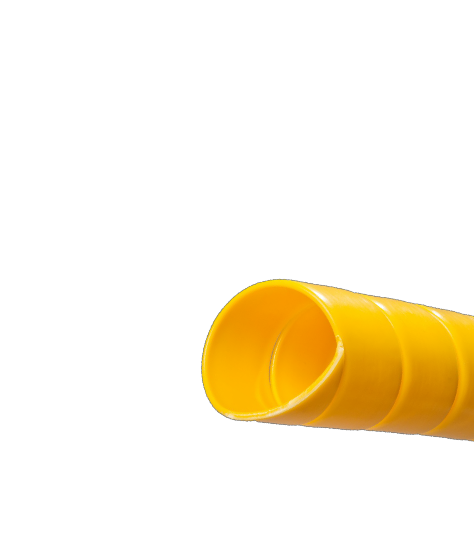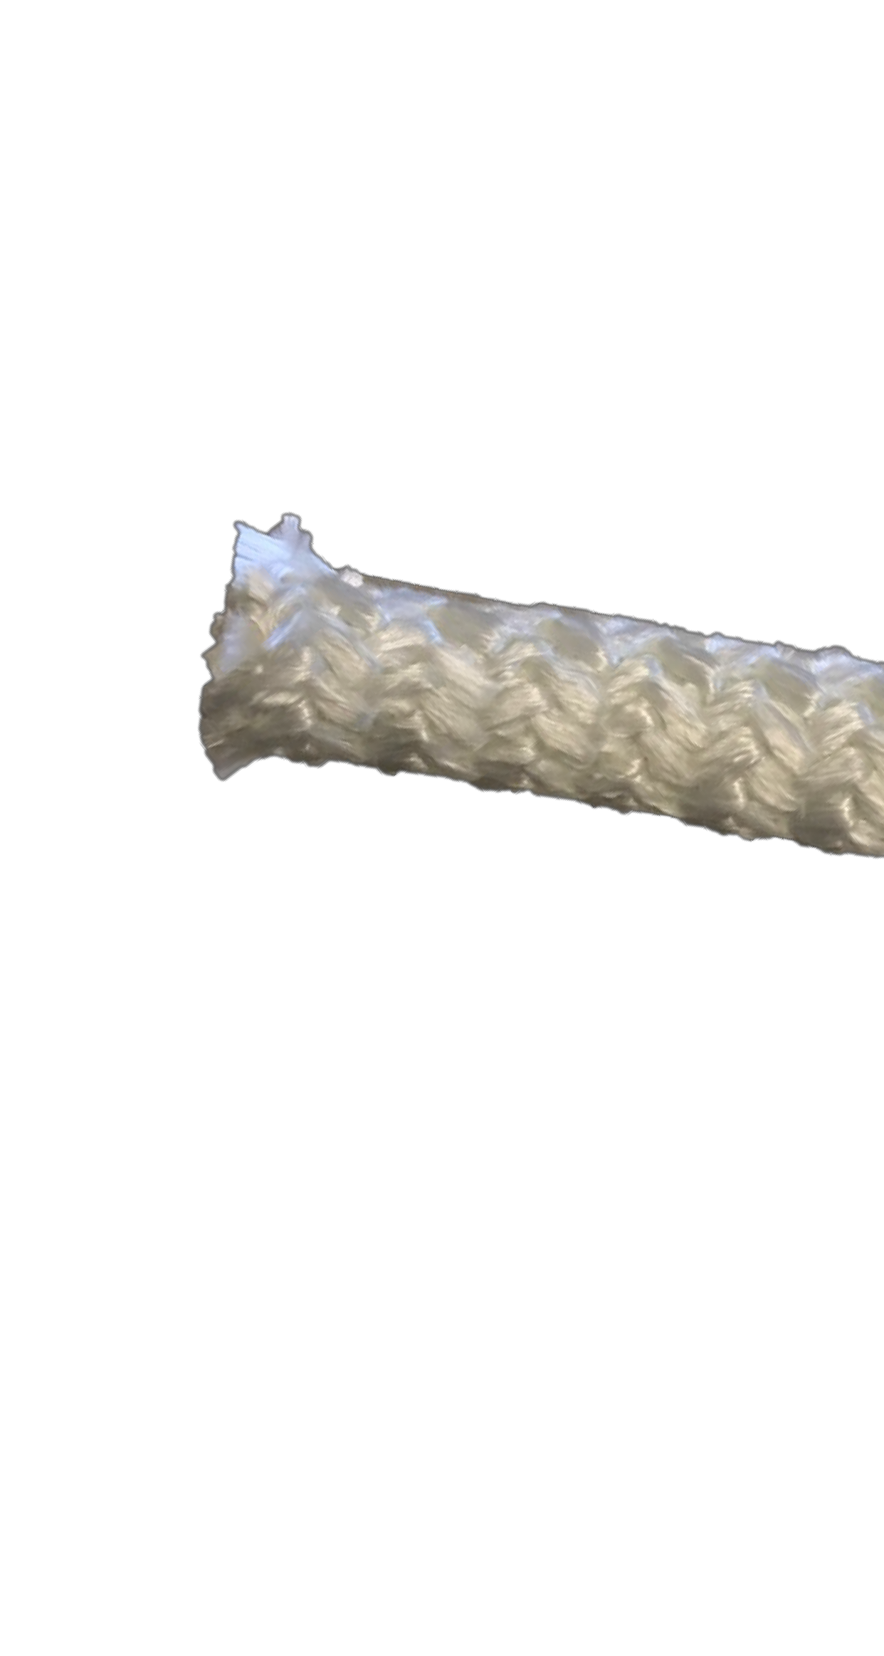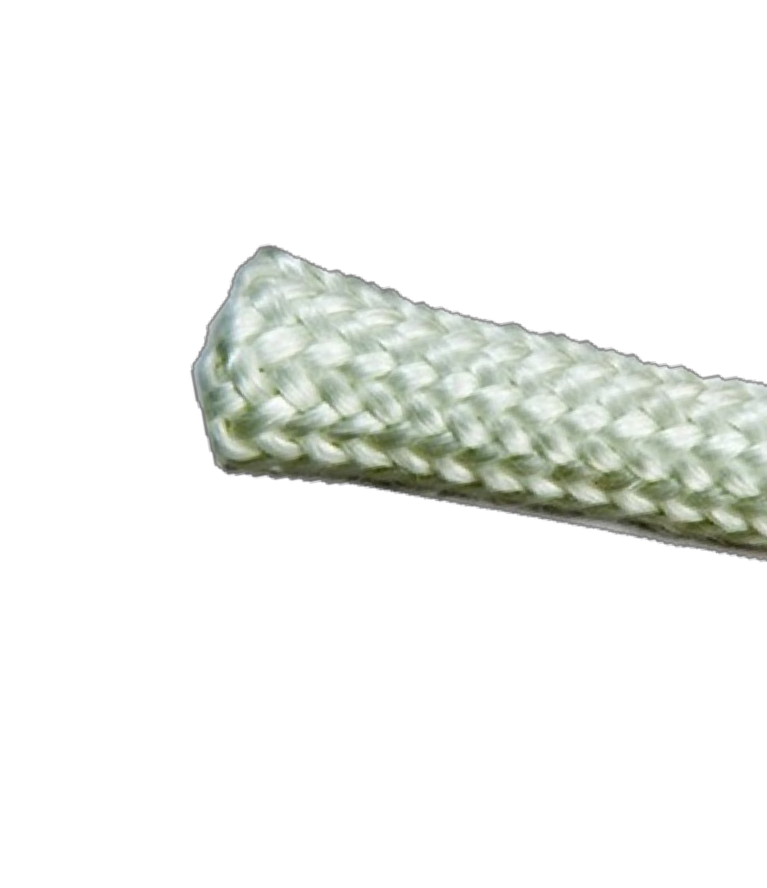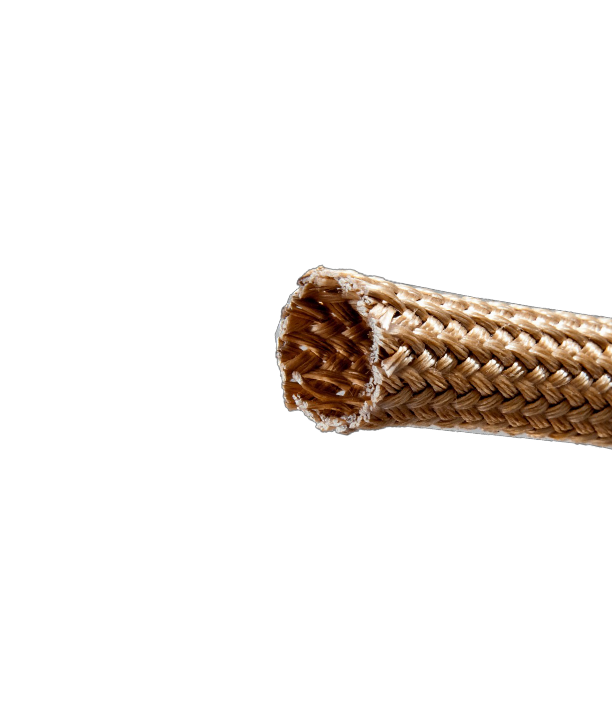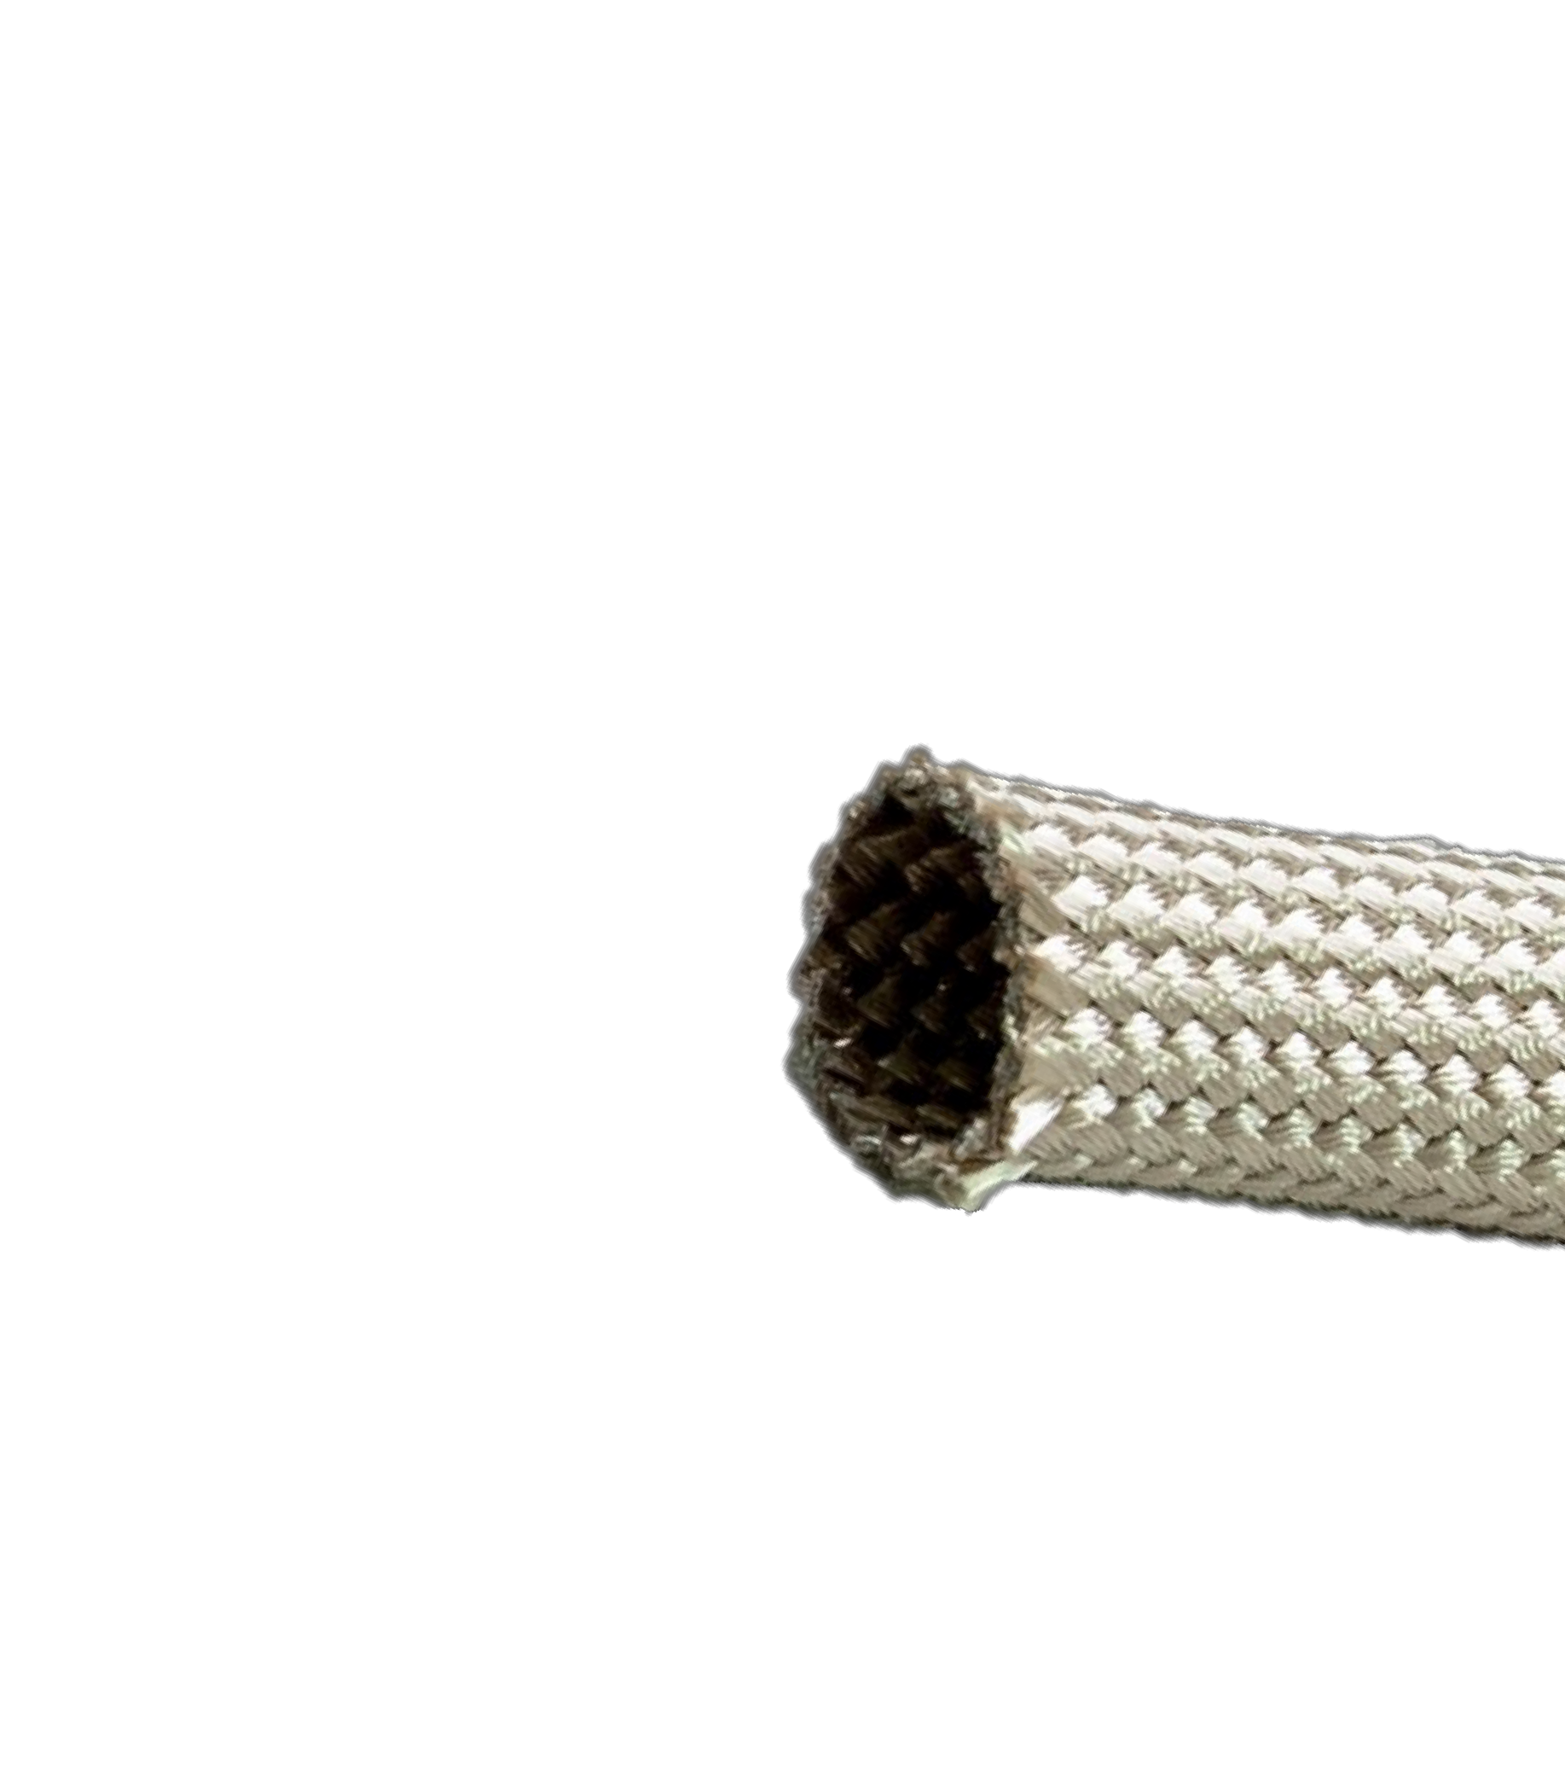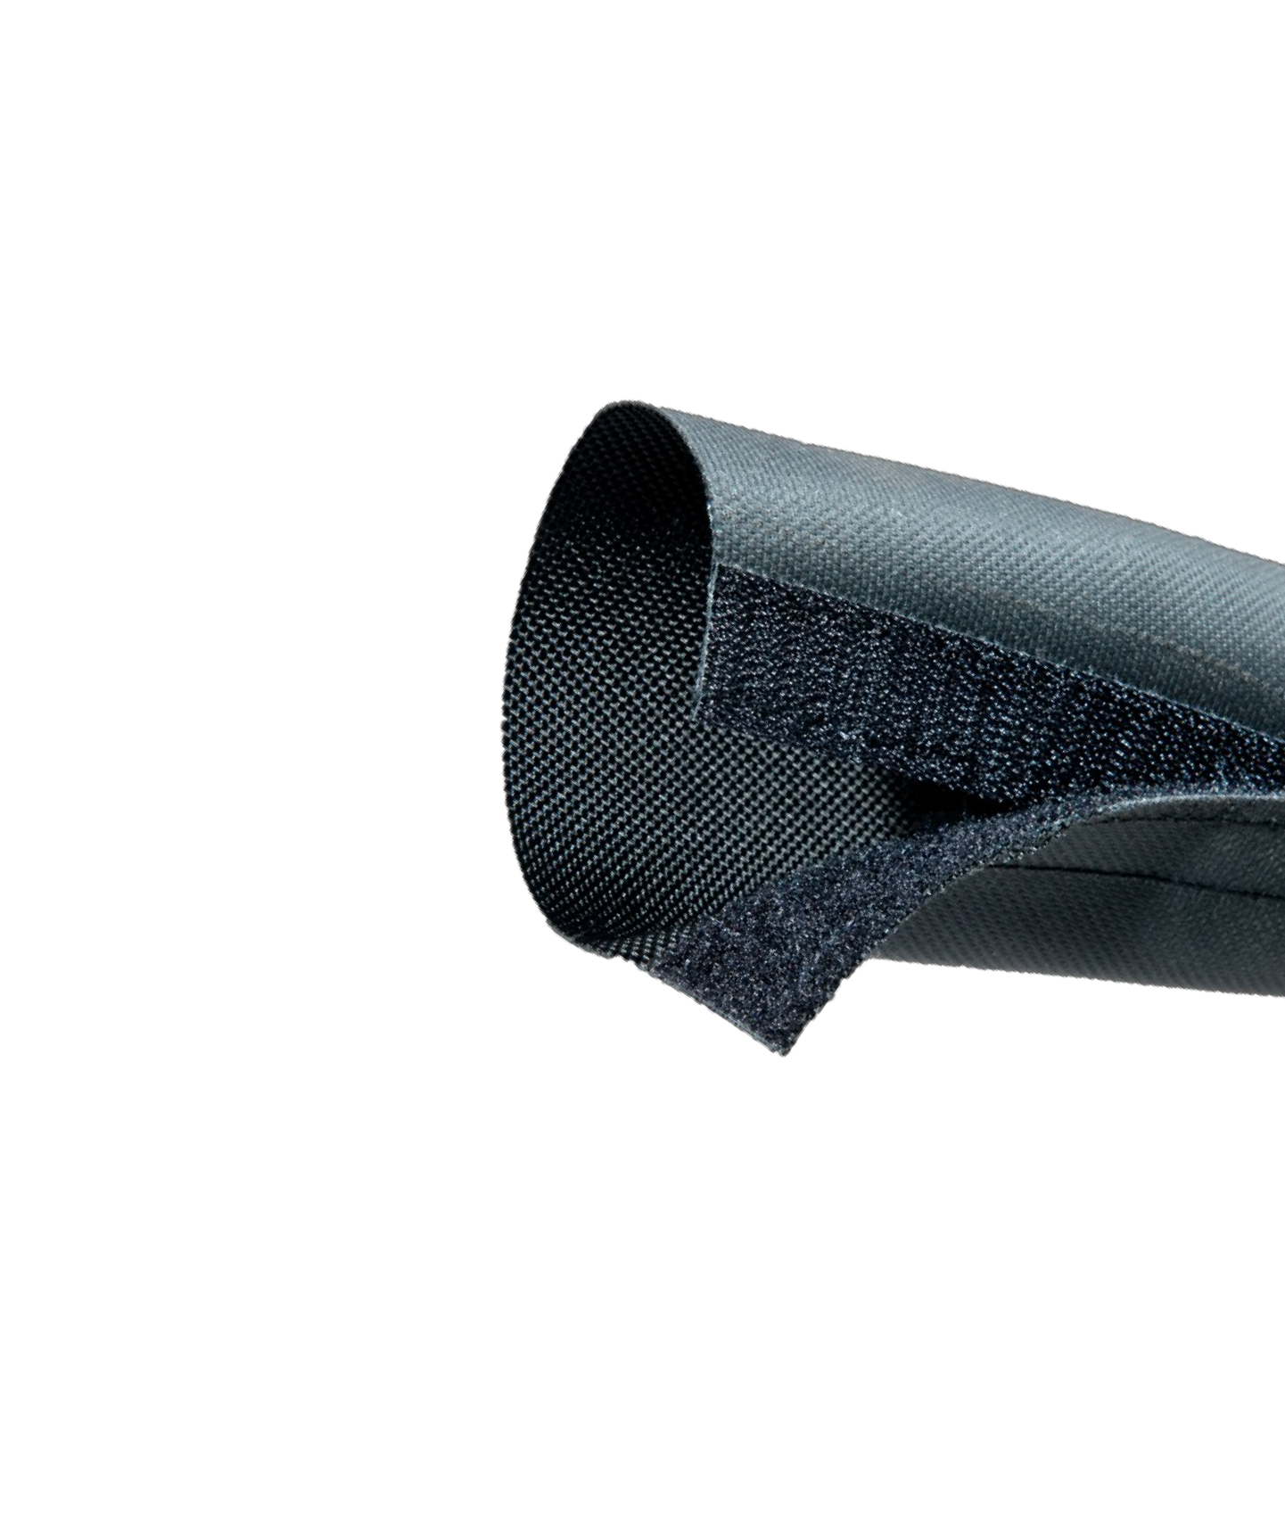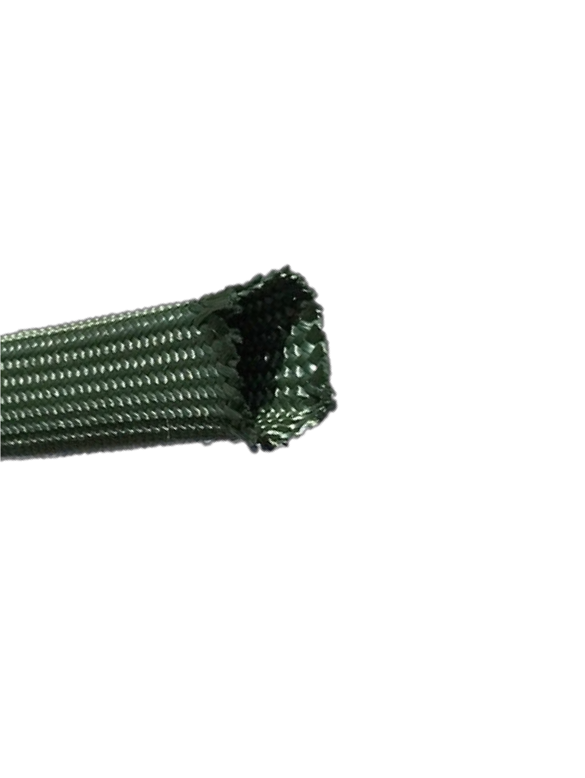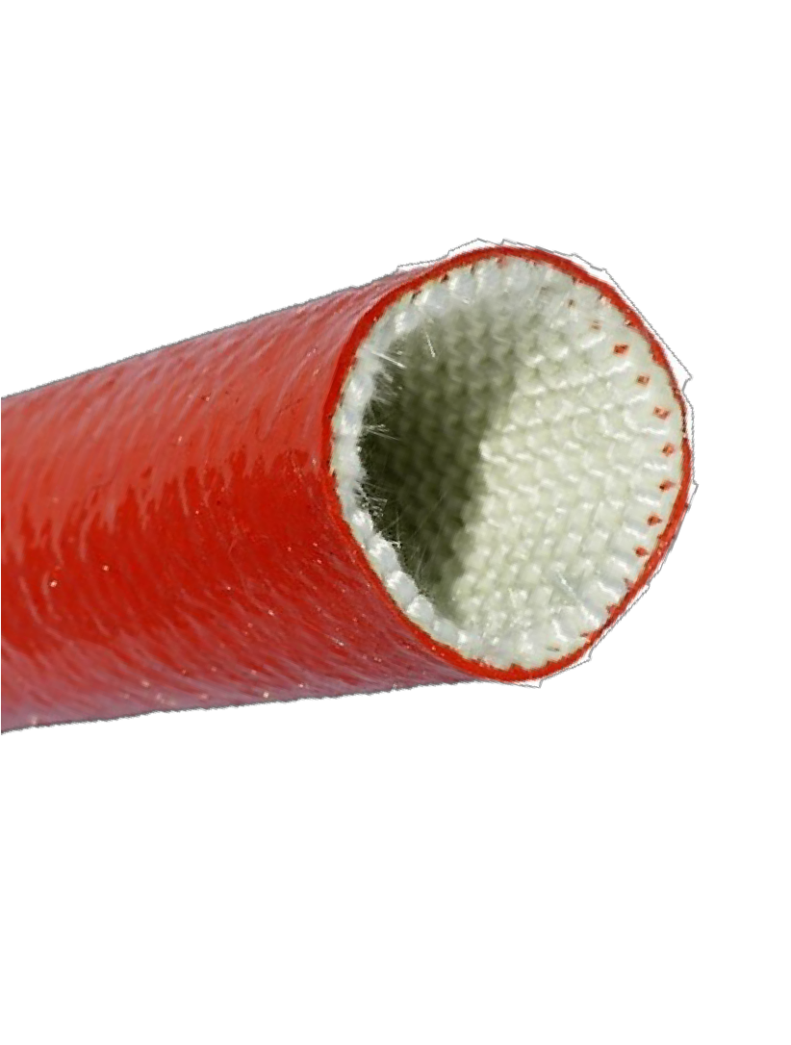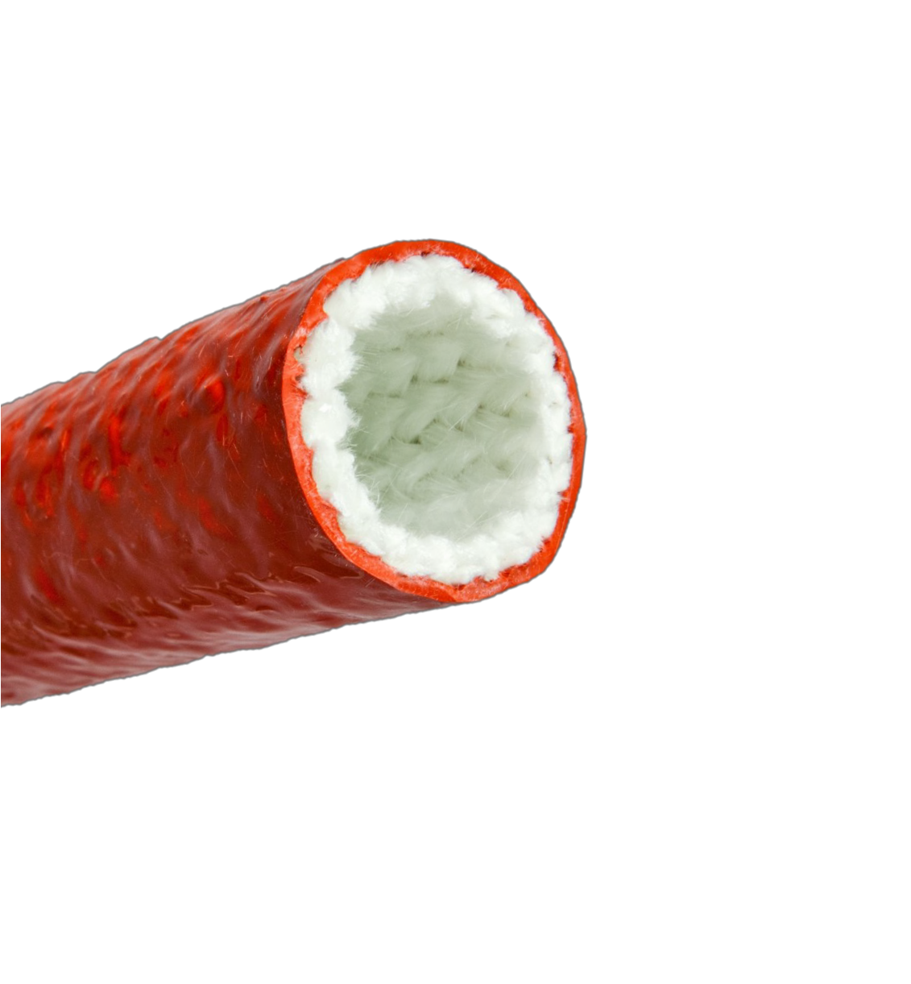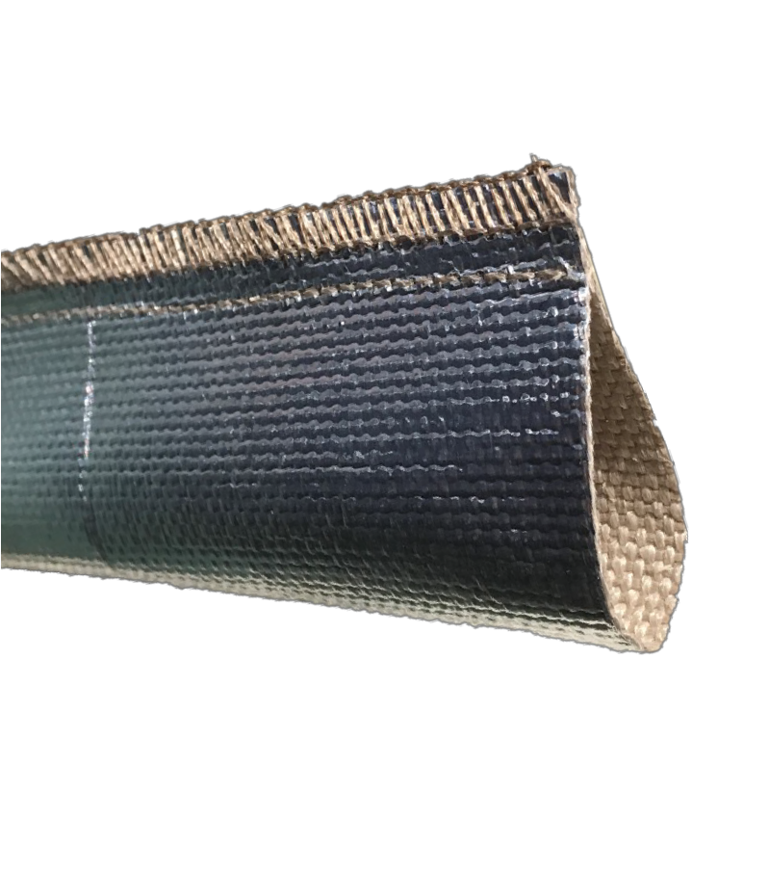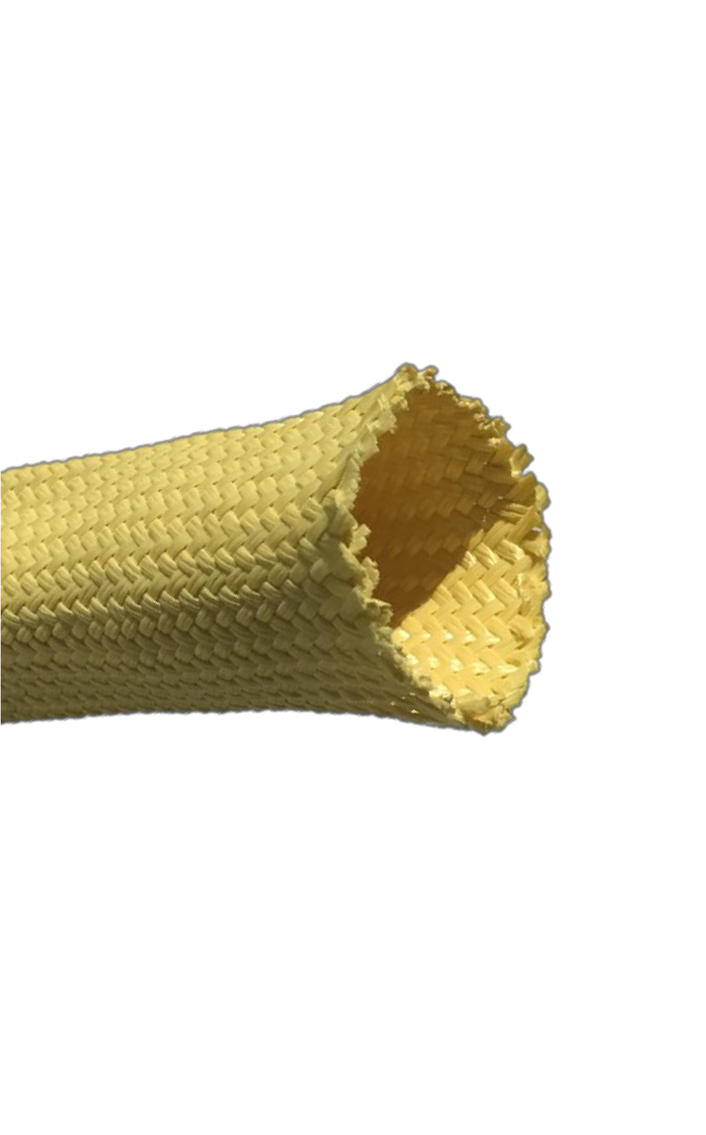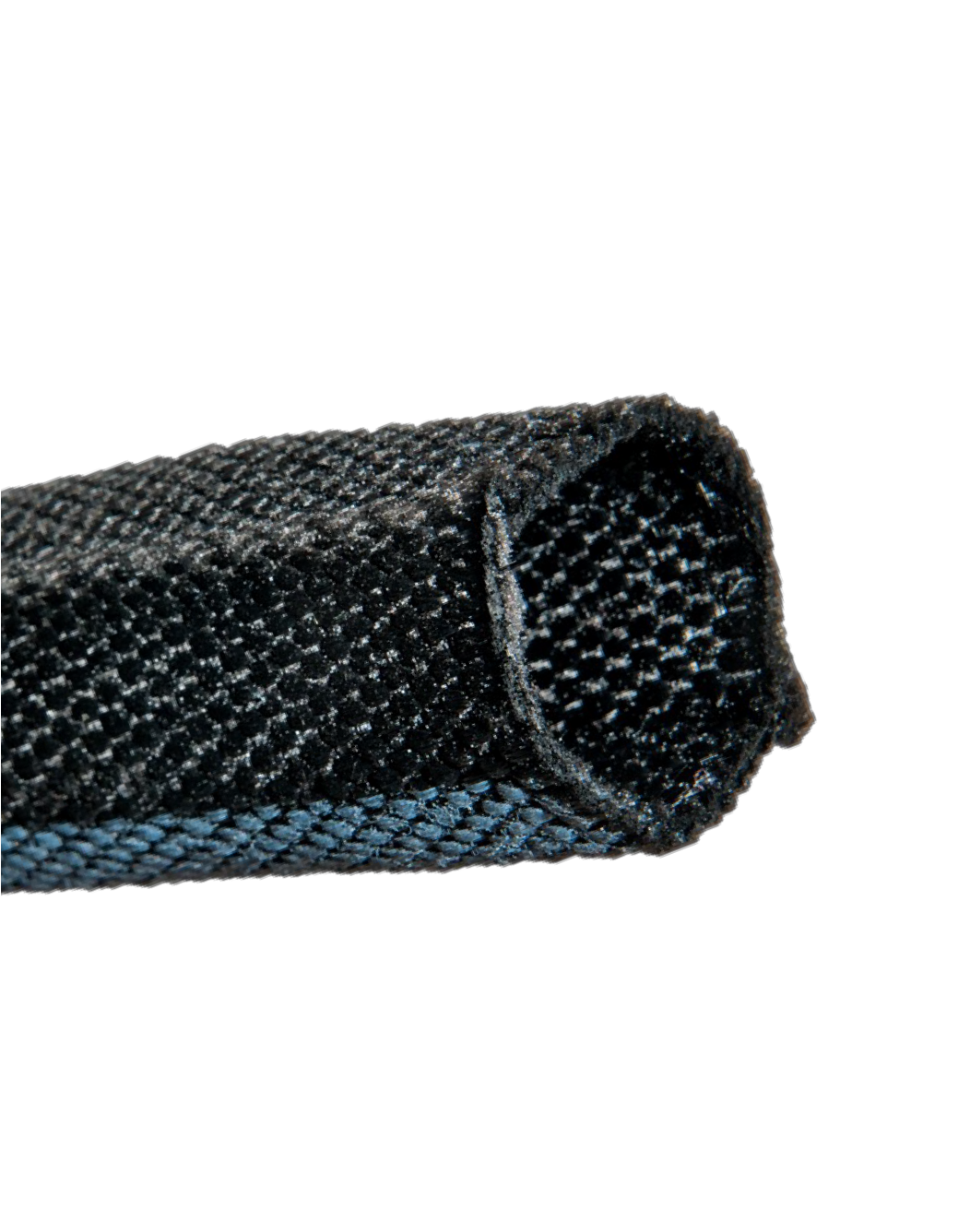CustomerService@atlantexmfg.com www.atlantexmfg.com
THERMAL SOLUTIONS
Pyrotex Firesleeve Pyrotherm Sleeve & Rope

Silicone-coated fiberglass sleeving insulates and protects from flame, molten splash, and continuous
temperatures up to 500°F.
- Knitted and braided constructions
  - 1/4” through 6” ID size range
    - 7 Coating colors available

Meta-Tex Aramid Sleeve
Highly texturized fiberglass insulates, seals, and protects systems facing
continuous exposure to temperatures up to 1000°F.
- 1/8” & 1/16” sleeve wall thickness
- 1/8” through 1-1/2” rope diameter
  - Economical system protection

Pyrotherm HS

Braided meta-aramid sleeve insulates and protects against heat and flame. Made with DuPont™ Nomex® fiber.
    - 1/8” through 2” ID range

ReflectTherm STS
Saturated braided fiberglass sleeve
insulates & resists end fray and wear.
- 1/4” through 4” ID range
- 7 Sleeve colors available

Pyrotherm HT

Lightweight aluminized fiberglass heatshield reflects 80+% of radiant energy away from components.
  - 1/2” through 4” ID range
Heat-cleaned fiberglass braided
insulating sleeve provides attractive and expandable protection to 1000°F.
- 1/4” through 4” ID range

ABRASION SOLUTIONS

Para-Tex Aramid Sleeve
Tufftex HLC

Braided protective sleeve made with DuPont™ Kevlar® fiber.
  - 1/4” through 4” ID range
  - 6 Sleeve colors available

Tufftex W
Urethane-coated ballistic Nylon with Velcro® bundles and protects against abrasion in all weather conditions.
- 1” through 8” ID range

Spiral Guard Wrap

Woven Nylon multifilament sleeve protects against abrasion and UV in aggressive environments.
  - 11/16” through 3-5/8” ID range
Durable and weather-resistant HDPE protective spiral bundles and protects against abrasion and external wear.
  - 3/8” through 5-1/2” size range

610-518-6601 CustomerService@atlantexmfg.com
DuPont™, Nomex®, and Kevlar® are trademarks or registered trademarks of E.I. du Pont de Nemours and Company

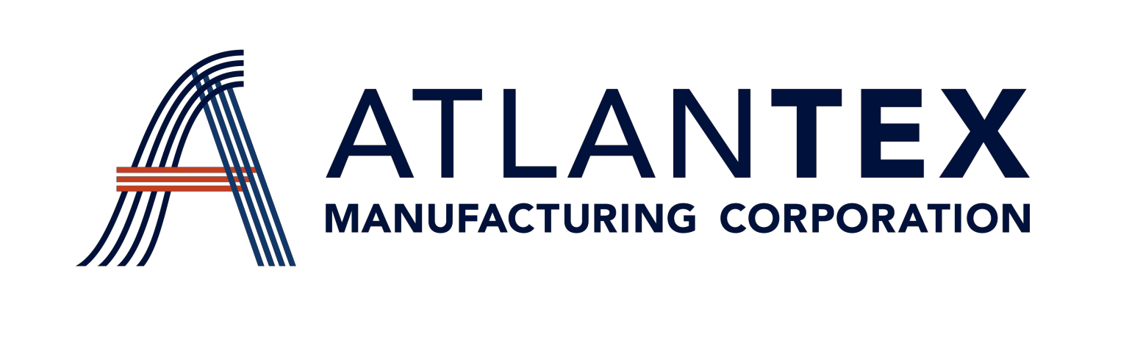
Phone: 610-518-6601
CustomerService@atlantexmfg.com www.atlantexmfg.com

SYSTEMS PROTECTION SOLUTIONS
Atlantex Manufacturing Corporation has rapidly grown to be a world leader in the manufacture of solutions-based technical textiles serving the industrial, automotive, and appliance markets. As a vertical manufacturer of high-temperature and abrasion-resistant textile products, Atlantex offers unmatched value and dependability. We take a great deal of pride in our products, and after decades of continual process improvement and market feedback, we truly believe that Atlantex provides the highest quality and best value in the systems protection industry.

QUALITY
THE ATLANTEX ADVANTAGE
INNOVATION

SERVICE

ISO 9001:2015 Registered Quality Management System
UL-Recognized Components PPAP Documentation
Customized product design and fabrication capabilities
Versatile material processing In-depth application knowledge
Extensive inventory and multiple warehouse locations
Family owned and operated USA manufacturer

