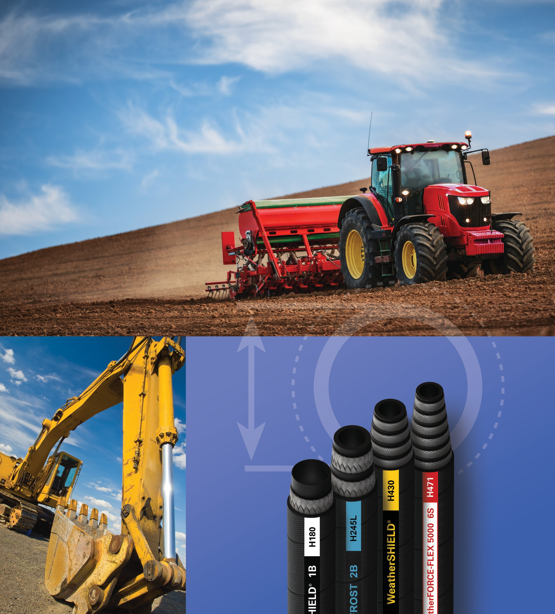

Eaton Weatherhead
Core Hydraulic Hose Products Brochure

Success made simple.

The new standard for hydraulic hose and fittings.

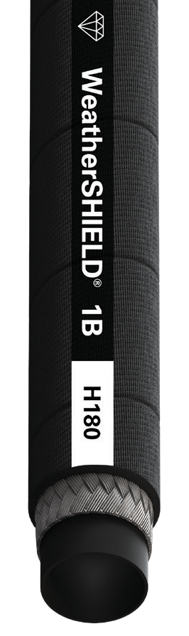
Sometimes less is more.
Focused products, smarter choices.

Eaton is taking a new approach to helping you succeed by reducing the complexity of our hydraulics hose and fittings product offering, while developing new, more intuitive ways to help you find the right product fast. We know that your workforce demographics, regulatory environment and global economics require a new approach, and we’re proactively leading the charge with a smaller—but smarter—hydraulics offering to help you spend less time combing through product options and more time competing in expanded markets, improving responsiveness, and closing new business.

2 EATON Weatherhead Core Hydraulic Hose Products Brochure

Premium Premium Low Temp. Premium High Temp. Premium Abrasion Standard
Operating Temperature Range
High: 260ºF
Low:
-40ºF
High: 212ºF Low: -70ºF
High: 302ºF
Low:
-40ºF
High: 212ºF Low: -40ºF
High: 212ºF Low: -40ºF
Cover Abrasion Resistance
WeatherSHIELD™ Coverings (8x greater than standard)
RhinoHide II™
Coverings
(700x greater than standard)
Standard Abrasion
(10,000 Cycles
per ISO 6945)
Bend Radius
1/2 bend
1/2 bend
Full bend
1/2 bend
1/2 bend
Impulse Life
Eaton Premium: All premium hoses exceed industry specifications for impulse cycles.
Eaton Standard
Fluid Compatibility and Rubber Compounding
Eaton Premium
Eaton Standard
Certifications
SAE EN ISO
ABS MSHA DNV
SAE EN MSHA
Customer specs
SAE EN
ABS MSHA
SAE EN
ABS DNV
Customer specs
U.S. Coast Guard
Customer specs
Customer specs
U.S. Coast Guard
SAE EN MSHA
Customer specs

Fittings
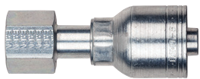
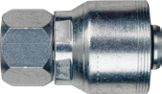
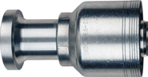
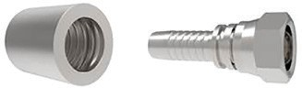

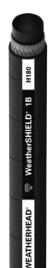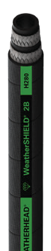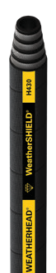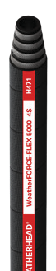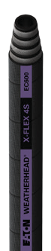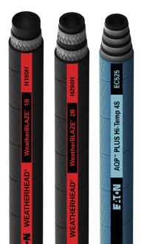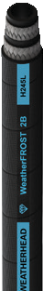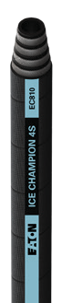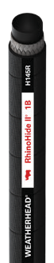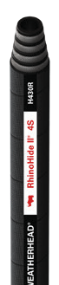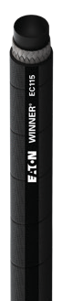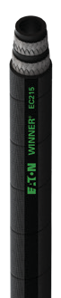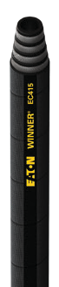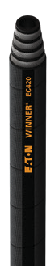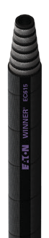Z-Series

Standard
Eaton Winner® hoses meet all industry standards for pressure, temperature and abrasion resistance, offering the right product at a competitive price point for OEM markets.
Premium Abrasion
Premium High Temp.
Premium Low Temp.
Premium
Premium
Our new core premium hoses for OEM or aftermarket use exceed industry standards for pressure, temperature and abrasion resistance, with options adapted to handle your toughest jobs.
Look for Diamond Advantage hoses for the highest pressure and temperature ratings to extend the life of your hose.
Eaton’s best-selling one-piece “Bite-the- wire” style hose fitting that is qualified with virtually all Weatherhead one and two wire braided hydraulic hoses.
4S/6S Spiral Series
A higher performing spiral hose assembly for the most demanding applications while using a simple more user-friendly hose and hose fitting assembly process. Industry leading class “0” cool-down leakage and higher operating performance.
Two-piece Winner
A competitive non-skive two-piece hose fitting that is qualified with the Eaton Winner standard hoses.

- Wire Braided

Premium
H180 WeatherSHIELD™ Hydraulic Hose
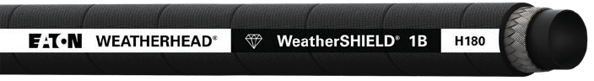
Exceeds SAE 100R1 AT Type S, EN 857 1SC, ISO 1436-1 Type 1SC Performance

Diamond Advantage
  - Pressure
  - Temperature
  - Abrasion Resistance
Inner Tube:
Synthetic rubber
Reinforcement:
- steel braid
Cover:
WeatherSHIELD™ synthetic rubber
Typical Application:
Low & medium pressure
 | mm | in | mm | in | bar | psi | bar | psi | mm | in | kg/m | lbs/ft
H18004 | 6.4 | 0.25 | 12.9 | 0.51 | 255 | 3,700 | 1,020 | 14,800 | 50 | 1.97 | 0.14 | 0.09
H18006 | 9.5 | 0.38 | 16.3 | 0.64 | 235 | 3,400 | 940 | 13,600 | 63 | 2.48 | 0.22 | 0.15
H18008 | 12.7 | 0.50 | 19.9 | 0.78 | 221 | 3,200 | 883 | 12,800 | 90 | 3.54 | 0.29 | 0.20
H18010 | 15.9 | 0.63 | 22.3 | 0.88 | 140 | 2,025 | 559 | 8,100 | 100 | 3.94 | 0.28 | 0.19
H18012 | 19.0 | 0.75 | 26.0 | 1.02 | 138 | 2,000 | 552 | 8,000 | 120 | 4.72 | 0.37 | 0.25
H18016 | 25.4 | 1.00 | 34.0 | 1.34 | 103 | 1,500 | 414 | 6,000 | 150 | 5.91 | 0.54 | 0.36
H18020 | 31.8 | 1.25 | 41.5 | 1.63 | 69 | 1,000 | 276 | 4,000 | 210 | 8.27 | 0.68 | 0.45
H18024 | 38.1 | 1.50 | 47.9 | 1.89 | 52 | 750 | 207 | 3,000 | 250 | 9.84 | 0.80 | 0.54
H18032 | 50.8 | 2.00 | 64.0 | 2.52 | 41 | 600 | 166 | 2,400 | 315 | 12.40 | 1.29 | 0.87

Part # Hose I.D.
Hose O.D. (nominal)
Working Pressure
Min. Burst Pressure
Min. Bend
Radius Weight
hydraulic systems, petroleum & water-based fluids, construction equipment, and agriculture equipment.
MSHA Approved

Operating Temperature:
-46°C to +127°C (-50°F to +260°F)

Standard
EC115 Hydraulic Hose
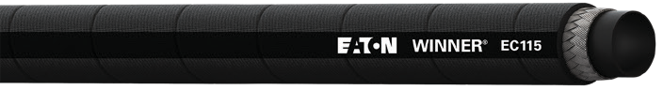
Meets EN 857 Type 1SC
Fittings:

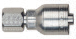

Z-Series

Inner Tube:
Synthetic rubber
Reinforcement:
1 steel braid
Cover:
Synthetic rubber
Typical Application:

Part # Hose I.D.
 | mm | in | mm | in | bar | psi | bar | psi | mm | in | kg/m | lbs/ft
EC115-04 | 6.4 | 0.25 | 12.6 | 0.50 | 225 | 3,250 | 900 | 13,000 | 50 | 1.97 | 0.18 | 0.12
EC115-06 | 9.5 | 0.38 | 16.0 | 0.63 | 180 | 2,600 | 720 | 10,400 | 63 | 2.48 | 0.26 | 0.17
EC115-08 | 12.7 | 0.50 | 19.4 | 0.77 | 160 | 2,300 | 640 | 9,200 | 90 | 3.54 | 0.34 | 0.23
EC115-10 | 15.9 | 0.62 | 22.4 | 0.88 | 130 | 1,900 | 520 | 7,600 | 100 | 3.94 | 0.42 | 0.28
EC115-12 | 19.0 | 0.75 | 26.0 | 1.02 | 105 | 1,525 | 420 | 6,100 | 120 | 4.72 | 0.50 | 0.34
EC115-16 | 25.4 | 1.00 | 33.8 | 1.33 | 88 | 1,275 | 352 | 5,100 | 160 | 6.30 | 0.74 | 0.50
EC115-20 | 31.8 | 1.25 | 41.2 | 1.62 | 63 | 925 | 252 | 3,700 | 210 | 8.27 | 0.99 | 0.67
EC115-24 | 38.1 | 1.50 | 48.0 | 1.89 | 50 | 725 | 200 | 2,900 | 300 | 11.81 | 1.20 | 0.81
EC115-32 | 50.8 | 2.00 | 61.0 | 2.41 | 40 | 580 | 160 | 2,320 | 400 | 15.75 | 1.50 | 1.01

Hose O.D. (nominal)
Working Pressure
Min. Burst Pressure
Min. Bend
Radius Weight
Hydraulic system service with petroleum and water-based fluids, for general industrial service.
MSHA Approved

Operating Temperature :
-40°C to +100°C (-40°F to +212°F)
Fittings:

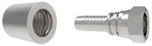
Z-Series Two-piece Winner

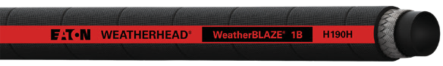
Premium High Temp.
H190H WeatherBLAZE™
Exceeds SAE 100R1 AT Type S, EN 853 1SN, ISO 1436-1 Type 1SN Performance

Part # Hose I.D.

Hose O.D. (nominal)

Working Pressure

Min. Burst Pressure

Min. Bend
Radius Weight

 | mm | in | mm | in | bar | psi | bar | psi | mm | in | kg/m | lbs/ft
H190H04 | 6.4 | 0.25 | 13.5 | 0.53 | 225 | 3,250 | 900 | 13,000 | 100 | 4.00 | 0.25 | 0.17
H190H06 | 9.7 | 0.38 | 17.5 | 0.69 | 215 | 3,125 | 860 | 12,500 | 125 | 5.00 | 0.37 | 0.25
H190H08 | 12.7 | 0.50 | 20.6 | 0.81 | 175 | 2,550 | 700 | 10,200 | 180 | 7.00 | 0.45 | 0.30
H190H10 | 16.0 | 0.63 | 23.9 | 0.94 | 140 | 2,050 | 560 | 8,200 | 205 | 8.00 | 0.54 | 0.36
H190H12 | 19.1 | 0.75 | 27.7 | 1.09 | 125 | 1,800 | 500 | 7,200 | 240 | 9.50 | 0.68 | 0.46
H190H16 | 25.4 | 1.00 | 35.8 | 1.41 | 90 | 1,300 | 360 | 5,200 | 300 | 12.00 | 0.98 | 0.66
H190H20 | 31.8 | 1.25 | 43.9 | 1.73 | 65 | 950 | 260 | 3,800 | 420 | 16.50 | 1.26 | 0.85
H190H24 | 38.1 | 1.50 | 52.1 | 2.05 | 50 | 725 | 200 | 2,900 | 500 | 19.69 | 1.58 | 1.06
H190H32 | 50.8 | 2.00 | 65.5 | 2.58 | 40 | 580 | 160 | 2320 | 630 | 24.80 | 2.04 | 1.37

Operating Temperature:
-40°C to +150°C (-40°F to +302°F)

Premium Low Temp.
Fittings:

Z-Series

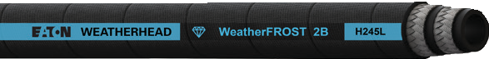
Exceeds SAE 100R16 Type S, EN 857 Type 2SC, ISO 11237-1 Type 2SC Performance
Full specs on page 7
H245L WeatherFROST™
Use compatible 2-Wire Braided Premium Low Temperature hose

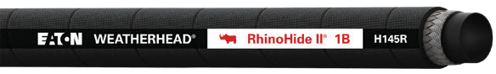
Premium Abrasion
H145R RhinoHide II™
Abrasion Resistant Constant Pressure Hydraulic Hose
Exceeds SAE 100R17 Performance
Hose O.D.

Working

Min. Burst

Min. Bend

Inner Tube:
Nitrile
Reinforcement:
1 steel braid
Cover:
Abrasion resistant UHMWPE
Typical Application:
3,000 PSI constant working pressure hose with abrasion resistant cover. Ideal for logging, construction, mining and other off highway applications.

Part # Hose I.D.
(nominal)
Pressure
Pressure
Radius Weight

 | mm | in | mm | in | bar | psi | bar | psi | mm | in | kg/m | lbs/ft
H145R04 | 6.4 | 0.25 | 12.7 | 0.50 | 210 | 3,050 | 840 | 12,200 | 50 | 1.97 | 0.22 | 0.15
H145R06 | 9.5 | 0.38 | 16.6 | 0.65 | 210 | 3,050 | 840 | 12,200 | 65 | 2.56 | 0.34 | 0.23
H145R08 | 12.7 | 0.50 | 20.9 | 0.82 | 210 | 3,050 | 840 | 12,200 | 90 | 3.54 | 0.48 | 0.32

Operating Temperature:
Weatherhead Core Products

Inner Tube:
CPE
Reinforcement:
1 steel braid
Cover:
CPE black
Typical Application:
Transfer of hydraulic fluid, water and air.

MSHA Approved ISO 1436a
-40°C to +100°C (-40°F to +212°F)
Fittings:

Z-Series

- Wire Braided

Premium
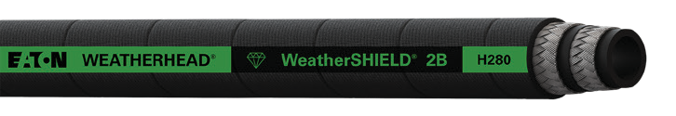
H280 WeatherSHIELD™ Hydraulic Hose

Exceeds SAE 100R16 Type S, EN 857 Type 2SC, ISO 11237-1 Type 2SC Performance

Diamond Advantage
- Pressure
- Temperature
- Abrasion Resistance
Inner Tube:
Synthetic rubber
Reinforcement:
- steel braids
Cover:
WeatherSHIELD™ synthetic rubber
Typical Application:
Low & medium pressure
 | mm | in | mm | in | bar | psi | bar | psi | mm | in | kg/m | lbs/ft
H28004 | 6.4 | 0.25 | 14.1 | 0.56 | 448 | 6,500 | 1,792 | 26,000 | 50 | 1.97 | 0.33 | 0.22
H28006 | 9.5 | 0.38 | 17.4 | 0.69 | 400 | 5,800 | 1,600 | 23,200 | 65 | 2.56 | 0.43 | 0.29
H28008 | 12.7 | 0.50 | 20.8 | 0.82 | 345 | 5,000 | 1,380 | 20,000 | 90 | 3.54 | 0.58 | 0.39
H28010 | 15.9 | 0.62 | 24.9 | 0.98 | 276 | 4,000 | 1,104 | 16,000 | 100 | 3.94 | 0.65 | 0.44
H28012 | 19.0 | 0.75 | 28.4 | 1.12 | 241 | 3,500 | 964 | 14,000 | 120 | 4.72 | 0.79 | 0.53
H28016 | 25.4 | 1.00 | 35.7 | 1.41 | 207 | 3,000 | 828 | 12,000 | 150 | 5.91 | 1.07 | 0.72
H28020 | 31.8 | 1.25 | 43.3 | 1.71 | 172 | 2,500 | 688 | 10,000 | 210 | 8.27 | 1.62 | 1.09
H28024 | 38.1 | 1.50 | 51.5 | 2.03 | 138 | 2,000 | 552 | 8,000 | 250 | 9.84 | 2.08 | 1.40
H28032 | 50.8 | 2.00 | 63.9 | 2.52 | 110 | 1,600 | 440 | 6,400 | 315 | 12.40 | 2.82 | 1.90

Part # Hose I.D.
Hose O.D. (nominal)
Working Pressure
Min. Burst Pressure
Min. Bend
Radius Weight
hydraulic systems, petroleum & water-based fluids, construction equipment, agriculture equipment.
MSHA Approved

Operating Temperature:
Petroleum based Hydraulic Fluids: -46°C to +127°C (-50°F to +260°F)
Water based Hydraulic Fluids: -46°C to +70°C (-50°F to +158°F)
Fittings:

Z-Series

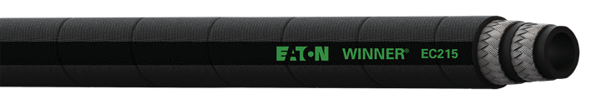Standard
EC215 Hydraulic Hose
Meets EN 857 Type 2SC

Part # Hose I.D.

Hose O.D. (nominal)

Working Pressure

Min. Burst Pressure

Min. Bend
Radius Weight

Inner Tube:
Synthetic rubber
Reinforcement:
2 steel braids
Cover:
Synthetic rubber
Typical Application:
Hydraulic system service with petroleum and waterbased fluids, for general industrial service.
 | mm | in | mm | in | bar | psi | bar | psi | mm | in | kg/m | lbs/ft
EC215-04 | 6.4 | 0.25 | 13.5 | 0.53 | 400 | 5,800 | 1,600 | 23,200 | 50 | 1.97 | 0.28 | 0.19
EC215-06 | 9.5 | 0.38 | 17.5 | 0.69 | 345 | 5,000 | 1,380 | 20,000 | 65 | 2.56 | 0.41 | 0.28
EC215-08 | 12.7 | 0.50 | 20.8 | 0.82 | 275 | 4,000 | 1,100 | 16,000 | 90 | 3.54 | 0.57 | 0.38
EC215-10 | 15.9 | 0.62 | 24.0 | 0.94 | 250 | 3,650 | 1,000 | 14,600 | 100 | 3.94 | 0.68 | 0.46
EC215-12 | 19.0 | 0.75 | 27.9 | 1.10 | 215 | 3,125 | 860 | 12,500 | 120 | 4.72 | 0.81 | 0.54
EC215-16 | 25.4 | 1.00 | 35.7 | 1.40 | 165 | 2,400 | 660 | 9,600 | 160 | 6.30 | 1.17 | 0.79
EC215-20 | 31.8 | 1.25 | 43.9 | 1.73 | 125 | 1,800 | 500 | 7,200 | 250 | 9.84 | 1.56 | 1.05
EC215-24 | 38.1 | 1.50 | 51.0 | 2.01 | 100 | 1,450 | 400 | 5,800 | 300 | 11.81 | 1.81 | 1.22
EC215-32 | 50.8 | 2.00 | 63.4 | 2.50 | 90 | 1,300 | 360 | 5,200 | 400 | 15.75 | 2.36 | 1.59

MSHA Approved

Operating Temperature :
-40°C to +100°C (-40°F to +212°F)
Fittings:

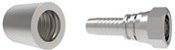
Z-Series Two-piece Winner

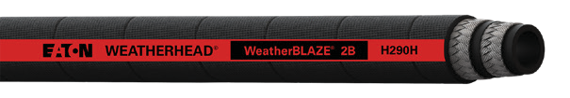
Premium High Temp.
H290H WeatherBLAZE™
Exceeds SAE 100R2AT Type S, EN 853 2SN, ISO 1436-1 Type 2SN Performance

Inner Tube:
CPE

Reinforcement:

Hose O.D.
Part # Hose I.D. (nominal)
 | mm | in | mm | in | bar | psi | bar | psi | mm | in | kg/m | lbs/ft
H290H04 | 6.4 | 0.25 | 15.2 | 0.60 | 400 | 5,800 | 1,600 | 23,200 | 102 | 4.02 | 0.4 | 0.27
H290H06 | 9.5 | 0.38 | 19.1 | 0.75 | 345 | 5,000 | 1,380 | 20,000 | 125 | 4.92 | 0.58 | 0.39
H290H08 | 12.7 | 0.50 | 22.1 | 0.87 | 293 | 4,250 | 1,172 | 17,000 | 180 | 7.09 | 0.68 | 0.46
H290H10 | 15.9 | 0.62 | 25.2 | 0.99 | 250 | 3,650 | 1,000 | 14,600 | 205 | 8.07 | 0.8 | 0.54
H290H12 | 19.0 | 0.75 | 29.5 | 1.16 | 215 | 3,125 | 860 | 12,500 | 240 | 9.45 | 1 | 0.67
H290H16 | 25.4 | 1.00 | 37.9 | 1.49 | 175 | 2,550 | 700 | 10,200 | 300 | 11.81 | 1.44 | 0.97
H290H20 | 31.8 | 1.25 | 48.8 | 1.92 | 155 | 2,250 | 620 | 9,000 | 420 | 16.54 | 2.38 | 1.60
H290H24 | 38.1 | 1.50 | 54.6 | 2.15 | 125 | 1,800 | 500 | 7,200 | 500 | 19.68 | 2.59 | 1.74
H290H32 | 50.8 | 2.00 | 68.6 | 2.70 | 105 | 1525 | 420 | 6,100 | 630 | 24.80 | 3.38 | 2.27

Working Pressure
Min. Burst Pressure
Min. Bend Radius
Weight
2 steel braids

Cover:
CPE black

Typical Application: High pressure hose for hydraulic fluid applications.

MSHA Approved

Operating Temperature:

-40°C to +150°C (-40°F to +302°F)
Fittings:

Z-Series

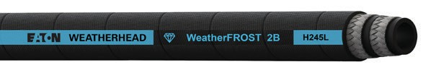
Premium Low Temp.
H245L WeatherFROST™
Exceeds SAE 100R16 Type S, EN 857 Type 2SC, ISO 11237-1 Type 2SC Performance
Inner Tube:
Weatherhead brand exclusive low temperature compound tube

Hose O.D.
Part # Hose I.D. (nominal)
 | mm | in | mm | in | bar | psi | bar | psi | mm | in | kg/m | lbs/ft
H245L04 | 6.4 | 0.25 | 14.2 | 0.56 | 414 | 6,000 | 1,656 | 24,000 | 51 | 2.00 | 0.30 | 0.20
H245L06 | 9.5 | 0.38 | 17.3 | 0.68 | 345 | 5,000 | 1,380 | 20,000 | 64 | 2.50 | 0.40 | 0.27
H245L08 | 12.7 | 0.50 | 20.8 | 0.82 | 310 | 4,500 | 1,240 | 18,000 | 89 | 3.50 | 0.58 | 0.39
H245L10 | 15.9 | 0.62 | 24.9 | 0.98 | 276 | 4,000 | 1,104 | 16,000 | 102 | 4.00 | 0.74 | 0.50
H245L12 | 19.0 | 0.75 | 28.4 | 1.12 | 241 | 3,500 | 964 | 14,000 | 121 | 4.75 | 0.92 | 0.62
H245L16 | 25.4 | 1.00 | 35.8 | 1.41 | 193 | 2,800 | 772 | 11,200 | 152 | 6.00 | 1.22 | 0.82
H245L20 | 31.8 | 1.25 | 43.4 | 1.71 | 159 | 2,300 | 636 | 9,200 | 210 | 8.25 | 1.59 | 1.07
H245L24 | 38.1 | 1.50 | 51.6 | 2.03 | 138 | 2,000 | 552 | 8,000 | 254 | 10.00 | 2.11 | 1.42
H245L32 | 50.8 | 2.00 | 63.8 | 2.51 | 103 | 1,500 | 412 | 6,000 | 318 | 12.50 | 2.80 | 1.88

Working Pressure

Min. Burst Pressure

Min. Bend Radius

Weight
Reinforcement:
2 steel braids

Cover: WeatherSHIELD™ synthetic rubber

Typical Application:
Low temperature flexing and hydraulic system service with petroleum and water-base fluids. For use in frigid environments on construction equipment and other mobile applications.

Operating Temperature:
-57°C to +100°C (-70°F to +212°F)
Diamond Advantage
  - Pressure
  - Temperature
  - Abrasion Resistance
Fittings:

Z-Series
MSHA Approved

Weatherhead Core Products
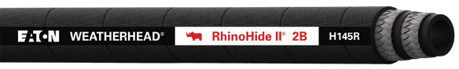
Premium Abrasion
H145R RhinoHide II™
Abrasion Resistant Constant Pressure Hydraulic Hose
Exceeds SAE 100R17 Performance
Hose O.D.
Part # Hose I.D. (nominal)
 | mm | in | mm | in | bar | psi | bar | psi | mm | in | kg/m | lbs/ft
H145R10 | 15.9 | 0.62 | 23.6 | 0.93 | 210 | 3,050 | 840 | 12,200 | 100 | 3.94 | 0.76 | 0.51
H145R12 | 19.0 | 0.75 | 27.9 | 1.10 | 210 | 3,050 | 840 | 12,200 | 120 | 4.72 | 0.94 | 0.63
H145R16 | 25.4 | 1.00 | 36.1 | 1.42 | 210 | 3,050 | 840 | 12,200 | 150 | 5.91 | 1.24 | 0.83

Operating Temperature:
-40°C to +100°C (-40°F to +212°F)

Working Pressure

Min. Burst Pressure

Min. Bend Radius

Fittings:
Z-Series

Weight

Inner Tube:
Nitrile

Reinforcement:
2 steel braids

Cover:
Abrasion resistant UHMWPE

Typical Application: 3,000 PSI constant working pressure hose with abrasion
resistant cover. Ideal for logging,
construction, mining and other off highway applications.

Spiral R12

Premium
H430 High Pressure Spiral Hydraulic Hose
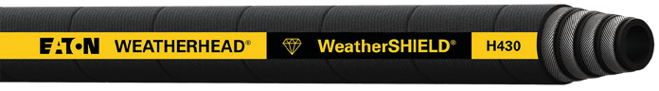
Exceeds SAE 100R12, EN 856 Type R12, EN 856 Type 4SP Performance

Diamond Advantage
- Pressure
- Temperature
- Abrasion Resistance
Inner Tube:
Synthetic rubber
Reinforcement:
4 wire spiral
Cover:
WeatherSHIELD™ synthetic rubber
Typical Application:
For very high pressure
 | mm | in | mm | in | bar | psi | bar | psi | mm | in | kg/m | lbs/ft
H43006 | 9.5 | 0.38 | 20.3 | 0.80 | 448 | 6,500 | 1,792 | 26,000 | 62.5 | 2.46 | 0.71 | 0.47
H43008 | 12.7 | 0.50 | 23.6 | 0.93 | 415 | 6,000 | 1,660 | 24,000 | 90.0 | 3.54 | 0.88 | 0.59
H43010 | 15.9 | 0.62 | 27.4 | 1.08 | 415 | 6,000 | 1,660 | 24,000 | 100.0 | 3.94 | 1.04 | 0.70
H43012 | 19.0 | 0.75 | 30.7 | 1.21 | 380 | 5,500 | 1,520 | 22,000 | 120.0 | 4.72 | 1.34 | 0.90
H43016 | 25.4 | 1.00 | 37.9 | 1.49 | 350 | 5,100 | 1,400 | 20,400 | 150.0 | 5.91 | 1.79 | 1.20
H43020 | 31.8 | 1.25 | 46.6 | 1.84 | 310 | 4,500 | 1,240 | 18,000 | 210.0 | 8.27 | 2.23 | 1.50
H43024 | 38.1 | 1.50 | 53.9 | 2.12 | 275 | 4,000 | 1,100 | 16,000 | 250.0 | 9.84 | 3.03 | 2.03
H43032 | 50.8 | 2.00 | 66.8 | 2.63 | 275 | 4,000 | 1,100 | 16,000 | 320.0 | 12.60 | 4.38 | 2.94

Part # Hose I.D.
Hose O.D. (nominal)
Working Pressure
Min. Burst Pressure
Min. Bend
Radius Weight
hydraulic lines subjected to pressure surges and flexing. Typical applications include construction, mining, farming, and high performance industrial equipment.
MSHA Approved Marine Application J1942/1 - Hydraulic only, ABS

Operating Temperature:
-40°C to +127°C (-40°F to +260°F)

Standard
EC415 Hydraulic Hose
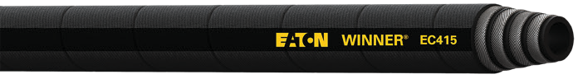
Meets SAE 100R12
Fittings:

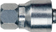

4S Series

Inner Tube:
Synthetic rubber
Reinforcement:
4 wire spiral
Cover:
Synthetic rubber
Typical Application:

Hose O.D.
Part # Hose I.D. (nominal)
 | mm | in | mm | in | bar | psi | bar | psi | mm | in | kg/m | lbs/ft
EC415-06 | 9.5 | 0.38 | 20.3 | 0.80 | 280 | 4,050 | 1120 | 16,200 | 125 | 4.92 | 0.60 | 0.40
EC415-08 | 12.7 | 0.50 | 23.8 | 0.94 | 280 | 4,050 | 1120 | 16,200 | 180 | 7.09 | 0.74 | 0.50
EC415-10 | 15.9 | 0.62 | 27.7 | 1.09 | 280 | 4,050 | 1120 | 16,200 | 200 | 7.87 | 1.03 | 0.69
EC415-12 | 19.0 | 0.75 | 30.7 | 1.21 | 280 | 4,050 | 1120 | 16,200 | 240 | 9.45 | 1.16 | 0.78
EC415-16 | 25.4 | 1.00 | 38.0 | 1.50 | 280 | 4,050 | 1120 | 16,200 | 300 | 11.81 | 1.76 | 1.18
EC415-20 | 31.8 | 1.25 | 47.0 | 1.85 | 210 | 3,050 | 840 | 12,200 | 420 | 16.54 | 2.46 | 1.65
EC415-24 | 38.1 | 1.50 | 53.5 | 2.11 | 175 | 2,550 | 700 | 10,200 | 500 | 19.68 | 2.87 | 1.92
EC415-32 | 50.8 | 2.00 | 66.7 | 2.63 | 175 | 2,550 | 700 | 10,200 | 630 | 24.80 | 4.03 | 2.70

Working Pressure
Min. Burst Pressure
Min. Bend Radius
Weight
Hydraulic systems service with petroleum and water based fluids, for general use.
MSHA Approved

Operating Temperature:
-40°C to +121°C (-40°F to +250°F)
Fittings:

4S Series

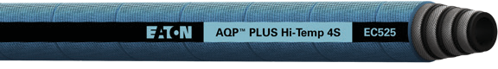
Premium High Temp.
EC525 Hydraulic Hose
Exceeds SAE 100R12, EN 856 Type R12 Performance

Part # Hose I.D.
Hose O.D. (nominal)
Working Pressure

Min. Burst Pressure
Min. Bend
Radius Weight

 | mm | in | mm | in | bar | psi | bar | psi | mm | in | kg/m | lbs/ft
EC525-12 | 19.1 | 0.75 | 30.7 | 1.21 | 345 | 5,000 | 1380 | 20,000 | 241.3 | 9.50 | 1.28 | 0.86
EC525-16 | 25.4 | 1.00 | 37.9 | 1.49 | 345 | 5,000 | 1380 | 20,000 | 304.8 | 12.00 | 1.73 | 1.16
EC525-20 | 31.8 | 1.25 | 46.6 | 1.84 | 240 | 3,500 | 960 | 14,000 | 419.1 | 16.50 | 2.30 | 1.55
EC525-24 | 38.1 | 1.50 | 53.9 | 2.12 | 240 | 3,500 | 960 | 14,000 | 508.0 | 20.00 | 2.95 | 1.99
EC525-32 | 50.8 | 2.00 | 67.3 | 2.65 | 225 | 3,250 | 900 | 13,000 | 635.0 | 25.00 | 4.40 | 2.97

Operating Temperature:
-40°C to +150°C (-40°F to +302°F)

Premium Low Temp.
Fittings:

4S Series

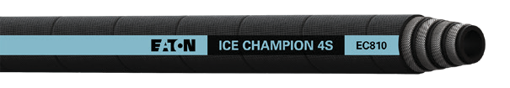
Exceeds SAE 100R15, EN 856 Type R15 Performance
Full specs on page 13
EC810 Hydraulic Hose
Use compatible Spiral R15 Premium Low Temp. hose

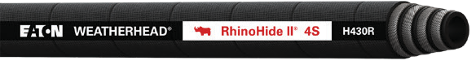
Premium Abrasion

Inner Tube:
Nitrile
Reinforcement:
4 wire spiral
Cover:
UHMWPE
Typical Application:
High abrasion applications. Hydraulic system service with petroleum and water- base fluids, for general industrial service.
H430R RhinoHide II™
High Pressure Hydraulic Hose
Exceeds SAE 100R12, EN 856 Type R12 Performance

Part # Hose I.D.

Hose O.D. (nominal)

Working Pressure

Min. Burst Pressure

Min. Bend
Radius Weight

 | mm | in | mm | in | bar | psi | bar | psi | mm | in | kg/m | lbs/ft
H430R06 | 9.5 | 0.38 | 20.3 | 0.80 | 280 | 4,050 | 1,120 | 16,200 | 125 | 4.92 | 0.74 | 0.50
H430R08 | 12.7 | 0.50 | 23.2 | 0.92 | 280 | 4,050 | 1,120 | 16,200 | 180 | 7.09 | 0.86 | 0.58
H430R10 | 15.9 | 0.62 | 27.4 | 1.08 | 280 | 4,050 | 1,120 | 16,200 | 200 | 7.87 | 1.04 | 0.70
H430R12 | 19.0 | 0.75 | 30.7 | 1.21 | 280 | 4,050 | 1,120 | 16,200 | 240 | 9.45 | 1.29 | 0.87
H430R16 | 25.4 | 1.00 | 38.0 | 1.50 | 280 | 4,050 | 1,120 | 16,200 | 300 | 11.81 | 2.08 | 1.40
H430R20 | 31.8 | 1.25 | 47.0 | 1.85 | 210 | 3,050 | 840 | 12,200 | 420 | 16.54 | 2.74 | 1.84
H430R24 | 38.1 | 1.50 | 53.5 | 2.11 | 175 | 2,550 | 700 | 10,200 | 500 | 19.69 | 3.12 | 2.10
H430R32 | 50.8 | 2.00 | 66.7 | 2.63 | 175 | 2,550 | 700 | 10,200 | 640 | 25.20 | 4.18 | 2.81

Operating Temperature:
Weatherhead Core Products

Inner Tube:
Synthetic rubber
Reinforcement:
4 wire spiral
Cover:
Synthetic rubber
Typical Application:
Hydraulic system service with petroleum, fire- resistant and water based fluids. Fuel and lubricating systems. For additional approved hydraulics
fluids reference the fluid compatibility charts shown in Eaton catalogs.
MSHA Approved
-40°C to +121°C (-40°F to +250°F)
Fittings:

4S Series

Spiral R13

Premium
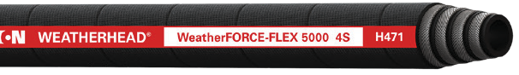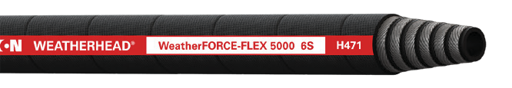H471 WeatherFORCE - FLEX 5000™ Hose
Exceeds SAE 100R13, EN 856 Type R13, ISO 3862 Type R13 Performance
Inner Tube:
Synthetic rubber
Reinforcement:
-12 to -24 size: 4 wire spiral
-32 size: 6 wire spiral

Cover:

Synthetic cover
Typical Application:
High pressure hydraulic system service with

Part # Hose I.D.

Hose O.D. (nominal)

Working Pressure

Min. Burst Pressure
Min. Bend
Radius Weight
petroleum and water-base fluids
MSHA Approved
 | mm | in | mm | in | bar | psi | bar | psi | mm | in | kg/m | lbs/ft
H47112 | 19.0 | 0.75 | 31.0 | 1.22 | 350 | 5,100 | 1,400 | 20,400 | 121 | 4.75 | 1.28 | 0.86
H47116 | 25.4 | 1.00 | 38.4 | 1.51 | 350 | 5,100 | 1,400 | 20,400 | 152 | 6.00 | 1.85 | 1.24
H47120 | 31.8 | 1.25 | 45.5 | 1.79 | 350 | 5,100 | 1,400 | 20,400 | 210 | 8.25 | 2.50 | 1.68
H47124 | 31.8 | 1.50 | 53.5 | 2.11 | 350 | 5,100 | 1,400 | 20,400 | 254 | 10.00 | 3.38 | 2.27
H47132 | 50.8 | 2.00 | 71.8 | 2.83 | 350 | 5,100 | 1,400 | 20,400 | 476 | 18.75 | 6.07 | 4.08

Temp. Range:
-40°C to +127°C (-40°F to +260°F)

Standard
EC420 Hydraulic Hose
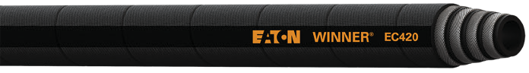
Meets SAE 100R13
Fittings:

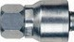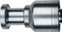

4S/6S Series

Inner Tube:
Synthetic rubber
Reinforcement:
-12, -16 size: 4 wire spiral
-20 to -32 size: 6 wire spiral

Cover:

Synthetic rubber

Hose O.D.
Part # Hose I.D. (nominal)
 | mm | in | mm | in | bar | psi | bar | psi | mm | in | kg/m | lbs/ft
EC420-12 | 19.0 | 0.75 | 32.1 | 1.27 | 350 | 5,100 | 1,400 | 20,400 | 240 | 9.45 | 1.54 | 1.03
EC420-16 | 25.4 | 1.00 | 38.7 | 1.53 | 350 | 5,100 | 1,400 | 20,400 | 300 | 11.81 | 2.01 | 1.35
EC420-20 | 31.8 | 1.25 | 49.8 | 1.96 | 350 | 5,100 | 1,400 | 20,400 | 420 | 16.54 | 3.78 | 2.54
EC420-24 | 38.1 | 1.50 | 57.3 | 2.26 | 350 | 5,100 | 1,400 | 20,400 | 500 | 19.69 | 4.73 | 3.18
EC420-32 | 50.8 | 2.00 | 71.6 | 2.82 | 350 | 5,100 | 1,400 | 20,400 | 630 | 24.80 | 6.26 | 4.21

Working Pressure

Min. Burst Pressure

Min. Bend Radius

Weight
Typical Application:
Suitable for use in hydraulic systems with high peak pressures and arduous operating conditions.
MSHA Approved

Operating Temperature :
-40°C to +121°C (-40°F to +250°F)
Fittings:

4S/6S Series

Premium High Temp.
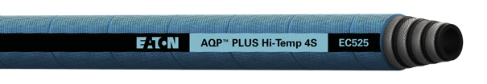
Exceeds SAE 100R12, EN 856 Type R12 Performance
Full specs on page 9
EC525 Hydraulic Hose
Use compatible Spiral R12 Premium High Temp. hose

Premium Low Temp.
Exceeds SAE 100R15, EN 856 Type R15 Performance
Full specs on page 13
EC810 Hydraulic Hose
Use compatible Spiral R15 Premium High Temp. hose

Premium Abrasion
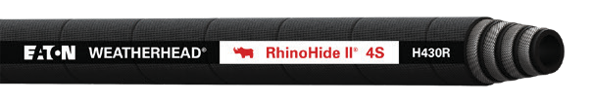
Exceeds SAE 100R12, EN 856 Type R12 Performance
Full specs on page 9
H430R RhinoHide II™ High Pressure Hydraulic Hose
Use compatible Spiral R12 Premium High Temp. hose

Spiral R15

Premium
EC600 X-FLEX Hydraulic Hose
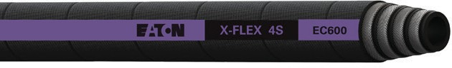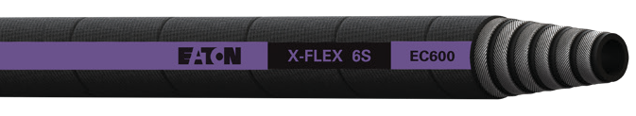
Exceeds SAE 100R15, ISO 18752-DC Performance
Inner Tube:
Synthetic rubber
Reinforcement:
-12, -16 size: 4 wire spiral
-20 size: 6 wire spiral

Cover:

WeatherSHIELD™ high abrasion synthetic rubber
Typical Application:
Hydraulic system service

Hose O.D.
Part # Hose I.D. (nominal)
 | mm | in | mm | in | bar | psi | bar | psi | mm | in | kg/m | lbs/ft
EC600-12 | 19.1 | 0.75 | 32.2 | 1.27 | 420 | 6,100 | 1,680 | 24,400 | 135 | 5.31 | 1.52 | 1.01
EC600-16 | 25.4 | 1.00 | 38.6 | 1.52 | 420 | 6,100 | 1,680 | 24,400 | 165 | 6.5 | 2.04 | 1.36
EC600-20 | 31.8 | 1.25 | 49.7 | 1.96 | 420 | 6,100 | 1,680 | 24,400 | 225 | 8.86 | 3.89 | 2.61

Working Pressure
Min. Burst Pressure
Min. Bend Radius
Weight
with petroleum and water-based fluids, for general industrial service.
MSHA Approved

Operating Temperature :
-40°C to +121°C (-40°F to +250°F)

Standard
EC615 Hydraulic Hose
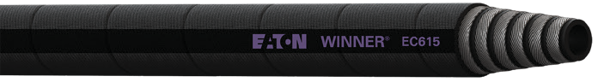
SAE 100R15 Performance

Fittings:

4S/6S Series

Inner Tube:
Synthetic rubber
Reinforcement:
-16 size: 4 wire spiral
-20, -24 size: 6 wire spiral

Cover:

Synthetic rubber

Hose O.D.
Part # Hose I.D. (nominal)
Working Pressure
Min. Burst Pressure
Min. Bend Radius

Weight
Typical Application:

mm in mm in bar psi bar psi mm in kg/m lbs/ft
EC615-16 25.4 1.00 38.7 1.52 420 6,100 1,680 24,400 330 12.99 2.00 1.35
EC615-20 31.8 1.25 49.8 1.96 420 6,100 1,680 24,400 445 17.52 3.77 2.53
EC615-24 38.1 1.50 57.3 2.26 420 6,100 1,680 24,400 530 20.87 5.17 3.47
Suitable for use in hydraulic and oil systems.
MSHA Approved

Operating Temperature :
-40°C to +121°C (-40°F to +250°F)
Fittings:

4S/6S Series

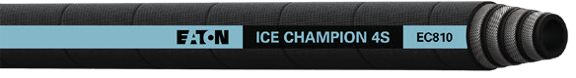
 | mm | in | mm | in | bar | psi | bar | psi | mm | in | kg/m | lbs/ft
EC810-12 | 19.0 | 0.75 | 32.2 | 1.27 | 420 | 6,100 | 1,680 | 24,400 | 280 | 11.02 | 1.61 | 1.08
EC810-16 | 25.4 | 1.00 | 39.0 | 1.54 | 420 | 6,100 | 1,680 | 24,400 | 340 | 13.39 | 2.02 | 1.36
EC810-20 | 31.8 | 1.25 | 49.4 | 1.95 | 420 | 6,100 | 1,680 | 24,400 | 420 | 16.54 | 3.55 | 2.39
EC810-24 | 38.1 | 1.50 | 57.3 | 2.26 | 420 | 6,100 | 1,680 | 24,400 | 510 | 20.08 | 4.74 | 3.19
EC810-32 | 50.8 | 2.00 | 71.1 | 2.80 | 420 | 6,100 | 1,490 | 21,610 | 630 | 24.80 | 6.70 | 4.50

Premium High Temp.
Exceeds SAE 100R12, EN 856 Type R12 Performance
Full specs on page 9
EC525 Hydraulic Hose
Use compatible Spiral R12 Premium High Temp. hose

Premium Low Temp.  Ice Champion™ EC810  Exceeds SAE 100R15, EN 856 Type R15 Performance  Hose O.D. Working Part # Hose I.D. (nominal) Pressure  Operating Temperature :  -57°C to +100°C (-70°F to +212°F) | Min. Burst Pressure | Min. Bend Radius  Fittings: | Weight  4S/6S Series | Inner Tube:
 |  |  |  | Exclusive low temperature tube
 |  |  |  | Reinforcement:
-12, -16 size: 4 wire spiral
-20 to -32 size: 6 wire spiral
 |  |  |  | Cover:
 |  |  |  | MSHA approved abrasion resistant rubber
 |  |  |  | Typical Application:
 |  |  |  | Hydraulic system with petroleum based fluids for low temperature applications.
 |  |  |  | MSHA Approved

Premium Abrasion
Exceeds SAE 100R13, EN 856 Type R13, ISO 3862 3862 Type R13 Performance
Full specs on page 9
H430R RhinoHide II™ High Pressure Hydraulic Hose
Use compatible Spiral R12 Premium High Temp. hose

Braided Hose Fittings Spiral Hose Fittings

Premium
Z-Series
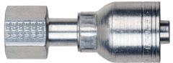
Features:
- New DURA-KOTE™ plating technology for up to 1,000 hours of corrosion resistance
- Bite the wire technology for best in class connection and sealing
- Class zero leakage SAE J1176 on approved hose styles
- Over 550 Z-Series part numbers available
- Eaton’s WeatherMATCH® program provides identification markings on the hose, hose fittings, and crimp dies for quick and easy assembly

Standard
Two-piece Winner
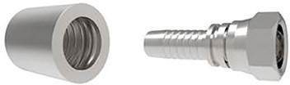
Features:
- Non-skive, two-piece crimp fitting
- One nipple part number for both EC115 & EC215 standard hoses
- Meets industry specifications when used with the EC115 & EC215 standard hoses
- Clear silver hexavalent chromium- free plating
- Carbon steel material

Premium
4S/6S Spiral Series
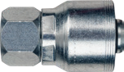
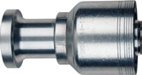
Features:
- New DURA-KOTE™ plating technology for up to 1,000 hours of corrosion resistance
- New patent pending DURA-SEAL™ technology to eliminate hose assembly cool-down leakage
- Class zero leakage SAE J1176 on approved hose styles
- Eaton’s WeatherMATCH® spiral - hose/ fitting identification system program provides identification markings on the hose, hose fittings, and crimp dies for quick and easy assembly

Engineered Assemblies
Eaton’s Weatherhead hoses and fittings are engineered and qualified to work as a system ensuring your confidence in a high quality hose assembly. The 4-Step WeatherMATCH® system for braided and spiral hose assemblies ensures proper mating of hose and qualified fittings.
4 Step
Hose Identification System

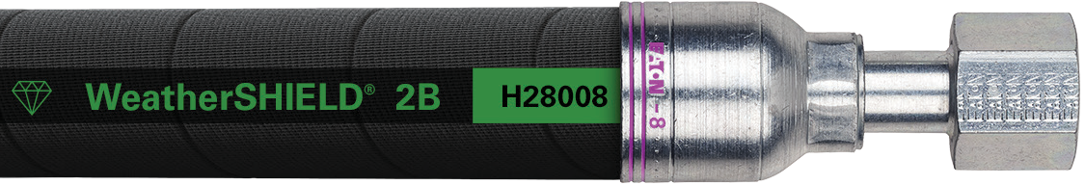Braided Hose Assembly

DURA-KOTE™ Plating Technology
Hose fittings that will now offer 3x the corrosion protection on carbon steel fittings as compared to competitive hose fittings. Eaton‘s DURA-KOTE fittings provide up to 1000 hours of corrosion protection. This is a huge step forward in metal fitting corrosion protection.
3X
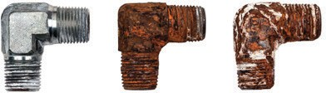
Carbon Steel Corrosion Protection

Fittings

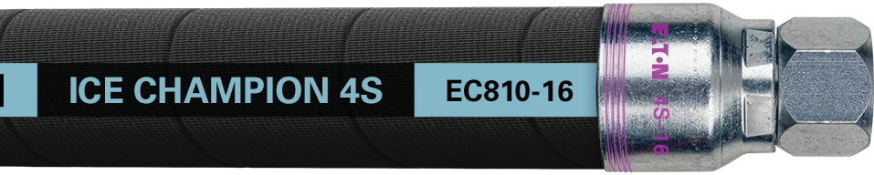Number of rings on socket correspond to hose identifier

Spiral Hose Assembly

Hose dash size is displayed on the socket

DURA-SEAL™ Technology
This patent-pending innovation from Eaton eliminates hose assembly cool-down leakage, while extending hose assembly life, reducing equipment down-time.
Class 0
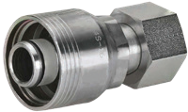
Cool-Down Leakage Protection

4S/6S Fitting

Global crimp nipples/fittings

Complete nipple part number: Product Group
4S A 12 FJ A 16

4S =

6S =
Spiral non-skive fitting part number for four-spiral hose Spiral non-skive fitting part
number for six-spiral hose

Material stock code
A = inch hex stock or metric equivalent

Terminal end connection size* Terminal end connection code

BF =
BP =
BT =
CT =
DK =
DL =
DS =
EK =
FH =
FJ =
FL =
FR =
FS =
JF =
BSP Female Swivel (1 Hex) BSP Male Parallel
BSP Male Tapered CAT Flange
24° Male (light duty)
DKO Female Swivel (light duty) DKO Female Swivel (heavy duty) 24° Male (heavy duty)
SAE Code 62 Flange
SAE JIC 37° Female Swivel SAE Code 61 Flange
ORS Female Swivel
SAE 45° Flare Female Swivel JIS Female Swivel

JM = KF =
KS =
BSP Female Swivel (2 Hexes) Komatsu Female Swivel Komatsu Split Flange

MB = MF = MJ = MP = MR = PF =
PS =
Male O-Ring Boss (ORB) Male Inverted Flare
SAE JIC 37° Male Rigid Male Pipe Rigid
ORS Male
Female Pipe Swivel Male Pipe Swivel

Terminal end connecting configuration
If nipple has a straight configuration, then this position collapses

A = 45°
D = 22 1/2°
H = 110°

B = 90°, standard
or short drop
E = 67 1/2° F = 30°

C = 90° long drop G = 60°
Spiral hose fittings part numbering system
Weatherhead Core Products
Hose size*
Material designation
C = stainless steel, if fitting is zinc plated carbon steel (standard), this position collapses.
* When ordering sizes 3, 4, 5, 6 and 8 the part number requires only single digits

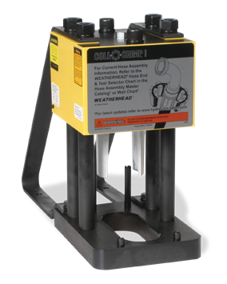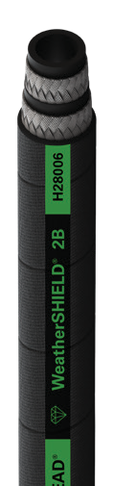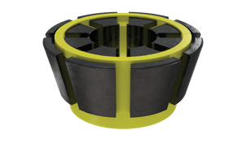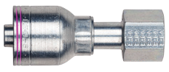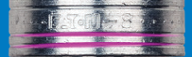
Tooling & Die Packages
T-400 Crimp Example
+
+
Match the rings on the Z-Series Fitting to the hose identifier.
Use the table above to select the right colored collet for a perfect crimp.

Newly designed tooling sets by machine group

Eaton is taking a new approach to helping you succeed by reducing the complexity of our hose and fitting products. This smarter range of key core products will make it easier for you to master our product portfolio, offer your business greater differentiation and reduce your overhead. But we’re not stopping there. Eaton is introducing newly designed tooling sets by machine group that will cover over 80% of your core product crimping needs. This means less issues on your end; from nesting diameters, sticking collets, and other interface problems that we have engineered away. It’s as easy as 1-2-3.
Hose Dash Size | Collet Cage Color Code | Z Series Collet | 4S Series Collet | 6S Series Collet
 |  | Black | Silver | Olive
-04 | Red | 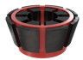 | N/A | N/A
-06 | Yellow | 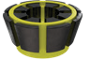 | 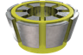 | N/A
-08 | Blue | 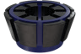 | 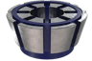 | N/A
-10 | Orange | 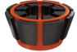 | 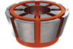 | N/A
-12 | Green | 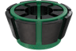 | 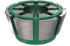 | N/A
-16 | Black | 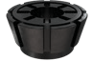 | 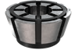 | N/A
-20 | White | 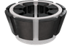 | 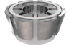 | 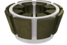
-24 | Dark Red | 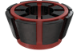 | 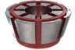 | 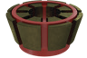
-32 | Dark Green | 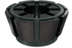 | 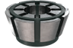 | 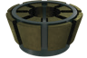

Once you’ve ordered the correct tooling package for your machine simply (refer to back of this sheet):
- Select your core hose and fitting product combination. (making sure that application and regulatory requirements are met)
- Based on the hose size, and the corresponding fitting selected, select the correct color coded collet.
(using the chart at right)
- Based on the crimp machine being used, refer to our core product tooling reference to determine if any spacer rings are required for your assembly.
Features & benefits
- Fitting locators are built into the collets
- Dies are designed for a specific fitting series
- Collet Cages are color coded by size
- Metal Collets are color coded by fitting series
- Part numbers and fitting series are CLEARLY labeled on the collet and spacer rings

Hose | H28006
Fitting | Z-Series
Die Collet Color | Black
Die Collet Cage Color | Yellow

Four tooling packages are conveniently offered
to cover Eaton’s most popular crimp machine models.

Follow this guide to determine what crimp machine support tooling is needed to crimp the hoses found in this brochure.

Optimized Tooling Conversion Packages

These tooling packages are designed for converting existing crimpers. New crimper replacement will require a different tooling package.
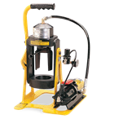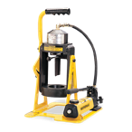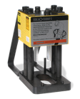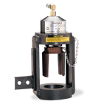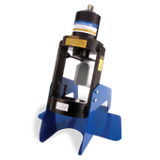
Tooling for Crimp Machines: T-400, T-460*, T-462*,T-465*
Package Part Number
T400TP-1001
Crimps: H180 with Z series sizes -04, -06, -08
H280 with Z series sizes -04, -06, -08, -12, -16
Package Contents
ET313DC-4Z 4Z Braided Collet ET400AR-10 Bowl
ET313DC-6Z 6Z Braided Collet ET313SR-090A H180 4-8 Ring
ET313DC-8Z 8Z Braided Collet ET400SR-280A H280 12-16 Ring
ET400DC-12Z 12Z Braided Collet
ET400DC-16Z 16Z Braided Collet
T-400 machines older than 1980 will not crimp -12 and -16 size due to limited stroke

* Will not crimp -12 and -16 sizes
Part Number Description
Part Number Description
Tooling for Crimp Machines: ET1000

Package Part Number
ET1000TP-1001
Crimps: H180/H280 with Z series sizes -04, -06, -08, -12, -16
H430 with 4S/6S sizes -08, -12, -16
Package Contents

ET313DC-4Z 4Z Braided Collet ET313SR-090A H180 Ring 4,6,8
ET313DC-6Z 6Z Braided Collet ET425SR-150A H180 Ring 12,16
ET313DC-8Z 8Z Braided Collet ET313DC-4S8 4S8 Spiral Collet
ET1000DC-12Z 12Z Braided Collet ET1000DC-4S12 4S12 Spiral Collet
ET1000DC-16Z 16Z Braided Collet ET1000DC-4S16 4S16 Spiral Collet
Part Number Description
Part Number Description

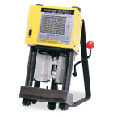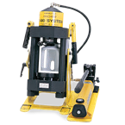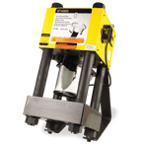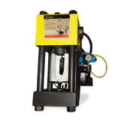
Tooling for Crimp Machines: T-420, T-480

Package Part Number
T420TP-1001
Crimps: H180/H280 with Z series sizes -04, -06, -08, -12, -16
H430 with 4S/6S sizes -08, -12, -16, -20
Package Contents

ET425DC-4Z 4Z Braided Collet ET425SR-105A H180 Ring
ET425DC-6Z 6Z Braided Collet ET425DC-4S8 4S8 Spiral Collet
ET425DC-8Z 8Z Braided Collet ET425DC-4S12 4S12 Spiral Collet
ET425DC-12Z 12Z Braided Collet ET425DC-4S16 4S16 Spiral Collet
ET425DC-16Z 16Z Braided Collet ET425DC-4S20 4S20 Spiral Collet
ET425AR-14 Bowl
Part Number Description
Part Number Description
Tooling for Crimp Machines: ET4000, ET4001, T-410*, T-440*

Package Part Number
ET4001TP-1001
Crimps: H180/H280 with Z series sizes -04, -06, -08, -12, -16
H430 with 4S/6S sizes -08, -12, -16, -20, -24, -32
Package Contents

ET525DC-4Z 4Z Braided Collet ET525DC-4S8 4S8 Spiral Collet
ET525DC-6Z 6Z Braided Collet ET525DC-4S12 4S12 Spiral Collet
ET525DC-8Z 8Z Braided Collet ET525DC-4S16 4S16 Spiral Collet
ET525DC-12Z 12Z Braided Collet ET525DC-4S20 4S20 Spiral Collet
ET525DC-16Z 16Z Braided Collet ET575DC-4S24 4S24 Spiral Collet
ET525SR-120A H180 Ring ET575DC-4S32 4S32 Spiral Collet
ET575SR-135A H43032 Ring

* These machines can not crimp 4S24, 4S32, 6S24, or 6S32 fittings
Part Number Description
Part Number Description

Standard Hose Premium Hose Premium High Temp. Hose Premium Low Temp. Hose Premium Abrasion Hose

T-400
- Wire Braided
- Wire Braided
Spiral R12

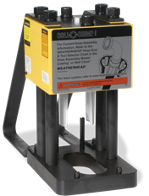
T-400
Dash Size Part Type |  | Part # | EC115 H180 H190H  H145R |  |  |  | EC215 H280 H290H  H245L |  |  |  | EC415  H430 H430R
-04 | Machine Bowl | T-400-8 | X | X | X | X | X | X | X | X
 | Collet | ET313DC-4Z | X | X | X | X | X | X | X | X
 | Spacer Ring | ET313SR-090A |  | X
 | Spacer Ring | ET313SR-075A | X |  | X
 | Spacer Ring | FSD* |  |  |  |  |  | X
 | Spacer Ring | ET313SR-045A |  |  |  |  | X
 | Spacer Ring | ET313SR-030A |  |  |  |  |  |  |  | X
 | Spacer Ring | ET313SR-060A |  |  |  | X
 | Spacer Ring | ET313SR-015D |  |  |  |  |  |  | X
-06 | Machine Bowl | T-400-8 | X | X | X | X | X | X | X | X | X | X | X
 | Collet | ET313DC-6Z | X | X | X | X | X | X | X | X
 | Collet | ET313DC-4S6 |  |  |  |  |  |  |  |  | X | X | X
 | Spacer Ring | ET313SR-090A | X | X | X
 | Spacer Ring | ET313SR-075A |  |  |  | X
 | Spacer Ring | FSD* |  |  |  |  | X | X |  |  |  | X | X
 | Spacer Ring | ET313SR-015A |  |  |  |  |  |  |  |  | X
 | Spacer Ring | ET313SR-030A |  |  |  |  |  |  |  | X
 | Spacer Ring | ET313SR-030D |  |  |  |  |  |  | X
-08 | Machine Bowl | T-400-8 | X | X | X | X | X | X | X | X | X | X | X
 | Collet | ET313DC-8Z | X | X | X | X | X | X | X | X
 | Collet | ET313DC-4S8 |  |  |  |  |  |  |  |  | X | X | X
 | Spacer Ring | ET313SR-090A | X | X
 | Spacer Ring | ET313SR-045A |  |  | X
 | Spacer Ring | ET313SR-060A |  |  |  | X
 | Spacer Ring | FSD* |  |  |  |  |  | X |  |  | X | X | X
 | Spacer Ring | ET313SR-030A |  |  |  |  | X
 | Spacer Ring | ET313SR-030D |  |  |  |  |  |  |  | X
 | Spacer Ring | ET313SR-060D |  |  |  |  |  |  | X
-10 | Machine Bowl | T-400-8 | X | X | X | X | X | X | X | X | X | X | X
 | Collet | ET313DC-10Z | X | X | X | X | X | X | X | X
 | Collet | ET313DC-4S10 |  |  |  |  |  |  |  |  | X | X | X
 | Spacer Ring | ET313SR-180A |  | X
 | Spacer Ring | ET313SR-150A | X
 | Spacer Ring | ET313SR-120A |  |  | X
 | Spacer Ring | FSD* |  |  |  | X |  | X |  | X |  | X | X
 | Spacer Ring | ET313SR-060A |  |  |  |  | X
 | Spacer Ring | ET313SR-015D |  |  |  |  |  |  | X
 | Spacer Ring | ET313SR-030D |  |  |  |  |  |  |  |  | X
-12 | Machine Bowl | ET400AR-10 |  |  |  |  | X | X | X | X
 | Collet | ET400DC-12Z |  |  |  |  | X | X |  | X
 | Spacer Ring | ET400SR-280A |  |  |  |  | X | X |  | X
-16 | Machine Bowl | ET400AR-10 |  |  |  |  | X | X | X | X
 | Collet | ET400DC-16Z |  |  |  |  | X | X |  | X
 | Spacer Ring | ET400SR-280A |  |  |  |  |  | X |  | X
 | Spacer Ring | ET400SR-250A |  |  |  |  | X

T-400 machines older than 1980 will not crimp -12 and -16 size due to limited stroke
* A spacer ring is required for this crimper, but any cupped 5 inch spacer ring FSD will work (examples include ET313SR-015D and T-400-10) Tooling is included in crimper tooling conversion package.

Standard Hose Premium Hose Premium High Temp. Hose Premium Low Temp. Hose Premium Abrasion Hose

T-460, T-462, T-465
  - Wire Braided
  - Wire Braided
Spiral R12

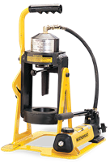

T-460

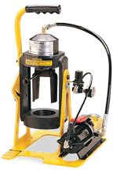
T-462

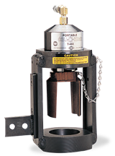
T-465

* A spacer ring is required for this crimper, but any cupped 5 inch spacer ring FSD will work (examples include ET313SR-015D and T-400-10). Tooling is included in crimper tooling conversion package.
Dash Size Part Type |  | Part # | EC115 H180 H190H  H145R |  |  |  | EC215 H280 H290H  H245L |  |  |  | EC415  H430 H430R
-04 | Machine Bowl | Integrated | X | X | X | X | X | X | X | X
 | Collet | ET313DC-4Z | X | X | X | X | X | X | X | X
 | Spacer Ring | ET313SR-090A |  | X
 | Spacer Ring | ET313SR-075A | X |  | X
 | Spacer Ring | FSD* |  |  |  |  |  | X
 | Spacer Ring | ET313SR-045A |  |  |  |  | X
 | Spacer Ring | ET313SR-030A |  |  |  |  |  |  |  | X
 | Spacer Ring | ET313SR-060A |  |  |  | X
 | Spacer Ring | ET313SR-015D |  |  |  |  |  |  | X
-06 | Machine Bowl | Integrated | X | X | X | X | X | X | X | X | X | X | X
 | Collet | ET313DC-6Z | X | X | X | X | X | X | X | X
 | Collet | ET313DC-4S6 |  |  |  |  |  |  |  |  | X | X | X
 | Spacer Ring | ET313SR-090A | X | X | X
 | Spacer Ring | ET313SR-075A |  |  |  | X
 | Spacer Ring | FSD* |  |  |  |  | X | X |  |  |  | X | X
 | Spacer Ring | ET313SR-015A |  |  |  |  |  |  |  |  | X
 | Spacer Ring | ET313SR-030A |  |  |  |  |  |  |  | X
 | Spacer Ring | ET313SR-030D |  |  |  |  |  |  | X
-08 | Machine Bowl | Integrated | X | X | X | X | X | X | X | X | X | X | X
 | Collet | ET313DC-8Z | X | X | X | X | X | X | X | X
 | Collet | ET313DC-4S8 |  |  |  |  |  |  |  |  | X | X | X
 | Spacer Ring | ET313SR-090A | X | X
 | Spacer Ring | ET313SR-045A |  |  | X
 | Spacer Ring | ET313SR-060A |  |  |  | X
 | Spacer Ring | FSD* |  |  |  |  |  | X |  |  | X | X | X
 | Spacer Ring | ET313SR-030A |  |  |  |  | X
 | Spacer Ring | ET313SR-030D |  |  |  |  |  |  |  | X
 | Spacer Ring | ET313SR-060D |  |  |  |  |  |  | X
-10 | Machine Bowl | Integrated | X | X | X | X | X | X | X | X | X | X | X
 | Collet | ET313DC-10Z | X | X | X | X | X | X | X | X
 | Collet | ET313DC-4S10 |  |  |  |  |  |  |  |  | X | X | X
 | Spacer Ring | ET313SR-180A |  | X
 | Spacer Ring | ET313SR-150A | X
 | Spacer Ring | ET313SR-120A |  |  | X
 | Spacer Ring | FSD* |  |  |  | X |  | X |  | X |  | X | X
 | Spacer Ring | ET313SR-060A |  |  |  |  | X
 | Spacer Ring | ET313SR-015D |  |  |  |  |  |  | X
 | Spacer Ring | ET313SR-030D |  |  |  |  |  |  |  |  | X

Standard Hose Premium Hose Premium High Temp. Hose Premium Low Temp. Hose Premium Abrasion Hose

ET1000

- Wire Braided

- Wire Braided

Spiral R12

Spiral R13
Spiral R15

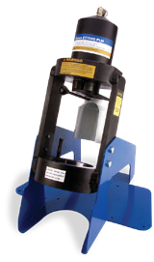

ET1000

* Requires a ET1000C-0012 pusher extension to be placed on top of these spacer rings
Dash Size Part Type |  | Part # | EC115 H180 H190H  H145R |  |  |  | EC215 H280 H290H  H245L |  |  |  | EC415 H430 EC525  H430R |  |  |  | EC420  H471 |  | EC615 EC600  EC810
-04 | Machine Bowl | Integrated | X | X | X | X | X | X | X | X
 | Adapter Bowl | ET1000AR-001 | X | X | X | X | X | X | X | X
 | Collet | ET313DC-4Z | X | X | X | X | X | X | X | X
 | Spacer Ring | ET313SR-090A |  | X
 | Spacer Ring | ET313SR-075A | X |  | X
 | Spacer Ring | ET313SR-060A |  |  |  | X
 | Spacer Ring | FSD** |  |  |  |  |  | X
 | Spacer Ring | ET313SR-045A |  |  |  |  | X
 | Spacer Ring | ET313SR-030A |  |  |  |  |  |  |  | X
 | Spacer Ring | ET313SR-015D |  |  |  |  |  |  | X
-06 | Machine Bowl | Intergrated | X | X | X | X | X | X | X | X | X | X |  | X
 | Adapter Bowl | ET1000AR-001 | X | X | X | X | X | X | X | X | X | X |  | X
 | Collet | ET313DC-6Z | X | X | X | X | X | X | X | X
 | Collet | ET313DC-4S6 |  |  |  |  |  |  |  |  | X | X |  | X
 | Spacer Ring | ET313SR-090A | X | X | X
 | Spacer Ring | ET313SR-075A |  |  |  | X
 | Spacer Ring | FSD** |  |  |  |  | X | X |  |  |  | X |  | X
 | Spacer Ring | ET313SR-015A |  |  |  |  |  |  |  |  | X
 | Spacer Ring | ET313SR-030A |  |  |  |  |  |  |  | X
 | Spacer Ring | ET313SR-030D |  |  |  |  |  |  | X
-08 | Machine Bowl | Intergrated | X | X | X | X | X | X | X | X | X | X |  | X
 | Adapter Bowl | ET1000AR-001 | X | X | X | X | X | X | X | X | X | X |  | X
 | Collet | ET313DC-8Z | X | X | X | X | X | X | X | X
 | Collet | ET313DC-4S8 |  |  |  |  |  |  |  |  | X | X |  | X
 | Spacer Ring | ET313SR-090A | X | X
 | Spacer Ring | ET313SR-045A |  |  | X
 | Spacer Ring | ET313SR-060A |  |  |  | X
 | Spacer Ring | FSD** |  |  |  |  |  | X |  |  | X | X |  | X
 | Spacer Ring | ET313SR-030A |  |  |  |  | X
 | Spacer Ring | ET313SR-030D |  |  |  |  |  |  |  | X
 | Spacer Ring | ET313SR-060D |  |  |  |  |  |  | X
-10 | Machine Bowl | Intergrated | X | X | X | X | X | X | X | X | X | X |  | X
 | Adapter Bowl | ET1000AR-001 | X | X | X | X | X | X | X | X | X | X |  | X
 | Collet | ET313DC-10Z | X | X | X | X | X | X | X | X
 | Collet | ET313DC-4S10 |  |  |  |  |  |  |  |  | X | X |  | X
 | Spacer Ring | ET313SR-150A | X
 | Spacer Ring | ET313SR-180A |  | X
 | Spacer Ring | ET313SR-120A |  |  | X
 | Spacer Ring | FSD** |  |  |  | X |  | X |  | X |  | X |  | X
 | Spacer Ring | ET313SR-060A |  |  |  |  | X
 | Spacer Ring | ET313SR-015D |  |  |  |  |  |  | X |  | X
-12 | Machine Bowl | Integrated | X | X | X | X | X | X | X | X | X | X | X | X | X | X |  | X | X
 | Collet | ET1000DC-12Z | X | X | X | X | X | X | X | X
 | Collet | ET1000DC-4S12 |  |  |  |  |  |  |  |  | X | X | X | X | X | X |  | X | X
 | Spacer Ring | ET425SR-075A* | X
 | Spacer Ring | ET425SR-150A* |  | X
 | Spacer Ring | ET425SR-030D |  |  | X
 | Spacer Ring | ET425SR-090D |  |  |  | X
 | Spacer Ring | FSD** |  |  |  |  | X | X |  |  |  | X |  |  | X
 | Spacer Ring | ET425SR-105D |  |  |  |  |  |  | X
 | Spacer Ring | ET425SR-015D |  |  |  |  |  |  |  | X |  |  | X |  |  |  |  |  | X
 | Spacer Ring | ET425SR-105A* |  |  |  |  |  |  |  |  | X
 | Spacer Ring | ET425SR-030A* |  |  |  |  |  |  |  |  |  |  |  | X
 | Spacer Ring | ET425SR-015A* |  |  |  |  |  |  |  |  |  |  |  |  |  | X
 | Spacer Ring | ET425SR-045A* |  |  |  |  |  |  |  |  |  |  |  |  |  |  |  | X
-16 | Machine Bowl | Integrated | X | X | X | X | X | X | X | X | X | X | X | X | X | X | X | X | X
 | Collet | ET1000DC-16Z | X | X | X | X | X | X | X | X
 | Collet | ET1000DC-4S16 |  |  |  |  |  |  |  |  | X | X | X | X | X | X | X | X | X
 | Spacer Ring | ET425SR-015D | X |  |  |  |  |  |  | X
 | Spacer Ring | ET425SR-150A* |  | X
 | Spacer Ring | ET425SR-090D |  |  | X |  | X
 | Spacer Ring | ET425SR-045D |  |  |  | X
 | Spacer Ring | FSD** |  |  |  |  |  | X |  |  |  | X | X |  |  |  |  |  | X
 | Spacer Ring | ET425SR-045A |  |  |  |  |  |  |  |  |  |  |  |  |  |  |  | X
 | Spacer Ring | ET425SR-225D |  |  |  |  |  |  | X
 | Spacer Ring | ET425SR-030A* |  |  |  |  |  |  |  |  | X |  |  |  | X |  | X
 | Spacer Ring | ET425SR-015A* |  |  |  |  |  |  |  |  |  |  |  | X
 | Spacer Ring | ET425SR-030D |  |  |  |  |  |  |  |  |  |  |  |  |  | X

** A spacer ring is required for this crimper, but any cupped 5 inch spacer ring FSD will work (examples include ET313SR-015D and T-400-10) Tooling is included in crimper tooling conversion package.

Standard Hose
Premium Hose
Premium High Temp. Hose
Premium Low Temp. Hose
Premium Abrasion Hose

T-420, T-480
1-Wire Braided
2-Wire Braided
Spiral R12
Spiral R13
Spiral R15

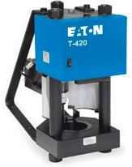
T-420

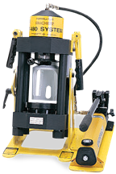

Tooling is included in crimper tooling conversion package.
Dash Size Part Type |  | Part # | EC115 H180 H190H  H145R |  |  |  | EC215 H280 H290H  H245L |  |  |  | EC415  H430 EC525 H430R |  |  |  | EC420  H471 |  | EC615 EC600  EC810
-04 | Machine Bowl | ET425AR-14 | X | X | X | X | X | X | X | X
 | Collet | ET425DC-4Z | X | X | X | X | X | X | X | X
 | Spacer Ring | ET425SR-090A | X
 | Spacer Ring | ET425SR-105A |  | X
 | Spacer Ring | ET425SR-075A |  |  | X
 | Spacer Ring | ET425SR-060A |  |  |  | X
 | Spacer Ring | ET425SR-045A |  |  |  |  | X
 | Spacer Ring | ET425SR-015D |  |  |  |  |  |  | X
 | Spacer Ring | ET425SR-030A |  |  |  |  |  |  |  | X
-06 | Machine Bowl | ET425AR-14 | X | X | X | X | X | X | X | X | X | X |  | X
 | Collet | ET425DC-6Z | X | X | X | X | X | X | X | X
 | Collet | ET425DC-4S6 |  |  |  |  |  |  |  |  | X | X |  | X
 | Spacer Ring | ET425SR-105A | X | X
 | Spacer Ring | ET425SR-090A |  |  | X
 | Spacer Ring | ET425SR-075A |  |  |  | X
 | Spacer Ring | ET425SR-045D |  |  |  |  |  |  | X
 | Spacer Ring | ET425SR-030A |  |  |  |  |  |  |  | X
 | Spacer Ring | ET425SR-015A |  |  |  |  |  |  |  |  | X
-08 | Machine Bowl | ET425AR-14 | X | X | X | X | X | X | X | X | X | X |  | X
 | Collet | ET425DC-8Z | X | X | X | X | X | X | X | X
 | Collet | ET425DC-4S8 |  |  |  |  |  |  |  |  | X | X |  | X
 | Spacer Ring | ET425SR-030D |  |  |  |  |  |  |  | X
 | Spacer Ring | ET425SR-060D |  |  |  |  |  |  | X
 | Spacer Ring | ET425SR-090A | X
 | Spacer Ring | ET425SR-105A |  | X
 | Spacer Ring | ET425SR-045A |  |  | X
 | Spacer Ring | ET425SR-030A |  |  |  |  | X
 | Spacer Ring | ET425SR-075A |  |  |  | X
 | Spacer Ring | ET425SR-015A |  |  |  |  |  |  |  |  | X
-10 | Machine Bowl | ET425AR-14 | X | X | X | X | X | X | X | X | X | X |  | X
 | Collet | ET425DC-10Z | X | X | X | X | X | X | X | X
 | Collet | ET425DC-4S10 |  |  |  |  |  |  |  |  | X | X |  | X
 | Spacer Ring | ET425SR-165A | X
 | Spacer Ring | ET425SR-195A |  | X
 | Spacer Ring | ET425SR-120A |  |  | X
 | Spacer Ring | ET425SR-060A |  |  |  |  | X
 | Spacer Ring | ET425SR-015D |  |  |  |  |  |  |  |  | X
 | Spacer Ring | ET425SR-030D |  |  |  |  |  |  | X
-12 | Machine Bowl | ET425AR-14 | X | X | X | X | X | X | X | X | X | X | X | X | X | X |  | X | X
 | Collet | ET425DC-12Z | X | X | X | X | X | X | X | X
 | Collet | ET425DC-4S12 |  |  |  |  |  |  |  |  | X | X | X | X | X | X |  | X | X
 | Spacer Ring | ET425SR-060A | X
 | Spacer Ring | ET425SR-105A |  | X
 | Spacer Ring | ET425SR-015D |  |  | X |  |  |  |  |  |  |  | X |  |  |  |  |  | X
 | Spacer Ring | ET425SR-075D |  |  |  | X |  |  | X
 | Spacer Ring | ET425SR-075A |  |  |  |  |  |  |  |  | X
 | Spacer Ring | ET425SR-015A |  |  |  |  |  |  |  |  |  |  |  | X
 | Spacer Ring | ET425SR-030A |  |  |  |  |  |  |  |  |  |  |  |  |  |  |  | X
-16 | Machine Bowl | ET425AR-14 | X | X | X | X | X | X | X | X | X | X | X | X | X | X | X | X | X
 | Collet | ET425DC-16Z | X | X | X | X | X | X | X | X
 | Collet | ET425DC-4S16 |  |  |  |  |  |  |  |  | X | X | X | X | X | X | X | X | X
 | Spacer Ring | ET425SR-015D | X |  |  |  |  |  |  | X |  |  |  |  |  | X
 | Spacer Ring | ET425SR-105A |  | X
 | Spacer Ring | ET425SR-030D |  |  |  | X
 | Spacer Ring | ET425SR-060D |  |  | X |  | X
 | Spacer Ring | ET425SR-165D |  |  |  |  |  |  | X
 | Spacer Ring | ET425SR-015A |  |  |  |  |  |  |  |  | X |  |  | X | X |  | X | X
-20 | Machine Bowl | ET425AR-14 | X | X | X | X | X | X | X | X | X | X | X | X |  | X
 | Collet | ET425DC-20Z | X | X | X |  | X | X | X | X
 | Collet | ET425DC-4S20 |  |  |  |  |  |  |  |  | X | X | X | X |  | X
 | Spacer Ring | ET425SR-105A | X | X | X
 | Spacer Ring | ET425SR-015D |  |  |  |  |  |  |  |  | X
 | Spacer Ring | ET425SR-030D |  |  |  |  | X
 | Spacer Ring | ET425SR-195D |  |  |  |  |  |  | X
 | Spacer Ring | ET425SR-015A |  |  |  |  |  |  |  |  |  |  |  | X
 | Spacer Ring | ET425SR-060A |  |  |  |  |  |  |  |  |  |  |  |  |  | X

T-480

Standard Hose Premium Hose Premium High Temp. Hose Premium Low Temp. Hose Premium Abrasion Hose

ET4000, ET4001
Dash Size Part Type |  | Part # | EC115 H180 H190H  H145R |  |  |  | EC215 H280 H290H  H245L |  |  |  | EC415  H430  EC525 H430R |  |  |  | EC420  H471 |  | EC615 EC600  EC810
-04 | Machine Bowl | ET4000AR-001 | X | X | X | X | X | X | X | X
 | Collet | ET525DC-4Z | X | X | X | X | X | X | X | X
 | Spacer Ring | ET525SR-105A | X
 | Spacer Ring | ET525SR-120A |  | X
 | Spacer Ring | ET525SR-090A |  |  | X
 | Spacer Ring | ET525SR-060A |  |  |  |  | X
 | Spacer Ring | ET525SR-075A |  |  |  | X
 | Spacer Ring | ET525SR-015D |  |  |  |  |  |  | X
 | Spacer Ring | ET525SR-045A |  |  |  |  |  |  |  | X
-06 | Machine Bowl | ET4000AR-001 | X | X | X | X | X | X | X | X | X | X |  | X
 | Collet | ET525DC-6Z | X | X | X | X | X | X | X | X
 | Collet | ET525DC-4S6 |  |  |  |  |  |  |  |  | X | X |  | X
 | Spacer Ring | ET525SR-120A | X | X
 | Spacer Ring | ET525SR-105A |  |  | X
 | Spacer Ring | ET525SR-90A |  |  |  | X
 | Spacer Ring | ET525SR-015A |  |  |  |  |  |  |  |  | X
 | Spacer Ring | ET525SR-045D |  |  |  |  |  |  | X
 | Spacer Ring | ET525SR-030A |  |  |  |  |  |  |  | X
-08 | Machine Bowl | ET4000AR-001 | X | X | X | X | X | X | X | X | X | X |  | X
 | Collet | ET525DC-8Z | X | X | X | X | X | X | X | X
 | Collet | ET525DC-4S8 |  |  |  |  |  |  |  |  | X | X |  | X
 | Spacer Ring | ET525SR-120A | X | X
 | Spacer Ring | ET525SR-045A |  |  | X |  | X
 | Spacer Ring | ET525SR-090A |  |  |  | X
 | Spacer Ring | ET525SR-015A |  |  |  |  |  |  |  |  | X
 | Spacer Ring | ET525SR-075D |  |  |  |  |  |  | X
 | Spacer Ring | ET525SR-030D |  |  |  |  |  |  |  | X
-10 | Machine Bowl | ET4000AR-001 |  |  |  |  |  |  |  |  | X | X |  | X
 | Collet | ET525DC-10Z | X | X | X | X | X | X | X | X
 | Collet | ET525DC-4S10 |  |  |  |  |  |  |  |  | X | X |  | X
 | Spacer Ring | ET525SR-195A | X
 | Spacer Ring | ET525SR-225A |  | X
 | Spacer Ring | ET525SR-150A |  |  | X
 | Spacer Ring | ET525SR-015D |  |  |  |  |  |  |  |  | X
 | Spacer Ring | ET525SR-075A |  |  |  |  | X
 | Spacer Ring | ET525SR-030D |  |  |  |  |  |  | X
-12 | Machine Bowl | ET4000AR-001 | X | X | X | X | X | X | X | X | X | X | X | X | X | X |  | X | X
 | Collet | ET525DC-12Z | X | X | X | X | X | X | X | X
 | Collet | ET525DC-4S12 |  |  |  |  |  |  |  |  | X | X | X | X | X | X |  | X | X
 | Spacer Ring | ET525SR-060A | X
 | Spacer Ring | ET525SR-120A |  | X
 | Spacer Ring | ET525SR-015D |  |  | X |  |  |  |  | X |  |  | X |  |  |  |  |  | X
 | Spacer Ring | ET525SR-075D |  |  |  | X
 | Spacer Ring | ET525SR-090D |  |  |  |  |  |  | X
 | Spacer Ring | ET525SR-075A |  |  |  |  |  |  |  |  | X
 | Spacer Ring | ET525SR-015A |  |  |  |  |  |  |  |  |  |  |  | X
 | Spacer Ring | ET525SR-030A |  |  |  |  |  |  |  |  |  |  |  |  |  |  |  | X
-16 | Machine Bowl | ET4000AR-001 | X | X | X | X | X | X | X | X | X | X | X | X | X | X | X | X | X
 | Collet | ET525DC-16Z | X | X | X | X | X | X | X | X
 | Collet | ET525DC-4S16 |  |  |  |  |  |  |  |  | X | X | X | X | X | X | X | X | X
 | Spacer Ring | ET525SR-015D | X |  |  |  |  |  |  | X |  |  |  |  |  | X
 | Spacer Ring | ET525SR-120A |  | X
 | Spacer Ring | ET525SR-075D |  |  | X |  | X
 | Spacer Ring | ET525SR-030D |  |  |  | X
 | Spacer Ring | ET525SR-030A |  |  |  |  |  |  |  |  | X |  |  |  | X |  | X | X
 | Spacer Ring | ET525SR-180D |  |  |  |  |  |  | X
 | Spacer Ring | ET525SR-015A |  |  |  |  |  |  |  |  |  |  |  | X

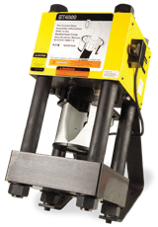
ET4000
- Wire Braided
- Wire Braided
Spiral R12
Spiral R13
Spiral R15

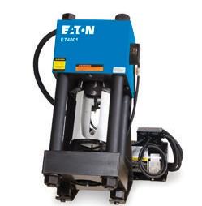
ET4001

Tooling is included in crimper tooling conversion package.

Standard Hose Premium Hose Premium High Temp. Hose Premium Low Temp. Hose Premium Abrasion Hose

ET4000, ET4001 _{(cont.)}

1-Wire Braided

2-Wire Braided

Spiral R12

Spiral R13

Spiral R15

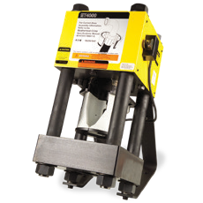
ET4000
Dash Size Part Type |  | Part # | EC115 H180 H190H  H145R |  |  |  | EC215 H280 H290H  H245L |  |  |  | EC415  H430  EC525 H430R |  |  |  | EC420  H471 |  | EC615  EC600 EC810
-20 | Machine Bowl | ET4000AR-001 | X | X | X | X | X | X | X | X | X | X | X | X | X | X | X | X | X
 | Collet | ET525DC-20Z | X | X | X |  | X | X | X | X
 | Collet | ET525DC-4S20 |  |  |  |  |  |  |  |  | X | X | X | X |  | X
 | Collet | ET525DC-6S20 |  |  |  |  |  |  |  |  |  |  |  |  | X |  | X | X | X
 | Spacer Ring | ET525SR-240A | X | X | X
 | Spacer Ring | ET525SR-090A |  |  |  |  | X
 | Spacer Ring | ET525SR-120A |  |  |  |  |  | X |  | X
 | Spacer Ring | ET525SR-120D |  |  |  |  |  |  | X
 | Spacer Ring | ET525SR-015D |  |  |  |  |  |  |  |  | X |  |  |  |  |  |  | X
 | Spacer Ring | ET525SR-030A |  |  |  |  |  |  |  |  |  |  |  | X
 | Spacer Ring | ET525SR-045D |  |  |  |  |  |  |  |  |  |  |  |  | X
 | Spacer Ring | ET525SR-075A |  |  |  |  |  |  |  |  |  |  |  |  |  | X
 | Spacer Ring | ET525SR-045A |  |  |  |  |  |  |  |  |  |  |  |  |  |  | X
-24 | Machine Bowl | ET4000AR-001 | X | X | X | X | X | X | X | X
 | Machine Bowl | ET4000AR-002 |  |  |  |  |  |  |  |  | X | X | X | X | X | X | X |  | X
 | Collet | ET525DC-24Z |  | X | X |  | X | X | X | X
 | Collet | ET575DC-4S24 |  |  |  |  |  |  |  |  | X | X | X | X |  | X
 | Collet | ET575DC-6S24 |  |  |  |  |  |  |  |  |  |  |  |  | X |  | X |  | X
 | Spacer Ring | ET525SR-225A |  | X |  |  |  | X
 | Spacer Ring | ET525SR-150A |  |  | X
 | Spacer Ring | ET525SR-180A |  |  |  |  | X
 | Spacer Ring | ET525SR-060D |  |  |  |  |  |  | X
 | Spacer Ring | ET525SR-210A |  |  |  |  |  |  |  | X
 | Spacer Ring | ET575SR-015A |  |  |  |  |  |  |  |  | X
 | Spacer Ring | ET575SR-045D |  |  |  |  |  |  |  |  |  |  |  |  | X
 | Spacer Ring | ET575SR-030A |  |  |  |  |  |  |  |  |  |  |  |  |  | X
-32 | Machine Bowl | ET4000AR-001 | X | X | X | X | X | X | X | X
 | Machine Bowl | ET4000AR-002 |  |  |  |  |  |  |  |  | X | X | X | X | X | X |  |  | X
 | Collet | ET525DC-32Z |  | X | X |  | X | X | X | X
 | Collet | ET575DC-4S32 |  |  |  |  |  |  |  |  | X | X | X | X
 | Collet | ET575DC-6S32 |  |  |  |  |  |  |  |  |  |  |  |  | X | X |  |  | X
 | Spacer Ring | ET525SR-180A |  | X |  |  |  | X |  | X
 | Spacer Ring | ET525SR-030D |  |  | X
 | Spacer Ring | ET525SR-015A |  |  |  |  |  |  | X |  |  |  |  |  |  | X
 | Spacer Ring | ET525SR-120A |  |  |  |  | X
 | Spacer Ring | ET575SR-060A |  |  |  |  |  |  |  |  |  |  |  |  | X
 | Spacer Ring | ET575SR-120A |  |  |  |  |  |  |  |  | X
 | Spacer Ring | ET575SR-135A |  |  |  |  |  |  |  |  |  | X | X | X
 | Spacer Ring | ET575SR-075A |  |  |  |  |  |  |  |  |  |  |  |  |  |  |  |  | X

ET4001

Tooling is included in crimper tooling conversion package.

Standard Hose Premium Hose Premium High Temp. Hose Premium Low Temp. Hose Premium Abrasion Hose

T-410*, T-440* 1-Wire
Braided

2-Wire Braided

Spiral R12

Spiral R13

Spiral R15

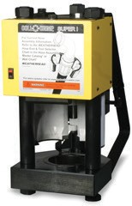
T-410
Dash Size Part Type |  | Part # | EC115 H180 H190H  H145R |  |  |  | EC215 H280 H290H  H245L |  |  |  | EC415  H430  EC525 H430R |  |  |  | EC420  H471 |  | EC615  EC600 EC810
-04 | Machine Bowl | T-410-26 | X | X | X | X | X | X | X | X
 | Collet | ET525DC-4Z | X | X | X | X | X | X | X | X
 | Spacer Ring | ET525SR-105A | X
 | Spacer Ring | ET525SR-120A |  | X
 | Spacer Ring | ET525SR-090A |  |  | X
 | Spacer Ring | ET525SR-060A |  |  |  |  | X
 | Spacer Ring | ET525SR-075A |  |  |  | X
 | Spacer Ring | ET525SR-015D |  |  |  |  |  |  | X
 | Spacer Ring | ET525SR-045A |  |  |  |  |  |  |  | X
-06 | Machine Bowl | T-410-26 | X | X | X | X | X | X | X | X | X | X |  | X
 | Collet | ET525DC-6Z | X | X | X | X | X | X | X | X
 | Collet | ET525DC-4S6 |  |  |  |  |  |  |  |  | X | X |  | X
 | Spacer Ring | ET525SR-120A | X | X
 | Spacer Ring | ET525SR-105A |  |  | X
 | Spacer Ring | ET525SR-90A |  |  |  | X
 | Spacer Ring | ET525SR-015A |  |  |  |  |  |  |  |  | X
 | Spacer Ring | ET525SR-045D |  |  |  |  |  |  | X
 | Spacer Ring | ET525SR-030A |  |  |  |  |  |  |  | X
-08 | Machine Bowl | T-410-26 | X | X | X | X | X | X | X | X | X | X |  | X
 | Collet | ET525DC-8Z | X | X | X | X | X | X | X | X
 | Collet | ET525DC-4S8 |  |  |  |  |  |  |  |  | X | X |  | X
 | Spacer Ring | ET525SR-120A | X | X
 | Spacer Ring | ET525SR-045A |  |  | X |  | X
 | Spacer Ring | ET525SR-090A |  |  |  | X
 | Spacer Ring | ET525SR-015A |  |  |  |  |  |  |  |  | X
 | Spacer Ring | ET525SR-075D |  |  |  |  |  |  | X
 | Spacer Ring | ET525SR-030D |  |  |  |  |  |  |  | X
-10 | Machine Bowl | T-410-26 | X | X | X | X | X | X | X | X | X | X |  | X
 | Collet | ET525DC-10Z | X | X | X | X | X | X | X | X
 | Collet | ET525DC-4S10 |  |  |  |  |  |  |  |  | X | X |  | X
 | Spacer Ring | ET525SR-195A | X
 | Spacer Ring | ET525SR-225A |  | X
 | Spacer Ring | ET525SR-150A |  |  | X
 | Spacer Ring | ET525SR-015D |  |  |  |  |  |  |  |  | X
 | Spacer Ring | ET525SR-075A |  |  |  |  | X
 | Spacer Ring | ET525SR-030D |  |  |  |  |  |  | X
-12 | Machine Bowl | T-410-26 | X | X | X | X | X | X | X | X | X | X | X | X | X | X | X | X | X
 | Collet | ET525DC-12Z | X | X | X | X | X | X | X | X
 | Collet | ET525DC-4S12 |  |  |  |  |  |  |  |  | X | X | X | X | X | X |  | X | X
 | Spacer Ring | ET525SR-060A | X
 | Spacer Ring | ET525SR-120A |  | X
 | Spacer Ring | ET525SR-015D |  |  | X |  |  |  |  | X |  |  | X |  |  |  |  |  | X
 | Spacer Ring | ET525SR-075D |  |  |  | X
 | Spacer Ring | ET525SR-090D |  |  |  |  |  |  | X
 | Spacer Ring | ET525SR-075A |  |  |  |  |  |  |  |  | X
 | Spacer Ring | ET525SR-015A |  |  |  |  |  |  |  |  |  |  |  | X
 | Spacer Ring | ET525SR-030A |  |  |  |  |  |  |  |  |  |  |  |  |  |  |  | X

* T-410 and T-440 machines can not crimp 4S24, 4S32, 6S24, or 6S32 fittings Tooling is included in crimper tooling conversion package.

Standard Hose Premium Hose Premium High Temp. Hose Premium Low Temp. Hose Premium Abrasion Hose

T-410*, T-440* (cont.)
Dash Size Part Type |  | Part # | EC115 H180 H190H  H145R |  |  |  | EC215 H280 H290H  H245L |  |  |  | EC415  H430  EC525 H430R |  |  |  | EC420  H471 |  | EC615 EC600  EC810
-16 | Machine Bowl | T-410-26 | X | X | X | X | X | X | X | X | X | X | X | X | X | X | X | X | X
 | Collet | ET525DC-16Z | X | X | X | X | X | X | X | X
 | Collet | ET525DC-4S16 |  |  |  |  |  |  |  |  | X | X | X | X | X | X | X | X | X
 | Spacer Ring | ET525SR-015D | X |  |  |  |  |  |  | X |  |  |  |  |  | X
 | Spacer Ring | ET525SR-120A |  | X
 | Spacer Ring | ET525SR-075D |  |  | X |  | X
 | Spacer Ring | ET525SR-030D |  |  |  | X
 | Spacer Ring | ET525SR-030A |  |  |  |  |  |  |  |  | X |  |  |  | X |  | X | X
 | Spacer Ring | ET525SR-180D |  |  |  |  |  |  | X
 | Spacer Ring | ET525SR-015A |  |  |  |  |  |  |  |  |  |  |  | X
-20 | Machine Bowl | T-410-26 | X | X | X | X | X | X | X | X | X | X | X | X | X | X | X |  | X
 | Collet | ET525DC-20Z | X | X | X |  | X | X | X | X
 | Collet | ET525DC-4S20 |  |  |  |  |  |  |  |  | X | X | X | X |  | X
 | Collet | ET525DC-6S20 |  |  |  |  |  |  |  |  |  |  |  |  | X |  | X |  | X
 | Spacer Ring | ET525SR-240A | X | X | X
 | Spacer Ring | ET525SR-090A |  |  |  |  | X
 | Spacer Ring | ET525SR-120A |  |  |  |  |  | X |  | X
 | Spacer Ring | ET525SR-120D |  |  |  |  |  |  | X
 | Spacer Ring | ET525SR-015D |  |  |  |  |  |  |  |  | X
 | Spacer Ring | ET525SR-030A |  |  |  |  |  |  |  |  |  |  |  | X
 | Spacer Ring | ET525SR-045D |  |  |  |  |  |  |  |  |  |  |  |  | X
 | Spacer Ring | ET525SR-075A |  |  |  |  |  |  |  |  |  |  |  |  |  | X
 | Spacer Ring | ET525SR-045A |  |  |  |  |  |  |  |  |  |  |  |  |  |  | X
-24 | Machine Bowl | T-410-26 | X | X | X | X | X | X | X | X
 | Collet | ET525DC-24Z |  | X | X |  | X | X | X | X
 | Collet | ET575DC-4S24
 | Collet | ET575DC-6S24
 | Spacer Ring | ET525SR-225A |  | X |  |  |  | X
 | Spacer Ring | ET525SR-150A |  |  | X
 | Spacer Ring | ET525SR-180A |  |  |  |  | X
 | Spacer Ring | ET525SR-060D |  |  |  |  |  |  | X
 | Spacer Ring | ET525SR-210A |  |  |  |  |  |  |  | X
 | Spacer Ring | ET575SR-015A
 | Spacer Ring | ET575SR-045D
 | Spacer Ring | ET575SR-030A
-32 | Machine Bowl | T-410-26 | X | X | X | X | X | X | X | X
 | Collet | ET525DC-32Z |  | X | X |  |  | X | X | X
 | Collet | ET575DC-4S32
 | Collet | ET575DC-6S32
 | Spacer Ring | ET525SR-180A |  | X |  |  |  | X |  | X
 | Spacer Ring | ET525SR-030D |  |  | X
 | Spacer Ring | ET575SR-060A
 | Spacer Ring | ET525SR-015A |  |  |  |  |  |  | X
 | Spacer Ring | ET575SR-120A
 | Spacer Ring | ET575SR-135A
 | Spacer Ring | ET575SR-075A

1-Wire Braided

2-Wire Braided

Spiral R12

Spiral R13

Spiral R15

* T-410 and T-440 machines can not crimp 4S24, 4S32, 6S24, or 6S32 fittings Tooling is included in crimper tooling conversion package.
T-410

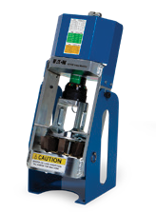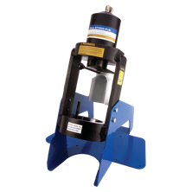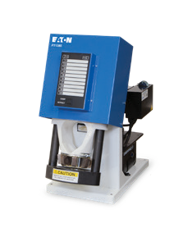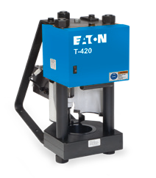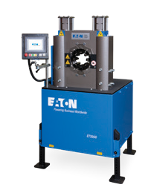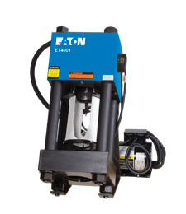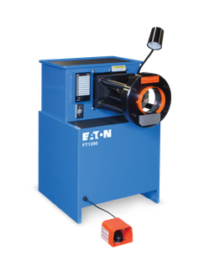

Crimp machine comparison chart
Eaton’s new lineup of positive stop and variable crimpers includes portable, general service, and industrial production options. Compare our new offering of crimp machines
and their associated features to understand which crimper is best for you.

Core crimp machines
 | ET1187 | ET1000 | FT1380 | T-420 | FT1390 | ET4001 | ET5050
Production volume | Low | Low | Medium | Medium | Medium/high | Medium | High
Type | Variable | Positive stop | Variable | Positive stop | Variable | Positive stop | Variable
Capability- braided (up to)  Capability- | 1 1/4 | 1" | 1 1/4" | 1 1/4" | 2" | 2" | 2"

*Capabilities based on Eaton core hose and fitting products
spiral (up to)
1"
1"
1 1/4"
1 1/4"
2"
2"
2"
Capability- industrial (up to)
1 1/4"
1"
1 1/4"
1 1/4"
2"
2"
4"
Application
Portable, job shops,
maintenance departments
Portable, job shops,
maintenance departments
Hose distributors, small assembly shops
Hose distributors, small assembly shops, factory, construction, mines
Hose distributors, assembly shops
Hose distributors, assembly shops, construction, mines
Industrial production facility, specialty
*Pump options
110v,
air/hydraulic, 12v, hand pump
110v,
air/hydraulic, 12v, hand pump
115v, 230v
110v, 220v
115v, 230v
220v
230v, 380v, 400v,
420v, 440v, 460v,
480v,
*See pump ordering options for each machine for specific kit numbers

Helpful tools and features

We're changing
the crimping game.
Mobile crimp tool
We’ve made it easier to help your customers find the proper crimp spec anytime, anywhere with the new mobile crimp spec tool on PowerSource.
Visit www.eaton.com/crimp on your mobile device and follow these steps:

- Find your machine
- Select your hose series
- Select your hose size
- Find your fitting style

Then view your results. Add the tool to your home screen for even quicker access.

Additional Weatherhead collateral

Wall charts Label sets Catalogs

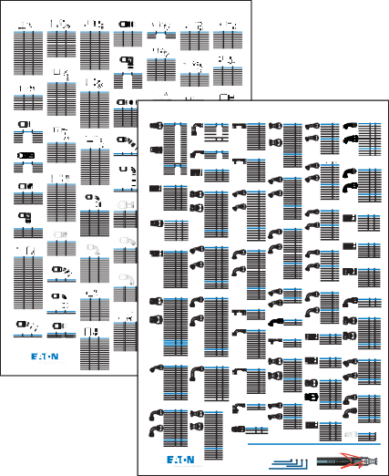
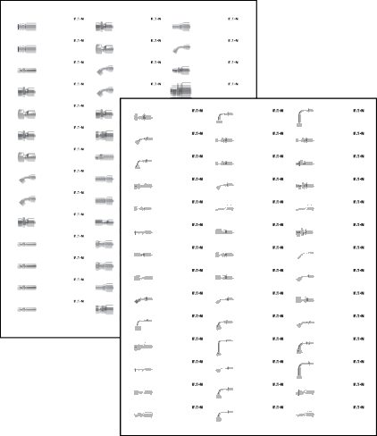
Eaton Weatherhead® Z-Series Braided Hose Ends | Quick Reference

Male Pipe Rigid (NPTF)

JIC/37° Female Swivel,

Female FOR-SEAL® Swivel Male Straight Thread O-ring Swivel Split Flange 22.5° Tube Elbow 60° Cone Female Swivel Straight Female Swivel DIN Universal Seat

45° Tube Elbow
(SAE Code 61)
(BSPP)
90° Tube Elbow, Light

04Z-04L
Sheet 1 of 15
Female (JIS) 30 Flare Swivel straight

04Z-10A
Male DIN 24° Seat (Light)

04Z-40T
Metric Standpipe Straight Tube

–16
Part Number Hose Size Thread Part Number Hose Size Thread Part Number Hose Size Thread Part Number Hose Size Thread Part Number Hose Size KØ Part Number Hose Size Thread Part Number Hose Size Thread
–16
1/4" Hose ID 1/4" Connection Size
*639789294197*
1/4" Hose ID 10mm Connection Size
*639789320063*
1/4" Hose ID 10mm Connection Size
*639789320421*

04Z-102 –04 1/8–27 04Z-684a –04 7/16–20 04Z-S64 –04 9/16–18 04Z-R04 –04 7/16–20 16Z-H03
04Z-104 –04 1/4–18 04Z-685a –04 1/2–20 04Z-S66 –04 11/16–16 06Z-R06 –06 9/16–18 16Z-H04
04Z-106 –04 3/8–18 04Z-686 –04 9/16–18 04Z-S68 –04 13/16–16 06Z-R08 –06 3/4–16 20Z-H04
04Z-108 –04 1/2–14 06Z-684 –06 7/16–20 06Z-S64 –06 9/16–18 08Z-R08 –08 3/4–16
06Z-104 –06 1/4–18 06Z-686 –06 9/16–18 06Z-S66 –06 11/16–18 08Z-R10 –08 7/8–14
06Z-106 –06 3/8–18 06Z-688a –06 3/4–16 06Z-S68 –06 13/16–16 08Z-R12 –08 11/16–12
1.75 04Z-354 –04 G 1/4–19 04Z-58D –04 M14 x 1.5
2.00 04Z-356 –04 G 3/8–19 04Z-60D –04 M16 x 1.5
–20
2.00 06Z-356 –06 G 3/8–19 06Z-60D –06 M16 x 1.5
06Z-358 –06 G 1/2–14 06Z-62D –06 M18 x 1.5
08Z-358 –08 G 1/2–14 08Z-65D –08 M22 x 1.5
08Z-360 –08 G 5/8–14 10Z-68D –10 M26 x 1.5

6 3 9 7 8 9 2 9 4 1 9 7

6 3 9 7 8 9 3 2 0 0 6 3

6 3 9 7 8 9 3 2 0 4 2 1

06Z-108 –06 1/2–14 08Z-688a –08 3/4–16 08Z-S66 –08 11/16–16 10Z-R08 –10 3/4–16 Split Flange 45° Tube Elbow 10Z-360 –10 G 5/8–14 12Z-72D –12 M30 x 2.0

08Z-104 –08 1/4–18 08Z-690a –08 7/8–14 08Z-S68 –08 13/16–16 12Z-R10 –12 7/8–14 (SAE Code 61)
08Z-106 –08 3/8–18 10Z-690a –10 7/8–14 08Z-S70 –08 1–14
08Z-108 –08 1/2–14 10Z-692 –10 11/16–12 08Z-S72 –08 13/16–12
08Z-112 –08 3/4–14 12Z-692 –12 11/16–12 10Z-S68 –10 13/16–16 Male Straight Thread
10Z-106 –10 3/8–18 12Z-696 –12 15/16–12 10Z-S70 –10 1–14 O-ring Swivel 90° Elbow
10Z-108 –10 1/2–14 16Z-696 –16 15/16–12 10Z-S72 –10 13/16–12
12Z-108 –12 1/2–14 a Swivel nuts are universal, both 37˚ and 45˚ connections. 12Z-S72 –12 13/16–12
10Z-112 –10 3/4–14 20Z-697 –20 15/8–12 12Z-S70 –12 1–14
12Z-362 –12 G 3/4–14 16Z-78D –16 M36 x 2.0
16Z-366 –16 G 1–11 20Z-85D –20 M45 x 2.0
20Z-370 –20 G 11/4–11

Male DIN 24° Seat, Light
60° Cone Female Swivel
Part Number Hose Size KØ 45° Tube Elbow (BSPP)

04Z-04S
READY-LOK Male Connector
1/4" Hose ID 1/4" Connection Size
*639789294203*
04Z-10C
Female Swivel DIN 24° Seat (Light) 1/4" Hose ID 10mm Connection Size
*639789320070*
04Z-44P
60 Cone Female Swivel 45° Tube Elbow (BSPP) 1/4" Hose ID 1/4" Connection Size
*639789294296*

12Z-112 –12 3/4–14
12Z-116 –12 1–111/2
16Z-112 –16 3/4–14
16Z-116 –16 1–111/2 JIC/37° Female Swivel,
16Z-120 –16 11/4–111/2 90° Elbow
20Z-116 –20 1–111/2
20Z-120 –20 11/4–111/2
12Z-S76 –12 17/16–12
16Z-S72 –16 13/16–12
16Z-S76 –16 17/16–12
16Z-S80 –16 111/16–12
20Z-S80 –20 111/16–12
24ZA-S84 –24 2–12
08Z-G41 –08 1.19
08Z-G42 –08 1.50
10Z-G42 –10 1.50
12Z-G42 –12 1.50
12Z-G46 –12 1.75
16Z-G46 –16 1.75
16Z-G50 –16 2.00
–06
–04

Part Number Hose Size Thread
04Z-06A –04 M12 x 1.5
04Z-08A –04 M14 x 1.5

6 3 9 7 8 9 2 9 4 2 0 3
04Z-054

6 3 9 7 8 9 3 2 0 0 7 0
04Z-10D

6 3 9 7 8 9 2 9 4 2 9 6
04Z-504

24Z-124 –24 11/2–111/2
Part Number Hose Size Thread 20Z-G46 –20 1.75 Part Number Hose Size Thread 04Z-10A –04 M16 x 1.5
Female Straight Pipe Swivel (NPSM)
Female Swivel DIN universal seat 45° Tube Elbow
SAE 37° (JIC) Male Rigid

32Z-132 –32 2–111/2
Female FOR-SEAL® Swivel, 04Z-R66
9/16–18 20Z-G50 –20 2.00 04Z-44P –04 G 1/4–19 06Z-10A –06 M16 x 1.5

45° Tube Elbow
06Z-R66
06Z-R68
06Z-R70
9/16–18 24Z-G62 –24 2.81 06Z-46P –06 G 3/8–19 06Z-12A –06 M18 x 1.5
3/4–16 32Z-G54 –32 2.37 08Z-48P –08 G 1/2–14 08Z-15A –08 M22 x 1.5
–06
7/ –14 32Z-G62 –32 2.81 10Z-50P –10 G 5/8–14 10Z-18A –10 M26 x 1.5
–06
–08
–08
1/4" Hose ID 1/4" Connection Size
*639789321350*
1/4" Hose ID 10mm Connection Size
*639789320407*
1/4" Hose ID 7/16" Connection Size
*639789292520*

Male Pipe Swivel
Part Number Hose Size Thread
04Z-664a –04 7/16–20
08Z-R68
08Z-R70
08Z-R72
/4–16
7/8–14
–12
–08
11/16–12
11/ –12
12Z-22A –12 M30 x 2.0
12Z-52P –12 G 3/4–14 16Z-28A –16 M36 x 2.0
16Z-56P –16 G 1–11 20Z-35A –20 M45 x 2.0

04Z-665a –04 1/2–20
04Z-666 –04 9/16–18
06Z-664 –06 7/16–20
06Z-666 –06 9/16–18 Part Number Hose Size Thread
12Z-R72
16 Split Flange 60° Tube Elbow 20Z-60P –20 G 11/4–11
(SAE Code 61)
60° Cone Female Swivel
Eaton 4S/6S Spiral Hose Ends | Quick Reference
Female Swivel DIN 24° Seat,
DKO Heavy
6 3 9 7 8 9 3 2 1 3 5 0
04Z-06A
6 3 9 7 8 9 3 2 0 4 0 7
04Z-10E
6 3 9 7 8 9 2 9 2 5 2 0
04Z-505

06Z-668a –06 3/4–16 04Z-L64 –04 9/16–18 Flareless Tube Rigid
Part Number Hose Size Thread 08Z-666 –08 9/16–18 04Z-L66 –04 11/16–16 Ermeto 7000 Series
04Z-J04 –04 1/4–18 08Z-668a –08 3/4–16 06Z-L64 –06 9/16–18
06Z-J04 –06 1/4–18 08Z-670a –08 7/8–14 06Z-L66 –06 11/16–16
06Z-J06 –06 3/8–18 10Z-670a –10 7/8–14 06Z-L68 –06 13/16–16
06Z-J08 –06 1/2–14 10Z-672 –10 11/16–12 08Z-L66 –08 11/16–16
08Z-J06 –08 3/8–18 12Z-670 –12 7/8 –14 08Z-L68 –08 13/16–16
08Z-J08 –08 1/2–14 12Z-672 –12 11/16–12 08Z-L70 –08 1–14
90° Elbow (BSPP)
Male DIN 24° Seat (Light)
1/4" Hose ID 6mm Connection Size
*639789295606*
Female Swivel DIN 24° Seat 45° Tube Elbow (Heavy)
1/4" Hose ID 10mm Connection Size
*639789294258*
6 3 9 7 8 9 2 9 4 2 5 8 6 3 9 7 8 9 2 9 4 3 0 2
04Z-10F 04Z-506
DIN 24° Seat (Heavy) SAE 37° (JIC) Male Rigid
Hose ID 10mm Connection Size 1/4" Hose ID 9/16" Connection Size
*639789294265* *639789292537*
6 3 9 7 8 9 2 9 4 2 6 5 6 3 9 7 8 9 2 9 2 5 3 7
04Z-14K 04Z-58C
Female Swivel 30 Flare Female Swivel DIN 24° Seat (Heavy)
Hose ID 1/4" Hose ID 8mm connection size
*639789294272* *639789294319*
6 3 9 7 8 9 2 9 4 2 7 2 6 3 9 7 8 9 2 9 4 3 1 9
04Z-154 04Z-58D
Pipe Rigid (BSPT) Female Swivel DIN universal seat 90° Tube Elbow
Hose ID 1/4" Connection Size 1/4" Hose ID 8mm connection size
*639789294289* *639789320094*
6 3 9 7 8 9 2 9 4 2 8 9 6 3 9 7 8 9 3 2 0 0 9 4
04Z-202 04Z-58E
Female Pipe Rigid, Dryseal NPTF Female Swivel DIN 24° seat 90° Tube Elbow (Heavy)
Hose ID 1/8" Connection Size 1/4" Hose ID 8mm connection size
*639789320841* *639789332134*
6 3 9 7 8 9 3 2 0 8 4 1 6 3 9 7 8 9 3 3 2 1 3 4
04Z-204 04Z-603
Female Pipe Rigid, Dryseal NPTF JIC 37° Female Swivel
Hose ID 1/4" Connection Size 1/4" Hose ID 3/8" Connection Size
*639789320872* *639789294326*
6 3 9 7 8 9 3 2 0 8 7 2 6 3 9 7 8 9 2 9 4 3 2 6
04Z-254 04Z-604
Female Pipe Swivel JIC 37° Female Swivel
Hose ID 1/4" Connection Size 1/4" Hose ID 7/16" Connection Size
*639789296474* *639789292544*
6 3 9 7 8 9 2 9 6 4 7 4 6 3 9 7 8 9 2 9 2 5 4 4
04Z-354 04Z-605
Cone Female Pipe Swivel (BSPP) JIC 37° Female Swivel
Hose ID 1/4" Connection Size 1/4" Hose ID 1/2" Connection Size
*639789292506* *639789294333*
6 3 9 7 8 9 2 9 2 5 0 6 6 3 9 7 8 9 2 9 4 3 3 3
04Z-356 04Z-606
Cone Female Pipe Swivel (BSPP) JIC 37° Female Swivel
Hose ID 3/8" Connection Size 1/4" Hose ID 9/16" Connection Size
*639789320087* *639789292384*
6 3 9 7 8 9 3 2 0 0 8 7 6 3 9 7 8 9 2 9 2 3 8 4
04Z-38T 04Z-60C
Standpipe Straight Tube Female Swivel DIN 24° Seat (Heavy)
Hose ID 8mm Connection Size 1/4" Hose ID 10mm Connection Size
*639789320414* *639789294340*
6 3 9 7 8 9 3 2 0 4 1 4 6 3 9 7 8 9 2 9 4 3 4 0
04Z-404 04Z-60D
45° Female Swivel Female Swivel DIN Universal 90° Tube Elbow
Hose ID 7/16" Connection Size 1/4" Hose ID 10mm Connection Size
*639789292513* *639789320100*
6 3 9 7 8 9 2 9 2 5 1 3 6 3 9 7 8 9 3 2 0 1 0 0
SAE 37° (JIC) Male Rigid
1/4" Hose ID 1/2" Connection Size
*639789294302*

12Z-J12 –12 3/4–14 12Z-676 –12 15/16–12 08Z-L72 –08 13/16–12 Part Number Hose Size Thread
16Z-J16 –16 1–111/2 16Z-676 –16 15/16–12 10Z-L70 –10 1–14 04Z-754 –04 7/16–20
16Z-677 –16 15/8–12 10Z-L72 –10 13/16–12 04Z-755 –04 1/2–20
20Z-677 –20 15/8–12 12Z-L70 –12 1–14 06Z-754 –06 7/16–20
24Z-678 –24 17/8–12 12Z-L72 –12 13/16–12 06Z-755 –06 1/2–20
Female Pipe Rigid (NPTF) a Swivel nuts are universal, both 37˚ and 45˚ connections. 12Z-L76 –12 17/16–12 06Z-756 –06 9/16–18
20Z-L80 –20 111/16–12 16Z-766 –16 15/16–12
20Z-L84 –20 2–12 20Z-770 –20 15/8–12
6 3 9 7 8 9 2 9 5 6 0 6
04Z-06C
Female Swivel DIN 24° Seat (Light)

Male
Sheet 1 of 11

90° Long Drop Tube Elbow
JIC/37° Female Swivel,
16Z-L72 –16 13/16–12 08Z-758 –08 3/4–16 MP Male Pipe NPTF – Rigid
16Z-L76 –16 17/16–12 08Z-760 –08 7/8–14 Straight
Part Number Hose Size KØ Part Number Hose Size Thread
16Z-H53 –16 1.75 04Z-58C –04 M16 x 1.5
04Z-60C –04 M18 x 1.5
04Z-62C –04 M20 x 1.5
Split Flange 67° Tube Elbow Part Number Hose Size Thread 06Z-60C –06 M18 x 1.5
06Z-62C –06 M20 x 1.5
(SAE Code 61) 04Z-74P –04 G 1/4–19 06Z-64C –06 M22 x 1.5 06Z-76P –06 G 3/8–19
06Z-78P –06 G 1/2–14 08Z-64C –08 M22 x 1.5
08Z-78P –08 G 1/2–14 08Z-66C –08 M24 x 1.5
08Z-80P –08 G 5/8–14 10Z-70C –10 M30 x 2.0
10Z-80P –10 G 5/8–14 12Z-70C –12 M30 x 2.0
12Z-82P –12 G 3/4–14 12Z-75C –12 M36 x 2.0
16Z-86P –16 G 1–11 16Z-80C –16 M42 x 2.0
20Z-90P –20 G 11/4–11 20Z-88C –20 M52 x 2.0
Part Number Hose Size KØ
20Z-H60 –20 2.00
20Z-H64 –24 2.37 Tapered Male Rigid (BSPT) Female Swivel DIN 24° Seat
45° Tube Elbow, Heavy

Split Flange 90° Tube Elbow (SAE Code 61)

Part Number Hose Size Thread Part Number Hose Size Thread 04Z-10E –04 M18 x 1.5
04Z-154 –04 R 1/4–19 06Z-12E –06 M20 x 1.5
06Z-156 –06 R 3/8–19 06Z-14E –06 M22 x 1.5
08Z-158 –08 R 1/2–14 08Z-16E –08 M24 x 1.5
12Z-162 –12 R 3/4–14 10Z-20E –10 M30 x 2.0
Part Number Hose Size KØ 16Z-166 –16 R 1–11 12Z-25E –12 M36 x 2.0 08Z-G71 –08 1.19 20Z-170 –20 R 11/4–11 16Z-30E –16 M42 x 2.0
08Z-G72 –08 1.50
10Z-G72 –10 1.50
12Z-G72 –12 1.50 60° Cone Male Rigid (BSPP) Female Swivel DIN 24° Seat 90°
12Z-G76 –12 1.75 Tube Elbow, DKO Heavy
12Z-G80 –12 2.00
16Z-G76 –16 1.75
16Z-G84 –16 2.00
16Z-G80 –16 2.37
20Z-G76 –20 1.75
20Z-G80 –20 2.00
24Z-G80 –20 2.37
24Z-G84 –24 2.37 Part Number Hose Size Thread
24Z-G92 –24 2.81 04Z-P54 –04 G 1/4–19 Part Number Hose Size Thread
32Z-G92 –32 2.81 06Z-P56 –06 G 3/8–19 04Z-58E –04 M16 x 1.5
32Z-G93 –32 3.31 08Z-P56 –08 G 3/8–19 04Z-60E –04 M18 x 1.5
06Z-P58 –06 G 1/2–14 06Z-62E –06 M20 x 1.5
08Z-P58 –08 G 1/2–14 06Z-64E –06 M22 x 1.5
10Z-P60 –10 G 5/8–14 08Z-66E –08 M24 x 1.5
Metric Split Flange Straight, 12Z-P62 –12 G 3/4–14 10Z-70E –10 M30 x 2.0
45° and 90° 16Z-P66 –16 G 1–11 12Z-75E –12 M36 x 2.0
(Komatsu, Linkbelt, etc.) 20Z-P67 –20 G 11/4–11 16Z-80E –16 M42 x 2.0

Female JIS Swivel 30° Flare Male DIN 24° Seat, Heavy Straight

Part Number Hose Size Thread
04Z-06F –04 M12 x 1.5
Part Number Hose Size KØ 04Z-08F –04 M16 x 1.5 10Z-G09 –10 34,2 Part Number Hose Size Thread 04Z-10F –04 M18 x 1.5
10Z-G69 –10 34,2 04Z-04L –04 G 1/4–19 06Z-10F –06 M18 x 1.5
10Z-G99 –10 34,2 06Z-06L –06 G 3/8–19 06Z-12F –06 M20 x 1.5
08Z-08L –08 G 1/2–14 06Z-14F –06 M22 x 1.5
10Z-12L –10 G 3/4–14 08Z-16F –08 M24 x 1.5
12Z-12L –12 G 3/4–14 10Z-20F –10 M30 x 2.0
READYLOK® Staple Male 16Z-16L –16 G 1–11 12Z-20F –12 M30 x 2.0
Connector 20Z-20L –20 G 11/4–11 12Z-25F –12 M36 x 2.0
16Z-30F –16 M42 x 2.0

Female Swivel 30° Flare
(Komatsu, Linkbelt) STC Straight Male

Part Number Hose Size Connect Size
04Z-04S –04 1/4
06Z-06S –06 3/8
06Z-08S –06 3/8 Part Number Hose Size Thread
08Z-08S –08 1/2 04Z-BC06 04
12Z-12S –12 3/4 Part Number Hose Size Thread 06Z-BC06 06
16Z-16S –16 1 04Z-14K –04 M14 x 1.5 06Z-BC08 06
20Z-20S –20 11/4 06Z-18K –06 M18 x 1.5 08Z-BC08 08
08Z-22K –08 M22 x 1.5 10Z-BC10 10
10Z-24K –10 M24 x 1.5 12Z-BC12 12
Standpipe Straight Tube 12Z-30K –12 M30 x 1.5 16Z-BC16 16
16Z-33K –16 M33 x 1.5
20Z-36K –20 M36 x 1.5
STC Male 45° Tube Elbow

Female Swivel DIN 24° Seat, DKO Light
Part Number Hose Size Tube O.D.
04Z-T04 –04 1/4
06Z-T06 –06 3/8
08Z-T08 –08 1/2 Part Number Hose Size Thread
10Z-T10 –10 5/8 04Z-BC46 04
12Z-T12 –12 3/4 06Z-BC46 06
16Z-T16 –16 1 Part Number Hose Size Thread 08Z-BC48 08
04Z-06C –04 M12 x 1.5 10Z-BC50 10
04Z-08C –04 M14 x 1.5 12Z-BC52 12
04Z-10C –04 M16 x 1.5
Metric Standpipe Straight Tube 06Z-10C –06 M16 x 1.5
06Z-12C –06 M18 x 1.5 STC Male 90° Tube Elbow
08Z-15C –08 M22 x 1.5
10Z-18C –10 M26 x 1.5
12Z-22C –12 M30 x 2.0
16Z-28C –16 M36 x 2.0
20Z-35C –20 M45 x 2.0
Part Number Hose Size Tube O.D.
04Z-38T –04 8
04Z-40T –04 10 Female Swivel DIN Universal Seat Part Number Hose Size Thread
06Z-40T –06 10 45° Tube Elbow, Light 06Z-BC66 06
06Z-42T –06 12 06Z-BC68 06
06Z-44T –06 14 08Z-BC68 08
08Z-45T –08 15 10Z-BC70 10
08Z-46T –08 16 12Z-BC72 12
10Z-48T –10 18 16Z-BC76 16
10Z-50T –10 20
12Z-52T –12 22
12Z-55T –12 25 Part Number Hose Size Thread
16Z-58T –16 28 04Z-08D –04 M14 x 1.5 STC Male 90° Long Drop Elbow
16Z-60T –16 30 04Z-10D –04 M16 X 1.5
06Z-10D –06 M16 x 1.5
06Z-12D –06 M18 x 1.5
BSPP Flat Face Female Swivel 08Z-15D –08 M22 x 1.5
10Z-18D –10 M26 x 1.5
12Z-22D –12 M30 x 2.0
16Z-28D –16 M36 x 2.0

Part Number Hose Size Thread
Part Number Hose Size Thread 06Z-BC86 06
06Z-06PA –06 G 3/8–19 08Z-BC88 08
06Z-08PA –06 G 1/2–14 12Z-BC92 12
08Z-08PA –08 G 1/2–14
08Z-12PA –08 G 3/4–14
12Z-12PA –12 G 3/4–14

© 2018 Eaton Corporation All Rights Reserved Printed in USA
Document No. W-HOSP-TT001-E1 June 2018
16Z-L80 –16 111/16–12 12Z-762 –12 11/16–12
10 -6
Part Number Hose Size Thread
4S
4SA4MP6 (06-104) 1/4-18

24Z-L84 –24 2–12
FJC Female JIC/37° Swivel
90° Elbow - Long Drop
DN Dash
Part Number Hose Size Thread

size
in
4S
FLD SAE Code 61 Flange
22.5° Elbow
DN Dash
Part Number Hose Size
4S12FLD8 (08-H02) 12 -8
size
in
4S
FH SAE Code 62 Flange
Straight
Part Number Hose Size
4S12FH8 (08-D12) 12 -8
DN Dash
size
4S
CTF CAT® Flange
30° Elbow
4S12CTF12 (12-BD42) 19 -12
DN Dash
size
BFA Female BSPP Swivel
60° Cone Seat – 45° Elbow
Part Number Hose Size
4S
DN Dash
size
4S
1/4" Hose ID 6mm Connection Size
*639789294210*
Part Number Hose Size Thread
DN Dash in
size
4S6BFA6 – 10 -6 G 3/8
1/4"
4S6BF6
Female BSPP 30° Swivel
4S10DSB6
DKO Female swivel heavy duty Elbow
4SA6FRC6
Female ORS Swivel 90° Long
Weatherhead 4S/6S Spiral Hose Fittings

Part Number Hose Size Thread
–04
04Z-204
4SA6MP6 (06-106) 3/8-18
4S 4SA8MP6 (06-108) 1/2-14
12 -8
12 -8
10 -6
10 -6
Swivel, 90° Tube Elbow
4SA4MP8 –
1/4-18
4SA6FJC6 (06-464) 9/16-18
4SA10FJC8 (08-650) 7/8-14 4S 4S8FLD8 (08-H01) 12 -8
19 -12
10 -6
12 -8
4SA16FJC16
4S12FH10 (10-D12) 16 -10

4S16FH12 (12-D16) 19 -12
4S 4S16CTF16 (16-BD46) 25 -16

4S24CTF24 (24-BD54) 38 -24
4S8BFA8 – 12 -8 G 1/2

4S16BFA12 (12-56P) 19 -12 G 1-11
6 3 9 7 8 9 2 9 4 2 1 0
815628029469*
815628029452*
815628029704*

04Z-202
1/ –27
® Flareless 45° Tube Elbow
4SA12FJC12
4S12FLD12 (12-H02) 19 -12 4S 4S12FH12 (12-D12) 19 -12 4S

06Z-204
6S
8 13
6S
4S
08Z-208
12Z-212
4S20FLD20 (20-H04) 31 -20
4S24FLD20 (20-H05) 31 -20
4S20FH16 (16-D20) 25 -16
DN Dash
size
4S20BFA16 (16-60P) 25 -16 G 1 1/4-11
Male DIN 24° Seat (Light)
1/4" Hose ID 8mm connection size
1/4"
4S6BFA6
4SA4FJ6
4SA6FS6
4S16FH20 (20-D16) 31 -20 6S 6S20CTF20 (20-BD50) 31 -20
4S20BFA20 (20-60P) 31 -20 G 1 1/4-11
Female Pipe Swivel
4S24FLD24 (24-H05) 38 -24
4S32FLD24 (24-H06) 38 -24
4S32FLD32 (32-H06) 51 -32
4S20FH20 (20-D20) 31 -20
4S24FH20 (20-D24) 31 -20
6S 4S24FH24 (24-D24) 38 -24
6S24CTF20 (20-BD54) 31 -20
6S24CTF24 (24-BD54) 38 -24
6S32CTF24 (24-BD62) 38 -24
6S
4S24BFA24 (24-64P) 38 -24 G 1 1/2-11
4S32BFA32 (32-65P) 51 -32 G 2-11
6S DN Dash in
Female BSPP 30° Swivel 45°
Female JIC/37° Swivel
Female SAE 45° Swivel
3 04Z-A24 –04 9/16–18
4S32FH24 (24-D32) 38 -24
4S32FH32 (32-D32) 51 -32
6S32CTF32 (32-BD62) 51 -32
6S24BFA24 (24-64P) 38 -24 G 1 1/2-11
815628029476*
815628029582*
815628029711*
06Z-956 –06 9/16–18
DN Dash
size
6S20FH20 (20-D20) 31 -20
®
6S32BFA32 (32-65P) 51 -32 G 2-11
“G” as part of thread size is ISO designation for parallel thread.
12Z-652 –12 11/16–12 08Z-A26 –08 11/16–16
16Z-656 –16 15/16–12 08Z-A28 –08 13/16–16
Part Number Hose Size Thread 20Z-657 –20 15/8–12 08Z-A30 –08 1–14
Part Number Hose Size
DN Dash
size
6S24FH20 (20-D24) 31 -20 CTA CAT Flange
6S24FH24 (24-D24) 38 -24 45° Elbow
8 1 5 6 2 8 0 2 9 4 7 6
8 1 5 6 2 8 0 2 9 5 8 2
8 1 5 6 2 8 0 2 9 7 1 1
8
1/4–18
–12
–08
–06
–06
–04
1/4–18
1/2–14
3/4–14
Female FOR-SEAL Short Drop Ermeto 7000 Series
4SA12MP8 (08-112) 3/4-14
(12-652)
(16-656L44)
38 -24
31 -20
25 -16
25 -16
25 -16
19 -12
19 -12
19 -12
16 -10
16 -10
12 -8
12 -8
4SA8MP8 (08-108) 1/2-14
4SA12MP10 (10-112) 3/4-14
(20-677L50)
4SA8MP12 (12-108) 1/2-14 FJG Female JIC/37° Swivel
4SA12MP12 (12-112) 3/4-14 60° Elbow
4SA16MP12 (12-116) 1-11 1/2
Part Number Hose Size Thread
4S
4SA12FJG12 (12-C62) 1 1/16-12 FLF SAE Code 61 Flange
4SA16FJG16 (16-C66) 1 5/16-12 30° Elbow
4SA16MP20 (20-116) 1-11 1/2
4S
4SA20MP20 (20-120) 1 1/4-11 1/2
4SA24MP24 (24-124) 1 1/2-11 1/2
1 1/16-12
1 5/16-12
25 -16
19 -12
size
DN Dash
31 -20
25 -16
1 5/8-12
in
4S16FLD12 (12-H03) 25 -12
4S16FLD16 (16-H03) 25 -16
4S12FH16 (16-D12) 25 -16
4S20CTF16 (16-BD50) 25 -16
4S12BFA12 (12-52P) 19 -12 G 3/4-14

04Z-08A
8 1 5 6 2 8 0 2 9 4 6 9
8 1 5 6 2 8 0 2 9 4 5 2
8 1 5 6 2 8 0 2 9 7 0 4

06Z-206
3/8–8
4SA6MP8 –
3/8-18 4S 4SA20FJC20
31 -20

DN Dash
51 -32
38 -24
31 -20
4SA8MP10 (10-108) 1/2-14
4SA12MP16 (16-112) 3/4-14
4SA16MP16 (16-116) 1-11 1/2
6S
4SA20MP16 (16-120) 1 1/4-11 1/2
Flareless 90° Tube Elbow
6S
6SA20MP20 (20-120) 1 1/4-11 1/2
Part Number Hose Size Thread
6SA24MP24 (24-124) 1 1/2-11 1/2
4S
51 -32
Straight
4S20FLD16 (16-H04) 25 -16
4S16FH16 (16-D16) 25 -16
4S32CTF32 (32-BD62) 51 -32
4S16BFA16 (16-56P) 25 -16 G 1-11
4S/6S

04Z-254
06Z-256
08Z-258
12Z-262
10Z-A30 –10 1–14
10Z-A32 –10 13/16–12
12Z-A30 –12 1–14
Female SAE 45° Swivel
Male O-ring Boss
16Z-266
12Z-A32 –12 13/16–12
1/4–18 a Swivel nuts are universal, both 37˚ and 45˚ connections.
3
–16
–12
–08
–06
–04
Part Number Hose Size Thread
04Z-644a –04 7/16–20
04Z-645a –04 1/2–20
06Z-644 –06 7/16–20 Part Number Hose Size Thread
06Z-646 –06 9/16–18
a
06Z-648 –06 /4–16 04Z-A26 –04 11/16–16
08Z-648a –08 3/4–16 Part Number Hose Size Thread
06Z-A24 –06 9/16–18
08Z-650a –08 7/8–14
10Z-650a –10 7/ –14 06Z-A26 –06 11/16–16
06Z-A28 –06 /16–16
/8–18
1/2–14
3/4–14
1–111/2 JIC/37° Male Rigid
08Z-A32 –08 13/16–12
Ermeto 7000 Series
4SA32MP32 (32-132) 2-11 1/2 FS Female SAE 45° Flare Swivel
4S8FLF8 (08-H21) 12 -8
4S12FLF12 (12-H22) 19 -12
4S
4S16FLF12 (12-H23) 19 -12
4S16FLF16 (16-H23) 25 -16
4S20FLF16 (16-H24) 25 -16
6S32FH24 (24-D32) 38 -24
Part Number Hose Size BFB Female BSPP Swivel
1/4" Hose ID 8mm Connection Size
*639789294234*
Z SERIES
*639789294227*
size
6 3 9 7 8 9 2 9 4 2 2 7
04Z-08C
Female Swivel DIN 24° Seat (Light)
Male
4S DN Dash 60° Cone Seat – 90° Elbow
4S12CTA12 (12-K42) 19 -12 Part Number Hose Size Thread
Female BSPP 30° Swivel 90°
DN Dash in
size
1/4"
4S6BFB6
4SA4FS6
4SA6MB6

12Z-A36 –12 17/16–12
06Z-506 –06 9/16–18
16Z-A36 –16 17/16–12
6SA32MP32 (32-132) 2-11 1/2
4SA4FS6 (06-404) 7/16-20
4SA6FS6 (06-406) 5/8-18
19 -12
12 -8
10 -6
10 -6
size
4S
in
4S20FLF20 (20-H24) 31 -20
4S24FLF20 (20-H25) 31 -20
4S
45° Elbow
4S16CTA16 (16-K46) 25 -16
4S20CTA16 (16-K50) 25 -16
size
6S
6S32FH32 (32-D32) 51 -32
FHA SAE Code 62 Flange
4S 4S16CTA12 (12-K46) 19 -12
4S6BFB6 – 10 -6 G 3/8
4S8BFB8 – 12 -8 G 1/2
4S
6 3 9 7 8 9 2 9 4 2 3 4
815628029483*
815628029605*
815628029728*

16
04Z-B03 –04 3/8–24
16Z-516 –16 15/16–12 04Z-J38 –04 /16–16
–0 16–
MR Male ORS – Rigid
Straight
FR Female ORS Swivel

Eaton
1000 Eaton Boulevard
Cleveland, OH 44122 United States Eaton.com

© 2019 Eaton
All Rights Reserved Printed in USA
Publication No. W-HOOV-BB010-E5 February 2019

Eaton is a registered trademark.

All other trademarks are property of their respective owners.

Follow us on social media to get the latest product and support information.

