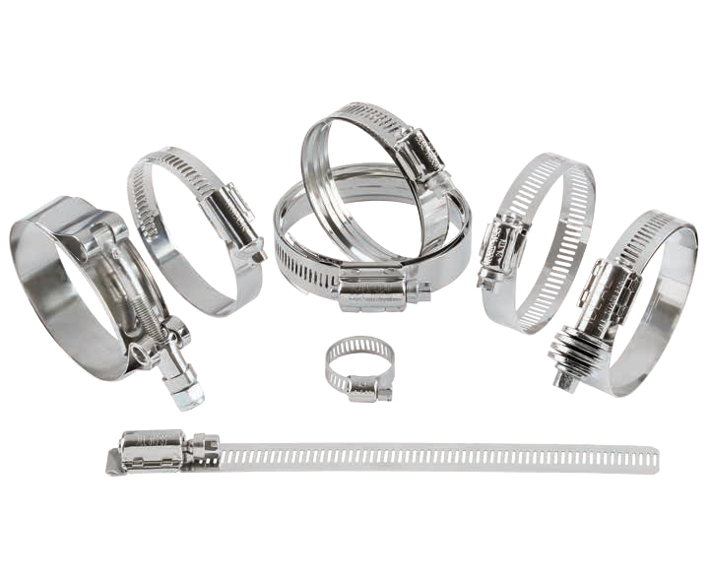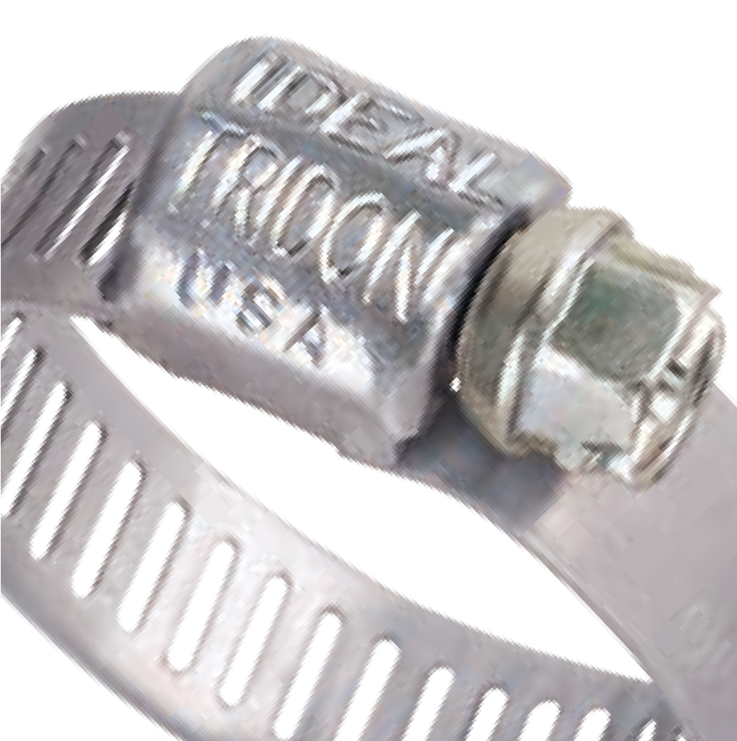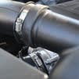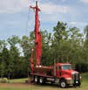PRODUCT CATALOG

P R O V E N D E S I G N S , B I L L I O N S O F T I M E S | I D E A L T R I D O N . C O M

About Us 3
Engineering & Quality 4
How to Use this Catalog 6
Products
SmartSeal® (37215) 8
WaveSeal360® (36003) 8
SmartSeal® HD (38215) 8
Micro-Gear® (359, 62M, 62P, 52M) 10
Fuel Injection (52F) 11
11
1/2" Hy-Gear® (67-4, 67-1, 67-5, 57-0, 52-0, 67-6) 12
9/16" Hy-Gear® (63-4, 68-0, 50-0, 64-0) 14
Non-Perforated (9mm 533xx, 12mm 534xx) 16
Band & Buckle (60080, 60081, 60082) 18
Pinch/Crimp Clamp & Tool (61) 19
Combo-Hex® (54-0) 20
Military Worm Drive (632) 20
Surelock Quick Engage (48, 49) 21
21
Snaplock® Quick Release (56-0, 500, 58-0, 550) 22
Wraplock® (59-0) 24
Lox-On® (69-0) 24
Turn-Key® (5Y/6Y) 25
Flexible Hose Clamp Driver (9999V) 25
Lined (65E, 615, 53-0, 67M) 26
Pow'r-Gear® (60, 6P, 6L, 6M, 6X) 28
T-Bolt - Min Dia. (30010, 30011, 30020, 30021) 30
T-Bolt - Nom. Dia. (30050, 30051) 32
Spring-Loaded T-Bolt (30030) 33
V-Bands (24000) 34
Clamp Safety Caps 35
Flex-Gear® (43, 47, 41, 45) 36
Merchandisers & Packaging 38
130 PC Rack 38
Clamp Shaped Racks 38
SmartSeal® Profit Center 40
25 PC Contractor Bags 40
10 PC Assortment Bags 41
41
Blister Product Line 41
41
Product Cross Reference Guide 43
Ideal Clamp Products, Inc. Global Headquarters
8100 Tridon Drive
Smyrna, TN USA 37167-6603
T: 800.251.3220 615.459.5800
F: 615.223.1550
Ideal Clamp Products, Inc.
7765 Padre Island Hwy. Ste 500 Brownsville, TX USA 78521
T: 956.838.5488 F: 956.838.5489
Ideal Clamp Products, Inc.
Western Regional DLVR/0305 1424 Raymond Ave South Fullerton, CA 92831
T: 800.251.3220 F: 615.223.1550
Auto Industrial de Parts, S.A. De C.V.
Lic. Albino Hernández No. 7 Pte.
H. Matamoros, Tamaulipas, Mexico 87340 T: +52.868.810.8310 F: +52.868.813.5668
Ideal Internacional S.A.
Mariano Matamoros #276 Col. Tlalpan, C.P. 14000 México D.F. Mexico
T: +52.55.5573.5696 F: +52.55.5573.6976
Ideal Tridon Clamps (Suzhou) Co., Ltd.
Unit 16 Suchun Industrial Square
428 Xing Long Street, Suzhou Industrial Park Suzhou, Jiangsu, PRC China, 215126
T: +86.512.8717.8660 F: +86.512.6283.8665
Ideal-Tridon Clamp Products Sawakyu Industries Co Limited
JR Central Towers 40fl. Suite 4008, 1-1-4 Meieki Nakamura-ku, Nagoya, 450-6040, Japan
T: +81.52.581.3900 F: +81.52.581.3902
Tridon Clamp Products Sp. z o. o.
ul. Aleksandra Fredry 3
57-350 Kudowa Zdro`j / Poland
T: +48.74.8135354 F: 48.74.8841017
Ideal-Tridon Clamp (Mumbai) Co. Pvt. Ltd.
A4, Ganesh Complex
Gundavali Village, Dapoda Road Bhiwandi, India 421302
T: +91(0)77383330657

TABLE OF CONTENTS
Global Presence
- Tennessee, USA Headquarters
- Texas, USA
- California, USA
- Matamoros, Mexico
- Mexico City, Mexico
- Suzhou, China
- Tokyo, Japan
- Kudowa Zdro`j / Poland
- Mumbai, India
- Industrial
- Truck & Engine
- Automotive
- Marine
- Hardware
- Plumbing
Industry Markets
- General Aftermarket & Replacement
- OEM: Original Equipment Manufacturing
- Telecommunications
- Heavy Equipment
- Government & Military
- Food Processing & Sanitation

IDEAL-TRIDON: The Fusion of
Experience and Strength

When Ideal and Tridon merged over a decade ago, two extraordinary companies with complementary strengths joined to create one world class leader in the engineered joint sealing industry. A reputation for superior quality was built upon both IDEAL brand and TRIDON brand products. For over a decade both brands have been made in the same facilities to the same high quality standards demanded by OEM and
ABOUT US
aftermarket customers alike. The next step is the evolution of the two brands to one—the IDEAL-TRIDON brand.
The IDEAL-TRIDON brand represents the legendary quality, reliability, and innovative engineering for which our products have always been known.
Although IDEAL-TRIDON is a forward-focused brand, we're also commemorating the rich and diverse history that led us to where we are today. The year 2016 marks a combined 196 years of experience in developing innovative joint-sealing solutions. Ideal was founded in 1913 by Philip Rauch, a taxi cab owner/operator with
IDEAL-TRIDON Customers benefit from:
- Quick quote turnaround*
- 1-5 day lead time*
- The widest selection of bands, screws, housings and special features
- Custom design and engineering expertise
- Metallurgical science specialists
- Automated assembly processes
- Advanced screw manufacturing technologies
- Sensors and visual control systems
- Attractive and marketable packaging
- Established distribution channels
- Quality testing and analysis
- Performance and specifications documentation
*On standard products
a background in automotive engineering. Tridon began in 1923 by Don Green, a young man trying to prove he could make it on his own. Throughout the last century literally billions of clamps have been made by the companies started by these two visionaries. The foundation for success built by both men sustains us to this day and will continue with our commitment to provide innovative clamping solutions backed by the best service in the industry.
Today we continue to build upon our founders’ innovative spirit by constantly pushing boundaries with new IDEAL-TRIDON products. Our latest innovation is the SmartSeal® product line. This next generation clamp
uses patented technology to continuously seal in a steady 360 degree pattern while responding to pressure and temperature changes. We’d say that’s pretty smart!
Weighing less than traditional self-compensating clamps, SmartSeal is now being used on the newest fuel-efficient vehicles coming to market.
With the IDEAL-TRIDON brand, you’re getting a product backed by 196 years of combined engineering excellence. Customers worldwide count on us to seal critical connections. Shouldn't you? After all, we've provided “Proven Designs, Billions of Times.”

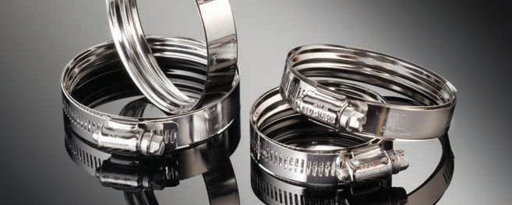

IDEAL-TRIDON's superior quality, environmental responsibility and process integrity has earned us certifications for TS16949 as well as ISO 9001 and 14001. All our facilities worldwide use only the finest quality certified steel and the best practice manufacturing processes to craft clamp products you can trust today and years into the future.

We operate using the latest manufacturing equipment and facilities, from networked manufacturing complexes to advanced laboratory analysis. Our diversified
ENGINEERING & QUALITY
team of engineers and operators are equipped with the most sophisticated testing labs and machine- tuning capabilities. We test and certify our clamp performance to stringent industry standards and real- life conditions to ensure your satisfaction.

Powerful Partnership
Let us help you create a clamp offering for your distribution or supply your next order for a production line. We can connect you with our sales representatives and welcome you to partner with us as you plan your next clamp program.

IDEAL-TRIDON brand offers:
- Unmatched customer service
- Mission critical engineering talent
- The world's broadest range of superior clamping products

Customization
IDEAL-TRIDON is the industry leader in custom joint sealing products. We can develop custom designs for any application, from band notching and slotting to special finishes and screw head designs. Using
  - modeling that includes stress and finite element analysis, we can help determine the best materials and configuration for your application.
Custom Options:
- Special cut-out and detents added to bands
- Black e-coat or black oxide finishes
- Locating clips to pre-attach clamps to hoses
- Positioning clips to set the clamp distance from the end of a hose
- V-band clamps in custom configurations
- Materials specific for your operating environment
- And more!
Whether you need a standardized product or specialized attention, we have the team, the facilities and the knowledge to deliver a sealing solution.

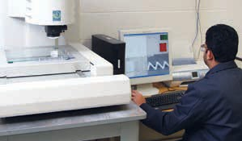
A
B

Photo Captions
C
    - VMM and CMM equipment provides precision measuring capability
    - Full metallurgical laboratory capabilities for identification of alloys, material hardness and micro-structure
    - On-site laboratory PVT chamber enables SAE J1610 pressure, vibration, and thermal testing
    - Micro-hardness tester provides accurate and fast in-depth analysis of components and finished product specimens
    - Accurate and controlled corrosion testing is possible using our salt-fog and cyclical corrosion test chambers
D
    - The 8-segment load tester and DC servo installation tools allow for quick and accurate installation simulations
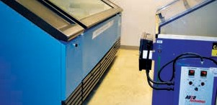
E
F

Part Number Explanation

IDEAL-TRIDON uses both 12-digit and 7-digit part numbers with Tridon part numbers listed for reference only. Putting your part number together is an easy two-step process.
Pack Type | 7-Digit Pack Code Suffix | 12-Digit Pack Code
10-Pack  (up to size 104) | 51 | 051
Bulk | 52 | 052
10-Pack Individually Barcoded  (up to size 104) | 53 | 053
Blister Pack | 58 | 058
* Not every product available in 10-Pack configuration, barcoded, or in blister pack

- Select the Ideal-Tridon part number by series and size listed in the tables throughout the catalog.
- Add appropriate pack code to the end.

Products are Color-Coded for Easy Identification
Ideal-Tridon 67-4
FIND YOUR PART NUMBER

Size

6
8

Min | Max | Min | Max | Ideal-Tridon | Tridon | Ideal-Tridon | Ideal-Tridon | Ideal-Tridon | Ideal-Tridon | Ideal-Tridon
(in) | (in) | (mm) | (mm) | 67-4 | 620P | 67-5 | 67-1 | 57-0 | 52-0 | 67-6
3/8 | 7/8 | 10 | 22 | 67004-0006 | 620-P06 | 6706-5 | 6706-1 | 57060 | 52060 | 6706-6
7/16 | 1 | 11 | 25 | 67004-0008 | 620-P08 | 6708-5 | 6708-1 | 57080 | 52080 | 6708-6

Clamp Sizing Information
Order with Ideal-Tridon No.
Min-Max Diameter

EXAMPLE USING 12-DIGIT PART NUMBERS (Ordering a Size 06 1/2" Hy-Gear 67-4 in a 10-Pack)
Series (First 5 Digits) | + | Size (Next 4 Digits) | + | Pack Code (Last 3 Digits) | = | Complete Part Number
67004 (Series 67-4) | + | 0006 (4-Digit Size) | + | 051 (3-Digit Pack Code) | = | 67004-0006-051

EXAMPLE USING 7-DIGIT PART NUMBERS (Ordering a Size 06 1/2" Hy-Gear 67-1 in 10-Pack)
Series & Size (First 5 Digits) | + | Pack Code (Last 2 Digits) | = | Complete Part Number
6706-1 (Series 67-1 in Size 06) | + | 51 (10-Pack) | = | 6706-1-51

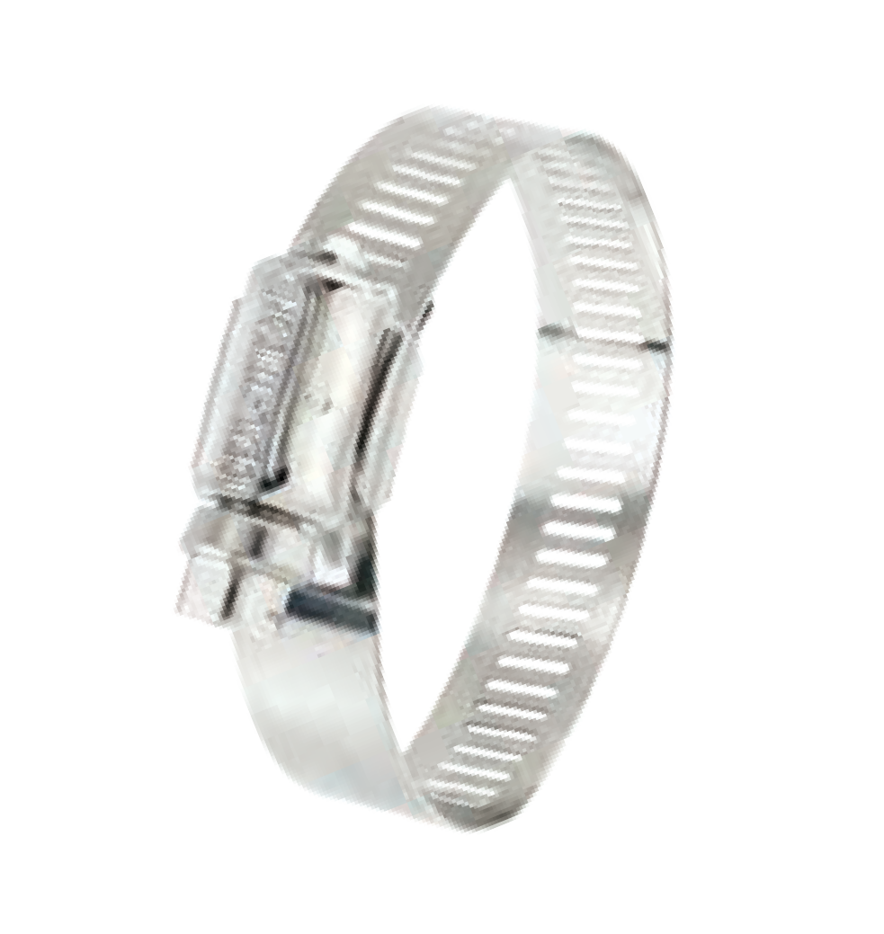About Our Clamps (3 Piece Design)

HOW TO USE THIS CATALOG

ONE-PIECE HOUSING
One piece mechanically interlocked housings are made from a single stamping with no tabs or stakes that can fail under higher tightening torques
MULTIPLE BAND WIDTHS
Our three piece clamps are produced in a multitude of band widths in a large variety of sizes, traditionally sized in increments of 1/16"

RECTANGULAR SHAPED NOTCHES
The rectangular notch design utilizes a radius at each corner which minimizes stress cracking under higher band loads and
enhances the overall strength of the band

About Our Steel

MORE CORROSION RESIST ANCE
 |  | Plated Carbon Steel | 400  Stainless | 200  Stainless | 300  Stainless | 316  Stainless
Markets | Automobile | • | • | • | • | •
 | Farm | • |  | • | • | •
 | Food |  |  |  | • | •
 | Garden |  |  | • | • | •
 | Heavy Duty |  | • |  | • | •
 | Home | • | • | • | • | •
 | Industrial/MRO | • |  | • | • | •
 | Marine |  |  |  | • | •
 | Medical |  |  |  |  | •
 | Plumbing/Watersystems |  | • | • | • | •
 | Turbo/Forced Air |  | • |  | • | •
Characteristics | Highest Corrosion Resistance |  |  |  |  | •
 | Best Corrosion Resistance |  |  |  | •
 | Better Corrosion Resistance |  |  | •
 | Good Corrosion Resistance |  | •
Properties* | Material is “Non-Magnetic” |  |  | • | • | •
 | Material is “Magnetic” | • | •
Certifications | IAPMO Listed Product Applications |  |  | • | •
*Materials may exhibit relatively small amounts of residual magnetism as a result of the manufacturing process

Icon Key

BAND
Width & Material
BOLT
Size & Material
BRIDGE
Width & Material
HOUSING
Size & Material
LINER
Width & Material
NUT
Size & Material

SCREW
Size & Material
SPRING
Size & Material
SPRING LINER
Width & Material
T-BOLT
Size & Material
TRUNNION
Material
RIT*
In-lbs & Nm

*RECOMMENDED INSTALLATION TORQUE
FIND YOUR MATERIAL
Overtightening your clamp can damage your hose and decrease clamping efficiency.

SMARTSEAL® & WAVESEAL360®

SmartSeal and WaveSeal360 hybrid smart clamps secure hose connections and prevent unwanted flow of fluid and air. Through patented hybrid technology, these next generation clamps seal in a steady 360 degree pattern in response to pressure and temperature changes. With their compact design and lower profile, you get an optimal heavy-duty constant tension clamp without all the bulk.
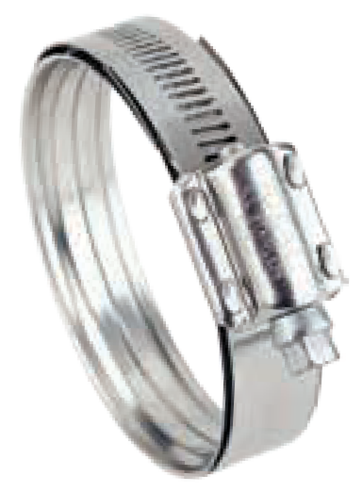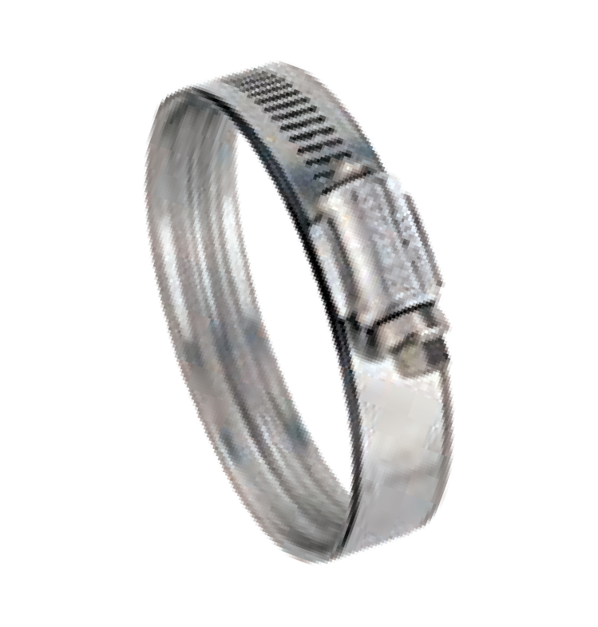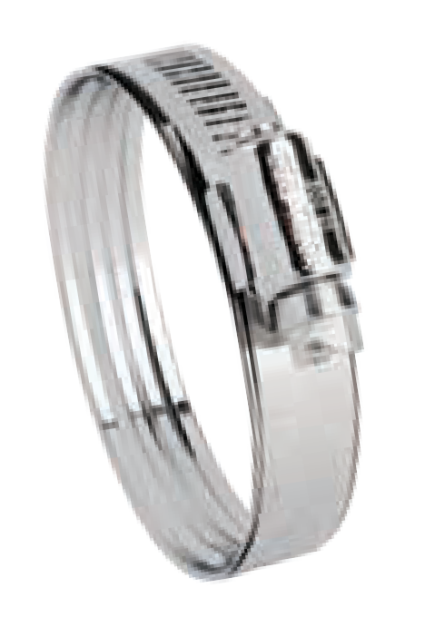
SmartSeal Ideal-Tridon 37215
5/16" Hex Head
Housing
1/2" Band
1/2" Spring Liner
300 Stainless
300 Stainless
300 Stainless
300 Stainless
WaveSeal360 Ideal-Tridon 36003
5/16" Hex Head
Housing
9/16" Band
9/16" Spring Liner
410 Stainless
300 Stainless
300 Stainless
300 Stainless
SmartSeal HD Ideal-Tridon 38215
5/16" Hex Head
2-Piece Housing
5/8" Band
5/8" Spring Liner
410 Stainless
300 Stainless
300 Stainless
300 Stainless
THE SMARTSEAL CHANNEL DESIGN
THE WAVESEAL O-RING EFFECT
High Pressure
- Spring compensation over 360 degrees
- Improved clamp roundness eliminates leak paths at housing juncture
- Trough-shaped design creates higher pressure loading compared to conventional worm gear, increasing resistance against potential leaks
- Trough shape helps clamp “grip” by penetrating deeper into the hose wall over a narrower cross-section (footprint)
High Pressure
Low Pressure
High Pressure
- Spring compensation over 360 degrees
- Improved clamp roundness eliminates leak paths at housing juncture
- O-ring effect allows hose to act as an additional spring component
- Outside, chamfered liner edge protects hose component from cutting

SmartSeal
WaveSeal360
FIND YOUR PART NUMBER
WHICH CLAMP IS RIGHT FOR ME?

General Guidelines | SmartSeal | WaveSeal360 | SmartSeal HD
Wall Thickness | Greater than .177" (4.5 mm) | Less than .177" (4.5 mm) | .080 to .315" (2-8 mm)
Hose Diameter | Greater than 3" (76 mm) | Less than 3" (76 mm) | Greater than 2" (51 mm)
Installation Torque (Most Applications) | Up to 48 in-lbs (5.4 Nm) | Up to 70 in-lbs (7.9 Nm) | Up to 100 in-lbs (11.3 Nm)
Band Width | 1/2" | 9/16" | 5/8"

Size | Min (in) | Max (in) | Min (mm) | Max (mm) | SmartSeal WaveSeal360
16 | 1-3/32 | 1-9/32 | 28
 |  |  |  | 33 | 37215-0016* | 36003-0016
20 | 1-1/8 | 1-9/16 | 29 | 40 | 37215-0020* | 36003-0020
22 | 1-7/16 | 1-11/16 | 36 | 43 | 37215-0022 | 36003-0022
24 | 1-1/2 | 1-13/16 | 38 | 46 | 37215-0024* | 36003-0024
28 | 1-3/4 | 2-1/16 | 43 | 52 | 37215-0028* | 36003-0028
32 | 1-15/16 | 2-5/16 | 48 | 59 | 37215-0032 | 36003-0032
34 | 2 | 2-7/16 | 50 | 62 | 37215-0034 | 36003-0034
36 | 2-1/8 | 2-9/16 | 53 | 65 | 37215-0036* | 36003-0036
40 | 2-5/16 | 2-13/16 | 58 | 71 | 37215-0040* | 36003-0040
44 | 2-1/2 | 3-1/16 | 63 | 78 | 37215-0044 | 36003-0044
48 | 2-11/16 | 3-5/16 | 67 | 84 | 37215-0048 | 36003-0048
52 | 2-7/8 | 3-9/16 | 73 | 91 | 37215-0052 | 36003-0052
56 | 3-1/16 | 3-13/16 | 77 | 97 | 37215-0056 | 36003-0056
60 | 3-1/4 | 4-1/16 | 82 | 103 | 37215-0060 | 36003-0060
64 | 3-7/16 | 4-5/16 | 87 | 110 | 37215-0064 | 36003-0064
72 | 3-3/4 | 4-13/16 | 96 | 122 | 37215-0072 | 36003-0072
80 | 4-3/16 | 5-5/16 | 105 | 135 | 37215-0080 | 36003-0080
88 | 4-1/2 | 5-13/16 | 115 | 148 | 37215-0088 | 36003-0088
SmartSeal 37215 series also available individually barcoded in 10-piece sub pack boxes
*Available in blister pack
SmartSeal HD
FIND YOUR PART NUMBER

Size | Min (in) | Max (in) | Min (mm) | Max (mm) | SmartSeal HD
238 | 1-5/8 | 2-1/8 | 42
 |  |  |  | 54 | 38215-0238
262 | 1-7/8 | 2-3/8 | 48 | 61 | 38215-0262
275 | 2 | 2-1/2 | 52 | 64 | 38215-0275
288 | 2-1/8 | 2-5/8 | 55 | 67 | 38215-0288
300 | 2-1/4 | 2-3/4 | 58 | 70 | 38215-0300
325 | 2-1/2 | 3 | 64 | 77 | 38215-0325
350 | 2-3/4 | 3-1/4 | 70 | 83 | 38215-0350
375 | 2-7/8 | 3-1/2 | 74 | 90 | 38215-0375
400 | 3-1/8 | 3-3/4 | 79 | 96 | 38215-0400
425 | 3-5/16 | 4 | 84 | 103 | 38215-0425
450 | 3-7/16 | 4-1/4 | 88 | 109 | 38215-0450
512 | 4-1/16 | 4-7/8 | 103 | 125 | 38215-0512
562 | 4-9/16 | 5-3/8 | 115 | 137 | 38215-0562
612 | 5-1/16 | 5-7/8 | 128 | 150 | 38215-0612

MICRO-GEAR®

Micro-Gear clamps are tiny, tough and precision-engineered to use in small hose applications including emission control, fuel lines and vacuum hoses. Slim, 5/16" bands and low profile housings allow installation in confined areas.

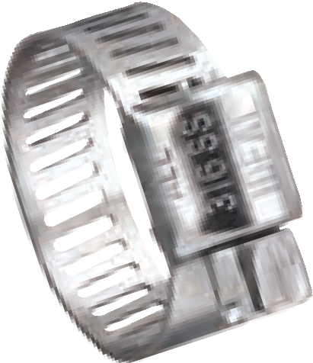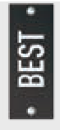
Micro-Gear Tridon 359
1/4" Hex Head Housing
5/16" Band Width
316 Stainless
316 Stainless
316 Stainless

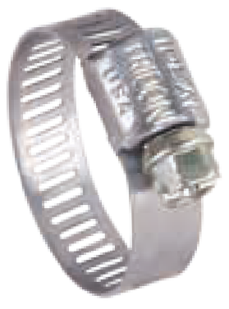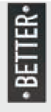
Micro-Gear Ideal-Tridon 62M • Tridon 345/MAH
1/4" Hex Head
Housing
5/16" Band Width
300 Stainless
300 Stainless
300 Stainless

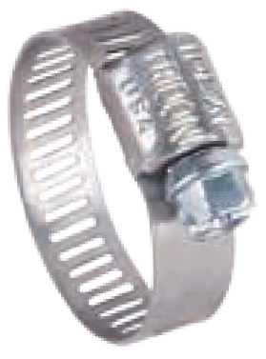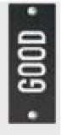
Micro-Gear Ideal-Tridon 62P • Tridon 325/MH
1/4" Hex Head
Housing
5/16" Band Width
Plated Carbon Steel
300 Stainless
300 Stainless

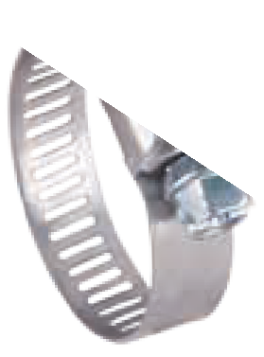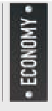
Micro-Gear Ideal-Tridon 52M
1/4" Hex Head
Housing
5/16" Band Width
Plated Carbon Steel
Plated Carbon Steel
300 Stainless

10 to 15 in-lbs (1.1 to 1.7 Nm) for most applications

FIND YOUR PART NUMBER
Size | Min (in) | Max (in) | Min (mm) | Max (mm) | Tridon 359 | Ideal-Tridon Ideal-Tridon Ideal-Tridon 62M 62P 52M
04 | 5/16 | 5/8 | 8 | 16 | 359-004 | 62604(1) | 6204(3) | 5202
05 | 5/16 | 3/4 | 8 | 19 | - | 62M05 | 62P05 | -
06 | 5/16 | 7/8 | 8 | 22 | 359-006 | 62606(2) | 6206(4) | 5203
08 | 7/16 | 1 | 11 | 25 | 359-008 | 62M08 | 62P08 | -
10 | 1/2 | 1-1/16 | 13 | 27 | 359-010 | 62M10 | 62P10 | -
12 | 9/16 | 1-1/4 | 14 | 32 | - | 62M12 | 62P12 | -
16 | 11/16 | 1-1/2 | 18 | 38 | - | 62M16 | 62P16 | -
20 | 3/4 | 1-3/4 | 19 | 44 | - | 62M20 | 62P20 | -
24 | 1 | 2 | 26 | 51 | - | 62M24 | 62P24 | -
28 | 1-1/4 | 2-1/4 | 32 | 57 | - | 62M28 | 62P28 | -
30 | 1-3/8 | 2-3/8 | 35 | 60 | - | 62M30 | 62P30 | -
32 | 1-1/2 | 2-1/2 | 38 | 63 | - | 62M32 | 62P32 | -
36 | 1-3/4 | 2-3/4 | 45 | 70 | - | 62M36 | 62P36 | -
44 | 2-1/4 | 3-1/4 | 57 | 82 | - | 62M44 | 62P44 | -
48 | 2-1/2 | 3-1/2 | 64 | 89 | - | 62M48 | 62P48 | -
(1) Old part no. 62602 (2) Old part no. 62603 (3) Old part no. 6202 (4) Old part no. 6203

Fuel Injection clamps are designed to provide the uniform sealing pressure required on fuel injection hoses. They feature a solid band with rolled edges and a special nut and bolt design.

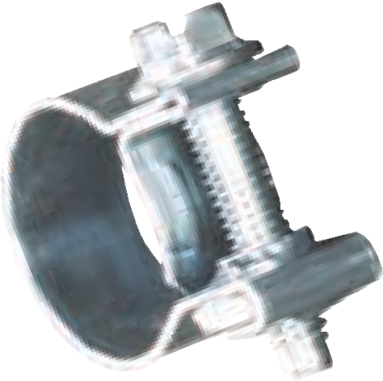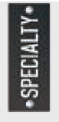
Fuel Injection Ideal-Tridon 52F • Tridon 905/FI
7 mm Hex Head
9 mm Band Width
Plated Carbon Steel
Plated Carbon Steel

Size | Min (in) | Max (in) | Min (mm) | Max (mm) | Ideal-Tridon Tridon 905/FI 52F
13 | 7/16 | 1/2 | 11 |  |  | 905-004
 |  |  |  | 13 | 52F13
15 | 1/2 | 9/16 | 13 | 15 | 52F15 | 905-006
16 | 9/16 | 5/8 | 14 | 16 | 52F16 | 905-008

1/2" Hy-Gear clamps are suitable for most common household, industrial, and automotive applications. The bands have clean punched rectangular perforations that hold strong and connect easily.

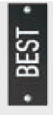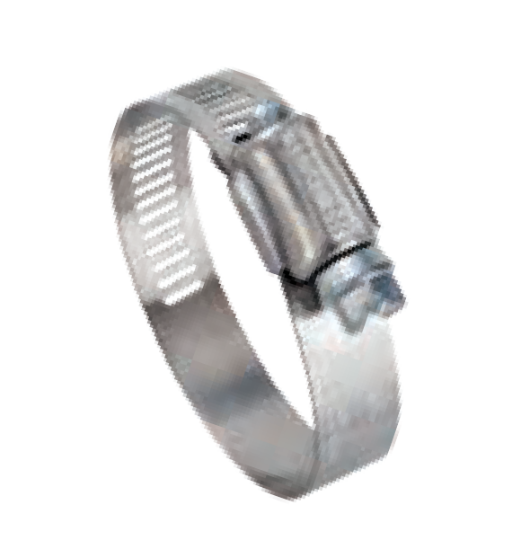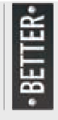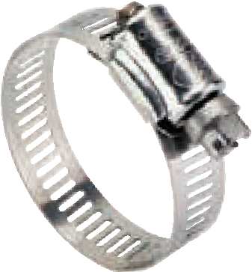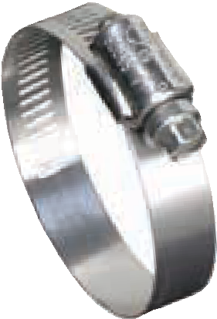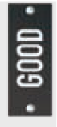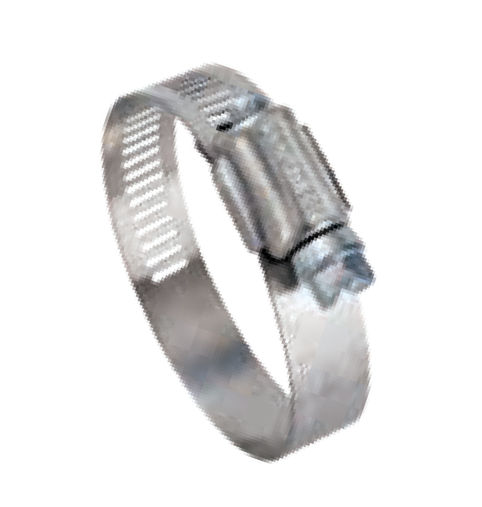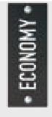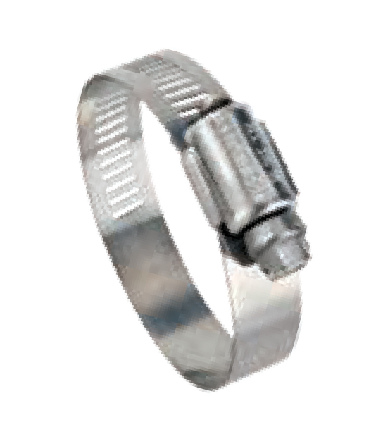1/2" Hy-Gear Ideal-Tridon 67-4 • Tridon 620P

5/16" Hex Head

300 Stainless
UPC Shield

300 Stainless
1/2" Band Width

300 Stainless

1/2" Hy-Gear Ideal-Tridon 67-1

5/16" Hex Head

410 Stainless*
Housing

200 Stainless
1/2" Band Width

200 Stainless

1/2" Hy-Gear Ideal-Tridon 67-5

5/16" Hex Head

200 Stainless
UPC Shield

200 Stainless
1/2" Band Width

200 Stainless

1/2" Hy-Gear Ideal-Tridon 57-0

5/16" Hex Head

Plated Carbon Steel
Housing

200 Stainless
1/2" Band Width

200 Stainless

1/2" Hy-Gear Ideal-Tridon 52-0

5/16" Hex Head

Plated Carbon Steel
Housing

Plated Carbon Steel
1/2" Band Width

200 Stainless

1/2" Hy-Gear Ideal-Tridon 67-6

5/16" Hex Head
1/2" HY-GEAR®

316 Stainless
Housing

316 Stainless
1/2" Band Width

316 Stainless

Size | Min (in) | Max (in) | Min (mm) | Max (mm) | Ideal-Tridon 67-4 | Tridon 620P | Ideal-Tridon 67-1 | Ideal-Tridon 67-5 | Ideal-Tridon 57-0 | Ideal-Tridon 52-0 | Ideal-Tridon 67-6
6 | 3/8 | 7/8 | 10
 |  |  |  | 22 | 67004-0006 | 620-P06 | 6706-1 | 6706-5 | 57060 | 52060 | 6706-6
8 | 7/16 | 1 | 11 | 25 | 67004-0008 | 620-P08 | 6708-1 | 6708-5 | 57080 | 52080 | 6708-6
10 | 1/2 | 1-1/16 | 13 | 27 | 67004-0010 | 620-P10 | 6710-1 | 6710-5 | 57100 | 52100 | 6710-6
12 | 1/2 | 1-1/4 | 13 | 32 | 67004-0012 | 620-P12 | 6712-1 | 6712-5 | 57120 | 52120 | 6712-6
16 | 11/16 | 1-1/2 | 18 | 38 | 67004-0016 | 620-P16 | 6716-1 | 6716-5 | 57160 | 52160 | 6716-6
20 | 3/4 | 1-3/4 | 19 | 44 | 67004-0020 | 620-P20 | 6720-1 | 6720-5 | 57200 | 52200 | 6720-6
24 | 1 | 2 | 25 | 51 | 67004-0024 | 620-P24 | 6724-1 | 6724-5 | 57240 | 52240 | 6724-6
28 | 1-1/4 | 2-1/4 | 32 | 57 | 67004-0028 | 620-P28 | 6728-1 | 6728-5 | 57280 | 52280 | 6728-6
32 | 1-1/2 | 2-1/2 | 38 | 63 | 67004-0032 | 620-P32 | 6732-1 | 6732-5 | 57320 | 52320 | 6732-6
36 | 3/4 | 2-3/4 | 19 | 70 | 67004-0036 | 620-P36 | 6736-1 | 6736-5 | 57360 | 52360 | 6736-6
40 | 1 | 3 | 26 | 76 | 67004-0040 | 620-P40 | 6740-1 | 6740-5 | 57400 | 52400 | 6740-6
44 | 1-1/4 | 3-1/4 | 32 | 82 | 67004-0044 | 620-P44 | 6744-1 | 6744-5 | 57440 | 52440 | 6744-6
48 | 1-1/2 | 3-1/2 | 38 | 89 | 67004-0048 | 620-P48 | 6748-1 | 6748-5 | 57480 | 52480 | 6748-6
52 | 1-3/4 | 3-3/4 | 44 | 95 | 67004-0052 | 620-P52 | 6752-1 | 6752-5 | 57520 | 52520 | 6752-6
56 | 2 | 4 | 51 | 101 | 67004-0056 | 620-P56 | 6756-1 | 6756-5 | 57560 | 52560 | 6756-6
60 | 2-1/4 | 4-1/4 | 57 | 108 | 67004-0060 | 620-P60 | 6760-1 | 6760-5 | 57600 | 52600 | 6760-6
64 | 2-1/2 | 4-1/2 | 64 | 114 | 67004-0064 | 620-P64 | 6764-1 | 6764-5 | 57640 | 52640 | 6764-6
72 | 3 | 5 | 76 | 127 | 67004-0072 | 620-P72 | 6772-1 | 6772-5 | 57720 | 52720 | 6772-6
80 | 3-1/2 | 5-1/2 | 89 | 140 | 67004-0080 | 620-P80 | 6780-1 | 6780-5 | 57800 | 52800 | 6780-6
88 | 4 | 6 | 102 | 152 | 67004-0088 | 620-P88 | 6788-1 | 6788-5 | 57880 | 52880 | 6788-6
96 | 4-1/2 | 6-1/2 | 114 | 165 | 67004-0096 | 620-P96 | 6796-1 | 6796-5 | 57960 | 52960 | 6796-6
104 | 5 | 7 | 127 | 178 | 67004-0104 | 62P-104 | 67104 | 6799-5 | 57104 | 52104 | 6799-6
112 | 5-1/2 | 7-1/2 | 140 | 190 | 67004-0112 | 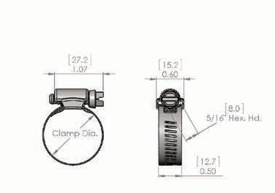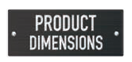  35 in-lbs (4 Nm) for most applications
116 | 5-3/4 | 7-3/4 | 146 | 197 | 67004-0116
120 | 6 | 8 | 152 | 203 | 67004-0120
128 | 6-1/2 | 8-1/2 | 165 | 216 | 67004-0128
132 | 6-3/4 | 8-3/4 | 171 | 222 | 67004-0132
140 | 7-1/4 | 9-1/4 | 184 | 235 | 67004-0140
152 | 2 | 10 | 51 | 254 | 67004-0152
164 | 1-3/4 | 10-3/4 | 44 | 273 | 67004-0164
176 | 9-1/2 | 11-1/2 | 241 | 292 | 67004-0176
188 | 2 | 12-1/4 | 52 | 311 | 67004-0188
208 | 11-1/4 | 13-1/2 | 294 | 343 | 67004-0208
212 | 11-1/2 | 13-3/4 | 300 | 349 | 67004-0212
224 | 12-1/2 | 14-1/2 | 319 | 368 | 67004-0224
236 | 13-1/4 | 15-1/4 | 338 | 387 | 67004-0236
248 | 1-3/4 | 16 | 44 | 406 | 67004-0248
270 | 15-1/4 | 17-1/2 | 392 | 441 | 67004-0270
312 | 18 | 20 | 459 | 508 | 67004-0312
332 | 19-1/4 | 21-1/4 | 491 | 540 | 67004-0332
390 | 14-1/2 | 25 | 371 | 636 | 67004-0390
502 | 28 | 32 | 711 | 812 | 67004-0502
538 | 24-3/4 | 34-1/4 | 628 | 869 | 67004-0538
569 | 32 | 36-1/4 | 810 | 819 | 67004-0569
Additional sizes available
Ideal-Tridon 67-4

9/16" Hy-Gear clamps have a wide range of applications, from simple home and auto repair to heavy industrial. The bands have clean punched rectangular perforations that hold strong and connect easily.

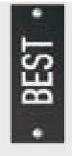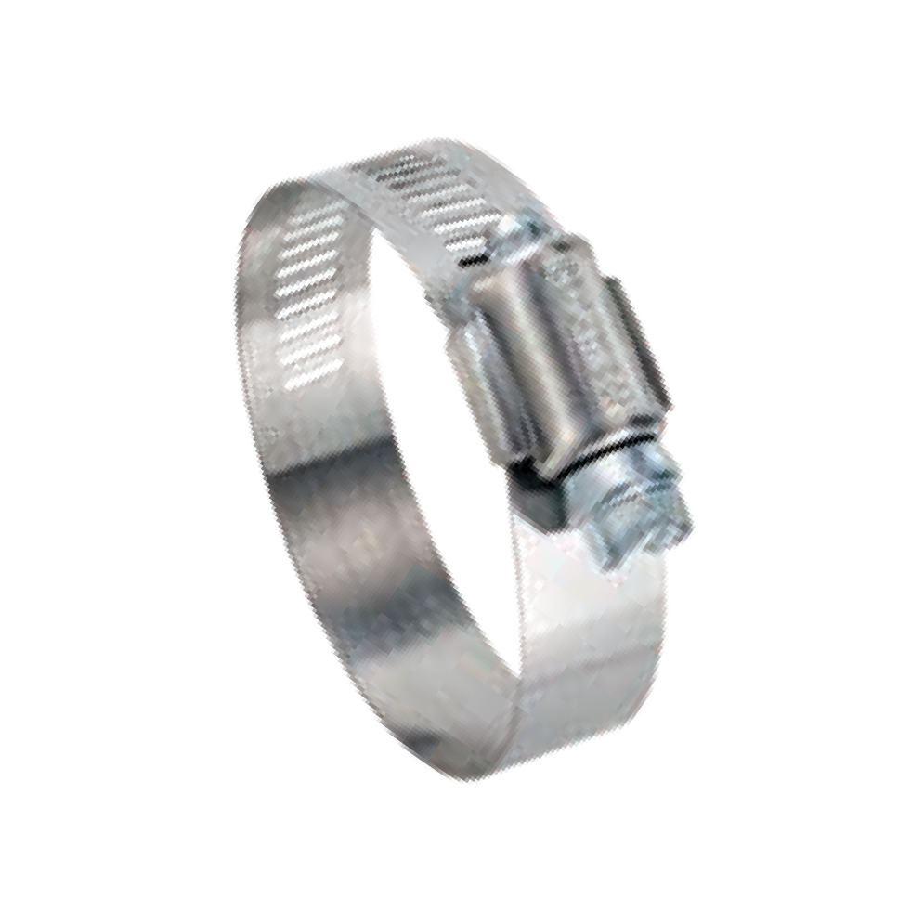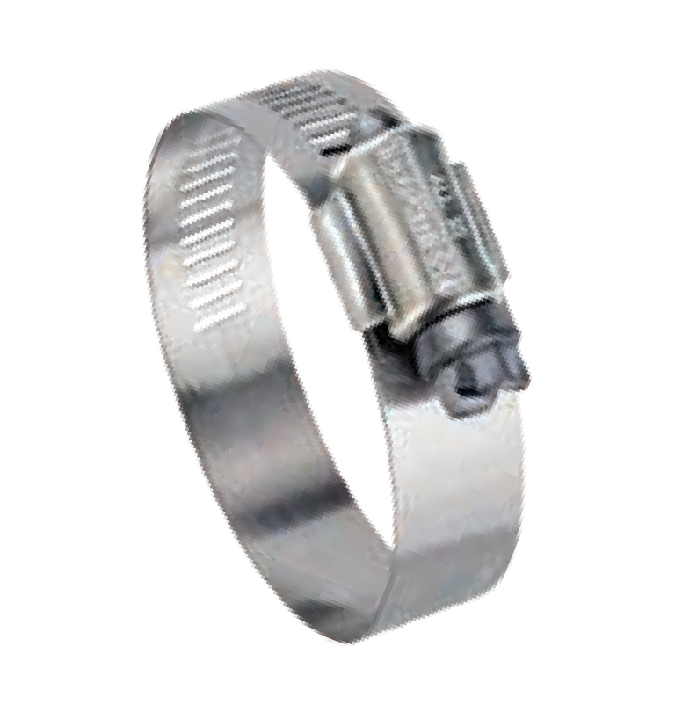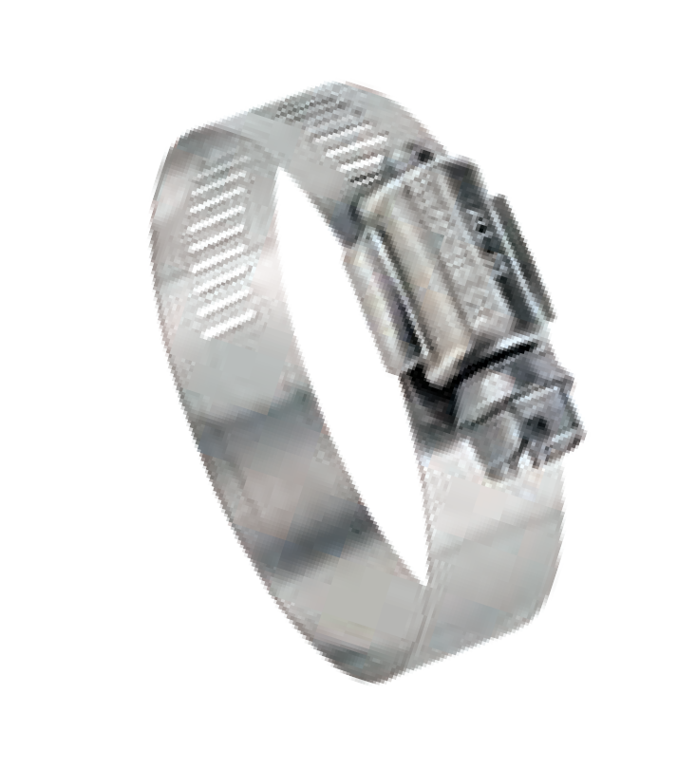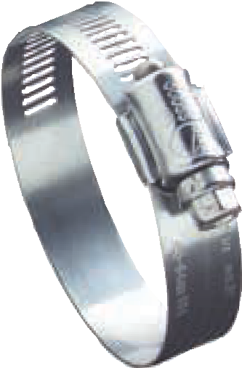Hy-Gear Ideal-Tridon 63-4

5/16" Hex Head

300 Stainless
UPC Shield

300 Stainless
9/16" Band Width

300 Stainless

Hy-Gear Ideal-Tridon 68-0

5/16" Hex Head

410 Stainless
Housing

200 Stainless
9/16" Band Width

200 Stainless

Hy-Gear Ideal-Tridon 50-0

5/16" Hex Head

Plated Carbon Steel
Housing

200 Stainless
9/16" Band Width

200 Stainless

Hy-Gear Ideal-Tridon 64-0

3/8" Hex Head

410 Stainless
Housing

200 Stainless
9/16" Band Width

200 Stainless

9/16" HY-GEAR®

35 in-lbs (4 Nm) for most applications

Size | Min (in) | Max (in) | Min (mm) | Max (mm) | Ideal-Tridon 63-4 | Ideal-Tridon 68-0 | Ideal-Tridon 50-0 | Ideal-Tridon 64-0
6 | 3/8 | 7/8 | 10 | 22 | 63004-0006 | 68060 | 50060 | 64060
8 | 7/16 | 1 | 11 | 25 | 63004-0008 | 68080 | 50080 | 64080
10 | 1/2 | 1-1/16 | 13 | 27 | 63004-0010 | 68100 | 50100 | 64100
12 | 1/2 | 1-1/4 | 13 | 32 | 63004-0012 | 68120 | 50120 | 64120
16 | 11/16 | 1-1/2 | 18 | 38 | 63004-0016 | 68160 | 50160 | 64160
20 | 3/4 | 1-3/4 | 19 | 44 | 63004-0020 | 68200 | 50200 | 64200
24 | 1 | 2 | 25 | 51 | 63004-0024 | 68240 | 50240 | 64240
28 | 1-1/4 | 2-1/4 | 32 | 57 | 63004-0028 | 68280 | 50280 | 64280
32 | 1-1/2 | 2-1/2 | 38 | 63 | 63004-0032 | 68320 | 50320 | 64320
36 | 3/4 | 2-3/4 | 19 | 70 | 63004-0036 | 68360 | 50360 | 64360
40 | 1 | 3 | 26 | 76 | 63004-0040 | 68400 | 50400 | 64400
44 | 1-1/4 | 3-1/4 | 32 | 83 | 63004-0044 | 68440 | 50440 | 64440
48 | 1-1/2 | 3-1/2 | 38 | 89 | 63004-0048 | 68480 | 50480 | 64480
52 | 1-3/4 | 3-3/4 | 44 | 95 | 63004-0052 | 68520 | 50520 | 64520
56 | 2 | 4 | 51 | 101 | 63004-0056 | 68560 | 50560 | 64560
60 | 2-1/4 | 4-1/4 | 57 | 108 | 63004-0060 | 68600 | 50600 | 64600
64 | 2-1/2 | 4-1/2 | 64 | 114 | 63004-0064 | 68640 | 50640 | 64640
72 | 3 | 5 | 76 | 127 | 63004-0072 | 68720 | 50720 | 64720
80 | 3-1/2 | 5-1/2 | 89 | 140 | 63004-0080 | 68800 | 50800 | 64800
88 | 4 | 6 | 102 | 152 | 63004-0088 | 68880 | 50880 | 64880
96 | 4-1/2 | 6-1/2 | 114 | 165 | 63004-0096 | 68960 | 50960 | 64960
104 | 5 | 7 | 127 | 178 | 63004-0104 | 68104 | 50104 | 64104
116 | 5-3/4 | 7-3/4 | 146 | 197 | 63004-0116 | 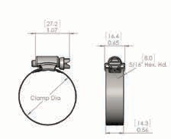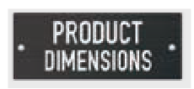
128 | 2-1/2 | 8-1/2 | 64 | 216 | 63004-0128
140 | 2-1/2 | 9-1/4 | 64 | 235 | 63004-0140
152 | 2-1/2 | 10 | 64 | 254 | 63004-0152
164 | 2-1/2 | 10-3/4 | 64 | 273 | 63004-0164
176 | 2-1/2 | 11-1/2 | 64 | 292 | 63004-0176
188 | 2-1/2 | 12-1/4 | 64 | 311 | 63004-0188
208 | 2-1/2 | 13-1/2 | 64 | 343 | 63004-0208
224 | 2-1/2 | 14-1/2 | 64 | 368 | 63004-0224
236 | 2-1/2 | 15-1/4 | 64 | 387 | 63004-0236
248 | 2-1/2 | 16 | 64 | 406 | 63004-0248
260 | 2-1/2 | 16-3/4 | 64 | 425 | 63004-0260
272 | 2-1/2 | 17-1/2 | 64 | 445 | 63004-0272
312 | 2-1/2 | 20 | 64 | 508 | 63004-0312
380 | 2-1/2 | 24-1/4 | 64 | 616 | 63004-0380
760 | 2-1/2 | 48 | 64 | 1219 | 63004-0760
Additional sizes available

NON-PERFORATED

Non-Perforated (Embossed) clamps are based on our popular general purpose worm gear clamps, but are engineered to prevent hose damage during installation. The non-perforated band keeps soft silicone hoses from shearing or extruding during installation and final torquing, maintaining the integrity of the connection, and providing a more stable seal. Plus, IDEAL-TRIDON Non-Perforated clamps are available in several material configurations making them perfect for automotive, marine and many industrial applications. Better yet, they act and perform just like traditional worm gear clamps, fitting into restricted spaces and holding tightly over time. Consider IDEAL-TRIDON Non-Perforated worm gear clamps for your next application, and get the assurance of damage-free clamping technology to keep your connection secure.

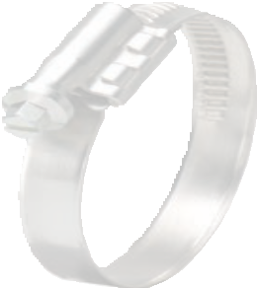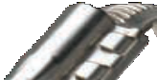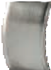
WIDE CROSS SADDLE
Wide cross saddle provides a more even support structure upon installation and longer term band tension.
MEETS OR EXCEEDS DIN 3017 STANDARD
MATERIAL SPECIFICATIONS AND CLAMPING RANGES
Material specifications and clamping ranges are stamped on clamp band for easy identification and proper
application fitment. (See chart on right)
SMOOTH INSIDE BAND
Smooth inside band protects soft hoses against shearing and fray,
extending service life.

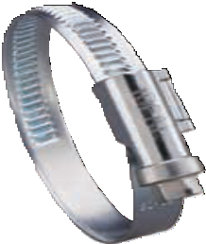
9 mm Band
7 mm Hex Head Housing
9 mm Band Width
For material composition please see chart on right.

18 in-lbs (2.0 Nm) for sizes 016 and below
27 in-lbs (3.0 Nm) for sizes 018 and up

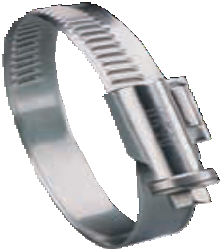
12 mm Band
7 mm Hex Head Housing
12 mm Band Width
For material composition please see chart on right.
44 in-lbs (5.0 Nm) for most applications

Band Width | Min (in) | Max (in) | Min (mm) | Max (mm) | W2  Ideal-Tridon | W2  Tridon | W3  Ideal-Tridon | W3  Tridon | W4  Ideal-Tridon | W4  Tridon | W5  Ideal-Tridon | W5  Tridon
9 mm | 5/16 | 15/32 | 8 | 12 | 53302-0012 | 53312-0012 | 53303-0012 | 53313-0012 | 53304-0012 | 53314-0012 | 53305-0012 | 53315-0012
 | 5/16 | 5/8 | 8 | 16 | 53302-0016 | 53312-0016 | 53303-0016 | 53313-0016 | 53304-0016 | 53314-0016 | 53305-0016 | 53315-0016
 | 15/32 | 25/32 | 12 | 20 | 53302-0020 | 53312-0020 | 53303-0020 | 53313-0020 | 53304-0020 | 53314-0020 | 53305-0020 | 53315-0020
 | 15/32 | 7/8 | 12 | 22 | 53302-0022 | 53312-0022 | 53303-0022 | 53313-0022 | 53304-0022 | 53314-0022 | 53305-0022 | 53315-0022
 | 5/8 | 1-1/16 | 16 | 27 | 53302-0027 | 53312-0027 | 53303-0027 | 53313-0027 | 53304-0027 | 53314-0027 | 53305-0027 | 53315-0027
 | 25/32 | 1-1/4 | 20 | 32 | 53302-0032 | 53312-0032 | 53303-0032 | 53313-0032 | 53304-0032 | 53314-0032 | 53305-0032 | 53315-0032
 | 29/32 | 1-3/8 | 23 | 35 | 53302-0035 | 53312-0035 | 53303-0035 | 53313-0035 | 53304-0035 | 53314-0035 | 53305-0035 | 53315-0035
 | 1 | 1-9/16 | 25 | 40 | 53302-0040 | 53312-0040 | 53303-0040 | 53313-0040 | 53304-0040 | 53314-0040 | 53305-0040 | 53315-0040
 | 1-3/16 | 1-3/4 | 30 | 45 | 53302-0045 | 53312-0045 | 53303-0045 | 53313-0045 | 53304-0045 | 53314-0045 | 53305-0045 | 53315-0045
 | 1-1/4 | 1-31/32 | 32 | 50 | 53302-0050 | 53312-0050 | 53303-0050 | 53313-0050 | 53304-0050 | 53314-0050 | 53305-0050 | 53315-0050
 | 1-9/16 | 2-3/8 | 40 | 60 | 53302-0060 | 53312-0060 | 53303-0060 | 53313-0060 | 53304-0060 | 53314-0060 | 53305-0060 | 53315-0060
 | 1-31/32 | 2-3/4 | 50 | 70 | 53302-0070 | 53312-0070 | 53303-0070 | 53313-0070 | 53304-0070 | 53314-0070 | 53305-0070 | 53315-0070
 | 2-3/8 | 3-1/8 | 60 | 80 | 53302-0080 | 53312-0080 | 53303-0080 | 53313-0080 | 53304-0080 | 53314-0080 | 53305-0080 | 53315-0080
 | 2-3/4 | 3-1/2 | 70 | 90 | 53302-0090 | 53312-0090 | 53303-0090 | 53313-0090 | 53304-0090 | 53314-0090 | 53305-0090 | 53315-0090
 | 3-1/8 | 3-15/16 | 80 | 100 | 53302-0100 | 53312-0100 | 53303-0100 | 53313-0100 | 53304-0100 | 53314-0100 | 53305-0100 | 53315-0100
 | 3-1/2 | 4-5/16 | 90 | 110 | 53302-0110 | 53312-0110 | 53303-0110 | 53313-0110 | 53304-0110 | 53314-0110 | 53305-0110 | 53315-0110
 | 3-15/16 | 4-23/32 | 100 | 120 | 53302-0120 | 53312-0120 | 53303-0120 | 53313-0120 | 53304-0120 | 53314-0120 | 53305-0120 | 53315-0120
 | 4-5/16 | 5-1/8 | 110 | 130 | 53302-0130 | 53312-0130 | 53303-0130 | 53313-0130 | 53304-0130 | 53314-0130 | 53305-0130 | 53315-0130
 | 4-23/32 | 5-1/2 | 120 | 140 | 53302-0140 | 53312-0140 | 53303-0140 | 53313-0140 | 53304-0140 | 53314-0140 | 53305-0140 | 53315-0140
 | 5-1/8 | 5-29/32 | 130 | 150 | 53302-0150 | 53312-0150 | 53303-0150 | 53313-0150 | 53304-0150 | 53314-0150 | 53305-0150 | 53315-0150
 | 5-1/2 | 6-5/16 | 140 | 160 | 53302-0160 | 53312-0160 | 53303-0160 | 53313-0160 | 53304-0160 | 53314-0160 | 53305-0160 | 53315-0160
12 mm | 5/8 | 1-1/16 | 16 | 27 | 53402-0027 | 53412-0027 | 53403-0027 | 53413-0027 | 53404-0027 | 53414-0027 | 53405-0027 | 53415-0027
 | 25/32 | 1-1/4 | 20 | 32 | 53402-0032 | 53412-0032 | 53403-0032 | 53413-0032 | 53404-0032 | 53414-0032 | 53405-0032 | 53415-0032
 | 1 | 1-9/16 | 25 | 40 | 53402-0040 | 53412-0040 | 53403-0040 | 53413-0040 | 53404-0040 | 53414-0040 | 53405-0040 | 53415-0040
 | 1-3/16 | 1- 3/4 | 30 | 45 | 53402-0045 | 53412-0045 | 53403-0045 | 53413-0045 | 53404-0045 | 53414-0045 | 53405-0045 | 53415-0045
 | 1-1/4 | 1-31/32 | 32 | 50 | 53402-0050 | 53412-0050 | 53403-0050 | 53413-0050 | 53404-0050 | 53414-0050 | 53405-0050 | 53415-0050
 | 1-9/16 | 2-3/8 | 40 | 60 | 53402-0060 | 53412-0060 | 53403-0060 | 53413-0060 | 53404-0060 | 53414-0060 | 53405-0060 | 53415-0060
 | 1-31/32 | 2-3/4 | 50 | 70 | 53402-0070 | 53412-0070 | 53403-0070 | 53413-0070 | 53404-0070 | 53414-0070 | 53405-0070 | 53415-0070
 | 2-3/16 | 2-15/16 | 55 | 75 | 53402-0075 | 53412-0075 | 53403-0075 | 53413-0075 | 53404-0075 | 53414-0075 | 53405-0075 | 53415-0075
 | 2-3/8 | 3-1/8 | 60 | 80 | 53402-0080 | 53412-0080 | 53403-0080 | 53413-0080 | 53404-0080 | 53414-0080 | 53405-0080 | 53415-0080
 | 2-3/4 | 3-1/2 | 70 | 90 | 53402-0090 | 53412-0090 | 53403-0090 | 53413-0090 | 53404-0090 | 53414-0090 | 53405-0090 | 53415-0090
 | 3-1/8 | 3-15/16 | 80 | 100 | 53402-0100 | 53412-0100 | 53403-0100 | 53413-0100 | 53404-0100 | 53414-0100 | 53405-0100 | 53415-0100
 | 3-1/2 | 4-5/16 | 90 | 110 | 53402-0110 | 53412-0110 | 53403-0110 | 53413-0110 | 53404-0110 | 53414-0110 | 53405-0110 | 53415-0110
 | 3-15/16 | 4-23/32 | 100 | 120 | 53402-0120 | 53412-0120 | 53403-0120 | 53413-0120 | 53404-0120 | 53414-0120 | 53405-0120 | 53415-0120
 | 4-5/16 | 5-1/8 | 110 | 130 | 53402-0130 | 53412-0130 | 53403-0130 | 53413-0130 | 53404-0130 | 53414-0130 | 53405-0130 | 53415-0130
 | 4-23/32 | 5-1/2 | 120 | 140 | 53402-0140 | 53412-0140 | 53403-0140 | 53413-0140 | 53404-0140 | 53414-0140 | 53405-0140 | 53415-0140
 | 5-1/8 | 5-29/32 | 130 | 150 | 53402-0150 | 53412-0150 | 53403-0150 | 53413-0150 | 53404-0150 | 53414-0150 | 53405-0150 | 53415-0150
 | 5-1/2 | 6-5/16 | 140 | 160 | 53402-0160 | 53412-0160 | 53403-0160 | 53413-0160 | 53404-0160 | 53414-0160 | 53405-0160 | 53415-0160
 | 5-29/32 | 6-11/16 | 150 | 170 | 53402-0170 | 53412-0170 | 53403-0170 | 53413-0170 | 53404-0170 | 53414-0170 | 53405-0170 | 53415-0170
 | 6-5/16 | 7-3/32 | 160 | 180 | 53402-0180 | 53412-0180 | 53403-0180 | 53413-0180 | 53404-0180 | - | 53405-0180 | -
 | 6-11/16 | 7-15/32 | 170 | 190 | - | 53412-0190 | - | 53413-0190 | - | - | 53405-0190 | -
 | 7-3/32 | 7-7/8 | 180 | 200 | - | 53412-0200 | - | 53413-0200 | - | - | 53405-0200 | -
W2
Ideal-Tridon
W4
Ideal-Tridon
W5
Ideal-Tridon
WHICH CLAMP IS RIGHT FOR ME?

 | Corrosion Resistance | Material Composition | Common Uses
W2 | Average Requirements | 430 Band & Housing Plated Carbon Steel Screw | Automotive • Truck Replacements • Industrial Applications
W3 | Medium Requirements | All 430 Stainless Steel | Automotive OE • Industrial Applications
W4 | High Requirements  Low Magnetic Permeability | All 304 Stainless Steel | Critical Connections in Cars such as Petrol Pipes • Close to Electronic Circuits  Agricultural Machinery • Motorbikes • Signs • General Outdoors • Stainless Steel Chimneys
W5 | Maximum Requirements Salt Water Resistant  Low Magnetic Permeability | All 316 Stainless Steel | Close to Electronic Circuits • Shipbuilding • Defense Technology • Food Processing Sewage Treatment Facilities

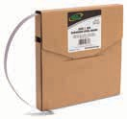
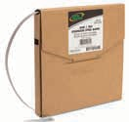
Part No.
Part No.
BAND & BUCKLE
ECONOMY 201 SS Bands
Width (in) | Width (mm) | Thickness (in) | Thickness (mm) | Length (ft) | Length (m) | Master Carton Qty | Part No.
1/4 | 6.4 | 0.020 | 0.51 | 100 | 30.5
 |  |  |  |  |  | 6 | 60080-0202-194
3/8 | 9.5 | 0.025 | 0.64 | 100 | 30.5 | 6 | 60080-0203-194
1/2 | 12.7 | 0.030 | 0.76 | 100 | 30.5 | 4 | 60080-0204-194
5/8 | 16 | 0.030 | 0.76 | 100 | 30.5 | 4 | 60080-0205-194
3/4 | 19 | 0.030 | 0.76 | 100 | 30.5 | 4 | 60080-0206-194
1/2 | 12.7 | 0.030 | 0.76 | 50 | 15 | 4 | 60080-5004-950
5/8 | 16 | 0.030 | 0.76 | 50 | 15 | 4 | 60080-5005-950
3/4 | 19 | 0.030 | 0.76 | 50 | 15 | 4 | 60080-5006-950

The IDEAL-TRIDON® band and buckle clamping system offers maximum banding and clamping capacity. Select the banding width, length and packaging option that works best for your lightweight or heavy duty application. Perfect for sturdy, all-weather binding and clamping. Exceptional value - use only as much as you need.

Stainless Steel Clamping System

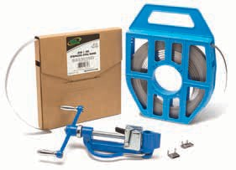
- Durable band - MADE IN USA
- Bands and Buckles are constructed of
201 stainless steel
- Easy to use band tensioning tool
- Easily forms to suit any diameter
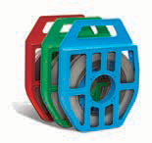
- Applications include insulation banding, sign mounting and cable bundling
Part No.
PLASTIC TOTES 201 SS Bands

Width (in) | Width (mm) | Thickness (in) | Thickness (mm) | Length (ft) | Length (m) | Master Carton Qty | Part No.
1/2 | 12.7 | 0.030 | 0.76 | 100 | 30.5
 |  |  |  |  |  | 2 | 60080-204B-193
5/8 | 16 | 0.030 | 0.76 | 100 | 30.5 | 2 | 60080-205G-193
3/4 | 19 | 0.030 | 0.76 | 100 | 30.5 | 2 | 60080-206R-193
STANDARD 201 SS Bands

Width (in) | Width (mm) | Thickness (in) | Thickness (mm) | Length (ft) | Length (m) | Master Carton Qty | Part No.
1/2 | 12.7 | 0.020 | 0.51 | 100 | 30.5
 |  |  |  |  |  | 4 | 60080-0181-200
3/4 | 19 | 0.020 | 0.51 | 100 | 30.5 | 4 | 60080-0161-200
1/2 | 12.7 | 0.020 | 0.51 | 200 | 61 | 2 | 60080-0183-200
3/4 | 19 | 0.020 | 0.51 | 200 | 61 | 2 | 60080-0163-200

Width (in) | Width (mm) | Master Carton Qty* | Part No.
1/4 | 6.4 | 100 | 60081-0252-194
3/8 | 9.5 | 100 | 60081-0253-194
1/2 | 12.7 | 100 | 60081-0254-194
5/8 | 16 | 100 | 60081-0255-194
3/4 | 19 | 100 | 60081-0256-194
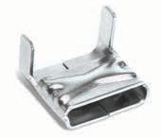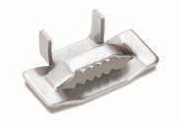*Must order in master carton quantities
Part No.
Part No.
EAR STYLE Buckles
WING STYLE Clips / Buckles

Width (in) | Width (mm) | Master Carton Qty* | Part No.
1/2 | 12.7 | 100 | 60081-0154-295
3/4 | 19 | 100 | 60081-0156-295
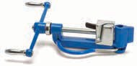
*Must order in master carton quantities
BAND TENSIONING TOOL
1
60082-0001-194
Master Carton Qty
Part No.
Single-Ear Pinch / Crimp Clamps and Tool

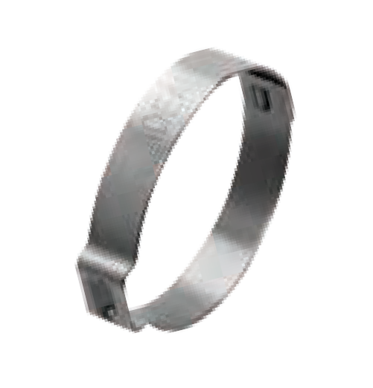Pinch clamps are designed to fit most popular polyethylene and polybutylene water service lines, and are perfect for sprinkler systems, irrigation systems and most other low-pressure applications.
FIND YOUR PART NUMBER

Ideal-Tridon® 61 Series

  - Marine Grade Clamps
Nominal Dia. (in) | Min (in) | Max (in) | Min (mm) | Max (mm) | Qty Per Bag | Ideal-Tridon 61 Series
3/4 | 0.669 | 0.779 | 17 | 20 | 100
 |  |  |  |  |  | 611985B
13/16 | 0.716 | 0.827 | 18 | 21 | 100 | 612105B
1 | 0.898 | 1.008 | 23 | 25 | 100 | 612565B
1-1/16 | 0.945 | 1.067 | 24 | 27 | 100 | 612715B
1-1/4 | 1.122 | 1.244 | 29 | 31 | 100 | 613165B
1-5/16 | 1.181 | 1.303 | 30 | 33 | 100 | 613315B
1-3/8 | 1.240 | 1.362 | 32 | 34 | 100 | 613465B
1-5/8 | 1.492 | 1.614 | 38 | 41 | 100 | 614105B
1-11/16 | 1.551 | 1.673 | 40 | 42 | 100 | 614255B
1-7/8 | 1.787 | 1.909 | 46 | 48 | 100 | 614855B

  - All 300 stainless steel for excellent corrosion resistance
  - Welded construction for superior strength
  - Easy installation
  - Permanent, tamper-proof 360° seal
  - 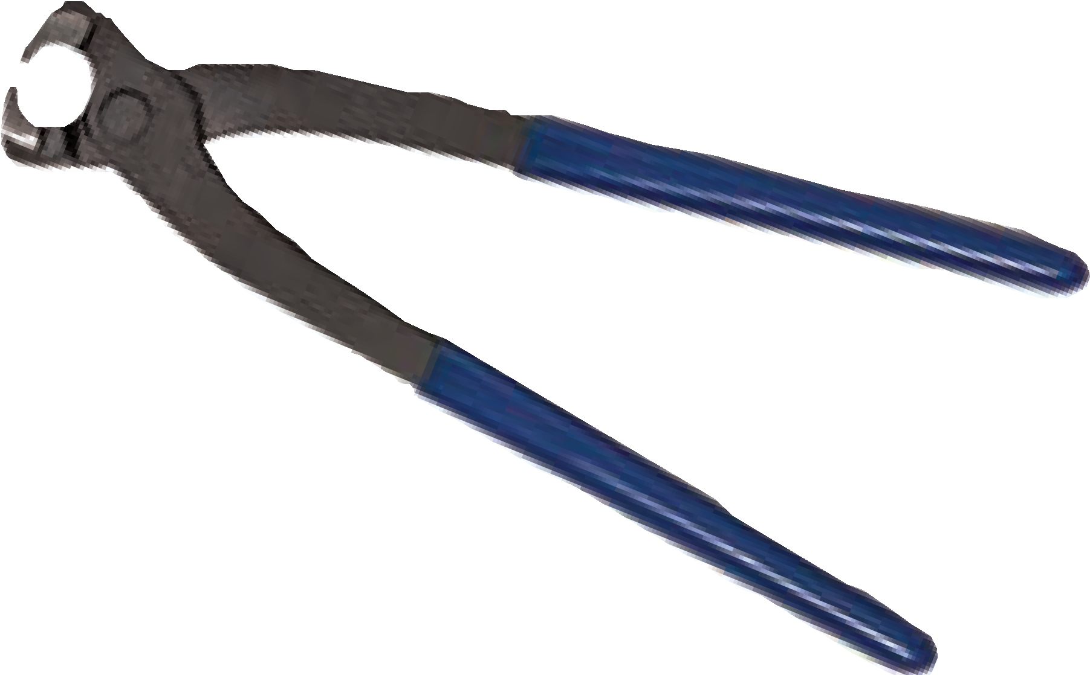Compatible with most clinching tools

Crimp Clamp Tool Part No. 6100158
Use to install or remove pinch / crimp clamps.

COMBO HEX® & MILITARY WORM DRIVE
FIND YOUR PART NUMBER

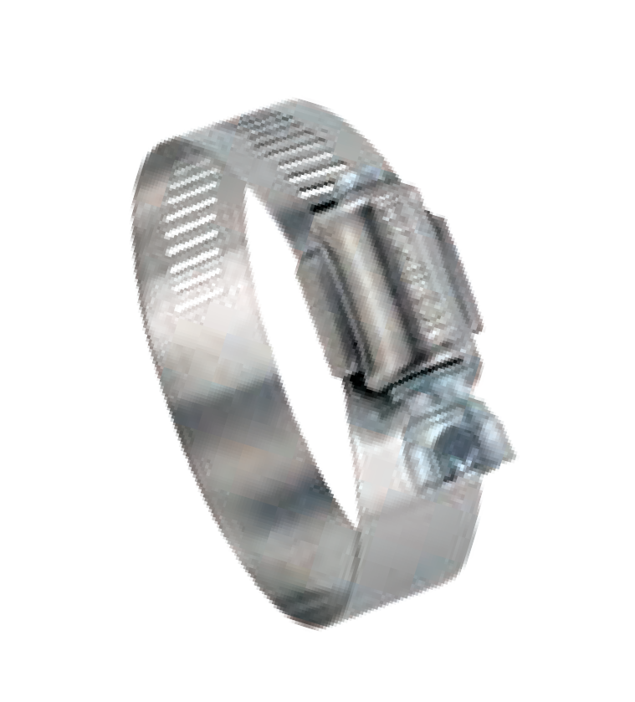Combo-Hex clamps are the clamps professional mechanics choose most often. Particularly helpful in hard-to-reach areas, they feature an exclusive, safety-collared, deep-slotted screw design that prevents screwdrivers from slipping and puncturing the hose wall. Combo-Hex clamps can be installed with a screwdriver, nutdriver or socket wrench.
Combo Hex Ideal-Tridon 54-0
3/8" Safety-Collared Hex • Deep-Slotted
Housing
9/16" Band Width
Plated Carbon Steel
200 Stainless
200 Stainless
35 in-lbs (4 Nm) for most applications

Military Worm Drive clamps are manufactured to military specification MS-35842 and AA-52506C.
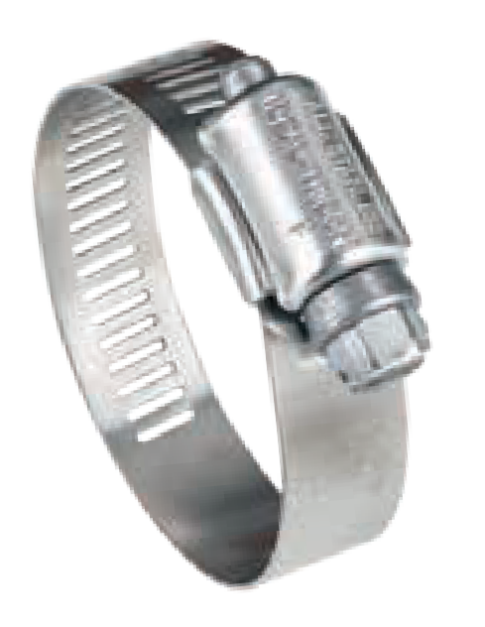
Military Worm Drive
5/16" Hex Head
Ideal-Tridon 632 • Tridon 632
Housing
1/2" Band Width
410 Stainless
201 Stainless
201 Stainless
35 in-lbs (4 Nm) for most applications

Size | Min (in) | Max (in) | Min (mm) | Max (mm) | Ideal-Tridon Ideal-Tridon 632  54-0 Tridon 632
6 | 3/8 | 7/8 | 10
 |  |  |  | 22 | 54060 | 632-006
8 | 7/16 | 1 | 11 | 25 | 54080 | -
10 | 1/2 | 1-1/16 | 13 | 27 | 54100 | -
12 | 1/2 | 1-1/4 | 13 | 32 | 54120 | 632-012
16 | 11/16 | 1-1/2 | 18 | 38 | 54160 | -
20 | 3/4 | 1-3/4 | 19 | 44 | 54200 | -
24 | 1 | 2 | 25 | 51 | 54240 | 632-024
28 | 1-1/4 | 2-1/4 | 32 | 57 | 54280 | -
32 | 1-1/2 | 2-1/2 | 38 | 63 | 54320 | -
36 | 3/4 | 2-3/4 | 19 | 70 | 54360 | 632-036
40 | 1 | 3 | 26 | 76 | 54400 | -
44 | 1-1/4 | 3-1/4 | 32 | 83 | 54440 | -
48 | 2-1/2 | 3-1/2 | 64 | 89 | 54480* | 632-048
52 | 1-3/4 | 3-3/4 | 44 | 95 | 54520 | -
56 | 2 | 4 | 51 | 101 | 54560 | -
60 | 3-5/16 | 4-1/4 | 84 | 108 | - | 632-060
104 | 4 | 7 | 102 | 178 | - | 632-104**
*Min for 54480 is 1-1/2" 38 mm
**Non-stocking item

Ideal-Tridon 48
Ideal-Tridon 49
SURELOCK QUICK ENGAGE
FIND YOUR PART NUMBER

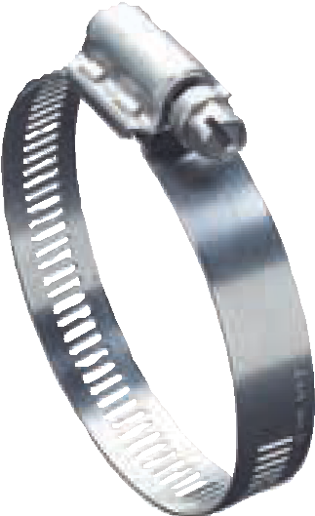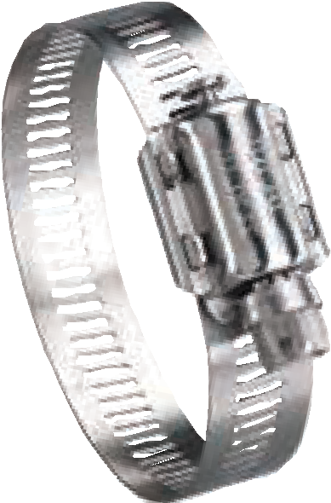Surelock Quick Engage worm drive clamps have a bind-free, pull-through design for fast installation. Captured screw design for quick fastening and trouble-free tensioning. Extended housing engages 25% more screw threads than competitive designs.
Surelock Ideal-Tridon 48
5/16" Hex Head
Two-Piece
9/16" Band Width
305 Stainless
304 Stainless
304 Stainless
Surelock Ideal-Tridon 49
5/16" Hex Head
Two-Piece
9/16" Band Width
316 Stainless
316 Stainless
316 Stainless
40 in-lbs (4.5 Nm) for most applications

Size | Min (in) | Max (in) | Min (mm) | Max (mm) | Ideal-Tridon Ideal-Tridon 48 49
12 | 1/2 | 1-1/4 | 13 | 32 | 48012 | -
20 | 3/4 | 1-3/4 | 19 | 44 | 48020 | -
24 | 3/4 | 2 | 19 | 51 | 48024 | -
28 | 1 | 2-1/4 | 25 | 57 | 48028 | -
32 | 1-1/4 | 2-1/2 | 32 | 64 | 48032 | 49032
36 | 7/8 | 2-3/4 | 22 | 70 | 48036 | -
48 | 1 | 3-1/2 | 25 | 89 | 48048 | -
56 | 1 | 4 | 25 | 102 | 48056 | -
72 | 2 | 5 | 51 | 127 | 48072 | 49073
80 | 1-13/16 | 5-1/2 | 48 | 140 | 48080 | 49080
88 | 2 | 6 | 51 | 152 | 48088 | -
104 | 2 | 7 | 51 | 178 | 48104 | 49104
116 | 1-3/4 | 7-3/4 | 44 | 196 | 48116 | -
128 | 4-1/4 | 8-1/2 | 108 | 216 | 48128 | 49128
152 | 4 | 10 | 102 | 254 | 48152 | -
180 | 7-3/4 | 11-3/4 | 197 | 298 | 48180 | 49180
188 | 6-1/4 | 12-1/4 | 159 | 311 | 48188 | -
190 | 6-3/8 | 12-3/8 | 162 | 314 | 48190 | 49190
218 | 11-3/16 | 14-5/16 | 284 | 359 | 48218 | 49218
224 | 8-1/2 | 14-1/2 | 216 | 368 | 48224 | -
232 | 9 | 15 | 229 | 381 | 48232 | -
242 | 12-11/16 | 15-5/8 | 323 | 397 | 48242 | 49242
248 | 2-1/2 | 16 | 63 | 406 | 48248 | -
258 | 13-11/16 | 16-5/8 | 348 | 422 | 48258 | 49258
272 | 11-1/2 | 17-1/2 | 292 | 445 | 48272 | -
282 | 15-3/16 | 18-1/8 | 386 | 460 | 48282 | 49282
288 | 12-1/2 | 18-1/2 | 318 | 470 | 48288 | -
306 | 14-1/16 | 19-5/8 | 357 | 498 | 48306 | 49306
312 | 2-3/8 | 20 | 60 | 508 | 48312 | -
Surelock 48: Sizes available up to size 598. Sizes 80 and above are shipped flat and disengaged • Surelock 49: All sizes are shipped flat and disengaged.

SNAPLOCK® QUICK RELEASE

Snaplock Quick Release worm drive clamps are good for closed system applications where the clamp must be disengaged to be applied. The swivel-action locking of screw to band makes installation and removal much faster. All Snaplock housings are 200 stainless steel.

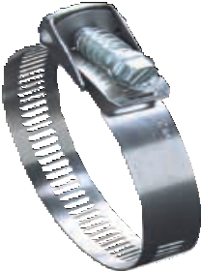
Snaplock Ideal-Tridon 56-0
5/16" Hex Head
Bridge
9/16" Band Width
Plated Carbon Steel
Plated Carbon Steel
200 Stainless
Snaplock Ideal-Tridon 500 • Tridon 500/LS
5/16" Hex Head
Bridge
1/2" Band Width
Plated Carbon Steel
410 Stainless
200 Stainless

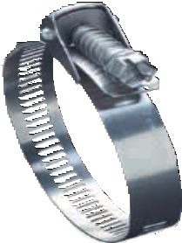
Snaplock Ideal-Tridon 58-0
3/8" Hex Head Bridge
9/16" Band Width
410 Stainless
410 Stainless
200 Stainless
Snaplock
5/16" Hex Head
Ideal-Tridon 550 • Tridon 550/LAS
Bridge
1/2" Band Width
410 Stainless
410 Stainless
200 Stainless

30 in-lbs (3.4 Nm) for most applications

Ideal-Tridon 550
Tridon 550
Ideal-Tridon 58
Ideal-Tridon 56-0
Ideal-Tridon 500
FIND YOUR PART NUMBER

Size | Min (in) | Max (in) | Min (mm) | Max (mm) | Ideal-Tridon 56-0 | Ideal-Tridon 500  Tridon 500/LS | Ideal-Tridon 58-0 | Ideal-Tridon 550 Tridon 550/LAS
12 | 1/2 | 1-1/4 | 13 | 32
 |  |  |  |  | 56120 | 500-012 | 5812 | -
20 | 3/4 | 1-3/4 | 19 | 44 | 56200 | 500-020 | 5820 | 550-020
24 | 1-1/16 | 2 | 27 | 51 | 56240 | - | 5824 | -
28 | 1 | 2-1/4 | 25 | 57 | 56280 | - | 5828 | 550-028
36 | 1 | 2-3/4 | 25 | 70 | 56360 | 500-036 | 5836 | 550-036
48 | 1-1/2 | 3-1/2 | 39 | 89 | 56480 | 500-048 | 5848 | 550-048
56 | 1 | 4 | 25 | 102 | 56560 | 500-056 | 5856 | 550-056
72 | 2 | 5 | 51 | 127 | 56720 | 500-072 | 5872 | 550-072
88 | 2 | 6 | 51 | 152 | 56880 | 500-088 | 5888 | 550-088
96 | 3-1/2 | 6-1/2 | 89 | 167 | - | 500-096 | - | 550-096
104 | 2-7/8 | 7 | 73 | 178 | 56104 | 500-104 | 58104 | 550-104
116 | 1-3/4 | 7-3/4 | 45 | 197 | 56116 | 500-116 | 58116 | 550-116
128 | 1-3/4 | 8-1/2 | 45 | 216 | 56128 | 500-128 | 58128 | 550-128
136 | 1-3/4 | 9 | 45 | 228 | 56136 | - | - | 550-136
152 | 2 | 10 | 51 | 254 | 56152 | 500-152 | 58152 | 550-152
188 | 2 | 12-1/4 | 51 | 311 | 56188 | 500-188 | 58188 | 550-188
216 | 10-3/16 | 14 | 259 | 356 | - | 500-216 | - | 550-216
224 | 2-1/2 | 14-1/4 | 64 | 362 | - | - | 58224 | 550-224
232 | 13-1/8 | 15 | 333 | 381 | 56232 | 500-232 | - | -
248 | 1-3/4 | 16 | 44 | 406 | - | 500-248 | - | 550-248
258 | 1-15/16 | 16-5/8 | 50 | 422 | 56258 | 500-258 | - | -
272 | 2 | 17 | 52 | 432 | 56272 | - | - | -
280 | 14-1/4 | 18 | 362 | 457 | - | 500-280 | - | 550-280
288 | 1-13/16 | 18-1/2 | 45 | 470 | 56288 | - | - | -
294 | 1-7/8 | 18-3/4 | 48 | 479 | - | 500-294 | - | -
312 | 1-7/8 | 20 | 48 | 508 | - | 500-312 | - | 550-312
332 | 2 | 21-1/4 | 51 | 540 | 56332 | - | 58332 | -
344 | 1-3/4 | 22 | 44 | 559 | - | 500-344 | - | 550-344
390 | 18-5/8 | 25 | 473 | 635 | - | - | - | 550-390

No-Hub Couplings
Ideal Clamp Products, Inc. manufactures no-hub couplings that are listed or certified by all major plumbing code bodies throughout U.S. and Canada. Visit www.idealtridon.com for more information.

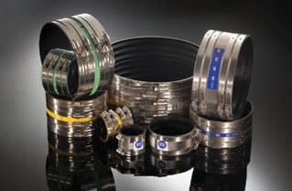
- Classic
- Standard
- Heavy Duty MD
- Heavy Duty HD
- 12" and 15"

WRAPLOCK® & LOX-ON®
FIND YOUR PART NUMBER
FIND YOUR PART NUMBER

Wraplock clamps, with their unique plated carbon steel buckles, conform to many shapes and are suitable for specialized applications.
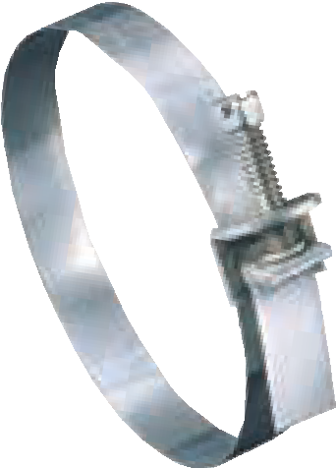
Wraplock Ideal-Tridon 59-0
5/16" Hex Head 1/2" Band Width
Plated Carbon Steel
Galvanized Steel

Size | Min (in) | Max (in) | Min (mm) | Max (mm) | Band Length (in) | Band Length (mm) | Ideal-Tridon 59-0
12 | 1 | 3-1/2 | 25 | 89 | 12 | 305
 |  |  |  |  |  |  | 5912
15 | 1 | 4-1/2 | 25 | 114 | 15 | 381 | 5915
18 | 1 | 5 | 25 | 127 | 18 | 457 | 5918
24 | 1 | 7 | 25 | 178 | 24 | 610 | 5924
30 | 1 | 9 | 25 | 229 | 30 | 762 | 5930
48 | 1 | 14-1/2 | 25 | 368 | 48 | 1219 | 5948
Product ships flat, shown engaged for illustration purposes only
Ideal-Tridon 59

Lox-On clamps are for extra-tough installations. The unique design provides double-locking security with a 301 stainless steel buckle and high band tension for high sealing pressures.

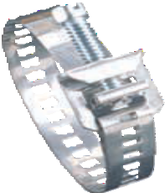
Lox-On
5/16" Hex Head
Ideal-Tridon 69-0
Housing
1/2" Band Width
305 Stainless
300 Stainless
300 Stainless • UPC Shield

Size | Min (in) | Max (in) | Min (mm) | Max (mm) | Band Length (in) | Band Length (mm) | Ideal-Tridon 69-0
12 | 11/16 | 1-1/4 | 17 | 32 | 4-13/16 | 122
 |  |  |  |  |  |  | 69120
20 | 11/16 | 1-3/4 | 17 | 44 | 6-13/32 | 163 | 69200
32 | 11/16 | 2-5/8 | 17 | 67 | 8-29/32 | 226 | 69320
72 | 1-3/4 | 5 | 44 | 127 | 16-5/16 | 414 | 69720
104 | 4 | 7-1/4 | 102 | 184 | 23-5/16 | 592 | 69104
Product ships flat, shown engaged for illustration purposes only
Ideal-Tridon 69

Ideal-Tridon 5Y
TURN-KEY® & FLEXIBLE HOSE CLAMP DRIVER

Turn-Key clamps offer innovative design and install with a simple hand twist. No tools are required.
Remove the reusable plastic screw cap for a tamper-resistant connection. Also available
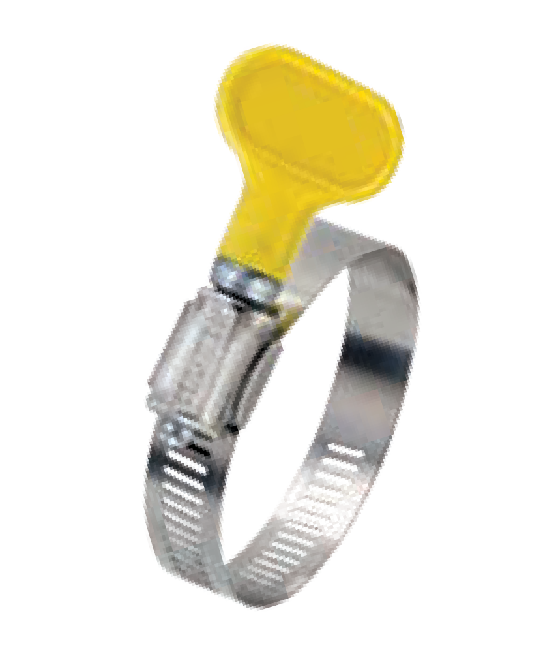in blister pack assortment options. Applications include dryer vent hose, filter bags, RV sewer hose, cable and wire bundling.
Turn-Key Ideal-Tridon 5Y/6Y*
Capped Screw
Housing
1/2" Band Width
Plated Carbon Steel
300 Stainless
200 Stainless
*5/16" Band Width for 6Y

Size | (in) | (in) | (mm) | (mm) | 5Y/6Y | Blister Packs
4 | 5/16 | 5/8 | 8 | 16 | 6Y004 | ‡
6 | 3/8 | 7/8 | 10 | 22 | 6Y006 | ‡
12 | 1/2 | 1-1/4 | 13 | 32 | 5Y012 | 5Y01258*
20 | 3/4 | 1-3/4 | 19 | 44 | 5Y020 | 5Y02058*
28 | 1-1/4 | 2-1/4 | 32 | 57 | 5Y028 | 5Y02858*
36 | 1-3/4 | 2-3/4 | 44 | 70 | 5Y036 | 5Y03658*
48 | 2-1/2 | 3-1/2 | 64 | 89 | 5Y048 | 5Y04858*
64 | 2-1/2 | 4-1/2 | 64 | 114 | 5Y064 | 5Y06458*

*Comes with 2 clamps per blister pack
FIND YOUR PART NUMBER
‡Micro Assortment: Two each of size 4 and size 6
Six-Pack Assortment: One each of size 4, 6, 12, 20, 28, 36
6Y00458
5Y00158
Ideal-Tridon
Ideal-Tridon
Max
Min
Max
Min

Flexible Hose Clamp Driver Stop using that old, rigid nut driver and add some flexibility to your work! The flexible shaft and slipless grip provide 90-degree work access and are best in tight spaces such as compact car and boat engines, as well as plumbing repair applications. The socket fits mini and standard hose clamp screw heads. Just flip the socket for the desired size of 1/4" or 5/16" hex. Part No. 9999V*
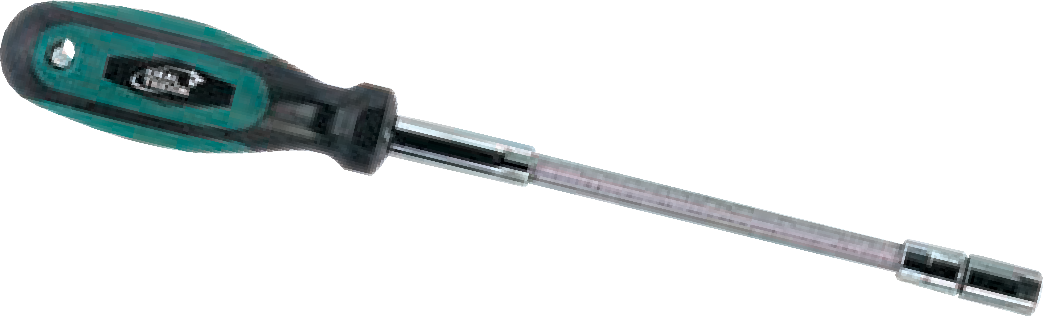
Flexible Hose Clamp Driver Part No. 9999V
1/4" Hex Head 5/16" Hex Head
or
*9999V shown on packaging. Complete part no. is 800019999058

LINED

Lined clamps are designed for use with silicone rubber and other soft hose applications. The liner protects the hose surface and prevents it from extruding or shearing through the band notches as the clamp is tightened.

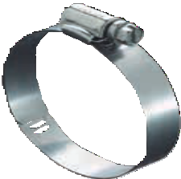
Lined Ideal-Tridon 65E
5/16" Hex Slotted
Housing
9/16" Lined Band
300 Stainless
300 Stainless
300 Stainless
Lined Ideal-Tridon 615
5/16" Hex Slotted
Housing
1/2" Lined Band
300 Stainless
200 Stainless
200 Stainless

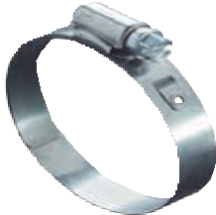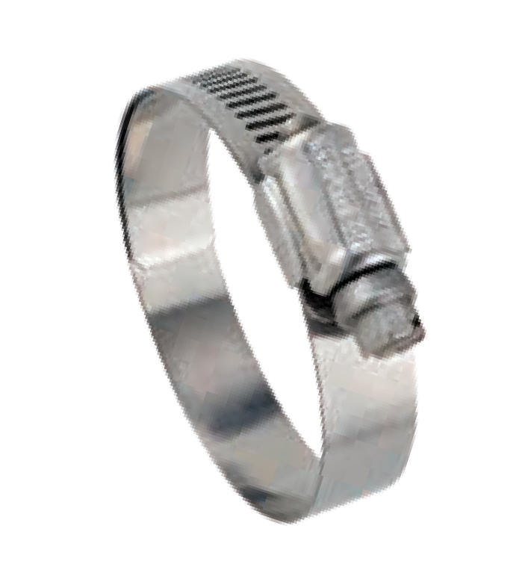
Lined Ideal-Tridon 53-0 • Tridon 613/ET
5/16" Hex Slotted
Housing
1/2" Lined Band
Plated Carbon Steel
200 Stainless
200 Stainless
Lined Ideal-Tridon 67M
5/16" Hex Slotted
Housing
1/2" Lined Band
316 Stainless
316 Stainless
316 Stainless

35 in-lbs (4 Nm) for most applications

Ideal-Tridon
Ideal-Tridon 67M
Ideal-Tridon 65E
Tridon 63/ET
Size | Min (in) | Max (in) | Min (mm) | Max (mm) | Ideal-Tridon 65E | Ideal-Tridon 615 | Ideal-Tridon 53-0 | Tridon 613/ET | Ideal-Tridon 67M
6 | 1/2 | 7/8 | 13 | 22 | 6506E | 615-006 | 53060 | 613-006 | N/A
8 | 5/8 | 1 | 16 | 25 | 6508E | 615-008 | 53080 | 613-008 | 6708M
10 | 11/16 | 1-1/16 | 17 | 27 | 6510E | 615-010 | 53100 | 613-010 | 6710M
12 | 11/16 | 1-1/4 | 17 | 32 | 6512E | 615-012 | 53120 | 613-012 | 6712M
16 | 3/4 | 1-1/2 | 19 | 38 | 6516E | 615-016 | 53160 | 613-016 | 6716M
20 | 1 | 1-3/4 | 25 | 44 | 6520E | 615-020 | 53200 | 613-020 | 6720M
24 | 1-1/16 | 2 | 27 | 51 | 6524E | 615-024 | 53240 | 613-024 | 6724M
28 | 1-5/16 | 2-1/4 | 33 | 57 | 6528E | 615-028 | 53280 | 613-028 | 6728M
32 | 1-9/16 | 2-1/2 | 40 | 63 | 6532E | 615-032 | 53320 | 613-032 | 6732M
36 | 1-13/16 | 2-3/4 | 46 | 70 | 6536E | 615-036 | 53360 | 613-036 | 6736M
40 | 2-1/16 | 3 | 52 | 76 | 6540E | 615-040 | 53400 | 613-040 | 6740M
44 | 2-5/16 | 3-1/4 | 59 | 82 | 6544E | 615-044 | 53440 | 613-044 | 6744M
48 | 2-9/16 | 3-1/2 | 65 | 89 | 6548E | 615-048 | 53480 | 613-048 | 6748M
52 | 2-13/16 | 3-3/4 | 72 | 95 | 6552E | 615-052 | 53520 | 613-052 | 6752M
56 | 3-1/16 | 4 | 78 | 101 | 6556E | 615-056 | 53560 | 613-056 | 6756M
60 | 3-5/16 | 4-1/4 | 84 | 108 | 6560E | 615-060 | 53600 | 613-060 | 6760M
64 | 3-9/16 | 4-1/2 | 91 | 114 | 6564E | 615-064 | 53640 | 613-064 | 6764M
72 | 4-1/16 | 5 | 103 | 127 | 6572E | 615-072 | 53720 | 613-072 | 6772M
80 | 4-9/16 | 5-1/2 | 116 | 140 | - | 615-080 | - | - | -
88 | 5-1/16 | 6 | 129 | 152 | - | - | - | - | 6788M
96 | 5-9/16 | 6-1/2 | 141 | 165 | - | - | - | - | 6796M

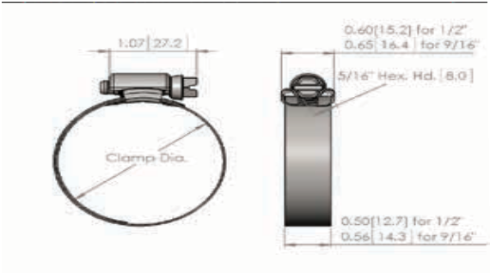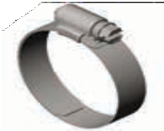

POW’R-GEAR®

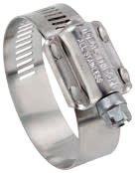Pow’r-Gear high performance clamps are designed for high vibration and stubborn leakage applications such as industrial machinery, heavy truck, farm and off-road equipment engines. Pow’r-Gears feature an extra wide 5/8" heavy gauge band and a wide profile housing that provides maximum engagement of screw threads to band. Engineered to deliver exceptionally high rates of band tension to handle the toughest sealing jobs.
Pow'r-Gear
5/16" Hex Head
Ideal-Tridon 60 • Tridon M850
Housing
5/8" Band Width
410 Stainless
300 Stainless
300 Stainless
Pow'r-Gear Ideal-Tridon 6P
5/16" Hex Head Housing
5/8" Band Width
305 Stainless
300 Stainless
300 Stainless

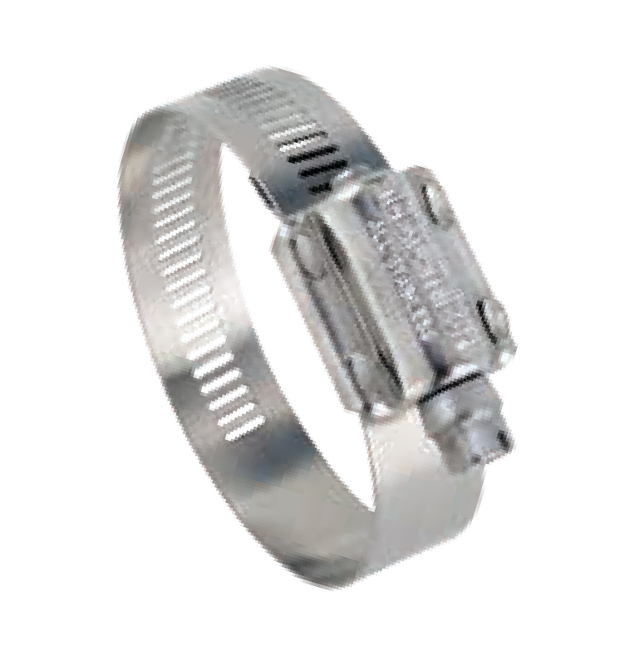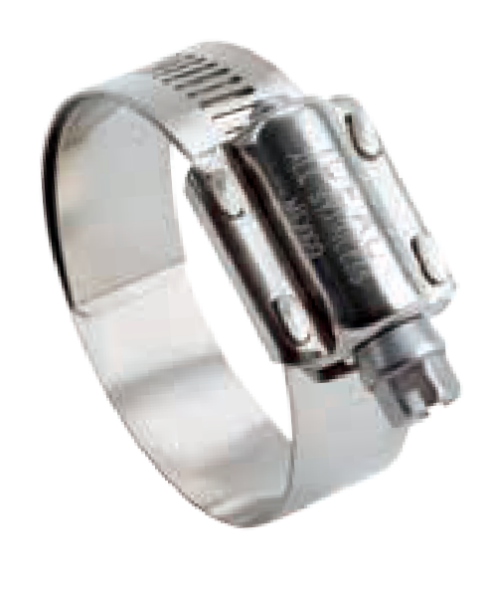
Pow'r-Gear
5/16" Hex Head
Ideal-Tridon 6L • Tridon M843
Housing
5/8" Lined Band
410 Stainless
300 Stainless
300 Stainless
Pow'r-Gear Ideal-Tridon 6M
5/16" Hex Head Housing
5/8" Lined Band
305 Stainless
300 Stainless
300 Stainless
Pow'r-Gear Ideal-Tridon 6X
5/16" Hex Head Housing
5/8" Band Width
410 Stainless
300 Stainless
300 Stainless
75-90 in-lbs (8.5-10 Nm) for most applications

Ideal-Tridon 60
Ideal-Tridon 6P
Ideal-Tridon 6M
Ideal-Tridon 6L
Size | Min (in) | Max (in) | Min (mm) | Max (mm) | Ideal-Tridon 60 | Tridon M850 | Ideal-Tridon 6P | Ideal-Tridon 6L | Tridon M843 | Ideal-Tridon 6M
175 | 1 | 1-3/4 | 25
 |  |  |  | 45 | 60175 | 850-175 | 6P175 | 6L175 | 843-175 | 6M175
212 | 1-1/4 | 2-1/8 | 32 | 54 | 60200 | 850-200 | 6P200 | 6L200 | 843-200 | 6M200
262 | 1-3/4 | 2-5/8 | 45 | 66 | 60250 | 850-250 | 6P250 | 6L250 | 843-250 | 6M250
312 | 2-1/4 | 3-1/8 | 57 | 79 | 60300 | 850-300 | 6P300 | 6L300 | 843-300 | 6M300
362 | 2-3/4 | 3-5/8 | 70 | 92 | 60350 | 850-350 | 6P350 | 6L350 | 843-350 | 6M350
412 | 3-1/4 | 4-1/8 | 83 | 105 | 60400 | 850-400 | 6P400 | 6L400 | 843-400 | 6M400
462 | 3-3/4 | 4-5/8 | 95 | 117 | 60450 | 850-450 | 6P450 | 6L450 | 843-450 | 6M450
512 | 4-1/4 | 5-1/8 | 108 | 130 | 60500 | 850-500 | 6P500 | 6L500 | 843-500 | 6M500
562 | 4-3/4 | 5-5/8 | 121 | 143 | 60550 | 850-550 | 6P550 | 6L550 | 843-550 | 6M550
612 | 5-1/4 | 6-1/8 | 133 | 155 | 60600 | 850-600 | 6P600 | 6L600 | 843-600 | 6M600
662 | 5-3/4 | 6-5/8 | 146 | 168 | 60650 | 850-650 | 6P650 | 6L650 | 843-650 | 6M650
712 | 6-1/4 | 7-1/8 | 159 | 181 | 60700 | 850-700 | 6P700 | 6L700 | 843-700 | 6M700
762 | 6-3/4 | 7-5/8 | 172 | 193 | 60750 | 850-750 | 6P750 | 6L750 | 843-750 | 6M750
812 | 7-1/4 | 8-1/8 | 184 | 206 | 60800 | 850-800 | 6P800 | 6L800 | 843-800 | 6M800
862 | 7-3/4 | 8-5/8 | 197 | 219 | 60850 | 850-850 | 6P850 | 6L850 | 843-850 | 6M850
912 | 8-1/4 | 9-1/8 | 210 | 232 | 60900 | 850-900 | 6P900 | 6L900 | 843-900 | 6M900

Pow’r-Gear 6X Series clamps have extra band notches for greater work range so five sizes cover clamping diameters from 1-1/4" to 10-1/8". This minimizes your inventory without compromising applications coverage. Plus, Pow'r-Gear clamps deliver over 800 lbs. of band tension at 150 in.-lbs. of torque. That’s over twice the holding power of conventional clamps!
FIND YOUR PART NUMBER

Size | Min (in) | Max (in) | Min (mm) | Max (mm) | Ideal-Tridon 6X
262 | 1-1/4 | 2-5/8 | 32
 |  |  |  | 66 | 6X200
412 | 2 | 4-1/8 | 51 | 105 | 6X300
612 | 4 | 6-1/8 | 102 | 155 | 6X400
912 | 6 | 9-1/8 | 153 | 231 | 6X500
1012 | 7 | 10-1/8 | 178 | 257 | 6X600
Additional sizes available
Ideal 6X

T-BOLTS - MINIMAL DIAMETERS

T-Bolt clamps provide uniform sealing pressure for a positive, reliable seal. Designed for use in high vibration and large diameter applications common in heavy trucks, industrial machinery, off-road equipment, agricultural irrigation and machinery. Features a 3/4" or 7/8" wide stainless steel band, depending upon size ordered, and welded construction for reliability.

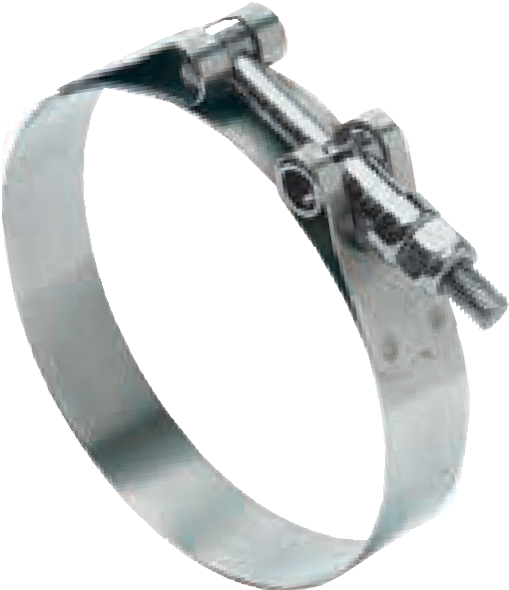
Standard T-Bolt Ideal-Tridon 30010
1/4" T-Bolt
7/16" Hex Nut
3/4" Band
3/4" Bridge
Trunnion
Plated Carbon Steel Plated Carbon Steel
Nylon Insert
300 Stainless
300 Stainless Plated Carbon Steel
Standard T-Bolt Ideal-Tridon 30011
1/4" T-Bolt
7/16" Hex Nut
3/4" Band
3/4" Bridge
Trunnion
300 Stainless
300 Stainless Nylon Insert
300 Stainless
300 Stainless 300 Stainless

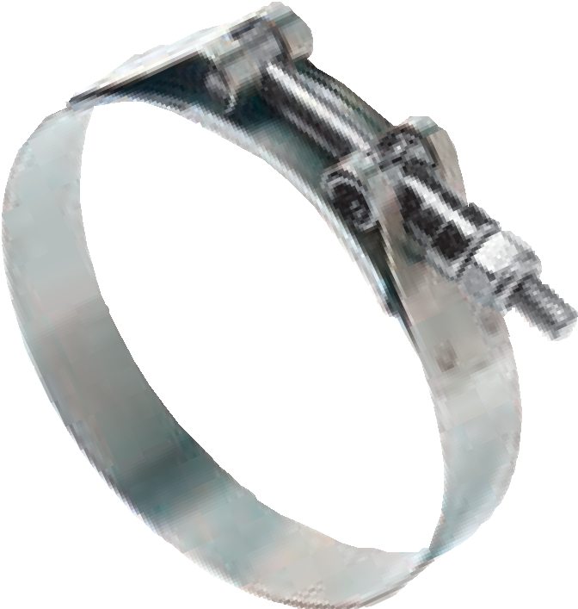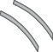
Channel Bridge T-Bolt Ideal-Tridon 30020
1/4" T-Bolt
7/16" Hex Nut
3/4" Band
3/4" Bridge
Trunnion
Plated Carbon Steel Plated Carbon Steel
Nylon Insert
300 Stainless
300 Stainless Plated Carbon Steel
Channel Bridge T-Bolt Ideal-Tridon 30021
1/4" T-Bolt
7/16" Hex Nut
3/4" Band
3/4" Bridge
Trunnion
300 Stainless
300 Stainless Nylon Insert
300 Stainless
300 Stainless 300 Stainless
Note: 7/8" wide bands and custom options by request

75 in-lbs (8.5 Nm) for most applications

Standard T-Bolt Channel Bridge
Size | Min (in) | Max (in) | Min (mm) | Max (mm) | Ideal-Tridon 30010* | Ideal-Tridon 30011* | Ideal-Tridon 30020 | Ideal-Tridon 30021
138 | 1.38 | 1.57 | 35.1 | 39.9 | 30010-0138 | 30011-0138 | 30020-0138 | 30021-0138
150 | 1.50 | 1.69 | 38.1 | 42.9 | 30010-0150 | 30011-0150 | 30020-0150 | 30021-0150
163 | 1.63 | 1.88 | 41.3 | 47.8 | 30010-0163 | 30011-0163 | 30020-0163 | 30021-0163
175 | 1.75 | 2.00 | 44.5 | 50.8 | 30010-0175 | 30011-0175 | 30020-0175 | 30021-0175
188 | 1.88 | 2.19 | 47.6 | 55.6 | 30010-0188 | 30011-0188 | 30020-0188 | 30021-0188
200 | 2.00 | 2.31 | 50.8 | 58.7 | 30010-0200 | 30011-0200 | 30020-0200 | 30021-0200
213 | 2.13 | 2.44 | 54.1 | 62.0 | 30010-0213 | 30011-0213 | 30020-0213 | 30021-0213
225 | 2.25 | 2.56 | 57.2 | 65.0 | 30010-0225 | 30011-0225 | 30020-0225 | 30021-0225
238 | 2.38 | 2.69 | 60.3 | 68.3 | 30010-0238 | 30011-0238 | 30020-0238 | 30021-0238
250 | 2.50 | 2.81 | 63.5 | 71.4 | 30010-0250 | 30011-0250 | 30020-0250 | 30021-0250
263 | 2.63 | 2.94 | 66.7 | 74.7 | 30010-0263 | 30011-0263 | 30020-0263 | 30021-0263
275 | 2.75 | 3.06 | 69.9 | 77.7 | 30010-0275 | 30011-0275 | 30020-0275 | 30021-0275
288 | 2.88 | 3.19 | 73.0 | 81.0 | 30010-0288 | 30011-0288 | 30020-0288 | 30021-0288
300 | 3.00 | 3.31 | 76.2 | 84.1 | 30010-0300 | 30011-0300 | 30020-0300 | 30021-0300
313 | 3.13 | 3.44 | 79.4 | 87.4 | 30010-0313 | 30011-0313 | 30020-0313 | 30021-0313
325 | 3.25 | 3.56 | 82.6 | 90.4 | 30010-0325 | 30011-0325 | 30020-0325 | 30021-0325
338 | 3.38 | 3.69 | 85.7 | 93.7 | 30010-0338 | 30011-0338 | 30020-0338 | 30021-0338
350 | 3.50 | 3.81 | 88.9 | 96.8 | 30010-0350 | 30011-0350 | 30020-0350 | 30021-0350
363 | 3.63 | 3.94 | 92.1 | 100.1 | 30010-0363 | 30011-0363 | 30020-0363 | 30021-0363
375 | 3.75 | 4.06 | 95.3 | 103.1 | 30010-0375 | 30011-0375 | 30020-0375 | 30021-0375
400 | 4.00 | 4.31 | 101.6 | 109.5 | 30010-0400 | 30011-0400 | 30020-0400 | 30021-0400
425 | 4.25 | 4.56 | 108.0 | 115.8 | 30010-0425 | 30011-0425 | 30020-0425 | 30021-0425
450 | 4.50 | 4.81 | 114.3 | 122.2 | 30010-0450 | 30011-0450 | 30020-0450 | 30021-0450
475 | 4.75 | 5.06 | 120.7 | 128.5 | 30010-0475 | 30011-0475 | 30020-0475 | 30021-0475
500 | 5.00 | 5.31 | 127.0 | 134.9 | 30010-0500 | 30011-0500 | 30020-0500 | 30021-0500
525 | 5.25 | 5.56 | 133.4 | 141.2 | 30010-0525 | 30011-0525 | 30020-0525 | 30021-0525
550 | 5.50 | 5.81 | 139.7 | 147.6 | 30010-0550 | 30011-0550 | 30020-0550 | 30021-0550
575 | 5.75 | 6.06 | 146.1 | 153.9 | 30010-0575 | 30011-0575 | 30020-0575 | 30021-0575
600 | 6.00 | 6.31 | 152.4 | 160.3 | 30010-0600 | 30011-0600 | 30020-0600 | 30021-0600
625 | 6.25 | 6.56 | 158.8 | 166.6 | 30010-0625 | 30011-0625 | 30020-0625 | 30021-0625
650 | 6.50 | 6.81 | 165.1 | 173.0 | 30010-0650 | 30011-0650 | 30020-0650 | 30021-0650
675 | 6.75 | 7.06 | 171.5 | 179.3 | 30010-0675 | 30011-0675 | 30020-0675 | 30021-0675
700 | 7.00 | 7.31 | 177.8 | 185.7 | 30010-0700 | 30011-0700 | 30020-0700 | 30021-0700
725 | 7.25 | 7.56 | 184.2 | 192.0 | 30010-0725 | 30011-0725 | 30020-0725 | 30021-0725
750 | 7.50 | 7.81 | 190.5 | 198.4 | 30010-0750 | 30011-0750 | 30020-0750 | 30021-0750
775 | 7.75 | 8.06 | 196.9 | 204.7 | 30010-0775 | 30011-0775 | 30020-0775 | 30021-0775
800 | 8.00 | 8.31 | 203.2 | 211.1 | 30010-0800 | 30011-0800 | 30020-0800 | 30021-0800
825 | 8.25 | 8.56 | 209.6 | 217.4 | 30010-0825 | 30011-0825 | 30020-0825 | 30021-0825
850 | 8.50 | 8.81 | 215.9 | 223.8 | 30010-0850 | 30011-0850 | 30020-0850 | 30021-0850
Additional sizes available
Ideal-Tridon 30020
Ideal-Tridon 30010
Ideal-Tridon 30011
*Available individually barcoded

T-BOLTS - NOMINAL DIAMETERS

Nominal Diameter Sized T-bolt clamps provide uniform sealing pressure for a positive, reliable seal. Designed for use in high vibration and large diameter applications common in heavy trucks, industrial machinery, off-road equipment, agricultural irrigation and machinery. Easy to interchange competitors part numbers.
Ideal-Tridon 30050
Ideal-Tridon 30051
FIND YOUR PART NUMBER

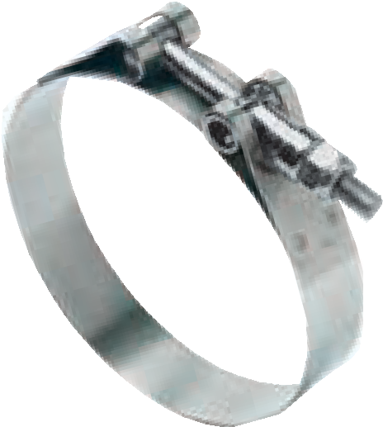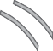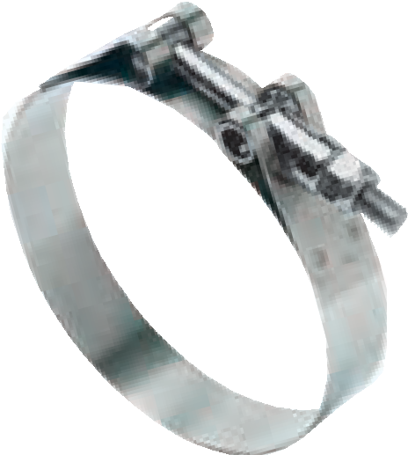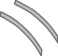

30050

1/4" T-Bolt

Plated Carbon Steel 7/16" Hex Nut

Plated Carbon Steel Nylon Insert
3/4" Band

300 Stainless 3/4" Bridge

300 Stainless Trunnion

Plated Carbon Steel

Standard T-Bolt

30051

1/4" T-Bolt

300 Stainless 7/16" Hex Nut

300 Stainless Nylon Insert
3/4" Band

300 Stainless 3/4" Bridge

300 Stainless Trunnion

300 Stainless

Standard T-Bolt
Nominal Diameter (in) | Nominal Diameter (mm) | Min (in) | Max (in) | Min (mm) | Max Ideal-Tridon Ideal-Tridon  (mm) 30050 30051
1.31 | 33.3 | 1.25 | 1.41 | 31.8 | 35.7 | 30050-0131 | 30051-0131
1.50 | 38.1 | 1.34 | 1.56 | 34.1 | 39.7 | 30050-0150 | 30051-0150
1.63 | 41.4 | 1.47 | 1.69 | 37.4 | 43.0 | 30050-0163 | 30051-0163
1.75 | 44.5 | 1.59 | 1.81 | 40.5 | 46.0 | 30050-0175 | 30051-0175
1.88 | 47.8 | 1.72 | 1.94 | 43.8 | 49.3 | 30050-0188 | 30051-0188
2.00 | 50.8 | 1.84 | 2.06 | 46.8 | 52.4 | 30050-0200 | 30051-0200
2.12 | 53.8 | 1.96 | 2.18 | 49.9 | 55.4 | 30050-0212 | 30051-0212
2.25 | 57.2 | 2.09 | 2.31 | 53.2 | 58.7 | 30050-0225 | 30051-0225
2.38 | 60.5 | 2.22 | 2.44 | 56.5 | 62.0 | 30050-0238 | 30051-0238
2.50 | 63.5 | 2.34 | 2.56 | 59.5 | 65.1 | 30050-0250 | 30051-0250
2.56 | 65.0 | 2.33 | 2.62 | 59.1 | 66.6 | 30050-0256 | 30051-0256
2.63 | 66.8 | 2.40 | 2.69 | 60.9 | 68.4 | 30050-0263 | 30051-0263
2.75 | 69.9 | 2.52 | 2.81 | 63.9 | 71.4 | 30050-0275 | 30051-0275
2.88 | 73.2 | 2.65 | 2.94 | 67.2 | 74.7 | 30050-0288 | 30051-0288
3.00 | 76.2 | 2.77 | 3.06 | 70.3 | 77.8 | 30050-0300 | 30051-0300
3.12 | 79.2 | 2.87 | 3.18 | 72.8 | 80.8 | 30050-0312 | 30051-0312
3.25 | 82.6 | 3.02 | 3.31 | 76.6 | 84.1 | 30050-0325 | 30051-0325
3.50 | 88.9 | 3.27 | 3.56 | 83.0 | 90.5 | 30050-0350 | 30051-0350
3.62 | 91.9 | 3.39 | 3.68 | 86.0 | 93.5 | 30050-0362 | 30051-0362
3.75 | 95.3 | 3.52 | 3.81 | 89.3 | 96.8 | 30050-0375 | 30051-0375
3.82 | 97.0 | 3.59 | 3.88 | 91.1 | 98.6 | 30050-0382 | 30051-0382
4.00 | 101.6 | 3.77 | 4.06 | 95.7 | 103.2 | 30050-0400 | 30051-0400
4.25 | 108.0 | 4.02 | 4.31 | 102.0 | 109.5 | 30050-0425 | 30051-0425
4.50 | 114.3 | 4.27 | 4.56 | 108.4 | 115.9 | 30050-0450 | 30051-0450
4.75 | 120.7 | 4.52 | 4.81 | 114.7 | 122.2 | 30050-0475 | 30051-0475
5.00 | 127.0 | 4.77 | 5.06 | 121.1 | 128.6 | 30050-0500 | 30051-0500
5.25 | 133.4 | 5.02 | 5.31 | 127.4 | 134.9 | 30050-0525 | 30051-0525
5.50 | 139.7 | 5.27 | 5.56 | 133.8 | 141.3 | 30050-0550 | 30051-0550
5.75 | 146.1 | 5.52 | 5.81 | 140.1 | 147.6 | 30050-0575 | 30051-0575
6.00 | 152.4 | 5.77 | 6.06 | 146.5 | 154.0 | 30050-0600 | 30051-0600
6.25 | 158.8 | 6.02 | 6.31 | 152.8 | 160.3 | 30050-0625 | 30051-0625
6.50 | 165.1 | 6.27 | 6.56 | 159.2 | 166.7 | 30050-0650 | 30051-0650
6.75 | 171.5 | 6.52 | 6.81 | 165.5 | 173.0 | 30050-0675 | 30051-0675
7.00 | 177.8 | 6.77 | 7.06 | 171.9 | 179.4 | 30050-0700 | 30051-0700
7.25 | 184.2 | 7.02 | 7.31 | 178.2 | 185.7 | 30050-0725 | 30051-0725
7.50 | 190.5 | 7.27 | 7.56 | 184.6 | 192.1 | 30050-0750 | 30051-0750
8.00 | 203.2 | 7.77 | 8.06 | 197.3 | 204.8 | 30050-0800 | 30051-0800
8.25 | 209.6 | 8.02 | 8.31 | 203.6 | 211.1 | 30050-0825 | 30051-0825
8.50 | 215.9 | 8.27 | 8.56 | 210.0 | 217.5 | 30050-0850 | 30051-0850
8.88 | 225.6 | 8.65 | 8.94 | 219.6 | 227.1 | 30050-0888 | 30051-0888
9.00 | 228.6 | 8.77 | 9.06 | 222.7 | 230.2 | 30050-0900 | 30051-0900
9.50 | 241.3 | 9.27 | 9.56 | 235.4 | 242.9 | 30050-0950 | 30051-0950
10.00 | 254.0 | 9.77 | 10.06 | 248.1 | 255.6 | 30050-1000 | 30051-1000
10.88 | 276.4 | 10.65 | 10.94 | 270.4 | 277.9 | 30050-1088 | 30051-1088
12.00 | 304.8 | 11.77 | 12.06 | 298.9 | 306.4 | 30050-1200 | 30051-1200
12.88 | 327.2 | 12.65 | 12.94 | 321.2 | 328.7 | 30050-1288 | 30051-1288

SPRING LOADED T-BOLTS

Spring Loaded T-Bolt clamps provide uniform sealing pressure for a positive, reliable seal. Designed for use in high vibration and large diameter applications common in heavy trucks, industrial machinery, off- road equipment, agricultural irrigation and machinery. Features a spring-loaded t-bolt assembly, a 3/4" wide stainless steel band and welded construction for reliability.
Ideal-Tridon 30030
FIND YOUR PART NUMBER

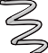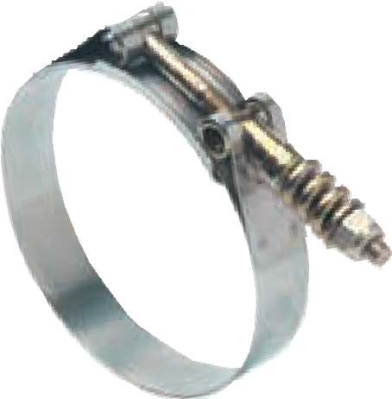
Spring Loaded T-Bolt Ideal-Tridon 30030
1/4" T-Bolt 7/16" Hex Nut 3/4" Band Width 3/4" Bridge Trunnion
Spring
Plated Carbon Plated Carbon Steel 300 Stainless
300 Stainless Plated Carbon
Steel
Steel
Steel
Nylon Insert

Size | Min (in) | Max (in) | Min (mm) | Max (mm) | Ideal-Tridon 30030
225 | 2.250 | 2.563 | 57.2 | 65.1 | 30030-0225
275 | 2.750 | 3.063 | 69.9 | 77.8 | 30030-0275
300 | 3.000 | 3.313 | 76.2 | 84.1 | 30030-0300
306 | 3.063 | 3.375 | 77.8 | 85.7 | 30030-0306
313 | 3.125 | 3.438 | 79.4 | 87.3 | 30030-0313
325 | 3.250 | 3.563 | 82.6 | 90.5 | 30030-0325
338 | 3.375 | 3.688 | 85.7 | 93.7 | 30030-0338
350 | 3.500 | 3.813 | 88.9 | 96.8 | 30030-0350
356 | 3.563 | 3.875 | 90.5 | 98.4 | 30030-0356
363 | 3.625 | 3.938 | 92.1 | 100.0 | 30030-0363
375 | 3.750 | 4.063 | 95.3 | 103.2 | 30030-0375
400 | 4.000 | 4.313 | 101.6 | 109.5 | 30030-0400
406 | 4.063 | 4.375 | 103.2 | 111.1 | 30030-0406
425 | 4.250 | 4.563 | 108.0 | 115.9 | 30030-0425
450 | 4.500 | 4.813 | 114.3 | 122.2 | 30030-0450
456 | 4.563 | 4.875 | 115.9 | 123.8 | 30030-0456
475 | 4.750 | 5.063 | 120.7 | 128.6 | 30030-0475
500 | 5.000 | 5.313 | 127.0 | 134.9 | 30030-0500
506 | 5.063 | 5.375 | 128.6 | 136.5 | 30030-0506
525 | 5.250 | 5.563 | 133.4 | 141.3 | 30030-0525
550 | 5.500 | 5.813 | 139.7 | 147.6 | 30030-0550
575 | 5.750 | 6.063 | 146.1 | 154.0 | 30030-0575
625 | 6.250 | 6.563 | 158.8 | 166.7 | 30030-0625
650 | 6.500 | 6.813 | 165.1 | 173.0 | 30030-0650
750 | 7.500 | 7.813 | 190.5 | 198.4 | 30030-0750

75 in-lbs (8.5 Nm) for most applications

Ideal P/N
V-BANDS
FIND YOUR PART NUMBER

- Bands seal connections for flanged joints. Typical applications include filter housings, turbocharger systems, exhaust systems and industrial applications where a flanged connection
is required. V-inserts can be manufactured to OE specifications and are made to order.
Additional alloys are available for severe environments.

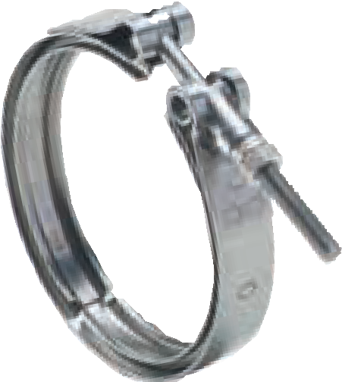
V-Band
1/4" T-Bolt 7/16" Hex Nut Band with V-Insert
Trunnion
410 Stainless
300 Stainless
300 Stainless
300 Stainless

Nominal Dia. (in) | Nominal Dia. (mm) | Dim "A"  (in) | Dim "A"  (mm) | Dim "B"  (in) | Dim "B"  (mm) | Dim "C"  (in) | Dim "C"  (mm) | Dim "D"  (in) | Dim "D"  (mm) | Dim "E"  (in) | Dim "E"  (mm) | Ideal-Tridon 24000
2.88 | 73.2 | 0.060 | 1.52 | 0.207 | 5.26 | 0.281 | 7.14 | 0.035 | 0.89 | 0.750
 |  |  |  |  |  |  |  |  |  |  | 19.05 | 24000-0288
3.21 | 81.5 | 0.050 | 1.27 | 0.262 | 6.65 | 0.141 | 3.58 | 0.035 | 0.89 | 0.750 | 19.05 | 24000-0321
3.82 | 97.0 | 0.077 | 1.96 | 0.207 | 5.26 | 0.281 | 7.14 | 0.040 | 1.02 | 0.875 | 22.23 | 24000-0382
4.06 | 103.1 | 0.077 | 1.96 | 0.239 | 6.07 | 0.281 | 7.14 | 0.050 | 1.27 | 0.875 | 22.23 | 24000-0406
4.13 | 104.9 | 0.050 | 1.27 | 0.262 | 6.65 | 0.141 | 3.58 | 0.035 | 0.89 | 0.750 | 19.05 | 24000-0413
4.19 | 106.4 | 0.050 | 1.27 | 0.400 | 10.16 | 0.281 | 7.14 | 0.040 | 1.02 | 0.875 | 22.23 | 24000-0419
4.25 | 108.0 | 0.050 | 1.27 | 0.400 | 10.16 | 0.281 | 7.14 | 0.040 | 1.02 | 0.875 | 22.23 | 24000-0425
4.50 | 114.3 | 0.077 | 1.96 | 0.207 | 5.26 | 0.281 | 7.14 | 0.040 | 1.02 | 0.875 | 22.23 | 24000-0450
4.61 | 117.1 | 0.050 | 1.27 | 0.156 | 3.96 | 0.281 | 5.54 | 0.035 | 0.89 | 0.750 | 19.05 | 24000-0461
4.75 | 120.7 | 0.050 | 1.27 | 0.400 | 10.16 | 0.281 | 7.14 | 0.079 | 2.01 | 0.875 | 22.23 | 24000-0475
4.81 | 122.2 | 0.077 | 1.96 | 0.207 | 5.26 | 0.281 | 7.14 | 0.040 | 1.02 | 0.875 | 22.23 | 24000-0481
4.94 | 125.5 | 0.050 | 1.27 | 0.181 | 4.60 | 0.281 | 7.14 | 0.035 | 0.89 | 0.750 | 19.05 | 24000-0494
5.25 | 133.4 | 0.050 | 1.27 | 0.262 | 6.65 | 0.141 | 3.58 | 0.035 | 0.89 | 0.750 | 19.05 | 24000-0525
5.81 | 147.6 | 0.077 | 1.96 | 0.207 | 5.26 | 0.281 | 7.14 | 0.062 | 1.57 | 0.875 | 22.23 | 24000-0581
5.88 | 149.4 | 0.050 | 1.27 | 0.400 | 10.16 | 0.281 | 7.14 | 0.079 | 2.01 | 0.875 | 22.23 | 24000-0588
5.92 | 150.4 | 0.090 | 2.29 | 0.293 | 7.44 | 0.296 | 7.52 | 0.050 | 1.27 | 0.875 | 22.23 | 24000-0592

HOW TO SPECIFY YOUR V-BAND
A |  | E  B | C | D

Specialty V-Bands for specific OE applications are available, such as the Univee and the Clam Shell. For information on how we can custom engineer a product for your specific application, contact your IDEAL-TRIDON sales representative.

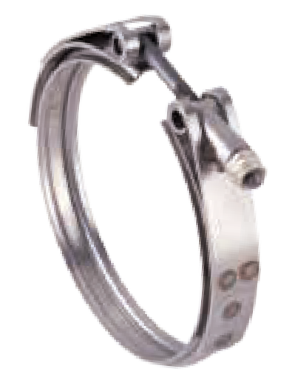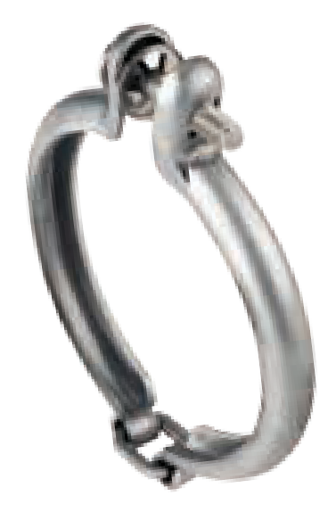
Univee V-Band
1/4" T-Bolt Band with V-Insert
Trunnion
420 Stainless
300 Stainless
300 Stainless
Pressed G, V-Band (Clamshell Design)
M6 Carriage Bolt
Band with V-Insert
300 Stainless
300 Stainless
90 in-lbs (10.2 Nm) for most applications

Clamp Safety Caps

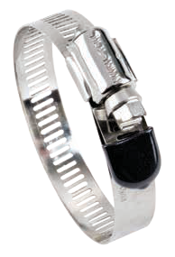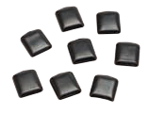Protects installers from cuts and scrapes
•

•
•
•
FIND YOUR PART NUMBER
Protects surrounding materials from abrasions and sharp edges
Provides a clean, professional and finished look for any application
Installs quickly and easily
Part #

Size (in) | Size (mm) | Qty Per Bag | Master Carton Qty | Part No.
1/2 | 13 | 25 | 40 bags per box* | 99999-0012-203
1/2 | 13 | 100 | 10 bags per box* | 99999-0012-207
9/16 | 14 | 25 | 40 bags per box* | 99999-0916-203
9/16 | 14 | 100 | 10 bags per box* | 99999-0916-207
*Must order in master carton quantities

FLEX-GEAR®

Flex-Gear clamps use a Belleville spring design to eliminate “cold flow” leakage that adjusts with the hose and fitting to maintain constant tension on the connection, eliminating leak paths. Flex-Gear clamps are an excellent choice for fluctuating temperature applications and thermal compensation. Features and Benefits: Belleville spring and clamp construction is built to respond to constant temperature fluctuations. The larger, heavier-gauge, precision-formed springs provide higher rates of band tension and adjustment for a more dependable seal. Inner liner protects against shearing of the hose surfaces.

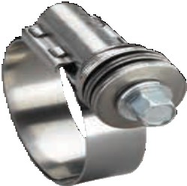
Flex-Gear Ideal-Tridon 43
5/16" Hex Head
Housing
Spring
9/16" Lined Band
Plated Carbon Steel
300 Stainless
300 Stainless
300 Stainless
Flex-Gear Ideal-Tridon 47
5/16" Hex Head
Housing
Spring
9/16" Lined Band
410 Stainless
300 Stainless
300 Stainless
300 Stainless

50 in-lbs (5.6 Nm) for most applications

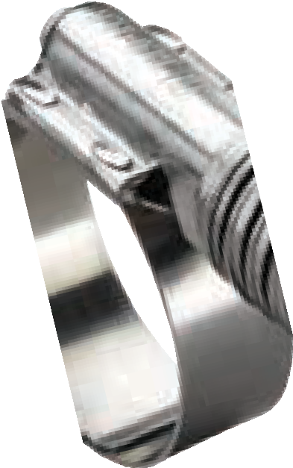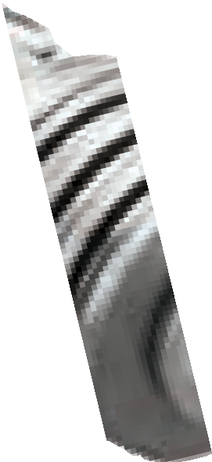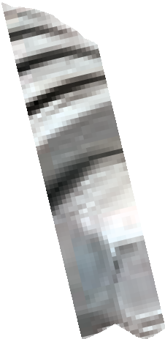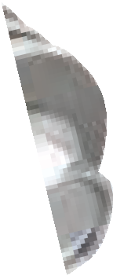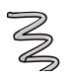
Flex-Gear HD Ideal-Tridon 41
3/8" Hex Head
Housing
Spring
5/8" Lined Band
Plated Carbon Steel
300 Stainless
300 Stainless
300 Stainless
Flex-Gear HD Ideal-Tridon 45
3/8" Hex Head
Housing
Spring
5/8" Lined Band
410 Stainless
300 Stainless
300 Stainless
300 Stainless

75 in-lbs (8.5 Nm) for most applications

Ideal-Tridon 43
Ideal-Tridon 47
Ideal-Tridon 45
Ideal-Tridon 41
FIND YOUR PART NUMBER

Size | Min (in) | Max (in) | Min (mm) | Max (mm) | Ideal-Tridon Ideal-Tridon 43 47
10 | 9/16 | 1-1/16 | 14
 |  |  |  | 27 | 43010 | 47010
12 | 5/8 | 1-1/4 | 16 | 32 | 43012 | 47012
16 | 13/16 | 1-1/2 | 21 | 38 | 43016 | 47016
20 | 13/16 | 1-3/4 | 20 | 44 | 43020 | 47020
24 | 1-1/16 | 2 | 27 | 51 | 43024 | 47024
28 | 1-5/16 | 2-1/4 | 33 | 57 | 43028 | 47028
32 | 1-9/16 | 2-1/2 | 40 | 63 | 43032 | 47032
36 | 1-13/16 | 2-3/4 | 46 | 70 | 43036 | 47036
40 | 2-1/16 | 3 | 52 | 76 | 43040 | 47040
44 | 2-5/16 | 3-1/4 | 59 | 82 | 43044 | 47044
48 | 2-9/16 | 3-1/2 | 65 | 89 | 43048 | 47048
FIND YOUR PART NUMBER

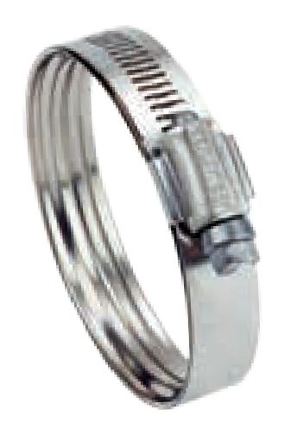IDEAL-TRIDON offers a next generation, lighter smart clamp that can be used instead of heavier Flex-Gear clamps? If weight savings and compact design are your key needs, review our lineup of SmartSeal clamps on page 8. SmartSeal clamps represent the pinnacle in joint sealing technology, and their ultra compact profile is perfect for high vibration and thermal cycling applications.
Size | Min (in) | Max (in) | Min (mm) | Max (mm) | Ideal-Tridon Ideal-Tridon 41 45
175 | 1 | 1-3/4 | 25 | 45 | 41175 | 45175
212 | 1-1/4 | 2-1/8 | 32 | 54 | 41200 | 45200
262 | 1-3/4 | 2-5/8 | 45 | 67 | 41250 | 45250
312 | 2-1/4 | 3-1/8 | 57 | 79 | 41300 | 45300
362 | 2-3/4 | 3-5/8 | 70 | 92 | 41350 | 45350
412 | 3-1/4 | 4-1/8 | 83 | 105 | 41400 | 45400
462 | 3-3/4 | 4-5/8 | 95 | 117 | 41450 | 45450
512 | 4-1/4 | 5-1/8 | 108 | 130 | 41500 | 45500
562 | 4-3/4 | 5-5/8 | 121 | 143 | 41550 | 45550
612 | 5-1/4 | 6-1/8 | 133 | 155 | 41600 | 45600
662 | 5-3/4 | 6-5/8 | 146 | 168 | 41650 | 45650
712 | 6-1/4 | 7-1/8 | 159 | 181 | 41700 | 45700
762 | 6-3/4 | 7-5/8 | 172 | 193 | 41750 | 45750
812 | 7-1/4 | 8-1/8 | 184 | 206 | 41800 | 45800
862 | 7-3/4 | 8-5/8 | 197 | 219 | 41850 | 45850
912 | 8-1/4 | 9-1/8 | 210 | 232 | 41900 | 45900

IDEAL-TRIDON offers a wide variety of display options to get your clamp stock in front of customers. Choose from three pre-assembled wire racks and display your clamps right on the counter. Or, attach the pegs and turn it into a shelf unit.
130 Piece Clamp Profit Center

SIZES AND QUANTITIES PER PACKAGE
Description | Micro 4 | Micro 6 | Size 10 | Size 12 | Size 20 | Size 28 | Size 36 | Part No.
130 Piece Rack Only | – | – | – | – | – | – | –
 |  |  |  |  |  |  |  | 2671001
Automotive Assortment  + Rack | 20 | 20 | 10 | 20 | 20 | 20 | 20 | 99903-0520-051
Automotive Assortment Clamps Only | 20 | 20 | 10 | 20 | 20 | 20 | 20 | 99902-0520-051
Industrial/Automotive Assortment + Rack | 20 | 20 | 10 | 20 | 20 | 20 | 20 | 99903-0570-051
Industrial/Automotive Assortment Clamps Only | 20 | 20 | 10 | 20 | 20 | 20 | 20 | 99902-0570-051
Hardware Assortment  + Rack | 20 | 20 | 10 | 20 | 20 | 20 | 20 | 99903-0671-053
Hardware Assortment Clamps Only | 20 | 20 | 10 | 20 | 20 | 20 | 20 | 99902-0671-053

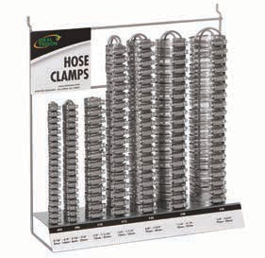130-Piece Clamp Profit Center
FIND YOUR PART NUMBER
Holds 130 clamps with multiple assortment options.
15" H x 14" W x 5" D
Clamp Onto Sales with Clamp Profit Centers

  - IDEAL-TRIDON exclusive
  - Eye-catching designs
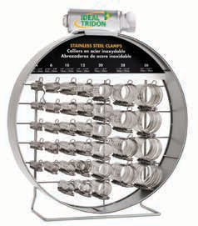
  - Tough with sturdy metal construction and durable styrene signs
Large Clamp Rack Part No: 2674001
Holds 250 clamps with multiple assortment options.
- Visible merchandise promotes efficient, organized stock control
- Pre-assembled
- Countertop or peg board display

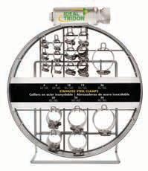
Small Clamp Rack Part No: 2673001
Holds 130 clamps with multiple assortment options.

FIND YOUR PART NUMBER

Clamp Shaped Rack Assortment Options

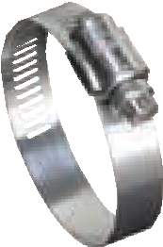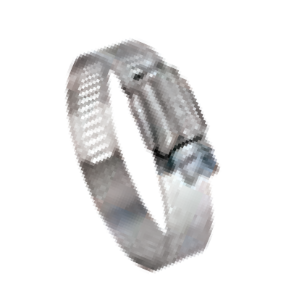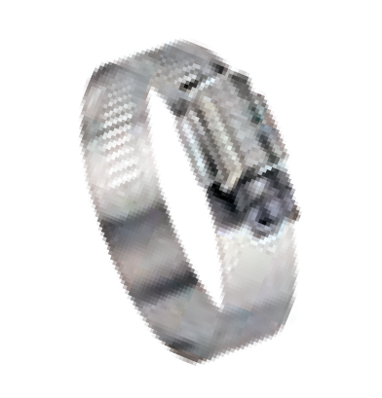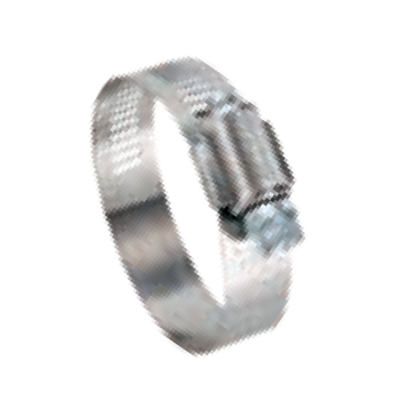
67-4
5/16" Hex Head
300 Stainless
UPC Shield
300 Stainless
1/2" Band Width
300 Stainless

1/2" Hy-Gear
67-1
5/16" Hex Head
410 Stainless
Housing
200 Stainless
1/2" Band Width
200 Stainless

1/2" Hy-Gear
57-0
5/16" Hex Head
Plated Carbon Steel
Housing
200 Stainless
1/2" Band Width
200 Stainless

1/2" Hy-Gear
68-0
5/16" Hex Head
410 Stainless
Housing
200 Stainless
9/16" Band Width
200 Stainless

9/16" Hy-Gear
50-0
5/16" Hex Head
Plated Carbon Steel
Housing
200 Stainless
9/16" Band Width
200 Stainless

9/16" Hy-Gear

SIZES AND QUANTITIES PER PACKAGE
 | Micro 4 | Micro 6 | Size 10 | Size 12 | Size 20 | Size 28 | Size 36
Small Clamp Rack + 250 Pieces | 40 | 40 | 40 | 40 | 30 | 30 | 30
Large Clamp Rack + 450 Pieces | 70 | 70 | 60 | 60 | 70 | 60 | 60
Large Clamp Rack + 600 Pieces | 100 | 100 | 80 | 80 | 80 | 80 | 80

Small Clamp Rack Only: 2673001 |  |  | Large Clamp Rack Only: 2674001
 | 67-4 | 67-1 | 57-0 | 68-0 | 50-0
250 Pieces + Small Rack | 99903-1674-051 | 99903-1671-051 | 99903-1570-051 | 99903-1680-051 | 99903-1500-051
450 Pieces + Large Rack | 99903-2674-051 | 99903-2671-051 | 99903-2570-051 | 99903-2680-051 | 99903-2500-051
600 Pieces + Large Rack | 99903-3674-051 | 99903-3671-051 | 99903-3570-051 | 99903-3680-051 | 99903-3500-051
250 Clamps Only | 99902-1674-051 | 99902-1671-051 | 99902-1570-051 | 99902-1680-051 | 99902-1500-051
450 Clamps Only | 99902-2674-051 | 99902-2671-051 | 99902-2570-051 | 99902-2680-051 | 99902-2500-051
600 Clamps Only | 99902-3674-051 | 99902-3671-051 | 99902-3570-051 | 99902-3680-051 | 99902-3500-051
*All assortments are available with individually barcoded clamps. Replace 051 in the part no. with 053.

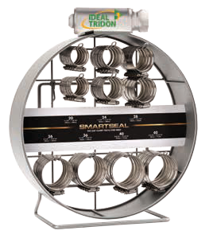
SmartSeal® Profit Center Kit
Includes
- SmartSeal Clamp Rack: holds 50 clamps and comes with peg-board hooks
- SmartSeal Clamps: 50 clamps in five 10-piece subpack boxes in sizes 20, 24, 28, 36, and 40
- SmartSeal Blister Assortment with clip strip:
comes with 10 SmartSeal blister packs, two each of sizes 20, 24, 28, 36, and 40
FIND YOUR PART NUMBER
17-3/8" H x 16" W x 6-13/16" D
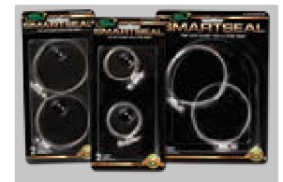
Part No: 2688001
SmartSeal Clamp Rack Only | 2688001
SmartSeal Clamps Only: 50 pcs | 99902-7215-051*
SmartSeal Clamp Rack + Clamps | 99903-7215-051*
SmartSeal Profit Center Kit:  Rack + Clamps + Blister Assortment with Strip Clip | 99904-7215-051*
Blister Assortment with Strip Clip | 99904-7215-058

*Available with individually barcoded clamps. Replace 051 in the part no. with 053

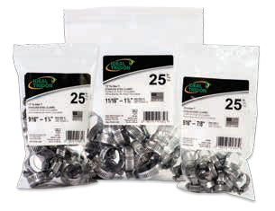
25-Piece Contractor Pack Bags
FIND YOUR PART NUMBER

  - All Stainless Steel
  - Uniform Plumber Code Certified (1/2" Hy-Gear Clamps)
Size | Min (in) | Max (in) | Min (mm) | Max (mm) | Description | Qty | Part No.
4 | 5/16 | 5/8 | 6 | 16 | Micro-Gear® | 25 | 6260450
6 | 5/16 | 7/8 | 8 | 22 | Micro-Gear® | 25 | 6260650
6 | 3/8 | 7/8 | 10 | 22 | 1/2" Hy-Gear® | 25 | 6706550
8 | 7/16 | 1 | 11 | 25 | 1/2" Hy-Gear® | 25 | 6708550
10 | 1/2 | 1-1/16 | 13 | 27 | 1/2" Hy-Gear® | 25 | 6710550
12 | 1/2 | 1-1/4 | 13 | 32 | 1/2" Hy-Gear® | 25 | 6712550
16 | 11/16 | 1-1/2 | 18 | 38 | 1/2" Hy-Gear® | 25 | 6716550
20 | 3/4 | 1-3/4 | 19 | 44 | 1/2" Hy-Gear® | 25 | 6720550
24 | 1 | 2 | 25 | 51 | 1/2" Hy-Gear® | 25 | 6724550
28 | 1-1/4 | 2-1/4 | 32 | 57 | 1/2" Hy-Gear® | 25 | 6728550
36 | 3/4 | 2-3/4 | 19 | 70 | 1/2" Hy-Gear® | 25 | 6736550
48 | 1-1/2 | 3-1/2 | 38 | 89 | 1/2" Hy-Gear® | 25 | 6748550
64 | 2-1/2 | 4-1/2 | 64 | 114 | 1/2" Hy-Gear® | 25 | 6764550

  - Durable Resealable Bag

10-Piece Assortment Bags
Part No. 671755J
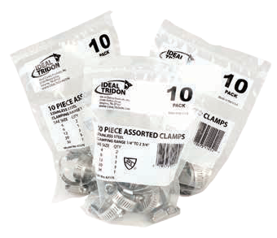
Master Carton Qty. of 10
    - Resealable Bags of 10-Piece
    - Assorted Stainless Steel Clamps
    - Clamping range 1/4" to 2-3/4"
    - Uniform Plumber Code Certified (1/2" Hy-Gear Clamps)

QUANTITIES PER BAG
Size | Qty
Micro-Gear® 4 | 2
1/2" Hy-Gear® 6 | 1
1/2" Hy-Gear® 12 | 3
1/2" Hy-Gear® 20 | 3
1/2" Hy-Gear® 36 | 1
Blister Pack Product Line

ADDING VALUE TO YOUR BUSINESS
IDEAL-TRIDON® offers an extensive blister pack product line. Blister packs offer ease of visibility, attractive packaging and convenient quantities. Various bandwidths, material specifications, size options and assortments are available. Popular blister pack products add value by offering
customers a quick and easy way to locate the clamp they need and purchase the smaller quantity that they are looking for.
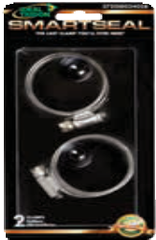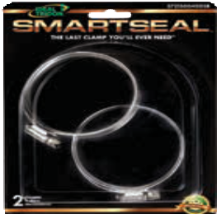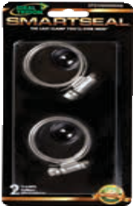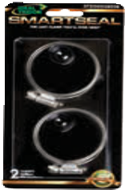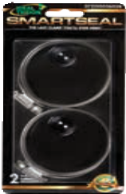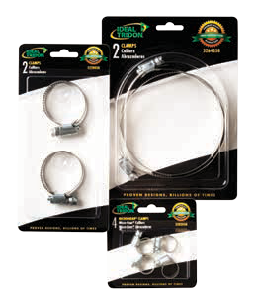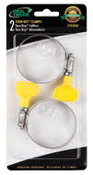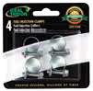

MERCHANDISERS & PACKAGING
FIND YOUR PART NUMBER

Description | Pack Qty | SAE Size | Min (in) | Max (in) | Min (mm) | Max (mm) | Band Mat. | Housing Mat. | Screw Mat. | Band width | Part Number
SmartSeal® 37215 Series | 2 | 16 | 1-3/32 | 1-9/32 | 28 | 33 | 300 SS | 300 SS | 300 SS
 |  |  |  |  |  |  |  |  |  | 1/2 | 37215-0016-058
SmartSeal® 37215 Series | 2 | 20 | 1-1/8 | 1-9/16 | 29 | 40 | 300 SS | 300 SS | 300 SS | 1/2 | 37215-0020-058
SmartSeal® 37215 Series | 2 | 24 | 1-1/2 | 1-13/16 | 38 | 46 | 300 SS | 300 SS | 300 SS | 1/2 | 37215-0024-058
SmartSeal® 37215 Series | 2 | 28 | 1-3/4 | 2-1/16 | 43 | 52 | 300 SS | 300 SS | 300 SS | 1/2 | 37215-0028-058
SmartSeal® 37215 Series | 2 | 36 | 2-1/8 | 2-9/16 | 53 | 65 | 300 SS | 300 SS | 300 SS | 1/2 | 37215-0036-058
SmartSeal® 37215 Series | 2 | 40 | 2-5/16 | 2-13/16 | 58 | 71 | 300 SS | 300 SS | 300 SS | 1/2 | 37215-0040-058
Emergency Clamp Kit Assortment 62M Series and 50 Series | 6 | 4, 12, 28  (2 each) | 1/4 | 2-1/4 | 6 | 57 | 200 SS | 200 SS | PCS | 5/16, 9/16 | 5004058
Hy-Gear® 50 Series Clamps | 2 | 12 | 1/2 | 1-1/4 | 13 | 32 | 200 SS | 200 SS | PCS | 9/16 | 5012058
Hy-Gear® 50 Series Clamps | 2 | 20 | 3/4 | 1-3/4 | 19 | 44 | 200 SS | 200 SS | PCS | 9/16 | 5020058
Hy-Gear® 50 Series Clamps | 2 | 28 | 1-1/4 | 2-1/4 | 32 | 57 | 200 SS | 200 SS | PCS | 9/16 | 5028058
Hy-Gear® 50 Series Clamps | 2 | 36 | 3/4 | 2-3/4 | 19 | 70 | 200 SS | 200 SS | PCS | 9/16 | 5036058
Hy-Gear® 50 Series Clamps | 2 | 48 | 1-1/2 | 3-1/2 | 38 | 89 | 200 SS | 200 SS | PCS | 9/16 | 5048058
Micro-Gear® 52M Series Clamps | 4 | 4 | 1/4 | 5/8 | 6 | 16 | 200 SS | PCS | PCS | 5/16 | 5202058
Micro-Gear® 52M Series Clamps | 4 | 6 | 5/16 | 7/8 | 8 | 22 | 200 SS | PCS | PCS | 5/16 | 5203058
52 Series Clamps Assortment | 6 | 4, 12, 28  (2 each) | 1/4 | 2-1/4 | 6 | 57 | 200 SS | PCS | PCS | 5/16, 1/2 | 5204058
52 Series Clamps | 2 | 12 | 1/2 | 1-1/4 | 13 | 32 | 200 SS | PCS | PCS | 1/2 | 5212058
52 Series Clamps | 2 | 20 | 3/4 | 1-3/4 | 19 | 44 | 200 SS | PCS | PCS | 1/2 | 5220058
52 Series Clamps | 2 | 28 | 1-1/4 | 2-1/4 | 32 | 57 | 200 SS | PCS | PCS | 1/2 | 5228058
52 Series Clamps | 2 | 36 | 1-3/4 | 2-3/4 | 44 | 70 | 200 SS | PCS | PCS | 1/2 | 5236058
52 Series Clamps | 2 | 48 | 2-1/2 | 3-1/2 | 64 | 89 | 200 SS | PCS | SS | 1/2 | 5248058
52 Series Clamps | 2 | 64 | 2-1/2 | 4-1/2 | 64 | 114 | 200 SS | PCS | PCS | 1/2 | 5264058
Hy-Gear® 57 Series Clamps | 2 | 12 | 1/2 | 1-1/4 | 13 | 32 | 200 SS | 200 SS | PCS | 1/2 | 5512058
Hy-Gear® 57 Series Clamps | 2 | 20 | 3/4 | 1-3/4 | 19 | 44 | 200 SS | 200 SS | PCS | 1/2 | 5520058
Hy-Gear® 57 Series Clamps | 2 | 28 | 1-1/4 | 2-1/4 | 32 | 57 | 200 SS | 200 SS | PCS | 1/2 | 5528058
Hy-Gear® 57 Series Clamps | 2 | 36 | 3/4 | 2-3/4 | 19 | 70 | 200 SS | 200 SS | PCS | 1/2 | 5536058
Micro-Gear® 62P Series Clamps | 4 | 4 | 5/16 | 5/8 | 8 | 16 | 300 SS | 300 SS | PCS | 5/16 | 6204058
Micro-Gear® 62P Series Clamps | 4 | 6 | 5/16 | 7/8 | 8 | 22 | 300 SS | 300 SS | PCS | 5/16 | 6206058
Fuel-Injection 52F Series Clamps | 4 | 13 | 7/16 | 1/2 | 11 | 13 | PCS | – | PCS | 9 mm | 52F1358
Fuel-Injection 52F Series Clamps | 4 | 15 | 1/2 | 9/16 | 13 | 15 | PCS | – | PCS | 9 mm | 52F1558
Fuel-Injection 52F Series Clamps | 4 | 16 | 9/16 | 5/8 | 14 | 16 | PCS | – | PCS | 9 mm | 52F1658
Turn-Key® 5Y Series Clamps Assortment | 6 | 4, 6, 12, 20, 28,  36 (1 each) | 5/16 | 2-3/4 | 8 | 70 | 200 SS | 300 SS | PCS | 5/16, 1/2 | 5Y00158
Turn-Key® 5Y Series Clamps | 2 | 12 | 1/2 | 1-1/4 | 13 | 32 | 200 SS | 300 SS | PCS | 1/2 | 5Y01258
Turn-Key® 5Y Series Clamps | 2 | 20 | 3/4 | 1-3/4 | 19 | 44 | 200 SS | 300 SS | PCS | 1/2 | 5Y02058
Turn-Key® 5Y Series Clamps | 2 | 28 | 1-1/4 | 2-1/4 | 32 | 57 | 200 SS | 300 SS | PCS | 1/2 | 5Y02858
Turn-Key® 5Y Series Clamps | 2 | 36 | 1-3/4 | 2-3/4 | 44 | 70 | 200 SS | 300 SS | PCS | 1/2 | 5Y03658
Turn-Key® 5Y Series Clamps | 2 | 48 | 2-1/2 | 3-1/2 | 64 | 89 | 200 SS | 300 SS | PCS | 1/2 | 5Y04858
Turn-Key® 5Y Series Clamps | 2 | 64 | 2-1/2 | 4-1/2 | 64 | 114 | 200 SS | 300 SS | PCS | 1/2 | 5Y06458
Turn-Key® 6Y Series Clamps Assortment | 4 | 4, 6 (2 each) | 5/16 | 7/8 | 8 | 22 | 200 SS | 300 SS | PCS | 5/16 | 6Y00458
SS = Stainless Steel
PCS = Plated Carbon Steel

Ideal-Tridon
PRODUCT CROSS REFERENCE GUIDE
Page

Product | Ideal-Tridon | Tridon | Product Description | NORMA  Breeze RG Ray | Murray | Dixon | Catalog
Turn-Key® |  | - | 1/2" Band, Consumer Product Partial SS Clamps - No Tools Required | - | T-SS | HS-Y | 25
 | 5Y
Pow'r-Gear® | 6L | M843 | 5/8" Band, High Performance Lined All SS Worm Drive Clamps | HTM-L | - | - | 28
Pow'r-Gear® | 6M | - | 5/8" Band, High Performance Lined All 300 SS Marine Clamps | HTS-L | - | - | 28
Pow'r-Gear® | 6P | - | 5/8" Band, High Performance All 300 SS Marine Worm Drive Clamps | HTM-SP | - | - | 28
Pow'r-Gear® | 6X | - | 5/8" Band, High Performance Wide Range All SS Worm Drive Clamps | HP | - | HP | 28
Pow'r-Gear® | 60 | M850 | 5/8" Band, High Performance All SS Worm Drive Clamps | HTM | - | HTM | 28
Flex-Gear HD® | 41 | - | 5/8" Band, Constant Tension Partial SS Clamps | CT-L | - | CT-L | 36
Flex-Gear® | 43 | - | 9/16" Band, Constant Tension Partial SS Clamps | CT-92 | - | - | 36
Flex-Gear HD® | 45 | - | 5/8" Band, Constant Tension All SS Clamps | CT-L SS | - | - | 36
Flex-Gear® | 47 | - | 9/16" Band, Constant Tension All SS Clamps | CT-94 | - | - | 36
Surelock | 48 | - | 9/16" Band, Quick Engage Clamps, 300 SS Marine | 600 | - | - | 21
Surelock | 49 | - | 9/16" Band, Quick Engage Clamps, 316 SS Marine | 616 | - | - | 21
9/16" Hy-Gear® | 50-0 | 150 | 9/16" Band, Partial SS Clamps | 100 | - | HS** | 14
1/2" Hy-Gear® | 52-0 | 600-603 | 1/2" Band, Partial SS Clamps |  |  |  | 12
Lined | 53-0 | 613/ET | 1/2" Band, Lined Partial SS Clamps | 92 | 48 | DL | 26
Combo-Hex® | 54-0 | - | 9/16" Band, Special 3/8"Hex Screw Partial SS Clamps | - | - | - | 20
Snaplock® | 56-0 | - | 9/16" Band, Quick Release 5/16" Hex Screw Partial Clamps | - | - | LS | 22
1/2" Hy-Gear® | 57-0 | 611/HS | 1/2" Band, General Purpose Partial SS Clamps | 62 | H | HS** | 12
Snaplock® | 58-0 | 58-0/LAS | 9/16" Band, Quick Release 3/8" Hex Screw All SS Clamps | - | - | LSS | 22
Wraplock® | 59-0 | - | 1/2" Band, Specialty Clamps | - | - | - | 24
Pinch | 61-0 |  | Single Ear Pinch All 300 SS Clamps |  | KS |  | 19
9/16" Hy-Gear® | 64-0 | - | 9/16" Band, Special 3/8" Hex Screw All SS Clamps | 200 | - | - | 14
9/16" Hy-Gear® | 68-0 | - | 9/16" Band, General Purpose All SS Clamps | 200 | - | - | 14
Lox-On® | 69-0 | - | 1/2" Band, Special Purpose All 300 Marine Clamps | - | - | - | 24
Snaplock® | 500 | 500/LS | 1/2" Band, Quick Release Partial SS Clamps | - | - | LS | 22
Snaplock® | 550 | 550/LSS | 1/2" Band, Quick Release All SS Clamps | QR | - | LSS | 22
Fuel Injection | 52F | 905/FI | 9 mm Band, Special Fuel Injection Clamps | FI | - | - | 11
Micro-Gear® | 52M | 300 | 5/16" Band, Partial SS Clamps |  |  |  | 10
Micro-Gear® | 359 | 359 | 5/16" Band, All 316 SS Marine Clamps | 38 | - | - | 10
Micro-Gear® | 62M | 345/MAH/MAS | 5/16" Band, All SS Clamps | 37/67 | MMF-SS | MAH | 10
Micro-Gear® | 62P | 325/MH | 5/16" Band, Partial SS Clamps | 35 | MM | MH | 10
Turn-Key® | 6Y |  | 5/16" Band, Consumer Product Partial SS Clamps - No Tools Required |  |  | MH | 25
Military | 632 | 632 | 1/2" Band, Military Spec All SS Clamps | MS | - | - | 20
9/16" Hy-Gear® | 63-4 | - | 9/16" Band, All 300 SS Marine Clamps | 300 | - | HSS** | 14
Lined | 65-E | 615* | 9/16" Band, Lined Clamps, All 300 SS Clamps | 94* | 48 | - | 26
1/2" Hy-Gear® | 67-1 | 625/HAS | 1/2" Band, General Purpose All SS Clamps | 64 | H-SS | - | 12
1/2" Hy-Gear® | 67-4 | 620P | 1/2" Band, All 300 SS Marine Clamps | 63 | HF-SS | HSS** | 12
1/2" Hy-Gear® | 67-5 | 620 | 1/2" Band, All 200 SS Clamps |  |  |  | 12
1/2" Hy-Gear® | 67-6 | 665 | 1/2" Band, All 316 SS Marine Clamps | - | HDL | MGC | 12
Lined | 67M | - | 1/2" Band, All 316 SS Lined Marine Clamps | 96 | - | - | 26
T-Bolt | 30010 | 813 | 3/4" Band, T-Bolt Partial SS Clamps | B9200 | TB | - | 30
T-Bolt | 30011 | 811 | 3/4" Band, T-Bolt All 300 SS Clamps | B9300 | TB-SS | - | 30
T-Bolt | 30020 | 814 | 3/4" Band, T-Bolt w/ Bridge Partial SS Clamps | B9222 | - | - | 30
T-Bolt | 30021 | 810 | 3/4" Band, T-Bolt w/ Bridge All 300 SS Clamps | - | - | - | 30
T-Bolt | 30030 | 819 | 3/4" Band, Spring Loaded Partial SS T-Bolt Clamps | B9226 | TB-L | - | 33
T-Bolt | 30050 |  | 3/4" Band, Nominal Sized Partial SS Clamps |  |  | TBC | 32
T-Bolt | 30051 |  | 3/4" Band, Nominal Sized All 300 SS Clamps |  |  | STBC | 32
WaveSeal360 ® | 36003 | 36013 | 9/16" Band, 360 Degree Seal Self-Adjusting Constant Pressure All SS Clamps | - | - | WSS | 8
SmartSeal® | 37215 | - | 1/2" Band, 360 Degree Seal Self-Adjusting Constant Pressure All SS Clamps | - | DB | - | 8
SmartSeal® HD | 38215 | 38210 | 5/8" Band, 360 Degree Seal Self-Adjusting Constant Pressure All SS Clamps | - | - | - | 8
Non-Perforated | 53302 | 53312 | 9 mm Band, W2 Non-Perforated (Embossed) W2 Partial SS Clamps | Torro W2** | EB9 | - | 16
Non-Perforated | 53303 | 53313 | 9 mm Band, W3 Non-Perforated (Embossed) W3 All 430 SS Clamps | Torro W3** | - | - | 16
Non-Perforated | 53304 | 53314 | 9 mm Band, W4 Non-Perforated (Embossed) W4 All 304 SS Clamps | Torro W4** | - | EB9 | 16
Non-Perforated | 53305 | 53315 | 9 mm Band, W5 Non-Perforated (Embossed) W5 All 316 SS Clamps | Torro W5** | - | EBL9 | 16
Non-Perforated | 53402 | 53412 | 12 mm Band, W2 Non-Perforated (Embossed) W2 Partial SS Clamps | Torro W2** | EB12 | - | 16
Non-Perforated | 53403 | 53413 | 12 mm Band, W3 Non-Perforated (Embossed) W3 All 430 SS Clamps | Torro W3** | - | - | 16
Non-Perforated | 53404 | 53414 | 12 mm Band, W4 Non-Perforated (Embossed) W4 All 304 SS Clamps | Torro W4** | - | EB12 | 16
Non-Perforated | 53405 | 53415 | 12 mm Band, W5 Non-Perforated (Embossed) W5 All 316 SS Clamps | Torro W5** | - | EBL12 | 16
*Comparable Product
**Check Bandwidth

California,
USA •
Texas, USA
Mexico
••
•
Global Headquarters Tennessee, USA
- Poland
•
•
Japan
China
India •

IDEAL TRIDON.COM | PROVEN DESIGNS, BILLIONS OF TIMES GLOBAL HEADQUARTERS
8100 TRIDON DRIVE SMYRNA, TN 37167 USA
800.251.3220 | 615.459.5800
USA | MEXICO | CHINA | JAP AN | POLAND | INDIA

PLEASE RECYCLE
© 2016 Ideal Clamp Products, Inc. — Part No. 99999-1001-099 JAN 2017

