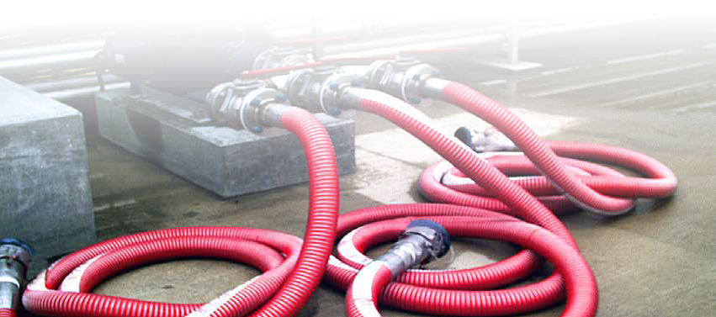
®

Uni-CHEM®
Composite Hoses

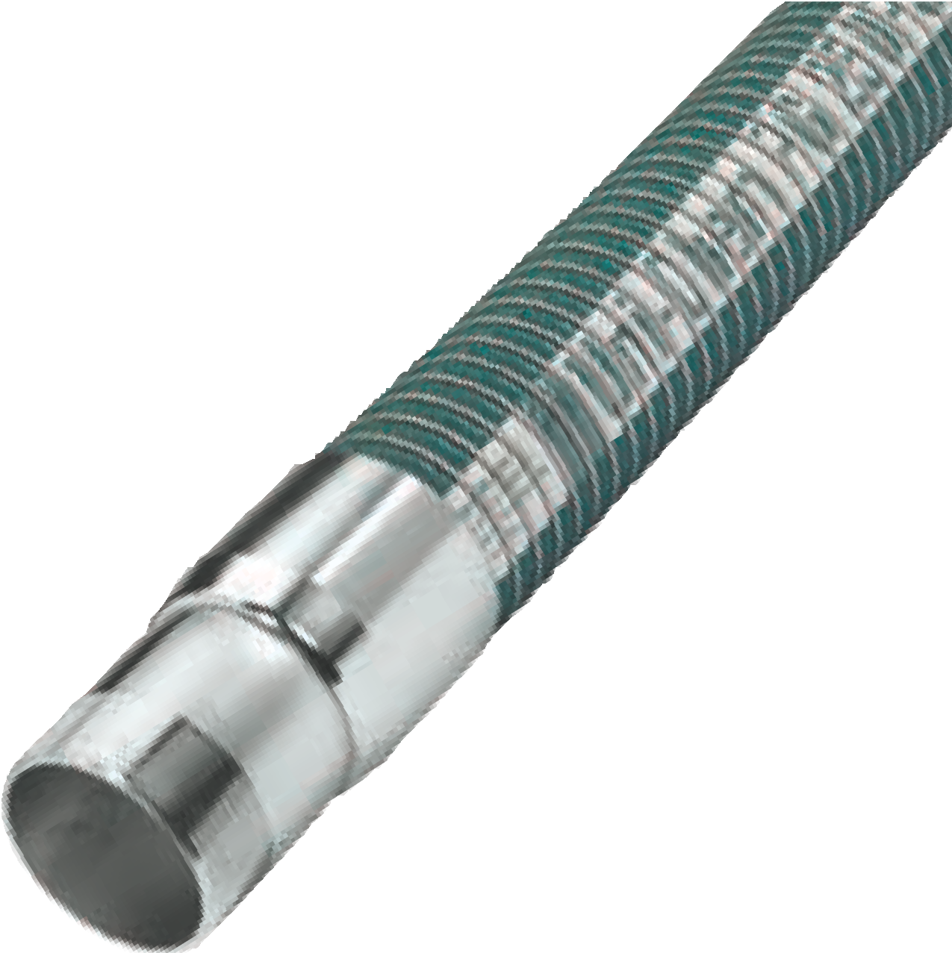Standard Chemical Service

Uni-CHEM™ PG, PS, SG and SS composite hoses are specifically designed for in-plant liquid transfer operations as well as tank truck delivery and rail car loading. Constructed with multiple plies of polypropylene films and polyester vapour barriers. Rated for full vacuum.
Uni-CHEM™ PG, PS
P-Polypropylene Coated Steel Inner Helix
G-High Tensile Galvanized Carbon Steel Outer Helix S-316L Stainless Steel - Outer Helix
Uni-CHEM™ SG, SS
S-316L Stainless Steel - Inner Helix
G-High Tensile Galvanized Carbon Steel Outer Helix S-316L Stainless Steel - Outer Helix
Maximum length: 100 ft. (10” = 80 ft.)
Operating Temperature: -40ºF to +212ºF (-40ºC to +100ºC)

ID (INS) | 1 | 1.5 | 2 | 3 | 4 | 6 | 8 | 10
ID (OUT) | 1.5 | 1.9 | 2.4 | 3.4 | 4.4 | 7.0 | 9.4 | 10.5
Max WP PSI | 250 | 250 | 250 | 250 | 250 | 250 | 250 | 200
Burst Pres PSI | 1000 | 1000 | 1000 | 1000 | 1000 | 1000 | 1000 | 800
Bend Rad. Inches | 4.0 | 5.0 | 6.0 | 7.9 | 11.9 | 22.0 | 30.0 | 40.0
Weight LB/FT | .58 | .79 | 1.18 | 1.88 | 2.68 | 7.2 | 11.0 | 14.5

ID (INS) | 1 | 1.5 | 2 | 3 | 4 | 6 | 8 | 10
ID (OUT) | 2 | 2 | 2.5 | 3.5 | 4.5 | 7.0 | 9.4 | 10.5
Max WP PSI | 250 | 250 | 250 | 250 | 250 | 250 | 250 | 200
Burst Pres PSI | 1000 | 1000 | 1000 | 1000 | 1000 | 1000 | 1000 | 800
Bend Rad. Inches | 4.0 | 5.0 | 6.0 | 7.9 | 11.9 | 22.0 | 30.0 | 40.0
Weight LB/FT | 0.6 | 0.8 | 1.6 | 2.40 | 3.20 | 7.20 | 11.0 | 14.5

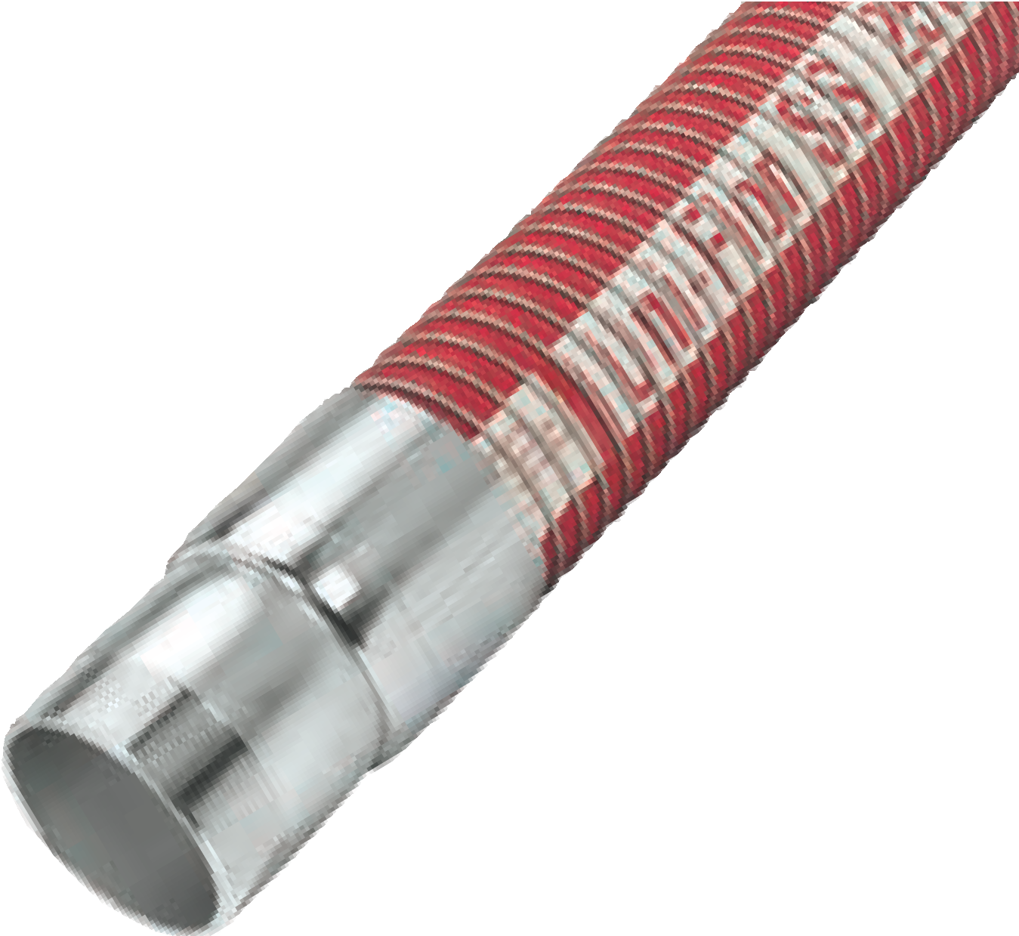Uni-CHEM® Composite Hose Assemblies meet USCG 154.500; are manufactured in compliance with BS 5842 and are available with EN 13765 compliant construction. Marine Service Applications: All Uni-CHEM® hose styles are constructed to marine service specifications in accordance with US Coast Guard spec.154.500 and I.M.O regulations.
Special Chemical Service
Uni-FLON™ special chemical service hoses are built to meet the demands of today’s highly aggressive media. Superior chemical resistance is achieved with a PTFE, inner liner, reinforced with multiple plies of polyester and polypropylene films. Rated for full vacuum.
Uni-FLON™ SG
S-316L Stainless Steel - Inner Helix
G-High Tensile Galvanized Carbon Steel Outer Helix
Uni-FLON™ SS
S-316L Stainless Steel - Inner Helix S-316L Stainless Steel - Outer Helix
Uni-FLON™ PS is available upon request Maximum length:100 ft. (10” = 80 ft.)
Operating Temperature: -40ºF to + 250ºF (-40ºC to +121ºC)

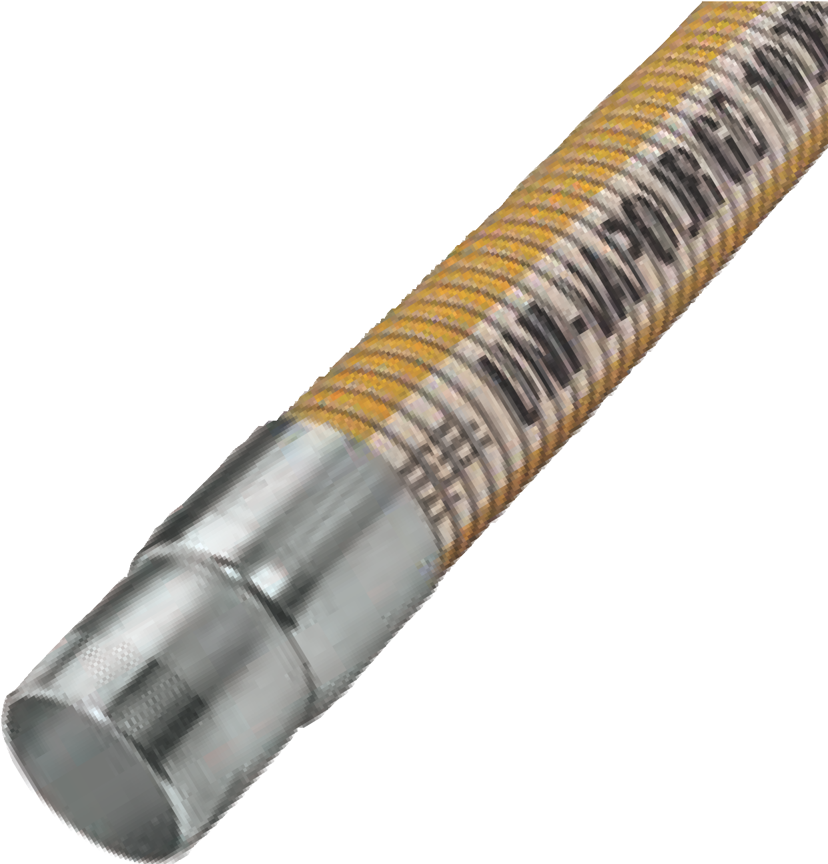
Vapor Recovery Service
Uni-VR™ hose is ideal for use in petroleum and petrochemical vapour recovery systems in ship-to-shore, bottom loading and tank truck applications. This hose is lightweight and flexible. Manufactured to meet specification CFR33-154. Rated for full vacuum.
Uni-VR™
G-High Tensile Galvanized Carbon Steel Inner Helix G-High Tensile Galvanized Carbon Steel Outer Helix Maximum length: 100 ft. (10” = 80 ft.)
Operating Temperature: -40ºF to +212ºF (-40ºC to +100ºC)

*Available with a polypropylene coated and stainless steel inner helix.
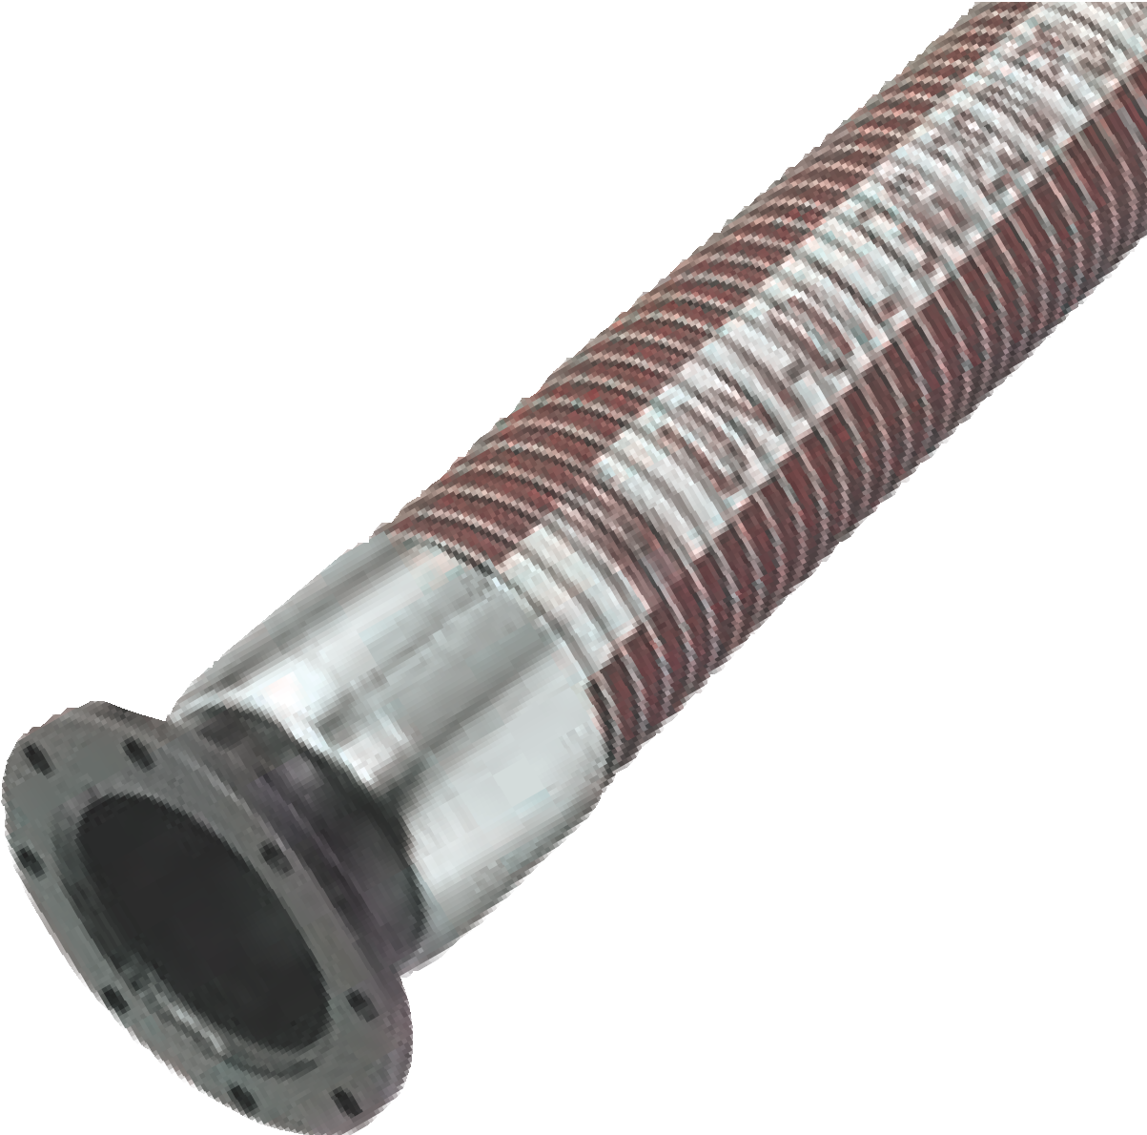Bottom Loading Service
Uni-BL, Uni-OIL™ or Uni-ZENE™
Uni-BL™ is ideal for transferring petroleum and aromatic products in production, refinery and distribution facilities. Suitable for all hose loading arms in bottom loading operations. Constructed with multiple plies of aromatic resistant films and fabrics. All hoses can be color coded to API color codes.
Rated for full vacuum.
Uni-BL™
G-High Tensile Galvanized Carbon Steel Inner Wire G-High Tensile Galvanized Carbon Steel Outer Helix
TTMA FLANGES ARE STANDARD EACH END
Maximum length:100 ft. (10” = 80 ft.) Operating Temperature:
Uni-OIL™: -40ºF to +212ºF (-40ºC to +100ºC)
Uni-ZENE™: -40ºF to +250ºF (-40ºC to +121ºC)

ID (INS) | 1 | 1.5 | 2 | 3 | 4 | 6 | 8 | 10
ID (OUT) | 1.5 | 1.9 | 2.4 | 3.4 | 4.4 | 7.0 | 9.4 | 10.5
Max WP PSI | 250 | 250 | 250 | 250 | 250 | 250 | 250 | 200
Burst Pres PSI | 1000 | 1000 | 1000 | 1000 | 1000 | 1000 | 1000 | 800
Bend Rad. Inches | 4.0 | 5.0 | 6.0 | 7.9 | 11.9 | 22.0 | 30.0 | 40.0
Weight LB/FT | .58 | .79 | 1.18 | 1.88 | 2.68 | 7.2 | 11.0 | 14.5

ID (INS) | 1 | 1.5 | 2 | 3 | 4 | 6 | 8 | 10
ID (OUT) | 1.5 | 1.9 | 2.4 | 3.4 | 4.4 | 6.75 | 9.0 | 10
Max WP PSI | 100 | 100 | 100 | 100 | 100 | 100 | 100 | 100
Burst Pres PSI | 400 | 400 | 400 | 400 | 400 | 400 | 400 | 400
Bend Rad. Inches | 4.0 | 5.0 | 6.0 | 7.9 | 11.9 | 22.0 | 30.0 | 40.0
Weight LB/FT | .58 | .79 | 1.18 | 1.88 | 2.68 | 7.0 | 10.0 | 13.0

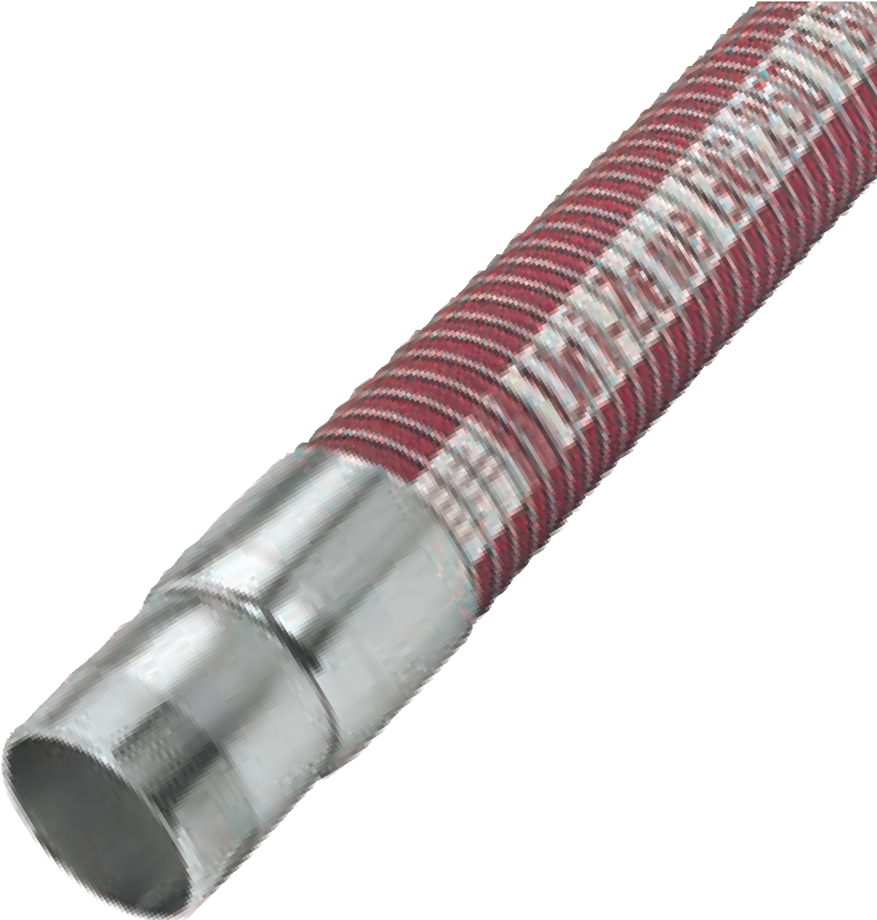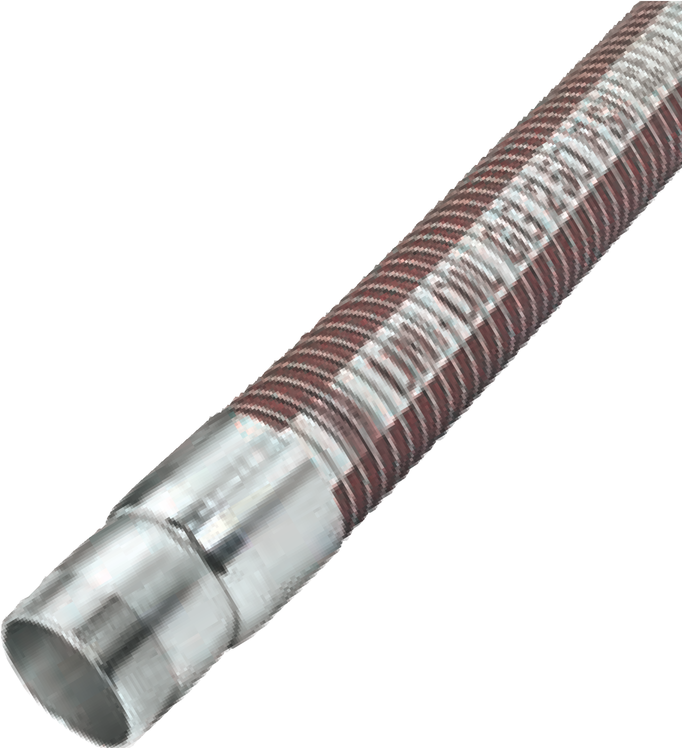
Special Petroleum Service
Uni-ZENE™ special service petroleum hose is designed to handle modern gasoline additives such as MTBE, ethanol and benzene.
Uni-ZENE™ hoses are built with an effective combination of polyamide, polyester and polypropylene film and fabrics to meet the demands of today’s additives. Also recommended for all JP aviation
fuels. Rated for full vacuum.
Uni-ZENE™
G-High Tensile Galvanized Carbon Steel Inner Helix. G-High Tensile Galvanized Carbon Steel Outer Helix. Maximum length: 100 ft. (10” = 80 ft.)
Operating Temperature: -40ºF to +250ºF (-40ºC to +121ºC)
Standard Petroleum Service
Uni-OIL™ GG standard petroleum service hoses are designed for the transfer of a wide range of petroleum products. Uni-OIL™ GG hoses are ideal for transfer of media from storage tanks and process piping to rail cars or tank trucks. Multiple plies of polypropylene films and fabrics are encased in a polyester vapor barrier for superior operation. Rated for full vacuum.
Uni-OIL™ GG
G-High Tensile Galvanized Carbon Steel Inner Helix G-High Tensile Galvanized Carbon Steel Outer Helix Maximum length: 100 ft. (10” = 80 ft.)
Operating Temperature: -40ºF to +212ºF (-40ºC to +100ºC)

ID (INS) | 1 | 1.5 | 2 | 3 | 4 | 6 | 8 | 10
ID (OUT) | 1.5 | 2 | 2.5 | 3.5 | 4.5 | 7.0 | 9.4 | 10.5
Max WP PSI | 250 | 250 | 250 | 250 | 250 | 250 | 250 | 200
Burst Pres PSI | 1000 | 1000 | 1000 | 1000 | 1000 | 1000 | 1000 | 800
Bend Rad. Inches | 4.0 | 5.0 | 6.0 | 7.9 | 11.9 | 22.0 | 30.0 | 40.0
Weight LB/FT | 0.6 | 0.8 | 1.60 | 2.40 | 3.20 | 7.20 | 11.0 | 14.5

ID (INS) | 1 | 1.5 | 2 | 3 | 4 | 6 | 8 | 10
ID (OUT) | 1.5 | 2 | 2.5 | 3.5 | 4.5 | 7.0 | 9.4 | 10.5
Max WP PSI | 250 | 250 | 250 | 250 | 250 | 250 | 250 | 200
Burst Pres PSI | 1000 | 1000 | 1000 | 1000 | 1000 | 1000 | 1000 | 800
Bend Rad. Inches | 4.0 | 5.0 | 6.0 | 7.9 | 11.9 | 22.0 | 30.0 | 40.0
Weight LB/FT | 0.6 | 0.8 | 1.60 | 2.40 | 3.20 | 7.20 | 11.0 | 14.5

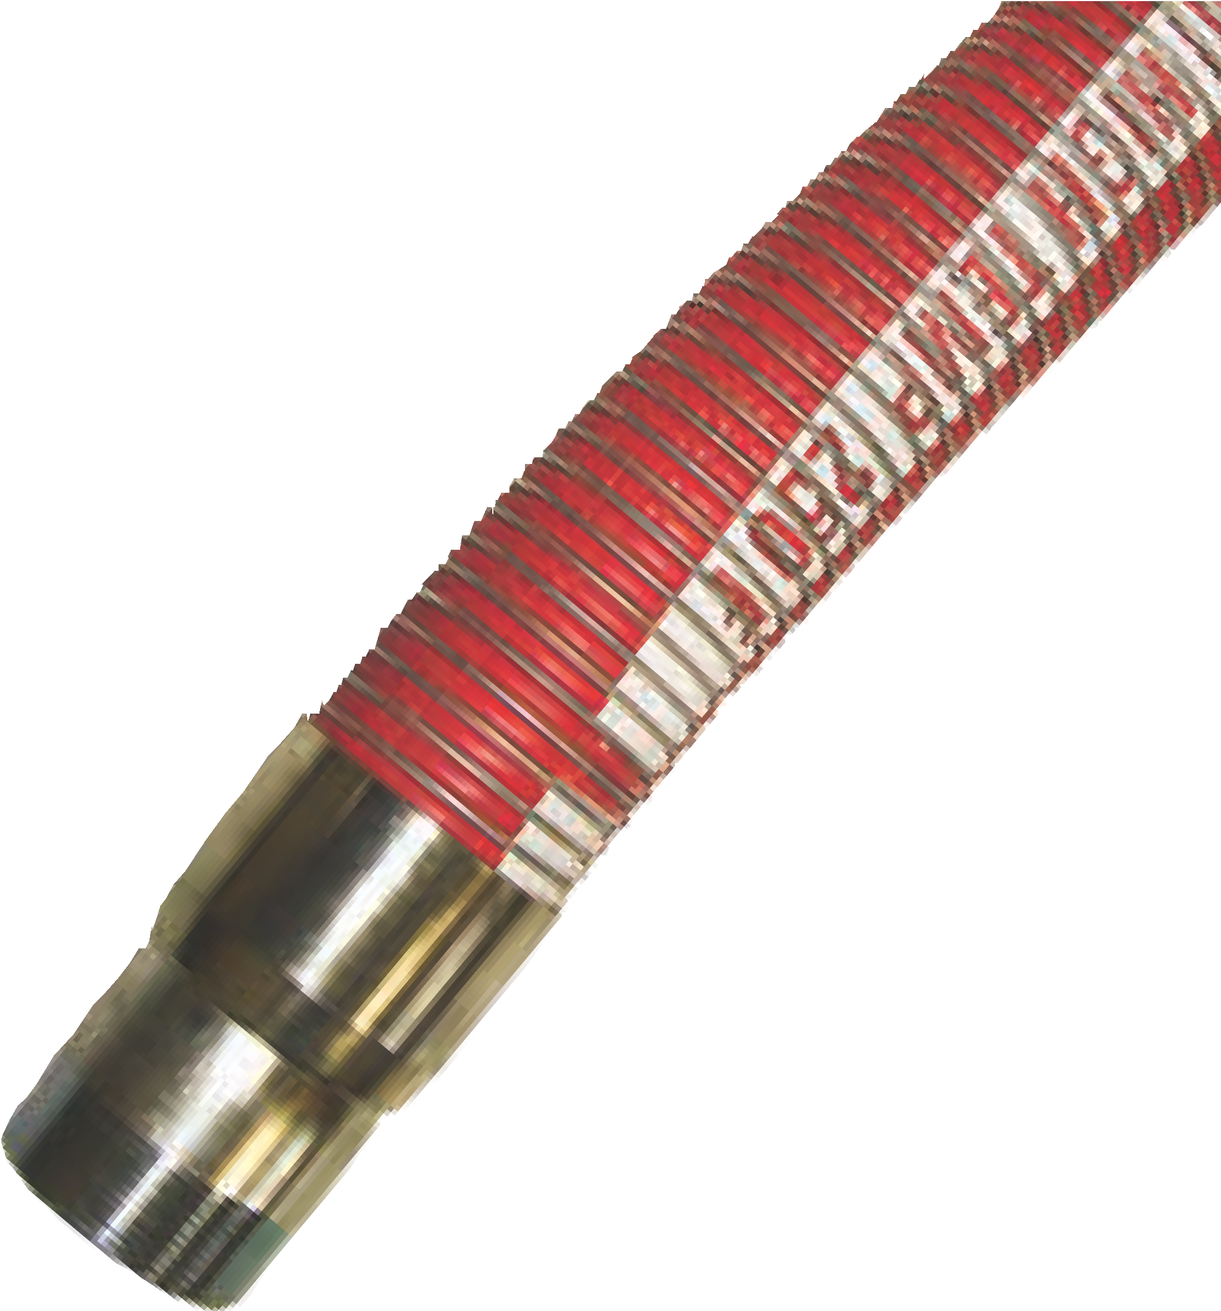
Uni-OIL™ 300HT High Temperature Composite Hose
NovaFlex Uni-OIL™ 300HT is a high temperature version of the standard Uni-OIL™ petroleum. This high temperature hose can handle maximum operating temperatures of +300°F (+149°C). The hose design uses a composite of temperature resistant materials and is rated for use with a wide range of petroleum products. Rated for full vacuum.
Maximum length: 100 ft. (10” = 80 ft.)
Operating Temperature: -40ºF to +212ºF (--40ºC to +100ºC)
Uni-FLON™ and Uni-OIL™ high temperature composite hoses provide optimum chemical resistance, strength and the versatility needed to get the job done.

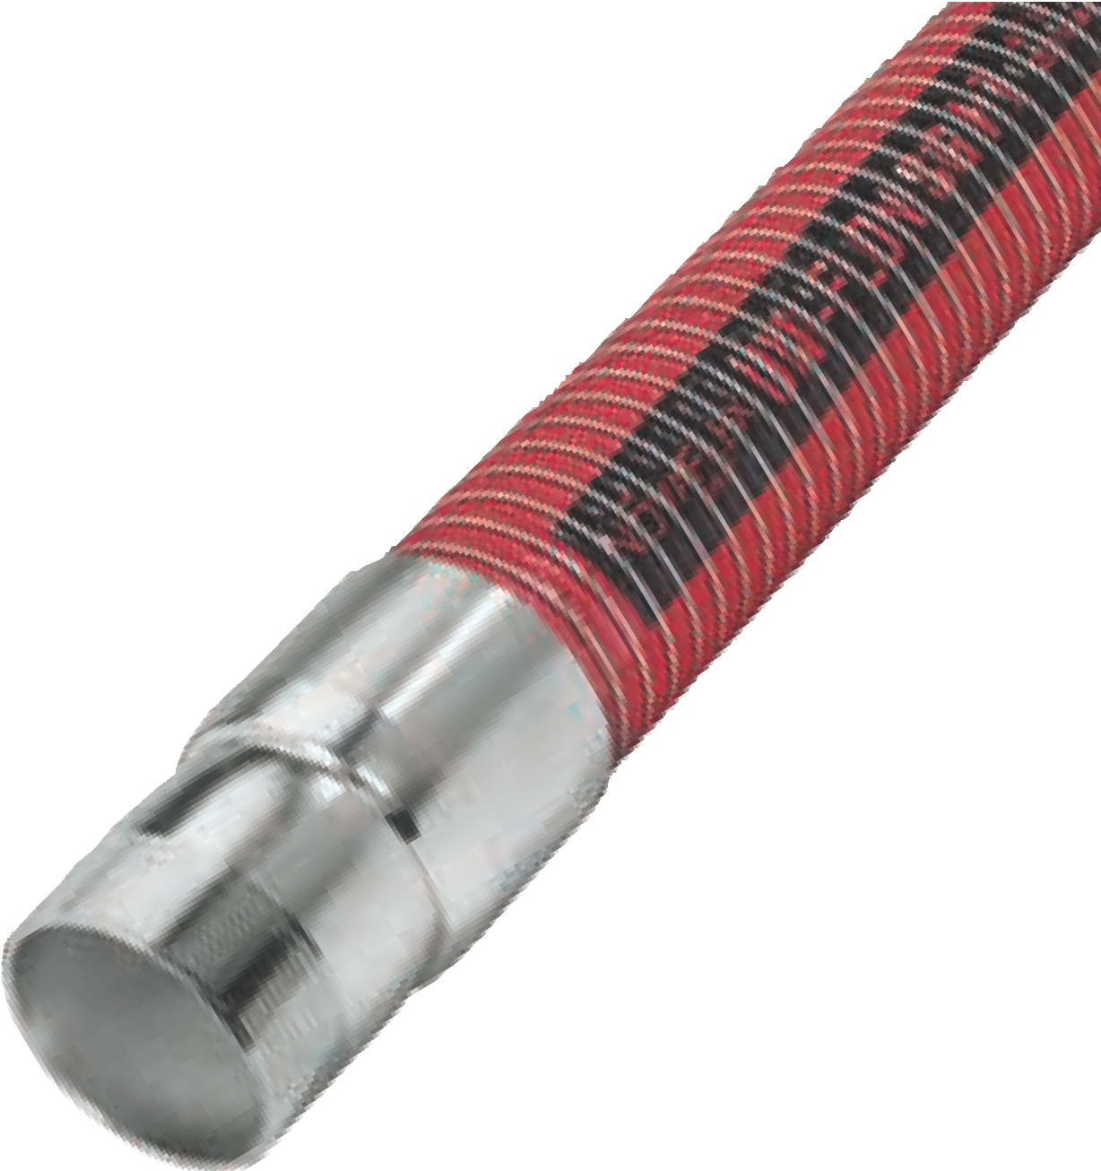Uni-FLON™ HT Composite Hose
NovaFlex Uni-FLON™ HT is designed as an upgraded version of NovaFlex’s standard,

except that it has a temperature rating of 147°C. The high temperature version has the same Teflon® tube but the reinforcement elements have been upgraded to polyamides and nylons that have superior strength at elevated temperatures permitting the 250psi working pressure to be maintained.
Rated for full vacuum.
Maximum length: 100 ft. (10” = 80 ft.)
Operating Temperature: -40ºF to +212ºF (--40ºC to +100ºC)
Uni-FLON™ SG
S-316L Stainless Steel - Inner Helix
G-High Tensile Galvanized Carbon Steel Outer Helix
Uni-FLON™ SS
S-316L Stainless Steel - Inner Helix S-316L Stainless Steel - Outer Helix

ID (INS) | 1 | 1.5 | 2 | 3 | 4 | 6 | 8 | 10
OUT ID (INS) | 1.5 | 2.0 | 2.5 | 3.5 | 4.5 | 7.0 | 9.4 | 10.5
Max WP (PSI) | 250 | 250 | 250 | 250 | 250 | 250 | 250 | 200
Burst Pres (PSI) | 1000 | 1000 | 1000 | 1000 | 1000 | 1000 | 1000 | 800
Bend Radius (INS) | 4.0 | 5.0 | 6.0 | 7.9 | 11.9 | 22.0 | 30.0 | 40.0
Weight LB/FT | .6 | .8 | 1.6 | 2.4 | 3.2 | 7.20 | 11.0 | 14.5
Max Lengths (FT) | 100 | 100 | 100 | 100 | 100 | 100 | 100 | 50

ID (INS) | 1 | 1.5 | 2 | 3 | 4 | 6 | 8 | 10
OUT ID (INS) | 1.5 | 2.0 | 2.5 | 3.5 | 4.5 | 7.0 | 9.4 | 10.5
Max WP ( PSI) | 250 | 250 | 250 | 250 | 250 | 250 | 250 | 200
Burst Pres ( PSI) | 1000 | 1000 | 1000 | 1000 | 1000 | 1000 | 1000 | 800
Bend Radius (INS) | 4.0 | 5.0 | 6.0 | 7.9 | 11.9 | 22.0 | 30.0 | 40.0
Weight LB/FT | .65 | .85 | 1.7 | 2.6 | 3.4 | 7.2 | 11.0 | 14.5
Max Lengths (FT) | 100 | 100 | 100 | 100 | 100 | 100 | 100 | 50

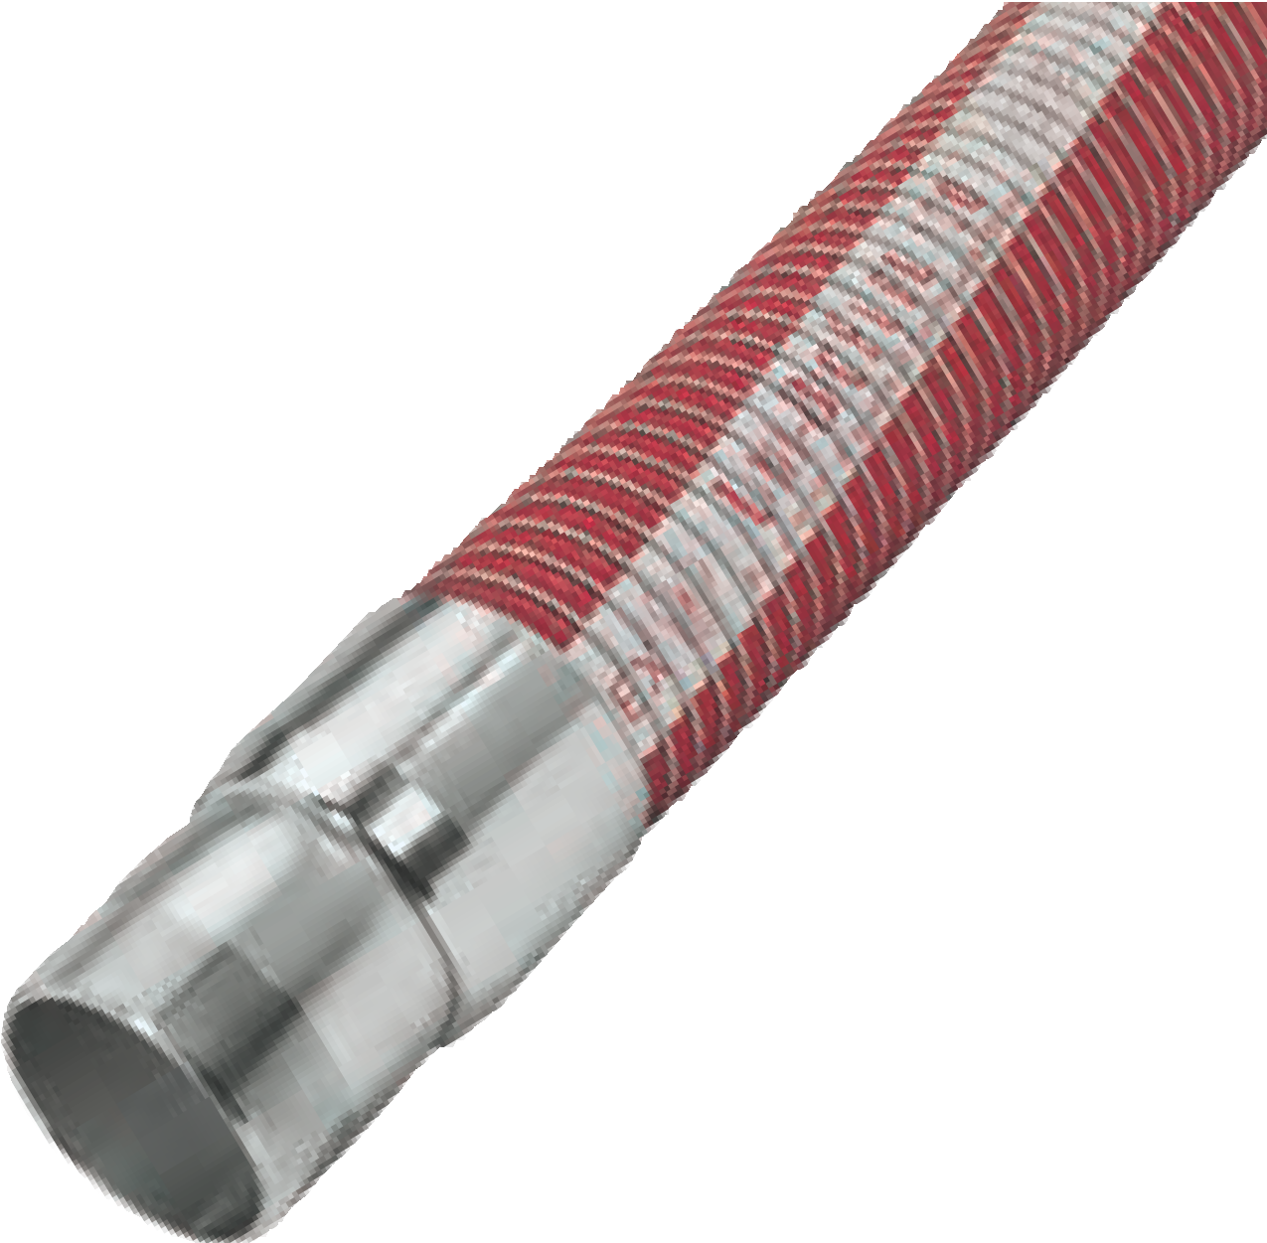
Uni-BioFuel™ 100
Biodiesel and Ethanol Service
Uni-BioFuel™ 100, a special alternative fuel hose designed to handle all grades of biodiesel, including 100% B100, neat biodiesel and E85 - 85% ethanol fuel blends. Uni-BioFuel™ hoses are built with a specialized combination of high performance films and fabrics designed to handle today’s fully concentrated alternative fuels. Rated for full vacuum.
Uni-BioFuel™ 100
G-High Tensile Galvanized Carbon Steel Inner Helix G-High Tensile Galvanized Carbon Steel Outer Helix Maximum length: 100 ft. (10” = 80 ft.)
Operating Temperature --40ºF to +250ºF (40ºC to +121°C)
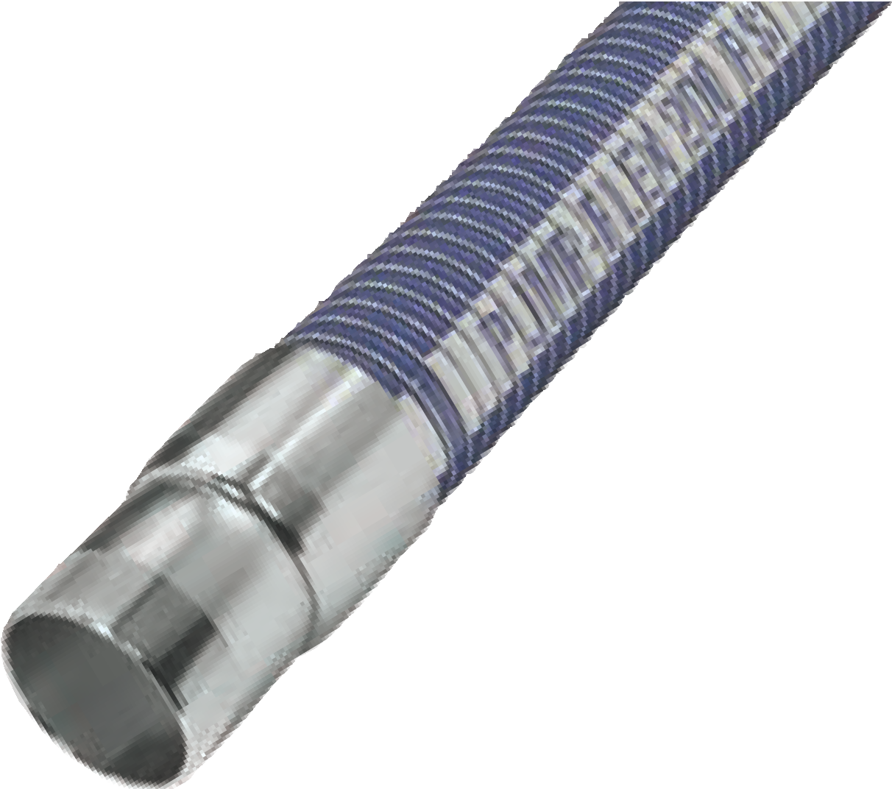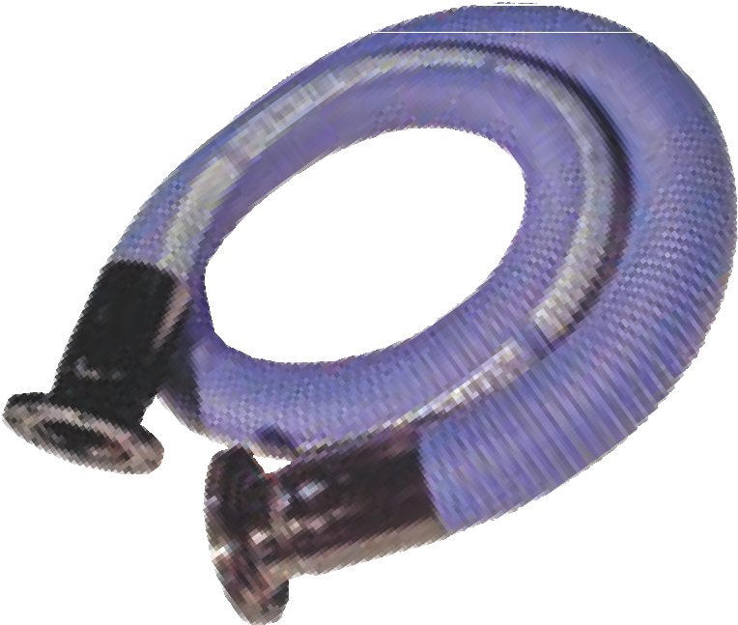NovaFlex Pump-Flex™ Composite Hose
Specifically Designed for the Pump Rental Industry
This rugged suction and discharge hose provides extreme flexibility, light-weight handling and excellent service life. Excellent for the transfer of water and oily water. Absorbs pump pulsations. Less manpower to install than rubber hose. Easy to package for shipping & storage.
Standard lengths:10 ft & 20 ft. with CS 150lb. fixed X floating flanges Crimped couplings. Other fitting combinations available. Rated for full vacuum. Maximum length: 100 ft. (10” = 80 ft.)
Operating Temperature --40ºF to +212ºF (-40ºC to +100ºC)
(Not for use in marine dock, crude oil, bunker oil or heavy viscous product applications. For these applications, contact NovaFlex. Consult NovaFlex chemical resistance chart for chemical compatibility before use.)

ID (INS) | 4 | 6 | 8 | 10
ID (OUT) | 4.4 | 6.75 | 9 | 10
Max WP PSI | 200 | 200 | 200 | 200
Burst Pres PSI | 800 | 800 | 800 | 800
Bend Rad. Inches | 14.2 | 22.0 | 30.0 | 40.0
Weight LB/FT | 2.7 | 7.0 | 10.0 | 13.0
150# Flange & Coupling LB ea. | 19 | 41 | 62 | 99

ID (INS) | 1 | 1.5 | 2 | 3 | 4 | 6 | 8 | 10
ID (OUT) | 1.0 | 2.0 | 2.5 | 3.5 | 4.5 | 7.0 | 9.4 | 10.5
Max WP PSI | 250 | 250 | 250 | 250 | 250 | 250 | 250 | 200
Burst Pres PSI | 1000 | 1000 | 1000 | 1000 | 1000 | 1000 | 1000 | 800
Bend Rad. Inches | 4.0 | 5.0 | 6.0 | 7.9 | 11.9 | 22.0 | 30.0 | 40.0
Max Lengths | 100 | 100 | 100 | 100 | 100 | 100 | 100 | 100

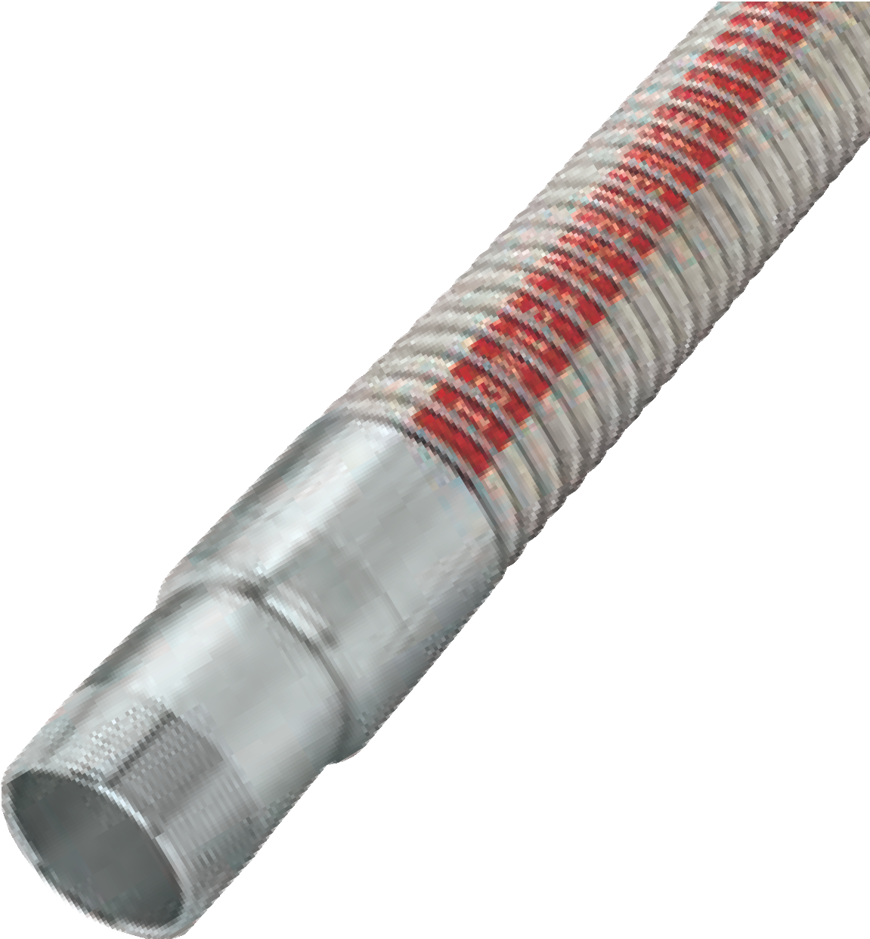
LPG Composite Style Hose
Designed for the Transfer of Liquified Petroleum Gas
Manufactured with CS inner and outer wire and polyamide reinforcement. Also available in 316SS inner and outer wires. Available with crimped on schedule 80 carbon steel or stainless steel threaded ends. Also available with ANSI flanges. All assemblies are hydrostatically tested and are tested for electrical continuity. CSA certified to CAN/CGA-8.1-M86.
Operating Temperature: -130°F to +176°F (-90°C to +80°C). Rated for full vacuum.

ID (INS) 1.25 2
OUT ID (INS) 1.75 2.6
Max WP ( PSI) 350 350
Burst Pres ( PSI) 1750 1750
Bend Radius (INS) 5.0 7.0
Weight LB/FT 1.1 1.7
Max Lengths (FT) 100 100
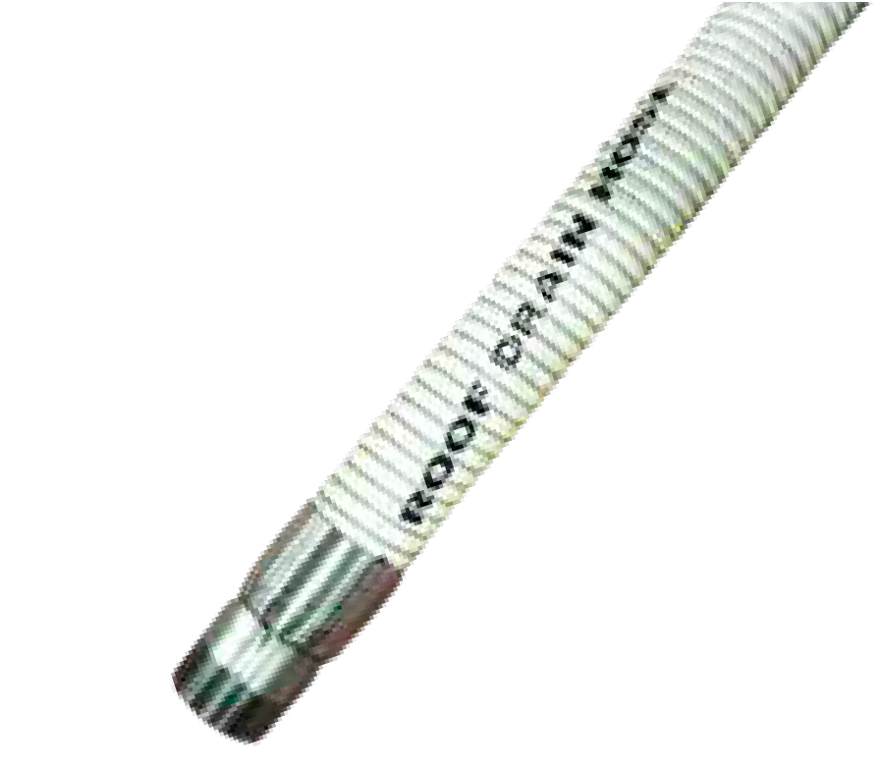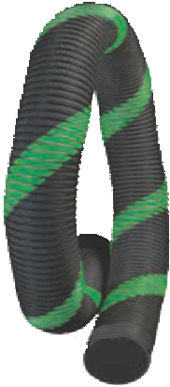
Roof Drain Hose
NovaFlex® Roof Drain Hose is manufactured for use in tanks with floating roof drain systems. It works well as a flexible elbow as it easily bends to 90°. Also suitable for oil skimmers, suction lines and water separators. Compatible both inside and out for a wide range of PH solutions and chemicals.
Diameters: 1” to 4” Lengths up to 100 ft.
Operating Temperature: -40ºF to +212ºF (-40ºC to +100ºC)
Nova-Glow™** Photo Luminescent Hose
With Minimal Exposure to Light Emits Soft Glow for Many Hours
Nova-Glow™ Patented Technology is a photo luminescent safety option for the complete line of
Uni-Chem® composite hoses. The Nova-Glow luminescent marker runs the length of the hose, offering both identification and safety hazard benefits at night or in reduced light & visibility conditions.
Nova-Glow™ equipped hoses, after having absorbed minimal light, store enough energy to emit an easily perceived glow that will last throughout the night, is non-toxic and deigned to perform its function for the reasonable service life of the hose.
Nova-Glow™ Hoses can assist in visual sighting of hoses such as those commonly used in dock transfer operations occurring during night hours. Nova-Glow™ hoses, after having absorbed minimal light, store enough energy to emit an easily perceived glow that will last throughout the night.
Nova-Glow™ strip is non-toxic and available on our complete range of composite hoses as well as select rubber hoses.
Integral Safety Feature - Photo-luminescent Hose for night time hose transfer operations Lightweight - Nova-Glow™ does not add any significant weight to hose assembly Long Service Life - Luminesce for minimum three years.*
*Note: Service life luminescent strip will be shortened if subject to abrasion / wear.
**Patent Protected US 8,667,993 B2, Canada 2,762,243 and others.

Bend Restrictor
A better way to move the tangent/flex point away from the end of the coupling system.
Uni-CHEM® bend restrictors provide increased service life on hose connections. Long lasting ozone resistant EPDM rubber blend. Reduced risk of premature hose wear due to kinking and hose fatigue at tangent point.
Part No.  5164BE-07333-FR  5164BE-09500-FR  5164BE-09500-FR | Hose Size  100  150  200 | Description EPDM FLEX RESISTOR EPDM FLEX RESISTOR EPDM FLEX RESISTOR | Hose in service: Note the gradual bend achieved off of the horizontal connections  Actual ID Actual OD Wall Ga. Length  4.875” 5.875” .500” 30”  7.333” 8.833” .750” 36”  9.500” 11.00” .750” 42”  Hose is coiled and when placed on a pallet, is ready for shipment.

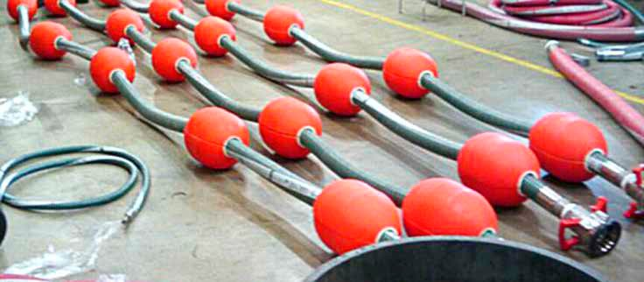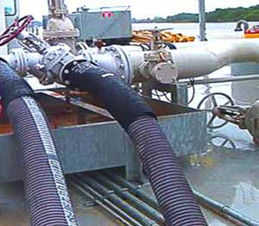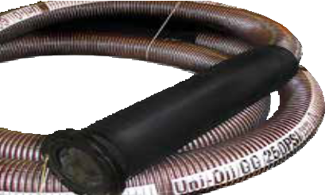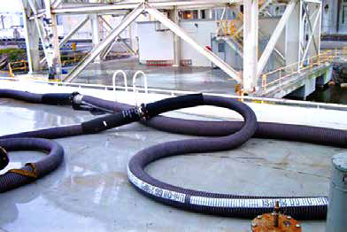Uni-CHEM® Composite Hoses With Custom Flotation Systems

Safety Advantages with Uni-CHEM® brand Composite Hose by NovaFlex
NovaFlex® is an industry leader in further advancements to composite hose design.
In a fluid transfer application, the hose is often the component that receives the least amount of consideration. NovaFlex® view safe and reliable composite hose assemblies as being equally critical as any other component of the transfer system. With decades of practical in field experience, NovaFlex® brings the same level of application specification, advanced material selection and design excellence to our complete hose and assembly range.

NovaFlex® differ from other manufacturers by offering a fitting lineup that is engineered to match each Uni-Chem® composite hose construction in every way. Where the broader industry often elect to use ‘off the shelf’ fittings from multiple sources, the Uni-Chem® composite hose fitting and seal program ensures repeatability, and superior performance with end fitting assembly.

NovaFlex® design all fittings for the Uni-Chem® composite hose program in house, and to our exacting specifications. All critical dimensions are machined as opposed to cast, thus ensuring unmatched consistency. Our production is backed up by ISO certified quality control systems covering all elements of our hose program.
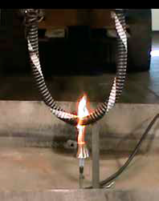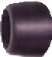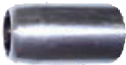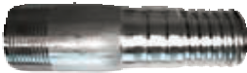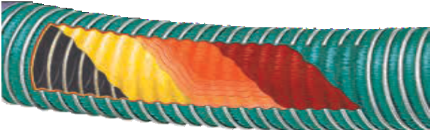
NovaFlex® EN Compliant
Composite Hose construction exceeds EN 13765:2010 Flammability Test.
As a global supplier of composite hose systems, NovaFlex® have invested heavily in ensuring full compliance with the latest standards. The most encompassing standard that addresses composite hose specifically, is the EN 13765 standard.
NovaFlex® continually engages in exhaustive testing programs, including independent third party verification of our results. Contributing significant safety benefits, the most rigorous performance element to the EN 13765 standard entails an exacting flame retardant specification.
NovaFlex® provide the most robust composite hose to meet and surpass this rigorous test, offering one of the only products available on the market that is in full compliance of this standard.
Versatile End Configurations
Only Uni-CHEM® offers uniformly crimped hose ends (1” to 10” I.D.). Combined with our custom tooled end
fittings Uni-CHEM® provides leak-free assembly every time. Male NPT Ends: Carbon Steel, 316 Stainless Steel, 304 Stainless Steel, Polypropylene
Flanged Ends: TTMA flanges for Bottom Loading hoses.
Fixed or floating in Carbon Steel, 304 and 316 Stainless Steel
Cam and Groove: Quick disconnect couplings in 304 and 316 Stainless Steel and Aluminum
PVC Impregnated Nylon Cover and Outer Helix Wire
Inner Helix Polypropylene Inner Vapor Barrier Reinforcing Wire tube Film & Fabric Films Fabric
Superior Performance from the Inside Out
Uni-CHEM® composite hoses are made only with carefully selected materials throughout. Their inner films and fabrics provide optimum chemical resistance against today’s highly aggressive media. Protected with the toughest PVC impregnated outer covers, Uni-CHEM® composite hoses provide the strength and versatility needed to get the job done.

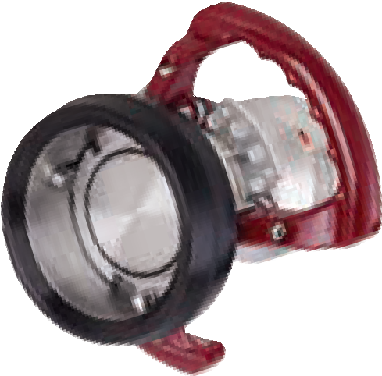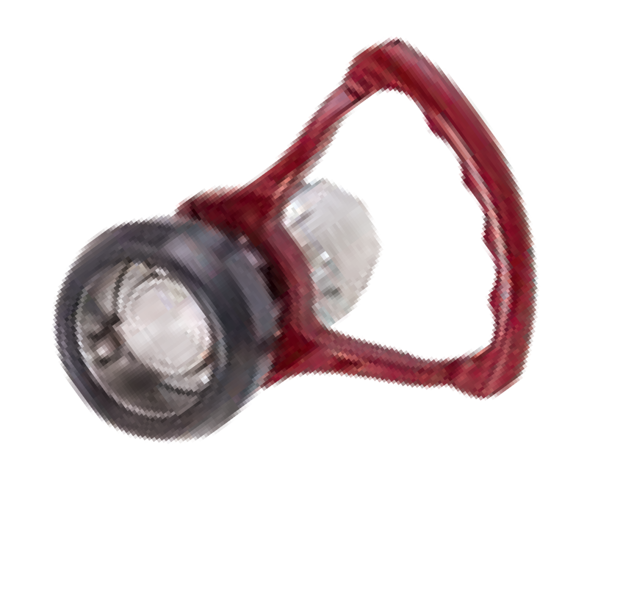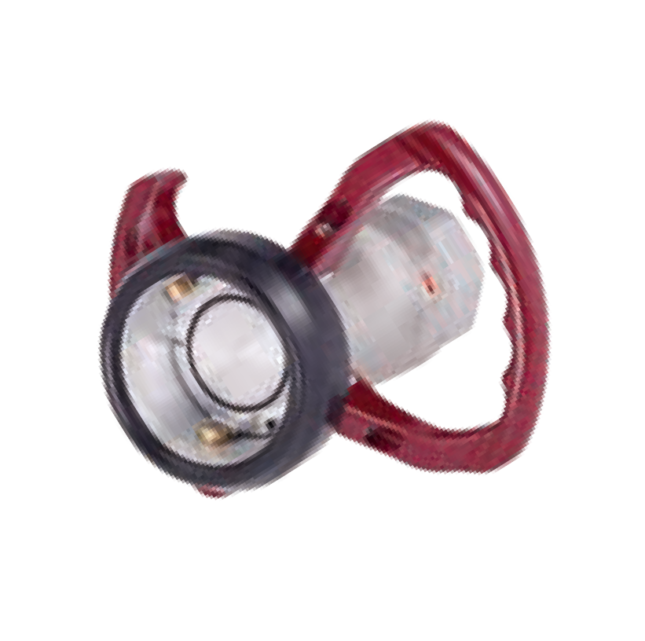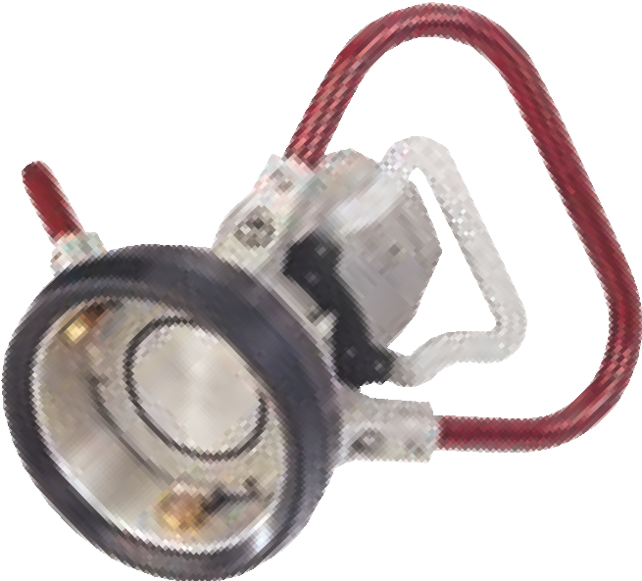NovaFlex® Hi-Flow Dry-Release™ Couplings ‘HDC’
The Next Generation in Dry-Release Technology
State of the art couplings designed to safely transfer the most aggressive and valuable product with minimum operator intervention.

The Next Generation in Dry-Release Technology
State of the art couplings designed to safely transfer the most aggressive and valuable product with minimum operator intervention.
How it works
Turning the hose unit 15° clockwise locks the units together. The valves are still closed and are not opened until a further rotation of 90° has been performed and then the product flow is guaranteed. To close the valves and to unlock the units, reverse the procedure.

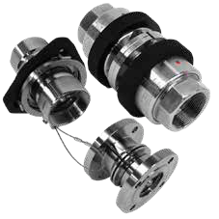
Safety Breakaway Couplings by NovaFlex®
Providing the highest standard of safety technology to protect personnel, critical assets and the environment.
Safety Breakaway Couplings (SBC) are an economical solution to costly accidental drive-aways and provide a lightweight full-flow means to prevent hard piping and loading arm damage. Available with female NPT threaded or ANSI 150 lb. flanged ends.

Prior to any application of the information within, please read carefully the following information:
This catalogue is a guide for use in selecting the correct hose for the correct application. It contains warnings, reference directions and directions for the safe use of industrial hose. All guidelines should be clearly understood before specifying or using any NovaFlex® product. Failure to follow recommended application information and recommended procedures may result in premature failure, resulting in bodily injury or property damage. Contact NovaFlex® or your local NovaFlex® distributor for assistance.
NovaFlex® recommends the use of NAHAD hose assembly guidelines.

Composite Hose Information
Composite hose is a unique hose composed of many layers of special materials, held together between an inner and outer wire. This type
of hose is still subject to the same operational parameters as regular hose. This type of hose can be maintained in accordance with the instructions in this booklet. The only additional points are:
Care should be taken to not damage the exterior of the hose. If the outer wire is broken or damaged, the hose should be replaced. If the outer cover plies are abraded to the point the inner carcass plies are exposed, the hose should be replaced. Insure the hose is used to transfer products in accordance with the chemical resistance chart.

Coupled Assemblies

NovaFlex® hoses have specific working pressures published. Never exceed the working pressure for any reason. The choice of coupling and the attachment method may cause the assembly to have a lower working pressure because the couplings may not be able to take the hose to its rated burst pressure.

Chemical Hose
- Always consult the NovaFlex® Chemical Resistance Chart to verify chemical compatibility. (See: www.novaflex.com)
- Do not use chemicals at higher temperatures than shown on the Chemical Resistance Chart. Higher temperatures increase the effect of chemicals on hose tubes.
If temperatures above +125º F (+52° C) are applicable, please consult NovaFlex®.

Proper Care Use & Maintenance
See NovaFlex® Correct Care and Maintenance Guide form no 2003-1
(See: www.NovaFlex.com).

Hose Coupling
- Always use the NAHAD Assembly Guidelines for working pressure.

It is impossible to test Uni-CHEM® hose under all conditions to which it might be subjected in the field. It is therefore the buyer and/or end user’s responsibility to test all Uni-CHEM® hose under conditions that duplicate the service condition prior to installation. Never use NovaFlex Composite Hose above the ratings listed by NovaFlex. Please Note: It is important to advise NovaFlex of the product being conveyed when ordering composite hoses. All hoses supplied have electrical continuity and are tested and certified accordingly. *WARNING! Elevated temperatures can change the chemical resistance rating of hose. Check the chemical resistance charts published by NovaFlex to verify that the chemical to be transferred is rated for use with the polypropylene
- Use Coupling Manufacturer’s recommendations for attachment,application and testing procedures. Temperature may effect the service life of a hose assembly. The temperature rating of the hose should never be exceeded. Even though the hose has a specific temperature rating, time can also effect the coupling attachment method. Always have an inspection and test program for all hoses every 6 months. Always err on the side of safety. Remove a hose from service if there is any doubt about its serviceability.
Attention: **Never use any NovaFlex® hose outside the hose temperature limits marked on the hose. It should be noted, that even within these indicated hose temperature limits other factors such as (but not limited to); attached end fittings, different hose installations can place additional stress on couplings (i.e. vertically hung) and hose diameters can impact performance under elevated temperatures.
For safety reasons NovaFlex® recommends that the hose working pressure should be de-rated by the following temperatures ranges:
+122°F to +175°F (+50°C to +80°C); reduce working pressure by 15%.
+178°F to +110°F (+81°C to +110°C); reduce working pressure by 30%. Over +230°F (+110º C); reduce working pressure by 50%.
tube at the temperature & concentrations listed. Most chemicals become more aggressive the higher the temperature, reducing the ability of the tube material to withstand them. Compatibility information is available from NovaFlex. If no data exists, it is the users responsibility to determine if the hose is compatible with the chemical to be transferred. All
improvements, all specifications are subject to change without prior notice. It is the buyer and/or end users’ responsibility to review our complete Terms and Conditions of Sale located on our web sites at: www.novaflex.com / www.z-flex.com
/ www.flexmaster.com.

Terms and Conditions of Sale

The items described in this document and other documents provided by NovaFlex® Hose Inc.,
NovaFlex® Industries Inc., Z-Flex U.S. Inc., their subsidiaries and their authorized representatives (“Seller”) are available for sale at prices established by Seller. An order from any customer (“Buyer”) shall be governed by all of the following terms and conditions of sale (“Terms and Conditions”). Upon Seller’s acceptance of Buyer’s purchase order the Terms and Conditions from apart of the agreement between Buyer and Seller. All goods available for sale are referred to as “Products”. The Terms and Conditions are also available on our website at www.novaflex.com. Prices; Price Adjustments; Payments. Prices stated in this document are valid for 30 days. Minimum purchase per order is $250. After 30 days, Seller may change prices to reflect any increase in its costs resulting from state, provincial, federal or local legislation, price increases from its suppliers, or any change in the rate, charge, or classification of any carrier. The prices in this document do not include any sales, use, or other taxes unless so stated. Buyer shall be responsible for any present or future sales, exercise or similar tax applicable to the sale or use of the Products. Unless otherwise specified by Seller, all prices are F.O.B. Seller’s facility, and payment is due 30 days from the date of invoice. After 30 days, Buyer shall pay interest on any unpaid invoices at the rate of 1.5% per month.
  - Delivery Dates; Title and Risk; Shipment. All delivery dates are approximate and Seller shall not be
responsible for any damages resulting from any delay due to a cause beyond its control. Regardless of manner of shipment, title to any Products and risk of loss or damage shall pass to Buyer upon tender to the carrier at Seller’s facility. Unless otherwise stated, Seller may exercise its judgment in choosing the carrier and means of delivery.
At Seller’s option carrier charges shall be prepaid and invoiced to Buyer. A $5.00 handling charge will be added to all UPS shipments. No deferment of shipment at Buyers’ request beyond the respective dates indicated will be made except on terms that will indemnify and hold Seller harmless against all loss and additional expense. Buyer shall be responsible for any additional shipping charges incurred by Seller due to Buyer’s changes in shipping or product specifications.
  - Buyer Responsibility and Acceptances. Buyer, and user, if different, through their own analysis and testing are solely responsible for making the final selection of Products and assuring that all performance, endurance, maintenance, safety and warning requirements are met. User must analyze all aspects of the application in the field and follow applicable industry standards and Product information. Adequate testing in actual service conditions must be carried out by Buyer and/or user to establish definite suitability for end use. If Seller suggests Products for an application based on data, drawings, designs, diagrams, specifications or other communications (“Information”) provided by Buyer or user, then Buyer and user are responsible for determining that the Information is suitable for use of the Product in the application. Submission of an order for production
quantities of a Product following receipt of a final version of a prototype is (a) Buyer's acceptance of the prototype as meeting all of Buyer's requirements as set out in the Information supplied by Buyer and, (b) Buyer's acceptance of the Products based on the prototype, provided the Products are manufactured within Seller's standard tolerances.
  - Returns, Cancellations and Changes. Returns shall not be accepted. Orders shall not be subject to cancellation or change by Buyer for any reason, except with Seller’s written consent on terms which protect Seller
from any loss. Seller may change product features, specifications, designs and availability with notice to Buyer.
  - Claims. Buyer shall promptly inspect all Products upon delivery. No claims for corrections or deductions from invoices will be allowed unless reported to Seller within 30 days of delivery.
  - Contingencies. Seller shall not be liable for any default or delay in performance if caused by circumstances beyond the reasonable control of Seller.
  - Warranty. Seller warrants that the Products sold hereunder shall be free from defects in material or workmanship for a period of twelve months from the date of delivery to Buyer. This warranty is made only to Buyer and does not extend to anyone to whom Products are sold after purchased from Seller. The prices
charged for Seller’s products are based upon the exclusive limited warranty stated above, and upon the following disclaimer: DISCLAIMER OF WARRANTY: This warranty comprises the sole and entire warranty pertaining to Products. Seller disclaims all other warranties, express and implied, including merchantability and fitness for a particular purpose.
  - Limitation of Liability. For a period of 30 days from delivery Seller will, upon notification, at its option, repair or replace a defective product, or refund the purchase price. In no event shall Seller be liable to Buyer for any special, indirect, incidental or consequential damages arising out of, or as the result of, the sale, delivery, non-delivery, servicing, use or loss of use of the Products or any part thereof, or for any charges or expenses of any nature incurred without Seller’s written consent, even if Seller has been negligent, whether in contract, tort or other legal theory. In no event shall Seller’s liability under any claim made by Buyer exceed the purchase price of the Products.
  - Improper Use and Indemnity. Buyer shall indemnify, defend, and hold Seller harmless from any claim, liability, damages, lawsuits, and costs (including lawyer’s fees), whether for personal injury, property damage, patent, trademark or copyright infringement or any other claim, brought by or incurred by Buyer, Buyer’s employees, or any other person, arising out of: (a) improper selection, improper application or other misuse
of Products purchased by Buyer; (b) any act or omission, negligent or otherwise, of Buyer; (c) Seller’s use of Information furnished by Buyer to manufacture Products; or (d) Buyer’s failure to comply with the Terms and Conditions. Seller will not indemnify Buyer under any circumstances except as otherwise provided.
  - Limitation on Assignment. Buyer may not assign its rights or obligations under this agreement without the prior written consent of Seller.
  - Entire Agreement. This agreement contains the entire agreement between the Buyer and Seller with respect to the subject matter of this agreement and supersedes all prior agreements, understandings, negotiations and discussions whether written or not.
  - Waiver. Failure to enforce any provision of this agreement will not waive the provision nor prejudice Seller’s right to enforce the provision in the future.
  - Governing Law. This agreement shall be governed by and construed in accordance with the laws of the State of New Hampshire.

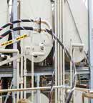
Uni-CHEM® Composite Hoses
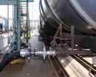
Designed to meet the most demanding applications
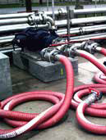
Composite Petro-Chemical Hose for use in petroleum, chemical and oil transfer, petrochemical vapour recovery, all loading arms in bottom loading operations, as well as tank truck delivery. Uni-CHEM’s flexible and lightweight liquid transfer and bottom loading composite hose offer optimum chemical resistance to aggressive media. Composite hose is available in a complete range of advanced films and fabrics to meet all hose requirements.
Uni-CHEM® Composite Hoses are externally crimped, have dry seal fittings and are available from 1” to 10” diameter.

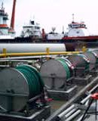
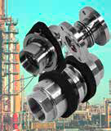
The NovaFlex Group is a market leader through excellence in product innovation and design. The NovaFlex Group is a privately held company committed to the continuous advancement in hose and connector solutions. NovaFlex has one of the broadest product ranges available in the hose and ducting marketplace, as well as the HVAC, Industrial Venting, Hose Industries and Commercial Exhaust Venting Systems. Products are sold in industries across North America and around the world.

®

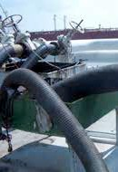
U.S.A.
HAW RIVER, NORTH CAROLINA INDIANAPOLIS, INDIANA WEST BERLIN, NEW JERSEY
Tel 336.578.2161 Tel 314.334.1444 Tel 856.756.2275
Fax 336.578.5554 Fax 314.334.1535 Fax 856.756.2385
Toll Free 800.334.4270 Toll Free 800.526.6288 Toll Free 800.225.0215

CANADA U.K.
AJAX, ONTARIO CALGARY, ALBERTA RICHMOND HILL, ONTARIO BROMBOROUGH, WIRRAL
Tel 905.686.5200 Tel 403.277.3115 Tel 905.731.9411 Tel 44.(0)151.334.0873
Fax 905.686.8349 Fax 403.276.1309 Fax 905.731.7086 Fax 44.(0)151.334.7145
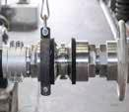
MONTREAL, QUEBEC DELTA, BRITISH COLUMBIA Email: sales@novaflex.co.uk
Tel 514.697.3701 Tel 604.940.6401
Fax 514.697.3767 Fax 604.940.6402
www.novaflex.com Email: sales@novaflex.com
ver: 04.2018

