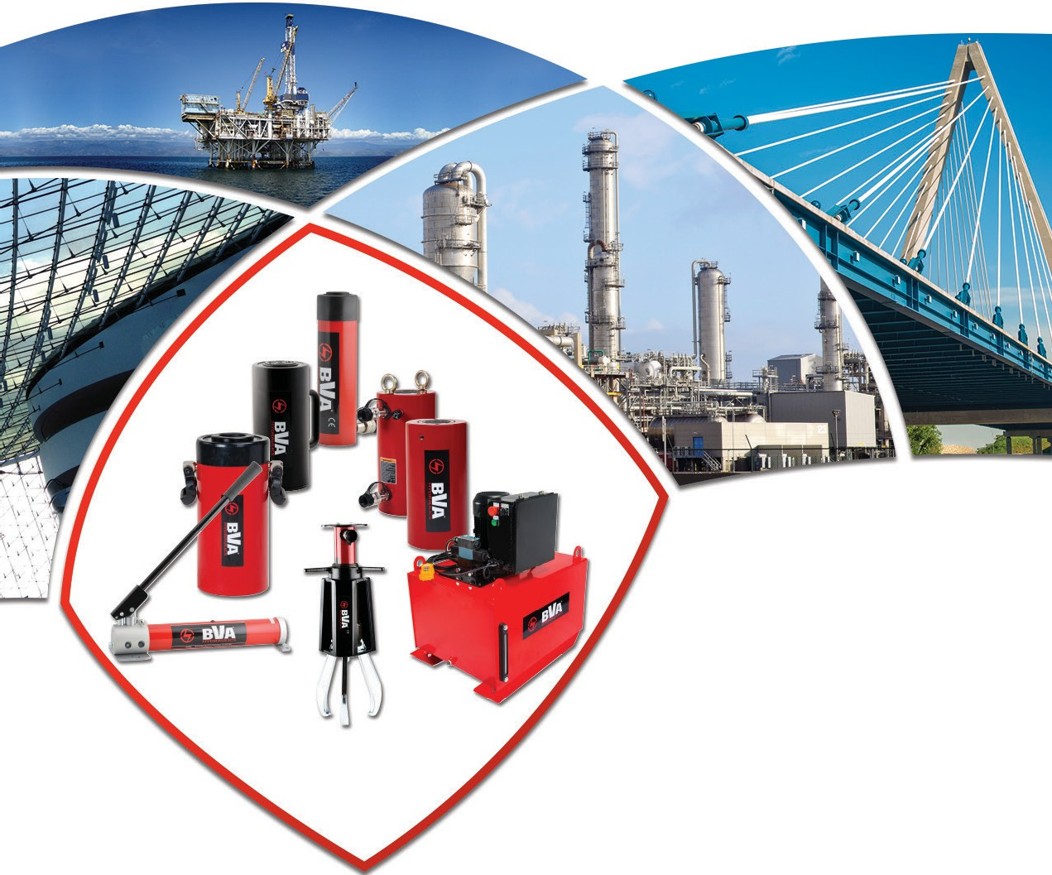 BVA H Y D R A U L I C S "

Dndlustriai Hydraulic Equipment

The BVA Advantage

BVA Hydraulics was launched in 2003 and is centrally located in the United States in Kansas City, Missouri. BVA is one of the Shinn Fu of America Companies including; Hein-Werner, Omega Lift, Pro-Lift, Blackhawk, Porto-Power, Bone Creeper, Omega Lighting and Save Phace. Shinn Fu was founded in Taiwan in 1971 and began doing business in the United States in 1978. Shinn Fu has over 2,000 Employees worldwide with its headquarters in Taipei, Taiwan.

Confidence Built on Quality
ISO 9001
BVA products are manufactured through an International Quality Assurance System, ISO 9001 which involves consistent observation of administration, management, manufacturing, and production control. Under this system, the related operations are monitored on all aspects from the purchase order to the assembly line and through to shipping the order.

Products comply with the following industry standards

ASME B30.1
The cylinders comply with load testing requirements and / or the safety factor for material yield strength while still functioning properly without oil leakage.
ANSI B40.1
BVA pressure gauges meet the criteria for grade A.
SAE 100
BVA hydraulic hoses comply with the Material Handling Institute’s specification of minimum life cycles
and minimum burst pressure rating.

BVA Limited Lifetime Warranty

BVA products are warranted to be free of defects in materials and workmanship. Any BVA product that does not conform to specification will be repaired or credited (at BVA’s option) at BVA’s expense for the life of the product. Contact BVA for disposition of this warranty.

This warranty does not cover ordinary wear and tear, abuse, misuse, alteration, or use of improper fluids or maintenance as determined by BVA and its authorized service centers. All electric motors, gas engines, batteries and other parts or materials sold with or part of BVA products but are separately warranted by another manufacturer, are covered by that manufacturer’s warranty
and not the BVA Lifetime Warranty. BVA shall not be liable for consequential or incidental damage or loss.

Repair Parts
Contact Us
For technical support, call
1-888-332-6419. For questions about your product, contact your local BVA dealer.
BVA Website
To view our most up-to-date catalog or view our new product, visit our website: www.BVAhydraulics.com
We offer a large range of product replacement parts, please contact your BVA dealer for more details.

1-888-332-6419
2 www.BVAhydraulics.com

Model Number Index

Cylinders

H
6
HUD
16
HL
26
HULN
32
HC
36
HP
41
HU
10
HG
18
HF
28
HLNF
33
HDC
38
HT
42
HD
12
HDG
22
HLN
30
HPD
43

Pages 6-43

Pumps
HUC/HUDC 40
Accessories 34

P Single Acting 46  Hand Pumps | PAR Rotary Air 49  Pumps | PA Double Acting 50 Air Pumps | PG Gas Engine 60  Pumps
P Double Acting 46 Hand Pumps | PA All Position 50  Air Pumps | PE 1-Phase 52  Electric Pumps | PD Diesel Engine 60  Pumps
P57 Foot Pumps 48 | PA Single Acting 50  Air Pumps | PE 3-Phase 56  Electric Pumps | PU Universal Motor 63 Pumps

Combo Kits

H | General Purpose Cylinder Combinations | 64 | HL | Low Profile Cylinder Combinations | 65
HF | Flat Body Cylinder Combinations | 64 | HLN | Lock Nut Cylinder Combinations | 65
HC | Hollow Hole Cylinder Combinations | 65 | HU | Aluminum Cylinder Combinations | 65

Pages 44-63

Pages 64-65

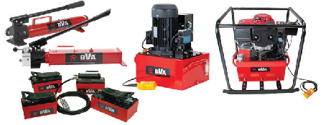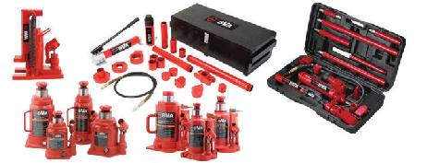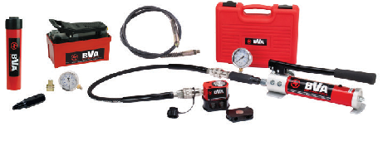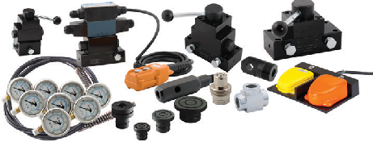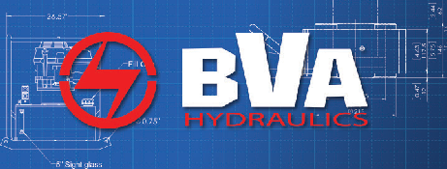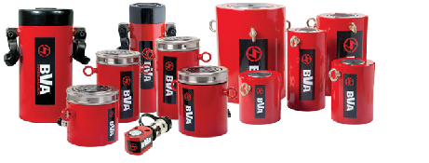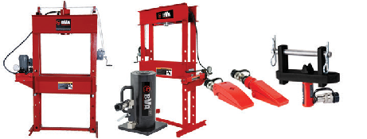
Control Valves & Accessories
Flow Control Valves
66
Gauge Adapters
69
Solenoid Valves
70
Wireless Controller
71
Pressure Switch
72
Directional Control Valves
74

Manifolds 68
Hydraulic Oil
70
Hydraulic Couplers
71
External Pressure Adj
71
Hydraulic Hoses
72
Fittings
75

69
70
72
Pump Mounted 73
Pages 66-75
Valves
Manifold Blocks
Foot Pedals 71
Coupler Dust Cover
Pressure Gauges

Presses/Tools
Movable Head 77  Shop Presses | Shop Press 80  Guards | Oil Field Valve 82  Seat Pullers | Hydraulic Gear Pullers 83
Fixed Head 78  Shop Presses | Flange Spreaders 81 | Aluminum Cylinder 82  w/ Base/Needle Valve | Mechanical Gear 83  Pullers
Shop Press 80  Accessories | Duck Bill 81  Spreaders | Hydraulic Bench Vise 82 | Nut Splitters 83

Pages 76-83

Maintenance Kits/Bottle Jacks
Maintenance Kits/Rail Cylinders | 85 | Manual Bottle Jacks | 88 | Mini Jacks | 89
Lifting Bags | 86 | Air/Manual Bottle Jacks | 88 | OMNI All-Position Jacks | 89
Lifting Bag Accessories | 87 | Toe Jacks | 88 | Orbital Jacks | 89

Pages 84-89

Cross-Reference & Engineering
BVA Cross Reference Chart | 90 | Hydraulic Formula Reference | 94
Safety Instructions | 92
Maintaining Your Equipment | 94

Pages 90-94

© Copyright 2016 SFA Companies
All rights reserved. Any copying or other use of the material in this catalog (text, illustrations, drawings, photos) without
prior express written consent is prohibited. Information in this catalog is subject to change without prior notice. 3

Cylinder Matrix Chart 1
T
06
30
DC
H

2 3 4 5

Cylinder Type
Cylinder Options
Cylinder Capacity
Cylinder Stroke
Suffix
Code

1 - Cylinder Type 3 - Cylinder Capacity 4 - Cylinder Stroke
H Hydraulic Cylinder | 02 | 2, 2.5 Tons | 75 | 75 Tons | 00 | 0.63"
 | 04 | 4 Tons | 100 | 100 Tons | 01 | 1"
2 - Cylinder Options | 05 | 5 Tons | 150 | 150 Tons | 02 | 2"
 | 09 | 9 Tons | 160 | 160 Tons | 04 | 4"
C S/A - Hollow Hole | 10 | 10 Tons | 200 | 200 Tons | 05 | 5"
D D/A - General Purpose | 12 | 12 Tons | 250 | 250 Tons | 06 | 6"
DC D/A - Hollow Hole | 15 | 15 Tons | 300 | 300 Tons | 08 | 8"
DG D/A - High Tonnage | 16 | 16 Tons | 400 | 400 Tons | 10 | 10"
F S/A - Flat Body | 20 | 20 Tons | 500 | 500 Tons | 12 | 12"
G S/A - Load Return High Tonnage | 25 | 25 Tons | 600 | 600 Tons | 13 | 13"
L S/A - Low Profile | 30 | 30 Tons | 700 | 700 Tons | 14 | 14"
LN S/A - Lock Nut | 50 | 50 Tons | 800 | 800 Tons | 18 | 18"
LNF S/A - Lock Nut Low Profile | 55 | 55 Tons | 1,000 | 1,000 Tons | 20 | 20"
P S/A - Pull | 60 | 60 Tons | 1,500 | 1,500 Tons | 24 | 24"
PD Precision Double Acting | 75 | 75 Tons |  |  | 32 | 32"
T S/A - Threaded

U S/A - Aluminum
UC S/A - Aluminum Hollow Hole UDC D/A - Aluminum Hollow Hole ULN S/A - Aluminum Lock Nut

5 - Suffix Code
T BVA Factory Designation
US US Made Cylinder

XT No Internal Threads, HC Series only
B Flat Body Cylinder Kit

Cylinder Accessories
See the assortment
of accessories designed
Safety Practices
Good industry practice recommends not exceeding
Safety Instructions
Visit our DO’S and DON’TS
section to review the best

to work with our products.
pg34
80% of maximum rated capacities of all our products.
methods of operation. Always be prepared.
pg 92

Heavy duty, heat treated, grooved saddle provides better surface traction during operation

Rod wiper seals out dirt and contamination

Industrial hard chrome plated rod prevents scratching and corrosion

One piece steel rod stopper for extra strength and prevents over travel

Steel stop ring for rod over travel protection

Collar fixture threads

Cylinders are burnish rolled smoother finish than honing, which reduces scoring and prolongs seal life

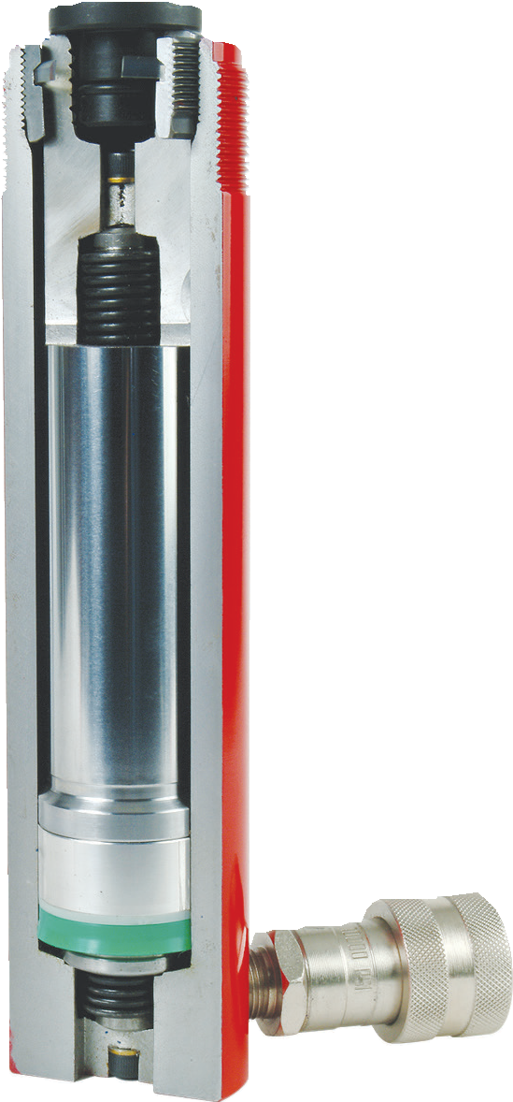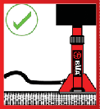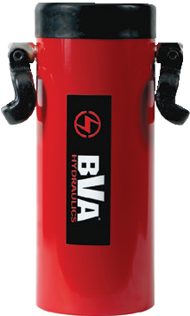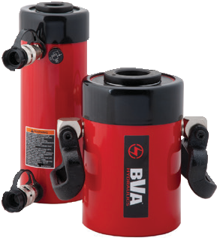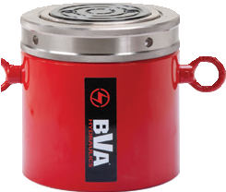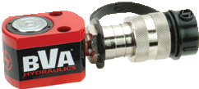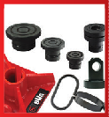

Polyurethane cup seal provides optimum performance

Rectangular return spring design eliminates spring breakage and provides quicker retraction
1-888-332-6419
4 www.BVAhydraulics.com
One piece high grade alloy bearing for side load protection and long life

High flow ball coupler provides more flow than conventional couplers

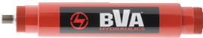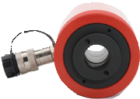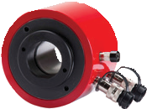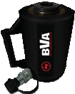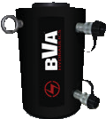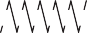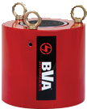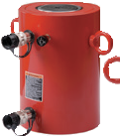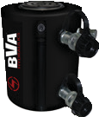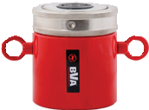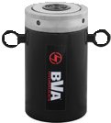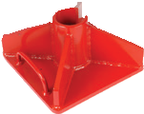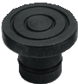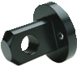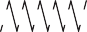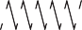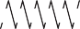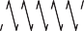
5
Cylinders

Cylinder | Cylinder Type | Max Capacity  Range | Max Stroke  Range | Page Number /
Series |  | (tons) | (in) | Reference Image
H | Single Acting Cylinders | 2-100 | 0.63-14.25 | 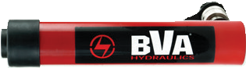 6-9
HU | Aluminum Single Acting Cylinders | 20-150 | 1.97-10.00 | 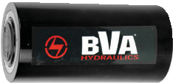 10-11
HD | Double Acting Cylinders | 10-500 | 5.90-24.00 | 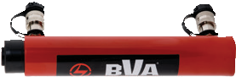 12-15
HUD | Aluminum Double Acting Cylinders | 30-150 | 1.97-10.00 | 16-17
HG | High Tonnage Single Acting Cylinders | 100-1500 | 1.97-11.81 | 18-21
HDG | High Tonnage Double Acting Cylinders | 200-1500 | 6.00-24.00 | 22-25
HL | Low Profile Cylinders | 10-100 | 1.5-2.44 | 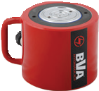 26-27
HF | Flat Body Cylinders | 5-150 | 0.24-0.63 | 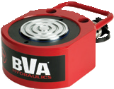 28-29
HLN | Lock Nut Cylinders | 55-300 | 1.97-11.81 | 30-31
HULN | Aluminum Lock Nut Cylinders | 30-150 | 1.97-11.81 | 32
HLNF | Low Profile Lock Nut  Cylinders | 60-250 | 1.77-1.97 | 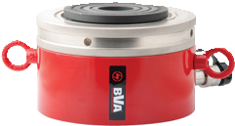 33
- | Cylinder Accessories | - | - | 34-35
HC | Hollow Hole Cylinders | 12-100 | 0.31-6.11 | 36-37
HDC | Double Acting Hollow Hole Cylinders | 30-150 | 1.50-10.13 | 38-39
HUC | Aluminum Hollow Hole Cylinders | 30-60 | 3.00-5.91 | 40
HUDC | Aluminum Double Acting Hollow Hole Cylinders | 30-150 | 5.91-9.84 | 40
HP | Pull Cylinders | 2.5-10 | 5.00-5.95 | 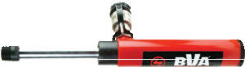 41
HT | Threaded Cylinders | 4-20 | 5.07-9.96 | 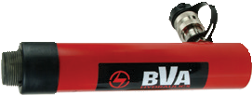 42
HPD | Precision Double Acting Cylinders | 9-16 | 1.77-3.14 | 43
Pump Section Page 44

Single Acting Cylinders

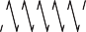H Series - General Purpose, Spring Return

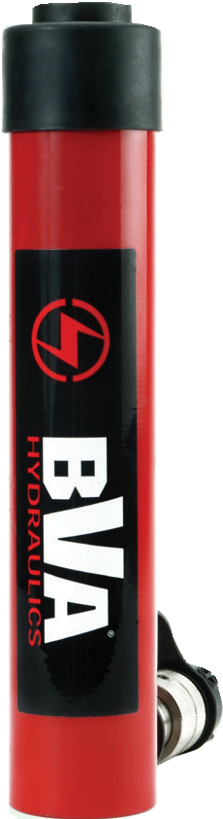Capacity:
H1514
2 - 100 Tons*

Stroke:
0.63 - 14.25 Inches

Max. Operating Pressure:
10,000 psi

Min. - Max. Height:
1.63 - 32.99 Inches

H10010

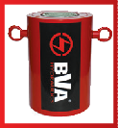H7513
* Larger Tonnages
For tonnages that exceed 100, please refer to our HG Section
pg
18

H1501

Safety Practices
Good industry practice recommends not exceeding 80% of maximum rated capacities of all our products.

HU Series – Aluminum Cylinders
Aluminum cylinders make a great lightweight alternative being up to 60% lighter
Single Acting Cylinder H1506 in the collapsed position with CB15 cylinder base for safety.

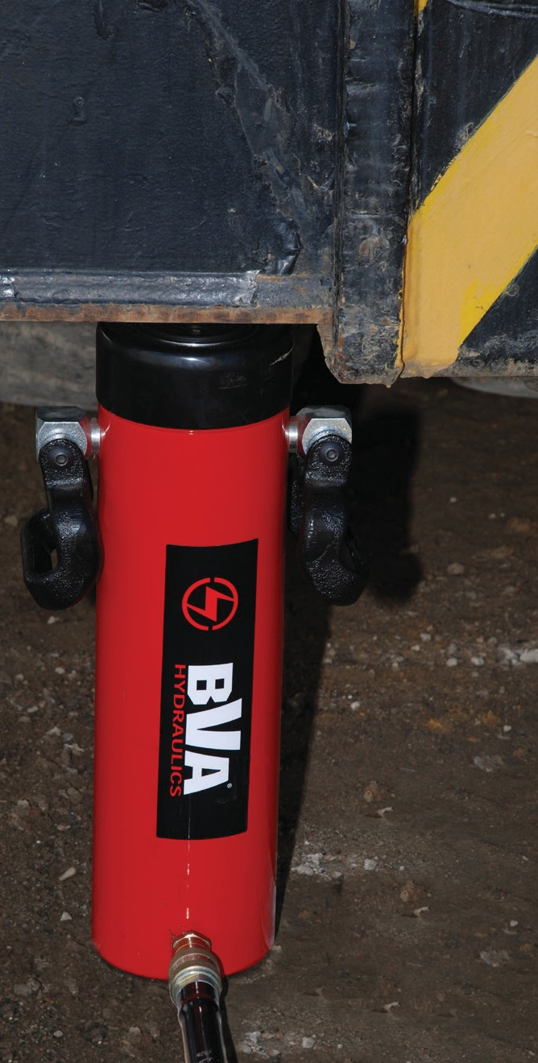
Single Acting Cylinder H5513 in the collapsed
position ready to lift a load

- Collar threads and base
mounting holes for fixturing
- Hard chrome plated piston rod protects against corrosion
and damage
- Polyurethane U-Cup seals provide a sure seal and long life
- Solid one piece alloy steel body
- One piece aluminum alloy bearing protects against cylinder wall damage
- CH38F high flow coupler with dust cap is standard on most cylinders**

than comparable steel models.

1-888-332-6419
pg10

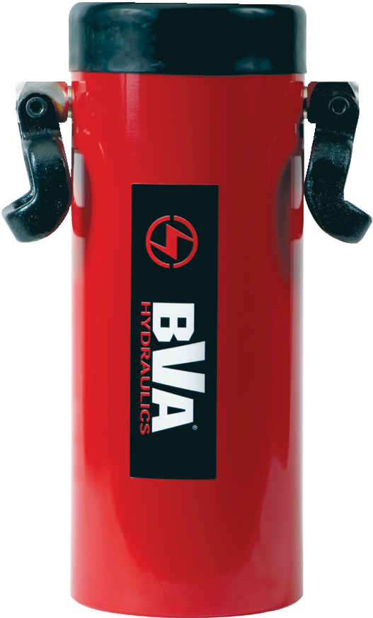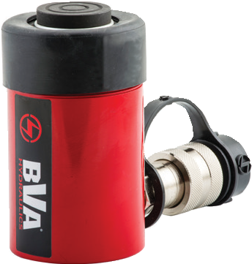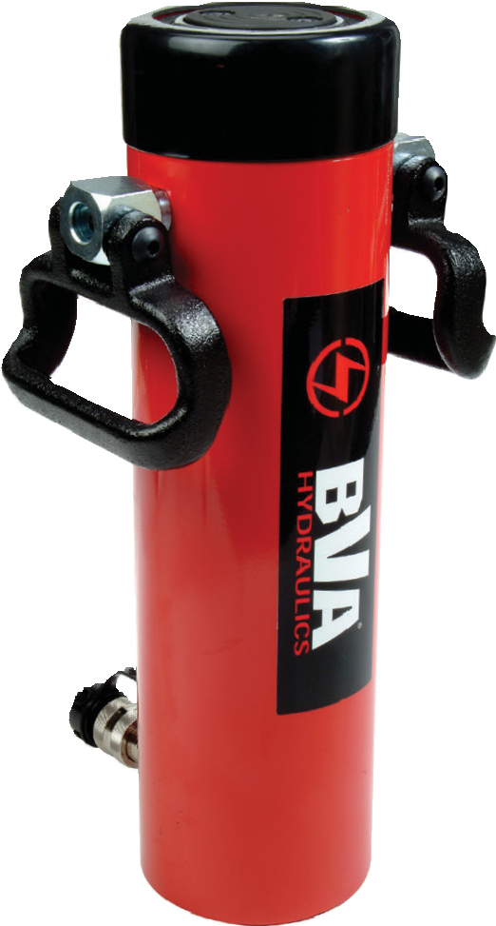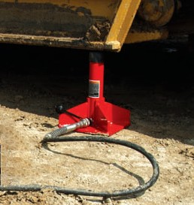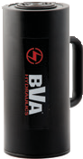6 www.BVAhydraulics.com

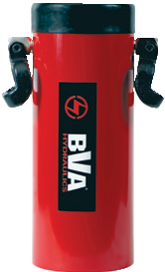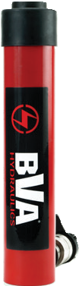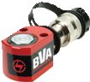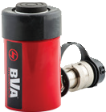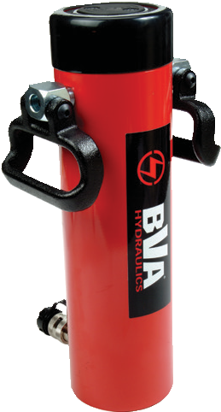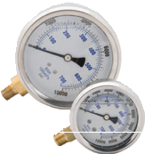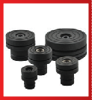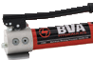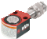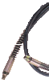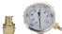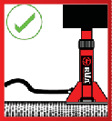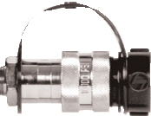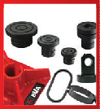
H Series
Related Product: Gauges
Reduce the risk of overloading your product by using a gauge.
A variety of graduations and types to suit any need.
pg69
Cylinder Accessories
See the assortment
of accessories designed to work with our products.
pg
34
Combo Kits
Most cylinders are available in easy to order kits: Cylinder, Gauge, Couplers, Hose
and Pump.
pg64
Safety Instructions
Visit our DO’S and DON’TS section to review the best methods of operation.
Always be prepared.
pg
92
High-Flow Couplers
High-Flow Coupler: CH38F is included on all models (except where specified).
Optional Tilt-Saddles
Saddles tilt to a 5% maximum to adjust to the load. Match up these saddles with the following cylinders:
SDT05 →
SDT10 →
H05 Cylinders*
H10 Cylinders

SDT15
→
H15 Cylinders
SDT25 → H25 Cylinders
SDT55 → H55, H75, H100 Cylinders
* Except the H0500 cylinder
pg 35
7

Quick Selection Guide
Cylinders
Cylinder Capacity (ton) | Stroke (in) | Model Number | Collapsed Height (in) | Oil Capacity (in3) | Weight (lbs)
2 | 3.07 | H0203* | 5.39 | 2.28 | 2.0
5 | 0.63 | H0500** | 1.63 | 0.69 | 1.9
 | 1.00 | H0501 | 4.58 | 1.00 | 3.1
 | 3.07 | H0503 | 6.65 | 3.07 | 3.2
 | 5.08 | H0505 | 8.70 | 5.08 | 3.9
 | 7.09 | H0507 | 10.71 | 7.09 | 4.7
 | 9.00 | H0509 | 12.75 | 9.03 | 5.5
10 | 0.98 | H1001 | 3.62 | 2.19 | 3.9
 | 2.01 | H1002 | 4.84 | 4.50 | 5.0
 | 4.02 | H1004 | 6.85 | 9.00 | 7.7
 | 5.94 | H1006 | 9.84 | 13.30 | 9.5
 | 7.95 | H1008 | 11.85 | 17.81 | 11.3
 | 9.96 | H1010 | 13.86 | 22.31 | 13.1
 | 11.97 | H1012 | 15.87 | 26.81 | 15.0
 | 14.02 | H1014 | 17.72 | 31.40 | 16.7
15 | 0.98 | H1501 | 4.88 | 3.07 | 6.9
 | 2.01 | H1502 | 5.87 | 6.31 | 8.5
 | 3.98 | H1504 | 7.87 | 12.49 | 11.1
 | 5.98 | H1506 | 10.63 | 18.77 | 14.8
 | 7.99 | H1508 | 12.64 | 25.08 | 17.3
 | 10.00 | H1510 | 14.65 | 31.40 | 20.0
 | 12.01 | H1512 | 16.65 | 37.71 | 22.5
 | 14.02 | H1514 | 18.66 | 44.02 | 25.2
25 | 1.02 | H2501 | 5.63 | 5.25 | 12.1
 | 2.01 | H2502 | 6.61 | 10.35 | 14.0
 | 4.02 | H2504 | 8.62 | 20.70 | 18.0
 | 6.10 | H2506 | 10.71 | 31.41 | 22.2
 | 8.11 | H2508 | 12.72 | 41.77 | 26.3
 | 10.12 | H2510 | 14.72 | 52.12 | 30.3
 | 12.20 | H2512 | 16.77 | 62.83 | 34.3
 | 14.25 | H2514 | 18.74 | 73.39 | 38.3
30 | 8.27 | H3008 | 15.24 | 53.67 | 40.7
55 | 2.01 | H5502 | 6.93 | 21.97 | 33.0
 | 4.06 | H5504 | 8.94 | 44.57 | 41.0
 | 6.26 | H5506† | 11.14 | 68.73 | 57.5
 | 10.25 | H5510† | 15.16 | 112.55 | 67.4
 | 13.27 | H5513† | 18.15 | 145.70 | 87.0
75 | 6.14 | H7506† | 11.22 | 98.85 | 74.0
 | 13.11 | H7513† | 19.37 | 211.07 | 122.0
100 | 2.01 | H10002A† | 8.62 | 41.34 | 66.0
 | 6.61 | H10006† | 14.06 | 136.03 | 127.0
 | 10.24 | H10010† | 17.68 | 210.74 | 153.0
See pages 8-9 for detailed specifications.

* H0203 load return.
** H0500 comes with CRZ14F coupler.
† Cylinder is equipped with carrying handle.

Single Acting Cylinders

H Series - Spring Return
Cylinder Capacity (ton) | Stroke (in) | Model Number | Cylinder Effective Area (in2) | Internal Pressure at Capacity (psi) | Oil Capacity (in3) | Weight (lbs)
2 | 3.07 | H0203* | 0.76 | 5,263 | 2.28 | 2.0
5 | 0.63 | H0500** | 1.10 | 9,091 | 0.69 | 1.9
 | 1.00 | H0501 | 1.00 | 10,000 | 1.00 | 3.1
 | 3.07 | H0503 | 1.00 | 10,000 | 3.07 | 3.2
 | 5.08 | H0505 | 1.00 | 10,000 | 5.08 | 3.9
 | 7.09 | H0507 | 1.00 | 10,000 | 7.09 | 4.7
 | 9.00 | H0509 | 1.00 | 10,000 | 9.03 | 5.5
10 | 0.98 | H1001 | 2.24 | 8,928 | 2.19 | 3.9
 | 2.01 | H1002 | 2.24 | 8,928 | 4.50 | 5.0
 | 4.02 | H1004 | 2.24 | 8,928 | 9.00 | 7.7
 | 5.94 | H1006 | 2.24 | 8,928 | 13.30 | 9.5
 | 7.95 | H1008 | 2.24 | 8,928 | 17.81 | 11.3
 | 9.96 | H1010 | 2.24 | 8,928 | 22.31 | 13.1
 | 11.97 | H1012 | 2.24 | 8,928 | 26.81 | 15.0
 | 14.02 | H1014 | 2.24 | 8,928 | 31.40 | 16.7
15 | 0.98 | H1501 | 3.14 | 9,554 | 3.07 | 6.9
 | 2.01 | H1502 | 3.14 | 9,554 | 6.31 | 8.5
 | 3.98 | H1504 | 3.14 | 9,554 | 12.49 | 11.1
 | 5.98 | H1506 | 3.14 | 9,554 | 18.77 | 14.8
 | 7.99 | H1508 | 3.14 | 9,554 | 25.08 | 17.3
 | 10.00 | H1510 | 3.14 | 9,554 | 31.40 | 20.0
 | 12.01 | H1512 | 3.14 | 9,554 | 37.71 | 22.5
 | 14.02 | H1514 | 3.14 | 9,554 | 44.02 | 25.2
25 | 1.02 | H2501 | 5.15 | 9,708 | 5.25 | 12.1
 | 2.01 | H2502 | 5.15 | 9,708 | 10.35 | 14.0
 | 4.02 | H2504 | 5.15 | 9,708 | 20.70 | 18.0
 | 6.10 | H2506 | 5.15 | 9,708 | 31.41 | 22.2
 | 8.11 | H2508 | 5.15 | 9,708 | 41.77 | 26.3
 | 10.12 | H2510 | 5.15 | 9,708 | 52.12 | 30.3
 | 12.20 | H2512 | 5.15 | 9,708 | 62.83 | 34.3
 | 14.25 | H2514 | 5.15 | 9,708 | 73.39 | 38.3
30 | 8.27 | H3008 | 6.49 | 9,245 | 53.67 | 40.7
55 | 2.01 | H5502 | 10.98 | 10,018 | 21.97 | 33.0
 | 4.06 | H5504 | 10.98 | 10,018 | 44.57 | 41.0
 | 6.26 | H5506† | 10.98 | 10,018 | 68.73 | 57.5
 | 10.25 | H5510† | 10.98 | 10,018 | 112.55 | 67.4
 | 13.27 | H5513† | 10.98 | 10,018 | 145.70 | 87.0
75 | 6.14 | H7506† | 16.10 | 9,316 | 98.85 | 74.0
 | 13.11 | H7513† | 16.10 | 9,316 | 211.07 | 122.0
100 | 2.01 | H10002A† | 20.58 | 9,718 | 41.34 | 66.0
 | 6.61 | H10006† | 20.58 | 9,718 | 136.03 | 127.0
 | 10.24 | H10010† | 20.58 | 9,718 | 210.74 | 153.0

G
3/8"-18NPTF

C E

A
B

** H0500 Only

Y
Y

D1

X D2

X
D F

K

J
E

L

H B

A

C
3/8"-18NPTF

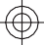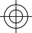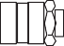
G
Z

1-888-332-6419
8 www.BVAhydraulics.com

- H0203 load return.
** H0203 comes with CRZ14F coupler.

† Cylinder is equipped with carrying handle.

Model Number | Collapsed Height  A  (in) | Extended  Height B  (in) | Cylinder Bore  C  (in) | Outside Dia. D  (in) | Rod Dia. E  (in) | Saddle Dia.  F  (in) | Base to Inlet Port  G  (in) | Collar Thread H  (in) |  | Collar Thread Length L  (in) | Rod Internal Thread J  (in) | Rod Thread Length K  (in) | Base Mounting Hole (in)
 |  |  |  |  |  |  |  |  |  |  |  |  | Bolt Circle X | Thread Y | Thread Depth Z
H0203* | 5.39 | 8.46 | 1.00 | 1.31 | 0.87 | 1.00 | 0.46 | 1¼”-16 |  | 0.54 | - | - | - | - | -
H0500** | 1.63 | 2.26 | 1.18 | 2.37x1.59‡ | 0.98 | - | 0.75 | - |  | - | - | - | 1.10 | - | -
H0501 | 4.58 | 5.58 | 1.13 | 1.50 | 1.00 | 0.98 | 0.79 | 1½”-16 |  | 1.10 | ¾”-16UNF | 0.63 | 1.00 | ¼”-20UNC | 0.55
H0503 | 6.65 | 9.72 | 1.13 | 1.50 | 1.00 | 0.98 | 0.79 | 1½”-16 |  | 1.10 | ¾”-16UNF | 0.63 | 1.00 | ¼”-20UNC | 0.55
H0505 | 8.70 | 13.78 | 1.13 | 1.50 | 1.00 | 0.98 | 0.79 | 1½”-16 |  | 1.10 | ¾”-16UNF | 0.63 | 1.00 | ¼”-20UNC | 0.55
H0507 | 10.71 | 17.80 | 1.13 | 1.50 | 1.00 | 0.98 | 0.79 | 1½”-16 |  | 1.10 | ¾”-16UNF | 0.63 | 1.00 | ¼”-20UNC | 0.55
H0509 | 12.75 | 21.75 | 1.12 | 1.50 | 1.00 | 0.98 | 0.79 | 1½”-16 |  | 1.10 | ¾”-16UNF | 0.63 | 1.00 | ¼”-20UNC | 0.55
H1001 | 3.62 | 4.60 | 1.69 | 2.26 | 1.49 | - | 0.77 | 2¼”-14 |  | 1.18 | - | 0.24 | 1.56 | ”-18UNC | 0.55
H1002 | 4.84 | 6.85 | 1.69 | 2.26 | 1.49 | 1.38 | 0.77 | 2¼”-14 |  | 1.18 | 1”-8UNC | 0.79 | 1.56 | ”-18UNC | 0.55
H1004 | 6.85 | 10.87 | 1.69 | 2.26 | 1.49 | 1.38 | 0.77 | 2¼”-14 |  | 1.18 | 1”-8UNC | 0.79 | 1.56 | ”-18UNC | 0.55
H1006 | 9.84 | 15.78 | 1.69 | 2.26 | 1.49 | 1.38 | 0.77 | 2¼”-14 |  | 1.18 | 1”-8UNC | 0.79 | 1.56 | ”-18UNC | 0.55
H1008 | 11.85 | 19.80 | 1.69 | 2.26 | 1.49 | 1.38 | 0.77 | 2¼”-14 |  | 1.18 | 1”-8UNC | 0.79 | 1.56 | ”-18UNC | 0.55
H1010 | 13.86 | 23.82 | 1.69 | 2.26 | 1.49 | 1.38 | 0.77 | 2¼”-14 |  | 1.18 | 1”-8UNC | 0.79 | 1.56 | ”-18UNC | 0.55
H1012 | 15.87 | 27.84 | 1.69 | 2.26 | 1.49 | 1.38 | 0.77 | 2¼”-14 |  | 1.18 | 1”-8UNC | 0.79 | 1.56 | ”-18UNC | 0.55
H1014 | 17.72 | 31.74 | 1.69 | 2.26 | 1.49 | 1.38 | 0.77 | 2¼”-14 |  | 1.18 | 1”-8UNC | 0.79 | 1.56 | ”-18UNC | 0.55
H1501 | 4.88 | 5.86 | 2.00 | 2.75 | 1.63 | 1.50 | 0.77 | 2¾”-16 |  | 1.18 | 1”-8UNC | 0.98 | 1.88 | ⅜”-16UNC | 0.51
H1502 | 5.87 | 7.88 | 2.00 | 2.75 | 1.63 | 1.50 | 0.77 | 2¾”-16 |  | 1.18 | 1”-8UNC | 0.98 | 1.88 | ⅜”-16UNC | 0.51
H1504 | 7.87 | 11.85 | 2.00 | 2.75 | 1.63 | 1.50 | 0.77 | 2¾”-16 |  | 1.18 | 1”-8UNC | 0.98 | 1.88 | ⅜”-16UNC | 0.51
H1506 | 10.63 | 16.61 | 2.00 | 2.75 | 1.63 | 1.50 | 0.98 | 2¾”-16 |  | 1.18 | 1”-8UNC | 0.98 | 1.88 | ⅜”-16UNC | 0.51
H1508 | 12.64 | 20.63 | 2.00 | 2.75 | 1.63 | 1.50 | 0.98 | 2¾”-16 |  | 1.18 | 1”-8UNC | 0.98 | 1.88 | ⅜”-16UNC | 0.51
H1510 | 14.65 | 24.65 | 2.00 | 2.75 | 1.63 | 1.50 | 0.98 | 2¾”-16 |  | 1.18 | 1”-8UNC | 0.98 | 1.88 | ⅜”-16UNC | 0.51
H1512 | 16.65 | 28.66 | 2.00 | 2.75 | 1.63 | 1.50 | 0.98 | 2¾”-16 |  | 1.18 | 1”-8UNC | 0.98 | 1.88 | ⅜”-16UNC | 0.51
H1514 | 18.66 | 32.68 | 2.00 | 2.75 | 1.63 | 1.50 | 0.98 | 2¾”-16 |  | 1.18 | 1”-8UNC | 0.98 | 1.88 | ⅜”-16UNC | 0.51
H2501 | 5.63 | 6.65 | 2.56 | 3.35 | 2.24 | 1.97 | 0.98 | 3 | ”-12 | 1.93 | 1½”-16 | 1.18 | 2.31 | ½”-13UNC | 0.75
H2502 | 6.61 | 8.62 | 2.56 | 3.35 | 2.24 | 1.97 | 0.98 | 3 | ”-12 | 1.93 | 1½”-16 | 1.18 | 2.31 | ½”-13UNC | 0.75
H2504 | 8.62 | 12.64 | 2.56 | 3.35 | 2.24 | 1.97 | 0.98 | 3 | ”-12 | 1.93 | 1½”-16 | 1.18 | 2.31 | ½”-13UNC | 0.75
H2506 | 10.71 | 16.81 | 2.56 | 3.35 | 2.24 | 1.97 | 0.98 | 3 | ”-12 | 1.93 | 1½”-16 | 1.18 | 2.31 | ½”-13UNC | 0.75
H2508 | 12.72 | 20.83 | 2.56 | 3.35 | 2.24 | 1.97 | 0.98 | 3 | ”-12 | 1.93 | 1½”-16 | 1.18 | 2.31 | ½”-13UNC | 0.75
H2510 | 14.72 | 24.84 | 2.56 | 3.35 | 2.24 | 1.97 | 0.98 | 3 | ”-12 | 1.93 | 1½”-16 | 1.18 | 2.31 | ½”-13UNC | 0.75
H2512 | 16.77 | 28.97 | 2.56 | 3.35 | 2.24 | 1.97 | 0.98 | 3 | ”-12 | 1.93 | 1½”-16 | 1.18 | 2.31 | ½”-13UNC | 0.75
H2514 | 18.74 | 32.99 | 2.56 | 3.35 | 2.24 | 1.97 | 0.98 | 3 | ”-12 | 1.93 | 1½”-16 | 1.18 | 2.31 | ½”-13UNC | 0.75
H3008 | 15.24 | 23.51 | 2.87 | 4.00 | 2.24 | 1.97 | 1.97 | 3 | ”-12 | 1.93 | 1½”-16 | 1.18 | 2.20 | - | -
H5502 | 6.93 | 8.94 | 3.74 | 5.00 | 3.15 | 2.76 | 1.22 | 5”-12 |  | 2.17 | - | - | 3.75 | ½”-13UNC | 0.75
H5504 | 8.94 | 13.00 | 3.74 | 5.00 | 3.15 | 2.76 | 1.22 | 5”-12 |  | 2.17 | - | - | 3.75 | ½”-13UNC | 0.75
H5506† | 11.14 | 17.40 | 3.74 | 5.00 | 3.15 | 2.76 | 1.22 | 5”-12 |  | 2.17 | - | - | 3.75 | ½”-13UNC | 0.75
H5510† | 15.16 | 25.41 | 3.74 | 5.00 | 3.15 | 2.76 | 1.22 | 5”-12 |  | 2.17 | - | - | 3.75 | ½”-13UNC | 0.75
H5513† | 18.15 | 31.42 | 3.74 | 5.00 | 3.15 | 2.76 | 1.22 | 5”-12 |  | 2.17 | - | - | 3.75 | ½”-13UNC | 0.75
H7506† | 11.22 | 18.36 | 4.53 | 5.79 | 3.74 | 2.76 | 1.18 | 5¾”-12 |  | 1.77 | - | - | - | - | -
H7513† | 19.37 | 32.48 | 4.53 | 5.79 | 3.74 | 2.76 | 1.18 | 5¾”-12 |  | 1.77 | - | - | 3.94 | ”-10UNC | 0.85
H10002A† | 8.62 | 10.63 | 5.12 | 6.25 | 4.13 | 2.76 | 1.50 | 6¼”-12 |  | 2.17 | - | - | - | - | -
H10006† | 14.06 | 20.67 | 5.12 | 6.25 | 4.13 | 2.76 | 1.57 | 6¼”-12 |  | 1.77 | - | - | 5.50 | ¾”-10UNC | 1.00
H10010† | 17.68 | 27.92 | 5.12 | 6.25 | 4.13 | 2.76 | 1.57 | 6¼”-12 |  | 1.77 | - | - | 5.50 | ¾”-10UNC | 1.00

* H0203 load return.
9
Cylinders
** H0500 comes with CRZ14F coupler.
† Cylinder is equipped with carrying handle.
‡ Length x Width

Aluminum Single Acting Cylinders

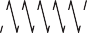HU Series - General Purpose, Spring Return, Lightweight

HU5006
Capacity:
20 - 150 Tons

Stroke:
1.97 - 10.00 Inches

Max. Operating Pressure:
10,000 psi

Min. - Max. Height:
6.85 - 15.73 Inches

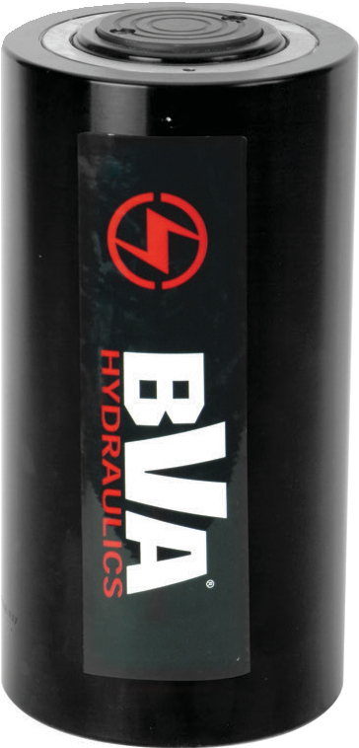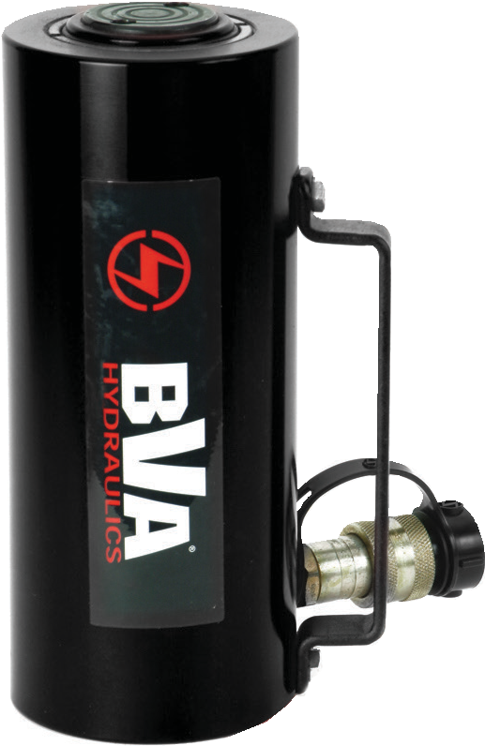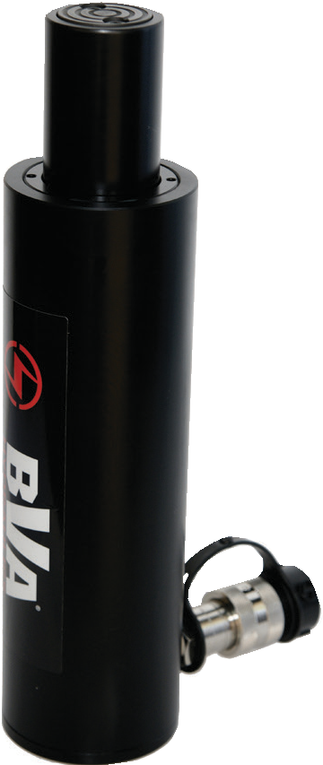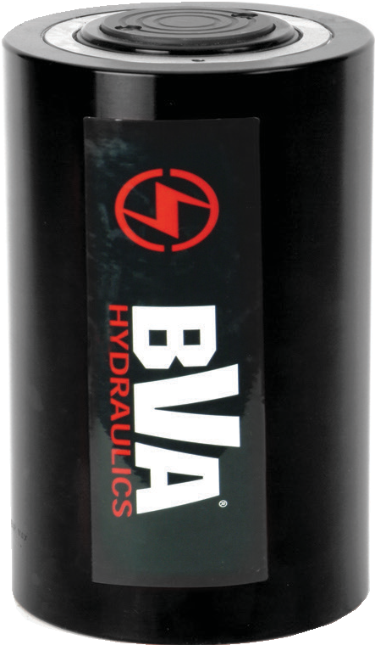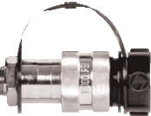
HU7506

HU2006

HU7504

  - 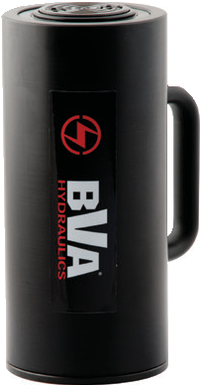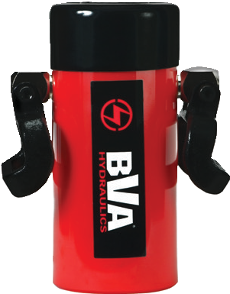Lightweight aluminum alloy construction
Aluminum vs. Steel Cylinders
Aluminum cylinders provide a great alternative to the traditional steel cylinder in many applications. Being up to 60% lighter in weight, Aluminum cylinders are highly portable and reduce user fatigue and strain. However, due to the finite properties of Aluminum vs. Steel, these cylinders should NOT be used in high cycle applications. The BVA Aluminum cylinders are designed for a maximum safety rating of 5,000 cycles. Under normal lifting applications this should provide a long service life.
HU5006T
H5506
Aluminum Cylinders
Steel Cylinders
•
•
•
•
60% lighter in weight than steel
Highly portable and reduces user fatigue Not used for high cycle applications Under normal conditions, the maximum rated safety cycle life is 5,000 cycles
Base of the cylinder contains a steel plate*
•
•

•
•
Much heavier than aluminum cylinders Low portability with heavier cylinders which creates user fatigue and strain
Will out-perform aluminum cylinders in higher cycle applications
- Can exceed aluminum cylinders maximum safety cycle life of 5,000 cycles.
*The base of the cylinders contain a steel plate with mounting holes that are designed to protect the cylinder
from damage and should NOT be used in fixturing applications and ONLY be used to attach larger base
mounting plates for lifting stability. They are NOT designed to withstand the full ratings of the cylinders.
  - Up to 60% lighter than comparable tonnage steel cylinders
  - Convenient carry handle on 50, 75 and 100 ton models
  - Hard anodized aluminum rod provides extra protection against corrosion and wear
  - Integral steel protective plate
  - Maximum working pressure: 10,000 psi / 700 bar

Safety Practices
Good industry practice recommends not exceeding 80% of maximum rated capacities of all our products.

High-Flow Couplers
High-Flow Coupler: CH38F is included on all models (except where specified).

1-888-332-6419
10 www.BVAhydraulics.com

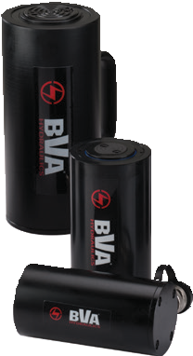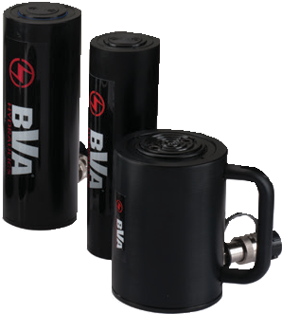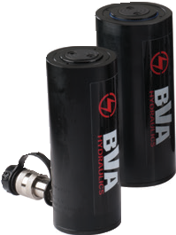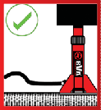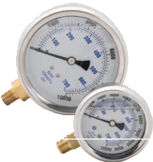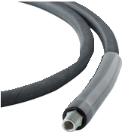
HU Series
Safety Instructions
Visit our DO’S and DON’TS section to review the best methods of operation.
Always be prepared.
pg
92
Related Product: Gauges
Reduce the risk of overloading your product by using a gauge. A variety of graduation’s and types to suit any need.
pg69
Related Product: Hoses
We offer a variety of hoses, fittings, lengths and materials.
pg
72
11

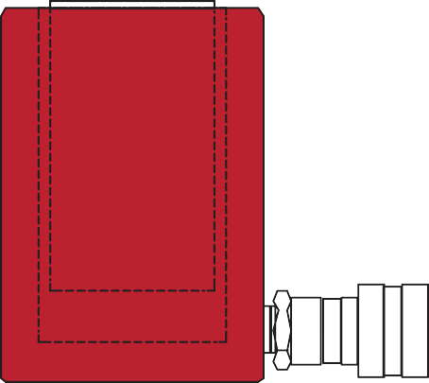E
F
B A
3/8”-18NPTF
G
C
D
Cylinders

Cylinder Capacity (tons) | Stroke (in) | Model Number | Cylinder Effective Area (in²) | Internal Pressure at Capacity (psi) | Oil Capacity (in³) | Collapsed Height  A  (in) | Extended  Height B  (in) | Cylinder Bore Dia.  C  (in) | Outside Dia. D  (in) | Rod Dia. E  (in) | Saddle Dia.  F  (in) | Base to Inlet Port G  (in) | Weight (lbs)
20 | 1.97 | HU2002T | 4.83 | 10,000 | 9.51 | 6.85 | 8.82 | 2.48 | 3.35 | 2.00 | 1.56 | 1.08 | 6.6
 | 3.94 | HU2004T | 4.83 | 10,000 | 19.02 | 8.82 | 12.76 | 2.48 | 3.35 | 2.00 | 1.56 | 1.08 | 8.1
 | 5.91 | HU2006T | 4.83 | 10,000 | 28.53 | 10.79 | 16.69 | 2.48 | 3.35 | 2.00 | 1.56 | 1.08 | 9.6
30 | 1.97 | HU3002T | 6.85 | 10,000 | 13.48 | 7.13 | 9.09 | 2.95 | 3.94 | 2.36 | 1.56 | 1.32 | 10.4
 | 3.94 | HU3004T | 6.85 | 10,000 | 26.96 | 9.09 | 13.03 | 2.95 | 3.94 | 2.36 | 1.56 | 1.32 | 12.0
 | 5.91 | HU3006T | 6.85 | 10,000 | 40.44 | 11.06 | 16.97 | 2.95 | 3.94 | 2.36 | 1.56 | 1.32 | 13.5
50 | 1.97 | HU5002T | 10.99 | 10,000 | 21.63 | 7.32 | 9.29 | 3.74 | 5.12 | 3.15 | 2.76 | 1.20 | 16.8
 | 3.94 | HU5004T | 10.99 | 10,000 | 43.25 | 9.29 | 13.23 | 3.74 | 5.12 | 3.15 | 2.76 | 1.20 | 22.6
 | 5.91 | HU5006T | 10.99 | 10,000 | 64.88 | 11.26 | 17.17 | 3.74 | 5.12 | 3.15 | 2.76 | 1.20 | 25.5
 | 7.87 | HU5008T | 10.99 | 10,000 | 86.51 | 13.23 | 21.10 | 3.74 | 5.12 | 3.15 | 2.76 | 1.20 | 27.1
 | 9.84 | HU5010T | 10.99 | 10,000 | 108.13 | 15.20 | 25.04 | 3.74 | 5.12 | 3.15 | 2.76 | 1.20 | 31.3
75 | 4.0 | HU7504 | 15.00 | 10,000 | 60.10 | 8.73 | 12.73 | 4.37 | 6.50 | 3.88 | 3.00 | 1.50 | 29.0
 | 6.0 | HU7506 | 15.00 | 10,000 | 90.20 | 10.73 | 16.73 | 4.37 | 6.50 | 3.88 | 3.00 | 1.50 | 35.0
100 | 2.0 | HU10002 | 20.70 | 9,662 | 41.40 | 6.50 | 8.50 | 5.10 | 8.00 | 4.30 | 3.50 | 1.50 | 36.0
 | 4.0 | HU10004 | 20.70 | 9,662 | 82.80 | 8.50 | 12.50 | 5.10 | 8.00 | 4.30 | 3.50 | 1.50 | 43.0
 | 6.0 | HU10006 | 20.70 | 9,662 | 124.40 | 10.50 | 16.50 | 5.10 | 8.00 | 4.30 | 3.50 | 1.50 | 51.0
 | 10.0 | HU10010 | 20.70 | 9,662 | 207.00 | 14.50 | 24.50 | 5.10 | 8.00 | 4.30 | 3.50 | 1.50 | 68.0
150 | 2.00 | HU15002 | 30.70 | 9662 | 61.40 | 7.73 | 9.73 | 6.26 | 10.00 | 5.00 | 4.50 | 1.50 | 55.0
 | 4.00 | HU15004 | 30.70 | 9662 | 122.70 | 9.73 | 13.73 | 6.26 | 10.00 | 5.00 | 4.50 | 1.50 | 65.0
 | 6.00 | HU15006 | 30.70 | 9662 | 184.10 | 11.73 | 17.73 | 6.26 | 10.00 | 5.00 | 4.50 | 1.50 | 81.0
 | 10.00 | HU15010 | 30.70 | 9662 | 306.80 | 15.73 | 25.73 | 6.26 | 10.00 | 5.00 | 4.50 | 1.50 | 110.0

Double Acting Cylinders

HD Series - General Purpose

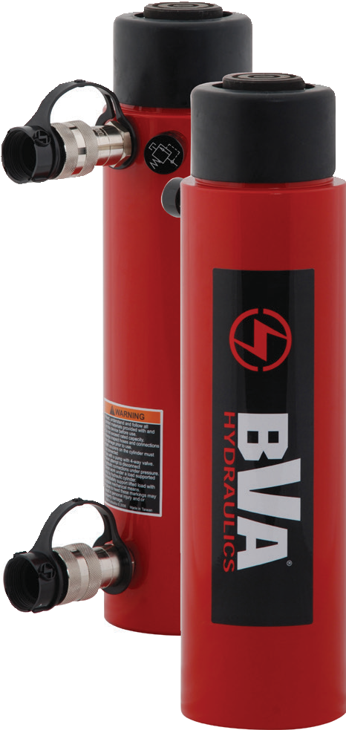
HD20013 HD3008

Capacity:
10 - 500 Tons

Stroke:
5.90 - 24.00 Inches

Pressure:
10,000 psi

Min. - Max. Height:
10.56 - 60.13 Inches

- Rod wiper seals out dirt and contamination
- High strength steel construction from gun drilled solid bar
- High flow 3/8″ NPTF female couplers
- One piece high grade alloy bearing for side load protec- tion and long life
- Ideal for pushing and pulling
- Maximum working pressure: 10,000 psi / 700 bar
- Threaded cylinders, removable saddle, thicker cylinder walls
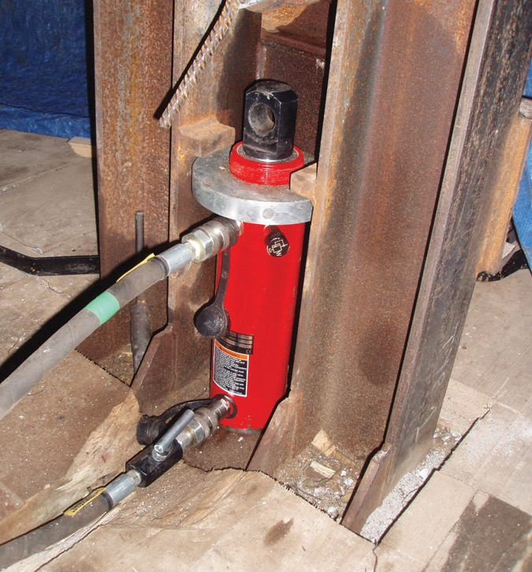
- Retract under hydraulic power for faster operation

Safety Practices
Good industry practice recommends not exceeding 80% of maximum rated capacities of all our products.

Clevis and Tangs
Install a clevis or a tang to your double acting

cylinder for a pulling application.
pg34

HD cylinders can be used in pushing and pulling applications. In this photo, we see a HD2506 HD cylinder set up for
a pull application using a Rod Clevis cylinder accessory

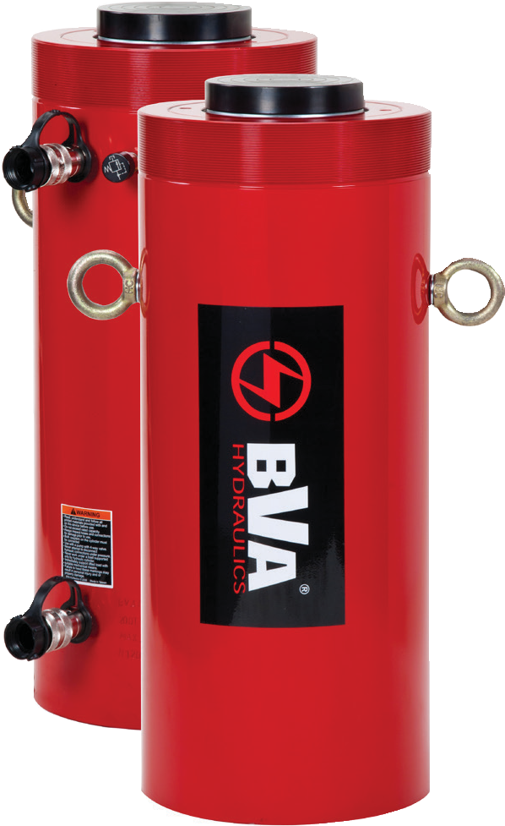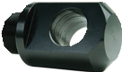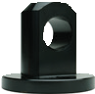
1-888-332-6419
12 www.BVAhydraulics.com

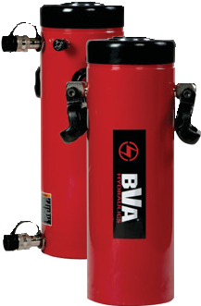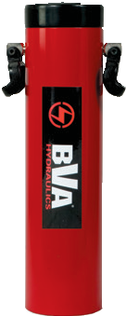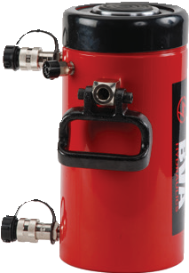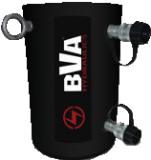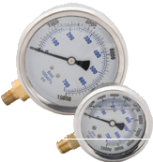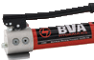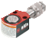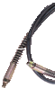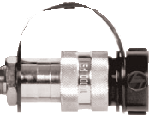
HD Series
Related Product: Gauges
Reduce the risk of overloading your product by using a gauge.
A variety of graduations and types to suit any need.
pg69
Cylinder Accessories
See the assortment
of accessories designed to work with our products.
pg
34
Combo Kits
Most cylinders are available in easy to order kits: Cylinder, Gauge, Couplers, Hose
and Pump.
pg64
Safety Instructions
Visit our DO’S and DON’TS section to review the best methods of operation.
Always be prepared.
pg
92
High-Flow Couplers
High-Flow Coupler: CH38F is included on all models (except where specified).
HUD Series – Aluminum Cylinders
Aluminum cylinders make a great lightweight alternative being up to 60% lighter than comparable
steel models.
pg
16
13
Cylinders

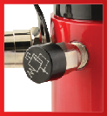

Relief Valve
All double acting cylinders are equipped with a
pressure relief valve located next to the retract port.
These pressure relief valves help prevent cylinder over pressurization on the return port side of the cylinder.

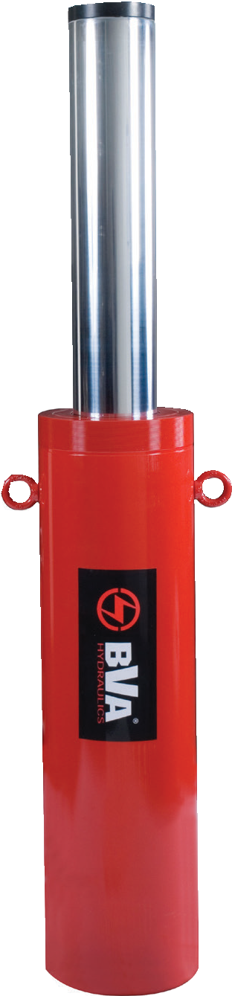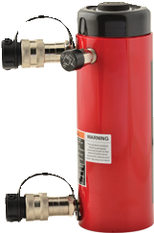With a variety of tonnage and sizes, you can apply our cylinders to a large variety of applications. Custom tonnages and stroke lengths are available upon request.
60.13”

10.56”

HD20024 HD2506

Quick Selection Guide

Cylinder Capacity (tons) | Stroke (in) | Model Number | Collapsed Height (in) | Oil Capacity |  | Weight (lbs)
 |  |  |  | Push (in3) | Pull (in3)
10 | 10.04 | HD1010 | 16.12 | 22.41 | 7.47 | 26.7
 | 11.97 | HD1012 | 18.03 | 26.71 | 8.90 | 30.0
25 | 5.90 | HD2506 | 10.56 | 30.35 | 15.81 | 24.8
30 | 8.15 | HD3008 | 15.31 | 52.93 | 26.02 | 43.0
 | 14.49 | HD3014 | 21.65 | 94.09 | 46.26 | 60.6
55 | 6.18 | HD5506‡ | 13.03 | 67.93 | 19.74 | 70.5
 | 13.19 | HD5513‡ | 20.04 | 144.94 | 42.11 | 104.0
 | 20.12 | HD5520‡ | 28.86 | 221.09 | 64.24 | 146.2
75 | 6.10 | HD7506‡ | 13.70 | 98.10 | 31.21 | 93.7
 | 13.11 | HD7513‡ | 20.71 | 210.93 | 67.06 | 136.8
100 | 6.57 | HD10006‡ | 14.06 | 135.23 | 62.98 | 138.6
 | 10.13 | HD10010‡ | 17.67 | 208.30 | 97.10 | 169.2
 | 13.11 | HD10013‡ | 20.63 | 269.66 | 125.58 | 193.6
 | 18.15 | HD10018‡ | 27.05 | 373.31 | 173.86 | 248.3
200 | 6.00 | HD20006 | 16.94 | 265.28 | 135.00 | 325.0
 | 13.00 | HD20013 | 23.94 | 574.78 | 293.00 | 440.0
 | 24.02 | HD20024 | 36.13 | 1061.00 | 528.00 | 616.0
300 | 6.00 | HD30006 | 19.13 | 425.56 | 228.00 | 441.0
500 | 6.00 | HD50006 | 22.75 | 678.92 | 378.00 | 953.0
See pages (pg.14-15) for detailed specifications.

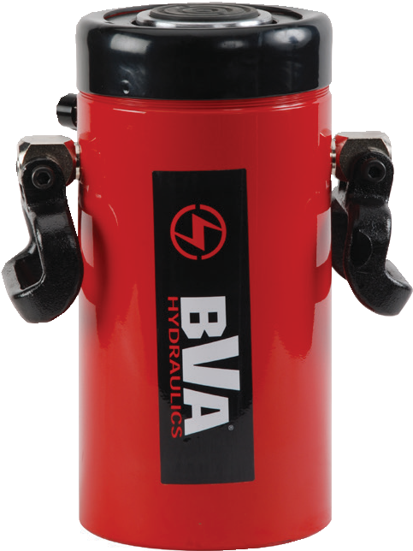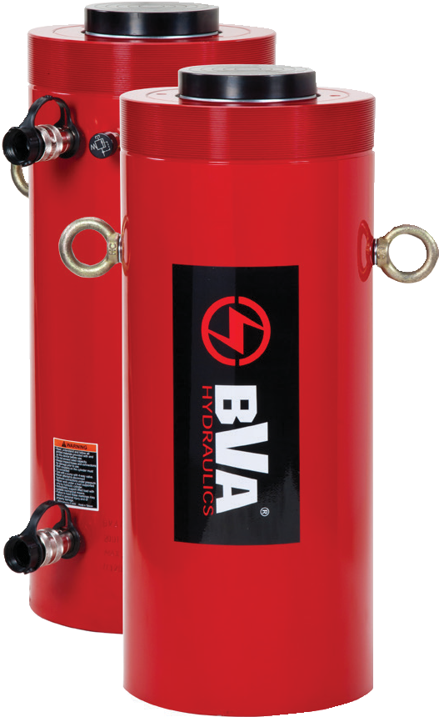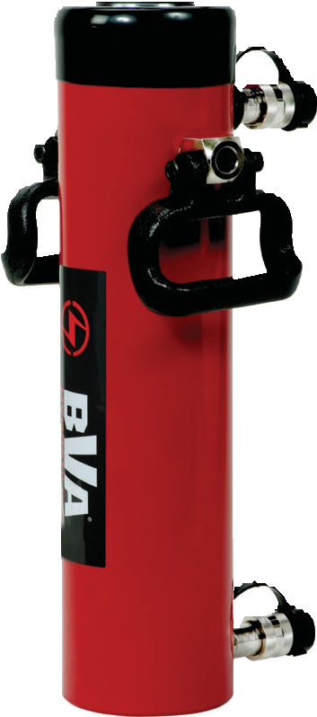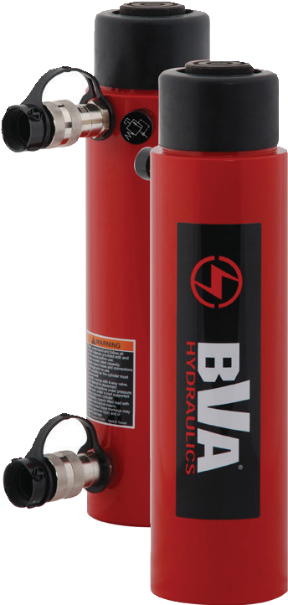Double Acting Cylinders

HD Series - General Purpose

Cylinder Accessories
See the assortment
of accessories designed
to work with our products. pg34

Related Product: Gauges
Reduce the risk of overloading your product by using a gauge.
A variety of graduations and types to suit any need.
pg69

Combo Kits
Most cylinders are available in easy to order kits: Cylinder,

HD20013

HD7513

Gauge, Couplers, Hose and Pump.
pg64

Safety Instructions
Visit our DO’S and DON’TS
section to review the best

methods of operation. Always be prepared.
pg92

HD10018

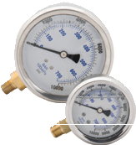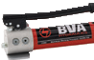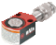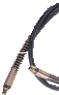
HD3008

Cylinder Capacity (tons) | Stroke (in) | Model Number | Maximum  Cylinder Capacity |  | Cylinder Effective Area |  | Oil Capacity |  | Weight (lbs) | Collapsed Height  A  (in) | Extended  Height B  (in) | Cylinder Bore Dia.  C  (in)
 |  |  | Push (ton) | Pull (ton) | Push (in2) | Pull (in2) | Push (in3) | Pull (in3)
10 | 10.04 | HD1010 | 11.40 | 3.80 | 2.24 | 0.74 | 22.41 | 7.47 | 26.7 | 16.12 | 26.19 | 1.69
 | 11.97 | HD1012 | 11.40 | 3.80 | 2.24 | 0.74 | 26.71 | 8.90 | 30.0 | 18.03 | 30.00 | 1.69
25 | 5.90 | HD2506 | 25.70 | 13.39 | 5.14 | 2.68 | 30.35 | 15.81 | 24.8 | 10.56 | 16.46 | 2.56
30 | 8.15 | HD3008 | 32.90 | 16.20 | 6.49 | 3.19 | 52.93 | 26.02 | 43.0 | 15.31 | 23.46 | 2.87
 | 14.49 | HD3014 | 32.90 | 16.20 | 6.49 | 3.19 | 94.09 | 46.26 | 60.6 | 21.65 | 36.14 | 2.87
55 | 6.18 | HD5506* | 55.70 | 16.20 | 10.99 | 3.19 | 67.93 | 19.74 | 70.5 | 13.03 | 19.21 | 3.74
 | 13.19 | HD5513* | 55.70 | 16.20 | 10.99 | 3.19 | 144.94 | 42.11 | 104.0 | 20.04 | 33.23 | 3.74
 | 20.12 | HD5520* | 55.70 | 16.20 | 10.99 | 3.19 | 221.09 | 64.24 | 146.2 | 28.86 | 49.98 | 3.74
75 | 6.10 | HD7506* | 81.70 | 25.90 | 16.09 | 5.12 | 98.10 | 31.21 | 93.7 | 13.70 | 19.80 | 4.53
 | 13.11 | HD7513* | 81.70 | 25.90 | 16.09 | 5.12 | 210.93 | 67.06 | 136.8 | 20.71 | 33.82 | 4.53
100 | 6.57 | HD10006* | 104.40 | 48.60 | 20.57 | 9.58 | 135.23 | 62.98 | 138.6 | 14.06 | 20.63 | 5.12
 | 10.13 | HD10010* | 104.40 | 48.60 | 20.57 | 9.58 | 208.30 | 97.10 | 169.2 | 17.67 | 27.80 | 5.12
 | 13.11 | HD10013* | 104.40 | 48.60 | 20.57 | 9.58 | 269.66 | 125.58 | 193.6 | 20.63 | 33.74 | 5.12
 | 18.15 | HD10018* | 104.40 | 48.60 | 20.57 | 9.58 | 373.31 | 173.86 | 248.3 | 27.05 | 45.20 | 5.12
200 | 6.57 | HD20006 | 221.00 | 112.50 | 44.21 | 22.50 | 265.28 | 135.00 | 325.0 | 16.94 | 22.94 | 7.50
 | 13.11 | HD20013 | 221.00 | 112.50 | 44.21 | 22.50 | 574.78 | 293.00 | 440.0 | 23.94 | 36.94 | 7.50
 | 24.00 | HD20024 | 221.00 | 112.50 | 44.21 | 22.50 | 1061.00 | 528.00 | 616.0 | 36.13 | 60.13 | 7.50
300 | 6.57 | HD30006 | 354.60 | 190.00 | 70.93 | 38.00 | 425.56 | 228.00 | 441.0 | 19.13 | 25.13 | 9.50
500 | 6.57 | HD50006 | 565.70 | 315.00 | 113.15 | 63.00 | 678.92 | 378.00 | 953.0 | 22.75 | 28.75 | 12.00
1-888-332-6419
14 www.BVAhydraulics.com

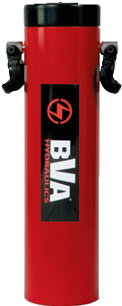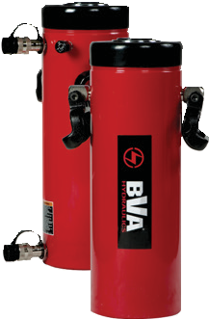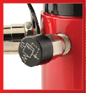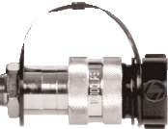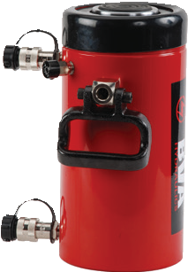
HD Series
Safety Practices
Good industry practice recommends not exceeding 80% of maximum rated capacities of all our products.
Relief Valve
All double acting cylinders are equipped with a
pressure relief valve located next to the retract port.
These pressure relief valves help prevent cylinder over pressurization on the return port side of the cylinder.
High-Flow Couplers
High-Flow Coupler: CH38F is included on all models (except where specified).
15

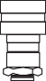Y
Cylinders

X
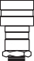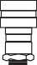 H G
3/8"-18NPTF

F E C D

J
K

M L Z
A B

Model Number | Outside Dia. D  (in) | Rod Dia. E  (in) | Saddle Dia.  F  (in) | Base to Adv. Port  G  (in) | Top to Return Port  H  (in) | Rod Internal Thread J  (in) | Rod Thread Length K  (in) | Collar Thread L  (in) | Collar Thread Length M  (in) | Base Mounting Hole
 |  |  |  |  |  |  |  |  |  | Bolt Circle X  (in) | Thread Y  (in) | Thread Depth Z  (in)
HD1010 | 2.87 | 1.38 | 1.38 | 1.42 | 2.09 | 1”-8 | 0.98 | 2¼”-14 | 1.02 | 1.30 | ”-18 | 0.60
HD1012 | 2.87 | 1.37 | 1.38 | 1.42 | 2.09 | 1”-8 | 0.98 | 2¼”-14 | 1.02 | 1.30 | ”-18 | 0.60
HD2506 | 3.62 | 1.77 | 1.50 | 0.98 | 1.93 | 1’-8 | 1.18 | 3”-12 | 0.98 | 2.30 | ½”-13 | 0.70
HD3008 | 3.98 | 2.13 | 1.97 | 1.65 | 2.91 | 1½”-16 | 0.98 | 3”-12 | 1.93 | 2.20 | ½”-13 | 0.70
HD3014 | 3.98 | 2.13 | 1.97 | 1.65 | 2.91 | 1½”-16 | 0.98 | 3”-12 | 1.93 | 2.20 | ½”-13 | 0.70
HD5506* | 5.00 | 3.14 | 2.76 | 1.14 | 2.87 | 1”-12 | 0.98 | 5”-12 | 1.73 | 3.70 | ½”-13 | 0.70
HD5513* | 5.00 | 3.14 | 2.76 | 1.14 | 2.87 | 1”-12 | 0.98 | 5”-12 | 1.73 | 3.70 | ½”-13 | 0.70
HD5520* | 5.00 | 3.14 | 2.76 | 1.14 | 2.87 | 1”-12 | 0.98 | 5”-12 | 1.73 | 3.70 | ½”-13 | 0.70
HD7506* | 5.75 | 3.75 | 2.76 | 1.18 | 2.80 | 1”-12 | 1.50 | 5¾”-12 | 1.50 | 4.00 | ¾”-10 | 0.90
HD7513* | 5.75 | 3.75 | 2.76 | 1.18 | 2.80 | 1”-12 | 1.50 | 5¾”-12 | 1.50 | 4.00 | ¾”-10 | 0.90
HD10006* | 6.97 | 3.75 | 2.95 | 1.22 | 2.95 | 1¾”-12 | 1.38 | 6⅞”-12 | 1.97 | 5.47 | ¾”-10 | 0.98
HD10010* | 6.97 | 3.74 | 2.95 | 1.22 | 2.95 | 1¾”-12 | 1.50 | 6⅞”-12 | 2.01 | 5.50 | ¾”-10 | 0.98
HD10013* | 6.97 | 3.75 | 2.95 | 1.22 | 2.95 | 1¾”-12 | 1.38 | 6⅞”-12 | 1.97 | 5.47 | ¾”-10 | 0.98
HD10018* | 6.97 | 3.75 | 2.95 | 1.50 | 2.95 | 1¾”-12 | 1.38 | 6⅞”-12 | 1.97 | 5.47 | ¾”-10 | 0.98
HD20006 | 9.75 | 5.25 | 5.25 | 2.25 | 3.81 | - | - | - | - | 5.00 | 1-8 | 1.00
HD20013 | 9.75 | 5.25 | 5.25 | 2.25 | 3.81 | 2½”-12 | 2.50 | 9¾”-12 | 2.13 | 5.00 | 1-8 | 1.00
HD20024 | 9.75 | 5.25 | 5.25 | 3.38 | 4.00 | 2½”-12 | 2.50 | 9¾”-12 | 2.13 | 5.00 | 1-8 | 1.00
HD30006 | 12.25 | 6.50 | 6.50 | 3.50 | 4.50 | 2½”-12 | 3.25 | 12¼”-12 | 2.31 | 6.25 | 1¼-7 | 1.75
HD50006 | 15.63 | 8.00 | 8.00 | 4.75 | 6.00 | 3¼”-12 | 4.25 | 15”-8 | 3.13 | 8.00 | 1¾-5 | 2.12
* 55-100 ton cylinders are equipped with carrying handles.

Aluminum Double Acting Cylinders

HUD Series - General Purpose, Lightweight

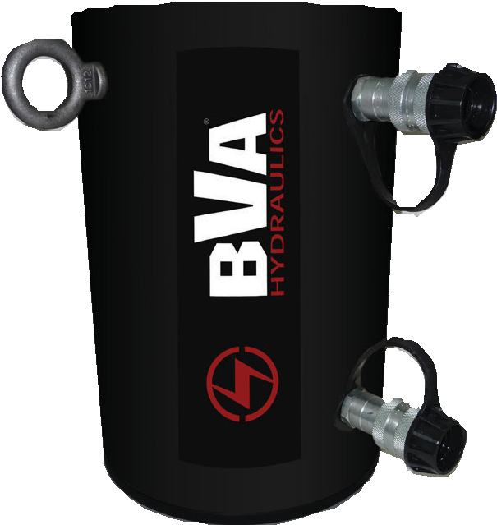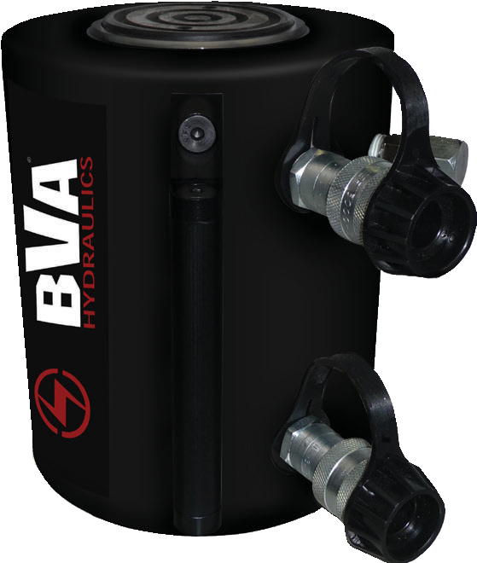 Capacity:
HUD7513
HUD15006
30 - 150 Tons

Stroke:
2 - 13 Inches

Max. Operating Pressure:
10,000 psi

Min. - Max. Height:
8.30 - 33.80 Inches
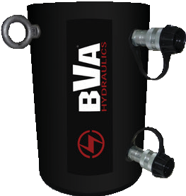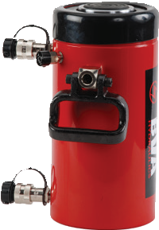
Aluminum vs. Steel Cylinders
Aluminum cylinders provide a great alternative to the traditional steel cylinder in multiple applications. Being up to 60% lighter in weight, Aluminum cylinders are highly portable and reduce user fatigue and strain. However, due to the finite properties of Aluminum vs. Steel, these cylinders should NOT be used in high cycle applications. The BVA Aluminum cylinders are designed for a maximum safety rating of 5,000 cycles. Under normal lifting applications this should provide a long service life.
HUD7513
HD7513
Aluminum Cylinders Steel Cylinders
- 60% lighter in weight than steel • Much heavier than aluminum cylinders
- Highly portable and reduces user fatigue • Low portability with heavier cylinders which
- Not used for high cycle applications creates user fatigue and strain
- Under normal conditions, the maximum • Will out-perform aluminum cylinders in rated safety cycle life is 5,000 cycles higher cycle applications
- Base of the cylinder contains a steel plate* • Can exceed aluminums maximum safety
cycle life of 5,000 cycles.

Cylinder Capacity (tons) | Stroke (in) | Model Number | Maximum Cylinder  Capacity (ton) |  | Cylinder Effective Area (in2) |  | Oil Capacity (in3) |  | Weight (lbs)
 |  |  | Push | Pull | Push | Pull | Push | Pull
30 | 6.00 | HUD3006 | 30.00 | 12.57 | 6.50 | 2.50 | 39.00 | 15.00 | 18.0
 | 8.00 | HUD3008 | 30.00 | 12.57 | 6.50 | 2.50 | 51.90 | 18.00 | 26.0
 | 13.00 | HUD3013 | 30.00 | 12.57 | 6.00 | 2.50 | 90.90 | 32.41 | 35.0
50 | 6.00 | HUD5006 | 50.00 | 13.50 | 10.30 | 2.70 | 61.80 | 16.00 | 28.0
 | 8.00 | HUD5008 | 50.00 | 13.50 | 10.30 | 2.70 | 88.30 | 22.00 | 36.0
 | 13.00 | HUD5013 | 50.00 | 13.58 | 10.30 | 2.70 | 143.50 | 35.80 | 48.0
75 | 6.00 | HUD7506 | 75.00 | 27.00 | 15.00 | 5.41 | 90.20 | 19.40 | 41.0
 | 8.00 | HUD7508 | 75.00 | 27.00 | 15.00 | 5.41 | 121.00 | 43.30 | 50.0
 | 13.00 | HUD7513 | 75.00 | 27.00 | 15.00 | 5.41 | 195.40 | 70.40 | 62.0
100 | 2.00 | HUD10002 | 100.00 | 23.75 | 20.60 | 4.75 | 41.20 | 9.40 | 42.0
 | 6.00 | HUD10006 | 100.00 | 23.75 | 20.60 | 4.75 | 123.70 | 28.30 | 57.0
 | 13.00 | HUD10013 | 100.00 | 23.75 | 20.60 | 4.75 | 268.10 | 61.40 | 90.0
150 | 6.00 | HUD15006 | 100.00 | 34.60 | 30.70 | 6.90 | 184.10 | 41.40 | 87.0
 | 13.00 | HUD15013 | 100.00 | 34.60 | 30.70 | 6.90 | 378.80 | 90.10 | 122.0

1-888-332-6419
16 www.BVAhydraulics.com
- The base of the cylinders contain a Steel plate with mounting holes and is designed to protect the cylinder from damage and should NOT be used in fixturing applications and ONLY be used to attach a larger base mounting plate for lifting stability. They are NOT designed to withstand the full rating of the cylinder.

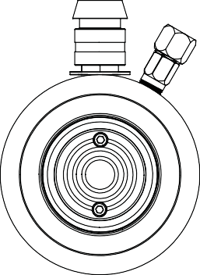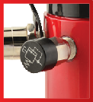 HUD Series
F
Relief Valve
All double acting cylinders are equipped with a
pressure relief valve located next to the retract port.
These pressure relief valves help prevent cylinder over pressurization on the return port side of the cylinder.
Cylinders

Safety Instructions
Visit our DO’S and DON’TS
section to review the best

methods of operation.
D Always be prepared.
H
G
A
pg92

Related Product: Gauges
Reduce the risk of overloading your product by using a gauge.
A variety of graduations and types to suit any need.
pg69

E C
Safety Practices
Good industry practice recommends not exceeding 80% of maximum rated capacities of all our products.

  - Lightweight aluminum alloy construction
  - Up to 60% lighter than comparable tonnage steel cylinders
  - Convenient carry handle on 50, 75, 100 and 150 ton models
  - Hard anodized aluminum rod provides extra protection
against corrosion and wear
  - Steel protective plate on cylinder base
  - Maximum working pressure: 10,000 psi / 700 bar
High-Flow Couplers
High-Flow Coupler: CH38F is included on all models (except where specified).

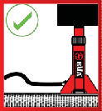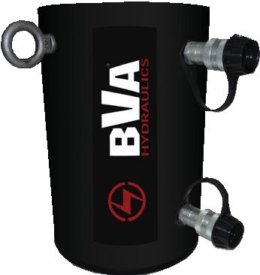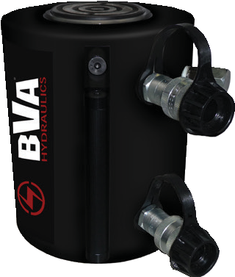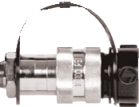

Model Number | Collapsed Height A (in) | Extended  Height B (in) | Cylinder Bore Dia. C (in) | Outside Diameter D (in) | Rod Dia. E (in) | Saddle Diameter F (in) | Base To Advance Port G (in) | Top To Retract Port H (in)
HUD3006 | 11.80 | 17.80 | 2.88 | 4.50 | 2.88 | 2.00 | 1.50 | 2.00
HUD3008 | 13.80 | 21.80 | 2.88 | 4.50 | 2.88 | 2.00 | 1.50 | 2.00
HUD3013 | 19.30 | 32.30 | 2.88 | 4.50 | 2.88 | 2.00 | 1.50 | 2.00
HUD5006 | 11.80 | 17.80 | 3.63 | 5.50 | 3.13 | 2.50 | 1.50 | 2.50
HUD5008 | 13.80 | 21.80 | 3.63 | 5.50 | 3.13 | 2.50 | 1.50 | 2.50
HUD5013 | 19.30 | 32.30 | 3.63 | 5.50 | 3.13 | 2.50 | 1.50 | 2.50
HUD7506 | 12.30 | 18.30 | 4.38 | 6.50 | 3.50 | 3.00 | 1.50 | 2.50
HUD7508 | 14.30 | 20.30 | 4.38 | 6.50 | 3.50 | 3.00 | 1.50 | 2.50
HUD7513 | 19.30 | 32.30 | 4.38 | 6.50 | 3.50 | 3.00 | 1.50 | 2.50
HUD10002 | 8.30 | 10.30 | 5.13 | 8.00 | 4.50 | 3.50 | 1.50 | 2.50
HUD10006 | 12.30 | 18.30 | 5.13 | 8.00 | 4.50 | 3.50 | 1.50 | 2.50
HUD10013 | 19.30 | 32.30 | 5.13 | 8.00 | 4.50 | 3.50 | 1.50 | 2.50
HUD15006 | 14.30 | 20.30 | 6.26 | 10.00 | 5.50 | 4.50 | 2.00 | 3.00
HUD15013 | 20.80 | 33.80 | 6.26 | 10.00 | 5.50 | 4.50 | 2.00 | 3.00
NOTE: The base of the aluminum cylinders contain a Steel plate with mounting holes and is designed to protect the
cylinder from damage and should NOT be used in fixturing applications and ONLY be used to attach larger
base mounting plates for lifting stability. The threads are NOT designed to withstand the full rating of the cylinder. 17

High Tonnage Single Acting Cylinders

HG series - Heavy Lifting, Load Return

Capacity:
100-1,500 Tons
Stroke:
1.97 - 11.81 Inches

Max. Operating Pressure:
10,000 psi

Min. - Max. Height:
7.17 - 43.86 Inches

HG10004

HG15006

HG20002

Related Product: Hoses
We offer a variety of
hoses, fittings, lengths
- Cylinders are burnish rolled creating a smoother surface than honing.
- Rod wiper seals out dirt and contamination
- Base mounting holes on all models

and materials.
pg 72
- High strength steel construction from gun drilled solid bar pro- viding extra combine strength for high tonnage applications
- High flow 3/8” NPTF coupler

Flow Control Valves
Control the speed of your
cylinder by adding a flow
  - Polyurethane cup seal provides optimum performance
  - Industrial hard chrome plated rod helps prevent rust and corrosion

control valve.
pg 66
- Maximum working pressure: 10,000 psi / 700 bar
- Custom sizes are available upon request
- Load Return

Gas/Diesel Engine Pumps Electric Motor Pumps

These HG cylinders pair up well with a Gas or Diesel Engine pumps.
We offer a variety of different flow rates, motor sizes and reservoir sizes.
Contact your local BVA dealer for more details.

These HG cylinders pair up well with Electric Motor pumps.
We offer a variety of different flow rates and motor sizes.
Contact your local BVA dealer for more details.

PG70M3N05
  - Will provide 10,000 psi. hydraulic force at remote locations
  - Industrial grade 5.5 or 10.2 hp Honda gas engine or 7.3 hp HATZ diesel engine.
  - Ideal for applications where electricity
isn’t easily accessible.
  - Two speed pump designed for rapid cylinder advance
  - Gas pump features a sturdy protective roll cage for use in the toughest environments
  - Electric start standard on PD80 and optional on PG90
    - Meets OSHA regulations for
sound (80dBA)
    - Two speed pump designed for rapid cylinder advance
    - Internal filter screens contamination
to prevent pump damage
    - All units are wired as 120 VAC 60 Hz; Optional wiring includes 50 Hz motors and 240VAC 60Hz
    - 100% Duty Cycle TEFC motors
    - All hand pendants are wired at 24VAC for safety
    - Full load starting capability

PE50W3N03A

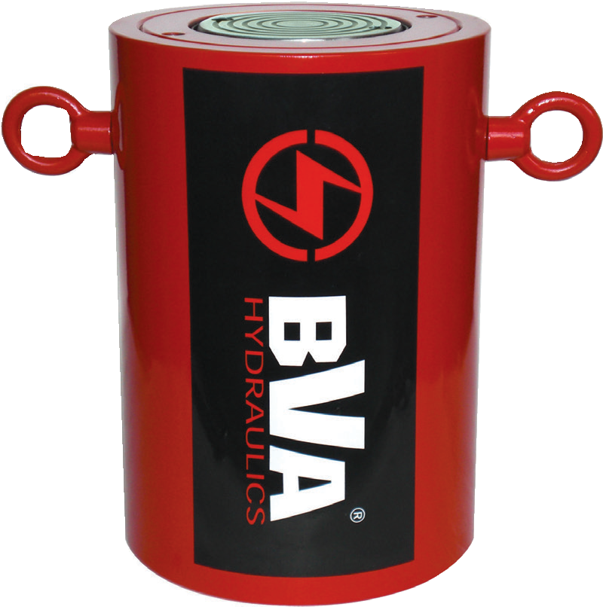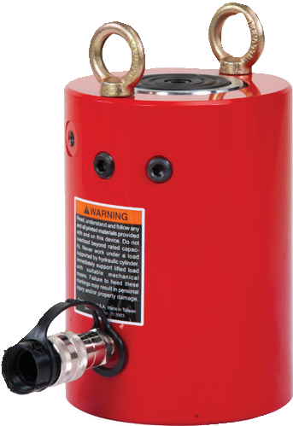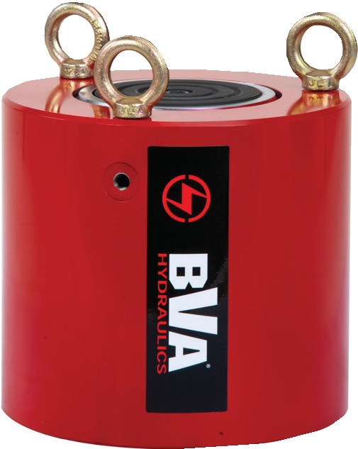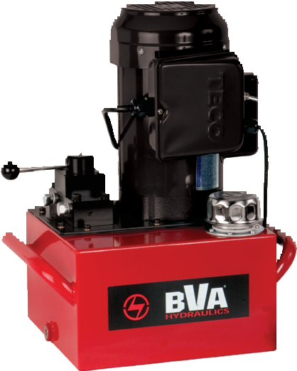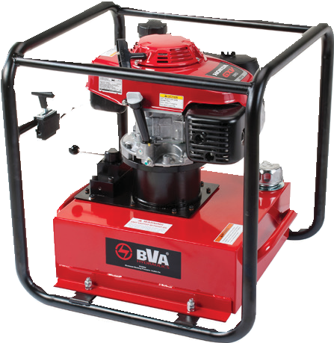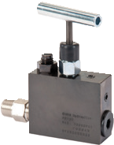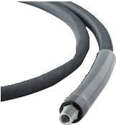
1-888-332-6419
18 www.BVAhydraulics.com

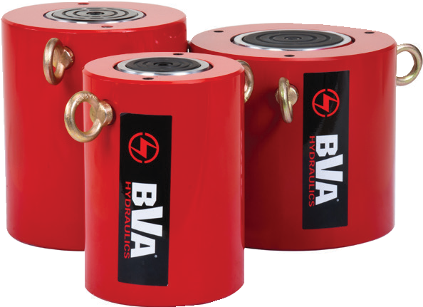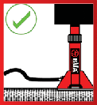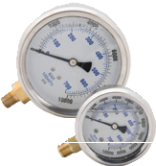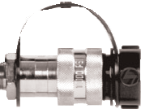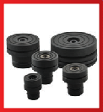
HG Series
Safety Practices
Good industry practice recommends not exceeding 80% of maximum rated capacities of all our products.
Related Product: Gauges
Reduce the risk of overloading your product by using a gauge.
A variety of graduations and types to suit any need.
pg 69
Safety Instructions
Visit our DO’S and DON’TS section to review the best methods of operation.
Always be prepared.
pg
92
High-Flow Couplers
High-Flow Coupler: CH38F is included on all models (except where specified).
Optional Tilt-Saddles
Saddles tilt to a 5% maximum to adjust to the load. View our cylinder accessories page to figure out what saddle best
fits these cylinders. pg 35
19

Quick Reference Guide
Cylinders
Cylinder Capacity (tons) | Stroke (in) | Model Number | Collapsed Height (in) | Oil Capacity (in3) | Weight (lbs)
100 | 1.97 | HG10002 | 7.17 | 40.50 | 61.0
 | 3.94 | HG10004 | 9.13 | 81.00 | 74.0
 | 5.91 | HG10006 | 11.10 | 121.50 | 87.0
 | 7.87 | HG10008 | 13.07 | 161.99 | 100.0
 | 9.84 | HG10010 | 15.04 | 202.49 | 114.0
 | 11.81 | HG10012 | 17.01 | 242.99 | 127.0
150 | 1.97 | HG15002 | 7.72 | 59.89 | 102.0
 | 3.94 | HG15004 | 9.69 | 119.78 | 122.0
 | 5.91 | HG15006 | 11.65 | 181.75 | 142.0
 | 7.87 | HG15008 | 13.62 | 239.57 | 162.0
 | 9.84 | HG15010 | 15.59 | 299.46 | 181.0
 | 11.81 | HG15012 | 17.56 | 359.35 | 202.0
200 | 1.97 | HG20002 | 8.50 | 80.68 | 121.0
 | 5.91 | HG20006 | 12.44 | 243.40 | 201.0
 | 7.87 | HG20008 | 14.41 | 322.73 | 242.0
 | 11.81 | HG20012 | 18.35 | 486.79 | 322.0
300 | 1.97 | HG30002 | 12.28 | 139.19 | 406.0
 | 5.91 | HG30006 | 16.22 | 417.56 | 511.0
 | 11.81 | HG30012 | 22.13 | 835.11 | 668.0
400 | 1.97 | HG40002 | 14.74 | 170.84 | 595.0
 | 5.91 | HG40006 | 18.68 | 512.51 | 728.0
 | 12.01 | HG40012 | 24.61 | 1042.10 | 928.0
500 | 1.97 | HG50002 | 16.50 | 222.92 | 884.0
 | 5.91 | HG50006 | 20.43 | 668.77 | 1058.0
 | 11.81 | HG50012 | 26.34 | 1338.00 | 1321.0
600 | 1.97 | HG60002 | 16.89 | 260.97 | 1045.0
 | 5.91 | HG60006 | 20.83 | 782.90 | 1246.0
 | 9.84 | HG60010 | 19.88 | 1408.93 | 948.0
 | 11.81 | HG60012 | 26.73 | 1566.00 | 1545.0
800 | 1.97 | HG80002 | 18.66 | 358.91 | 1634.0
 | 5.91 | HG80006 | 22.60 | 1077.00 | 1914.0
 | 11.81 | HG80012 | 28.50 | 2153.00 | 2332.0
1000 | 1.97 | HG100002 | 22.20 | 447.23 | 2341.0
 | 5.91 | HG100006 | 26.14 | 1342.00 | 2674.0
 | 11.81 | HG100012 | 32.05 | 2683.00 | 3172.0
1100-1500 | For these higher tonnages, contact your local BVA dealer for pricing and details
See next pages (pg.20-21) to view more detail stats on High Tonnage Single Acting Cylinders.

High Tonnage Single Acting Cylinders

HG Series - Heavy Lifting, Load Return

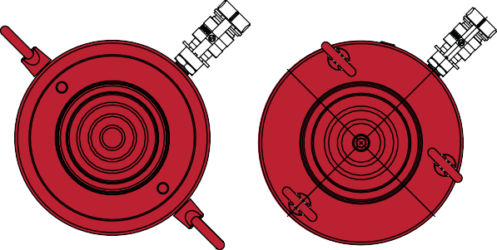
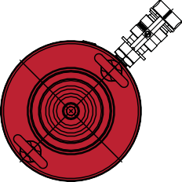
E F

B

3/8"-18NPTF

A

C HG100

HG150 HG200

G
Cylinder Capacity (tons) | Stroke (in) | Model Number | Maximum Cylinder Capacity (ton) | Cylinder Effective Area (in2) | Oil Capacity (in3) | Weight (lbs)
100 | 1.97 | HG10002 | 102.86 | 20.57 | 40.50 | 61.0
 | 3.94 | HG10004 | 102.86 | 20.57 | 81.00 | 74.0
 | 5.91 | HG10006 | 102.86 | 20.57 | 121.50 | 87.0
 | 7.87 | HG10008 | 102.86 | 20.57 | 161.99 | 100.0
 | 9.84 | HG10010 | 102.86 | 20.57 | 202.49 | 114.0
 | 11.81 | HG10012 | 102.86 | 20.57 | 242.99 | 127.0
150 | 1.97 | HG15002 | 152.11 | 30.43 | 59.89 | 102.0
 | 3.94 | HG15004 | 152.11 | 30.43 | 119.78 | 122.0
 | 5.91 | HG15006 | 153.90 | 30.78 | 181.75 | 142.0
 | 7.87 | HG15008 | 152.11 | 30.43 | 239.57 | 162.0
 | 9.84 | HG15010 | 152.11 | 30.43 | 299.46 | 181.0
 | 11.81 | HG15012 | 152.11 | 30.43 | 359.35 | 202.0
200 | 1.97 | HG20002 | 204.92 | 40.99 | 80.68 | 121.0
 | 5.91 | HG20006 | 206.10 | 41.22 | 243.40 | 201.0
 | 7.87 | HG20008 | 204.92 | 40.99 | 322.73 | 242.0
 | 11.81 | HG20012 | 206.10 | 41.22 | 486.79 | 322.0
300 | 1.97 | HG30002 | 353.60 | 70.71 | 139.19 | 406.0
 | 5.91 | HG30006 | 353.60 | 70.71 | 417.56 | 511.0
 | 11.81 | HG30012 | 353.60 | 70.71 | 835.11 | 668.0
400 | 1.97 | HG40002 | 433.90 | 86.78 | 170.84 | 595.0
 | 5.91 | HG40006 | 433.90 | 86.78 | 512.51 | 728.0
 | 12.01 | HG40012 | 433.90 | 86.78 | 1042.10 | 928.0
500 | 1.97 | HG50002 | 566.30 | 113.25 | 222.93 | 884.0
 | 5.91 | HG50006 | 566.30 | 113.25 | 668.78 | 1058.0
 | 11.81 | HG50012 | 566.30 | 113.25 | 1337.56 | 1321.0
600 | 1.97 | HG60002 | 662.90 | 132.57 | 260.97 | 1045.0
 | 5.91 | HG60006 | 662.90 | 132.57 | 782.90 | 1246.0
 | 9.84 | HG60010 | 670.90 | 134.18 | 1408.93 | 948.0
 | 11.81 | HG60012 | 662.90 | 132.57 | 1566.00 | 1545.0
800 | 1.97 | HG80002 | 911.60 | 182.32 | 358.91 | 1634.0
 | 5.91 | HG80006 | 911.60 | 182.32 | 1077.00 | 1914.0
 | 11.81 | HG80012 | 911.60 | 182.32 | 2153.00 | 2332.0
1000 | 1.97 | HG100002 | 1136.00 | 227.19 | 447.23 | 2341.0
 | 5.91 | HG100006 | 1136.00 | 227.19 | 1342.00 | 2674.0
 | 11.81 | HG100012 | 1136.00 | 227.19 | 2683.00 | 3172.0

Z
Y
X
D

Safety Instructions
Visit our DO’S and DON’TS
section to review the best

methods of operation. Always be prepared.
pg 92

High-Flow Couplers
High-Flow Coupler: CH38F is included on all models (except where specified).

Related Product: Gauges
Reduce the risk of overloading your product by using a gauge.
A variety of graduations and types to suit any need.
pg69

Optional Tilt-Saddles
Saddles tilt to a 5% maximum to adjust to the load. View our cylinder accessories page to figure out what saddle best

fits these cylinders.
pg 35

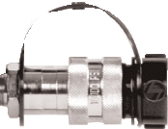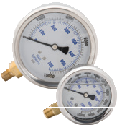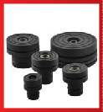

1-888-332-6419
20 www.BVAhydraulics.com

HG Series
Safety Practices
Good industry practice recommends not exceeding 80% of maximum rated capacities of all our products.
21

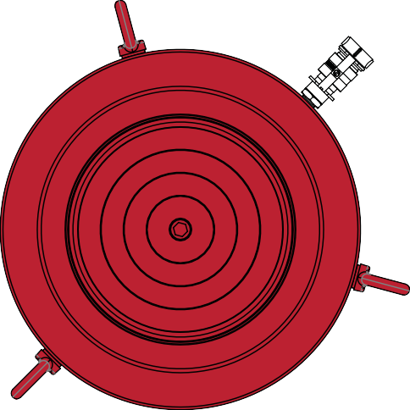
HG300 - HG1000
Cylinders

Model Number | Collapsed Height  A  (in) | Extended  Height B  (in) | Cylinder Bore Dia.  C  (in) | Outside Dia.  D  (in) | Rod Dia. E  (in) | Saddle Dia.  F  (in) | Base To Adv. Port G (in) | Base Mounting Holes
 |  |  |  |  |  |  |  | Bolt Circle (in) X | Thread Size (mm) | Thread Depth (in) Z
HG10002 | 7.17 | 9.14 | 5.12 | 3.50 | 3.74 | 2.95 | 2.13 | 3.74 | M12 | 0.87
HG10004 | 9.13 | 13.07 | 5.12 | 3.50 | 3.74 | 2.95 | 2.13 | 3.74 | M12 | 0.87
HG10006 | 11.10 | 17.01 | 5.12 | 3.50 | 3.74 | 2.95 | 2.13 | 3.74 | M12 | 0.87
HG10008 | 13.07 | 20.94 | 5.12 | 3.50 | 3.74 | 2.95 | 2.13 | 3.74 | M12 | 0.87
HG10010 | 15.04 | 24.88 | 5.12 | 3.50 | 3.74 | 2.95 | 2.13 | 3.74 | M12 | 0.87
HG10012 | 17.01 | 28.82 | 5.12 | 3.50 | 3.74 | 2.95 | 2.13 | 3.74 | M12 | 0.87
HG15002 | 7.72 | 9.69 | 6.22 | 8.07 | 4.33 | 3.70 | 2.40 | 5.12 | M12 | 0.87
HG15004 | 9.69 | 13.62 | 6.22 | 8.07 | 4.33 | 3.70 | 2.40 | 5.12 | M12 | 0.87
HG15006 | 11.65 | 17.56 | 6.22 | 8.07 | 4.33 | 3.70 | 2.40 | 5.12 | M12 | 0.87
HG15008 | 13.62 | 21.50 | 6.22 | 8.07 | 4.33 | 3.70 | 2.40 | 5.12 | M12 | 0.87
HG15010 | 15.59 | 25.43 | 6.22 | 8.07 | 4.33 | 3.70 | 2.40 | 5.12 | M12 | 0.87
HG15012 | 17.56 | 29.37 | 6.22 | 8.07 | 4.33 | 3.70 | 2.40 | 5.12 | M12 | 0.87
HG20002 | 8.50 | 10.47 | 7.22 | 9.25 | 5.31 | 4.45 | 2.62 | 6.50 | M12 | 0.80
HG20006 | 12.44 | 18.35 | 7.24 | 9.25 | 5.31 | 4.45 | 2.62 | 6.50 | M12 | 0.80
HG20008 | 14.41 | 22.28 | 7.22 | 9.25 | 5.31 | 4.45 | 2.62 | 6.50 | M12 | 0.80
HG20012 | 18.35 | 30.16 | 7.24 | 9.25 | 5.31 | 4.45 | 2.62 | 6.50 | M12 | 0.80
HG30002 | 12.28 | 14.25 | 9.49 | 12.20 | 7.76 | 6.97 | 3.98 | 7.09 | M16 | 1.42
HG30006 | 16.22 | 22.13 | 9.49 | 12.20 | 7.76 | 6.97 | 3.98 | 7.09 | M16 | 1.42
HG30012 | 22.13 | 33.94 | 9.49 | 12.20 | 7.76 | 6.97 | 3.98 | 7.09 | M16 | 1.42
HG40002 | 14.74 | 16.71 | 10.51 | 13.78 | 8.50 | 7.72 | 4.49 | 8.07 | M16 | 1.42
HG40006 | 18.68 | 24.59 | 10.51 | 13.78 | 8.50 | 7.72 | 4.49 | 8.07 | M16 | 1.42
HG40012 | 24.61 | 36.61 | 10.51 | 13.78 | 8.50 | 7.72 | 4.49 | 8.07 | M16 | 1.42
HG50002 | 16.50 | 18.46 | 12.01 | 15.75 | 9.76 | 8.98 | 4.49 | 9.84 | M24 | 1.50
HG50006 | 20.43 | 26.34 | 12.01 | 15.75 | 9.76 | 8.98 | 4.49 | 9.84 | M24 | 1.50
HG50012 | 26.34 | 38.15 | 12.01 | 15.75 | 9.76 | 8.98 | 4.49 | 9.84 | M24 | 1.50
HG60002 | 16.89 | 18.86 | 12.99 | 16.93 | 10.51 | 9.72 | 4.49 | 10.83 | M24 | 1.50
HG60006 | 20.83 | 26.73 | 12.99 | 16.93 | 10.51 | 9.72 | 4.49 | 10.83 | M24 | 1.50
HG60010 | 18.00 | 28.50 | 13.07 | 17.05 | 9.00 | 7.87 | 4.49 | 10.83 | M24 | 1.50
HG60012 | 26.73 | 38.54 | 12.99 | 16.93 | 10.51 | 9.72 | 4.49 | 10.83 | M24 | 1.50
HG80002 | 18.66 | 20.63 | 15.24 | 19.88 | 12.48 | 11.69 | 5.87 | 12.99 | M24 | 1.50
HG80006 | 22.60 | 28.50 | 15.24 | 19.88 | 12.48 | 11.69 | 5.87 | 12.99 | M24 | 1.50
HG80012 | 28.50 | 40.31 | 15.24 | 19.88 | 12.48 | 11.69 | 5.87 | 12.99 | M24 | 1.50
HG100002 | 22.20 | 24.17 | 17.01 | 22.05 | 13.50 | 12.72 | 6.85 | 14.76 | M24 | 1.50
HG100006 | 26.14 | 32.05 | 17.01 | 22.05 | 13.50 | 12.72 | 6.85 | 14.76 | M24 | 1.50
HG100012 | 32.05 | 43.86 | 17.01 | 22.05 | 13.50 | 12.72 | 6.85 | 14.76 | M24 | 1.50

High Tonnage Double Acting Cylinders

HDG Series - Heavy Lifting

HDG10002

HDG30006

HDG10008

HDG20008

HDG15006
Capacity:
100-1,500 Tons
Stroke:
1.97 - 11.81 Inches

Max. Operating Pressure:
10,000 psi

Min. - Max. Height:
7.17 - 43.80 Inches

Safety Instructions
Visit our DO’S and DON’TS
section to review the best

methods of operation. Always be prepared.
pg 92
- Cylinders are burnish rolled creating a smoother
finish than honing
- Industrial hard chrome plated rod prevents

Related Product: Hoses
We offer a variety of
hoses, fittings, lengths
scratching and corrosion
- Base mounting holes standard on all models
- Rod wiper seals out dirt and contamination

and materials.
pg 72
- High strength steel construction from gun drilled solid bar
- High flow 3/8″ NPTF couplers

Flow Control Valves
Control the speed of your
cylinder by adding a flow
  - Maximum working pressure: 10,000 psi / 700 bar
  - Custom sizes are available upon request

control valve.
pg 66

Gas/Diesel Engine Pumps Electric Motor Pumps

These HDG cylinders pair up well with a Gas or Diesel Engine pumps. We offer a variety of different flow rates, motor sizes and reservoir sizes on our gas/diesel engine pumps. Contact your local BVA dealer for more details.

These HDG cylinders pair up well with Electric Motor pumps. We offer a
variety of different flow rates and motor sizes on our electric motor pumps.
Contact your local BVA dealer for more details.

PG70M4N05
    - Gas engine pump will provide 10,000 psi. hydraulic force at remote locations
    - Industrial grade 5.5 or 10.2 hp Honda gas engine or 7.3 hp HATZ diesel engine.
    - Ideal for applications where electricity
isn’t easily accessible.
    - Two speed pump designed for rapid cylinder advance
    - Gas pump features a sturdy protective roll cage for use in the toughest environments
    - Optional electric start
      - Meets OSHA regulations for
sound (80dBA)
      - Two speed pump designed for rapid cylinder advance
      - Internal filter screens contamination
to prevent pump damage
      - All units are wired as 120 VAC 60 Hz; Optional wiring includes 50 Hz motors and 240VAC 60Hz
      - 100% Duty Cycle TEFC motors
      - All hand pendants are wired at 24VAC for safety
      - Full load starting capability

PE50W4N03A

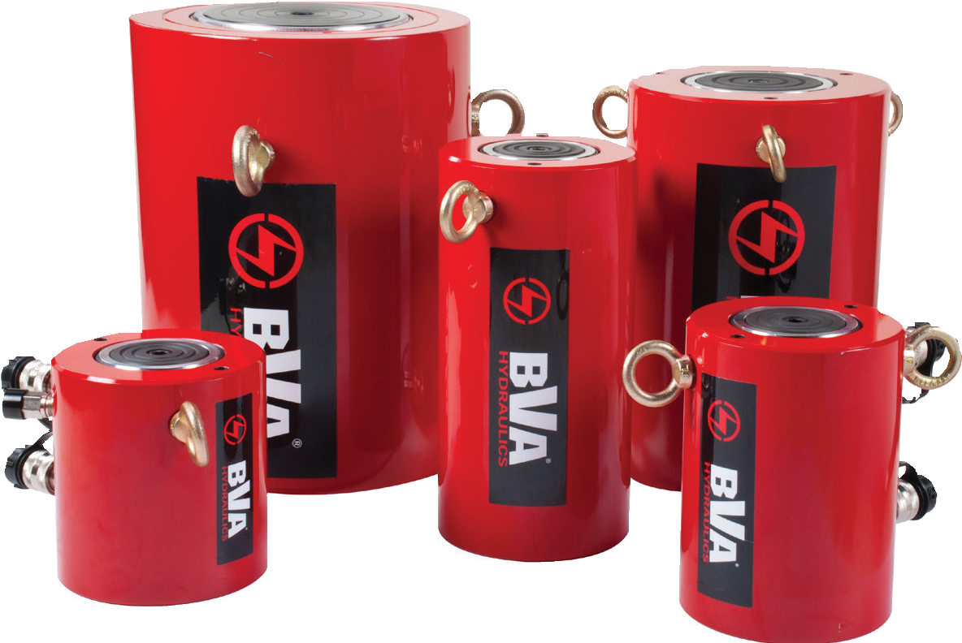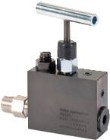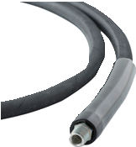

1-888-332-6419
22 www.BVAhydraulics.com

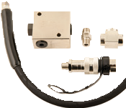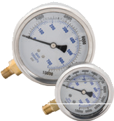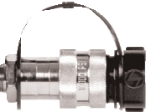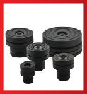
HDG Series
Safety Practices
Good industry practice recommends not exceeding 80% of maximum rated capacities of all our products.
Related Product: Gauges
Reduce the risk of overloading your product by using a gauge.
A variety of graduations and types to suit any need.
pg 69
High-Flow Couplers
High-Flow Coupler: CH38F is included on all models (except where specified).
Safety Check: CVP3-K
Pilot operated check valve kit. Used to hold the load in the event of a pressure loss in the system.
Relief Valve
All double acting cylinders are equipped with a
pressure relief valve located next to the retract port.
These pressure relief valves help prevent cylinder over pressurization on the return port side of the cylinder.
Optional Tilt-Saddles
Saddles tilt to a 5% maximum to adjust to the load. View our cylinder accessories page to figure out what saddle best
fits these cylinders. pg 35
23

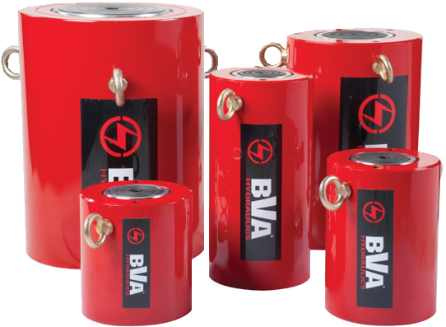
Quick Reference Guide
Cylinders

Cylinder Capacity (tons) | Stroke (in) | Model Number | Collapsed Height (in) | Oil Capacity (in3) | Weight (lbs)
100 | 1.97 | HDG10002 | 7.17 | 40.50 | 61.0
 | 3.94 | HDG10004 | 9.13 | 81.00 | 74.0
 | 5.91 | HDG10006 | 11.10 | 121.50 | 87.0
 | 7.87 | HDG10008 | 13.07 | 161.99 | 100.0
 | 9.84 | HDG10010 | 15.04 | 202.49 | 114.0
 | 11.81 | HDG10012 | 17.01 | 242.99 | 127.0
150 | 1.97 | HDG15002 | 7.72 | 59.89 | 102.0
 | 3.94 | HDG15004 | 9.69 | 119.78 | 122.0
 | 5.91 | HDG15006 | 11.65 | 181.75 | 142.0
 | 7.87 | HDG15008 | 13.62 | 239.57 | 162.0
 | 9.84 | HDG15010 | 15.59 | 299.46 | 181.0
 | 11.81 | HDG15012 | 17.56 | 359.35 | 202.0
200 | 1.97 | HDG20002 | 8.50 | 80.68 | 121.0
 | 5.91 | HDG20006 | 12.44 | 243.40 | 201.0
 | 7.87 | HDG20008 | 14.41 | 322.73 | 242.0
 | 11.81 | HDG20012 | 18.35 | 486.79 | 322.0
300 | 1.97 | HDG30002 | 12.28 | 139.19 | 406.0
 | 5.91 | HDG30006 | 16.22 | 417.56 | 511.0
 | 11.81 | HDG30012 | 22.13 | 835.11 | 668.0
400 | 1.97 | HDG40002 | 14.74 | 170.84 | 595.0
 | 5.91 | HDG40006 | 18.68 | 512.51 | 728.0
 | 12.01 | HDG40012 | 24.61 | 1042.10 | 928.0
500 | 1.97 | HDG50002 | 16.50 | 222.92 | 884.0
 | 5.91 | HDG50006 | 20.43 | 668.77 | 1058.0
 | 11.81 | HDG50012 | 26.34 | 1337.56 | 1321.0
600 | 1.97 | HDG60002 | 16.89 | 260.97 | 1045.0
 | 5.91 | HDG60006 | 20.83 | 782.90 | 1246.0
 | 9.84 | HDG60010 | 19.88 | 1408.93 | 948.0
 | 11.81 | HDG60012 | 26.73 | 1566.00 | 1545.0
800 | 1.97 | HDG80002 | 18.66 | 358.91 | 1634.0
 | 5.91 | HDG80006 | 22.60 | 1077.00 | 1914.0
 | 11.81 | HDG80012 | 28.50 | 2153.00 | 2332.0
1000 | 1.97 | HDG100002 | 22.20 | 447.23 | 2341.0
 | 5.91 | HDG100006 | 26.14 | 1342.00 | 2674.0
 | 11.81 | HDG100012 | 32.05 | 2683.00 | 3172.0
1100-1500 | For these higher tonnages, contact your local BVA dealer for pricing and details
See next pages (pg.20-21) to view more detail stats on High Tonnage Single Acting Cylinders.

High Tonnage Double Acting Cylinders

HDG Series - Heavy Lifting

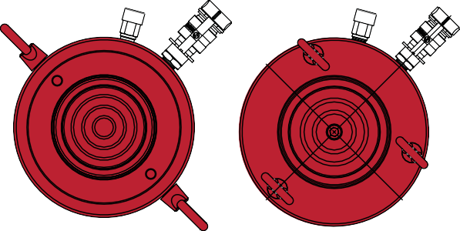
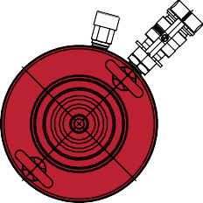
E F

H
B

3/8"-18NPTF

G
A

C HDG100
Z
Cylinder Capacity (tons) | Stroke (in) | Model Number | Maximum Cylinder Capacity (ton) |  | Cylinder Effective Area (in2) |  | Oil Capacity (in3) |  | Weight (lbs)
 |  |  | Push | Pull | Push | Pull | Push | Pull
100 | 1.97 | HDG10002 | 102.86 | 47.93 | 20.57 | 9.59 | 40.50 | 18.87 | 61.0
 | 3.94 | HDG10004 | 102.86 | 47.93 | 20.57 | 9.59 | 81.00 | 37.74 | 74.0
 | 5.91 | HDG10006 | 102.86 | 47.93 | 20.57 | 9.59 | 121.50 | 56.61 | 87.0
 | 7.87 | HDG10008 | 102.86 | 47.93 | 20.57 | 9.59 | 161.99 | 75.49 | 100.0
 | 9.84 | HDG10010 | 102.86 | 47.93 | 20.57 | 9.59 | 202.49 | 94.36 | 114.0
 | 11.81 | HDG10012 | 102.86 | 47.93 | 20.57 | 9.59 | 242.99 | 113.23 | 127.0
150 | 1.97 | HDG15002 | 152.15 | 78.50 | 30.43 | 15.70 | 59.89 | 30.90 | 102.0
 | 3.94 | HDG15004 | 152.15 | 78.50 | 30.43 | 15.70 | 119.78 | 61.79 | 122.0
 | 5.91 | HDG15006 | 152.15 | 78.50 | 30.43 | 15.70 | 181.75 | 88.32 | 142.0
 | 7.87 | HDG15008 | 152.15 | 78.50 | 30.43 | 15.70 | 239.57 | 123.59 | 162.0
 | 9.84 | HDG15010 | 152.15 | 78.50 | 30.43 | 15.70 | 299.46 | 154.48 | 181.0
 | 11.81 | HDG15012 | 152.15 | 78.50 | 30.43 | 15.70 | 359.35 | 185.38 | 202.0
200 | 1.97 | HDG20002 | 204.95 | 94.00 | 40.99 | 18.80 | 80.68 | 37.01 | 121.0
 | 5.91 | HDG20006 | 204.95 | 94.00 | 40.99 | 18.80 | 243.40 | 116.23 | 201.0
 | 7.87 | HDG20008 | 204.95 | 94.00 | 40.99 | 18.80 | 322.73 | 148.03 | 242.0
 | 11.81 | HDG20012 | 204.95 | 94.00 | 40.99 | 18.80 | 486.79 | 232.46 | 322.0
300 | 1.97 | HDG30002 | 353.60 | 117.00 | 70.71 | 23.46 | 139.19 | 46.18 | 406.0
 | 5.91 | HDG30006 | 353.60 | 117.00 | 70.71 | 23.46 | 417.56 | 138.55 | 511.0
 | 11.81 | HDG30012 | 353.60 | 117.00 | 70.71 | 23.46 | 835.11 | 277.10 | 668.0
400 | 1.97 | HDG40002 | 433.90 | 152.55 | 86.78 | 30.51 | 170.84 | 59.03 | 595.0
 | 5.91 | HDG40006 | 433.90 | 152.55 | 86.78 | 30.51 | 512.51 | 177.09 | 728.0
 | 12.01 | HDG40012 | 433.90 | 152.55 | 86.78 | 30.51 | 1042.10 | 366.38 | 928.0
500 | 1.97 | HDG50002 | 566.30 | 192.00 | 113.25 | 38.37 | 222.92 | 75.54 | 884.0
 | 5.91 | HDG50006 | 566.30 | 192.00 | 113.25 | 38.37 | 668.77 | 226.61 | 1058.0
 | 11.81 | HDG50012 | 566.30 | 192.00 | 113.25 | 38.37 | 1337.56 | 453.23 | 1321.0
600 | 1.97 | HDG60002 | 662.90 | 229.00 | 132.57 | 45.79 | 260.97 | 90.13 | 1045.0
 | 5.91 | HDG60006 | 662.90 | 229.00 | 132.57 | 45.79 | 782.90 | 270.39 | 1246.0
 | 9.84 | HDG60010 | 670.90 | 352.85 | 134.18 | 70.57 | 1408.93 | 740.94 | 948.0
 | 11.81 | HDG60012 | 662.90 | 229.00 | 132.57 | 45.79 | 1566.00 | 540.79 | 1545.0
800 | 1.97 | HDG80002 | 911.60 | 300.00 | 182.32 | 59.99 | 358.91 | 118.09 | 1634.0
 | 5.91 | HDG80006 | 911.60 | 300.00 | 182.32 | 59.99 | 1077.00 | 354.28 | 1914.0
 | 11.81 | HDG80012 | 911.60 | 300.00 | 182.32 | 59.99 | 2153.00 | 708.57 | 2332.0
1000 | 1.97 | HDG100002 | 1136.00 | 420.00 | 227.19 | 83.97 | 447.23 | 165.29 | 2341.0
 | 5.91 | HDG100006 | 1136.00 | 420.00 | 227.19 | 83.97 | 1342.00 | 495.87 | 2674.0
 | 11.81 | HDG100012 | 1136.00 | 420.00 | 227.19 | 83.97 | 2683.00 | 991.75 | 3172.0

Y
X D

HDG150 HDG200

Relief Valve
All double acting cylinders are equipped with a
pressure relief valve located next to the retract port.
These pressure relief valves help prevent cylinder over pressurization on the return port side of the cylinder.

Safety Instructions
Visit our DO’S and DON’TS
section to review the best

methods of operation. Always be prepared.
pg 92

Related Product: CVP3-K
Pilot operated check valve kit. Used to hold the load in the event of a pressure loss in the system.

High-Flow Couplers
High-Flow Coupler: CH38F is included on all models (except where specified).

Optional Tilt-Saddles
Saddles tilt to a 5% maximum to adjust to the load. View our cylinder accessories page to figure out what saddle best

fits these cylinders.
pg 35

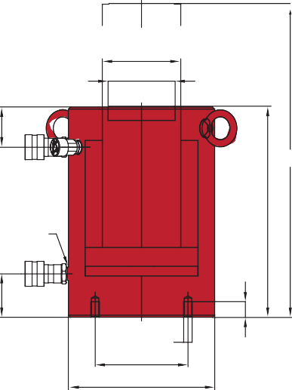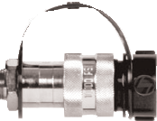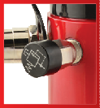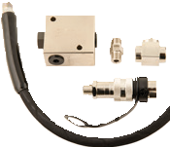

1-888-332-6419
24 www.BVAhydraulics.com

HDG Series
Safety Practices
Good industry practice recommends not exceeding 80% of maximum rated capacities of all our products.
25
Cylinders

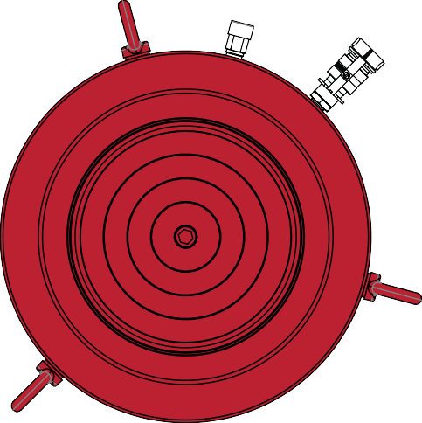
HDG300 - HDG1000

Model Number | Collapsed Height  A  (in) | Extended  Height B  (in) | Cylinder Bore Dia.  C  (in) | Outside Dia.  D  (in) | Rod Dia. E  (in) | Saddle Dia.  F  (in) | Base To Adv. Port G  (in) | Top To Retract Port H  (in) | Base Mounting Holes
 |  |  |  |  |  |  |  |  | Bolt Circle X  (in) | Thread Size (mm) | Thread Depth Z (in)
HDG10002 | 7.17 | 9.14 | 5.12 | 3.50 | 3.74 | 2.95 | 2.13 | 1.89 | 3.74 | M12 | 0.87
HDG10004 | 9.13 | 13.07 | 5.12 | 3.50 | 3.74 | 2.95 | 2.13 | 1.89 | 3.74 | M12 | 0.87
HDG10006 | 11.10 | 17.01 | 5.12 | 3.50 | 3.74 | 2.95 | 2.13 | 1.89 | 3.74 | M12 | 0.87
HDG10008 | 13.07 | 20.94 | 5.12 | 3.50 | 3.74 | 2.95 | 2.13 | 1.89 | 3.74 | M12 | 0.87
HDG10010 | 15.04 | 24.88 | 5.12 | 3.50 | 3.74 | 2.95 | 2.13 | 1.89 | 3.74 | M12 | 0.87
HDG10012 | 17.01 | 28.82 | 5.12 | 3.50 | 3.74 | 2.95 | 2.13 | 1.89 | 3.74 | M12 | 0.87
HDG15002 | 7.72 | 9.69 | 6.22 | 8.07 | 4.33 | 3.70 | 2.40 | 2.22 | 5.12 | M12 | 0.87
HDG15004 | 9.69 | 13.62 | 6.22 | 8.07 | 4.33 | 3.70 | 2.40 | 2.22 | 5.12 | M12 | 0.87
HDG15006 | 11.65 | 17.56 | 6.22 | 8.07 | 4.33 | 3.70 | 2.40 | 2.22 | 5.12 | M12 | 0.87
HDG15008 | 13.62 | 21.50 | 6.22 | 8.07 | 4.33 | 3.70 | 2.40 | 2.22 | 5.12 | M12 | 0.87
HDG15010 | 15.59 | 25.43 | 6.22 | 8.07 | 4.33 | 3.70 | 2.40 | 2.22 | 5.12 | M12 | 0.87
HDG15012 | 17.56 | 29.37 | 6.22 | 8.07 | 4.33 | 3.70 | 2.40 | 2.22 | 5.12 | M12 | 0.87
HDG20002 | 8.50 | 10.47 | 7.22 | 9.25 | 5.31 | 4.45 | 2.62 | 2.22 | 6.50 | M12 | 0.80
HDG20006 | 12.44 | 18.35 | 7.24 | 9.25 | 5.31 | 4.45 | 2.62 | 2.22 | 6.50 | M12 | 0.80
HDG20008 | 14.41 | 22.28 | 7.22 | 9.25 | 5.31 | 4.45 | 2.62 | 2.22 | 6.50 | M12 | 0.80
HDG20012 | 18.35 | 30.16 | 7.24 | 9.25 | 5.31 | 4.45 | 2.62 | 2.22 | 6.50 | M12 | 0.80
HDG30002 | 12.28 | 14.25 | 9.49 | 12.20 | 7.76 | 6.97 | 3.98 | 2.95 | 7.09 | M16 | 1.42
HDG30006 | 16.22 | 22.13 | 9.49 | 12.20 | 7.76 | 6.97 | 3.98 | 2.95 | 7.09 | M16 | 1.42
HDG30012 | 22.13 | 33.94 | 9.49 | 12.20 | 7.76 | 6.97 | 3.98 | 2.95 | 7.09 | M16 | 1.42
HDG40002 | 14.74 | 16.71 | 10.51 | 13.78 | 8.50 | 7.72 | 4.49 | 4.13 | 8.07 | M16 | 1.42
HDG40006 | 18.68 | 24.59 | 10.51 | 13.78 | 8.50 | 7.72 | 4.49 | 4.13 | 8.07 | M16 | 1.42
HDG40012 | 24.59 | 36.40 | 10.51 | 13.78 | 8.50 | 7.72 | 4.49 | 4.13 | 8.07 | M16 | 1.42
HDG50002 | 16.50 | 18.46 | 12.01 | 15.75 | 9.76 | 8.98 | 4.49 | 5.31 | 9.84 | M24 | 1.50
HDG50006 | 20.43 | 26.34 | 12.01 | 15.75 | 9.76 | 8.98 | 4.49 | 5.31 | 9.84 | M24 | 1.50
HDG50012 | 26.34 | 38.15 | 12.01 | 15.75 | 9.76 | 8.98 | 4.49 | 5.31 | 9.84 | M24 | 1.50
HDG60002 | 16.89 | 18.86 | 12.99 | 16.93 | 10.51 | 9.72 | 4.49 | 5.31 | 10.83 | M24 | 1.50
HDG60006 | 20.83 | 26.73 | 12.99 | 16.93 | 10.51 | 9.72 | 4.49 | 5.31 | 10.83 | M24 | 1.50
HDG60010 | 18.00 | 28.50 | 13.07 | 17.05 | 9.00 | 7.87 | 4.49 | 5.31 | 10.83 | M24 | 1.50
HDG60012 | 26.73 | 38.54 | 12.99 | 16.93 | 10.51 | 9.72 | 4.49 | 5.31 | 10.83 | M24 | 1.50
HDG80002 | 18.66 | 20.63 | 15.24 | 19.88 | 12.48 | 11.69 | 5.87 | 5.31 | 12.99 | M24 | 1.50
HDG80006 | 22.60 | 28.50 | 15.24 | 19.88 | 12.48 | 11.69 | 5.87 | 5.31 | 12.99 | M24 | 1.50
HDG80012 | 28.50 | 40.31 | 15.24 | 19.88 | 12.48 | 11.69 | 5.87 | 5.31 | 12.99 | M24 | 1.50
HDG100002 | 22.20 | 24.17 | 17.01 | 22.05 | 13.50 | 12.72 | 6.85 | 6.69 | 14.76 | M24 | 1.50
HDG100006 | 26.14 | 32.05 | 17.01 | 22.05 | 13.50 | 12.72 | 6.85 | 6.69 | 14.76 | M24 | 1.50
HDG100012 | 32.05 | 43.86 | 17.01 | 22.05 | 13.50 | 12.72 | 6.85 | 6.69 | 14.76 | M24 | 1.50

Low Profile Cylinders

HL Series - Low Clearance Lifting

- 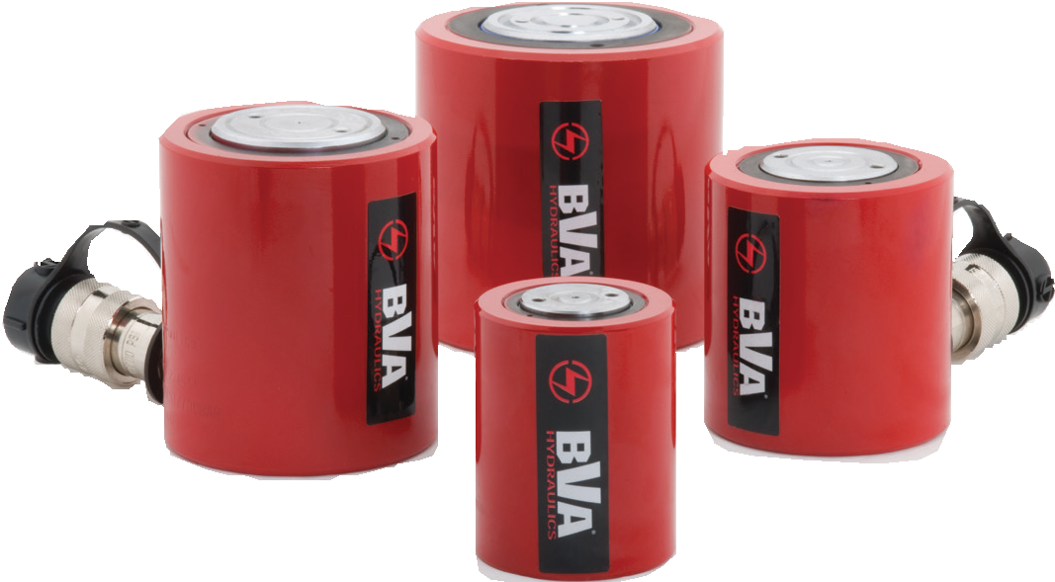Compact design for use in confined spaces
HL Series
- Rod wiper helps seal out dirt and contamination
- Specially designed return spring provides quick retraction and extends the life of the spring
- Hard chrome plated rod helps prevent scratching and corrosion
- Rod end is grooved to reduce load slippage
- Includes high flow coupler and dust cap
- HL1001, HL2002, and HL3002 coupler is tilted 5° for added clearance

E Z
4.63”
HL6003KK ONLY*
3/8"-16 UNC
Y

X

B

A

5°

C 3/8"-18NPTF D

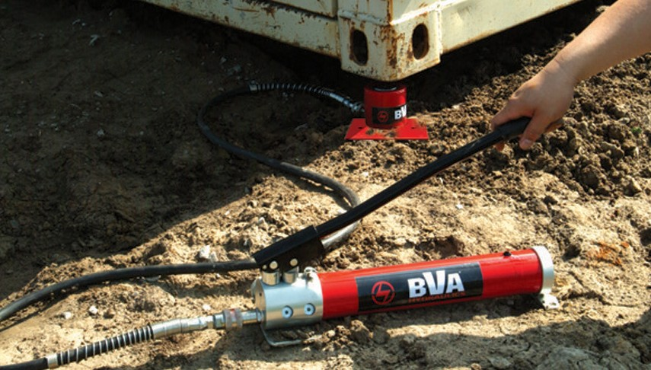Low profile cylinders are great for confined spaces.
Cylinder Capacity (tons) | Stroke (in) | Model Number | Cylinder Effective Area (in2) | Internal Pressure at Capacity (psi) | Oil Capacity (in3) | Weight (lbs)
10 | 1.50 | HL1001 | 2.35 | 8,511 | 3.53 | 5.7
20 | 1.75 | HL2002 | 4.37 | 9,153 | 7.65 | 11.0
30 | 2.44 | HL3002 | 6.49 | 9,245 | 15.84 | 15.0
50 | 2.36 | HL5002 | 9.87 | 10,132 | 23.29 | 21.8
60 | 2.50 | HL6003KK* | 12.57 | 10,183 | 31.40 | 28.0
100 | 2.24 | HL10002 | 19.64 | 10,183 | 44.07 | 45.4

Model Number | Collapsed Height  A  (in) | Extended  Height B  (in) | Cylinder Bore Diameter C  (in) | Outside Diameter D  (in) | Rod Diameter E  (in) | Rod Mounting
 |  |  |  |  |  | Bolt Circle X  (in) | Thread Y  (mm) | Thread Depth Z  (in)
HL1001 | 3.48 | 4.98 | 1.73 | 2.75 | 1.50 | 1.03 | M4 | 0.32
HL2002 | 3.90 | 5.65 | 2.36 | 3.63 | 2.00 | 1.56 | M4 | 0.32
HL3002 | 4.61 | 7.05 | 2.87 | 4.00 | 2.50 | 1.56 | M5 | 0.32
HL5002 | 4.80 | 7.17 | 3.54 | 4.88 | 2.76 | 1.56 | M5 | 0.32
HL6003KK* | 5.63 | 8.13 | 4.00 | 5.26 | 3.15 | - | - | -
HL10002 | 5.55 | 7.80 | 5.00 | 6.50 | 3.54 | 2.19 | M8 | 0.10

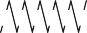1-888-332-6419
26 www.BVAhydraulics.com
- HL6003KK is equipped with 4x 3/8”-16UMC mounting holes

J72101

Low Profile Cylinders Combo Kit

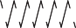Low Clearance Lifting
  - Compact design for use in confined spaces
  - Ideal for pushing applications
  - Rod wiper helps seal out dirt and contamination
  - Return spring ensures a quick retraction and ex- tends the life of the spring
Cylinders
  - Industrial hard chrome plated rod helps prevent scratching and corrosion
  - Includes stackable 1″, 2″, and 3″ aluminum adapt- ers that conveniently snap into the base of the rod
  - Includes high flow CH38F coupler and dust cap

HL Series
- Convenient storage case

Safety Practices
Good industry practice recommends not exceeding 80% of maximum rated capacities of all our products.

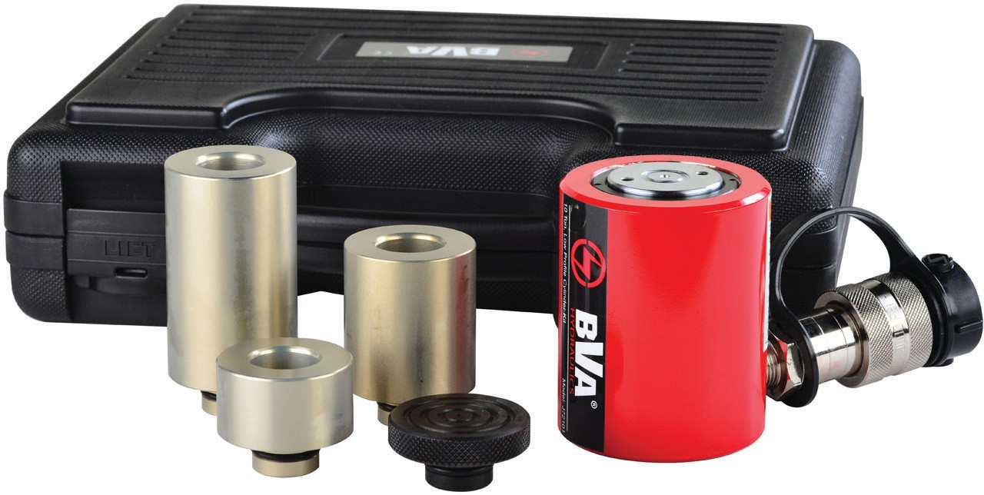Related Product: Hoses
We offer a variety of
hoses, fittings, lengths

and materials.
pg 72

3"
Adapter

1"
Adapter

2"
Adapter

1.5"
Saddle

J72101

High-Flow Couplers
High-Flow Coupler: CH38F is included on all models (except where specified).

Cylinder Capacity (ton) | Model Number | Stroke (in) | Cylinder Effective Area (in2) | Collapsed Height (in) | Extended  Height w/o adapter  (in) | Internal Pressure at Capacity (psi) | Cylinder Housing Diameter (in) | Rod Diameter (in) | Weight (lbs)
10 | J72101 | 1.50 | 2.35 | 3.48 | 4.98 | 8,511 | 2.75 | 1.50 | 10 .0

Bolt-On Tilt Saddles

SDTL50

SDTL100

SDTL10
Bolt-On tilt saddles are designed specifically for use with the HL Series Low Profile Cylinders and Low Profile Cylinder Kit. These saddles provide a max. 5° tilt for uneven loads.

Model Number | Height (in) | Description
SDTL10 | 0.83 | J72101, HL1001 Cylinder Kit
SDTL50 | 1.14 | HL5002 Cylinder
SDTL100 | 1.39 | HL10002 Cylinder

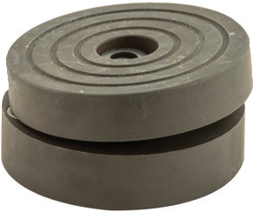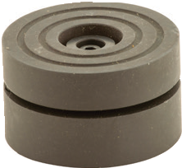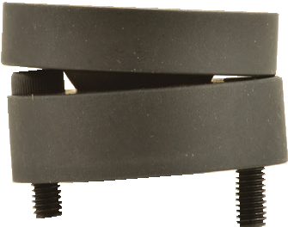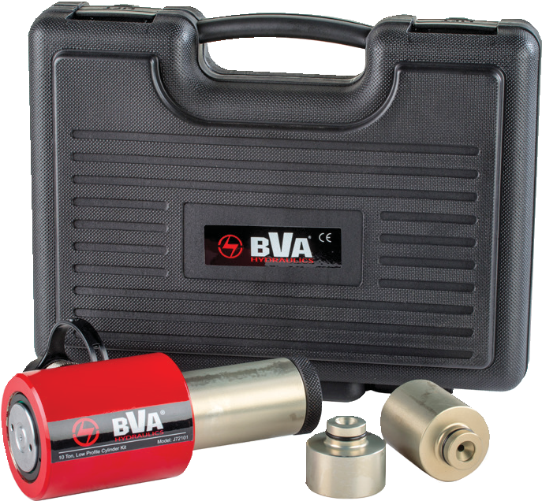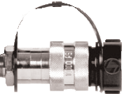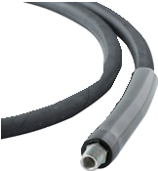

27

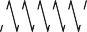Flat Body Cylinders

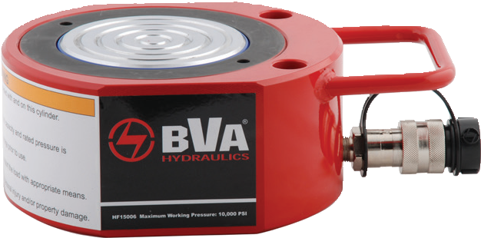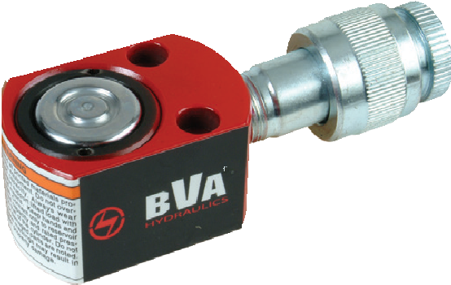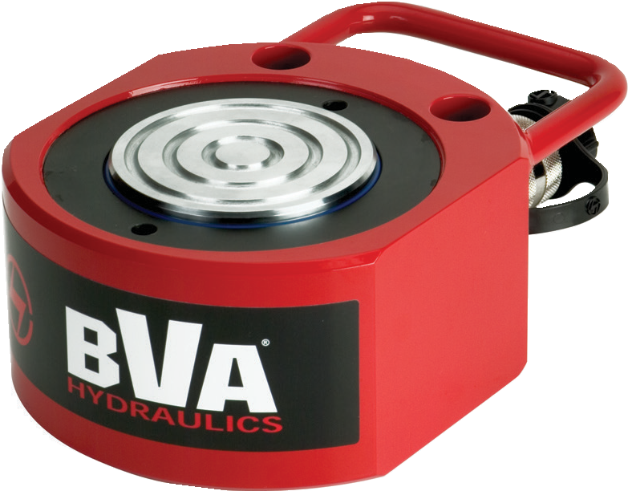Extremely Low Lifting
HF15006
HF0503
HF10006
HF Series
E
3/8” - 18NPTF
B
A
G

  - Extremely low collapsed height for applications with minimal clearance at the lift point
  - Maximum working pressure 10,000 psi / 700 bar
  - HF0503 and HF0503B come with a 3/8″ regular flow coupler

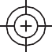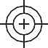 Y
X
L
M
D1

D2

C

HF5006 in the collapsed position ready to lift a load with a PA1500 foot pump.

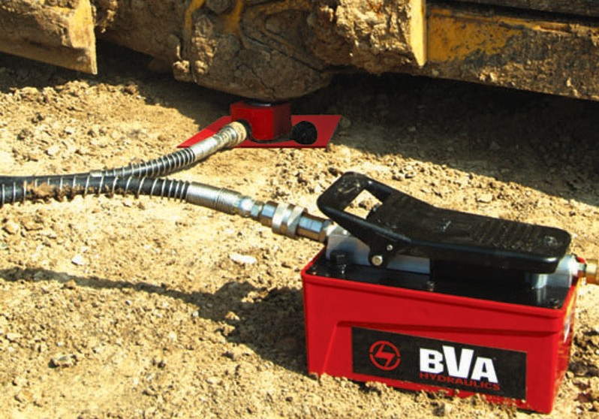
Cylinder Capacity (tons) | Stroke (in) | Model Number | Cylinder Effective Area (in2) | Internal Pressure at Capacity (psi) | Oil Capacity (in3) | Weight (lbs)
5 | 0.24 | HF0503* | 1.10 | 9,090 | 0.26 | 1.3
10 | 0.43 | HF1005 | 2.36 | 8,470 | 1.01 | 3.3
20 | 0.43 | HF2005 | 4.38 | 9,130 | 1.88 | 5.9
30 | 0.51 | HF3005 | 6.49 | 9,240 | 3.31 | 9.7
50 | 0.63 | HF5006 | 9.86 | 10,140 | 6.21 | 14.9
75 | 0.63 | HF7506 | 16.10 | 9,320 | 10.14 | 25.4
100 | 0.63 | HF10006 | 19.64 | 10,180 | 12.37 | 31.5
150 | 0.63 | HF15006 | 30.67 | 9,780 | 19.32 | 53.4

Model Number | Collapsed Height  A  (in) | Extended  Height B  (in) | Cylinder Bore Dia.  C  (in) | Outside Dia.  D1 x D2  D  (in) | Rod Dia. E  (in) | Base to Port G  (in) | Rod to Base L  (in) | Rod to Mtg. Hole M  (in) | Hole Pitch X  (in) | Hole Dia. Y  (in) | Counter Bore Dia. (in) | Counter Bore Depth (in)
HF0503* | 1.26 | 1.50 | 1.18 | 2.4x1.6 | 0.98 | 0.69 | 0.80 | 0.87 | 1.12 | 0.20 | 0.31 | 0.17
HF1005 | 1.69 | 2.12 | 1.73 | 3.3x2.2 | 1.50 | 0.77 | 1.12 | 1.32 | 1.44 | 0.28 | 0.42 | 0.31
HF2005 | 2.01 | 2.44 | 2.36 | 4.0x3.0 | 2.00 | 0.75 | 1.54 | 1.56 | 1.94 | 0.40 | 0.59 | 0.39
HF3005 | 2.31 | 2.82 | 2.87 | 4.6x3.8 | 2.50 | 0.79 | 1.88 | 1.75 | 2.06 | 0.40 | 0.63 | 0.44
HF5006 | 2.64 | 3.27 | 3.54 | 4.5x4.5 | 2.76 | 0.79 | 2.25 | 2.13 | 2.62 | 0.43 | 0.75 | 0.50
HF7506 | 3.13 | 3.76 | 4.53 | 6.5x5.5 | 3.54 | 0.77 | 2.75 | 2.63 | 3.00 | 0.51 | 0.83 | 0.56
HF10006 | 3.37 | 4.00 | 5.00 | 7.0x6.0 | 3.54 | 0.79 | 3.00 | 2.94 | 3.00 | 0.51 | 0.83 | 0.56
HF15006 | 3.94 | 4.57 | 6.25 | 8.5x7.5 | 4.65 | 0.94 | 3.75 | 3.25 | 4.62 | 0.51 | 0.83 | 0.56

1-888-332-6419
28 www.BVAhydraulics.com
*HF0503 comes equipped with the CR38F coupler instead of CH38F

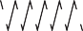Flat Body Cylinder Kits

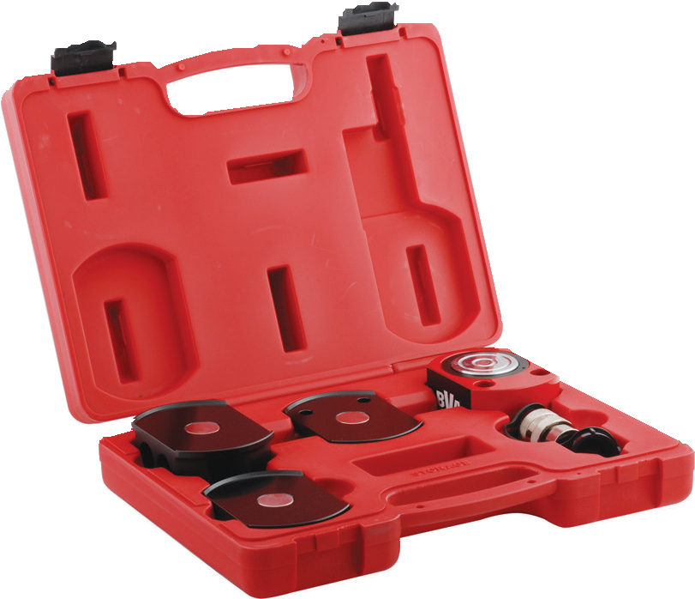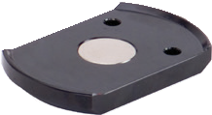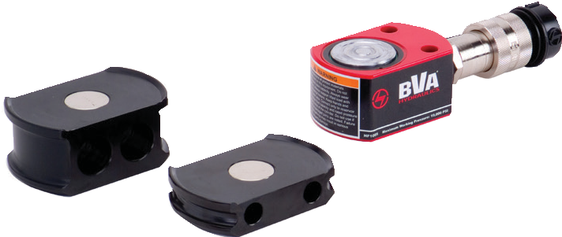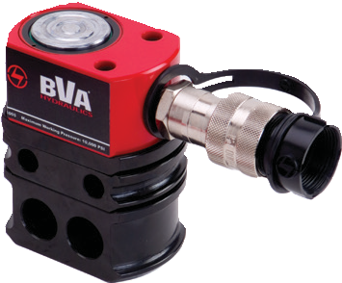HF Series - Kits
•
•
•
•

Various height stackable magnetic adapters eliminate dangerous cribbing
Convenient carrying case Magnetic adapters are stackable
Cylinders
U.S. Patent No.7,237,762 B2

Safety Practices
Good industry practice recommends not exceeding 80% of maximum rated capacities of all our products.

HF Series

Magnet Shim

High-Flow Couplers
High-Flow Coupler: CH38F is included on all models (except where specified)

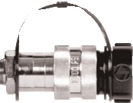

Magnet Shim
F B
G
E
D
C

A

Cylinder Capacity (tons) | Stroke (in) | Model Number | Cylinder Model | Oil Capacity (in3) | Collapsed Height (in) | Weight (lbs) | Adapter Dimensions
 |  |  |  |  |  |  | A  (in) | B  (in) | C  (in) | D  (in) | E  (in) | F  (in) | G  (in)
5 | 0.24 | HF0503B** | HF0503 | 0.26 | 1.26 | 5.5 | 0.17 | 1.61 | 2.56 | 2.32 | 0.48 | 1.10 | 0.24
 |  |  |  |  |  |  | 0.42 | 1.61 | 2.56 | 2.32 | 0.48 | 1.10 | 0.24
 |  |  |  |  |  |  | 0.92 | 1.61 | 2.56 | 2.32 | 0.48 | 1.10 | 0.24
 |  |  |  |  |  |  | 1.17 | 1.61 | 2.56 | 2.32 | 0.48 | 1.10 | 0.24
10 |  |  |  |  |  |  | 0.39 | 2.20 | 3.54 | 3.23 | 0.81 | 1.46 | 0.28
 | 0.43 | HF1005B | HF1005 | 1.01 | 1.69 | 9.2 | 0.79 | 2.20 | 3.54 | 3.23 | - | - | -
 |  |  |  |  |  |  | 1.57 | 2.20 | 3.54 | 3.23 | - | - | -
20 | 0.43 | HF2005B | HF2005 | 1.88 | 2.01 | 15.0 | 0.39 | 2.99 | 4.25 | 3.94 | 1.08 | 1.93 | 0.39
 |  |  |  |  |  |  | 0.79 | 2.99 | 4.25 | 3.94 | - | - | -
 |  |  |  |  |  |  | 1.57 | 2.99 | 4.25 | 3.94 | - | - | -
30 |  |  |  |  |  |  | 0.39 | 3.75 | 4.76 | 4.45 | 1.32 | 2.06 | 0.39
 | 0.51 | HF3005B | HF3005 | 3.31 | 2.31 | 21.0 | 0.79 | 3.75 | 4.76 | 4.45 | - | - | -
 |  |  |  |  |  |  | 1.57 | 3.75 | 4.76 | 4.45 | - | - | -
50 | 0.63 | HF5006B | HF5006 | 6.21 | 2.64 | 32.3 | 0.39 | 4.49 | 5.89 | 5.57 | 1.61 | 2.62 | 0.43
 |  |  |  |  |  |  | 0.79 | 4.49 | 5.89 | 5.57 | - | - | -
 |  |  |  |  |  |  | 1.57 | 4.49 | 5.89 | 5.57 | - | - | -
**HF0503B comes equipped with the coupler CR38F

29

Lock Nut Cylinders

HLN Series - Heavy Lifting w/ Mechanical Lock Nut

HLN15006

HLN5504

Capacity:
55-300 Tons
Stroke:
1.97 - 11.81 Inches

Max. Operating Pressure:
10,000 psi

Min. - Max. Height:
  - - 33.27 Inches

HLN10012
    - Single acting cylinder with mechanical safety lock nut
    - Designed to support loads without hydraulic pressure
    - Overflow port prevents cylinders
from over travel
    - Load return
    - Solid steel cylinder body
    - Electroless nickel plated rod to resist corrosion and rust
    - Maximum working pressure: 10,000 psi / 700 bar

Optional Tilt Saddles

HLN10002

SDT55 | → | HLN55, HLN100 Cylinders
SDT200 | → | HLN150, HLN200 Cylinders

Saddles tilt to a 5° max to adjust to the load.

pg35

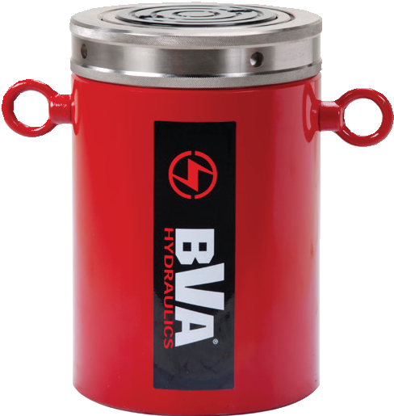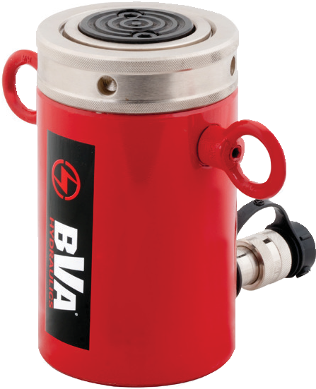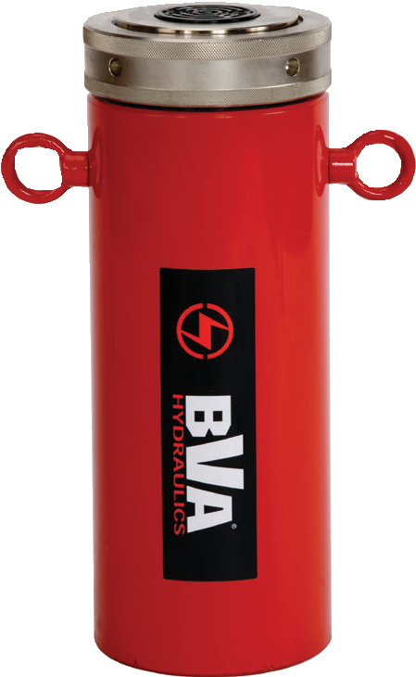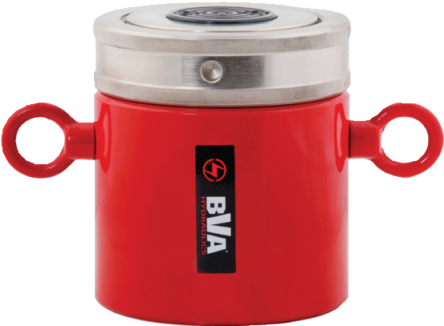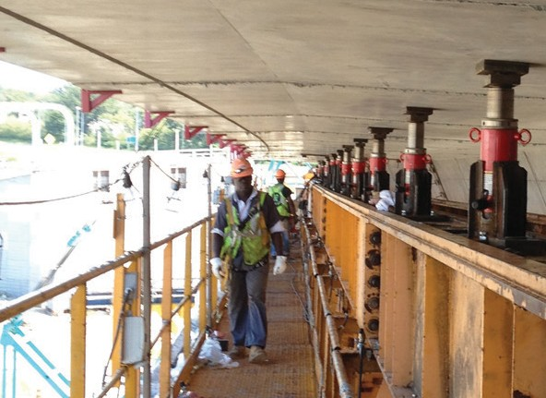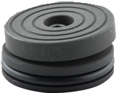
(42) HLN5508 lock nut cylinders lifting the Jordan Bridge in Chesapeake, VA.

1-888-332-6419
Cylinder Capacity (tons) | Stroke (in) | Model Number | Cylinder Effective Area (in2) | Oil Capacity (in3) | Weight (lbs)
55 | 1.97 | HLN5502 | 10.99 | 21.65 | 34.0
 | 3.94 | HLN5504 | 10.99 | 43.27 | 45.0
 | 5.91 | HLN5506 | 10.99 | 64.90 | 55.0
 | 7.87 | HLN5508 | 10.99 | 86.54 | 66.0
 | 9.84 | HLN5510 | 10.99 | 108.17 | 77.0
 | 11.81 | HLN5512 | 10.99 | 129.80 | 87.0
100 | 1.97 | HLN10002 | 20.57 | 40.49 | 67.0
 | 3.94 | HLN10004 | 20.57 | 80.98 | 86.0
 | 5.91 | HLN10006 | 20.57 | 121.48 | 104.0
 | 7.87 | HLN10008 | 20.57 | 161.97 | 123.0
 | 9.84 | HLN10010 | 20.57 | 202.46 | 141.0
 | 11.81 | HLN10012 | 20.57 | 242.95 | 160.0
150 | 1.97 | HLN15002 | 31.16 | 61.39 | 116.0
 | 3.94 | HLN15004 | 31.16 | 122.79 | 145.0
 | 5.91 | HLN15006 | 31.16 | 184.18 | 174.0
 | 7.87 | HLN15008 | 31.16 | 245.27 | 202.0
 | 9.84 | HLN15010 | 31.16 | 306.66 | 231.0
 | 11.81 | HLN15012 | 31.16 | 368.05 | 259.0
200 | 1.97 | HLN20002 | 41.00 | 80.70 | 181.0
 | 3.94 | HLN20004 | 41.00 | 161.38 | 218.0
 | 5.91 | HLN20006 | 41.00 | 242.00 | 256.0
 | 7.87 | HLN20008 | 41.00 | 323.00 | 293.0
 | 9.84 | HLN20010 | 41.00 | 403.50 | 331.0
 | 11.81 | HLN20012 | 41.00 | 484.15 | 368.0
250 | 1.97 | HLN25002 | 56.27 | 110.77 | 253.0
 | 5.91 | HLN25006 | 56.27 | 332.32 | 356.0
 | 11.81 | HLN25012 | 56.27 | 664.64 | 510.0
300 | 1.97 | HLN30002 | 70.41 | 138.61 | 379.0
 | 5.91 | HLN30006 | 70.41 | 415.83 | 510.0
 | 11.81 | HLN30012 | 70.41 | 831.66 | 706.0

30 www.BVAhydraulics.com

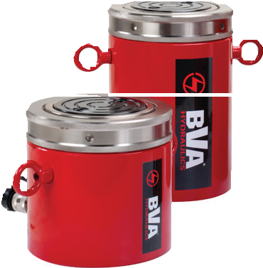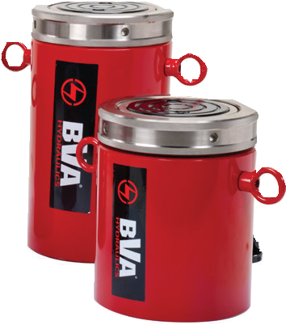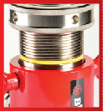
HLN Series

Safety Color Band
BVA Lock nut cylinders are equipped with a yellow safety band. Do not extend the ram beyond this point as it may result in a loss of hydraulic oil and damage to the cylinder and/or load.

Safety Practices
Good industry practice recommends not exceeding 80% of maximum rated capacities of all our products.
31

I
H 3/8"-18NPTF

G1

F C D
Cylinders

G2

A
B

Model Number | Collapsed Height  A  (in) | Extended  Height B  (in) | Cylinder Bore Diameter C  (in) | Outside Diameter D  (in) | Saddle Diameter F  (in) | Depth of Rod Hole G1  (in) | Saddle Protrusion From Rod G2  (in) | Lock Nut Length H  (in) | Base to Inlet Port I  (in)
HLN5502 | 6.50 | 8.40 | 3.70 | 4.90 | 2.80 | 0.51 | 0.08 | 1.40 | 1.10
HLN5504 | 8.40 | 12.40 | 3.70 | 4.90 | 2.80 | 0.51 | 0.08 | 1.40 | 1.10
HLN5506 | 10.40 | 16.30 | 3.70 | 4.90 | 2.80 | 0.51 | 0.08 | 1.40 | 1.10
HLN5508 | 12.40 | 20.20 | 3.70 | 4.90 | 2.80 | 0.51 | 0.08 | 1.40 | 1.10
HLN5510 | 14.30 | 24.20 | 3.70 | 4.90 | 2.80 | 0.51 | 0.08 | 1.40 | 1.10
HLN5512 | 16.30 | 28.10 | 3.70 | 4.90 | 2.80 | 0.51 | 0.08 | 1.40 | 1.10
HLN10002 | 7.40 | 9.30 | 5.10 | 6.50 | 2.80 | 0.51 | 0.08 | 1.80 | 1.10
HLN10004 | 9.30 | 13.30 | 5.10 | 6.50 | 2.80 | 0.51 | 0.08 | 1.80 | 1.10
HLN10006 | 11.30 | 17.20 | 5.10 | 6.50 | 2.80 | 0.51 | 0.08 | 1.80 | 1.10
HLN10008 | 13.30 | 21.10 | 5.10 | 6.50 | 2.80 | 0.51 | 0.08 | 1.80 | 1.10
HLN10010 | 15.20 | 25.10 | 5.10 | 6.50 | 2.80 | 0.51 | 0.08 | 1.80 | 1.10
HLN10012 | 17.20 | 29.00 | 5.10 | 6.50 | 2.80 | 0.51 | 0.08 | 1.80 | 1.10
HLN15002 | 8.23 | 10.20 | 6.30 | 8.07 | 5.12 | 0.98 | 0.08 | 1.73 | 1.54
HLN15004 | 10.20 | 14.13 | 6.30 | 8.07 | 5.12 | 0.98 | 0.08 | 1.73 | 1.54
HLN15006 | 12.17 | 18.07 | 6.30 | 8.07 | 5.12 | 0.98 | 0.08 | 1.73 | 1.54
HLN15008 | 14.13 | 22.01 | 6.30 | 8.07 | 5.12 | 0.98 | 0.08 | 1.73 | 1.54
HLN15010 | 16.10 | 25.94 | 6.30 | 8.07 | 5.12 | 0.98 | 0.08 | 1.73 | 1.54
HLN15012 | 18.07 | 29.88 | 6.30 | 8.07 | 5.12 | 0.98 | 0.08 | 1.73 | 1.54
HLN20002 | 9.57 | 11.50 | 7.22 | 9.25 | 5.12 | 0.98 | 0.08 | 1.97 | 1.97
HLN20004 | 11.54 | 15.47 | 7.22 | 9.25 | 5.12 | 0.98 | 0.08 | 1.97 | 1.97
HLN20006 | 13.50 | 19.50 | 7.22 | 9.25 | 5.12 | 0.98 | 0.08 | 1.97 | 1.97
HLN20008 | 15.50 | 23.40 | 7.22 | 9.25 | 5.12 | 0.98 | 0.08 | 1.97 | 1.97
HLN20010 | 17.40 | 27.30 | 7.22 | 9.25 | 5.12 | 0.98 | 0.08 | 1.97 | 1.97
HLN20012 | 19.41 | 31.22 | 7.22 | 9.25 | 5.12 | 0.98 | 0.08 | 1.97 | 1.97
HLN25002 | 9.80 | 11.77 | 8.46 | 10.83 | 5.91 | 0.98 | 0.08 | 2.20 | 1.97
HLN25006 | 13.74 | 19.65 | 8.46 | 10.83 | 5.91 | 0.98 | 0.08 | 2.20 | 1.97
HLN25012 | 19.65 | 31.46 | 8.46 | 10.83 | 5.91 | 0.98 | 0.08 | 2.20 | 1.97
HLN30002 | 11.61 | 13.58 | 9.47 | 12.20 | 5.47 | 0.98 | 0.20 | 2.36 | 2.32
HLN30006 | 15.55 | 21.46 | 9.47 | 12.20 | 5.47 | 0.98 | 0.20 | 2.36 | 2.32
HLN30012 | 21.46 | 33.27 | 9.47 | 12.20 | 5.47 | 0.98 | 0.20 | 2.36 | 2.32

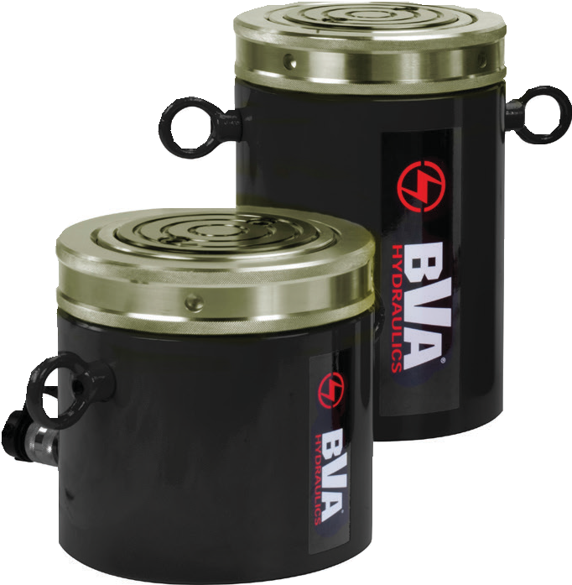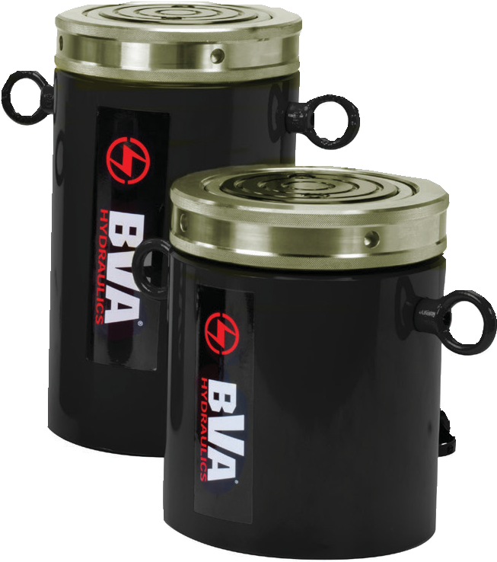Lock Nut Aluminum Cylinders

HULN Series - Heavy Lifting w/ Mechanical Lock Nut

Safety Practices
Good industry practice recommends not exceeding 80% of maximum rated capacities of all our product.

F
G2
G
G1

H

HULN Series

B

A

3/8"-18NPTF

I

C D
- Single acting cylinder with mechanical safety lock nut
- Designed to support loads without hydraulic pressure
- Overflow port prevents cylinders from over travel
- Load return
- Lightweight aluminum cylinder body
- Steel saddle
- Hard anodized rod to resist corrosion and rust
- Maximum working pressure: 10,000 psi / 700 bar

Cylinder Capacity (tons) | Stroke (in) | Model Number | Cylinder Effective Area (in2) | Oil Capacity (in3) | Weight (lbs) | Collapsed Height  A  (in) | Extended  Height B  (in) | Cylinder Bore Dia.  C  (in) | O.D. D  (in) | Saddle Dia.  F  (in) | Saddle Protrusion from Rod  G  (in) | Lock Nut Length H  (in) | Base To Adv Port  I  (in)
30 | 2.00 | HULN3002 | 6.50 | 13.00 | 15.0 | 7.75 | 9.75 | 2.88 | 4.50 | 2.00 | 0.10 | 1.25 | 1.50
 | 4.00 | HULN3004 | 6.50 | 26.00 | 18.0 | 9.75 | 13.75 | 2.88 | 4.50 | 2.00 | 0.10 | 1.25 | 1.50
 | 6.00 | HULN3006 | 6.50 | 39.00 | 21.0 | 11.75 | 17.75 | 2.88 | 4.50 | 2.00 | 0.10 | 1.25 | 1.50
 | 8.00 | HULN3008 | 6.50 | 52.00 | 24.0 | 13.75 | 21.75 | 2.88 | 4.50 | 2.00 | 0.10 | 1.25 | 1.50
 | 10.00 | HULN3010 | 6.50 | 65.00 | 27.0 | 15.75 | 25.75 | 2.88 | 4.50 | 2.00 | 0.10 | 1.25 | 1.50
50 | 2.00 | HULN5002 | 11.04 | 21.65 | 21.0 | 8.13 | 10.13 | 3.75 | 5.50 | 2.50 | 0.10 | 1.50 | 1.50
 | 4.00 | HULN5004 | 11.04 | 43.30 | 26.0 | 10.13 | 14.13 | 3.75 | 5.50 | 2.50 | 0.10 | 1.50 | 1.50
 | 6.00 | HULN5006 | 11.04 | 64.92 | 29.0 | 12.13 | 18.13 | 3.75 | 5.50 | 2.50 | 0.10 | 1.50 | 1.50
 | 8.00 | HULN5008 | 11.04 | 86.56 | 34.0 | 14.13 | 22.13 | 3.75 | 5.50 | 2.50 | 0.10 | 1.50 | 1.50
 | 10.00 | HULN5010 | 11.04 | 108.20 | 38.0 | 16.13 | 26.13 | 3.75 | 5.50 | 2.50 | 0.10 | 1.50 | 1.50
100 | 2.00 | HULN10002 | 20.68 | 40.51 | 43.0 | 8.38 | 10.38 | 5.13 | 8.00 | 3.50 | 0.10 | 1.75 | 1.50
 | 4.00 | HULN10004 | 20.68 | 81.00 | 51.0 | 10.38 | 14.38 | 5.13 | 8.00 | 3.50 | 0.10 | 1.75 | 1.50
 | 6.00 | HULN10006 | 20.68 | 121.50 | 60.0 | 12.38 | 18.38 | 5.13 | 8.00 | 3.50 | 0.10 | 1.75 | 1.50
 | 8.00 | HULN10008 | 20.68 | 162.00 | 69.0 | 14.38 | 22.38 | 5.13 | 8.00 | 3.50 | 0.10 | 1.75 | 1.50
 | 10.00 | HULN10010 | 20.68 | 202.50 | 77.0 | 16.38 | 26.38 | 5.13 | 8.00 | 3.50 | 0.10 | 1.75 | 1.50
150 | 2.00 | HULN15002 | 30.68 | 60.60 | 66.0 | 8.38 | 10.38 | 6.25 | 10.00 | 4.50 | 0.10 | 1.75 | 1.50
 | 4.00 | HULN15004 | 30.68 | 121.20 | 79.0 | 10.38 | 14.38 | 6.25 | 10.00 | 4.50 | 0.10 | 1.75 | 1.50
 | 6.00 | HULN15006 | 30.68 | 181.80 | 92.0 | 12.38 | 18.38 | 6.25 | 10.00 | 4.50 | 0.10 | 1.75 | 1.50
 | 8.00 | HULN15008 | 30.68 | 242.40 | 106.0 | 14.38 | 22.38 | 6.25 | 10.00 | 4.50 | 0.10 | 1.75 | 1.50
 | 10.00 | HULN15010 | 30.68 | 303.00 | 123.0 | 16.38 | 26.38 | 6.25 | 10.00 | 4.50 | 0.10 | 1.75 | 1.50
1-888-332-6419
32 www.BVAhydraulics.com

Low Profile Lock Nut Cylinders

Low Clearance Lifting w/ Mechanical Lock Nut
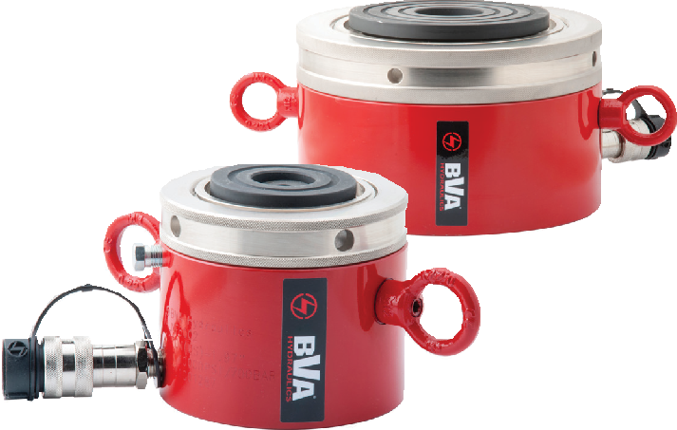
- Single acting cylinder with mechanical safety lock nut
- Designed to support loads without hydraulic pressure
- Low profile for confined spaces
- 5° tilting saddle is standard
Cylinders
- Maximum working pressure: 10,000 psi/700 bar
- Equipped with CH38F high flow coupler
- Load Return
Safety Instructions
Visit our DO’S and DON’TS
section to review the best
methods of operation. 92
Always be prepared. pg

HLNF Series
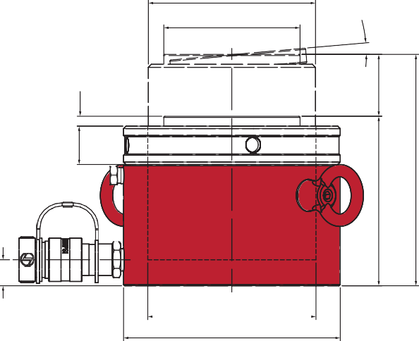
E F
Safety Color Band
BVA Lock nut cylinders are equipped with a yellow safety band. Do not extend the ram beyond this point as it may result in a loss of hydraulic oil and damage to the cylinder and/or load.

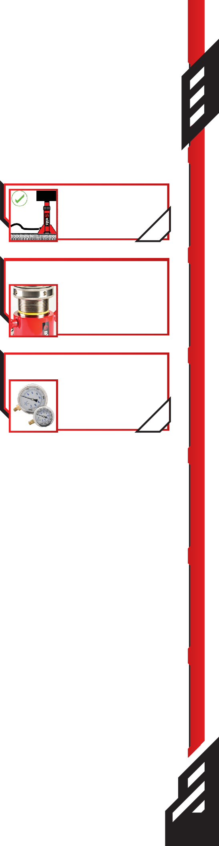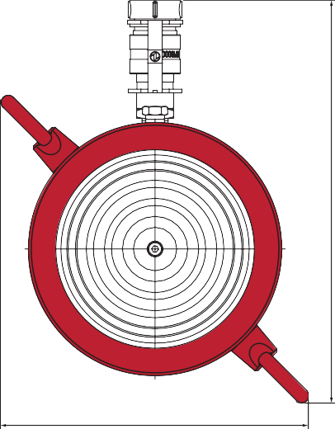5°
G Related Product: Gauges
Reduce the risk of overloading your product by using a gauge.
A variety of graduations and
H types to suit any need.
B pg69

A

I

C D

J
Cylinder Capacity (tons) | Stroke (in) | Model Number | Cylinder Effective Area (in2) | Oil Capacity (in3) | Weight (lbs)
60 | 1.97 | HLNF6002 | 13.42 | 26.42 | 31.3
100 | 1.97 | HLNF10002 | 22.47 | 44.23 | 54.1
160 | 1.77 | HLNF16002 | 35.51 | 62.91 | 91.0
200 | 1.77 | HLNF20002 | 43.95 | 77.86 | 118.6
250 | 1.77 | HLNF25002 | 56.27 | 99.70 | 154.6

K

Model Number | Collapsed Height  A  (in) | Extended  Height B  (in) | Cylinder Bore Dia.  C  (in) | Outside Dia. D  (in) | Rod Outside Thread E | Saddle Dia.  F  (in) | Saddle Protrusion From Rod G  (in) | Lock Nut Length H  (in) | Base to Inlet Port  I  (in) | Coupler to Eylet J  (in) | Eyelet to Eyelet  K  (in)
HLNF6002 | 4.92 | 6.89 | 4.13 | 5.51 | TW105-4N | 3.23 | 0.24 | 1.10 | 0.75 | 9.78 | 7.39
HLNF10002 | 5.39 | 7.36 | 5.35 | 6.89 | TW135-4N | 4.33 | 0.31 | 1.22 | 0.83 | 10.95 | 8.37
HLNF16002 | 5.83 | 7.60 | 6.72 | 8.66 | TW170-4N | 5.83 | 0.35 | 1.57 | 1.06 | 12.46 | 9.62
HLNF20002 | 6.10 | 7.87 | 7.48 | 9.66 | TW190-4N | 6.30 | 0.39 | 1.69 | 1.18 | 13.30 | 10.31
HLNF25002 | 6.26 | 8.03 | 8.46 | 10.83 | TW215-4N | 7.28 | 0.43 | 1.73 | 1.26 | 14.31 | 11.15

33

Cylinder Lifting Handles

- 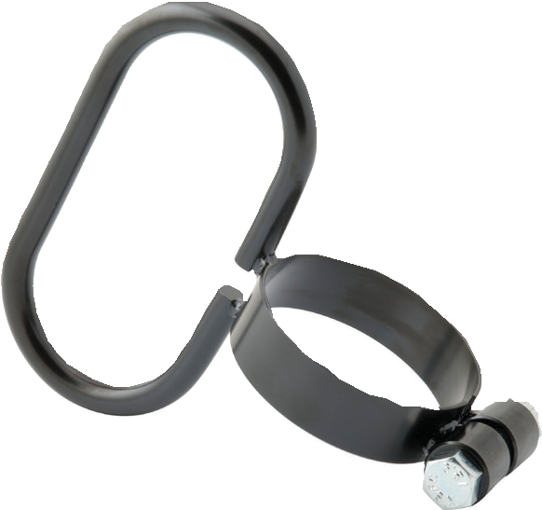Designed for ease of carrying cylinders
LH25T34
- Provides better control for positioning cylinder
- Easy installation

Model Number | For Cylinders
LH25T34 | H2504 through H2514
LH30T40 | H3008, HD3008, HD3014, HC2002T, HC2006T
LH30T45 | HC3002T, HC3006T, HD3007, HDC3010
LH55T49 | HLN5504 through HLF5512
Clevis and Tangs

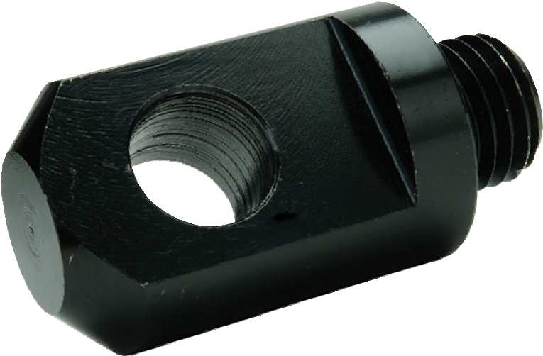
Rod
CEP Series

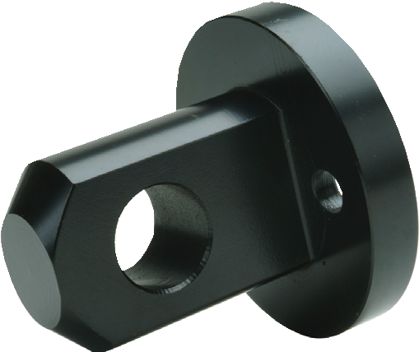CEB Series
Base

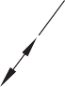G
B
H
D
C

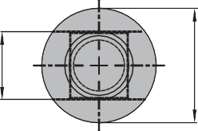F
B

F

HD cylinders can be used in pushing and pulling applications. In this photo, we see a HD2506 HD cylinder set up for a pull application using a rod clevis cylinder accessory
D
H
C

A A
Safety Practices
Good industry practice recommends not exceeding 80% of maximum rated capacities of all our products.

Application | Cylinder Series | Model Number | Dimensions (in)
 |  |  | A | B | C | D | F | G | H
Rod | H05* | CEP05 | ¾″-16N | 1.13 | 2.25 | 0.63 | 0.56 | - | 0.63
 | H10**, H15, HD10 | CEP15 | 1″-8UN | 1.69 | 3.31 | 0.88 | 1.00 | - | 1.00
 | H25 | CEP25 | 1½″-16UNC | 2.25 | 3.81 | 1.25 | 1.50 | - | 1.25
Base | H05* | CEB05 | 1.52 | 1.75 | 2.13 | 0.63 | 1.13 | 1.00 | 0.63
 | H10 | CEB10 | 2.28 | 2.50 | 2.87 | 0.88 | 0.32 | 1.56 | 1.00
 | H15 | CEB15 | 2.77 | 3.00 | 2.87 | 0.88 | 0.38 | 1.88 | 1.00
 | H25 | CEB25 | 3.40 | 3.75 | 3.37 | 1.25 | 0.56 | 2.31 | 1.25

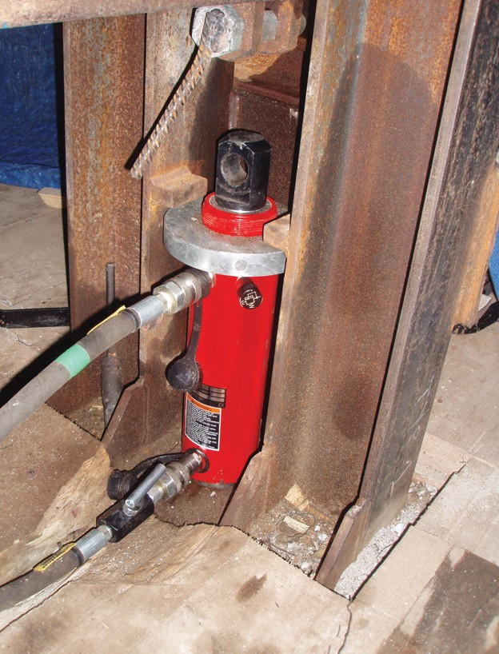1-888-332-6419
34 www.BVAhydraulics.com
*Except H0500
**Except H1001

Cylinder Bases

D
C

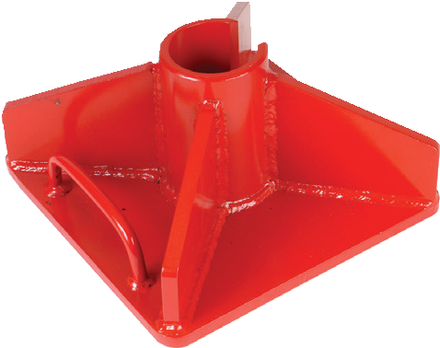
C

B
A

Safety Instructions
For use with Cylinder Series | Model Number | Dimensions (in)
 |  | A | B | C | D
H05* | CB05 | 0.32 | 4.65 | 7.87 | 1.54
H10** | CB10 | 0.39 | 4.72 | 9.06 | 2.28
H15 | CB15 | 0.47 | 4.80 | 10.00 | 2.76
H25 | CB25 | 0.63 | 4.96 | 11.02 | 3.41

Visit our DO’S and DON’TS
Cylinder Accessories
section to review the best

Cylinder Saddles

Grooved, Tilt, and Threaded

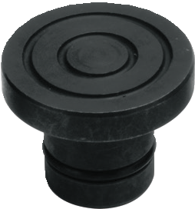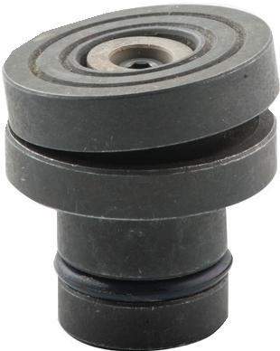

SD Series SDT Series

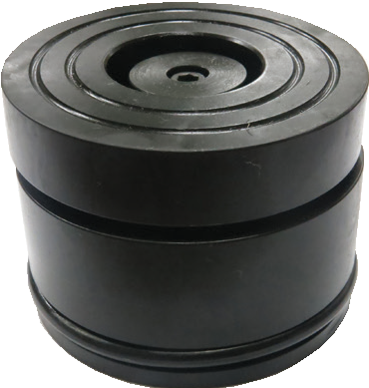

SDTG Series
methods of operation. Always be prepared.

HTD10
pg 92

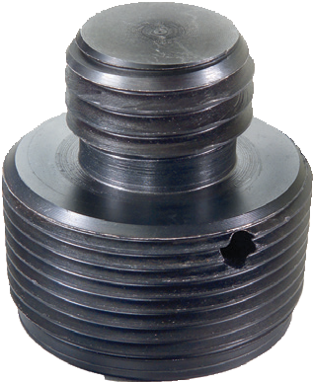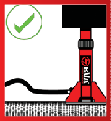
A
B
D
C
A
B
A

B 5˚ B
D D D

C C
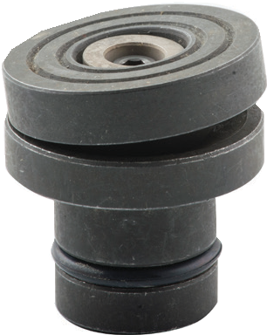A

Saddle Type | Model Number | Capacity (ton) | For Cylinder(s) | Dimensions (in)
 |  |  |  | A | B | C | D
Tilt | SDT05 | 5 | H05* | 0.98 | 1.22 | 0.67 | 1.20
 | SDT10 | 10 | H10** | 1.38 | 1.50 | 0.86 | 1.50
 | SDT15 | 15 | H15 | 1.50 | 1.57 | 0.86 | 1.58
 | SDT25 | 25 | H25 | 1.97 | 1.60 | 1.14 | 1.59
 | SDT55 | 55-100 | H55, HD55, H75, HD75, H100, HLN55 and HLN100 | 2.80 | 1.29 | 0.50 | 1.30
 | SDTG100 | 100 | HG100 and HDG100 | 2.95 | 2.64 | 1.71 | 0.79
 | SDTG150 | 150 | HG150 and HDG150 | 3.70 | 2.71 | 1.77 | 0.77
 | SDTG200 | 200 | HG200 and HDG200 | 4.45 | 3.25 | 1.95 | 1.10
 | SDT200 | 150-200 | HLN150 and HLN200 | 5.12 | 1.77 | 1.02 | 0.58
Grooved | SD05 | 5 | H05* | 0.98 | 0.81 | - | 0.24
 | SD10 | 10 | H10** | 1.38 | 1.06 | - | 0.24
 | SD15 | 15 | H15 | 1.50 | 1.18 | - | 0.28
 | SD25 | 25 | H25 | 1.97 | 1.14 | - | 0.28
Threaded | HTD10 | 10 | HT1006 and HT1010 H1002-H1014, HD1010-HD1012 | 1-1/4"-  11.5NPTF | 0.95 | 1"- 8UNC | 1.77
*Except H0500
**Except H1001

35

Hollow Hole Cylinders

HC Series

HC1201T

HC6006T
Capacity:
12-100 Tons
Stroke:
0.31 - 6.11 Inches

Max. Operating Pressure:
10,000 psi

Min. - Max. Height:
  - - 19.13 Inches

Here is a HC6006T in a pulling application.

HC3002T

    - Ideal for pulling and pushing applications
    - Heavy duty compression spring
    - Dual wipers help prevent contamination
    - Collar thread protector
    - High flow coupler with dust cap
    - XT cylinders do not come with internal rod threads
    - 60 and 100 Ton models are equipped with carrying handles

Cylinder Capacity (tons) | Stroke (in) | Model Number | Cylinder Effective Area (in2) | Internal Pressure at Capacity (psi) | Oil Capacity (in3) | Weight (lbs) | Collapsed Height  A  (in) | Extended  Height B  (in) | Bore Dia. C  (in) | O.D. D  (in)
12 | 0.31 | HC1201T* | 2.91 | 8,236 | 0.89 | 3.3 | 2.36 | 2.67 | 1.92 | 2.76
 | 1.61 | HC1202T* | 2.91 | 8,236 | 4.70 | 6.2 | 4.74 | 6.36 | 1.92 | 2.76
 | 1.61 | HC1202XT* | 2.91 | 8,236 | 4.70 | 6.2 | 4.74 | 6.36 | 1.92 | 2.76
 | 2.99 | HC1203XT | 2.91 | 8,236 | 8.72 | 8.6 | 7.24 | 10.24 | 1.92 | 2.76
20 | 2.01 | HC2002T | 4.90 | 8,167 | 9.83 | 15.9 | 6.38 | 8.39 | 2.50 | 3.92
 | 6.06 | HC2006T | 4.90 | 8,167 | 29.70 | 29.5 | 12.05 | 18.11 | 2.50 | 3.92
30 | 2.52 | HC3002T | 6.32 | 9,488 | 15.93 | 22.9 | 7.05 | 9.57 | 2.84 | 4.50
 | 6.11 | HC3006T | 6.32 | 9,488 | 38.67 | 43.0 | 13.02 | 19.13 | 2.84 | 4.50
60 | 3.00 | HC6003T** | 13.05 | 9,195 | 39.10 | 65.7 | 9.77 | 12.77 | 4.08 | 6.25
 | 6.00 | HC6006T** | 13.05 | 9,195 | 78.25 | 81.1 | 12.76 | 18.76 | 4.08 | 6.25
100 | 3.00 | HC10003T** | 22.13 | 9,036 | 66.31 | 113.3 | 10.00 | 13.00 | 5.31 | 8.39

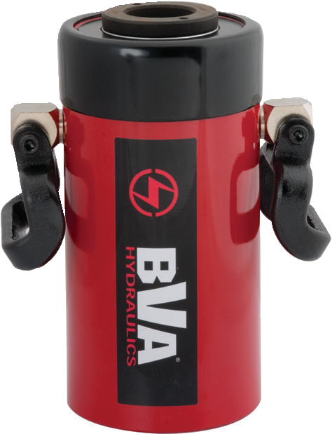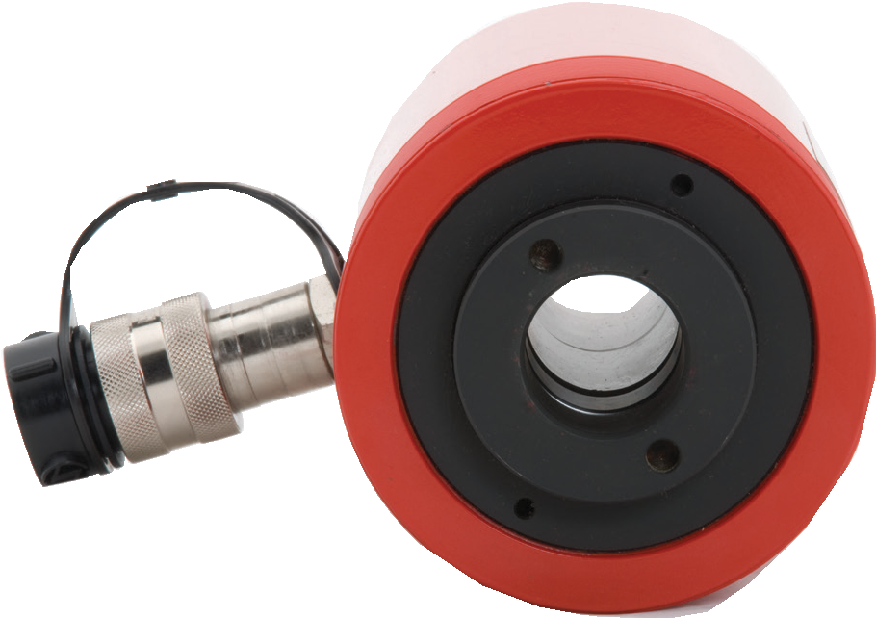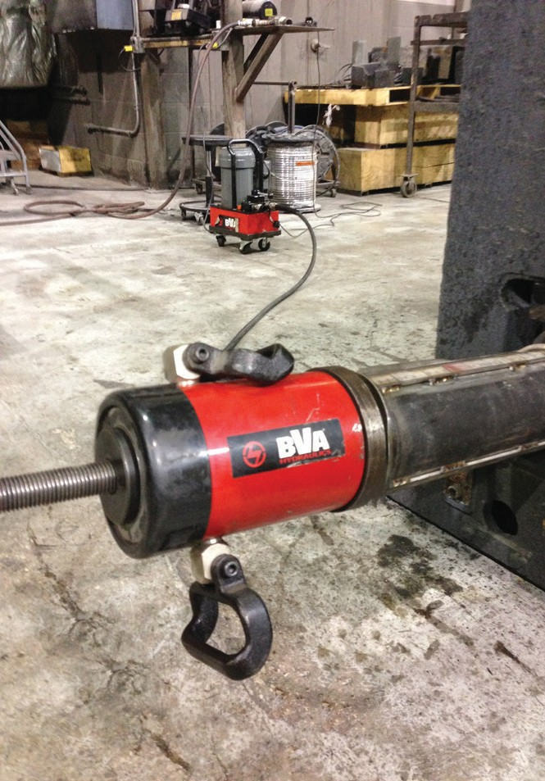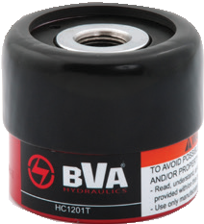1-888-332-6419
36 www.BVAhydraulics.com
- Cylinder comes with a CRZ14F regular flow coupler
** Cylinder is equipped with carrying handles

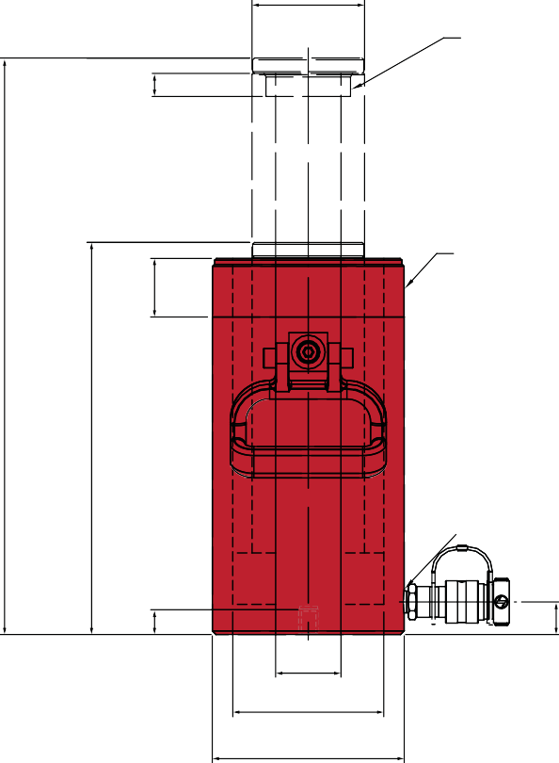
F

J

K

HC Series
Cylinders

H
Safety Practices
L Good industry practice
B recommends not exceeding
80% of maximum rated capacities of all our products.

A

3/8”-18NPTF
Related Product: Gauges
Reduce the risk of overloading your product by using a gauge.
A variety of graduations and types to suit any need.

pg69

Z G
Safety Instructions
E Visit our DO’S and DON’TS
section to review the best

C methods of operation.
Always be prepared.
D
pg92

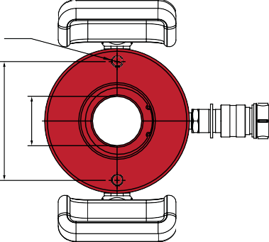
Combo Kits
Y Most cylinders are available
in easy to order kits: cylinder,

gauge, couplers, hose and pump.
pg64

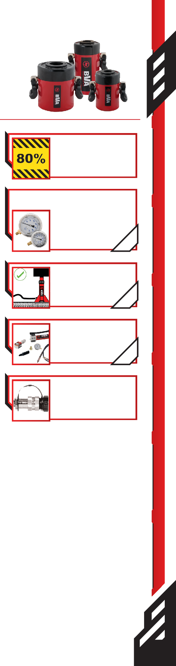
X E

High-Flow Couplers
High-Flow Coupler: CH38F is included on all models (except where specified).

Model Number | Rod |  |  |  | Collar Thread |  | Base to Inlet Port G  (in) | Base Mounting Hole
 | I.D. E  (in) | O.D. F  (in) | Internal Thread J  (in) | Internal Thread Length K  (in) | Diameter H  (in) | Length L  (in) |  | Bolt Circle X  (in) | Thread Y  (in) | Thread Depth Z  (in)
HC1201T* | 0.77 | 1.38 | ¾″-16UN | 0.63 | 2¾″-16 | 1.81 | 0.57 | 2.00 | 5/16″-18UNC | 0.35
HC1202T* | 0.77 | 1.38 | ¾″-16UN | 0.63 | 2¾″-16 | 1.81 | 0.59 | 2.00 | 5/16″-18UNC | 0.35
HC1202XT* | 0.77 | 1.38 | - | - | 2¾″-16 | 1.81 | 0.59 | 2.00 | 5/16″-18UNC | 0.35
HC1203XT | 0.77 | 1.38 | - | - | 2¾″-16 | 1.81 | 0.75 | 2.00 | 5/16″-18UNC | 0.35
HC2002T | 1.06 | 2.15 | 1-9/16″-16UN | 0.75 | 3⅞″-12 | 1.50 | 0.75 | 3.25 | ⅜″-16UNC | 0.37
HC2006T | 1.06 | 2.15 | 1-9/16″-16UN | 0.75 | 3⅞″-12 | 1.50 | 0.75 | 3.25 | ⅜″-16UNC | 0.37
HC3002T | 1.31 | 2.48 | 1-13/16″-16UN | 0.87 | 4½″-12 | 1.66 | 0.91 | 3.62 | ⅜″-16UNC | 0.55
HC3006T | 1.31 | 2.48 | 1-13/16″-16UN | 0.87 | 4½″-12 | 1.66 | 0.91 | 3.62 | ⅜″-16UNC | 0.55
HC6003T** | 2.13 | 3.66 | 2¾″-16UN | 0.75 | 6¼″-12 | 1.91 | 1.06 | 5.12 | ½″-13UNC | 0.55
HC6006T** | 2.13 | 3.66 | 2¾″-16UN | 0.75 | 6¼″-12 | 1.91 | 1.06 | 5.12 | ½″-13UNC | 0.55
HC10003T** | 3.11 | 4.92 | 4″-16UN | 0.98 | 8⅜″-12 | 2.38 | 1.06 | 7.01 | ⅝″-11UNC | 0.75
* Cylinder comes with a CRZ14F regular flow coupler
** Cylinder is equipped with carrying handles

37

Double Acting Hollow Hole Cylinders

HDC Series

HDC3010

HDC10001
Capacity:
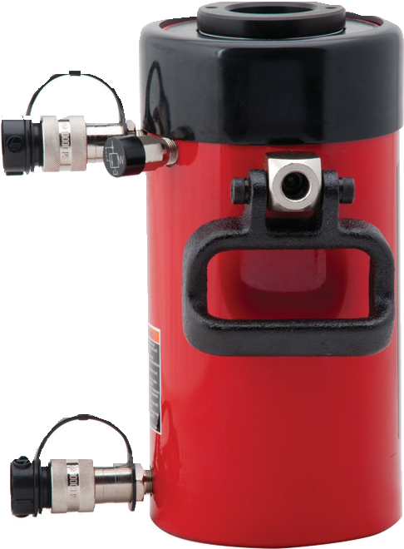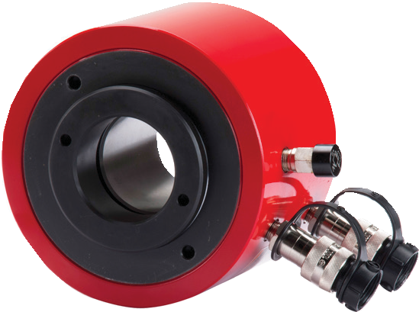30 - 150 Tons
HDC6006
Stroke:
1.50 - 10.13 Inches

Max. Operating Pressure:
10,000 psi

Min. - Max. Height:
6.50 - 28.27 Inches

Related Product: Gauges
Reduce the risk of overloading your product by using a gauge.
A variety of graduations and types to suit any need.

  - Ideal for pushing and pulling applications.
  - Dual wipers help prevent contamination
  - CH38F - 3/8” high flow female coupler

pg69
- Hard chrome rod prevents rust and corrosion
- Hardened steel seat

Related Product: Hoses
We offer a variety of
hoses, fittings, lengths

and materials.
pg 72

Combo Kits
Most cylinders are available in easy to order kits: Cylinder,

Gauge, Couplers, Hose and Pump.
pg64

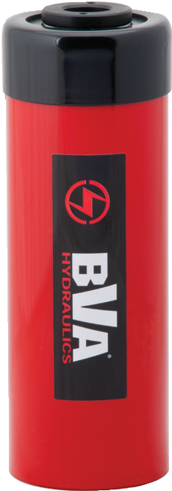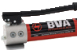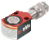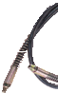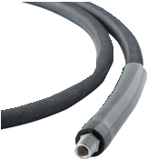

Cylinder Capacity |  | Stroke (in) | Model Number | Oil Capacity |  | Collapsed Height (in) | Extended Height (in) | Center Hole I.D.  (in) | Rod O.D.  (in) | Max Pressure (psi) | Weight (lbs)
Push (ton) | Pull (ton) |  |  | Push (in3) | Pull (in3)
30 | 20 | 7.00 | HDC3007 | 44.31 | 27.74 | 13.02 | 20.02 | 1.31 | 2.48 | 10.000 | 43.0
 |  | 10.13 | HDC3010 | 64.15 | 40.16 | 17.00 | 27.13 | 1.31 | 2.48 | 10.000 | 56.7
60 | 44 | 3.50 | HDC6003 | 45.75 | 30.49 | 9.77 | 13.28 | 2.13 | 3.62 | 10.000 | 65.7
 |  | 6.50 | HDC6006 | 84.81 | 56.53 | 12.76 | 19.26 | 2.13 | 3.62 | 10.000 | 81.1
 |  | 10.12 | HDC6010 | 132.10 | 88.04 | 17.25 | 27.37 | 2.13 | 3.62 | 10.000 | 112.4
100 | 71 | 1.50 | HDC10001 | 33.23 | 21.18 | 6.50 | 8.00 | 3.11 | 4.92 | 10.000 | 73.7
 |  | 3.00 | HDC10003 | 66.47 | 42.37 | 10.00 | 13.00 | 3.11 | 4.92 | 10.000 | 113.3
 |  | 6.00 | HDC10006 | 132.39 | 84.73 | 13.49 | 19.49 | 3.11 | 4.92 | 10.000 | 153.2
 |  | 10.13 | HDC10010 | 224.52 | 143.11 | 18.14 | 28.27 | 3.11 | 4.92 | 10.000 | 198.9
150 | 82.8 | 8.00 | HDC15008 | 259.19 | 132.44 | 13.75 | 21.75 | 3.94 | 5.91 | 10.000 | 239.2
1-888-332-6419
38 www.BVAhydraulics.com

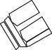Y HDC Series
E
Cylinders

Safety Practices
Good industry practice recommends not exceeding 80% of maximum rated
X capacities of all our products.

Relief Valve
All double acting cylinders are equipped with a
pressure relief valve located next to the retract port.
These pressure relief valves help prevent cylinder over pressurization on the return port side of the cylinder.

L

G
K
3/8"-18NPTF

High-Flow Couplers
High-Flow Coupler: CH38F is included on all models (except where specified).

J H F
Safety Instructions
Visit our DO’S and DON’TS
C
D section to review the best

methods of operation. Always be prepared.
pg 92

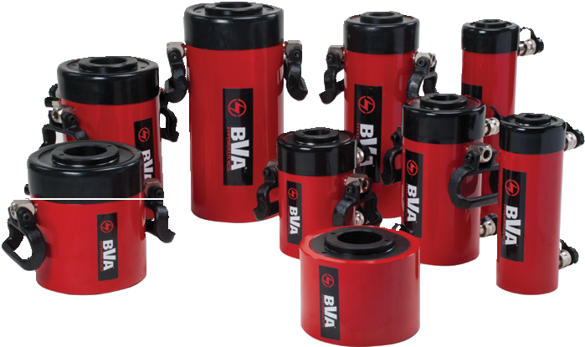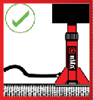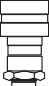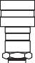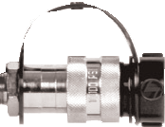
I

Z
A

Model Number | Min. Height A  (in) | Max. Height B  (in) | Dia. of  Center Tube C  (in) | O.D. D  (in) | I.D. E  (in) | O.D. F  (in) | Base to Inlet Port  G  (in) | Top to Return Port  L  (in) | Internal Thread H  (in) | Internal Thread Length I  (in) | Collar Thread |  | Base Mounting Hole
 |  |  |  |  |  |  |  |  |  |  | Dia. J  (in) | Length K  (in) | Bolt Circle X  (in) | Thread Y  (in) | Thread Depth Z  (in)
HDC3007 | 13.02 | 20.02 | 3.35 | 4.50 | 1.31 | 2.48 | 0.91 | 2.38 | 1 "-16UN | 0.94 | 4½"-12 | 1.66 | 3.62 | ⅜"-16UNC | 0.55
HDC3010 | 17.00 | 27.13 | 3.35 | 4.50 | 1.31 | 2.48 | 0.91 | 2.38 | 1 "-16UN | 0.94 | 4½"-12 | 1.66 | 3.62 | ⅜"-16UNC | 0.55
HDC6003 | 9.77 | 13.28 | 4.92 | 6.25 | 2.13 | 3.62 | 1.06 | 2.64 | 2¾"-16UN | 0.83 | 6¼"-12 | 1.91 | 5.12 | ½" 13UNC | 0.55
HDC6006 | 12.76 | 19.26 | 4.92 | 6.25 | 2.13 | 3.62 | 1.06 | 2.64 | 2¾"-16UN | 0.83 | 6¼"-12 | 1.91 | 5.12 | ½" 13UNC | 0.55
HDC6010 | 17.25 | 27.37 | 4.92 | 6.25 | 2.13 | 3.62 | 1.06 | 2.64 | 2¾"-16UN | 0.83 | 6¼"-12 | 1.91 | 5.12 | ½" 13UNC | 0.55
HDC10001 | 6.50 | 8.00 | 6.50 | 8.39 | 3.11 | 4.92 | 1.06 | 1.75 | 4"- 16UN | 1.06 | - | - | 7.01 | ⅝" 11UNC | 0.75
HDC10003 | 10.00 | 13.00 | 6.50 | 8.39 | 3.11 | 4.92 | 1.06 | 3.39 | 4"- 16UN | 1.06 | 8⅜"-12 | 2.38 | 7.01 | ⅝" 11UNC | 0.75
HDC10006 | 13.49 | 19.49 | 6.50 | 8.39 | 3.11 | 4.92 | 1.06 | 3.39 | 4"- 16UN | 1.06 | 8⅜"-12 | 2.38 | 7.01 | ⅝" 11UNC | 0.75
HDC10010 | 18.14 | 28.27 | 6.50 | 8.39 | 3.11 | 4.92 | 1.06 | 3.39 | 4"- 16UN | 1.06 | 8⅜"-12 | 2.38 | 7.01 | ⅝" 11UNC | 0.75
HDC15008 | 13.75 | 21.75 | 7.48 | 9.75 | 3.94 | 5.91 | 1.50 | 2.38 | - | - | - | - | - | - | -

39

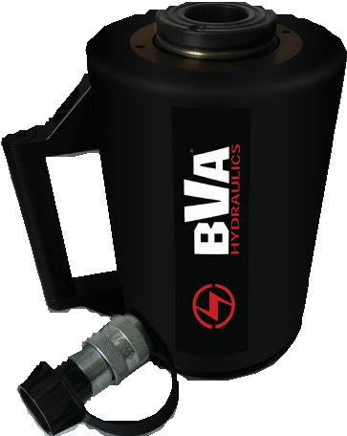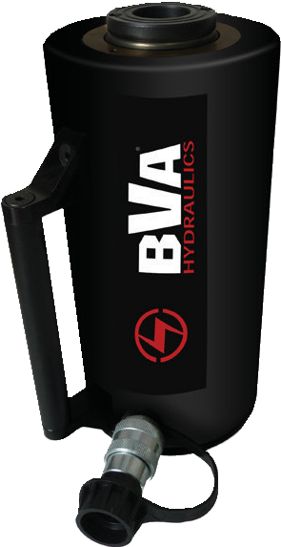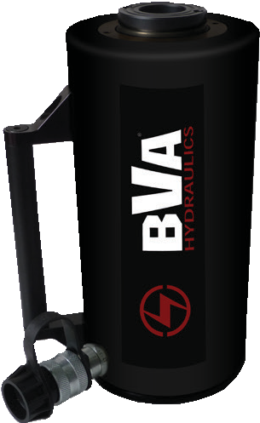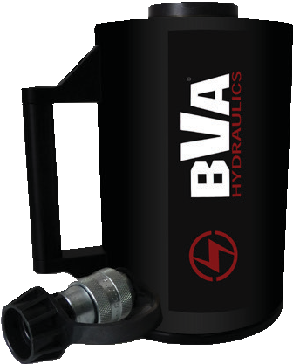Hollow Hole Aluminum Cylinders

HUC Series - Lightweight, Spring Return

Safety Practices
Good industry practice recommends not exceeding 80% of maximum rated capacities of all our products.

Related Product: Gauges
Reduce the risk of overloading your product by using a gauge.
A variety of graduations and

types to suit any need.

pg69
HUC Series

Cylinder Capacity (tons) | Stroke (in) | Model Number | Cylinder Effective Area (in2) | Oil Capacity (in3) | Weight (lbs) | Collapsed Height (in) | Extended Height (in) | Center Hole Diameter (in) | Outside Diameter (in) | Base To Advance Port  (in) | Handle or Eyelets
30 | 3.00 | HUC3003 | 7.21 | 22.00 | 22.0 | 8.68 | 11.68 | 1.31 | 5.50 | 1.00 | H
 | 6.00 | HUC3006 | 7.21 | 44.00 | 30.0 | 11.68 | 17.68 | 1.31 | 5.50 | 1.00 | H
60 | 3.00 | HUC6003 | 12.3 | 37.00 | 42.0 | 10.25 | 13.25 | 2.13 | 7.50 | 1.00 | H
 | 6.00 | HUC6006 | 12.3 | 74.00 | 55.0 | 13.25 | 19.25 | 2.13 | 7.50 | 1.00 | H

Double Acting Aluminum Hollow Hole Cylinders
HUDC Series - Lightweight

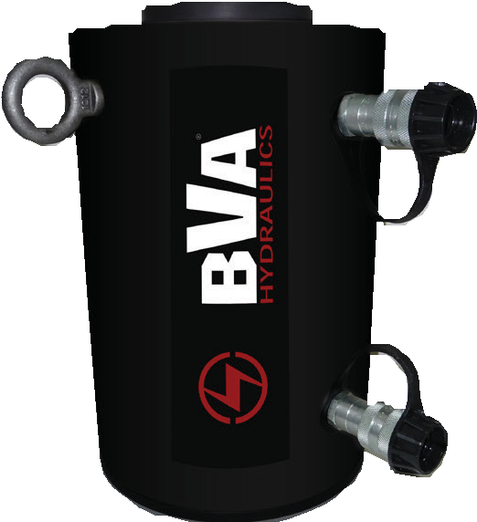
Safety Instructions
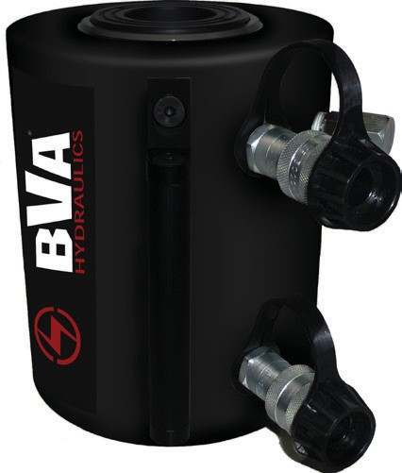
Visit our DO’S and DON’TS
section to review the best

methods of operation. Always be prepared.
pg92

Relief Valve
All double acting cylinders are equipped with a
pressure relief valve located next to the retract port.
These pressure relief valves help prevent cylinder over pressurization on the return port side of the cylinder.

HUDC Series

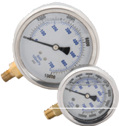

Cylinder Capacity (tons) | Stroke (in) | Model Number | Maximum  Cylinder Capacity (ton) |  | Cylinder Effective Area  (in2) |  | Oil Capacity  (in3) |  | Weight (lbs) | Collapsed Height  (in) | Extended Height (in) | Cylinder Bore Dia. (in) | Outside Dia. (in) | Base To Adv.  Port  (in) | Top To Retract Port  (in) | Handles or Eyelets
 |  |  | Push | Pull | Push | Pull | Push | Pull
30 | 6.00 | HUDC3006 | 30.00 | 10.12 | 6.35 | 2.02 | 38.07 | 12.15 | 30.0 | 11.50 | 17.50 | 1.50 | 5.50 | 2.00 | 2.00 | H
 | 10.00 | HUDC3010 | 30.00 | 10.12 | 6.35 | 2.02 | 63.45 | 20.25 | 40.0 | 15.50 | 25.50 | 1.50 | 5.50 | 2.00 | 2.00 | H
50 | 6.00 | HUDC5006 | 50.00 | 17.18 | 10.30 | 3.43 | 61.85 | 20.61 | 50.0 | 11.50 | 17.50 | 2.13 | 7.50 | 2.00 | 2.00 | H
 | 10.00 | HUDC5010 | 50.00 | 17.18 | 10.30 | 3.43 | 103.08 | 34.36 | 65.0 | 15.50 | 25.50 | 2.13 | 7.50 | 2.00 | 2.00 | H
100 | 6.00 | HUDC10006 | 100.00 | 37.55 | 21.59 | 7.51 | 129.59 | 45.06 | 125.0 | 14.50 | 20.50 | 3.50 | 11.00 | 2.50 | 2.00 | E
 | 10.00 | HUDC10010 | 100.00 | 37.55 | 21.59 | 7.51 | 215.98 | 75.10 | 142.0 | 18.50 | 28.50 | 3.50 | 11.00 | 2.50 | 2.50 | E
150 | 6.00 | HUDC15006 | 150.00 | 55.00 | 30.00 | 11.00 | 183.73 | 65.97 | 158.0 | 14.50 | 20.50 | 3.50 | 12.00 | 2.50 | 2.00 | E
 | 10.00 | HUDC15010 | 150.00 | 55.00 | 30.00 | 11.00 | 306.30 | 109.95 | 180.0 | 18.50 | 28.50 | 3.50 | 12.00 | 2.50 | 2.50 | E
1-888-332-6419
40 www.BVAhydraulics.com

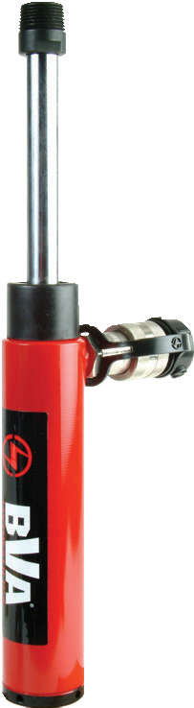
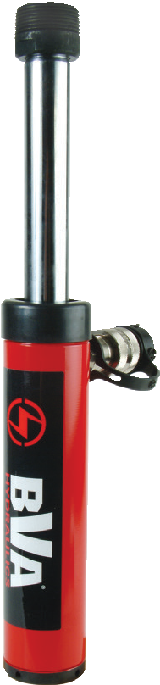
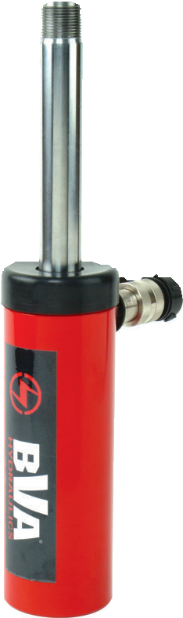
Pull Cylinders
HP Series - High-Tonnage Pulling
- High strength steel construction
- One piece high grade alloy bearing for side load protection and longer life
- Polyurethane cup seal provides optimum performance
Cylinders
- External rod threads and Internal base threads
- Used for pulling and tensioning
- Maximum working pressure: 10,000 psi / 700 bar
- Spring extend return

HP Series
Related Product: Hoses
We offer a variety of
hoses, fittings, lengths

26.81

20.87
and materials.
pg 72

3/8"-18NPTF
2.78

CP10

M30X2 M30X2
G

The CP10* comes was a male/female set. This clevis is designed to aid in pulling applications with all the HP series cylinders.
3.35
2.17

Z 3/8”-18NPTF
6.30”
3.74”

M30x2

2.56”

D A C E F H
1.38”
2.95”

L P
A
B
1.18”

* CP10 only works with HP1006

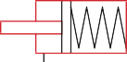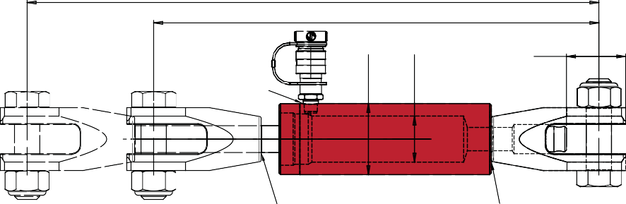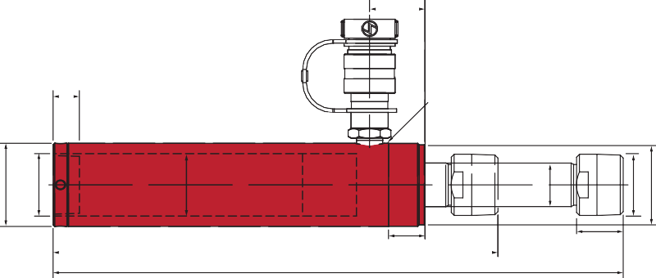

Cylinder Capacity (tons) | Stroke (in) | Model Number | Cylinder Effective Area (in2) | Internal Pressure At Capacity (psi) | Oil Capacity (in3) | Collapsed Height  A  (in) | Extended  Height B  (in) | Outside Dia. D  (in) | Cylinder Bore Dia.  C  (in) | Top to Inlet Port G  (in) | Collar
 |  |  |  |  |  |  |  |  |  |  | Thread H | Thread Length L  (in)
2.5 | 5.00 | HP0205 | 0.56 | 7,905 | 2.78 | 10.55 | 15.55 | 1.89 | 1.13 | 1.65 | 1½˝-16UN | 0.98
5 | 5.55 | HP0505 | 1.14 | 8,772 | 6.34 | 11.93 | 17.48 | 2.25 | 1.69 | 1.50 | 2¼˝-14UN | 1.00
10 | 5.95 | HP1006* | 2.44 | 7,663 | 14.48 | 11.75 | 17.70 | 3.35 | 2.17 | 1.50 | M85x2 | 1.00

Model Number | Adapter |  | Rod |  |  | Base Mounting Hole |  | Weight (lbs)
 | Thread F  (in) | Length P  (in) | Dia. E  (in) | Thread Length K  (in) | Thread Q  (mm) | Thread Y | Depth Z  (in)
HP0205 | ¾˝-14NPTF | 1.13 | 0.75 | 0.76 | M16 x 1.5 | ¾˝-14NPTF | 0.72 | 6.4
HP0505 | 1¼˝-11.5NPTF | 1.25 | 1.18 | 0.93 | M28 x 1.5 | 1¼˝-11.5NPTF | 0.95 | 9.3
HP1006* | - | - | 1.26 | 1.02 | M30 x 2 | M30x2 | 0.98 | 20.9
* CP10 only works with HP1006

41

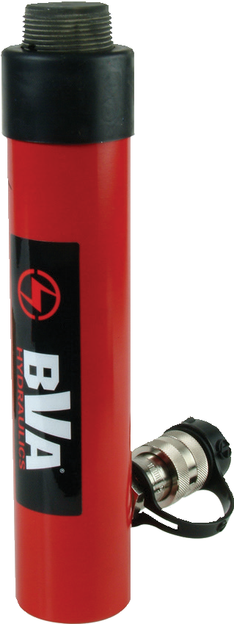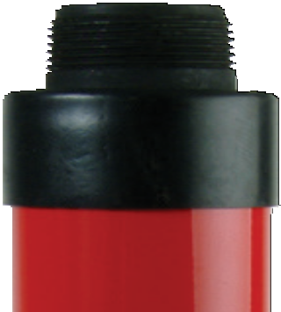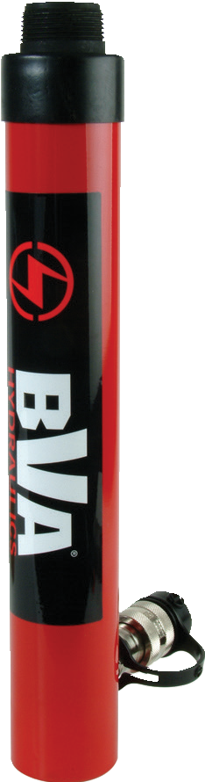Threaded Cylinders
HT Series

HT Series

- Ideal for frame pulling machines
- Threaded rod and base
- Single acting cylinders with spring return
- Removable threaded Rod adapter used to attach accessories to rod end and base
- Maximum working pressure: 10,000 psi / 700 bar

Safety Practices
Good industry practice recommends not exceeding 80% of maximum rated capacities of all our products.

Safety Instructions
Visit our DO’S and DON’TS
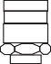section to review the best
3/8" - 18NPTF

L
V
E
K
S
A
B

methods of operation. Always be prepared.
pg 92 G

Combo Kits
Most cylinders are available in easy to order kits: cylinder,

gauge, couplers, hose and pump.
pg64
D

High-Flow Couplers T High-Flow Coupler: CH38F is
included on all models (except where specified).

Cylinder Capacity (tons) | Stroke (in) | Model Number | Cylinder Effective Area (in2) | Internal Pressure at Capacity (psi) | Oil Capacity (in3) | Collapsed Height  A  (in) | Extended  Height B  (in) | Weight (lbs)
4 | 5.07 | HT0405* | 1.00 | 10,120 | 5.00 | 10.31 | 15.39 | 5.0
10 | 5.95 | HT1006 | 2.24 | 8,928 | 13.33 | 11.46 | 17.41 | 10.6
 | 9.96 | HT1010 | 2.24 | 8,928 | 22.30 | 15.47 | 25.43 | 14.1
20 | 5.16 | HT2005 | 5.14 | 10,741 | 25.70 | 11.77 | 16.93 | 22.0

Model Number | Outside Dia. D  (in) | Rod Dia. E  (in) | Base to Inlet Port G  (in) | Collar K | Collar Thread Length L  (in) | Saddle Height S  (in) | Base Threads T  (in) | Rod Threads V  (in)
HT0405* | 1.50 | 1.33 | 1.33 | 1.5”-16UNF | 0.94 | 1.00 | ¾” - 14 NPSM | 0.75” - 14 NPTF
HT1006 | 2.26 | 1.49 | 1.67 | 2.25”-14UN | 1.13 | 0.94 | 1.25” -11.5 NPSM | 1.25” -11.5 NPSM
HT1010 | 2.26 | 1.49 | 1.67 | 2.25”-14UN | 1.13 | 0.94 | 1.25” -11.5 NPSM | 1.25” -11.5 NPSM
HT2005 | 3.35 | 2.24 | 1.85 | 3.31”-12UN | 1.98 | 1.40 | 2” -11.5 NPTF | 2” -11.5 NPSM

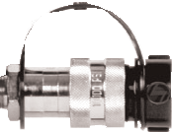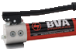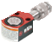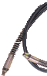1-888-332-6419
42 www.BVAhydraulics.com
- Cylinder comes with a coupler: CRZ14F instead of CH38F

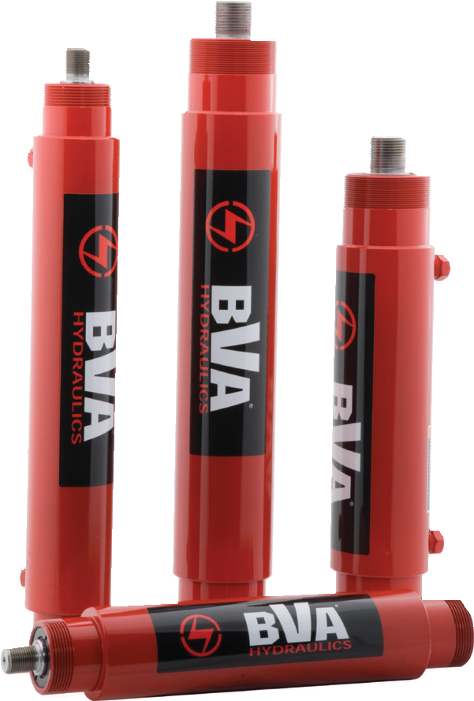 Precision Double Acting Cylinders

HPD Series - High-Cycle Fixtured Application

B

A
M L I
Cylinders
Q P
H G

E C D

F

HPD Series
*Note: Precision double acting cylinders do not come with couplers.

  - Provides hydraulic power on both extend and retract
  - Designed for high cycle production applications
  - High strength steel construction from gun drilled solid bar
  - Rod wiper seals keep dirt and contamination out

N
K 3/8"-18NPTF J

Related Product: Hoses
We offer a variety of
hoses, fittings, lengths

  - Clevis eye attachments are available
  - Maximum working pressure: 10,000 psi / 700 bar
and materials.
pg 72

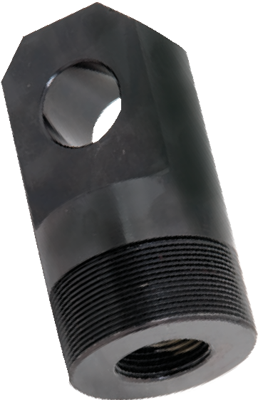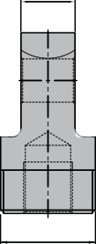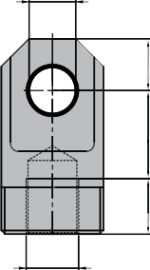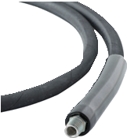

Cylinder Capacity (tons) | Model Number | Push Effective Area (in2) | Pull Effective Area  (in2) | Collapsed Height  A  (in) | Extended  Height B  (in) | Cylinder Bore Dia.  C  (in) | Outside Dia. D  (in)
9 | HPD0906 | 1.77 | 1.01 | 13.78 | 19.88 | 1.50 | 2.52
 | HPD0910 | 1.77 | 1.01 | 17.80 | 27.91 | 1.50 | 2.52
16 | HPD1606 | 3.14 | 1.56 | 15.31 | 21.57 | 2.00 | 2.99
 | HPD1610 | 3.14 | 1.56 | 19.29 | 29.53 | 2.00 | 2.99

Model Number | Rod |  |  |  | Base to Adv. Port  J  (in) | Top to Return Port  K  (in) | Collar |  |  |  |  | Weight (lbs)
 | Dia. E  (in) | Protrusion F  (in) | Thread G  (in) | Thread Length H  (in) |  |  | Length L  (in) | Thread M  (in) | Thread Length N  (in) | Int. Base Thread P  (in) | Int. Base Thread Length Q  (in)
HPD0906 | 0.98 | 0.98 | ¾″-16 | 0.75 | 1.50 | 2.20 | 1.50 | 2″-12 | 0.60 | 1-11/16″-18 | 1.37 | 14.6
HPD0910 | 0.98 | 0.98 | ¾″-16 | 0.75 | 1.50 | 2.20 | 1.50 | 2″-12 | 0.60 | 1-11/16″-18 | 1.37 | 18.5
HPD1606 | 1.42 | 1.16 | 1⅛″-12 | 0.98 | 2.12 | 2.87 | 2.12 | 2⅝″-16 | 0.98 | 2-3/16″-16 | 1.61 | 22.0
HPD1606 | 1.42 | 1.16 | 1⅛″-12 | 0.98 | 2.12 | 2.87 | 2.12 | 2⅝″-16 | 0.98 | 2-3/16″-16 | 1.61 | 28.2

A D CED Series
B By attaching this clevis eye to a HPD cylinder, you gain the ability to pull applica- tions. For use with the 9 or 16 ton HPD cylinders only.
E
Dimensions (in)
Model Number | A | B | C | D | E | F | G
CED09 | 1.00 | 0.90 | 1-11/16”-16N | 0.75 | 1.31 | 0.94 | ¾”-16N
CED16 | 1.25 | 1.10 | 2-3/16”-16N | 1.00 | 1.88 | 1.19 | 1⅛”12N

F

C G

43

Hand Pump Matching Chart

Hand Pumps
- Match up the stroke length to the capacity of your cylinder to
find the selected hand pump to go with your cylinder

Stroke (in) | Capacity (tons)
 | 5 | 10 | 15 | 25 | 30 | 55 | 75 | 100
< 1.0 | 0.69 | - | - | - | - | - | - | -
1.0 | 1.00 | 2.24 | 3.14 | 5.14 | 6.49 | 10.99 | 16.10 | 20.57
2.0 | 2.00 | 4.48 | 6.28 | 10.28 | 12.98 | 21.98 | 32.20 | 41.14
3.0 | 3.00 | 6.72 | 9.42 | 15.42 | 19.47 | 32.97 | 48.30 | 61.71
4.0 | 4.00 | 8.96 | 12.56 | 20.56 | 25.96 | 43.96 | 64.40 | 82.28
5.0 | 5.00 | 11.20 | 15.70 | 25.70 | 32.45 | 54.95 | 80.50 | 102.85
6.0 | 6.00 | 13.44 | 18.84 | 30.84 | 38.94 | 65.94 | 96.60 | 123.42
7.0 | 7.00 | 15.68 | 21.98 | 35.98 | 45.43 | 76.93 | 112.70 | 143.99
8.0 | 8.00 | 17.92 | 25.12 | 41.12 | 51.92 | 87.92 | 128.80 | 164.56
9.0 | 9.00 | 20.16 | 28.26 | 46.26 | 58.41 | 98.91 | 144.90 | 185.13
10.0 | 10.00 | 22.40 | 31.40 | 51.40 | 64.90 | 109.90 | 161.00 | 205.70
12.0 | 12.00 | 26.88 | 37.68 | 61.68 | 77.80 | 131.88 | 193.20 | 246.84
13.0 | 13.00 | 29.12 | 40.82 | 66.82 | 84.37 | 142.87 | 209.30 | 267.41
14.0 | 14.00 | 31.36 | 43.96 | 71.96 | 90.86 | 153.86 | 225.40 | 287.98
Suggested* Hand Pump Models | P350 P601S | P1000 P1201S P1201 |  | P2001 P2301 P2301M |  | P4301 |  | P8701 P8701M
*The suggested pump model is based on oil capacity requirements of the cylinder.
Matching Chart

Air, Electric, and Gas Engine Pumps

- Match up the stroke length and capacity of the cylinder to find the
suggested pump to work with your application

Stroke (in) | Capacity (tons)
 | 5 | 10 | 15 | 25 | 30 | 55 | 75 | 100
< 1.0 | 0.69 | - | - | - | - | - | - | -
1.0 | 1.00 | 2.24 | 3.14 | 5.14 | 6.49 | 10.99 | 16.10 | 20.57
2.0 | 2.00 | 4.48 | 6.28 | 10.28 | 12.98 | 21.98 | 32.20 | 41.14
3.0 | 3.00 | 6.72 | 9.42 | 15.42 | 19.47 | 32.97 | 48.30 | 61.71
4.0 | 4.00 | 8.96 | 12.56 | 20.56 | 25.96 | 43.96 | 64.40 | 82.28
5.0 | 5.00 | 11.20 | 15.70 | 25.70 | 32.45 | 54.95 | 80.50 | 102.85
6.0 | 6.00 | 13.44 | 18.84 | 30.84 | 38.94 | 65.94 | 96.60 | 123.42
7.0 | 7.00 | 15.68 | 21.98 | 35.98 | 45.43 | 76.93 | 112.70 | 143.99
8.0 | 8.00 | 17.92 | 25.12 | 41.12 | 51.92 | 87.92 | 128.80 | 164.56
9.0 | 9.00 | 20.16 | 28.26 | 46.26 | 58.41 | 98.91 | 144.90 | 185.13
10.0 | 10.00 | 22.40 | 31.40 | 51.40 | 64.90 | 109.90 | 161.00 | 205.70
12.0 | 12.00 | 26.88 | 37.68 | 61.68 | 77.80 | 131.88 | 193.20 | 246.84
13.0 | 13.00 | 29.12 | 40.82 | 66.82 | 84.37 | 142.87 | 209.30 | 267.41
14.0 | 14.00 | 31.36 | 43.96 | 71.96 | 90.86 | 153.86 | 225.40 | 287.98
Suggested Air/Electric/Gas Pump  Models | PA600 | PA1500 PA1500L PA1500M PA2000 |  |  | PA3801 PA3801M PE30M3N01A |  | PE40M3N02A PE50M3N03A PG70M3N05
1-888-332-6419
44 www.BVAhydraulics.com

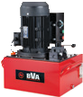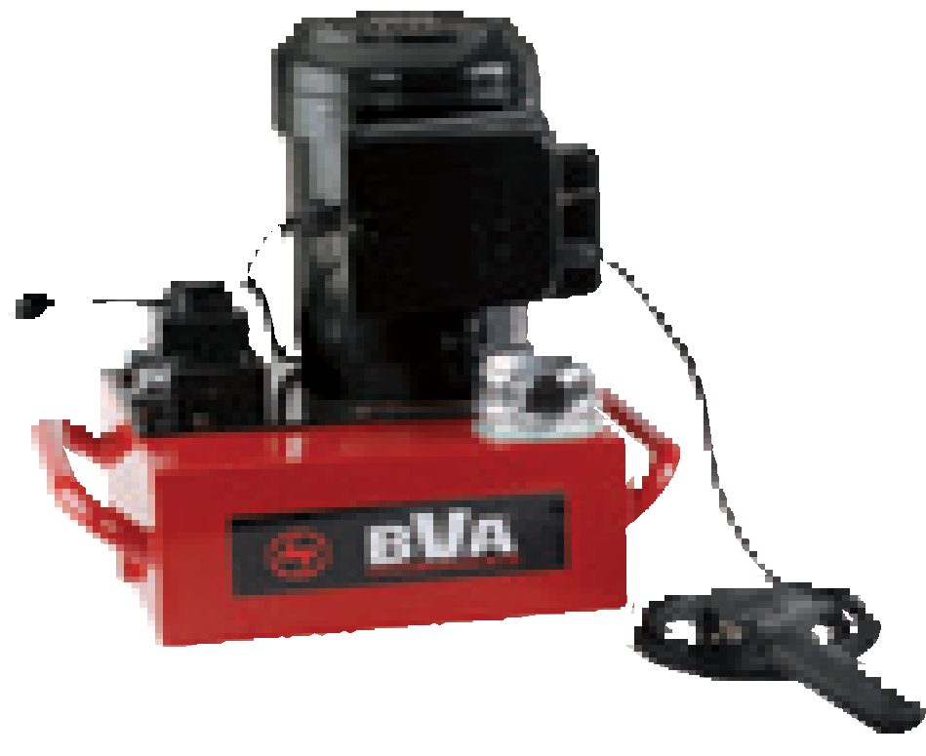
45
m
Pumps

Power | Pump Type | Page Number /
Source |  | Reference I | age
Manual | Single Speed Metal Hand Pumps (P-Series) 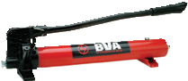 |  | 46-47
 | Two Speed Metal Hand Pumps (P-Series) 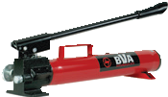
 | Two Speed Aluminum Hand Pumps (P-Series) 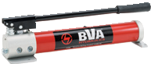
 | Double Acting Hand Pumps (P-Series) 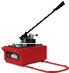
 | Low Pressure Hand Pump (P-Series) 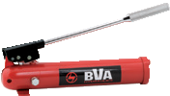
 | Two Speed Aluminum Multi Direction Hand Pump (P-Series) 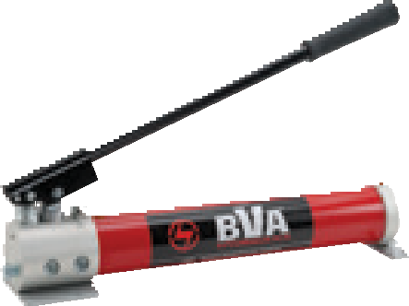
 | Foot Pump (P57-Series) 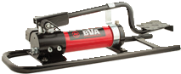 |  | 48
Air | Rotary Air Pumps (PAR-Series) 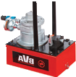 |  | 49
 | Portable Air Pump (PA-Series) 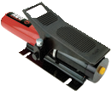 |  | 50-51
 | Metal Air Pumps (PA-Series) 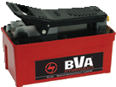
 | Double Acting Air Pump (PA-Series) 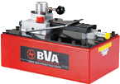
 | Remote Control Air Pump (PA-Series) 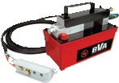
Electric | Single Phase Electric Pumps 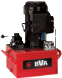 |  | 52-55
 | PE30 0.5 HP Electric Pumps 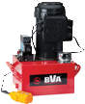
 | PE40 1.0 HP Electric Pumps 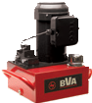
 | PE50 1.5 HP Electric Pumps
 | 3 Phase Electric Pumps |  | 56-59
 | PE40 1.0 HP 3 Phase Electric Pumps 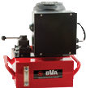
 | PE60 3.0 HP 3 Phase Electric Pumps 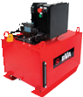
 | Universal Motor Pumps (PU-Series) 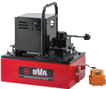 |  | 63
Gas | PG70 5.5 HP Gas Engine Pump 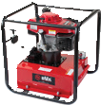 |  | 60-62
 | PG90 10.2 HP Gas Engine Pump 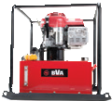
 | PD80 7.3 HP HATZ Diesel Engine Pump 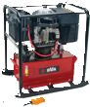
Control Valves and Accessories Page 66

Hand Pumps

Aluminum and Steel

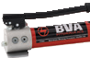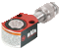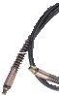 P Series
Combo Kits
Most hand pumps are available in easy to order kits; Pump, Gauge, Couplers, Hose
and Cylinder
pg
64

P1201S

Related Product: Gauges
Reduce the risk of overloading your product by using a gauge.
A variety of graduations and types to suit any need.
pg69

P601S

P240L

P350

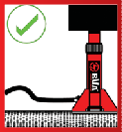P4301
Safety Instructions
Visit our DO’S and DON’TS section to review the best methods of operation.
Always be prepared.
pg
92

P2301

Product Information
- Metal reservoirs resist cracking
- Internal pressure relief valve for overload protection
- Good for use with cylinders and hydraulic tools or OEM applications
- Two-Speed pumps reduce user fatigue and increase productivity
- P1000AD can be not only be used in the standard horizontal position, but can also be used with the outlet port facing upwards or downwards positions providing more
flexibility in operation
  - P1000RP comes with a 7/16”-20 return-to-tank port for applications where
this is required

P1201

P1000

P8701M

P2301M

Model Number | Usable Oil Capacity  (in3) | Oil Outlet Port | Pressure Rating/Oil Displacement per Stroke |  | Piston Stroke (in) | Handle Operating Force (lbs) | Reservoir Construction
 |  |  | 1st Stage (psi/in3) | 2nd Stage (psi/in3)
Single Speed - Single Acting
P240L | 15 | ¼"-18 NPTF | n/a | 7,200 / 0.09 | 0.63 | 56 | Steel
P601S | 37 | ⅜"-18 NPTF | n/a | 10,000 / 0.15 | 0.79 | 109 | Steel
P1201S | 67 | ⅜"-18 NPTF | n/a | 10,000 / 0.13 | 0.82 | 89 | Steel
2-Speed - Single Acting
P350 | 21.4 | ¼"-18 NPTF | 200 / 0.18 | 10,000 / 0.05 | 0.38 | 88 | Aluminum
P1000 | 61 | ⅜"-18 NPTF | 200 / 0.81 | 10,000 / 0.14 | 0.82 | 99 | Aluminum
P1000AD* | 53-62 | ⅜"-18 NPTF | 200 / 0.81 | 10,000 / 0.14 | 0.82 | 99 | Aluminum
P1000RP** | 61 | ⅜"-18 NPTF | 200 / 0.81 | 5,000 / 0.14 | 0.82 | 99 | Aluminum
P1201 | 67 | ⅜"-18 NPTF | 200 / 0.81 | 10,000 / 0.14 | 0.82 | 99 | Steel
P2001 | 122 | ⅜"-18 NPTF | 200 / 0.81 | 10,000 / 0.14 | 0.82 | 95 | Steel
P2301 | 134 | ⅜"-18 NPTF | 200 / 0.81 | 10,000 / 0.14 | 0.82 | 99 | Steel
P4301 | 250 | ⅜"-18 NPTF | 200 / 0.81 | 10,000 / 0.14 | 0.82 | 99 | Steel
P8701 | 476 | ⅜"-18 NPTF | 290 / 7.71 | 10,000 / 0.29 | 1.69 | 143 | Steel
2-Speed - Double Acting
P2301M | 134 | ⅜"-18 NPTF | 200 / 0.81 | 10,000 / 0.14 | 0.82 | 99 | Steel
P8701M | 476 | ⅜"-18 NPTF | 290 / 7.71 | 10,000 / 0.29 | 1.69 | 143 | Steel

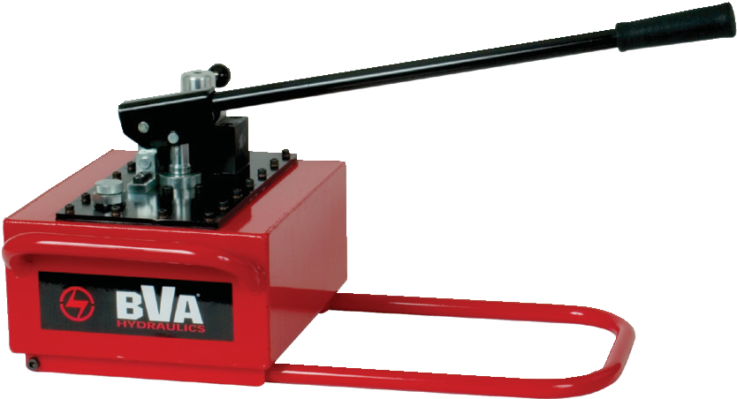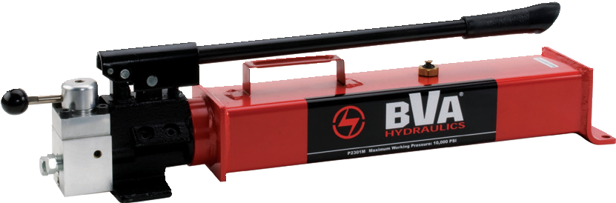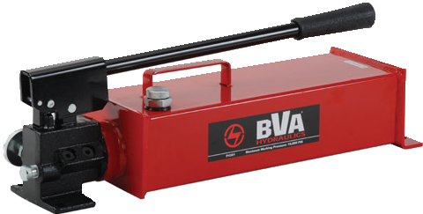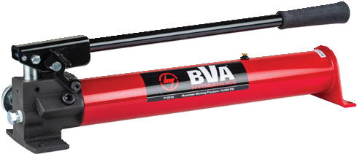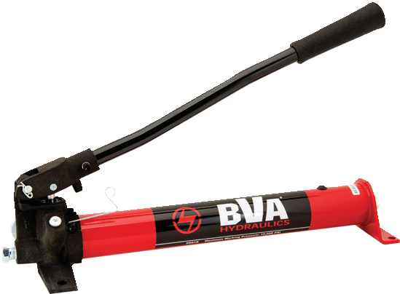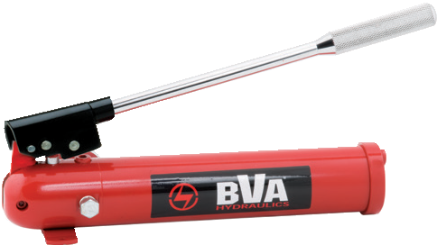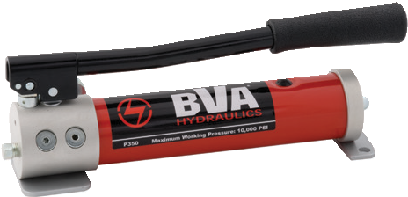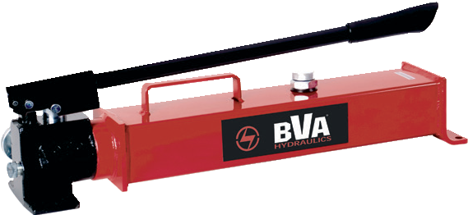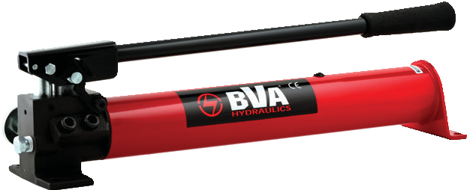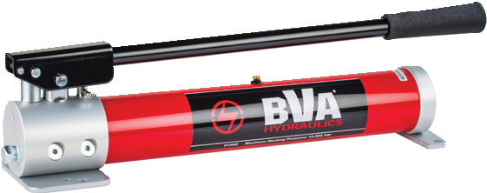1-888-332-6419
46 www.BVAhydraulics.com
- Oil capacity varies by position. Pump can be mounted outlet up or down
** Unit is equipped with a 7/16”-20 Tank Return Port

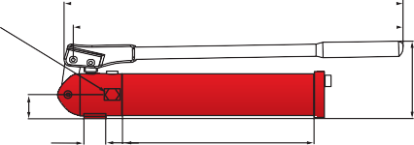
G G
⅜"-18NPTF
¼"- 18NPTF A A
G (P1201S)
G (P1201)
A (P1201S)

B
F B
F
E D D
A (P1201)

B
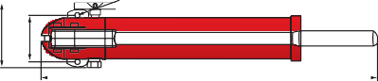
0.236Ø E C
H J F
E D
C

C
⅜”-18NPTF

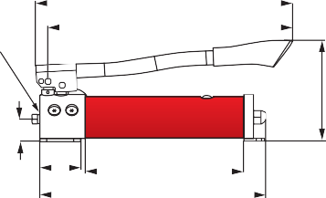
G
A
¼"-18NPTF

B

F
H J
K H J K
0.4

H J
G
Pumps
⅜” -18NPTF
K A

E D G
2°

C
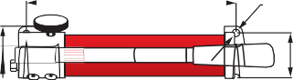
K 0.4 H J

⅜"-18NPTF

F

Ø.4
A B

B F E D C

E D H J
C (P1000 &P1000AD)
C (P1000RP) K

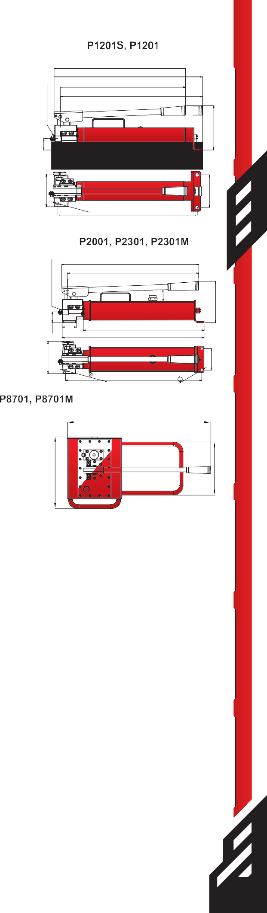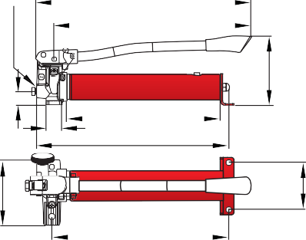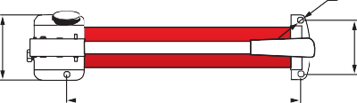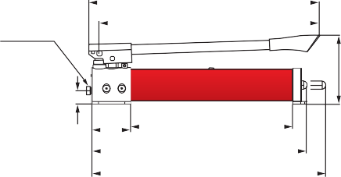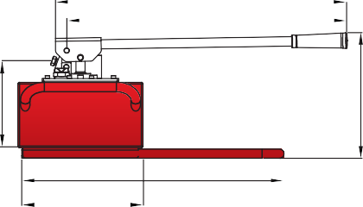
H J
G
K A C
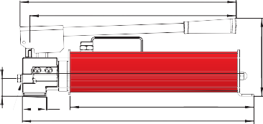
G A
F B H J
B

F
E
E D
⅜” -18NPTF C D

Model Number | Dimensions |  |  |  |  |  |  |  |  |  | Weight w/Oil (lbs)
 | A | B | C | D | E | F | G | H | J | K
Single Speed - Single Acting
P240L | 14.80 | 4.25 | 15.45 | 8.68 | 1.00 | 1.25 | 15.25 | 3.50 | 2.44 | - | 9.0
P601S | 18.94 | 6.46 | 19.53 | 15.35 | 1.57 | 1.26 | 20.79 | 5.20 | 3.74 | 14.45 | 13.0
P1201S | 20.50 | 6.50 | 21.75 | 17.50 | 2.13 | 1.75 | 22.63 | 5.25 | 3.74 | 21.25 | 20.0
2-Speed - Single Acting
P350 | 13.43 | 5.91 | 13.89 | 9.09 | 2.36 | 1.34 | 14.13 | 3.35 | 2.56 | - | 6.6
P1000 | 21.77 | 6.34 | 23.03 | 14.96 | 3.59 | 1.26 | 19.96 | 4.88 | 3.94 | 16.93 | 13.7
P1000AD* | 21.77 | 6.34 | 23.03 | 14.96 | 3.59 | 1.26 | 19.96 | 4.88 | 3.94 | 16.93 | 13.7
P1000RP** | 21.63 | 6.50 | 20.50 | 15.13 | 3.63 | 1.26 | 22.63 | 4.88 | 3.75 | 15.50 | 13.7
P1201 | 21.73 | 6.73 | 23.07 | 18.38 | 2.13 | 1.73 | 22.63 | 4.92 | 3.74 | 18.27 | 20.5
P2001 | 22.91 | 6.89 | 24.29 | 18.38 | 2.25 | 1.73 | 23.75 | 4.80 | 2.56 | - | 24.2
P2301 | 21.73 | 6.81 | 23.98 | 3.74 | 1.00 | 1.73 | 23.50 | 5.31 | 3.74 | 22.56 | 27.7
P4301 | 21.73 | 7.68 | 22.87 | 3.74 | 1.06 | 1.73 | 22.40 | 5.31 | 3.74 | 21.46 | 37.6
P8701 | 25.79 | 11.61 | 30.35 | 11.54 | 24.17 | 8.25 | 26.94 | 15.24 | 11.18 | - | 76.0
2-Speed - Double Acting
P2301M | 25.45 | 6.81 | 27.44 | 3.74 | 1.06 | 1.50 | 21.76 | 4.72 | 3.54 | 22.56 | 32.3
P8701M | 25.79 | 11.61 | 30.35 | 11.54 | 24.17 | 9.00 | 26.94 | 15.24 | 11.18 | - | 77.4
- Oil capacity varies by position. Pump can be mounted outlet up or down and does not need to be horizontal
** Unit is equipped with a 7/16”-20 Tank Return Port

47

Foot Pump

P57 Series - 10,000 PSI

3.25”
19”
P570FP

Safety Practices
Good industry practice recommends not exceeding 80% of maximum rated capacities of all our products.

Related Product: Frac/Oil Industry
Our valve seat puller is designed for removal of valve seats. Use the following model number for ordering purposes:
1.8”

3/8” - 18NPTF
7.32”
15.75”

1.06”

  - HVSP125
pg 82

SP5-3814
This combination kit will work well with this product. See our combo section for more details.
7.68”
4.53” 11.05”
24.02”

HF Kits
Consider using our portable HF kits in conjunction with this pump.

pg29
20.5”

Related Product: Nut Splitters

Safety Instructions
Visit our DO’S and DON’TS section to review the best methods of operation.
92
Always be prepared. pg
The HNS nut splitters pair up with this portable foot pump. Our hydraulic nut splitters come in a spacious tool box so its easy to carry around with you from site-to-site. This tool box is large enough to hold small cylinders, saddles, spacers or whatever tool you need to
bring with you to your next job site.

Model Number Nut Size Capacity ATF Stud Dimension

High-Flow Couplers
High-Flow Coupler: CH38F is
HNS105 HNS200
0.4375” - 0.875”
7/16” - 7/8”
1.1875” - 2.375”
0.625” - 1.4375”

included on all models (except
where specified).
HNS308 2.625” - 3.5” 1.75” - 2.25”
pg83

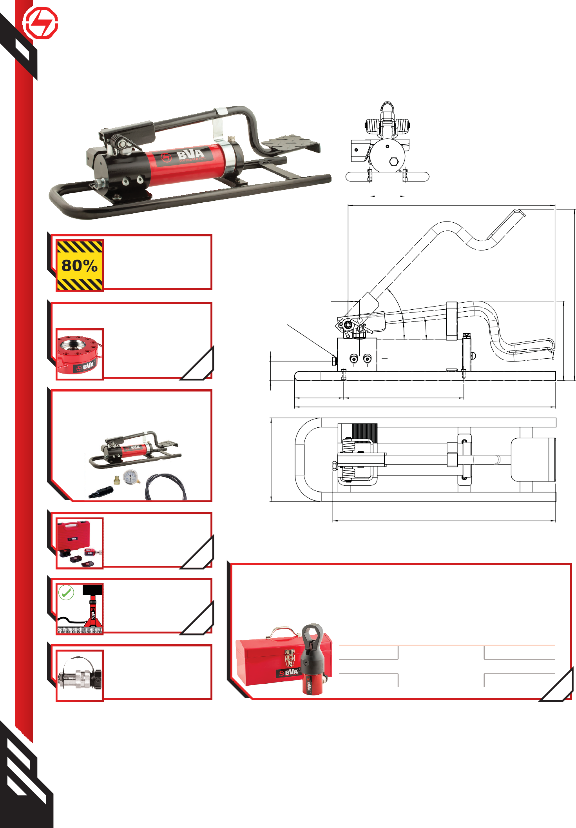

Usable Oil (In3) | Model Number | Pressure Rating (psi) |  | Oil Displacement per Stroke (In3) |  | Max. Handle Effort (lbs) | Piston Stroke | Weight (Lbs)
 |  | 1st Stage | 2nd Stage | "1st Stage" | 2nd Stage
30.50 | P570FP | 200 | 10,000 | 0.81 | 0.14 | 127.2 | 0.82 | 18.0
1-888-332-6419
48 www.BVAhydraulics.com

PARD1701

PARD1703
PARM4003

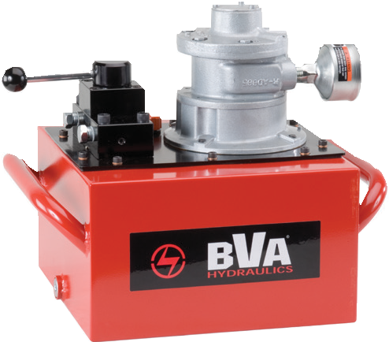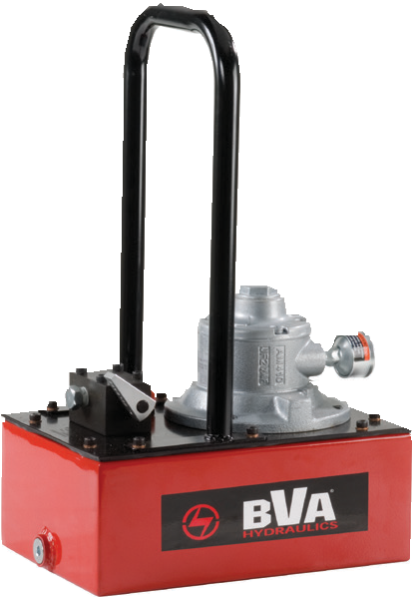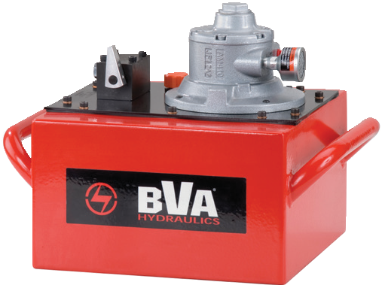PAR Series

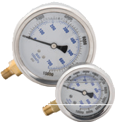
Rotary Air Pumps
PAR Series - 10,000 PSI Rated
Related Product: Gauges
Reduce the risk of overloading your product by using a gauge.
A variety of graduations and types of gauges to suit
any need. pg69
Related Product: Hoses
We offer a variety of hoses, fittings, lengths and materials.
pg
72
1/2” - NPT Air Inlet
49

PARD1701 PAR1703 and PAR4003
3/8"-18NPTF (x2)
Pumps
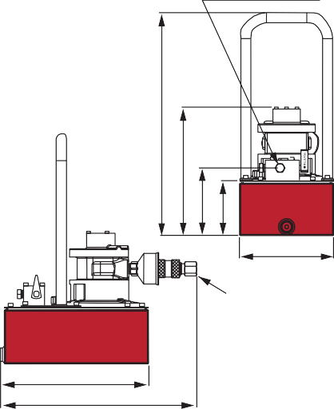3/8"-18NPTF(x2)
A
B
C D

E

1/2” - NPT Air Inlet
F
G
B
C D
E

A

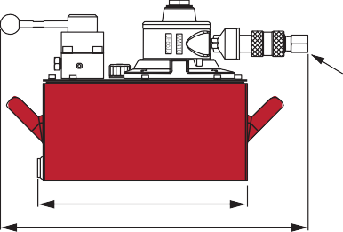
F G

Used with Cylinder | Motor Size (hp) | Usable Oil Capacity (gal) | Model Number | Pressure Rating (psi) | Pressure Rating |  | Oil Output Flow Rate |  | Valve Type | Valve Function | Air Pressure Range (psi)
 |  |  |  |  | 1st Stage (psi) | 2nd Stage (psi) | 1st Stage (in³/min) | 2nd Stage (in³/min)
Single Acting | 1.7 | 1 | PARD1701 | 10,000 | 700 | 10,000 | 313 | 22 | Dump | Advance/Return | 60 ~ 80
 | 1.7 | 3 | PARD1703 | 10,000 | 700 | 10,000 | 313 | 22 | Dump | Advance/Return | 60 ~ 80
 | 1.7 | 3 | PAR1703 | 10,000 | 700 | 10,000 | 417 | 22 | Manual PW3 | Advance/Hold/Return | 60 ~ 80
 | 4 | 1 | PARD4001 | 10,000 | 700 | 10,000 | 465 | 70 | Dump | Advance/Return | 60 ~ 100
 | 4 | 3 | PARD4003 | 10,000 | 700 | 10,000 | 465 | 70 | Dump | Advance/Return | 60 ~ 100
 | 4 | 3 | PAR4003 | 10,000 | 700 | 10,000 | 512 | 70 | Manual PW3 | Advance/Hold/Return | 60 ~ 100
Double Acting | 1.7 | 3 | PARM1703 | 10,000 | 700 | 10,000 | 417 | 22 | Manual PW4 | Advance/Hold/Return | 60 ~ 80
 | 4 | 3 | PARM4003 | 10,000 | 700 | 10,000 | 512 | 70 | Manual PW4 | Advance/Hold/Return | 60 ~ 100

Model Number | Air Consumption (cfm) | Max Sound Level  (dBA) | Dimensions (in) |  |  |  |  |  |  | Weight (lbs)
 |  |  | A | B | C | D | E | F | G
PARD1701 | 44 | 93 | 19.10 | 9.39 | 5.79 | 4.72 | 8.07 | 12.34 | 15.90 | 42.0
PARD1703 | 44 | 93 | - | 11.95 | 8.35 | 7.28 | 12.01 | 12.34 | 17.96 | 54.0
PAR1703 | 44 | 93 | 11.94 | 10.53 | 8.21 | 7.28 | 12.01 | 12.34 | 18.08 | 55.0
PARD4001 | 95 | 100 | 19.10 | 11.00 | 5.79 | 4.72 | 8.07 | 12.34 | 16.34 | 54.0
PARD4003 | 95 | 100 | - | 13.56 | 8.35 | 7.28 | 12.01 | 12.34 | 18.40 | 66.0
PAR4003 | 95 | 100 | 13.55 | 10.53 | 8.21 | 7.28 | 12.01 | 12.34 | 18.52 | 67.0
PARM1703 | 44 | 93 | 11.94 | 10.53 | 8.21 | 7.28 | 12.01 | 12.34 | 18.08 | 55.0
PARM4003 | 95 | 100 | 13.55 | 10.53 | 8.21 | 7.28 | 12.1 | 12.34 | 18.52 | 67.0

Air Pumps

Air Actuated Power

PA Series

Flow Rate @ 100 psi air pressure

70

60
Oil Flow (in3/min) 

50

40

30

20

PA1500L

PA1500

PA600H

PA600

10

0
0 2,000 4,000 6,000 8,000 10,000
Pressure (psi)
Pressure (psi) 
Model PA1500
Model PA2000 (Turbo)
Air Consumption= 7.8cfm

Product Information
- Metal reservoirs resist cracking
- US Patent No. 5,946,912, a built in bypass device protects the hydraulic system from over pumping damage
- A compact yet powerful Air Turbo Motor US
Patent No. 5,341,723
  - Suggested air inlet range: 110-175 psi / 7.6-12.1 bar
  - Maximum working pressure: 10,000 psi / 700 Bar

PA2000

PA3801

PA7550

PA1500A Pressure Adjustment
PA1500A Pressure can be adjusted externally from 1,000 to 10,000 psi.

PA7550M
PA3801M

PA1500M

Model Number | Usable Oil Capacity | Oil Outlet Port | Output Flow Rate |  | Input Air Pressure Required (psi) | Air Consumption (cfm) | Reservoir Construction
 |  |  | No Load (in3/min) | Load (in3/min)
Single Acting
PA600 | 36.6 | ⅜"-18 NPTF | 61 | 9 | 110-175 | 7.8 | Steel
PA600H | 36.6 | ⅜"-18 NPTF | 61 | 9 | 110-175 | 7.8 | Steel
PA1500 | 91.5 | ⅜"-18 NPTF | 66 | 11 | 110-175 | 7.8 | Aluminum
PA1500A* | 91.5 | ⅜"-18 NPTF | 66 | 11 | 110-175 | 7.8 | Aluminum
PA1500L** | 91.5 | ⅜"-18 NPTF | 61 | 10 | 110-175 | 7.8 | Aluminum
PA2000 | 122.1 | ⅜"-18 NPTF | 65 | 12 | 110-175 | 7.8 | Aluminum
PA3801 | 231.9 | ⅜"-18 NPTF | 65 | 11 | 110-175 | 7.8 | Steel
PA3801L** | 231.9 | ⅜"-18 NPTF | 61 | 10 | 110-175 | 7.8 | Steel
PA7550 | 460.6 | ⅜"-18 NPTF | 65 | 11 | 110-175 | 7.8 | Steel
Double Acting
PA1500M | 91.5 | ⅜"-18 NPTF | 66 | 11 | 110-175 | 7.8 | Aluminum
PA3801M | 231.9 | ⅜"-18 NPTF | 65 | 11 | 110-175 | 7.8 | Steel
PA7550M | 460.6 | ⅜"-18 NPTF | 65 | 11 | 110-175 | 7.8 | Steel

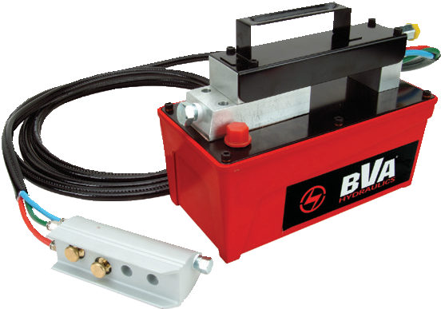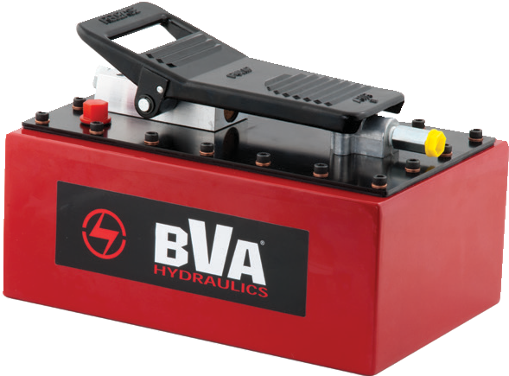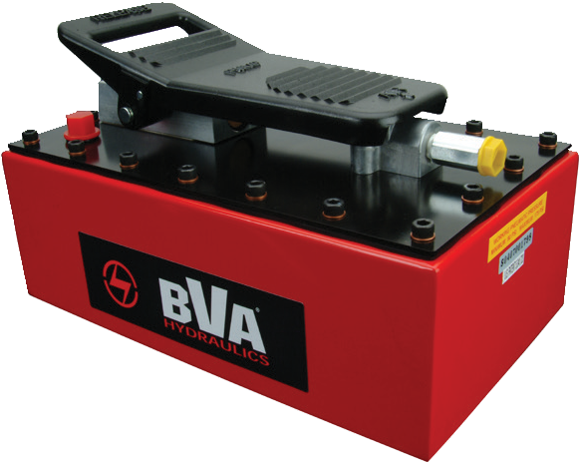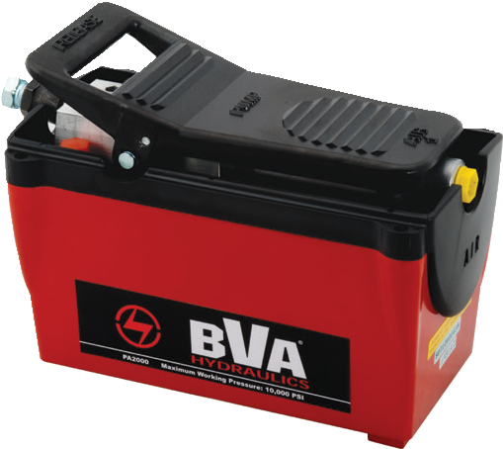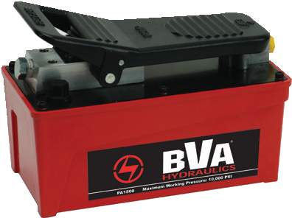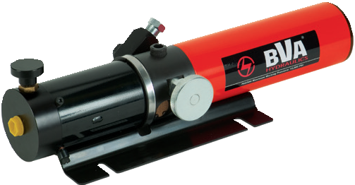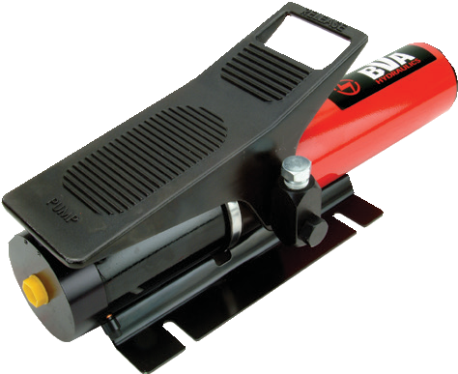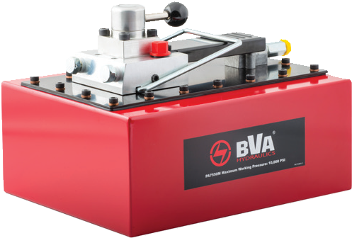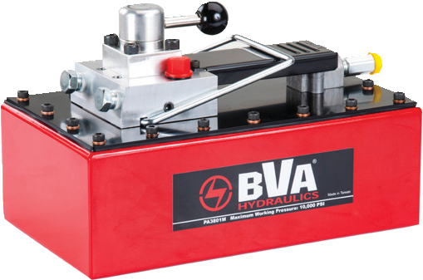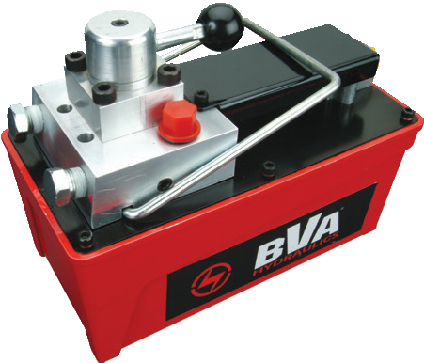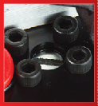1-888-332-6419
50 www.BVAhydraulics.com
- This unit is equipped with an external pressure adjustment (1,000-10,000psi)
**These pumps are equipped with a hand held air powered pendant

PA600
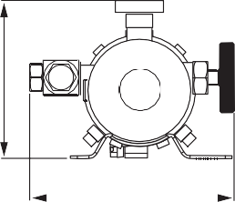
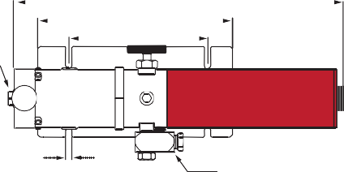
A
¼"-18NPTF
B
C

D

0.31"

⅜"-18NPTF
PA Series
E

FRL-145

¼"-18NPTF ⅜"-18NPTF

C

PA1500

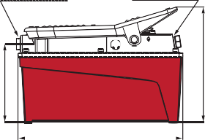
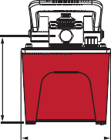

0.23"
Ø0.20"
4.57"

9.66"
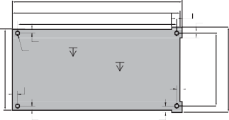
9.53"
9.05"

1.00"

0.61"
0.61"
Use in compressed air lines upstream of all PA series air/hydraulic pumps to provide clean filtered (5um), lubricated air source to ensure
long air motor life. Assembly is equipped with a
metal bowl with sight glass and a 0-145 PSIG pressure gauge. 145 PSIG maximum
Pumps

B D

A E

PA1500L
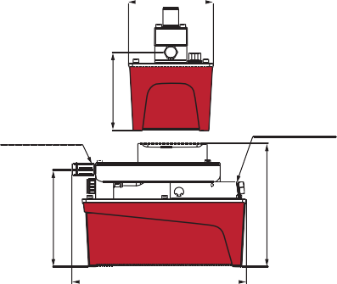
E

D
1/4-20 UNC 2A
0.30"

0.23"

PA1500M
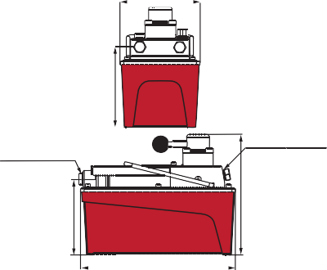
E

D
0.75"

0.35"

0.31"
working pressure. 3/8” NPT Ports. Use Class-1 Turbine Oil (ISO VG32).

AD-145
4.82"
4.12"
Use in compressed air lines upstream of BVA FRL-145 and all PA series air/hydraulic
pumps to remove 99% of free water from the air line to ensure long air motor life.
145 PSIG maximum working pressure. 3/8” NPT Ports.

1/4"-18NPTF 3/8"-18NPTF
1/4"-18NPTF

B C B

3/8"-18NPTF

Related Product: Hoses
We offer a variety of
hoses, fittings, lengths

A

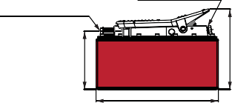
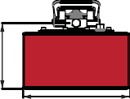
PA3801 and PA7550

A

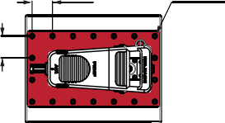
1.89”

M6x15L
and materials.
pg 72

1/4”-18NPTF
3/8”-18NPTF

C

2.04”
Air Pump Combo
Most air pumps are available in easy to order kits: pump,

B D gauge, coupler, hose
and cylinder

A E
pg64

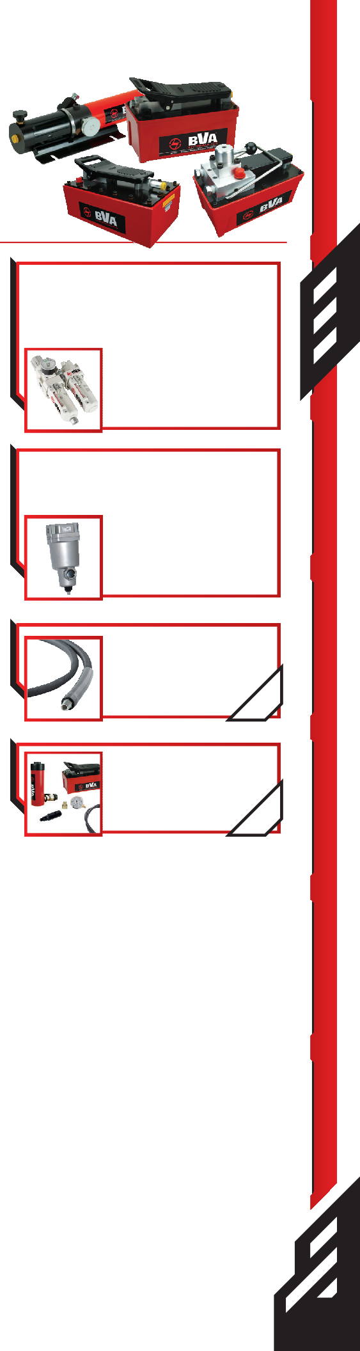
Model Number | Base Mounting Holes | Dimensions (in) |  |  |  |  | Weight w/ Oil (lbs)
 |  | A | B | C | D | E
Single Acting
PA600 | yes | 16.77 | 9.84 | 7.01 | 6.18 | 5.59 | 14.1
PA600H | yes | 16.77 | 9.84 | 7.01 | 4.49 | 5.75 | 12.5
PA1500 | yes | 10.35 | 5.00 | 7.28 | 5.16 | 5.35 | 18.1
PA1500A* | yes | 10.35 | 5.00 | 7.28 | 5.16 | 5.35 | 18.1
PA1500L** | yes | 10.96 | 6.30 | 8.03 | 5.12 | 5.35 | 19.4
PA2000 | yes | 12.64 | 6.42 | 8.15 | 5.20 | 7.36 | 20.1
PA3801 | no | 12.64 | 5.08 | 7.36 | 5.24 | 7.36 | 27.1
PA3801L** | no | 12.64 | 6.42 | 8.15 | 5.20 | 7.36 | 30.4
PA7550 | no | 12.64 | 5.00 | 8.31 | 6.14 | 8.43 | 36.0
Double Acting
PA1500M | yes | 10.51 | 5.00 | 7.99 | 5.35 | 5.35 | 19.1
PA3801M | no | 12.64 | 5.04 | 8.03 | 5.31 | 7.36 | 24.0
PA7550M | no | 12.64 | 5.98 | 9.02 | 6.34 | 10.04 | 40.0
* Unit is equipped with an external pressure adjustment (1,000-10,000psi)
**These pumps are equipped with a hand held air powered pendant

51

Electric Pumps

PE30, PE40, PE50 Series
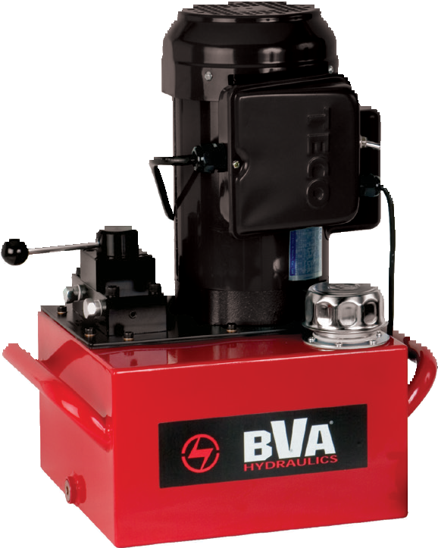
- Single Phase

- Meets OSHA regulations for sound (80dBA)
- 2 Stage pumps provide fast run up before the high pressure stage
- Suction strainers screen out contamination to prevent pump damage
- All units are wired as 120 VAC 60 Hz; Optional wiring includes 50 Hz motors and 240 VAC 60 Hz
- 100% Duty Cycle, NEMA 5 Enclosure TEFC motors
- All hand pendants are wired 24 VAC for safety
- Starts under full load

PE50W4N03A |  | Use with Cylinder Type | Flow Rate |  |  |  | Motor Size
 |  |  | 1st Stage |  | 2nd Stage
 |  |  | in3/min | psi | in3/min | psi
Dump Manual Valve w/10 ft. Motor Pendant
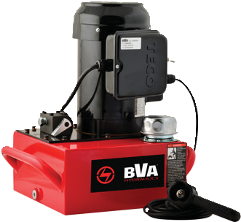 | 2W/2P  Advance/Return |  | 293 | 350 | 18 | 10,000 | 0.5 Hp
 |  |  | 311 | 700 | 37 | 10,000 | 1.0 Hp
 |  |  | 476 | 700 | 61 | 10,000 | 1.5 Hp
Dump Solenoid Valve w/10 ft. Pendant
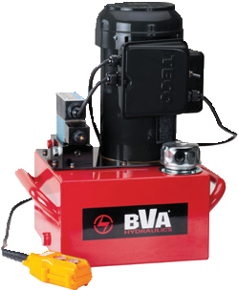 | 2W/2P  Advance  /Return (Auto*) |  | 293 | 350 | 18 | 10,000 | 0.5 Hp
 |  |  | 311 | 700 | 37 | 10,000 | 1.0 Hp
 |  |  | 476 | 700 | 61 | 10,000 | 1.5 Hp
 | 3W/2P  Advance  /Return** |  | 293 | 350 | 18 | 10,000 | 0.5 Hp
 |  |  | 311 | 700 | 37 | 10,000 | 1.0 Hp
 |  |  | 476 | 700 | 61 | 10,000 | 1.5 Hp
Manual Valve
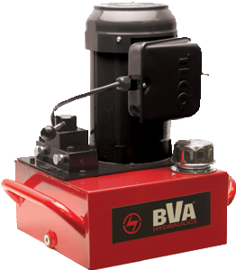 | 3W/3P  Advance  /Hold Return | 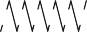 | 293 | 350 | 18 | 10,000 | 0.5 Hp
 |  |  | 311 | 700 | 37 | 10,000 | 1.0 Hp
 |  |  | 476 | 700 | 61 | 10,000 | 1.5 Hp
 | 4W/3P  Advance  /Hold/Return |  | 293 | 350 | 18 | 10,000 | 0.5 Hp
 |  |  | 311 | 700 | 37 | 10,000 | 1.0 Hp
 |  |  | 476 | 700 | 61 | 10,000 | 1.5 Hp
Manual Valve w/10 ft. Motor Pendant
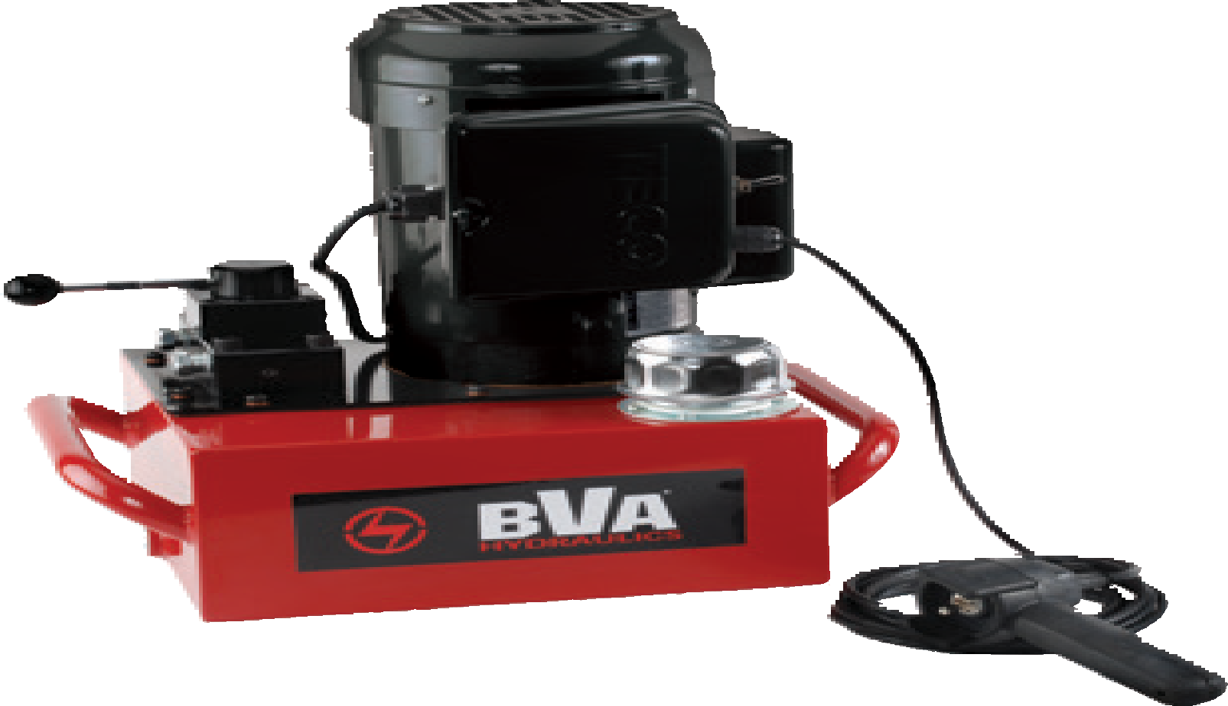 | 3W/3P  Advance  /Hold Return |  | 293 | 350 | 18 | 10,000 | 0.5 Hp
 |  |  | 311 | 700 | 37 | 10,000 | 1.0 Hp
 |  |  | 476 | 700 | 61 | 10,000 | 1.5 Hp
 | 4W/3P  Advance  /Hold/Return |  | 293 | 350 | 18 | 10,000 | 0.5 Hp
 |  |  | 311 | 700 | 37 | 10,000 | 1.0 Hp
 |  |  | 476 | 700 | 61 | 10,000 | 1.5 Hp
Solenoid Valve w/10 ft. Pendant & Locking Plate
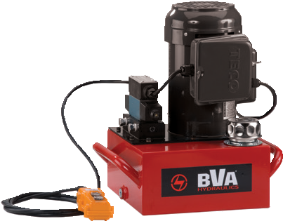 | 3W/3P  Advance  /Hold Return |  | 293 | 350 | 18 | 10,000 | 0.5 Hp
 |  |  | 311 | 700 | 37 | 10,000 | 1.0 Hp
 |  |  | 476 | 700 | 61 | 10,000 | 1.5 Hp
 | 4W/3P  Advance  /Hold/Return |  | 293 | 350 | 18 | 10,000 | 0.5 Hp
 |  |  | 311 | 700 | 37 | 10,000 | 1.0 Hp
 |  |  | 476 | 700 | 61 | 10,000 | 1.5 Hp

1-888-332-6419
52 www.BVAhydraulics.com
- Advance position holds pressure with motor running or off. Return retracts cylinder with motor off
** Advance position holds pressure with motor running and cylinder Returns when button is released.

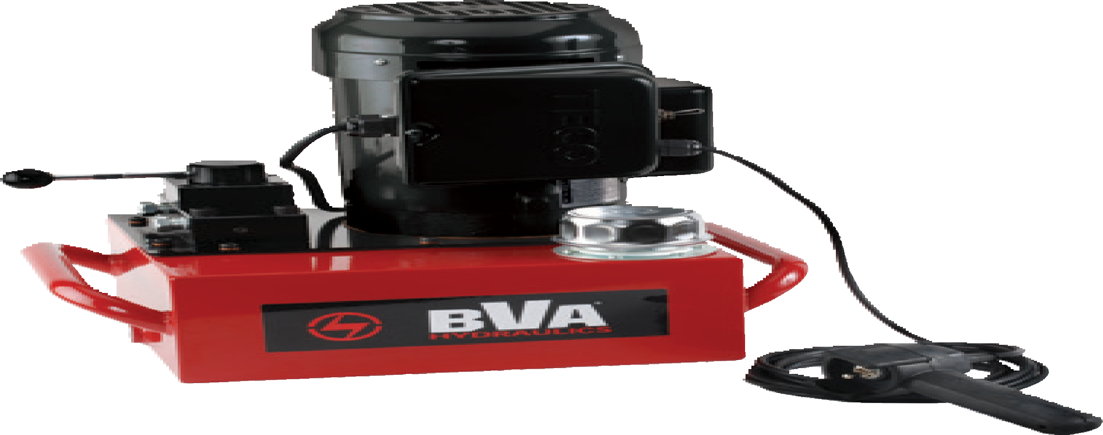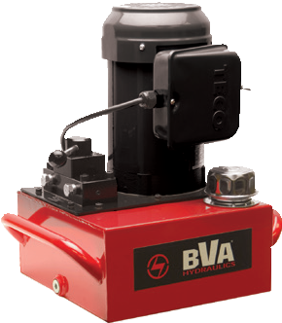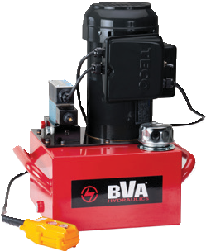
PE Series
Safety Practices
Good industry practice recommends not exceeding 80% of maximum rated capacities of all our products.
53

Electric Pumps Flow Chart
800

600
Oil Flow (in3/min) 

400

200

0
0 2,000 4,000 6,000 8,000 10,000
Pressure (psi) 

Model PE30 (0.5hp) Model PE40 (1hp)

Model PE50 (1.5hp)
Pumps

Usable Oil Capacity
1 Gal | 2 Gal | 3 Gal | 5 Gal | 10 Gal | 15 Gal | 25 Gal
Model Number | Model Number | Model Number | Model Number | Model Number | Model Number | Model Number
Dump Manual Valve w/10 ft. Motor Pendant
PE30DMP01A | PE30DMP02A | PE30DMP03A | - | - | - | -
- | PE40DMP02A | PE40DMP03A | PE40DMP05A | PE40DMP10A | - | -
- | - | PE50DMP03A | PE50DMP05A | PE50DMP10A | PE50DMP15A | PE50DMP25A
Dump Solenoid Valve w/10 ft. Pendant
PE30H2S01A | PE30H2S02A | PE30H2S03A | - | - | - | -
- | PE40H2S02A | PE40H2S03A | PE40H2S05A | PE40H2S10A | - | -
- | - | PE50H2S03A | PE50H2S05A | PE50H2S10A | PE50H2S15A | PE50H2S25A
PE30DSP01A | PE30DSP02A | PE30DSP03A | - | - | - | -
- | PE40DSP02A | PE40DSP03A | PE40DSP05A | PE40DSP10A | - | -
- | - | PE50DSP03A | PE50DSP05A | PE50DSP10A | PE50DSP15A | PE50DSP25A
Manual Valve
PE30M3N01A | PE30M3N02A | PE30M3N03A | - | - | - | -
- | PE40M3N02A | PE40M3N03A | PE40M3N05A | PE40M3N10A | PE40M3N15A | PE40M3N25A
- | - | PE50M3N03A | PE50M3N05A | PE50M3N10A | PE50M3N15A | PE50M3N25A
PE30M4N01A | PE30M4N02A | PE30M4N03A | - | - | - | -
- | PE40M4N02A | PE40M4N03A | PE40M4N05A | PE40M4N10A | PE40M4N15A | PE40M4N25A
- | - | PE50M4N03A | PE50M4N05A | PE50M4N10A | PE50M4N15A | PE50M4N25A
Manual Valve w/10 ft. Motor Pendant
PE30W3N01A | PE30W3N02A | PE30W3N03A | - | - | - | -
- | PE40W3N02A | PE40W3N03A | PE40W3N05A | PE40W3N10A | PE40W3N15A | PE40W3N25A
- | - | PE50W3N03A | PE50W3N05A | PE50W3N10A | PE50W3N15A | PE50W3N25A
PE30W4N01A | PE30W4N02A | PE30W4N03A | - | - | - | -
- | PE40W4N02A | PE40W4N03A | PE40W4N05A | PE40W4N10A | PE40W4N15A | PE40W4N25A
- | - | PE50W4N03A | PE50W4N05A | PE50W4N10A | PE50W4N15A | PE50W4N25A
Solenoid Valve w/10 ft. Pendant & Locking Plate
PE30S3L01A | PE30S3L02A | PE30S3L03A | - | - | - | -
- | PE40S3L02A | PE40S3L03A | PE40S3L05A | PE40S3L10A | PE40S3L15A | PE40S3L25A
- | - | PE50S3L03A | PE50S3L05A | PE50S3L10A | PE50S3L15A | PE50S3L25A
PE30S4L01A | PE30S4L02A | PE30S4L03A | - | - | - | -
- | PE40S4L02A | PE40S4L03A | PE40S4L05A | PE40S4L10A | PE40S4L15A | PE40S4L25A
- | - | PE50S4L03A | PE50S4L05A | PE50S4L10A | PE50S4L15A | PE50S4L25A
* Advance position holds pressure with motor running or off. Return retracts cylinder with motor off
** Advance position holds pressure with motor running and cylinder Returns when button is released.

Electric Pumps

Electric Power Source

PE30 Series

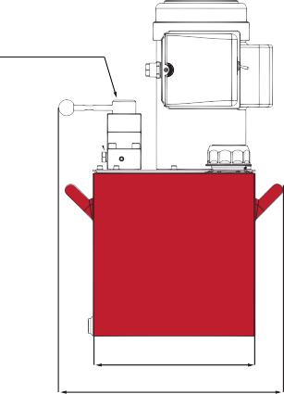
3/8"-18 NPTF

C

F 5/8”-18UNF
E D

G H
B A

PE50M4N03A

PE40/PE50 Series

Pump Accessories
See the assortment
of accessories designed to work with these pumps.
pg 69

Safety Practices
Good industry practice recommends not exceeding 80% of maximum rated capacities of all our products.

C

F 5/8”-18UNF
E
D

G
B

3/8"-18 NPTF

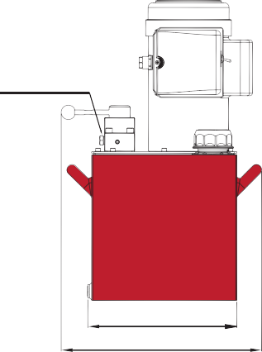
H A

Safety Instructions
Visit our DO’S and DON’TS
section to review the best
PE40/PE50 Series With Casters

methods of operation. Always be prepared.
pg 92

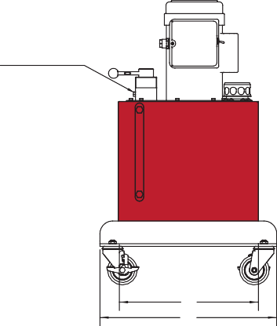
3/8"-18 NPTF

Pressure Settings
Custom pressure settings available upon request. Contact your local
BVA dealer.

C

F E D

5/8”-18UNF

Reservoir Sizing
Recommended reservoir sizing
is Extended Cylinder + Hose G
Volume Oil Capacity x 1.3 H
B
A

Reservoir Size | Dimensional Table (in) |  |  |  |  |  |  |  | Pump Weight by Series* (lbs)
 | A | B | C | D | E | F | G | H | PE30 | PE40 | PE50
1 Gal | 12.7 | 10.3 | 19.1 | 4.7 | 5.7 | 12.0 | 8.1 | 12.4 | 61.0 | - | -
2 Gal | 16.7 | 12.0 | 17.9 | 6.0 | 6.9 | 13.2 | 4.5 | 12.4 | 75.0 | 72.0 | -
3 Gal | 16.7 | 12.0 | 19.7 | 7.2 | 8.2 | 10.5 | 4.5 | 12.4 | 84.0 | 81.0 | 91.0
5 Gal | 16.7 | 12.0 | 24.8 | 12.3 | 13.2 | 15.5 | 4.5 | 12.4 | - | 102.0 | 112.0
10 Gal | 20.9 | 16.5 | 31.5 | 19.0 | 19.9 | 22.3 | 8.3 | 16.5 | - | 184.0 | 194.0
15 Gal | 20.9 | 16.5 | 34.6 | 22.1 | 23.1 | 25.4 | 8.3 | 16.5 | - | 255.0 | 265.0
25 Gal | 25.6 | 21.3 | 34.6 | 22.1 | 23.1 | 25.4 | 10.6 | 21.3 | - | 362.0 | 372.0

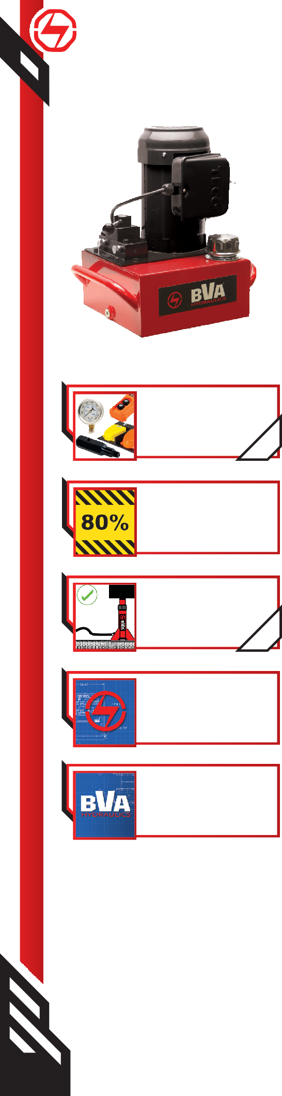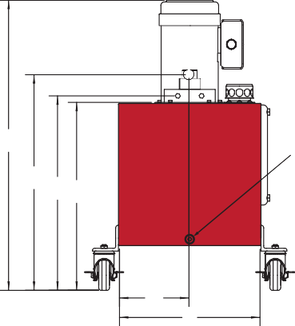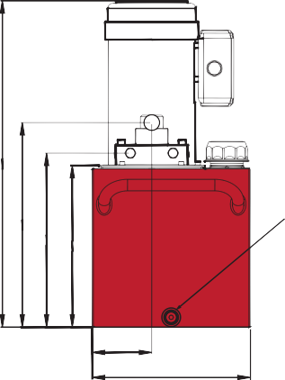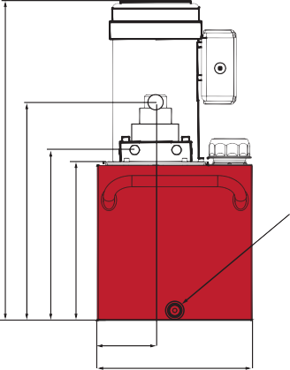1-888-332-6419
54 www.BVAhydraulics.com
- Pump weights include oil.

Single Phase Pump Matrix Chart
If you don’t see a pump that would fit your application needs, you can custom build a pump to your desired specifications. Use this Pump Matrix Chart as a guide for creating your very own custom built Electric Pump. For assistance in building your pump, call your local BVA Representative.

P
G
A
A
02
S4L
30
E

1
Product
Type
2
Motor
Type
3
Flow
Group
4
Valve Type
/Operation
5
Reservoir
Size
6 7
Voltage Pump
Options

- - Product Type
P Pump

- - Motor Type
E Induction Electric Motor, TEFC

- - Flow Group
Pumps
30 293/18 in3/min @ 350/10,000 psi, 0.5 Hp
40 311/37 in3/min @ 700/10,000 psi, 1.0 Hp
50 476/61 in3/min @ 700/10,000 psi, 1.5 Hp
- - Valve Type/Operation

CMR WMR
DMP DSP H2S
M2N M3N M4N M3L M4L W2N W3N W4N W3L W4L
S3N S4N S3L S4L
Pump Mounted Manifold Block - Pressure & Return Ports Only CMR Block w/10ft Motor Control Pendant
Dump Valve w/motor pendant 2W/2P
Dump Solenoid Valve w/pendant 3W/2P (Spool Type Valve)
Solenoid Valve 2W/2P - Pendant Control On/Off Only (Poppet Type Valve)

Manual Valve 3W/2P Manual Valve 3W/3P Manual Valve 4W/3P
Manual Valve 3W/3P w/Locking Plate Manual Valve 4W/3P w/Locking Plate
Manual Valve 3W/2P w/10ft Motor Control Pendant Manual Valve 3W/3P w/10ft Motor Control Pendant Manual Valve 4W/3P w/10ft Motor Control Pendant
Manual Valve 3W/3P w/Locking Plate and 10ft Motor Control Pendant Manual Valve 4W/3P w/Locking Plate and 10ft Motor Control Pendant
Solenoid Valve 3W/3P (Spool Type) Solenoid Valve 4W/3P (Spool Type)
Solenoid Valve 3W/3P w/Locking Plate (Spool Type Valve) Solenoid Valve 4W/3P w/Locking Plate (Spool Type Valve)

- 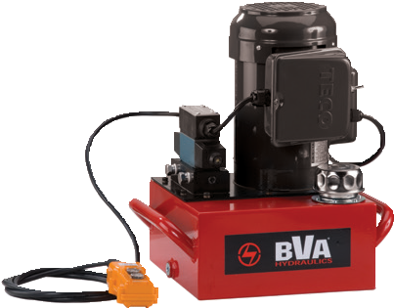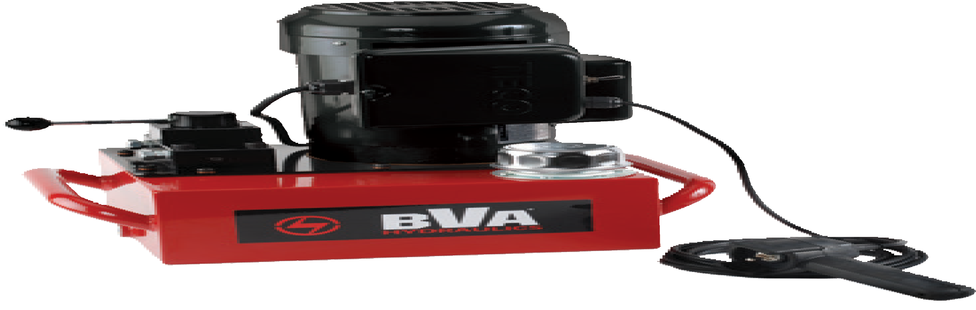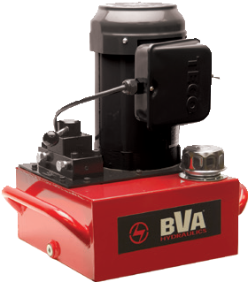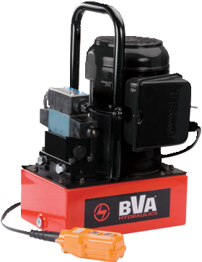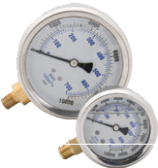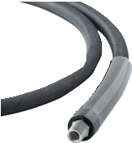- Reservoir Size
PE Series
Ordering Example
PE30S4L02A-A

After reviewing this model number, we know that the pump has the
following specifications:

- Electric power source
- ½ Hp flow group
- Solenoid Valve w/Locking Plate 4W/3P
- 2 gallon reservoir tank
- External Pressure Adjustment Block
PE30S4L02A-A
Related Product: Gauges
Reduce the risk of overloading your product by using a gauge.
A variety of graduations and types to suit any need.
pg69
Safety Instructions
Visit our DO’S and DON’TS section to review the best methods of operation.
Always be prepared.
pg
92
Related Product: Hoses
We offer a variety of hoses, fittings, lengths and materials.
pg
72
55
- 1 Gallon
- 2 Gallons
- 3 Gallons
05 5 Gallons
10 10 Gallons
15 15 Gallons
25 25 Gallons
- - Voltage
A 120V 1 ph 60 Hz - US Plug NEMA 5-15P
- 230V 1 ph 50 Hz - European Plug
- 240V 1 ph 60 Hz - No Plug
- - Pump Options
A External Pressure Adjustment Block (available on any models with 3W/3P or 4W/3P)
G Gauge w/Gauge Adapter 0-15,000 psi 2-1/2” Wet - Installed “A” Port
M Intermittent Motor Option (available on solenoid equipped models only EXCEPT H2S option)
P Pressure Switch (available on solenoid equipped models only)
U Foot Control Switch (available on solenoid equipped models only)
W Wireless Control (available on solenoid equipped models only)

Not all options are available in all configurations. Table is for reference only. Please consult your
local BVA dealer if you want to order a custom pump or if you have questions.

3-Phase Electric Pumps

Electric Power Source

PE40DSP02G

PE60S4L06G

Pressure Settings
Custom pressure settings available upon request. Contact your local
BVA dealer.

Safety Instructions
Visit our DO’S and DON’TS
section to review the best
  - All hand pendants are wired with 24 VAC
  - Quiet operation meets OSHA regulations (80dBA)
  - 2 speed operation allows for faster cylinder advance
  - Full load starting capacities
  - Internal suction strainer keeps contamination from damaging pump
  - Rugged durable design meets the demands of industrial applications
  - Precision components to minimize wear and improve overall dependability
  - Motors are rated 50/60 Hz for voltage
  - Reservoirs equipped with sight level gauges
  - PE40 models are standard as 240 VAC 60 Hz
  - PE60 Models are standard as 480 VAC 60 Hz

methods of operation. 92  Always be prepared. ^{pg} |  | Use with Cylinder Type | Flow Rate |  |  |  | Motor Size***
 |  |  | 1st Stage |  | 2nd Stage
 |  |  | in3/min | psi | in3/min | psi
Dump Solenoid Valve w/10 ft. Pendant
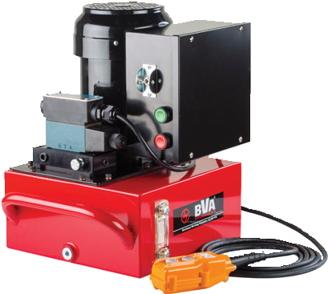 | 2W/2P  Advance/Return (Auto*) |  | 311 | 700 | 37 | 10,000 | 1.0 Hp
 |  |  | 592 | 700 | 110 | 10,000 | 3.0 Hp
 | 3W/2P  Advance/Return** |  | 311 | 700 | 37 | 10,000 | 1.0 Hp
 |  |  | 592 | 700 | 110 | 10,000 | 3.0 Hp
Manual Valve
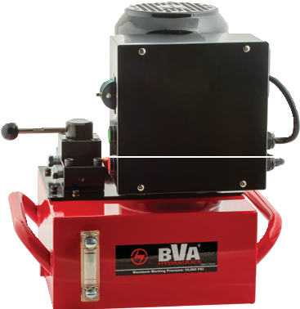 | 3W/3P  Advance/Hold Return |  | 311 | 700 | 37 | 10,000 | 1.0 Hp
 |  |  | 592 | 700 | 110 | 10,000 | 3.0 Hp
 | 4W/3P  Advance/Hold/Return |  | 311 | 700 | 37 | 10,000 | 1.0 Hp
 |  |  | 592 | 700 | 110 | 10,000 | 3.0 Hp
Solenoid Valve w/10 ft. Pendant & Locking Plate
 | 3W/3P  Advance/Hold Return |  | 311 | 700 | 37 | 10,000 | 1.0 Hp
 |  |  | 592 | 700 | 110 | 10,000 | 3.0 Hp
 | 4W/3P  Advance/Hold/Return |  | 311 | 700 | 37 | 10,000 | 1.0 Hp
 |  |  | 592 | 700 | 110 | 10,000 | 3.0 Hp

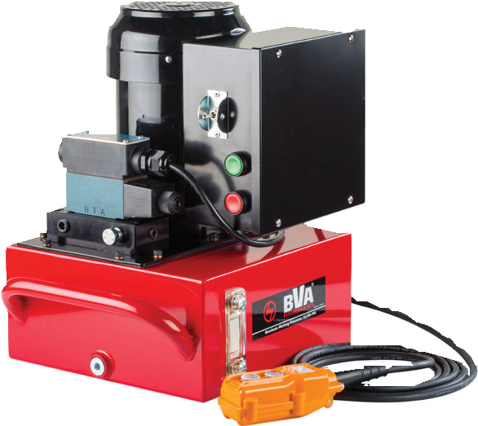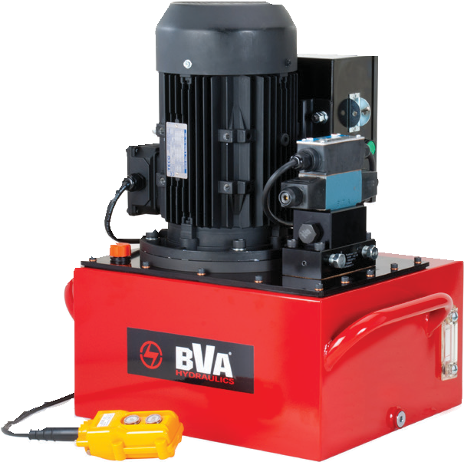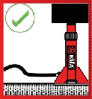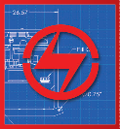1-888-332-6419
56 www.BVAhydraulics.com
- Advance position holds pressure with motor running or off. Return retracts cylinder with motor off
** Advance position holds pressure with motor running and cylinder Returns when button is released.
*** Standard voltage on the 1 Hp pump is 208-240 VAC 60 Hz; 3 Hp pump is 460-480 VAC 60 Hz

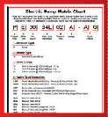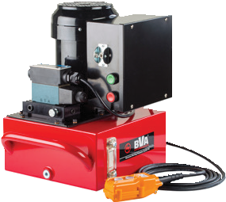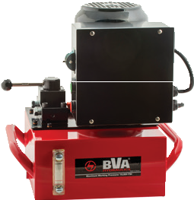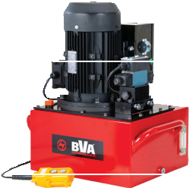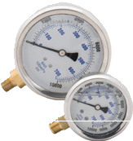
PE Series

Safety Practices
Good industry practice recommends not exceeding 80% of maximum rated capacities of all our products.

Related Product: Gauges
Reduce the risk of overloading your product by using a gauge.
A variety of graduations and types to suit any need.
pg69

Additional Voltages
Additional voltage options are available, see part number
matrix for options
pg
59
57
Pumps

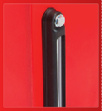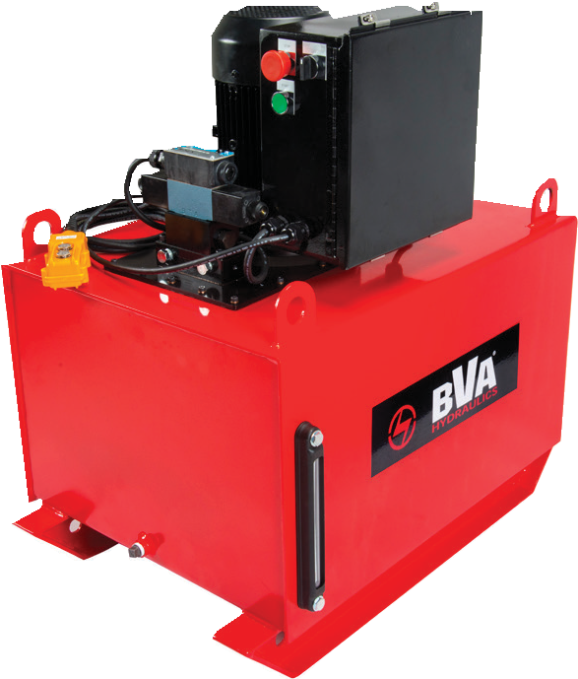
40 Gallon Reservoir Features

4 Point Lifting Eyes
PE60S4L40J

The 40-Gallon Reservoir is fabricated with a baffle separating return oil from suction oil. Comes standard with an aluminum sight and temperature gauge.

Usable Oil Capacity
2 Gal | 3 Gal | 5 Gal | 6 Gal | 10 Gal | 15 Gal | 25 Gal | 40 Gal
Model Number
Dump Solenoid Valve w/10 ft. Pendant
PE40H2S02G | PE40H2S03G | PE40H2S05G | - | PE40H2S10G | PE40H2S15G | PE40H2S25G | -
- | - | - | PE60H2S06J | PE60H2S10J | PE60H2S15J | - | PE60H2S40J
PE40DSP02G | PE40DSP03G | PE40DSP05G | - | PE40DSP10G | PE40DSP15G | PE40DSP25G | -
- | - | - | PE60DSP06J | PE60DSP10J | PE60DSP15J | - | PE60DSP40J
Manual Valve
PE40M3N02G | PE40M3N03G | PE40M3N05G | - | PE40M3N10G | PE40M3N15G | PE40M3N25G | -
- | - | - | PE60M3N06J | PE60M3N10J | PE60M3N15J | - | PE60M3N40J
PE40M4N02G | PE40M4N03G | PE40M4N05G | - | PE40M4N10G | PE40M4N15G | PE40M4N25G | -
- | - | - | PE60M4N06J | PE60M4N10J | PE60M4N15J | - | PE60M4N40J
Solenoid Valve w/10 ft. Pendant & Locking Plate
PE40S3L02G | PE40S3L03G | PE40S3L05G | - | PE40S3L10G | PE40S3L15G | PE40S3L25G | -
- | - | - | PE60S3L06J | PE60S3L10J | PE60S3L15J | - | PE60S3L40J
PE40S4L02G | PE40S4L03G | PE40S4L05G | - | PE40S4L10G | PE40S4L15G | PE40S4L25G | -
- | - | - | PE60S4L06J | PE60S4L10J | PE60S4L15J | - | PE60S4L40J
* Advance position holds pressure with motor running or off. Return retracts cylinder with motor off
** Advance position holds pressure with motor running and cylinder Returns when button is released.
*** Standard voltage on the 1 Hp pump is 208-240 VAC 60 Hz; 3 Hp pump is 460-480 VAC 60 Hz

3-Phase Electric Pumps

Electric Power Source

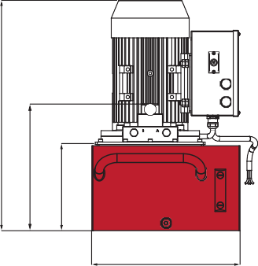
PE60S4L40J C

PE60M4N06G F
D

Safety Practices
Good industry practice B
recommends not exceeding B
80% of maximum rated capacities of all our products.

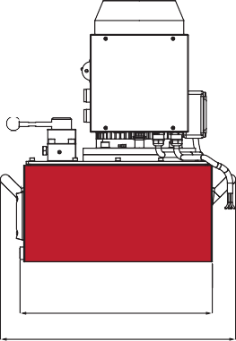
Related Product: Gauges
Reduce the risk of overloading your product by using a gauge.
A variety of graduations and types to suit any need.
pg69 C

F
Pressure Settings
Custom pressure settings available upon request.

H
Contact your local A A BVA dealer.

Reservoir Size | Dimensional Table (in.) |  |  |  |  |  | Pump Weight by Series* (lbs.)
 | A | B | C | D | F | H | PE40
2 Gal | 16.65 | 12.01 | 21.00 | 5.98 | 13.16 | 12.36 | 72.0
3 Gal | 16.65 | 12.01 | 22.25 | 7.24 | 10.51 | 12.36 | 81.0
5 Gal | 16.65 | 12.01 | 27.25 | 12.28 | 15.53 | 12.36 | 102.0
10 Gal | 20.87 | 16.54 | 28.25 | 18.98 | 22.25 | 16.54 | 184.0
15 Gal | 20.87 | 16.54 | 37.25 | 22.13 | 25.40 | 16.54 | 255.0
25 Gal | 25.59 | 21.26 | 39.25 | 22.13 | 25.40 | 21.26 | 362.0

Reservoir Size | Dimensional Table (in.) |  |  |  |  |  | Pump Weight by Series* (lbs.)
 | A | B | C | D | F | H | PE60
6 Gal | 20.63 | 14.80 | 22.95 | 8.82 | 16.04 | 16.87 | 187.0
10 Gal | 27.13 | 19.53 | 24.82 | 11.75 | 17.91 | 23.13 | 348.0
15 Gal | 27.13 | 23.46 | 24.82 | 11.75 | 17.91 | 23.13 | 396.0
40 Gal | 34.50 | 23.13 | 38.58 | 24.00 | 31.67 | - | 628.0

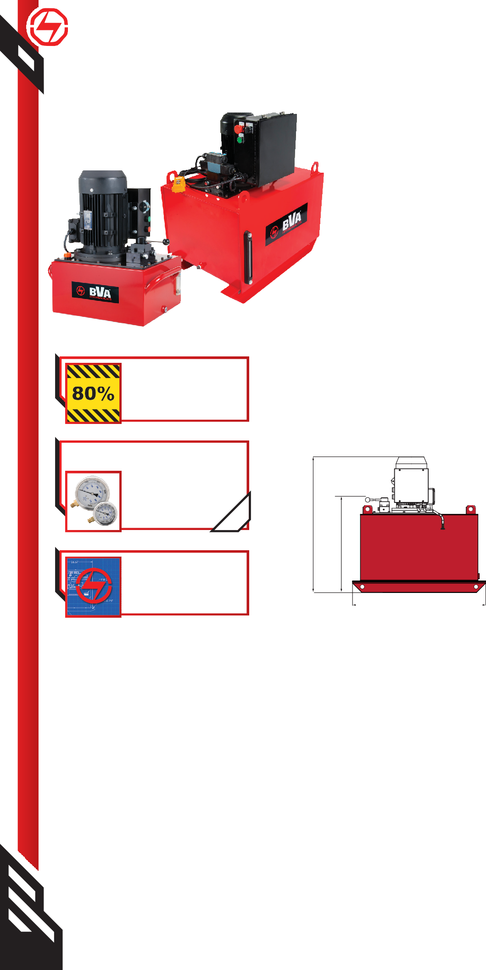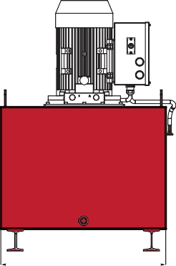1-888-332-6419
58 www.BVAhydraulics.com
  - Pump weights include oil.

3-Phase Pump Matrix Chart
If you don’t see a pump that would fit your application needs, you can custom build a pump to your desired specifications. Use this Pump Matrix Chart as a guide for creating your very own custom built Electric Pump. For assistance in building your pump, call your local BVA Representative.

P E 40 DSP 02 G A G

1
Product
Type
2
Motor
Type
3
Flow
Group
4
Valve Type
/Operation
5
Reservoir
Size
6 7
Voltage Pump
Options

1 - Product Type
P Pump

- - Motor Type
E Induction Electric Motor, TEFC

- - Flow Group
Pumps
40 311/37 in3/min @ 700/10,000 psi, 1.0 Hp
60 592/110 in3/min @ 700/10,000 psi, 3.0 Hp
- - Valve Type/Operation

CMR

DSP H2S

M2N M3N M4N M3L M4L

S3N S4N S3L S4L
Pump Mounted Manifold Block - Pressure & Return Ports Only

Dump Solenoid Valve w/pendant 3W/2P (Spool Type Valve)
Solenoid Valve 2W/2P - Pendant Control On/Off Only (Poppet Type Valve)

Manual Valve 3W/2P Manual Valve 3W/3P Manual Valve 4W/3P
Manual Valve 3W/3P w/Locking Plate Manual Valve 4W/3P w/Locking Plate

Solenoid Valve 3W/3P (Spool Type) Solenoid Valve 4W/3P (Spool Type)
Solenoid Valve 3W/3P w/Locking Plate (Spool Type Valve) Solenoid Valve 4W/3P w/Locking Plate (Spool Type Valve)

- 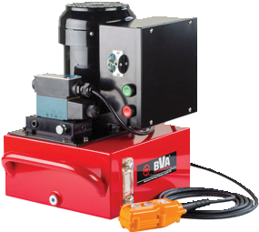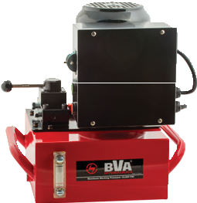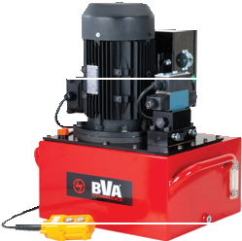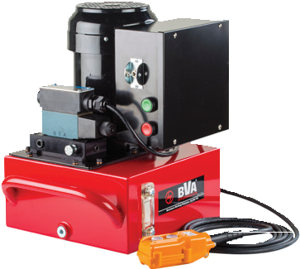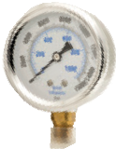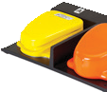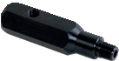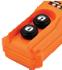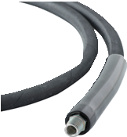- Reservoir Size
PE Series
Ordering Example
PE40DSP02G

After reviewing this model number, we know that the pump has the
following specifications:

- Electric power source
- 1 Hp flow group
- Dump Solenoid Valve w/Pendant 3W/2P
- 2 gallon reservoir tank
- 208-240V 3 ph 60 Hz Voltage - No Plug
PE40DSP02G

Pump Accessories
See the assortment
of accessories designed
to work with these pumps.
pg 69
Safety Instructions
Visit our DO’S and DON’TS section to review the best methods of operation.
Always be prepared.
pg 92
Related Product: Hoses
We offer a variety of hoses, fittings, lengths and materials.
pg
72
59
- 2 Gallon
- 3 Gallons
- 5 Gallons
- 6 Gallons
10 10 Gallons
15 15 Gallons
25 25 Gallons
40 40 Gallons
6 - Voltage
G 208-240V 3 ph 60 Hz - No Plug
W 380-415V 3 ph 50 Hz - No Plug
J 460-480V 3 ph 60 Hz - No Plug or Wire
7 - Pump Options
A External Pressure Adjustment Block (available on any models with 3W/3P or 4W/3P)
G Gauge w/Gauge Adapter 0-15,000 psi 2-1/2” Wet - Installed “A” Port
P Pressure Switch (available on solenoid equipped models only)
U Foot Control Switch (available on solenoid equipped models only)
W Wireless Control (available on solenoid equipped models only)

Not all options are available in all configurations. Table is for reference only. Please consult
your local BVA dealer if you want to order a custom pump or if you have questions.

Gas and Diesel Pumps

PG/PD Series - Portable Power

PG70M4N05

PD80S4L05

PG90S4L10

Safety Practices
Good industry practice recommends not exceeding 80% of maximum rated capacities of all our products.

Gas Pumps Diesel Pumps

Safety Instructions
Visit our DO’S and DON’TS
section to review the best

methods of operation. Always be prepared.
pg 92

Related Product: Gauges
Reduce the risk of overloading your product by using a gauge.
A variety of graduations and types to suit any need.
pg69

Related Product: Hoses
We offer a variety of
hoses, fittings, lengths

    - Gas engine pumps will provide 10,000 psi at remote locations
    - Industrial grade 5.5 or 10.2 hp Honda Gas Engine
    - Ideal for applications at remote locations
    - Two speed pump designed for rapid cylinder advance
    - Gas pump features a sturdy protective roll cage for use in the toughest environments
    - Manual control valve for use with single or

      - Diesel engine pumps will provide 10,000 psi at remote locations
      - Industrial grade 7.3 hp HATZ Diesel engine
      - Locking solenoid control valve for use with single or double acting cylinders or tools
      - Two speed pump designed for rapid cylinder advance
      - Pump features a sturdy protective roll cage for use in the toughest environments
      - Ideal for application when diesel fuel in

and materials.
pg 72
double acting cylinders or tools
      - Optional electric start
remote environments is required
        - Comes standard with electric start

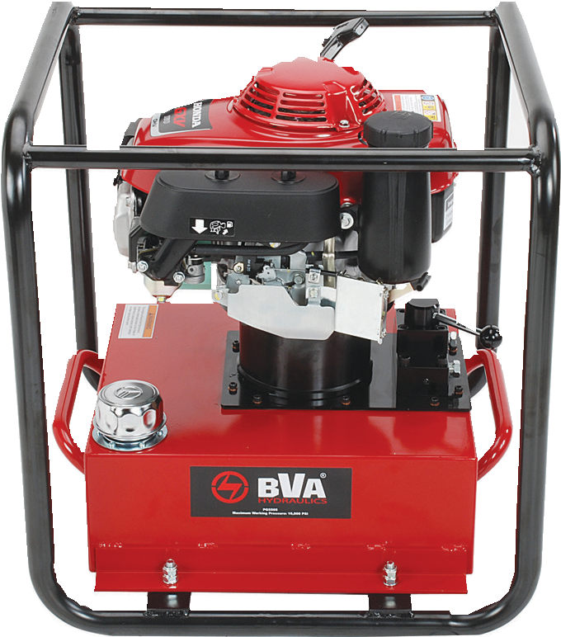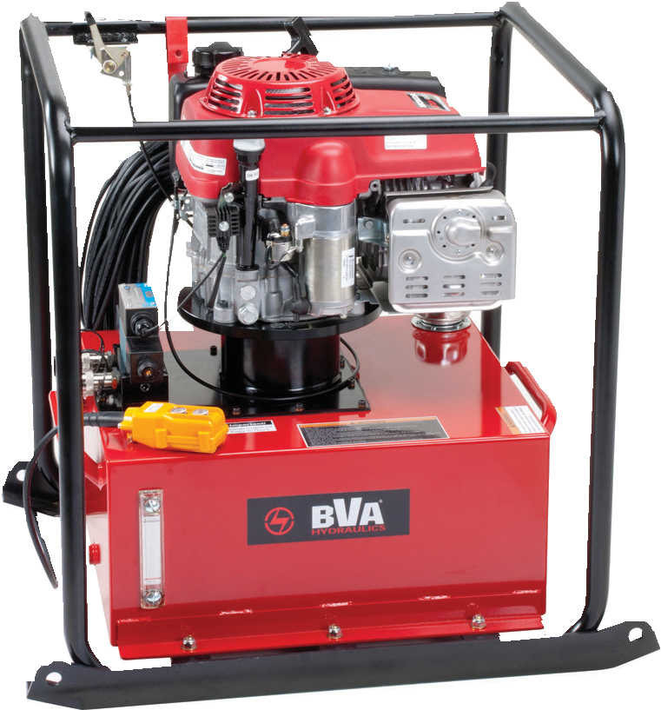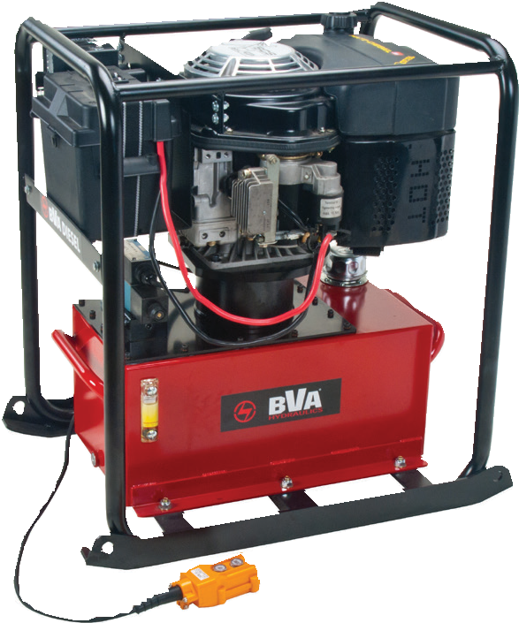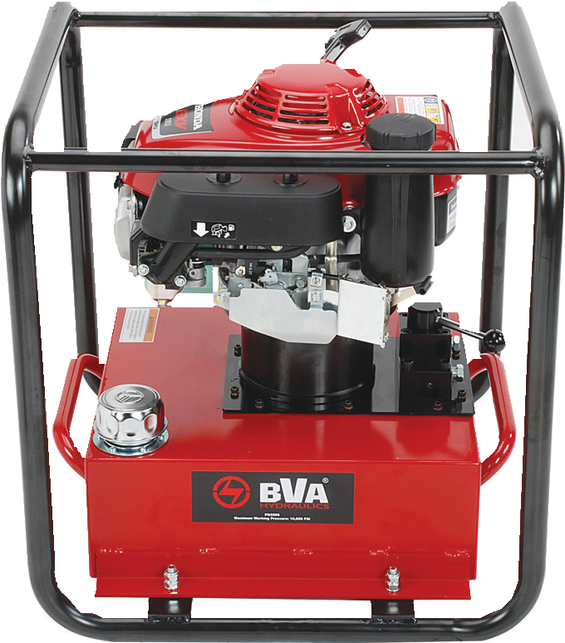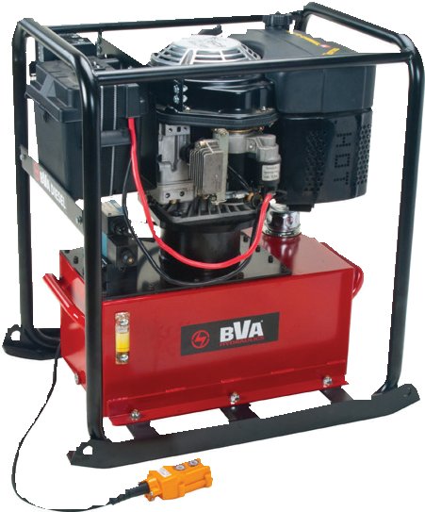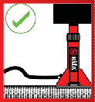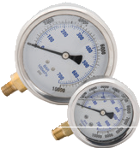

Valve Function | Valve Type | Use with Cylinder Type | Flow Rate
 |  |  | 1st Stage |  | 2nd Stage
 |  |  | in3/min | psi | in3/min | psi
3W/3P  Advance/Hold Return | Manual |  | 427 | 700 | 100 | 10,000
 | Solenoid |  | 600 | 700 | 200 | 10,000
 | Solenoid |  | 600 | 700 | 200 | 10,000
4W/3P  Advance/Hold Return | Manual |  | 427 | 700 | 100 | 10,000
 | Solenoid |  | 600 | 700 | 200 | 10,000
 | Solenoid |  | 600 | 700 | 200 | 10,000
1-888-332-6419
60 www.BVAhydraulics.com

Gas/Diesel Pump Matrix Chart
If you don’t see a pump that would fit your application needs, you can custom build a pump to your desired specifications. Use this Pump Matrix Chart as a guide for creating your very own custom gas/diesel pump. For assistance in building your pump, call your local BVA Representative.
P
G
90
S4L
10
A
G

1
Product
Type
2
Motor
Type
3
Flow
Group
4*
Valve Type
/Operation
5
Reservoir
Size
7
Pump
Options

1 - Product Type
P Pump
- - Motor Type
G Gas Motor
D Diesel Motor
- - Flow Group
Pumps
70 427/100 in3/min @ 700/10,000 psi, 5.5 Hp
80 600/200 in3/min @ 700/10,000 psi, 7.3 Hp
90 1070/200 in3/min @ 700/10,000 psi, 10.2 Hp
4* - Valve Type/Operation

CMR

DSP H2S

M2N M3N M4N M3L M4L

S3N S4N S3L S4L
Pump Mounted Manifold Block - Pressure & Return Ports Only

Dump Solenoid Valve w/pendant 3W/2P (Spool Type Valve)
Solenoid Valve 2W/2P - Pendant Control On/Off Only (Poppet Type Valve)

Manual Valve 3W/2P Manual Valve 3W/3P Manual Valve 4W/3P
Manual Valve 3W/3P w/Locking Plate Manual Valve 4W/3P w/Locking Plate

Solenoid Valve 3W/3P (Spool Type) Solenoid Valve 4W/3P (Spool Type)
Solenoid Valve 3W/3P w/Locking Plate (Spool Type Valve) Solenoid Valve 4W/3P w/Locking Plate (Spool Type Valve)

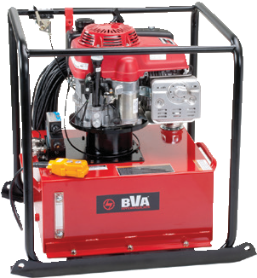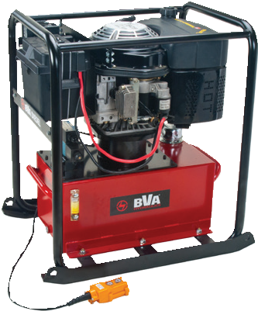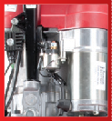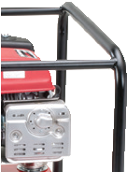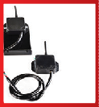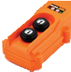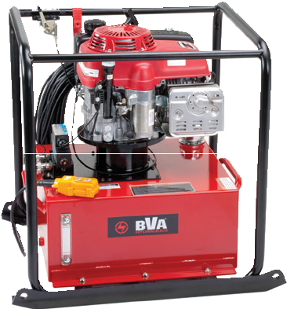5 - Reservoir Size
PG/PD Series
Ordering Example
PG90S4L10

After reviewing this model number, we know that the pump has the
following specifications:

- Gasoline power source
- 10.2 Hp flow group
- Solenoid Valve w/Locking Plate 4W/3P
- 10 gallon reservoir tank
PG90S4L10
Roll Cages
All gas and diesel pumps are equipped with roll cages to prevent any damage that might occur on a job site.
Wireless Controller
PG90 and PD80 pumps have an optional wireless controller. Visit the gas/diesel pump matrix and pump accessories page
for more details.
pg 71
Optional Electric Start
PG90 has an optional electric start.
PD80 comes standard with an electric start.
Refer to the Gas/Diesel Pump Matrix.
61
5 5 Gallons
10 10 Gallons
15 15 Gallons
25 25 Gallons
40 40 Gallons
6 - Pump Options
A External Pressure Adjustment Block (available on any models with 3W/3P or 4W/3P)
G Gauge w/Gauge Adapter 0-15,000 psi 2-1/2” Wet - Installed “A” Port
P Pressure Switch (available on solenoid equipped models only)
E Foot Control Switch (available on solenoid equipped models only)
W Wireless Control (available on solenoid equipped models only)
* Solenoid options are not available on the PG70 Series Gas Pumps

Not all options are available in all configurations. Table is for reference only. Please consult
your local BVA dealer if you want to order a custom pump or if you have questions.

Motor HP / Type | Usable Oil Capacity
 | 5 Gallons | 10 Gallons | 15 Gallons | 40 Gallons
 | Model Number | Model Number | Model Number | Model Number
Gas - 5.5 Hp Honda | PG70M3N05 | - | - | -
Gas - 10.2 Hp Honda | PG90S3L05 | PG90S3L10 | PG90S3L15 | PG90S3L40
Diesel - 7.3 Hp HATZ | PD80S3L05 | PD80S3L10 | PD80S3L15 | PD80S3L40
Gas - 5.5 Hp Honda | PG70M4N05 | - | - | -
Gas - 10.2 Hp Honda | PG90S4L05 | PG90S4L10 | PG90S4L15 | PG90S4L40
Diesel - 7.3 Hp HATZ | PD80S4L05 | PD80S4L10 | PD80S4L15 | PD80S4L40

Gas and Diesel Pumps
PG70/PG90/PD80 Series

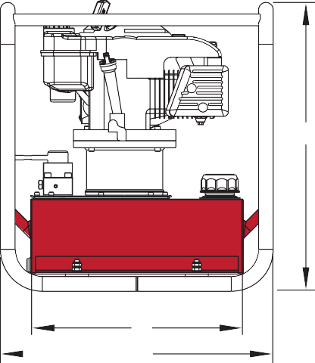
PD80S4L05

PG90M4N10

Safety Practices ^{H}
Good industry practice recommends not exceeding 80% of maximum rated
capacities of all our products. G
F E

Related Product: Gauges
D
Reduce the risk of overloading B

your product by using a gauge. A variety of graduations and
types to suit any need.
C A

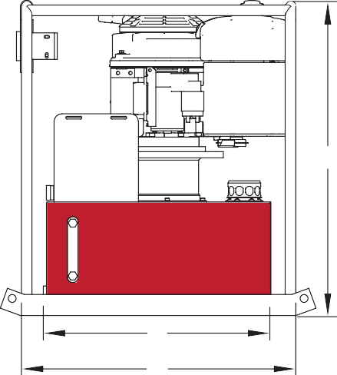
pg69

Safety Instructions
Visit our DO’S and DON’TS
section to review the best H

methods of operation. Always be prepared.
pg 92

G
F E
Related Product: Hoses
We offer a variety of
hoses, fittings, lengths D B

and materials.
pg 72
C A

Model Number* | Dimensions (in) |  |  |  |  |  |  |  | Weight** (lbs)
 | A | B | C | D | E | F | G | H
Gas Pumps
PG70xxx05 | 26.57 | 21.50 | 20.94 | 10.47 | 11.50 | 12.43 | 15.47 | 24.70 | 162
PG90xxx10 | 28.25 | 23.37 | 27.00 | 13.50 | 12.00 | 12.93 | 17.38 | 24.70 | 303
PG90xxx15 | 28.25 | 23.37 | 27.00 | 13.50 | 12.00 | 12.93 | 17.38 | 24.70 | 372
Diesel Pumps
PD80xxx05 | 26.57 | 21.50 | 20.94 | 10.47 | 11.50 | 12.43 | 15.47 | 32.60 | 255
PD80xxx10 | 28.25 | 23.37 | 27.00 | 13.5 | 12.00 | 12.93 | 17.38 | 32.60 | 329
PD80xxx15 | 28.25 | 26.00 | 27.00 | 13.5 | 12.00 | 12.93 | 17.38 | 32.60 | 403

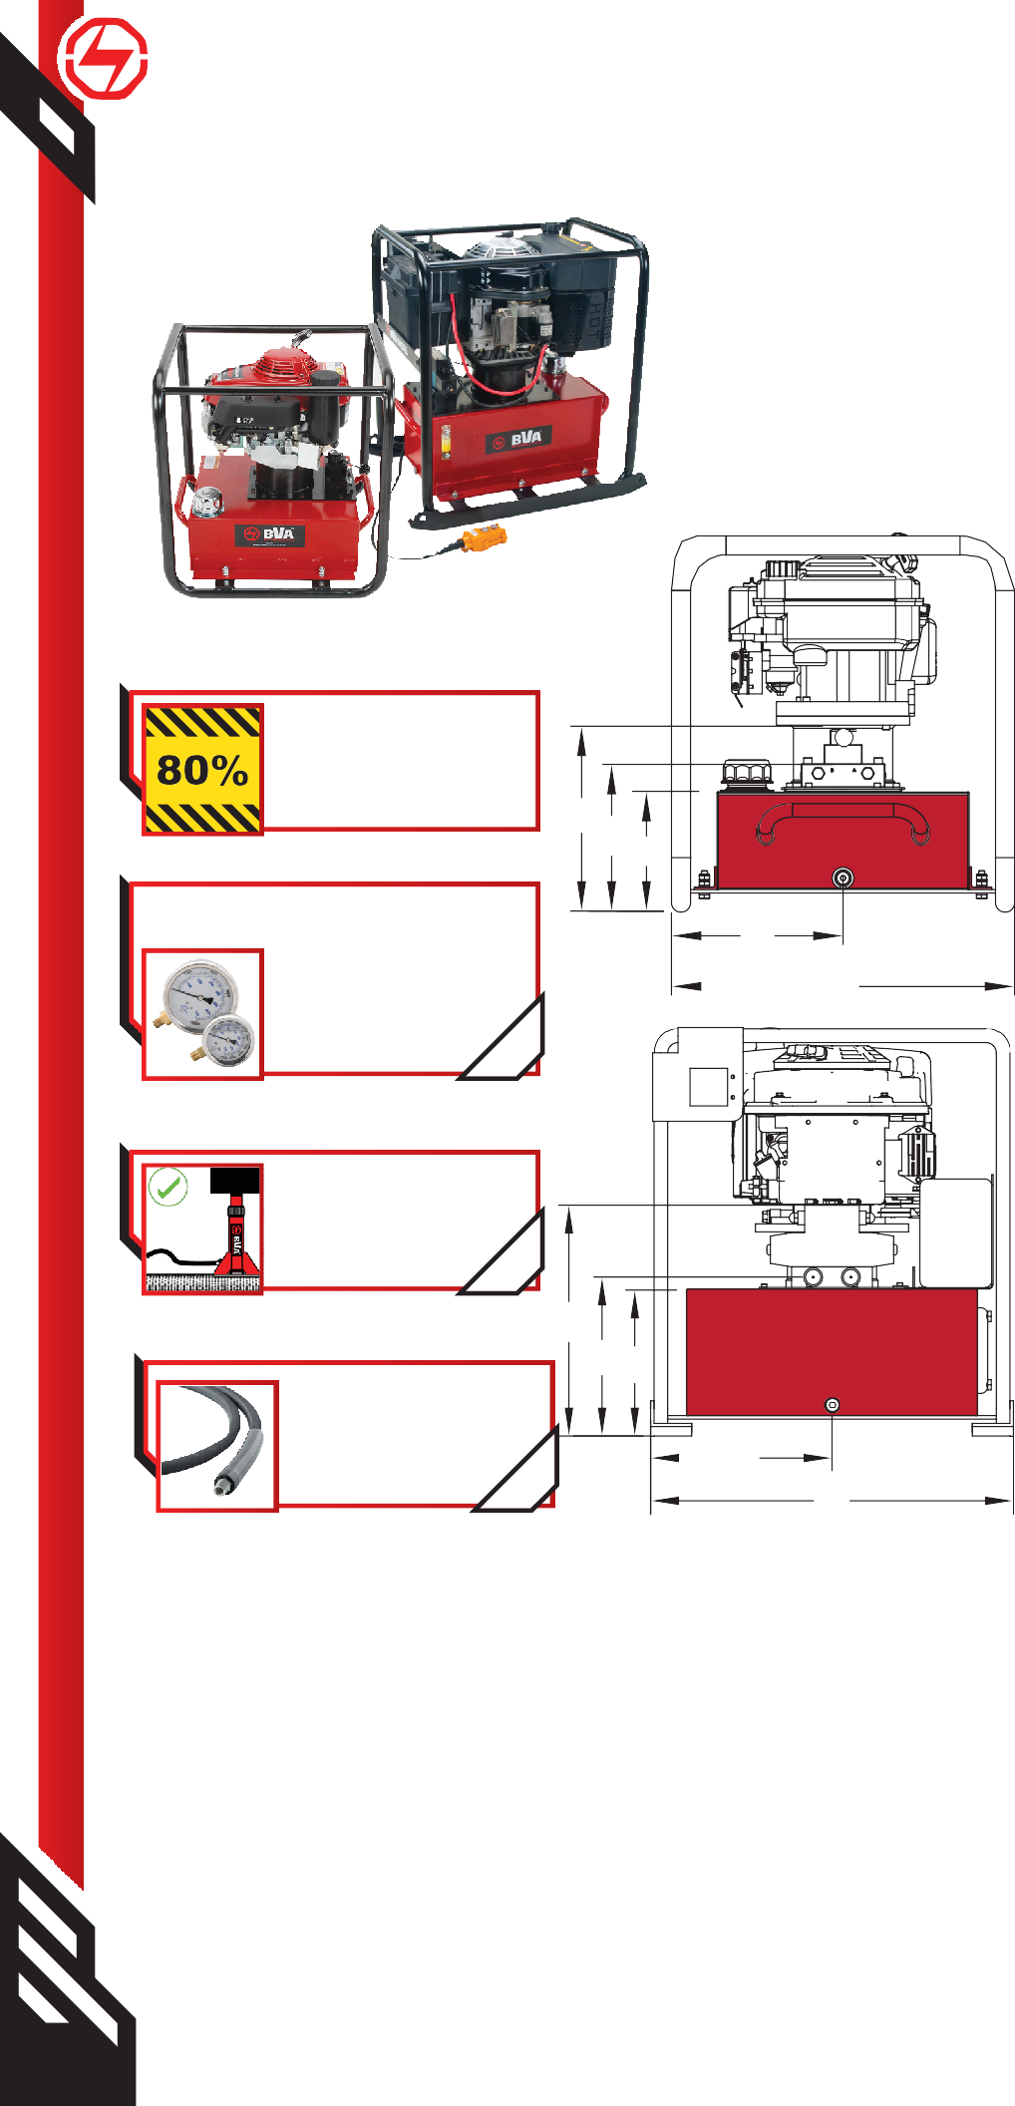1-888-332-6419
62 www.BVAhydraulics.com
- “xxx” in the model number refers to the type of valve you may use on the gas/diesel engine pump. Refer to your local BVA dealer or the Matrix Chart (on page 61) to build your own pump.
** Pump weights include oil.

Universal Motor Pumps

PU Series - Light-Weight Pumps

  - Portable, light weight and compact design
  - Universal Motor, starts under full load and is available in either 120VAC 50/60 HZ or 240VAC 50/60HZ
  - 10ft 24 VAC pendant control for safety
  - Weighs only 37 lbs. with oil
  - External pressure adjustment is available
  - Designed for intermittent duty operation
  - Gauge port on control valve

PU20M4N01B

PU20DMP01B

Hydraulic Gear Pullers
Pumps
5, 10, 15, 25, 50 & 100 Ton Hydraulic Gear Pullers come with a safety cage design help
keep the jaws tight to the gear and prevent slippage that can cause injury. Pair these with BVA’s PU20M3N01B Lightweight

e-pump for portability.
pg 83

12.99”

1/4”-NPTF
1/4”-NPTF

1/4”-NPTF
Hydraulic Nut Splitters
Available in 3 models, each nut splitter can
split a wide range of nut sizes thereby
reducing the number of splitters needed. The BVA PU20DMP01B dump style pump works well with

these splitters
pg 83

3/8”-18NPTF
8.07”
7.95”

5.51”

4.45”

5.59”

Flange Spreaders
BVA’s Pin Type Flange Spreaders are
available in both 5 & 10 Ton models and well suited for most environments. For portability and speed the PU20M3N01B would be an ideal choice. pg 81

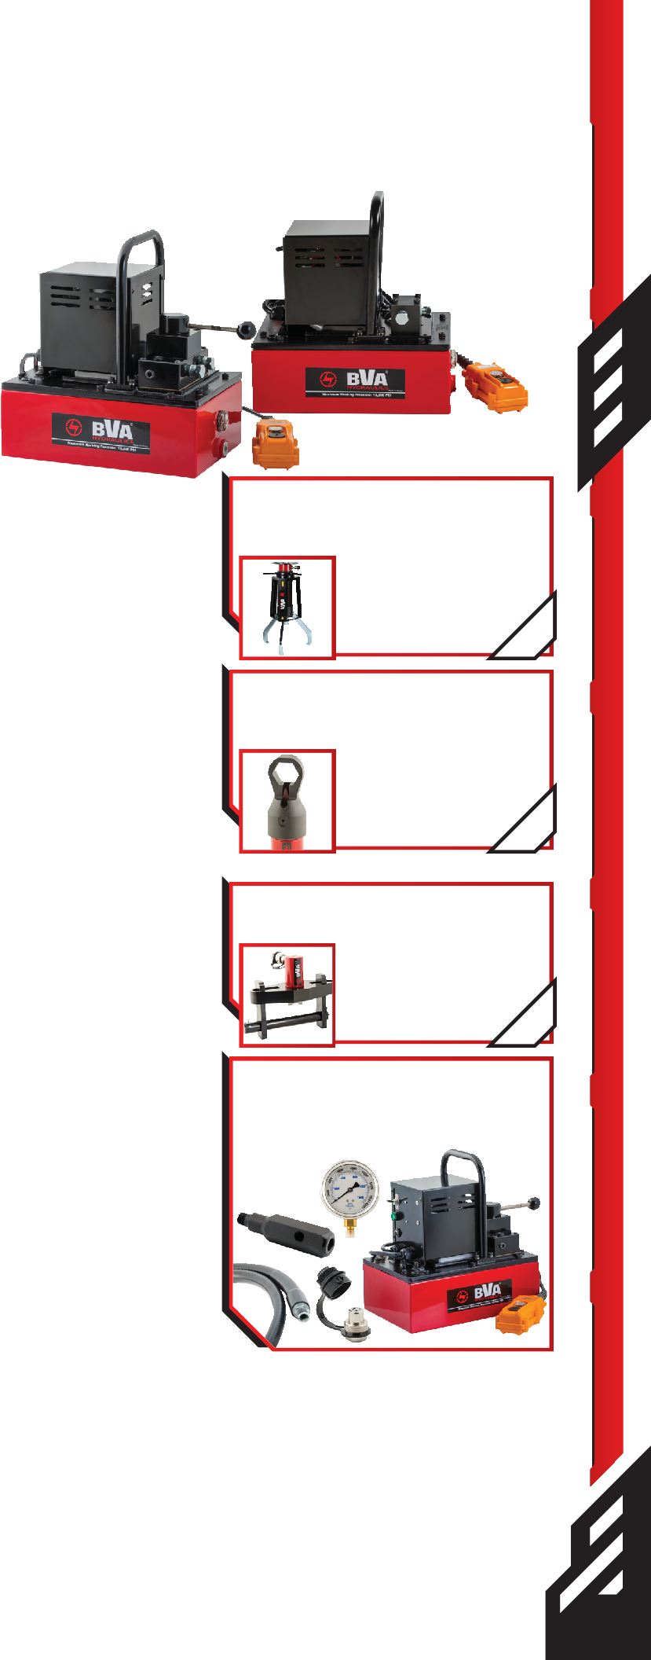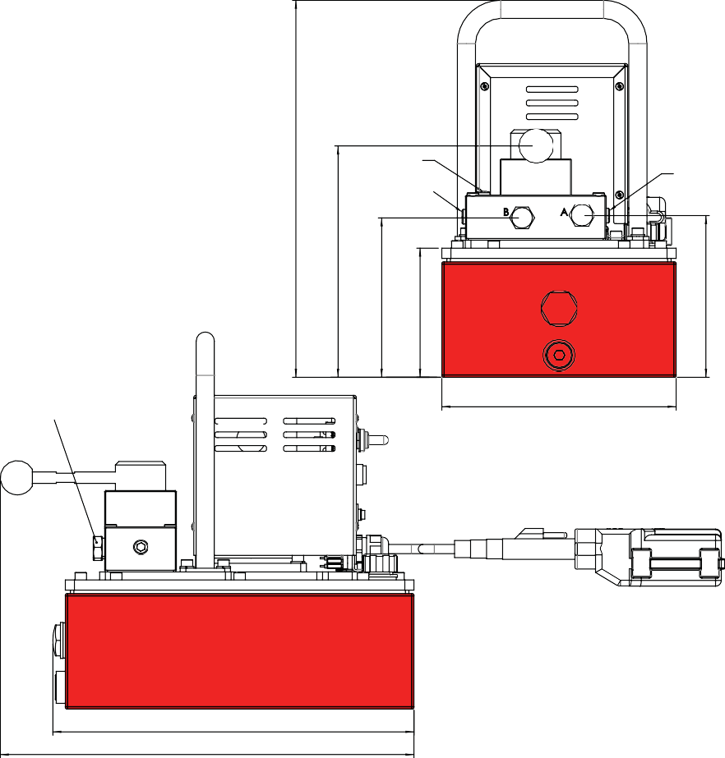
HGP-1 Pump Kit

HGP-1 Pump Kit contains: PU20M3N01B, CF3814, GW2514, CS3838C, and CH38M

12.44”
14.25”

Valve Function | Flow Rate |  |  |  | Motor Size | Voltage 50/60 Hz |  | Weight (lbs) | Length (in) | Width (in) | Height (in)
 | 1st Stage |  | 2nd Stage |  |  | 120 VAC | 240 VAC
 | in3/min | psi | in3/min | psi |  | Model # | Model #
2W/2P Advance/Return | 133 | 200 | 28 | 10,000 | 1.0 Hp | PU20DMP01B | PU20DMP01C | 37.0 | 12.44 | 8.07 | 11.81
3W/3P Advance/Hold Return | 133 | 200 | 28 | 10,000 | 1.0 Hp | PU20M3N01B | PU20M3N01C | 37.0 | 14.25 | 8.07 | 11.81
4W/3P Advance/Hold/Return | 133 | 200 | 28 | 10,000 | 1.0 Hp | PU20M4N01B | PU20M4N01C | 37.0 | 14.25 | 8.07 | 11.81

63

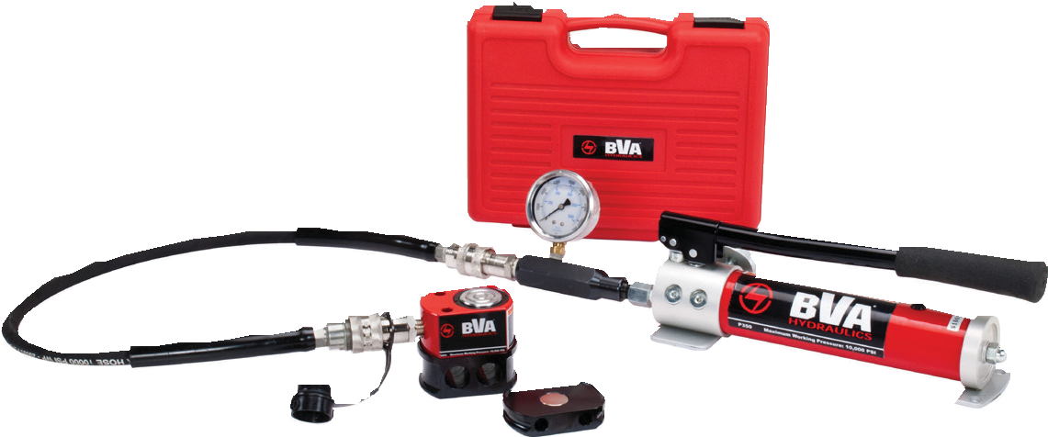
Combinations

Pump and Cylinder Sets
Each set includes:
  - ¼" ID 6 foot Hydraulic Hose
  - ⅜" High Flow Male Coupler
  - Adapter (SP3 Models Only)
  - 2½" Face Diameter Wet Gauge

Single Acting Cylinder Type | Cylinder |  |  |  | Hand Pump P350  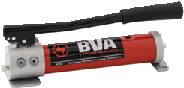 | Hand Pump P1000  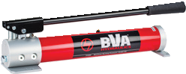 | Hand Pump P2301  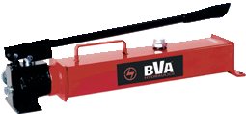 | Air Pump PA1500  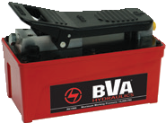
 | Capacity (Ton) | Model Number | Stroke (in) | Collapsed Height (in)
General Purpose Cylinders  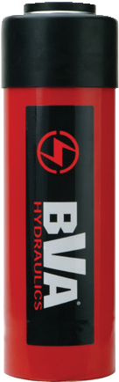 | 5 | H0505 | 5.08 | 8.70 | SP3-0505 | - | - | -
 | 10 | H1002 | 2.01 | 4.84 | - | SP10-1002 | - | SA15-1002
 |  | H1004 | 4.02 | 6.85 | - | SP10-1004 | - | SA15-1004
 |  | H1006 | 5.94 | 9.84 | - | SP10-1006 | - | SA15-1006
 |  | HT1006 | 5.95 | 11.46 | - | SP10-1006T | - | SA15-1006T
 |  | H1010 | 9.96 | 13.86 | - | SP10-1010 | - | SA15-1010
 |  | HT1010 | 9.96 | 15.47 | - | SP10-1010T | - | SA15-1010T
 | 15 | H1504 | 3.98 | 7.87 | - | SP10-1504 | - | SA15-1504
 |  | H1506 | 5.98 | 10.63 | - | SP10-1506 | - | SA15-1506
 | 25 | H2502 | 2.01 | 6.61 | - | SP10-2502 | - | SA15-2502
 |  | H2504 | 4.02 | 8.62 | - | SP10-2504 | - | SA15-2504
 |  | H2506 | 6.10 | 10.71 | - | SP10-2506 | - | SA15-2506
 |  | H2508 | 8.11 | 12.72 | - | - | SP23-2508 | SA15-2508
 |  | H2514 | 14.25 | 18.74 | - | - | SP23-2514 | SA15-2514
 | 55 | H5506 | 6.26 | 11.14 | - | - | SP23-5506 | SA15-5506
 | 100 | H10002A | 2.01 | 8.62 | - | - | SP23-10002A | -
Flat Body Cylinders  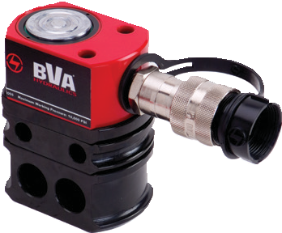 | 5 | HF0503* | 0.24 | 1.26 | SP3-0503F | - | - | -
 |  | HF0503B * | 0.24 | 1.26 | SP3-0503B | - | - | -
 | 10 | HF1005 | 0.43 | 1.69 | SP3-1005F | - | - | -
 |  | HF1005B | 0.43 | 1.69 | SP3-1005B | - | - | -
 | 20 | HF2005 | 0.43 | 2.01 | SP3-2005F | - | - | -
 |  | HF2005B | 0.43 | 2.01 | SP3-2005B | - | - | -
 | 30 | HF3005 | 0.51 | 2.31 | SP3-3005F | - | - | -
 |  | HF3005B | 0.51 | 2.31 | SP3-3005B | - | - | -
 | 50 | HF5006 | 0.63 | 2.64 | SP3-5006F | - | - | -
 |  | HF5006B | 0.63 | 2.64 | SP3-5006B | - | - | -
 | 75 | HF7506 | 0.63 | 3.13 | SP3-7506F | - | - | -
 | 100 | HF10006 | 0.63 | 3.37 | SP3-10006F | - | - | -
 | 150 | HF15006 | 0.63 | 3.94 | - | SP10-15006F | - | -

1-888-332-6419
64 www.BVAhydraulics.com
- HF0503 comes with CR38M coupler
** HC1202 comes with CRZ14M coupler

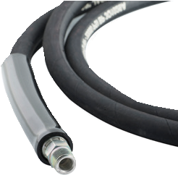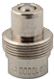

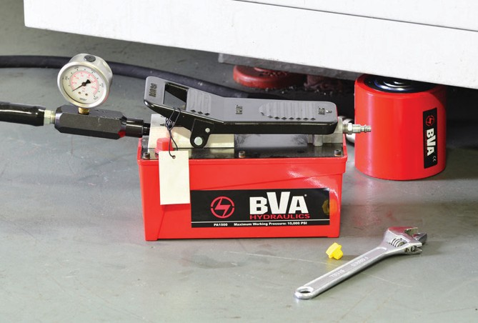

* HF0503 comes with CR38M coupler
Single Acting Cylinder Type | Cylinder |  |  |  | Hand Pump P350  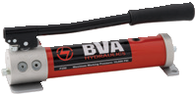 | Hand Pump P1000  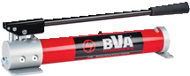 | Hand Pump P2301  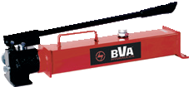 | Air Pump PA1500  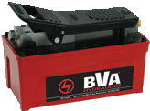
 | Capacity (Ton) | Model | Stroke (in) | Collapsed Height (in)
Hollow Hole Cylinders  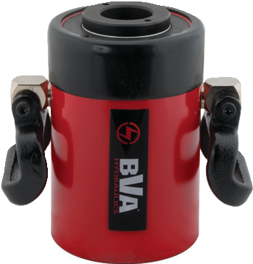 | 12 | HC1201T** | 0.31 | 2.36 | SP3-1201T | - | - | -
 |  | HC1202T** | 1.61 | 4.74 | SP3-1202T | - | - | -
 |  | HC1202XT** | 1.61 | 4.74 | SP3-1202XT | - | - | -
 |  | HC1203XT | 2.99 | 7.24 | - | SP10-1203XT | - | -
 | 20 | HC2002T | 2.01 | 6.38 | - | SP10-2002T | - | SA15-2002T
 | 30 | HC3002T | 2.52 | 7.05 | - | SP10-3002T | - | -
 |  | HC3006T | 6.11 | 13.02 | - | SP10-3006T | - | SA15-3006T
 | 60 | HC6003T | 3.00 | 9.77 | - | SP10-6003T | - | SA15-6003T
 |  | HC6006T | 6.00 | 12.76 | - | - | SP23-6006T | SA15-6006T
 | 100 | HC10003T | 3.00 | 10.00 | - | - | SP23-10003T | SA15-10003T
Low Profile  Cylinders  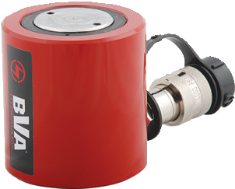 | 10 | HL1001 | 1.50 | 3.48 | SP3-1001L | SP10-1001L | - | SA15-1001L
 | 20 | HL2002 | 1.75 | 3.90 | SP3-2002L | SP10-2002L | - | SA15-2002L
 | 30 | HL3002 | 2.44 | 4.61 | SP3-3002L | SP10-3002L | - | SA15-3002L
 | 50 | HL5002 | 2.36 | 4.80 | - | SP10-5002L | - | SA15-5002L
 | 60 | HL6003KK | 2.50 | 5.63 | - | SP10-6003L | SP23-6003L | SA15-6003L
 | 100 | HL10002 | 2.24 | 5.55 | - | SP10-10002L | SP23-10002L | SA15-10002L
Lock Nut Cylinders  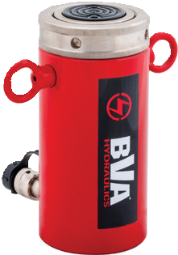 | 55 | HLN5502 | 1.97 | 6.50 | - | - | SP23-5502LN | SA15-5502LN
 |  | HLN5504 | 3.94 | 8.40 | - | - | SP23-5504LN | SA15-5504LN
 |  | HLN5506 | 5.91 | 10.40 | - | - | SP23-5506LN | SA15-5506LN
Aluminum Cylinders  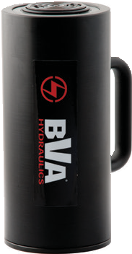 | 30 | HU3002T | 2.00 | 6.50 | SP3-3002U | - | - | SA15-3002U
 |  | HU3006T | 6.00 | 10.50 | - | SP10-3006U | - | SA15-3006U
 | 50 | HU5006T | 6.00 | 10.50 | - | - | SP23-5006U | SA15-5006U

** HC1202 comes with CRZ14M coupler

We see here our combo kit SA15-3002L getting set up to lift a load. This combo kit includes a HL3002 cylinder, PA1500 air pump, CS3814 hose/CH38M coupler set, CF3814 gauge adapter and a GW2514 pressure gauge.

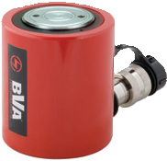

Combinations

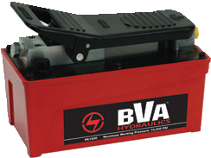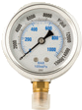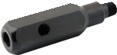Pump and Cylinder Sets
Combination Kits

65

Flow Control Valves

10,000 PSI Rated

2.52”
3.48”
2.52”

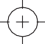CVN1 and CVN3
1.26”
1.45”

3/8” - 18NPTF
3.88”

CVC3
1.45”

2.77”
2.01”
2.96”
1.36”
1.50”

Ø.32”
TYP OF 2
1.61”

0.76”

CVP3

3/8”-18 NPTF

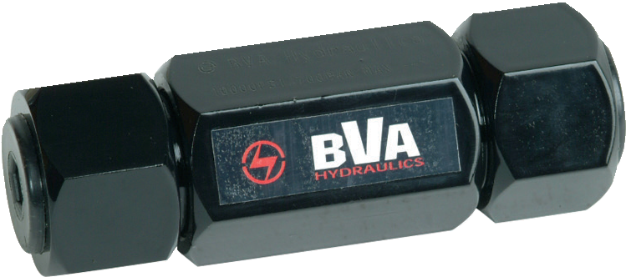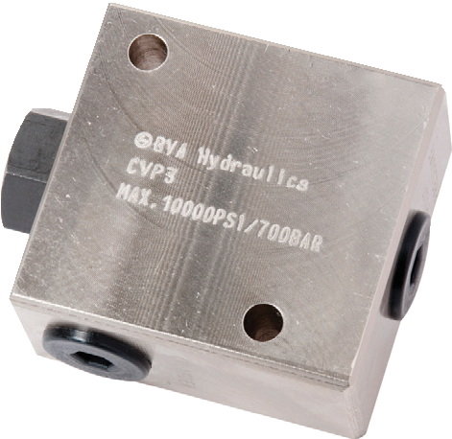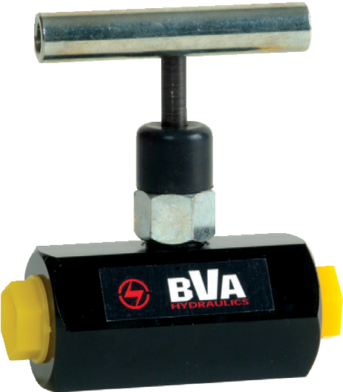
Valve Type | Model Number | Ports | Applications | Hydraulic Symbol
Needle Valve | CVN1 | ¼"-18NPTF | Controls cylinder speed and acts as temporary shut-off valve for load holding.
 | CVN3 | "-18NPTF
Check Valve | CVC3 | "-18NPTF | Allows flow in one direction only.
Pilot Operated Check Valve | CVP3 | "-18NPTF | Mounted in line to a cylinder which will hold pressure in the event of pressure loss in the system. Most often used on double-acting cylinders with pilot port, receiving pressure from a tee off of the cylinder retracting line. Pilot pressure ratio 15% or 6.5:1
1-888-332-6419
66 www.BVAhydraulics.com

Flow Control Valves

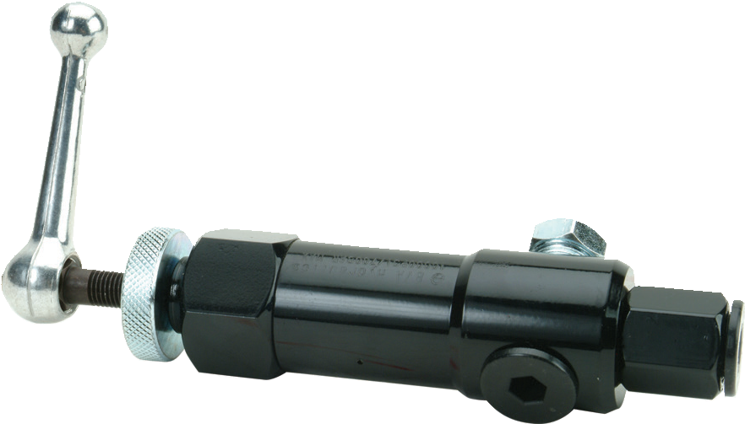
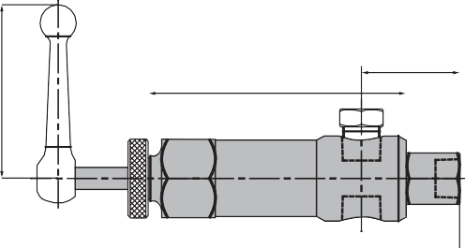10,000 PSI Rated
1.73"
4.53"
3/8"-18NPTF
7.44"
3/8"-18NPTF
3.05"

CVR3
Ø 1.5"

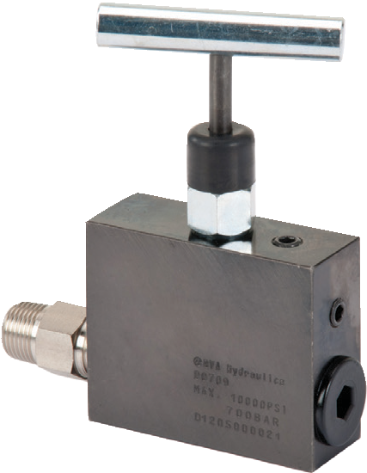4.79"
CVM3
4.65"
3.94"
2.76"

2.28"
0.63"
0.63"

1.02"

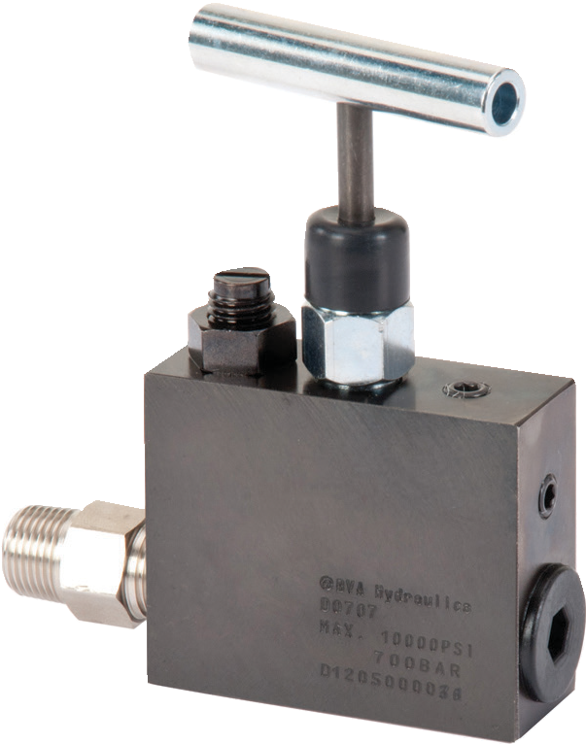
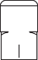4.79"
4.65"
2.76"
3.94"

2.28"
0.63"
0.63"
1.02"

CVMS3
Control Valves / Accessories

Valve Type | Model Number | Ports | Applications | Hydraulic Symbol
Pressure Relief Valve | CVR3 | ”-18NPTF | Controls pressure developed by the pump in hydraulic loop. By-pass occurs when preset pressure reaches 0-10,000 PSI. Turns clockwise to increase pressure,  counter-clockwise to decrease.
Manual Operated Check Valve | CVM3 | ”-18NPTF | Mounted in line to a cylinder and will hold pressure in the cylinder in the event of pressure loss in the system.  Pressure is manually released.
 | CVMS3 | ”-18NPTF | Mounted in line to a cylinder and will hold pressure in the cylinder in the event of pressure loss in the system. This model is equipped with high-pressure bypass. Pressure is manually released.

67

Manifolds
10,000 PSI Rated

1.5"

1/4" - 20 UNC
  - " Depth (x2)

0.82"
2" 1.63"

CMH6
3/8"-18NPTF (x6)

8"

CM7

3/8"-18NPTF (x7) 0.625"

1.25"
2.24"

0.625"

0.25"
2" 3" 2”
Ø¼" (x2)

0.625"

1.25"
1.5"
1.5"
1.5"
1.25"

CM14

3/8"-18NPTF (x7)

2.24"
0.625"

0.25"
3.25"
15.48"

8"
3.25"
Ø 1/4" (x2)

0.625"

1.25"
0.625"

1.25" 4" 4" 4" 1.25"

MFC4

Ø 0.28"

MFC2

Ø 0.28"

0.5"
0.5"

0.5"

11"
0.5" 5"

3/8”-18NPTF (x5)

1.62"
1.5"
2.61"

3"
12"

1"
3.86"
4.13"
3"

FCMH6
3"

2.61"
3/8”-18NPTF (x3)

1"
3.86"
4.13"
1.625"

1.5" 3"
6"

FCMH6
    - Controls the flow of (5) hydraulic hoses from one central location
    - Sturdy design for long product life
    - Convenient carry handle

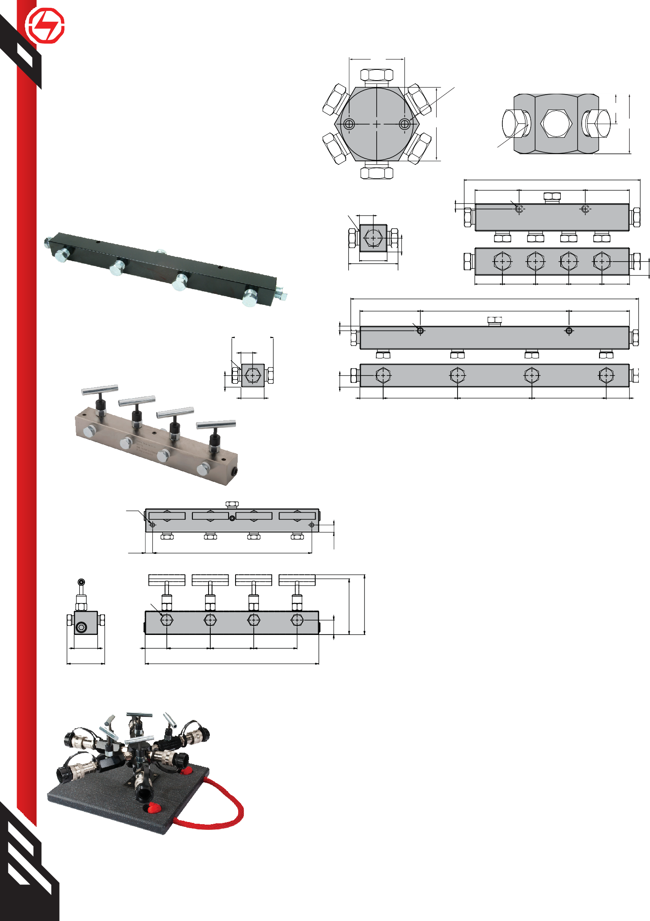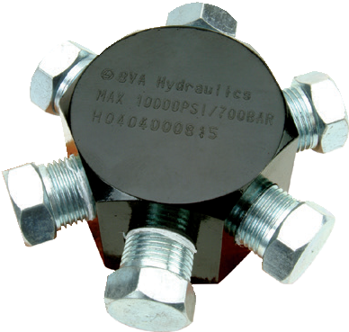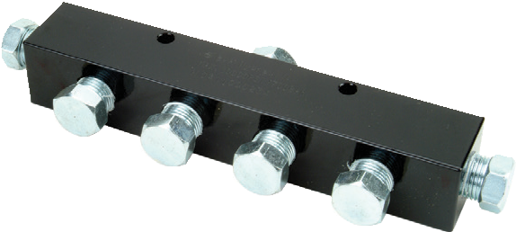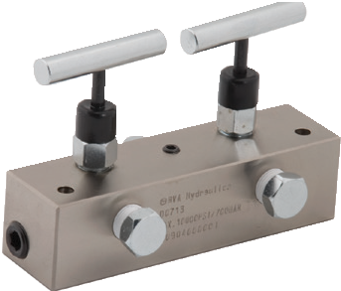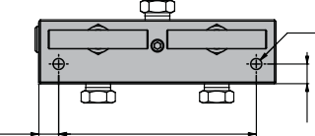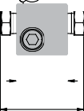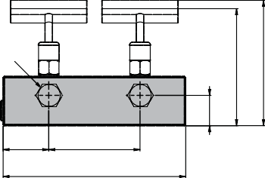

1-888-332-6419
Manifold Type | Model Number | Number of Ports | Port Size | Mounting Holes
6-Port Hexagon Manifold | CMH6 | 6 | ⅜″-18NPTF | ¼″-20UNC
7″ Long Manifold | CM7 | 7 | ⅜″-18NPTF | ¼″-20UNC
14″ Long Manifold | CM14 | 7 | ⅜″-18NPTF | ¼″-20UNC
Manifold with Two Needle Valves | MFC2 | 3 | ⅜″-18NPTF | 0.28” Dia.
Manifold with Four Needle Valves | MFC4 | 5 | ⅜″-18NPTF | 0.28” Dia.
Spider Valves | FCMH6 | 6 | ⅜″-18NPTF | -

68 www.BVAhydraulics.com

Hydraulic Pressure Gauge
Digital or Analog

GW4014

GW2514

GD2514

GE2514

GE2514 Back-Lit digital pressure gauge displays in: PSI, BAR, KG/CM2 and MPa

Gauge Type | Model Number | Certified Gauge | Face Dia. (in) | Thread (in) | Material | Pressure Range |  | Graduation
 |  |  |  |  |  |  |  | Major Graduation (psi) | Minor Graduation (psi) | Major Graduation (bar) | Minor Graduation (bar)
 |  |  |  |  |  | (psi) | (bar)
Digital | GE2514 | - | 2.50 | 1/4"-18 NPTF | Stainless | 0 - 10,000 | 0 - 700 | - | - | - | -
Dry | GD2514 | - | 2.50 | 1/4"-18 NPTF | Brass | 0 - 15,000 | 0 - 1,034 | 2,000 | 200 | 100 | 20
 | GD4014 | - | 4.00 | 1/4"-18 NPTF | Brass | 0 - 15,000 | 0 - 1,034 | 2,000 | 200 | 100 | 20
 | GD2512 | - | 2.50 | 1/2"-14 NPTF | Brass | 0 - 10,000 | 0 - 700 | 2,000 | 200 | 100 | 20
 | GD4012 | - | 4.00 | 1/2"-14 NPTF | Brass | 0 - 10,000 | 0 - 700 | 2,000 | 200 | 100 | 20
Wet | GW2514 | - | 2.50 | 1/4"-18 NPTF | Brass | 0 - 15,000 | 0 - 1,034 | 2,000 | 200 | 100 | 20
 | GW4014 | - | 4.00 | 1/4"-18 NPTF | Brass | 0 - 15,000 | 0 - 1,034 | 2,000 | 200 | 100 | 20
 | GW4014-CERT | yes | 4.00 | 1/4"-18 NPTF | Stainless | 0 - 20,000 | 0 - 1,379 | 2,000 | 200 | 100 | 20
 | GW2512 | - | 2.50 | 1/2"-14 NPTF | Brass | 0 - 10,000 | 0 - 700 | 2,000 | 200 | 100 | 20
 | GW4012 | - | 4.00 | 1/2"-14 NPTF | Brass | 0 - 10,000 | 0 - 700 | 2,000 | 200 | 100 | 20

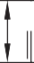Gauge Adapter
C
E
A
Control Valves / Accessories
B

10,000 PSI Rated

D F

CF3814

CF3812E
B
C
F

D E

F
CF3812
B
C

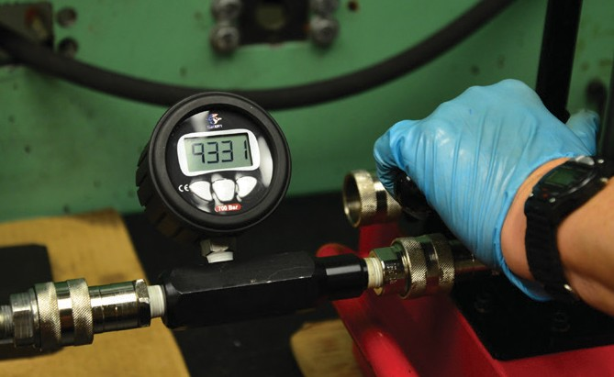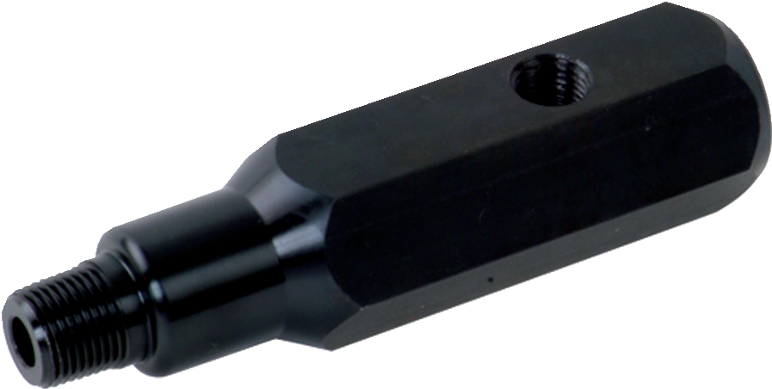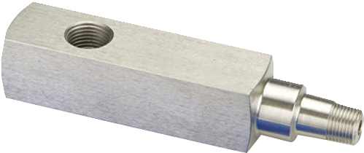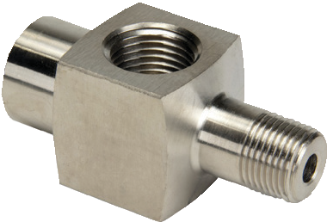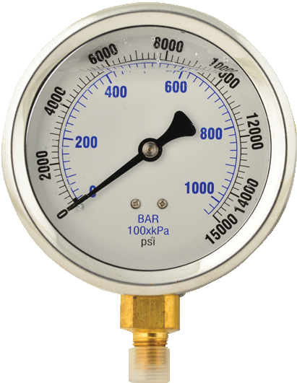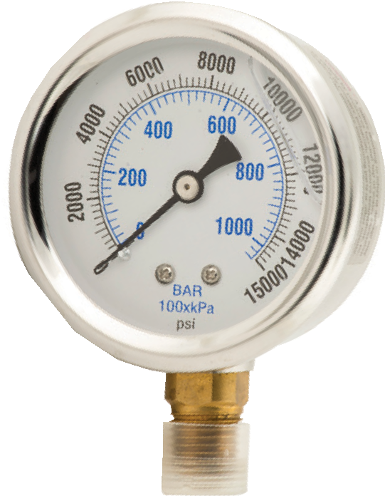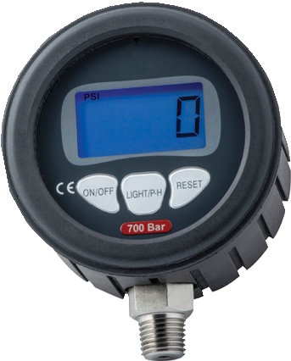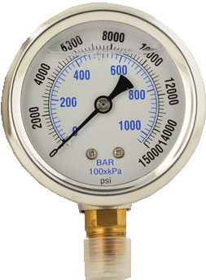
A

D E
Model Number | Dimensions (in)
 | A | B | C | D | E | F
CF3814 | 5.12 | 1.38 | ¼″-18NPTF | ⅜″-18NPTF | ⅜″-18NPTF | 1.25
CF3812 | 2.81 | 1.38 | ½"-14NPTF | ⅜"-18NPTF | ⅜"-18NPTF | 1.25
CF3812E | 6.10 | 1.38 | ½"-14NPTF | ⅜"-18NPTF | ⅜"-18NPTF | 1.25

A

69

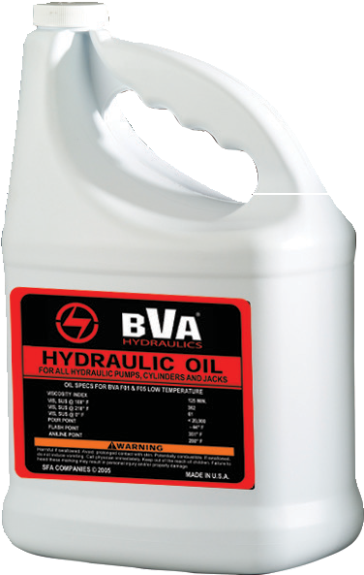
Hydraulic Oil

ISO 46
- Recommended for all BVA cylinders and pumps
Volume (gal) | Model Number | Viscosity Index (min) | Viscosity @ 100°F (S.U.S.) | Viscosity @ 210°F (S.U.S.) | ASTM  Grade | Flash Point (°F) | Pour Point (°F) | API  Gravity
1 | F01 | 144 | 234 | 53 | 215 | 356 | -49 | 30.8
55 | F55 | 144 | 234 | 53 | 215 | 356 | -49 | 30.8

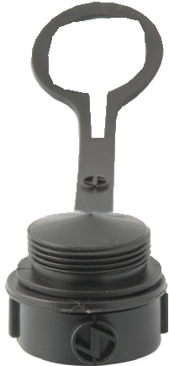
Coupler Dust Cover
- Keeps contaminants out of the system

Model Number | Coupler Compatibility
CDC38 | CH38, CH38F, CH38M

Solenoid Valves
Pump Mounted
- Pump mounted solenoid kits converts your manual pump to an electrically controlled pump.

CDC38

F01

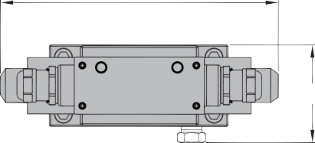8.54"
A
B
3"

7.24"

0.93"

A

PS33L

3/8-16UNC-2LX4

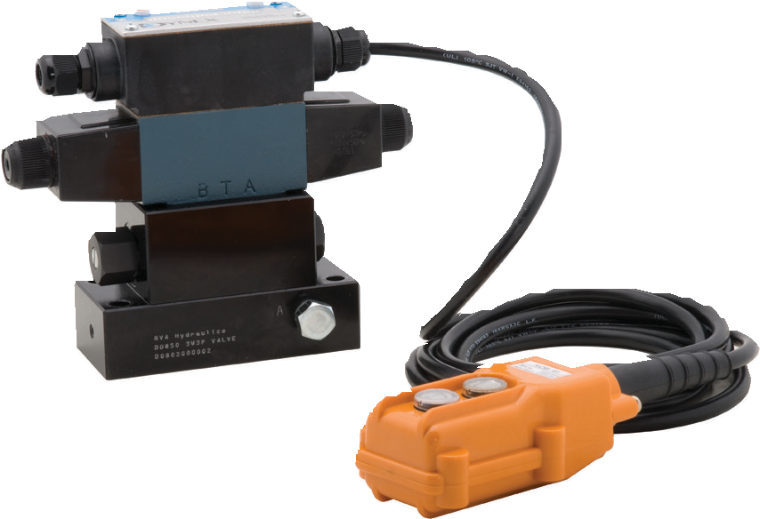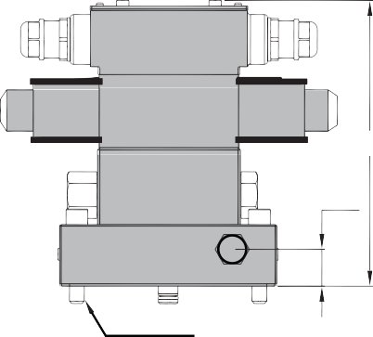

Use With Cylinder | Model Number | Valve Type | Valve Function | Hydraulic Symbol | Schematic Flow path |  |  | Weight (lbs)
Single Acting | PS33L | Solenoid 115VAC | Advance/ Hold/Re- turn |  |  |  |  | 7.0
Single Acting | PD33 | Solenoid 115VAC | Advance/ / Return |  |  |  | - | 6.0
Double Acting | PS43L | Solenoid 115VAC | Advance/ Hold/Re- turn |  |  |  |  | 7.0
1-888-332-6419
70 www.BVAhydraulics.com

CH38
A
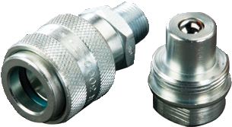
D G

E C H D C

Hydraulic Couplers

10,000 PSI Rated

F J B
CFS38

CR38

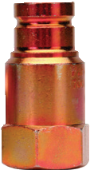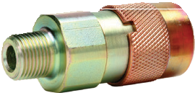 A
G

E C H D
A
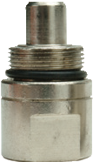
D
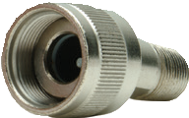
C E C H D C

F J B J G F

CH14 A
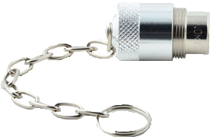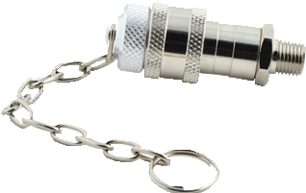 B G
CRZ14 A
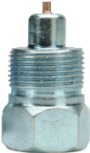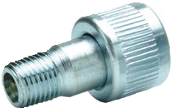B
D

E C H D C

F J
E C H D C
J G
F

Coupler Type | Model Numbers |  |  | Dimensions (in)
 | Complete Set | Male Half | Female Half | A* | B | C | D | E | F | G | H | J
High-Flow Coupler | CH38 | CH38M | CH38F | 3.35 | 2.84 | 3/8"-18NPTF | 1.10 | - | 1.00 | 0.75 | 0.63 | 0.63
Flush-Face Coupler | CFS38 | CFS38M | CFS38F | 4.36 | 2.85 | 3/8"-18NPTF | 1.21 | 1.06 | 1.12 | 0.79 | 0.63 | 0.63
Regular-Flow Coupler | CR38 | CR38M | CR38F | 3.15 | 2.20 | 3/8"-18NPTF | 1.04 | - | 0.73 | 0.50 | 0.53 | 0.53
High-Flow Coupler | CH14 | CH14M | CH14F | 2.83 | 2.35 | 1/4"-18NPTF | 0.87 | - | 0.83 | 0.62 | 0.41
Zinc Coupler | CRZ14 | CRZ14M | CRZ14F | 2.42 | 1.67 | 1/4"-18NPTF | 0.95 | 0.83 | 0.58 | 0.39 | 0.35 | 0.35

* Value A is total length when male and female couplers are connected.
Foot Pedals
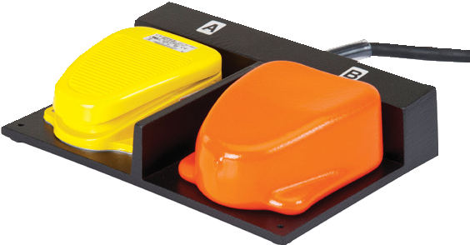Single or Double
FP2
- Hands free pump operation
- Can be used with all pumps equipped with solenoid valves
Control Valves / Accessories

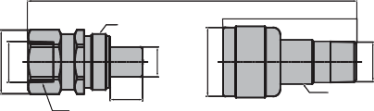

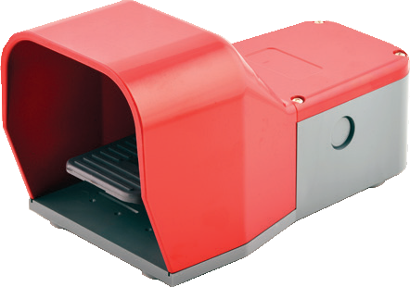Foot controls with 10’ cord. This option replaces the hand controls on solenoid equipped models.
FP1

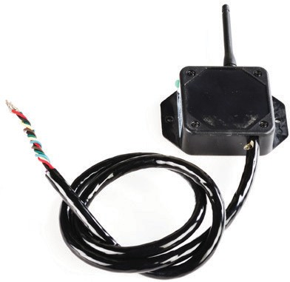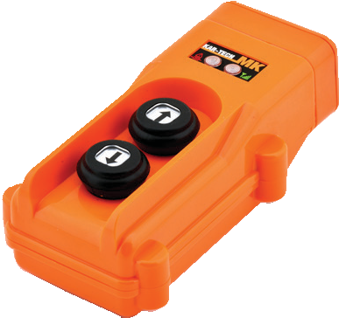 Wireless Hand Held Control
WR12K

  - Allows for increased mobility and safety
  - Nominal range of 325 feet (greater w/ unobstructed line of sight)
  - Batteries last 100 hours with continuous key press (2 AAA batteries)
  - For hands free pump operation
  - Contact your local BVA dealer for further information

External Pressure Adjustment
Sandwich Mounted
    - 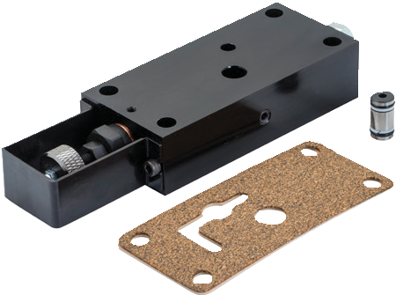Pressure can be adjusted
PW-AS1
Model Number | Pressure Adj. Range (psi) | Interval (psi) | Suitable Model
PW-AS1 |  |  | PE Series, 1 Gal. Reservoir
PW-AS2 | 1,000 |  | PE Series, 2+ Gal. Reservoir
 | ~ | 50
PW-AS3 |  |  | PU20 Series Pump
 | 10,000
PW-AS4 |  |  | PU20DMP Series

externally (1,000-10,000 psi)
    - Works with single and double acting cylinders

71

CMR2
Pressure Switch
CVS1
Pump Mounted Manifold Block
CMR2
- Converts BVA pumps with mounted valves for use with remote mounted valves
- Comes with 4 mounting bolts

  - 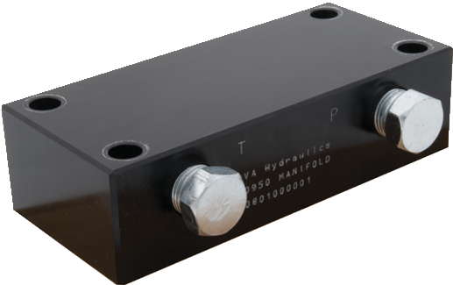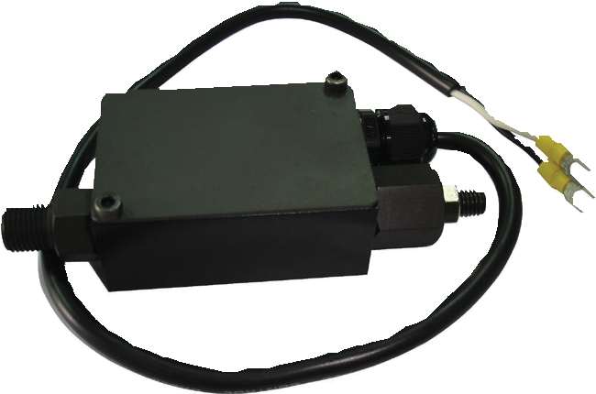Automatically shuts off electric pump when predetermined system pressure is reached
CVS1

Model Number | Adjustable Pressure Range | Electrical Rating | Port Size | Weight (lbs)
CVS1 | 1,000~10,150 psi | 15 amp @ 250V max | ¼"-18NPTF | 1.32
Hydraulic Hoses
Rubber or Thermoplastic
  - All hoses are designed with a Maximum Working Pressure of 10,000 psi
  - Heavy Duty Rubber Hoses are made with 2 layers of steel braids and comply with the Material Handling Institutes IJ-100 standard for hoses and carries a 2:1 safety factor
  - Thermoplastic Hoses are made with 2 layers of steel braids with wrapped in a Polyurethane jacket and carries a 4:1 safety factor

Hose ID  (in) | Hose Length (ft) | Hose End 1 | Hose End 2  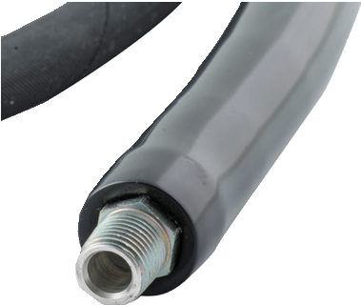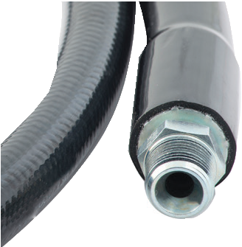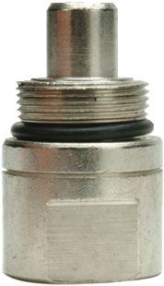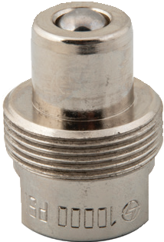  1/4"-18 NPTF 3/8"-18 NPTF CR38M Coupler CH38M Coupler
 |  |  | Rubber Thermoplastic  Model Number |  | Rubber Thermoplastic  Model Number |  | Rubber Thermoplastic  Model Number |  | Rubber Thermoplastic  Model Number
¼” | 6 | ¼"-18  NPTF | CS1414 | CT1414 | - | - | - | - | CS1414M | CT1414M
 | 2 | ⅜"-18  NPTF | - | - | CS3814A | - | CS3814AMR | - | CS3814AM | -
 | 3 | ⅜”-18  NPTF | - | - | CS3814B | CT3814B | CS3814BRM | - | CS3814BM | -
 | 6 | ⅜”-18  NPTF | - | - | CS3814 | CT3814 | CS3814MR | - | CS3814M | CT3814M
 | 10 | ⅜”-18  NPTF | - | - | CS3814C | CT3814C | CS3814CRM | - | CS3814CM | CT3814CM
 | 20 | ⅜”-18  NPTF | - | - | CS3814D | CT3814D | CS3814DRM | - | CS3814DM | CT3814DM
 | 30 | ⅜”-18  NPTF | - | - | CS3814G | CT3814E | - | - | CS3814GM | CT3814EM
⅜” | 6 | ⅜”-18  NPTF | - | - | CS3838 | CT3838 | CS3838MR | - | CS3838M | CT3838M
 | 10 | ⅜”-18  NPTF | - | - | CS3838C | CT3838C | - | - | CS3838CM | CT3838CM
 | 20 | ⅜”-18  NPTF | - | - | CS3838D | CT3838D | - | - | CS3838DM | CT3838DM
 | 30 | ⅜”-18  NPTF | - | - | CS3838E | CT3838E | - | - | CS3838EM | CT3838EM
 | 50 | ⅜”-18  NPTF | - | - | CS3838F | CT3838F | - | - | CS3838FM | CT3838FM
1-888-332-6419
72 www.BVAhydraulics.com

PW2
2.97"

6.37"

Pump Mounted Valves

For PE, PG and PD Pumps Only

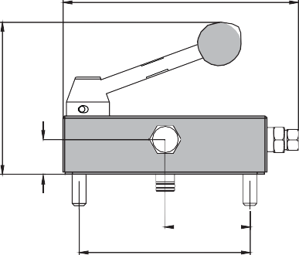
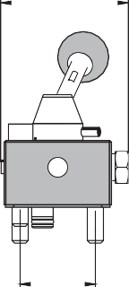
PW33L

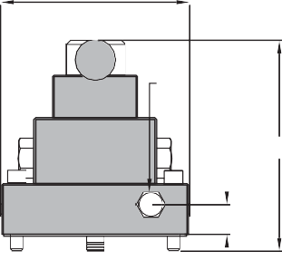
5.58"

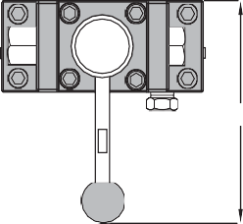
4.10"
3/8-18NPTF

0.93"
6.23" 6.08"

1.75"

2.31"
4.63"
A
0.87"

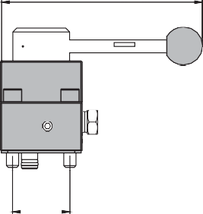
6.13"
PW3 and PW4

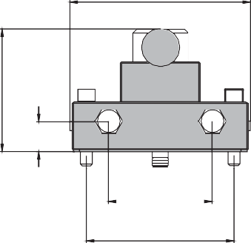
5.66"

5.58"

PW43L

1.75"

3.84"

0.93"

B A

3.25"
3/8-18NPTF

B A
0.87"

6.23" 6.08"

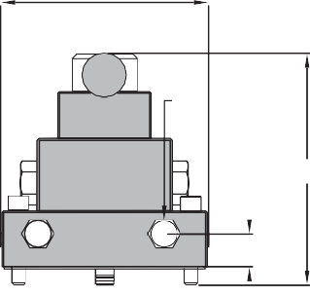
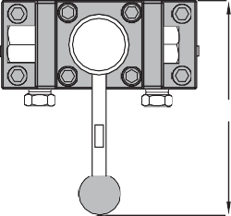
4.63"
Control Valves / Accessories

Valve Operation | Valve Type | Use w/ Cylinder | Model Number |  | Hydraulic Symbol | Schematic Flow path |  |  | Weight (lbs)
 | 3-Way, 2-Position | Single Acting | PW2 | 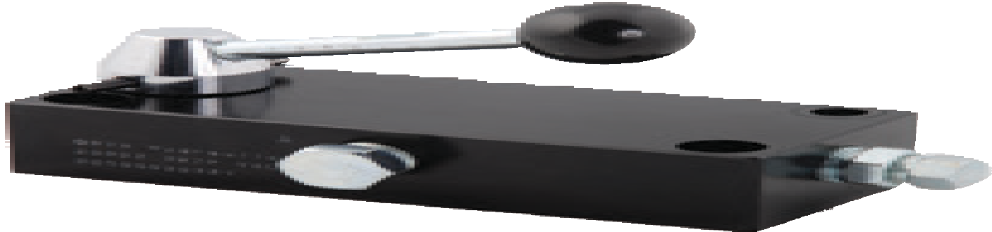 | 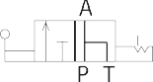 | 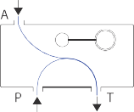 | 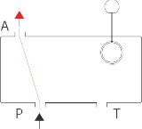 | - | 4
 | 3-way, |  |  | 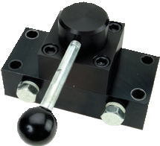 | 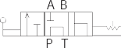 | 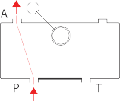 | 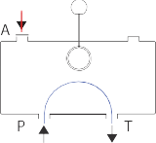 | 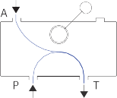
 | 3-Position,  Tandem | Single  Acting | PW3 |  |  |  |  |  | 4
 | center
 | 4-Way, |  |  | 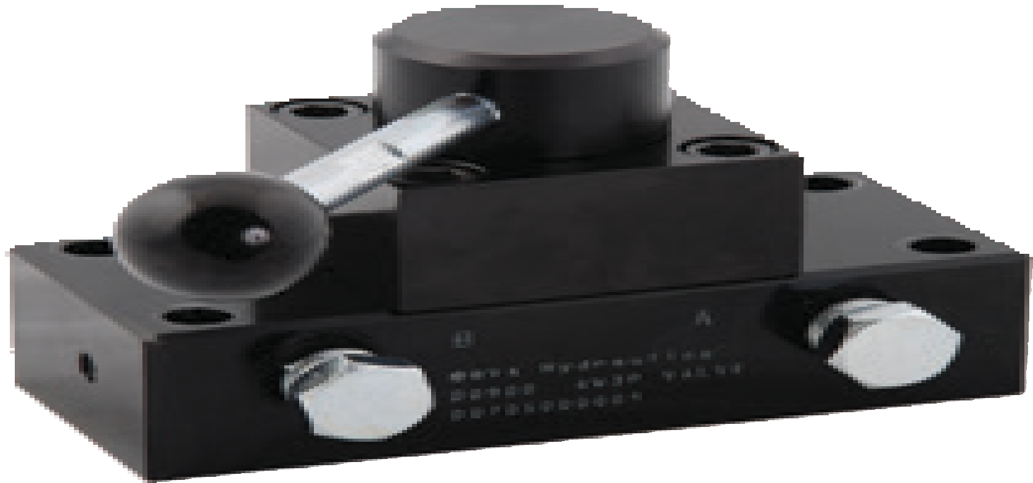 | 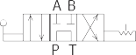 | 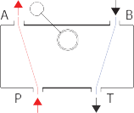 | 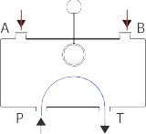 | 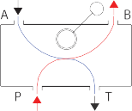
Manual | 3-Position,  Tandem | Double  Acting | PW4 |  |  |  |  |  | 3
 | center
 | 3-Way, | Single Acting |  | 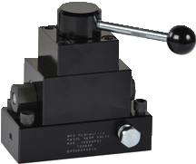 | 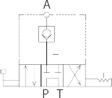 | 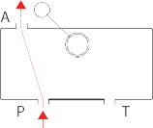 | 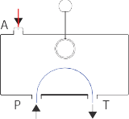 | 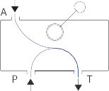
 | 3-Position,
 | Tandem |  | PW33L |  |  |  |  |  | 6
 | center,
 | Locking
 | 4-Way, | Double Acting |  | 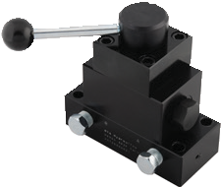 | 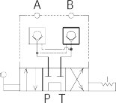 | 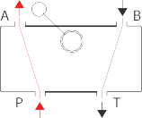 | 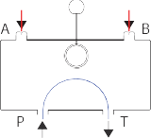 | 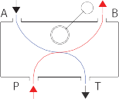
 | 3-Position,
 | Tandem |  | PW43L |  |  |  |  |  | 6
 | center,
 | Locking

73

Remote Mounted Directional Control Valves

Not to be used with Hand Pumps

PR33, PR33C PR33L , PR33CL
PR43, PR43C
PR43CL

3.80"
4.49"
4.21"

4.49"

6.93"
6.93"

6.93"
3/8"-18NPTF (x3)

6.93"

3/8”-18NPTF (x3)

4.21"

6.16"

4.21"
3/8”-18NPTF(x4)

6.16"

1/4"-18NPTF (x4)

0.75"
1.38" 1/4”-20UNC (x4)

0.75"

1.38"
1/4"-20UNC (x4)
0.75" T
1.38"
1/4”-20UNC(x4)

0.75" 1.38"
1/4”-20UNC (x4)"

Valve Operation
Valve Type
Use w/ Cylinder
Model Number
Hydraulic Symbol
Schematic Flow path Weight

3-Way, 3 Position,
(lbs)
Tandem center
PR33 3.5

3-Way, 3 Position,
Closed center
PR33C 3.5

3-Way, 3 Position,
Tandem center, Locking
Single Acting
PR33L 5.7

- Way, 3 Position,
Closed center, Locking
PR33CL 5.7

Manual

- Way, 3 Position,
Tandem center
PR43 3.5

4-Way, 3 Position,
Tandem center, Locking
PR43L 5.7

4-Way, 3 Position,
Closed center
Double Acting
PR43C 3.5

4-Way, 3 Position,
Closed center, Locking
PR43CL 5.7

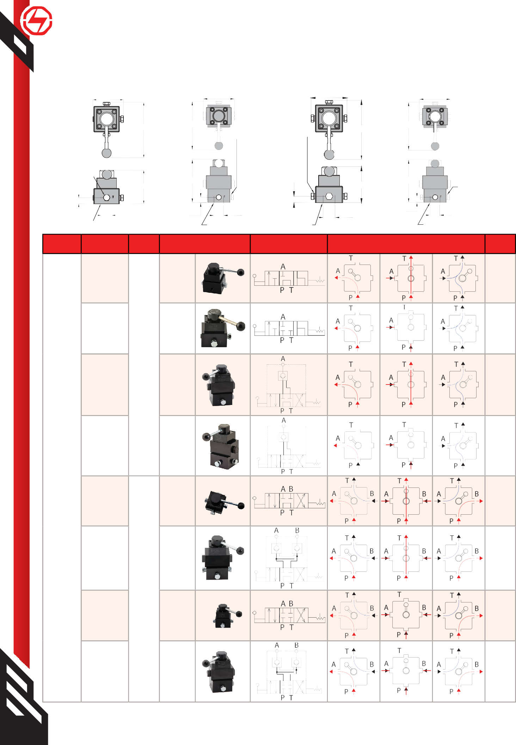1-888-332-6419
74 www.BVAhydraulics.com
All valves have a detent in the center position.

Fittings

10,000 PSI Rated
Control Valves / Accessories

Fitting Type |  | Model Number | Dimensions |  |  |  | Display Image
 |  |  | A  (in) | B  (in) | C | D
Adapters
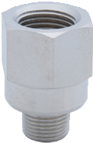 | Adapter  ½″-14NPTF - Female  ⅜″-18NPTF - Male | FT108 | 1.69 | 1.14 | Male  ⅜″-18NPTF | Female  ½″-14NPTF | B |  | A  D C
 | Adapter  ½″-14NPTF - Female  ¼″-18NPTF - Male | FT118 | 1.69 | 1.14 | Male  ¼″-18NPTF | Female  ½″-14NPTF
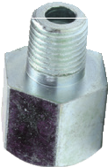 | Fitting | CA3814 | 1.38 | 0.91 | Male  ¼″-18NPTF | Female  ⅜″-18NPTF | B | D | A |  | C
Bushings/Connectors
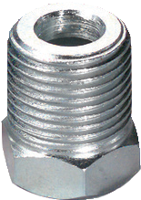 | Bushing | CB1438 | 0.87 | 0.67 | Male  ⅜″-18NPTF | Female  ¼″-18NPTF | B | D | A |  | C
 | Bushing | CB1412 | 1.10 | 0.87 | Male  ½″-14NPTF | Female  ¼″-18NPTF
 | Bushing | CB3812 | 1.10 | 0.87 | Male  ½″-14NPTF | Female  ⅜″-18NPTF
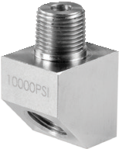 | 2 way 45° Connector  Street Elbow, ⅜″ to  ⅜″-NPTF | FT045 | 1.89 | 1.02 | Male  ⅜″-18NPTF | Female  ⅜″-18NPTF | B | D | A | C
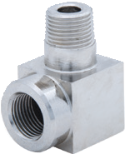 | 2 way 90° Connector  Street Elbow, ⅜″ to  ⅜″-NPTF | FT101 | 1.81 | 1.02 | Male  ⅜″-18NPTF | Female  ⅜″-18NPTF | B | D | A  C
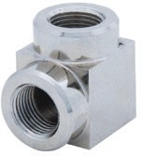 | 2 way 90° Connector  Elbow, ⅜″ to  ⅜″ - NPTF | FT107 | 1.40 | 1.02 | Female  ⅜″-18NPTF | Female  ⅜″-18NPTF | B | D | A | C
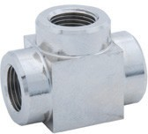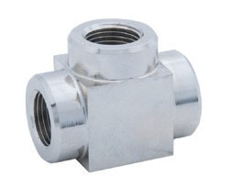 | 3 Way Connector  ⅜″ to ⅜″ - NPTF | FT106 | 1.77 | 1.02 | Female  ⅜″-18NPTF | Female  ⅜″-18NPTF | B |  | A |  | D C
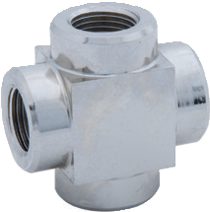 | 4 Way Connector  Cross, ⅜″ to  ⅜″ - NPTF | FT105 | 1.77 | 1.02 | Female  ⅜″-18NPTF | Female  ⅜″-18NPTF | B |  | A | D | C
Couplings
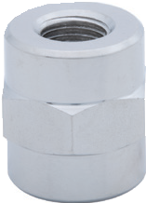 | Coupling Reducing  Connector, ⅜″ to ¼″-NPTF | FT102 | 1.18 | 1.02 | Female  ¼″-18NPTF | Female  ⅜″-18NPTF | B | D | A  C
 | Coupling Reducing Con-  nector, ½″ to ⅜″ - NPTF | FT112 | 1.89 | 1.14 | Female  ½″-14NPTF | Female  ⅜″-18NPTF
 | Coupling ⅜″ to ⅜″- NPTF | FT103 | 1.18 | 1.02 | Female  ⅜″-18NPTF | Female  ⅜″-18NPTF
Hex Nipples
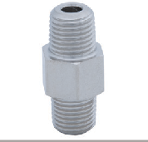 | Male Connector Hex  Nipple, ¼″ to ¼″ - NPTF | FT104 | 1.50 | 0.67 | Male  ¼″-18NPTF | Male  ¼-18NPTF | B | D | A  C
 | Male Connector Hex  Nipple, ⅜″ to ⅜″- NPTF | FT114 | 1.50 | 0.75 | Male  ⅜″-18NPTF | Male  ⅜″-18NPTF
 | Male Connector Hex  Nipple, ¼″ to ⅜″- NPTF | FT124 | 1.45 | 0.75 | Male  ¼″-18NPTF | Male  ⅜″-18NPTF

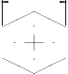
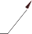75

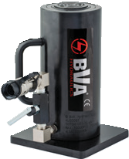
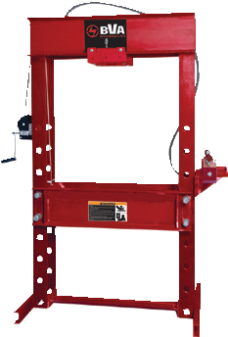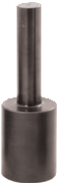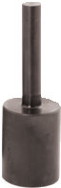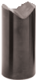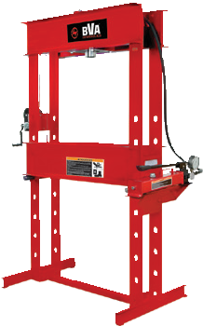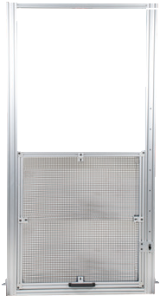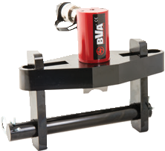
76

Presses | Reference Image Page Number | Presses | Page Number / Reference Image
Movable Head Shop Press | 77 | Shop Press Accessories | 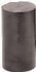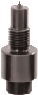 | 80
Fixed Head  Shop Presses | 78-79 | Press Guards |  | 80
Tools |  |  | Page Number / Reference Image
Flange Spreaders |  |  |  | 81
Duck Bill Spreaders |  |  | 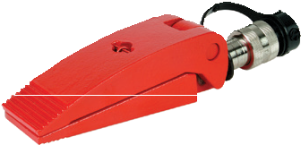 | 81
Oil Field Valve Seat Pullers 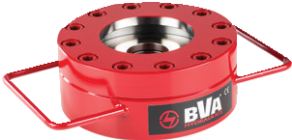 82
50 Ton Cylinder with Base and Needle Valve Kit 82
Hydraulic Bench Vise |  |  | 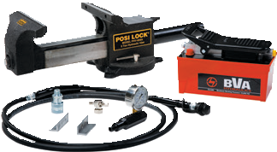 | 82
Hydraulic Gear Pullers |  |  | 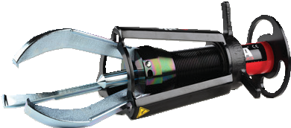 | 83
Mechanical Gear Pullers |  |  |  | 83
Hydraulic Nut Splitters |  |  | 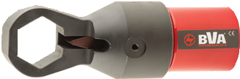 | 83
Maintenance/Bottle Jacks Page 84
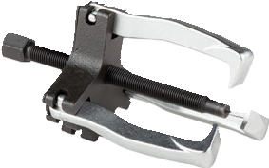1-888-332-6419
www.BVAhydraulics.com

Shop Presses / Tools
Capacity (Tons) | Model Number | Pump Type | Pump Model | Cylinder Model | Cylinder Stroke (In) | Bed Positions | Press Dimensions  (H x L x W) | Working Space (Min - Max) (in)
Single Acting
55 | IAPR5506 | Air | PA2000 | H5506 | 6 | 7 | 78" X 46.5" X 30" | 15.38" X 51.38"
 | IEPR5506 | Electric | PE40W3N02A | H5506 | 6 | 7 | 78" X 46.5" X 30" | 15.38" X 51.38"
 | IAPR5513 | Air | PA3801 | H5513 | 13 | 7 | 85" X 46.5" X 30" | 15.38" X 51.38"
 | IEPR5513 | Electric | PE40W3N02A | H5513 | 13 | 7 | 85" X 46.5" X 30" | 15.38" X 51.38"
 | IEPRS5513 | Electric/Solenoid | PE40S3L02A | H5513 | 13 | 7 | 85" X 46.5" X 30" | 15.38" X 51.38"
Double Acting
55 | IAPDR5506 | Air | PA3801M | HD5506 | 6 | 7 | 78" X 46.5" X 30" | 15.38" X 51.38"
 | IEPDR5513 | Electric | PE40W4N02A | HD5513 | 13 | 7 | 85" X 46.5" X 30" | 15.38" X 51.38"
 | IEPDRS5513 | Electric/Solenoid | PE40S4L02A | HD5513 | 13 | 7 | 85" X 46.5" X 30" | 15.38" X 51.38"

55 Ton Shop Press with Movable Work Head

H-Frame
- 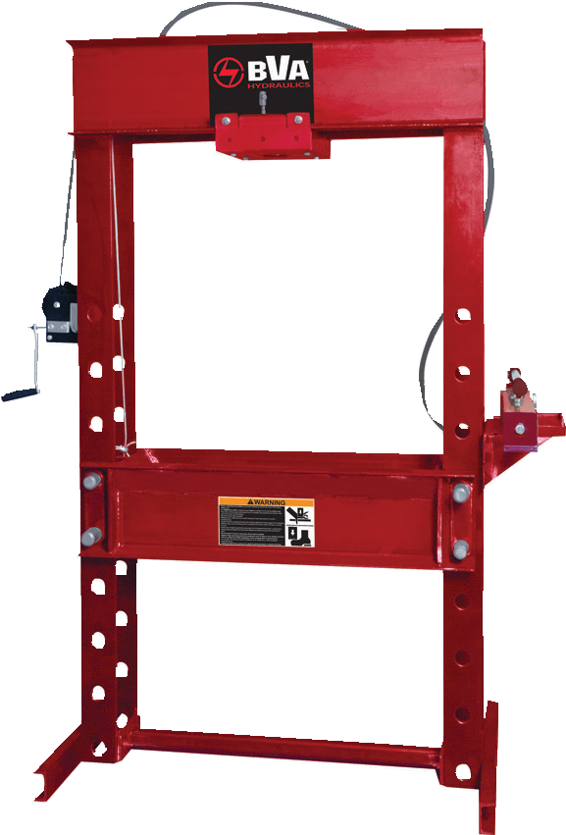Welded steel construction
Movable work head
- Cylinder moves from side to side and locks into position
- Multi-position bed for work height adjustment
- Pump, cylinder, hose, gauge and fittings are included

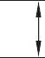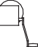B
K
J
H
D
A (min)
A (max)
F
E
G
C

77
Model Number | Dimensions (in) |  |  |  |  |  |  |  |  |  |  | Weight (lbs)
 | A  (Min.) | A  (Max.) | B | C | D | E | F | G | H | J | K
Single Acting
IAPR5506 | 15.38 | 51.38 | 78 | 46.5 | 30 | 35.75 | 6 | 4 | 9 | 10 | 15 | 950.0
IEPR5506 | 15.38 | 51.38 | 78 | 46.5 | 30 | 35.75 | 6 | 4 | 9 | 10 | 15 | 1015.0
IAPR5513 | 15.38 | 51.38 | 85 | 46.5 | 30 | 35.75 | 6 | 4 | 9 | 10 | 15 | 991.0
IEPR5513 | 15.38 | 51.38 | 85 | 46.5 | 30 | 35.75 | 6 | 4 | 9 | 10 | 15 | 1048.0
IEPRS5513 | 15.38 | 51.38 | 85 | 46.5 | 30 | 35.75 | 6 | 4 | 9 | 10 | 15 | 1050.0
Double Acting
IAPDR5506 | 15.38 | 51.38 | 78 | 46.5 | 30 | 35.75 | 6 | 4 | 9 | 10 | 15 | 955.0
IEPDR5513 | 15.38 | 51.38 | 85 | 46.5 | 30 | 35.75 | 6 | 4 | 9 | 10 | 15 | 1020.0
IEPDRS5513 | 15.38 | 51.38 | 85 | 46.5 | 30 | 35.75 | 6 | 4 | 9 | 10 | 15 | 1022.0

Shop Presses
- Welded steel construction
- Ideal for the removal or installation of gears, universal joints, pulleys, wrist pins, and other press jobs
- Multi-position bed for work height adjustment
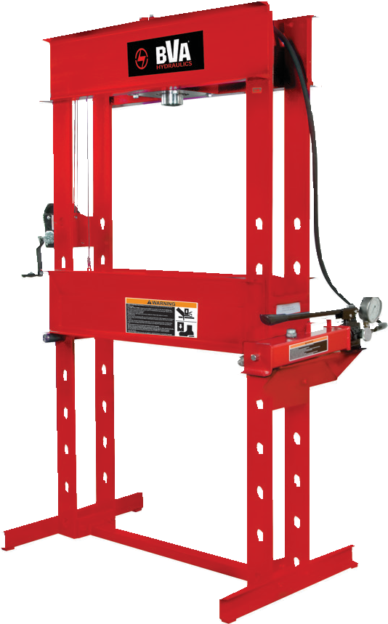
- Excellent for bending, bonding, or straightening applications

Cylinder H2506

Cylinder H5506

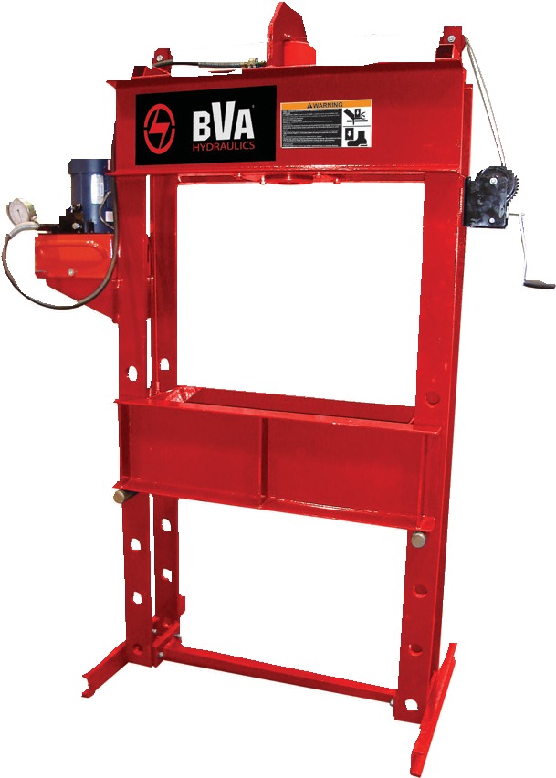
Pump
PE40W3N02A
Cylinder H10010

Pump PA1500
Pump P2301

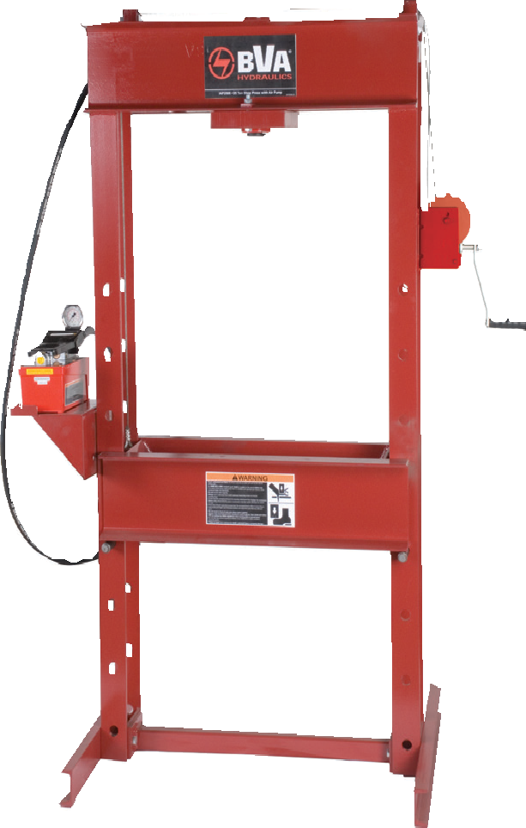Press IMP5506
Press IAP2506
Press IEP10010

Capacity (Tons) | Model Number | Pump Type | Pump Model | Cylinder Model | Cylinder Stroke (In) | Bed Positions | Press Dimen- sions  (H X L X W) | Working Space (Min - Max) (in)
Single Acting
25 | IMP2506 | Manual | P1000 | H2506 | 6 | 8 | 71” X 48” X 28” | 4.5” X 47.25”
 | IAP2506 | Air | PA1500 | H2506 | 6 | 8 | 71” X 48” X 28” | 4.5” X 47.25”
 | IEP2506 | Electric | PE30W3N01A | H2506 | 6 | 8 | 71” X 48” X 28” | 4.5” X 47.25”
 | IMP2514 | Manual | P2001 | H2514 | 14 | 8 | 71” X 48” X 28” | 4.5” X 47.25”
 | IAP2514 | Air | PA2000 | H2514 | 14 | 8 | 71” X 48” X 28” | 4.5” X 47.25”
 | IEP2514 | Electric | PE30W3N01A | H2514 | 14 | 8 | 71” X 48” X 28” | 4.5” X 47.25”
 | IEPS2514 | Electric/Solenoid | PE30S3L01A | H2514 | 14 | 8 | 71” X 48” X 28” | 4.5” X 47.25”
55 | IMP5506 | Manual | P2301 | H5506 | 6 | 9 | 79” X 56” X 30” | 14” X 55.5”
 | IAP5506 | Air | PA1500 | H5506 | 6 | 9 | 79” X 56” X 30” | 14” X 55.5”
 | IEP5506 | Electric | PE40W3N02A | H5506 | 6 | 9 | 79” X 56” X 30” | 14” X 55.5”
 | IAP5513 | Air | PA3801 | H5513 | 13 | 9 | 79” X 56” X 30” | 14” X 55.5”
 | IEP5513 | Electric | PE40W3N02A | H5513 | 13 | 9 | 79” X 56” X 30” | 14” X 55.5”
100 | IAP10010 | Air | PA7550 | H10010 | 10 | 8 | 89” X 63” X 30” | 11.25” X 51”
 | IEP10010 | Electric | PE40W3N02A | H10010 | 10 | 8 | 89” X 63” X 30” | 11.25” X 51”
 | IEPS10010 | Electric/Solenoid | PE40S3L02A | H10010 | 10 | 8 | 89” X 63” X 30” | 11.25” X 51”
Double Acting
25 | IMPD2506 | Manual | P2301M | HD2506 | 6 | 6 | 71” X 48” X 28” | 4.5” X 47.25”
 | IAPD2506 | Air | PA3801M | HD2506 | 6 | 6 | 71” X 48” X 28” | 4.5” X 47.25”
 | IEPD2506 | Electric | PE30W4N01A | HD2506 | 6 | 6 | 71” X 48” X 28” | 4.5” X 47.25”
 | IEPDS2506 | Electric/Solenoid | PE30S4L01A | HD2506 | 6 | 6 | 71” X 48” X 28” | 4.5” X 47.25”
55 | IEPD5513 | Electric | PE40W4N02A | HD5513 | 13 | 9 | 79” X 56” X 30” | 14” X 55.5”
100 | IEPD10010 | Electric | PE40W4N02A | HD10010 | 10 | 8 | 89” X 63” X 30” | 11.25” X 51”
 | IEPDS10010 | Electric/Solenoid | PE40S4L02A | HD10010 | 10 | 8 | 89” X 63” X 30” | 11.25” X 51”
1-888-332-6419
78 www.BVAhydraulics.com

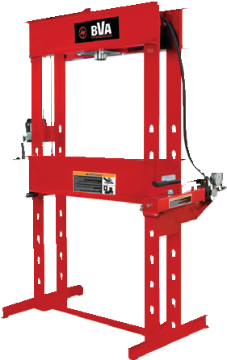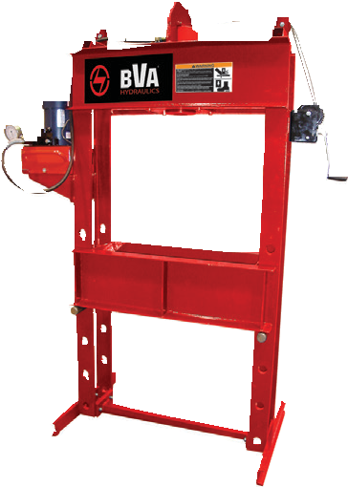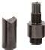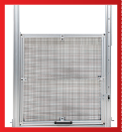
I Series
Made in the U.S.A.
All press frames are made in the USA and meet ISO 9001/2008 and CE
certification.
Press Accessories
See the assortment of accessories designed to work with these product.
pg
80
Press Guards
Add a layer of protection between the operator and the work for extra safety.
pg 80
79
Shop Presses / Tools

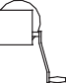B
K
J
H
D
A (min)
A (max)
F
E
G
C

Model Number | Dimensions (in) |  |  |  |  |  |  |  |  |  |  | Weight (lbs)
 | A  (Min.) | A  (Max.) | B | C | D | E | F | G | H | J | K
Single Acting
IMP2506 | 6.25 | 48.25 | 71.00 | 38.75 | 28.00 | 30.00 | 6.00 | 3.00 | 6.50 | 8.00 | 11.50 | 442.0
IAP2506 | 6.25 | 48.25 | 71.00 | 38.75 | 28.00 | 30.00 | 6.00 | 3.00 | 6.50 | 8.00 | 11.50 | 447.0
IEP2506 | 6.25 | 48.25 | 71.00 | 38.75 | 28.00 | 30.00 | 6.00 | 3.00 | 6.50 | 8.00 | 11.50 | 490.0
IMP2514 | 6.25 | 48.25 | 79.03 | 38.75 | 28.00 | 30.00 | 6.00 | 3.00 | 6.50 | 8.00 | 11.50 | 469.0
IAP2514 | 6.25 | 48.25 | 79.03 | 38.75 | 28.00 | 30.00 | 6.00 | 3.00 | 6.50 | 8.00 | 11.50 | 465.0
IEP2514 | 6.25 | 48.25 | 79.03 | 38.75 | 28.00 | 30.00 | 6.00 | 3.00 | 6.50 | 8.00 | 11.50 | 506.0
IEPS2514 | 6.25 | 48.25 | 79.03 | 38.75 | 28.00 | 30.00 | 6.00 | 3.00 | 6.50 | 8.00 | 11.50 | 508.0
IMP5506 | 8.00 | 55.88 | 80.50 | 46.25 | 30.00 | 35.63 | 6.00 | 3.00 | 9.00 | 10.00 | 14.75 | 847.0
IAP5506 | 8.00 | 55.88 | 80.50 | 46.25 | 30.00 | 35.63 | 6.00 | 3.00 | 9.00 | 10.00 | 14.75 | 837.0
IEP5506 | 8.00 | 55.88 | 80.50 | 46.25 | 30.00 | 35.63 | 6.00 | 3.00 | 9.00 | 10.00 | 14.75 | 880.0
IAP5513 | 8.00 | 55.88 | 87.51 | 46.25 | 30.00 | 35.63 | 6.00 | 3.00 | 9.00 | 10.00 | 14.75 | 876.0
IEP5513 | 8.00 | 55.88 | 87.51 | 46.25 | 30.00 | 35.63 | 6.00 | 3.00 | 9.00 | 10.00 | 14.75 | 910.0
IAP10010 | 14.38 | 52.38 | 90.00 | 46.25 | 40.00 | 35.50 | 8.00 | 4.00 | 10.13 | 11.00 | 16.25 | 1142.0
IEP10010 | 14.38 | 52.38 | 90.00 | 46.25 | 40.00 | 35.50 | 8.00 | 4.00 | 10.13 | 11.00 | 16.25 | 1178.0
IEPS10010 | 14.38 | 52.38 | 90.00 | 46.25 | 40.00 | 35.50 | 8.00 | 4.00 | 10.13 | 11.00 | 16.25 | 1180.0
Double Acting
IMPD2506 | 6.25 | 48.25 | 71.00 | 38.75 | 28.00 | 30.00 | 6.00 | 3.00 | 6.50 | 8.00 | 11.50 | 468.0
IAPD2506 | 6.25 | 48.25 | 71.00 | 38.75 | 28.00 | 30.00 | 6.00 | 3.00 | 6.50 | 8.00 | 11.50 | 459.0
IEPD2506 | 6.25 | 48.25 | 71.00 | 38.75 | 28.00 | 30.00 | 6.00 | 3.00 | 6.50 | 8.00 | 11.50 | 496.0
IEPDS2506 | 6.25 | 48.25 | 71.00 | 38.75 | 28.00 | 30.00 | 6.00 | 3.00 | 6.50 | 8.00 | 11.50 | 498.0
IEPD5513 | 8.00 | 55.88 | 87.51 | 46.25 | 30.00 | 35.63 | 6.00 | 3.00 | 9.00 | 10.00 | 14.75 | 942.0
IEPD10010 | 14.38 | 52.38 | 90.00 | 46.25 | 40.00 | 35.50 | 8.00 | 4.00 | 10.13 | 11.00 | 16.25 | 1198.0
IEPDS10010 | 14.38 | 52.38 | 90.00 | 46.25 | 40.00 | 35.50 | 8.00 | 4.00 | 10.13 | 11.00 | 16.25 | 1200.0

25 Ton Shop Press Accessories

CS25 includes:
- Rod forcing cap
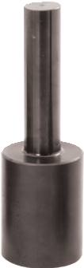
- V push adapter
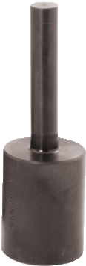
- Threaded adapter
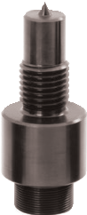
- ¾″ push adapter
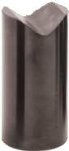
- 1″ push adapter
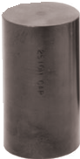
- Arbor plates (in pairs)

55 Ton Shop Press Accessories
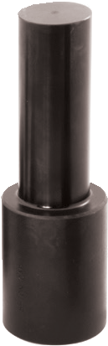
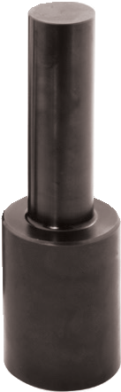
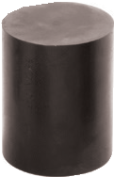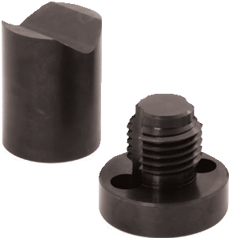
100 Ton Shop Press Accessory

CS55 includes:
- Rod forcing cap
- Threaded adapter
- 1½″ push adapter
- 1¼″ push adapter
- V push adapter
- Arbor plates (in pairs)

AP100 includes:

Press Guards

Add a barrier layer between the operator and the work for added safety. Press guards help keep hands out of work area and shields flying debris from being ejected from the press and prevents them from becoming a hazard.

- Sturdy construction
- Fits all types of shop presses (single and double acting)
- Prevent possible injury/damage from flying debris from
occurring in case of an issue
  - Arbor plates (in pairs)

Model Number | Capacity (tons) | Shop Press Compatibility
SPG25 | 25 | All Manual, Electric and Air 25 Tons Presses (Single and Double Acting)
SPG100 | 55 & 100 | All Manual, Electric and Air 55 and 100 Tons Presses (Single and Double Acting)

1-888-332-6419
80 www.BVAhydraulics.com

Flange Spreader
Pin Type

SP3-3814
This combination kit works well with our Hand Pump. See our combo section for more details.

HFS05
Kit: SP3-3814

pg64

SP5-3814
This combination kit works well with our Foot Pump. See our combo section for more details.

HFS10
HFS05
- Designed for heavy duty industrial environment
- Adjustable jaw width for a wide range of applications and ease of use
- Spare wedge attachment comes standard

Capacity  (tons) | Model Number | Stroke  (in.) | Oil Capacity  (in³) | Maximum Flange  Thickness (in.)
5 | HFS05 | 1.00 | 1.00 | 2 X 2.3
10 | HFS10 | 2.01 | 4.50 | 2 X 3.6

Spreaders
SR10
SR05
Duck Bill Spreader
- Designed to work in confined working spaces
- Ideal for wedging, prying, and opening
Shop Presses / Tools
- High strength forged steel
- Spring return for easy operation

B B
3/8"- 18NPTF
3/8"- 18NPTF

D
CAPACITY 12 TON
D

SR10
E
C
SR05
A
C

A

E

Cylinder Capacity (tons) | Model Number | Cylinder Effective Area (in²) | Oil Capacity (in³) | Dimensions (in) |  |  |  |  | Weight (lbs)
 |  |  |  | A | B | C | D | E
0.5 | SR05 | 1.22 | 0.58 | 3.54 | 7.57 | 0.51 | 2.05 | 2.36 | 4.8
1 | SR10 | 1.09 | 0.86 | 3.90 | 6.57 | 0.47 | 2.17 | 2.20 | 5.1

81

Valve Seat Puller

Frac Pump Maintenance

- Pump kit to operate HVSP Series cylinders. Part number: SP12-CSG4
- Pump kit includes: P1201S, CS3814, CH38M, GW4014, and CF3814.

HVSP120

SP5-3814

HVSP125

50 Ton Cylinder w/ Base & Needle Valve
Cylinder Capacity (tons) | Model Number | Center Hole ID (in) | Stroke (in) | Collapsed Height (in) | Weight (lbs)
120 | HVSP120 | 2.13” | 0.607 | 3.63 | 61.7
125 | HVSP125 | 2.13” | 0.607 | 3.63 | 54.0

This combination kit works well with this product. See our combo section for more details.

Safety Practices
Good industry practice recommends not exceeding 80% of maximum rated capacities of all our products.
Hydraulic Truck Jack

- Aluminum Cylinder
- Anodized ram with carry handle
- Shutoff valve
- High/low temp functionality
- CH38F 3/8”-18NPTF high flow female coupler
- 50 Ton @ 9,091 PSI

JU506

Cylinder Capacity (tons) | Model Number | Collapsed Height (in) | Extended Height  (in) | Stroke (in) | Weight (lbs)
50 | JU506 | 11.6 | 17.6 | 6.0 | 28.0

Hydraulic Bench Vise

5 Ton Holding Force

- Hands free operation with foot pump control
HFS10
- Air control valve for variable speed and added safety
- Cast steel construction 52,000 PSI tensile strength
- Hydraulic pressure closes jaws, spring return opens jaws

Safety Instructions
Visit our DO’S and DON’TS
section to review the best

methods of operation. Always be prepared.
pg92

Model Number | Capacity (tons) | Jaw Width (in) | Jaw Clearance (in) | Jaw Opening (in)
HBV5 | 5 | 8.00 | 3.50 | 8.00
1-888-332-6419
82 www.BVAhydraulics.com

HGP253
HGP503

HGP153

HGP103

HGP053

Hydraulic Gear Pullers

POSILOCK®
- Safety cage design prevents jaws from slipping
- Cylinders are removable for ease of servicing
- Each puller comes with a lift plate and a ram point set

HGP-1
Capacity (tons) | Model Number | Reach (in) | Spread Range (in) | Ram Stroke (in) | Jaw Style
5 | HGP053 | 6” | 0.5” - 8” | 5” | External
10 | HGP103 | 8” | 0.75” - 12” | 6.13” | External
15 | HGP153 | 10” | 1” - 15” | 10” | External
25 | HGP253 | 12” | 2.5” - 18” | 14” | External
25 | HGP253IE | 12” | 2.5” - 18” | 14” | External/Internal
50 | HGP503 | 14” | 3” - 25” | 13.25” | External
100 | HGP1003 | 50” | 7.5” - 70” | 10.25” | External

This combination kit will work well with the hydraulic gear pullers. See our combo section for more details.

  - Able to use 2 or 3 jaws
  - Reversible ratchet jaws
  - Forged, heat treated high quality steel
  - Designed for heavy duty industrial environment
  - Adjustable jaw width for a wide range of applications for ease of use
  - Easily transportable
Mechanical Gear Pullers
2, 5, 7 Tons

MGP07

Hydraulic Nut Splitter w/ Case
Capacity (Ton) | Model Number | Maximum Spread (in) | Maximum Reach (in) | Screw Length (in)
2 | MGP02 | 3-1/4” | 2-5/8” | 4-1/2”
5 | MGP05 | 5” | 4” | 8-1/4”
7 | MGP07 | 10” | 10” | 12”

Compact and Heavy Duty

MGP05

MGP02

Safety Instructions
Shop Presses / Tools
Visit our DO’S and DON’TS
section to review the best

    - Spacers included
HNS105
    - Straight chisel with a 60/40 angle, and works on all type of materials, including
stainless steel
methods of operation. Always be prepared.

SP5-3814
This combination kit works well with
pg92

    - Chisel can be re-sharpened multiple times
    - Comes with a padded tool box to hold the head, cylinder, tips and spacers

Capacity (tons) | Model Number | Nut Size Capacity ATF | Stud Dimension | Weight (lbs)
25 | HNS105 | 0.625” - 1.4375” | 0.4375” - 0.875” | 20.0
25 | HNS200 | 1.1875” - 2.375” | 7/16” - 7/8” | 21.0
100 | HNS308 | 2.625” - 3.5” | 1.75” - 2.25” | 95.0
POSILOCK® is a registered trade mark of Posilock Puller Inc.
the hydraulic nut splitter set. See our combo section for more details.

High-Flow Couplers
High-Flow Coupler: CH38F is included on all models (except where specified).

83

84

Maintenance Kits / Bottle Jacks ^{Page} ^{Number} /
Reference Image
Rail Car Jack |  |  |  |  |  | 85
Maintenance Kits |  |  |  |  |  | 85
Lifting Bags |  |  |  |  |  | 86
Lifting Bag Accessories |  |  |  |  |  | 87
Manual Bottle Jacks |  |  |  |  |  | 88
Air/Manual Bottle Jacks |  |  |  |  |  | 88
Toe Jacks |  |  |  |  |  | 88
Mini Jacks |  |  |  | 89
OMNI Jacks |  |  |  | 89
Orbital Jacks |  |  |  | 89
Cross Referencing and |  | Engineering Page |  |  | 90

1-888-332-6419
www.BVAhydraulics.com

Rail Car Jack, JDR80, lifting the back of a rail car for the operator to start mainte-
nance on the car’s wheels.
Rail Car Jack

Double Acting Alum. Cylinder
- High strength aluminum construction suitable for rough working environments.
- Specially designed saddle
- Rod wiper seals out dirt and contamination
- Connect under pressure flush face quick couplers with pressure
relief feature for ease of installation and/or removal
- Max. working pressure: 4200 PSI / 290 Bar

Jack Sets
JDR80

JDR8-PG95

JDR8-PE45
- PE45M4N10A - 1 hp Electric Motor Pump
- 2x CS38JDRF - Extend Hoses (20 Feet)
- 2x CS38JDRM - Retract Hoses (20 Feet)
- 2x JDR80 Cylinders
JDR80 PE45M4N10A
  - PG95M4N10 - 10.2 hp Gas Engine Pump
  - 2x CS38JDRF - Extend Hoses (20 Feet)
  - 2x CS38JDRM - Retract Hoses (20 Feet)
  - 2x JDR80 Cylinders
JDR80 PG95M4N10

Model Number | Cylinder Capacity (tons) | Max. Pressure (psi) | Stroke (in) | Cylinder Effective Area (in2) | Oil Capacity (in3) |  | Weight (lbs) | Col- lapsed Ht.  A (in) | Extend- ed Ht. B (in) | Cylinder Bore Dia. C (in) | Outside Dia.  D (in) | Rod Dia.  E (in) | Saddle Dia.  F (in)
 |  |  |  |  | Extend | Retract
JDR80 | 80 | 4200 | 16.2 | 39.44 | 639.00 | 331.00 | 200.0 | 24.76 | 40.96 | 7.09 | 8.50 | 4.92 | 6.00

Maintenance Kits
Maintenance Kits / Bottle Jacks

4, 10, 20 Ton

J50100

J50040
J50200

- Sets are portable for ease of use on the job site
- Custom fitted, rugged blow molded storage case
- 10 ton set has wheels for ease of transport
- Designed for pushing, spreading, pressing, and more

Capacity (tons) | Pump Capacity (psi) | Model Number | Rod |  |  | Number of Attachments | Weight (lbs)
 |  |  | Collapsed Height (in²) | Extended Height  (in³) | Effective Area (in²)
4 | 8,000 | J50040 | 11.00 | 15.75 | 0.998 | 14 | 46.0
10 | 10,000 | J50100 | 13.63 | 19.75 | 2.411 | 13 | 81.0
20 | 10,000 | J50200 | 11.77 | 16.93 | 5.14 | 16 | 206.0
* When extension tubes and/or offset attachments are used, the capacity is reduced.

85

Lifting Bags

Aramid Reinforced

A lifting bag raising the axle of this train car for maintenance

Lifting bags are useful for many different types of applications

- High pressure air lifting bags require only 1” clearance and can lift up to 86 tons
- 3 or 4 layers of Aramid Fiber on both sides of the bag to create a lifting bag unequaled in strength and durability.
- Made in the USA and is ISO 9001/2008 and CE Certified
- Product replacement 3 year unconditional warranty.
- Marked with a distinct “bulls eye with tonnage rating”
- Conical, interlocking surface to limit slippage and aid in stacking.
- Each bag has either molded carry handles and/or tabs/eyelets

Made in the U.S.A.
A
B
C
LB-50
All lifting bags are made in the USA and meet ISO 9001/2008 and CE certification.

Model Number | Capacity (tons) | Max. Lifting  Height (in) | Max Working Pressure (psi) | Reinforcing Material | Handles or Eyelets | Dimensions (in) |  |  | Weight (lbs)
 |  |  |  |  |  | Length A | Width B | Deflated Ht C
LB-1 | 1.5 | 2.5 | 120 | Aramid | 2 Eyelets | 6.0 | 6.0 | 0.75 | 2.0
LB-3 | 3.3 | 3.0 | 120 | Aramid | 4 Eyelets | 12.0 | 6.0 | 0.75 | 3.0
LB-6 | 6 | 4.5 | 120 | Aramid | 4 Eyelets | 10.0 | 10.0 | 1.0 | 4.0
LB-13 | 13 | 7.5 | 120 | Aramid | 4 Eyelets | 15.0 | 15.0 | 1.0 | 12.0
LB-15 | 15 | 7.5 | 120 | Aramid | 2 Eyelets | 15.0 | 21.0 | 1.0 | 15.0
LB-22 | 22 | 9.5 | 120 | Aramid | 1 Handle | 20.0 | 20.0 | 1.0 | 22.0
LB-32 | 32 | 11.0 | 120 | Aramid | 1 Handle | 21.0 | 25.0 | 1.0 | 28.0
LB-37 | 37 | 9.0 | 120 | Aramid | 2 Handles | 40.0 | 105.0 | 1.0 | 34.0
LB-50 | 50 | 15.0 | 120 | Aramid | 2 Handles | 29.0 | 29.0 | 1.0 | 45.0
LB-70 | 70 | 18.0 | 120 | Aramid | 2 Handles | 34.0 | 34.0 | 1.0 | 65.0
LB-86 | 86 | 24.0 | 120 | Steel | 4 Handles | 42.0 | 42.0 | 1.0 | 118.0
1-888-332-6419
86 www.BVAhydraulics.com

Lifting Bag Accessories

Aramid Reinforced
Maintenance Kits / Bottle Jacks

Reference Image | Model Number | Description
 | LB-ACVC | Air-Cock Shut-off Valve W/Safety Coupler
 | LB-AT80CF | 80 cu ft Air Tank, 3,000psi
 | LB-AR1 | Air Bottle Regulator w/safety coupler
 | LB-DDC | Dual Deadman Control w/safety coupler
 | LB-SDC | Single Deadman Control w/safety coupler
 | LB-RH10C | 10 ft Green Regulator Hose w/Safety Couplers
 | LB-H16YC | 20 ft Yellow High Pressure Hose w/safety coupler
 | LB-H32YC | 32 ft Yellow High Pressure Hose w/safety coupler
 | LB-H16BC | 20 ft Blue High Pressure Hose w/safety coupler
 | LB-H32BC | 32 ft Blue High Pressure Hose w/safety coupler
 | LB-H16RC | 20 ft Red High Pressure Hose w/safety coupler
 | LB-H32RC | 32 ft Red High Pressure Hose w/safety coupler
 | LB-MCP4 | Master Control Pkg #4
 | LB-MCP3 | Master Control Pkg #3

87

Manual Bottle Jacks

Ton
    - Hydraulic system is protected from internal damage by a patented by-pass mechanism (U.S. Patent No.5,946,912)
    - Machined and polished cylinders with die-cut threads provide non-abrasive leak-free performance
    - Fabricated from hard-cast steel with heat-treated critical stress areas
    - Unique cross-type forged release valve assures positive load control
    - A wide, rugged base provides stability and strength

Capacity (ton) | Model Number | Min. Height (in) | Max. Height (in) | Hydraulic Lifting (in) | Extension  Screw (in) | Base Size (in) |  | Weight (lbs)
 |  |  |  |  |  | Length | Width
12 | J10125 | 9.5 | 18.6 | 6.0 | 3.1 | 5.3 | 5.1 | 17.5
12 | J10129 | 6.0 | 10.6 | 3.0 | 1.6 | 5.3 | 5.1 | 14.9
20 | J10205 | 9.5 | 18.6 | 6.0 | 3.1 | 6.3 | 5.9 | 27.5
20 | J10209 | 6.5 | 11.3 | 3.1 | 1.6 | 6.3 | 5.9 | 21.8
30 | J10300 | 11.0 | 18.0 | 7.0 | - | 8.1 | 6.9 | 53.5
50 | J10500 | 9.5 | 13.9 | 4.4 | - | 10.9 | 7.4 | 103.5
Air/Manual Bottle Jacks
  - Ton
    - Air operation reduces operator fatigue and increases speed
    - A compact/powerful air turbo motor (U.S. Patent No. 5,341,723) is equipped to raise the load to the desired height efficiently, effortlessly, and safely
    - Hydraulic system is protected from internal damage by a patented
by-pass mechanism (U.S. Patent No.5,946,912)
    - Versatile ″Quick Connector″ design provides easy removal of the air
hose from the air motor, allowing compact storage or remote operation

Capacity (ton) | Model Number | Min. Height (in) | Max. Height (in) | Hydraulic Lifting (in) | Extension  Screw (in) | Base Size Length (in) | Base Size Width  (in) | Input Air Pressure Range (psi) | Weight (lbs)
12 | J18124 | 9.5 | 18.5 | 5.5 | 3.5 | 7.6 | 6.5 | 110-175 | 28.6
20 | J18204 | 9.8 | 18.8 | 5.1 | 3.9 | 8.3 | 7.3 | 110-175 | 37.4
30 | J18302 | 11.0 | 18.0 | 7.0 | - | 10.3 | 8.3 | 110-175 | 60.5
50 | J18502 | 12.0 | 19.0 | 7.0 | - | 10.9 | 7.4 | 110-175 | 128.5
100 | J18992* | 12.0 | 18.1 | 6.1 | - | 12.6 | 9.4 | 110-175 | 205.9
*Air Operated Only

Toe Jacks

Low Height
    - Heat treated and chrome plated medium-carbon steel cylinder
    - Chrome plated rod promotes longer seal life and optimum performance
    - U.S. Patented by-pass device protects hydraulic system from over travel damage
    - Hydraulic system is protected from internal damage by a patented by-pass mechanism (U.S. Patent No.5,946,912)

Capacity (tons) | Model Number | Toe Saddle |  | Head Saddle |  | Hydraulic Lifting (in) | Base Size  (L x W)  (in) | Weight (lbs)
 |  | Min. Height (in) | Max. Height  (in) | Min. Height (in) | Max. Height  (in)
3 | J13060 | 0.6 | 5.8 | 9.0 | 14.1 | 5.1 | 6.0 x 4.4 | 36.1
6 | J13120 | 0.9 | 6.0 | 10.5 | 15.6 | 5.1 | 11.0 x 7.5 | 55.0
10 | J13200 | 1.1 | 6.3 | 11.0 | 16.1 | 5.1 | 11.6 x 9.0 | 84.0
15 | J13300 | 1.1 | 6.6 | 13.1 | 18.6 | 5.5 | 12.5 x 10.8 | 116.6
1-888-332-6419
88 www.BVAhydraulics.com

Mini Jacks
J11050
J11100
Compact

- Low profile mini jack
- Compact and lightweight
- Convenient for storage

Interchangeable saddle on model J11050 and J11055

These mini jacks are lightweight and will fit in the
palm of your hand. We see here a J11050 Mini Jack.

Capacity (tons) | Model Number | Minimum Height (in) | Maximum Height (in) | Hydraulic Lifting (in) | Base Size  (L x W)  (in) | Weight (lbs)
5 | J11050 | 2.8 | 3.1 | 0.8 | 4.1 x 4.0 | 4.6
5 | J11055 | 3.8 | 4.9 | 1.5 | 4.1 x 4.0 | 5.3
10 | J11100 | 4.8 | 6.3 | 1.6 | 4.9 x 4.4 | 12.5
20 | J11200 | 5.1 | 6.8 | 1.6 | 5.4 x 4.8 | 16.7

J11050

OMNI Jacks
Maintenance Kits / Bottle Jacks

Multi-Position Jack

- A wide, rugged base provides stability and strength while operating in
a vertical or horizontal position
- Hydraulic lift is protected from internal damage by a by-pass mecha- nism U.S. Patent No. 5,946,912
- Machined and polished cylinders with die-cut threads provide non-abrasive leak-free, durable performance
- Fabricated from hard-cast steel with heat-treated critical stress areas

J16123
Capacity (tons) | Model Number | Minimum Height (in) | Maximum Height (in) | Hydraulic Lifting (in) | Extension  Screw (in) | Base Size  (L x W)  (in) | Weight (lbs)
12 | J16123 | 9.5 | 18.6 | 6.0 | 3.1 | 5.3 x 5.1 | 18.0
20 | J16203 | 9.5 | 18.6 | 6.0 | 3.1 | 6.3 x 5.9 | 28.0

J16203

Orbital Jacks

Rotating Handle

  - Serrated, heat-treated saddle provides generous lifting area and secure grip
  - Heat-treated extension screw allows low pick-up height adjustment and maximum lift height
  - U.S. Patented built-in by-pass device protects hydraulic system from over-pumping damage

J10124
J10204

J10126

J10206

89
Capacity | Model Number | Min Height (in) | Max  Height (in) | Hydraulic Lifting (in) | Extension  Screw (in) | Base Size (in) | Weight (lbs)
12 | J10124 | 9.5 | 18.6 | 6.0 | 3.1 | 7.5 x 4.6 | 19.6
 | J10126 | 6.1 | 10.6 | 3.0 | 1.5 | 7.5 x 4.6 | 16.5
20 | J10204 | 9.6 | 18.8 | 5.1 | 4.0 | 7.5 x 5.4 | 29.3
 | J10206 | 6.5 | 11.3 | 2.8 | 2.0 | 7.5 x 5.4 | 22.2

BVA Cross Reference Chart*

Compatibility Check
Ton | BVA | Enerpac | Power  Team | Simplex
55 | H5502 | RC-502 | C552C | R552
 | H5504 | RC-504 | C554C | R554
 | H5506 | RC-506 | C556C | R556
 | H5513 | RC-5013 | C5513C | R5513
75 | H7506 | RC-756 | C756C | R756
 | H7513 | RC-7513 | C7513C | R7513
100 | H10006 | RC-1006 | C1006C | R1006
 | H10010 | RC-10010 | C10010C | R10010
Threaded Cylinders
10 | HT1006 | - | C106CBT | -
 | HT1010 | - | C1010CBT | -
Aluminum Cylinders
20 | HU2002T | RAC-202 | RA202 | -
 | HU2004T | RAC-204 | RA204 | -
 | HU2006T | RAC-206 | RA206 | -
30 | HU3002 | RAC-302 | RA302 | -
 | HU3004 | RAC-304 | RA304 | -
 | HU3006 | RAC-306 | RA306 | RAS306B
50 | HU5002 | RAC-502 | RA552 | RAS502A
 | HU5004 | RAC-504 | RA554 | -
 | HU5006 | RAC-506 | RA556 | RAS508A
 | HU5010 | RAC-5010 | RA5510 | -
75 | HU7504 | - | - | -
 | HU7506 | - | - | -
700 | HU10002 | RAC-1002 | RA1002 | RAS1002A
 | HU10006 | RAC-1006 | RA1006 | RAS1008A
 | HU10010 | RAC-10010 | - | -
Low Profile Cylinders
10 | HL1001 | RCS-101 | RSS101 | RLS101
20 | HL2002 | RCS-201 | RSS202 | RLS201
30 | HL3002 | RCS-302 | RSS302 | RLS302
50 | HL5002 | RCS-502 | RSS502 | RLS502
100 | HL10002 | RCS-1002 | RSS1002 | RLS1002
Flat Body Cylinders
5 | HF0503 | RSM-50 | RLS50 | -
 | HF0503B kit | - | - | -
10 | HF1005 | RSM-100 | RLS100 | RFS10
 | HF1005B kit | - | - | -

Ton | BVA | Enerpac | Power  Team | Simplex
Single Acting Cylinders
5 | H0500 | RC-50 | - | R50
 | H0501 | RC-51 | C51C | R51
 | H0503 | RC-53 | C53C | R53
 | H0505 | RC-55 | C55C | R55
 | H0507 | RC-57 | C57C | R57
 | H0509 | RC-59 | C59C | R59
10 | H1001 | RC-101 | C101C | R101
 | H1002 | RC-102 | C102C | R102
 | H1004 | RC-104 | C104C | R104
 | H1006 | RC-106 | C106C | R106
 | H1008 | RC-108 | C108C | R108
 | H1010 | RC-1010 | C1010C | R1010
 | H1012 | RC-1012 | C1012C | R1012
 | H1014 | RC-1014 | C1014C | R1014
15 | H1501 | RC-151 | C151C | -
 | H1502 | RC-152 | C152C | R152
 | H1504 | RC-154 | C154C | R154
 | H1506 | RC-156 | C156C | R156
 | H1508 | RC-158 | C158C | -
 | H1510 | RC-1510 | C1510C | R1510
 | H1512 | RC-1512 | C1512C | -
 | H1514 | RC-1514 | C1514C | R1514
25 | H2501 | RC-251 | C251C | R251
 | H2502 | RC-252 | C252C | R252
 | H2504 | RC-254 | C254C | R254
 | H2506 | RC-256 | C256C | R256
 | H2508 | RC-258 | C258C | R258
 | H2510 | RC-2510 | C2510C | R2510
 | H2512 | RC-2512 | C2512C | R2512
 | H2514 | RC-2514 | C2514C | R2514
30 | H3008 | RC-308 | - | R308
BVA ® is a registered trademark of SF Companies.
Enerpac® is a registered trademark of the Actuant Corporation. Power Team® is a registered trademark of SPX Corporation.
Simplex® is registered of the Actuant Corporation.
1-888-332-6419
90 www.BVAhydraulics.com

Cross-Referencing / Engineering

BVA Cross Reference Chart*

Compatibility Check
Ton | BVA | Enerpac | Power  Team | Simplex
20 | HF2005 | RSM-200 | RLS200 | RFS20
 | HF2005B kit | - | - | -
30 | HF3005 | RSM-300 | RLS300 | RFS30
 | HF3005B kit | - | - | -
50 | HF5006B | RSM-500 | RLS500S | RFS50
75 | HF7506 | RSM-750 | RLS750S | RFS75
100 | HF10006 | RSM-1000 | RLS1000S | RFS100
150 | HF15006 | RSM-1500 | RLS1500S | RFS150
Pull Cylinders
2 | HP0205 | BRC-25 | RP25 | RP25
5 | HP0505 | BRC-46 | RP55 | RP55
10 | HP1006 | BRC-106 | - | -
Hollow Hole Cylinders
12 | HC1201T | RCH-120 | RH120 | RC120
 | HC1202T | RCH-121 | RH121 | RC121
 | HC1202XT | RCH-1211 | RH121T | RC1211
 | HC1203XT | RCH-123 | RH123 | RC123
20 | HC2002T | RCH-202 | RH202 | RC202
 | HC2006T | RCH-206 | RH206 | RC206
30 | HC3002T | RCH-302 | RH302 | RC302
 | HC3006T | RCH-306 | RH306 | RC306
60 | HC6003T | RCH-603 | RH603 | RC603
 | HC6006T | RCH-606 | RH606 | RC606
100 | HC10003T | RCH-1003 | RH1003 | RC1003
Lock Nut Cylinders
55 | HLN5502 | CLL-502 | R552L | RLN502
 | HLN5504 | CLL-504 | - | -
 | HLN5506 | CLL-506 | R556L | RLN506
 | HLN5508 | CLL-508 | - | -
 | HLN5510 | CLL-5010 | R5510L | RLN5010
 | HLN5512 | CLL-5012 | - | -
100 | HLN10002 | CLL-1002 | R1002L | RLN1002
 | HLN10004 | CLL-1004 | - | -
 | HLN10006 | CLL-1006 | R1006L | RLN1006
 | HLN10008 | CLL-1008 | - | -
 | HLN10010 | CLL-10010 | R10010L | RLN10010
 | HLN10012 | CLL-10012 | - | -

Ton | BVA | Enerpac | Power  Team | Simplex
10 | HD1010 | RR-1010 | RD1010 | RDA1010
 | HD1012 | RR-1012 | - | -
30 | HD3008 | RR-308 | - | RDA308
 | HD3014 | RR-3014 | RD2514 | RDA3014
55 | HD5506 | RR-506 | RD556 | RDA556
 | HD5513 | RR-5013 | RD5513 | RDA5512
 | HD5520 | RR-5020 | RD5518 | RDA5523
75 | HD7506 | RR-756 | - | -
 | HD7513 | RR-7513 | - | -
100 | HD10006 | RR-1006 | RD1006 | RDA1006
 | HD10013 | RR-10013 | RD10013 | RDA10012

*For comparison purposes only. Products are not identical. To view complete cross over list go to www.BVAhydraulics.com
BVA | Enerpac | Power  Team | Simplex
Hand Pumps
P601S | P-39 | P12 | P41
P1201S | P-391 | P55 | -
P350 | P-142 | - | -
P1000 | P-392 | P59 | P60
P2001 | P-80 | P157 | P82
P2301 | P-80 | P159 | P140
P4301 | P-801 | P157 | P230
P8701 | P-462 | P460 | P461
P2301M | P-84 | P157D | P230D
P8701M | P-464 | P460D | P461D
P240L | P-18 | - | -
Air Pumps
PA600 | PA-133 | PA9 | -
PA600H | - | PA9H | -
PA1500 | - | PA6 | GA90
PA1500L | PARG-1102N | PA6R | GA90R
PA1500M | - | PA6DM | -
PA2000 | PATG-1102N | - | -
PA3801 | PATG-1105N | PA6-1 | GA9230
PA3801L | - | - | GA9230R
PAR1703 | - | PA174 | -
PAR4003 | ZA4310MX | PA462 | G5733
PARD1701 | - | PA172 | -
PARD1703 | - | PA174 | -

91

Safety Instructions
Safety Instructions
- Read and understand all printed materials provided with and on this cylinder
- Do not exceed rated capacities
- Use only on hard level surface capable of sustaining the load
- Do not connect actuators to pumps with higher pressure ratings
- Always inspect hoses and connections for damage prior to use
- Keep hands and feet clear of work area
- LIFTING DEVICE ONLY! Immediately after lifting, support the load with appropriate means
- Use only manufacturer approved hydraulic fluid
- A flow-restricting component shall not be present between the relief valve and the tank
- No alterations shall be made to this cylinder
- Failure to heed these markings may result in injury and/or property damage
- Each double-acting cylinder shall be fitted with a relief valve on the retract circuit, which
bleeds off the smaller effective area of the cylinder

Industry Safety Standards

General
▲
Do not override the factory setting of relief valves. Always use a gauge
to check system pressure.

Cylinders

▲
Provide a solid support for the entire cylinder base area. Use cylinder base attachment
for more stability.
▲
The entire cylinder saddle must be in contact with the load. Movement of the cylinder must be parallel with the movement of the load.
▲
Do not use cylinder without saddle. This will cause rod to “mushroom” Saddles distribute load evenly on the rod.

▲
As with jacks, never place any part of your body under the load. Load must be on cribbing before venturing under.

Jacks

▲
Provide a level and solid support for the entire jack base area.
▲
Always protect cylinder threads for use with attachments.

▲
Never place any part of your body under the load. Ensure the load is solidly supported before venturing under.
▲
Keep hydraulic equipment away from open
fire and temperatures above 150°F (65°C).

▲
The entire jack saddle must be in contact with load. Movement of the load must be in the same direction as jack rod.
▲
Remove the jack handle when not in use.

Good industry practice recommends not exceeding 80% of maximum rated capacities.
- Use only on hard, level surfaces capable of sustaining the load.
- Immediately after lifting, support the load with appropriate means
- Failure to heed these warnings may result in personal injury as well as property damage.
80% Rule

1-888-332-6419
92 www.BVAhydraulics.com

Hydraulic Pump Safety Instructions
- READ AND UNDERSTAND ALL WARNINGS, INSTRUCTIONS AND OWNER’S MANUAL INFORMATION BEFORE ATTEMPTING TO USE THIS EQUIPMENT
- Burst hazard exists if hose or connection pressure exceeds rated pressure.
- Do not exceed the rated capacity of this device. Monitor pressure and load at all times.
- Verify load with calibrated load cell and indicator, accurate pressure gauge or equivalent devices.
- Inspect hoses and connections for damage prior to use. Never attempt to grasp a leaking pressurized hose.
- Release the hydraulic pressure before disconnecting hoses or couplers, and before servicing the pump or accessory.
- Immediately after lifting, support the load with appropriate means. Never rely on hydraulic pressure to support a load.
- Wear protective clothing and eye protection that meets ANSI Z87.1 and OSHA standards when operating this equipment.
- Ensure that the chosen application is stable to work on and around.
- Do not subject the pump and its components to shock loads.
- Do not connect to application which can return more oil to the reservoir than the pump reservoir can hold.
- Ensure that the rated pressure of all applications and fittings be equal to or greater than the rated pressure of this pump.
- Keep hydraulic equipment away from flames and heat.
- No alterations shall be made to this device.
- Failure to heed these warnings may result in personal injury as well as property damage.

Pumps
▲
Do not use handle extender. Hand pumps should be easy to operate when used correctly.

▲
Fill pump only to recommended level. Fill only when connected cylinder is fully retracted.

Hoses and Couplers

▲
Close release valve finger tight. Using force will
damage the valve.

▲
Use only genuine BVA hydraulic oil. The wrong fluid can destroy your seals and pump and will render your warranty null and void.

Electric Pump Safety Instructions
TO AVOID ELECTROCUTION HAZARD:
- Owner/Operator must read, understand and follow all printed material provided with this device before use.
- Connect ONLY to properly grounded electrical source. Connect to GFI outlet ONLY! For use in dry locations.
- Avoid the use of extension cords. If used, extension cord lengths up to 25 ft shall be SJT-14X3 or heavier. For cords up to 50 ft, use SJT-12X3 or heavier.
- For extension cord lengths up to 100 ft, use SJT-10X3 or heavier. NEVER use a 3 prong adapter.
Cross-Referencing / Engineering
- Do not operate this device in an explosive atmosphere or in the presence of
conductive liquids.

▲
Clean both coupler parts before connecting. Use dust caps when coupler parts are not connected.

▲
Keep hoses away from the area beneath loads.
▲
Detach cylinder only when fully retracted or use shut-off valves or safety valves to lock-in cylinder pressure.
▲
Do not kink hoses. Bending radius should be at least 4½". Do not drive over or drop heavy objects on the hoses.
▲
Don’t lift hydraulic equipment by the hoses.

93

Maintaining Your Equipment

Ensure a longer life span of your equipment
Hydraulic Fluids
  - Use only ISO 46 BVA Hydraulic Oil P/N’s; F01 (1 gal) or F55 (55 gal) for pumps and cylinders.
  - Viscosity @ 100 deg F 234 (S.U.S.); Viscosity @210 deg F=53 (S.U.S.); ASTM Grade 215; Flash Point 356
deg F; Pour Point -49 deg F, API Gravity =30.8.

Air Line Lubricants
  - Use Class 1 Turbine Oil (ISO VG32) for Air Line Lubricant

Hydraulic and Pneumatic Filtration
  - Hydraulic fluid must be kept clean, cool and free of water.
  - Use Hydraulic Filtration to provide fluid which meets ISO 17/15/12 cleanliness levels.
  - Air Line Filtration for solid particulate contamination removal: Use BVA P/N; FRL-145, 5uM Pneumatic Filter.
  - Air Line Water Removal; Use BVA P/N; AD-145, Ambient Dryer.

Proper Operation of Equipment
  - Refer to individual Product Owner’s Manuals and BVA Catalogs for; general information, specifications,
safety, set up, operation, maintenance, trouble shooting, storage and warnings for all BVA products.

Formulas

Cylinder Rod Speed
Key to Measurements
Weight: |  | Length
1 pound (lb.) | =0.4536 kg | 1 in | =25.4 mm
1 kg | =2.205 lbs | 1 mm | =0.039 in
1 ton (short, US) | =2,000 lbs | 1 in² | =6.452 cm²
1 ton (metric) | =2,205 lbs | 1 cm² | =0.155 in²
Volume: |  | Pressure:
1 in³ | =16.387 cm³ | 1 psi (lb/in²) | =0.69 bar
1 cm³ | =0.061 in³ | 1 bar | =14.5 psi
1 liter | =61.02 in³ | 1 kPa | =0.145 psi
 | =0.264 gal(US)
1 gal (US, liquid) | =3.785 liter | Temperature:
 | =231 in³ | 0°F | =(0°C x 1.8) + 32
 | =3,785 cm³ | 0°C | =(0°F - 32) ÷ 1.8

Formula → V = A × 60
Q
Cylinder Rod Speed (sec/in) =
Cylinder Effective Area (in2) × 60 (sec) Pump Flow Rate (in3/min) 1

Force
Formula → F = P × A
Force (lbs) = Hydraulic Working Pressure (lb/in2) × Cylinder Effective Area (in2)

Cylinder Oil Capacity
Formula → C = A × L
Oil Capacity (in3) = Cylinder Effective Area (in2) × Cylinder Stroke (in)

¼” Hose Oil Capacity
Formula → C = 0.5892 × H
Oil Capacity (in3) = 0.5892 × Length of Hose (ft)

⅜” Hose Oil Capacity
Formula → C = 1.3608 × H
Oil Capacity (in3) = 1.3608 × Length of Hose (ft)

Cylinder Effective Area
Formula → A = × D2
4
Cylinder Effective Area = × (Cylinder Bore Diameter)2
4

= 3.14159265359
1-888-332-6419
94 www.BVAhydraulics.com

Model Number Index

Cylinders

H
6
HUD
16
HL
26
HULN
32
HC
36
HP
41
HU
10
HG
18
HF
28
HLNF
33
HDC
38
HT
42
HD
12
HDG
22
HLN
30
HPD
43

Pages 6-43

Pumps
HUC/HUDC 40
Accessories 34

P Single Acting 46  Hand Pumps | PAR Rotary Air 49  Pumps | PA Double Acting 50 Air Pumps | PG Gas Engine 60  Pumps
P Double Acting 46 Hand Pumps | PA All Position 50  Air Pumps | PE 1-Phase 52  Electric Pumps | PD Diesel Engine 60  Pumps
P57 Foot Pumps 48 | PA Single Acting 50  Air Pumps | PE 3-Phase 56  Electric Pumps | PU Universal Motor 63 Pumps

Combo Kits

H | General Purpose Cylinder Combinations | 64 | HL | Low Profile Cylinder Combinations | 65
HF | Flat Body Cylinder Combinations | 64 | HLN | Lock Nut Cylinder Combinations | 65
HC | Hollow Hole Cylinder Combinations | 65 | HU | Aluminum Cylinder Combinations | 65

Pages 44-63

Pages 64-65

Control Valves & Accessories
Flow Control Valves
66
Gauge Adapters
69
Solenoid Valves
70
Wireless Controller
71
Pressure Switch
72
Directional Control Valves
74

Manifolds 68
Hydraulic Oil
70
Hydraulic Couplers
71
External Pressure Adj
71
Hydraulic Hoses
72
Fittings
75

69
70
72
Pump Mounted 73
Pages 66-75
Valves
Manifold Blocks
Foot Pedals 71
Coupler Dust Cover
Pressure Gauges

Presses/Tools
Movable Head 77  Shop Presses | Shop Press 80  Guards | Oil Field Valve 82  Seat Pullers | Hydraulic Gear Pullers 83
Fixed Head 78  Shop Presses | Flange Spreaders 81 | Aluminum Cylinder 82  w/ Base/Needle Valve | Mechanical Gear 83  Pullers
Shop Press 80  Accessories | Duck Bill 81  Spreaders | Hydraulic Bench Vise 82 | Nut Splitters 83

Pages 76-83

Maintenance Kits/Bottle Jacks
Maintenance Kits/Rail Cylinders | 85 | Manual Bottle Jacks | 88 | Mini Jacks | 89
Lifting Bags | 86 | Air/Manual Bottle Jacks | 88 | OMNI All-Position Jacks | 89
Lifting Bag Accessories | 87 | Toe Jacks | 88 | Orbital Jacks | 89

Pages 84-89

Cross-Reference & Engineering
BVA Cross Reference Chart | 90 | Maintaining Your Equipment | 94
Hydralic Formula Reference | 91 | Maintaining Your Equipment | 94
Safety Instructions | 92

Pages 90-94

© Copyright 2016 SFA Companies
All rights reserved. Any copying or other use of the material in this catalog (text, illustrations, drawings, photos) without
prior express written consent is prohibited. Information in this catalog is subject to change without prior notice. 95

Cylinders

Contact Information

Pages 6-43

Pumps

United States of America
Shinn Fu Company of America
Address: 10939 N. Pomona Ave.
Kansas City, MO 64153
Tel: 888-332-6419
816-891-6390
Fax: 816-448-2142
Email: sales@bvahydraulics.com

Pages 44-63

Combo Kits

Canada

Global Locations

Europe

Pages 64-65

Control Valves & Accessories
Shinn Fu Company of Canada
Address: 6355 Shawson Dr.
Unit 1 Mississauga, Ontario L5T 1S7 Canada
Tel: 1-905-362-2277
Fax: 1-905-362-2280
Email: sales@shinnfucanada.ca
Shinn Fu Company of Europe
Address: Tussenrimer 20, 4704 SR
Roosendaal, The Netherlands
Tel: 31-165-583-300
Fax: 31-165-583-310
Email: sales@sfeu.nl

Pages 66-75

Presses/Tools
Australia
Shinn Fu Company of Australia
Address: 15 Viewtech Place
Rowville, Victoria 3178, Australia
Tel: 61-3-9755-8277
Fax: 61-3-9755-8219
Email: sales@bvaonline.com.au
Taiwan
Shinn Fu Corporation Headquarters
Address: 7F., No.408 Ruei Gaung Rd Nei Hu Disctrict Taipei City 114 Tiawan R.O.C
Tel: 886-2-8751-7888
Fax: 886-2-8741-7999
Email: sales@shinnfu.com

Pages 76-83

Maintenance Kits/Bottle Jacks

Pages 84-89

Cross-Reference & Engineering

Pages 90-94

Catalog Download
Scan this QR code with your phone to download our catalog
OR
Visit our website
www.BVAhydraulics.com

BVA is a division of

