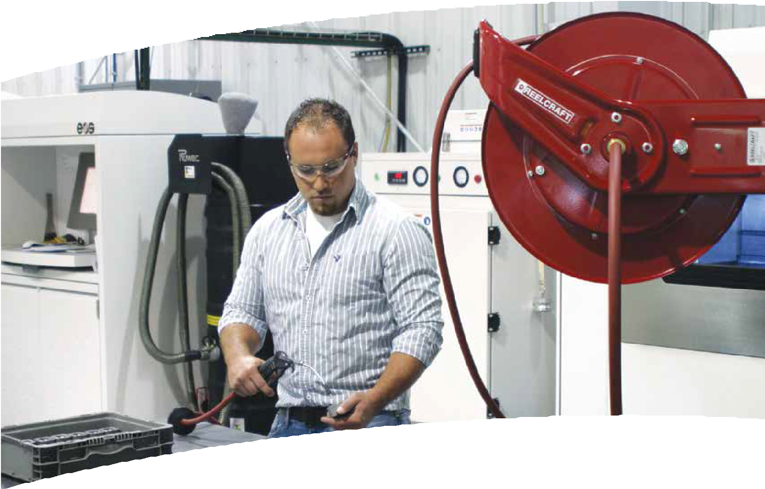
Reel Catalog
Hose, cord and cable reels

reelcraft.com

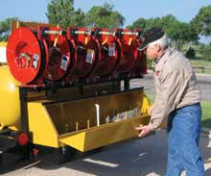Why use hose reels?

Why use hose reels? Because they make hose handling more efficient and safer. Your hoses, cables and cords will last up to five times longer. You will improve hose management, which decreases labor costs. Your chances of injuries from tripping
hazards will decrease, which saves lost work time, medical bills and higher insurance.
You also save the expense and time to replace expensive hoses, cables and cords that get run over by fork lifts and other vehicles.

Series 7000 - Photo courtesy of Sage Oil Vac

Five reasons why hose reels add value
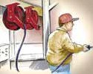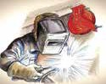

Improve efficiency Hoses, cable and cords are where you want/need them.
Increase safety Reduce tripping accidents and lost work time.
Minimize leakages Reduce costs of air and water leakages.
Reduce hose wear
Hose and cord on reels can last up to five times longer.
Increase productivity No more tangled hoses improves efficiency.

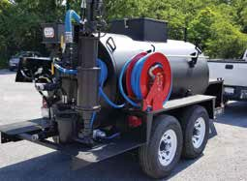OSHA says reduce your trips and falls

“There are many situations that may cause slips, trips and falls. The controls needed to prevent these hazards are usually obvious, but too often ignored, such as... coiling up extension cords, lines and hoses when not in use and keeping electrical and
other wires out of the way.” OSHA’s “Fall Prevention Tips” include, “Practice good housekeeping. Keep cords, welding leads and air hoses out of walkways or adjacent work areas."
Source: www.osha.gov

Series 80000 - Photo courtesy of Nealco Equipment, LLC

Same-day quick ship program offers fastest service
Because we are centrally located in the US and have three North American warehouses, upon request, we can quickly ship our standard products
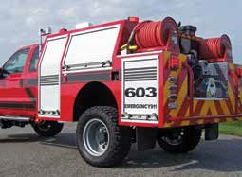the same day for domestic orders of ten or fewer standard models. Orders must be received by 1:00 pm Eastern Time. Look for the shipping icons in this catalog for designated models. For the most current list of Quick Ship reels, please visit www.reelcraft.com.

Series 30000 - Photo courtesy of 1st Attack Engineering
Two Year Limited Warranty and Return Policy
Reelcraft now offers a two-year limited warranty. All reels manufactured by Reelcraft Industries, Inc. are warranted to be free of defects due to faulty material or work- manship for 24 months from date of shipment. Exception: LD, LG, LH cord reels
- 1 year; hose and light bulbs - 6 months. Normal wear and tear is not considered a defect in material or workmanship. For complete warranty information, online warranty registration and return information please visit www.reelcraft.com or call Reelcraft's Customer Service Department toll-free at 1-855-634-9109.

*Please refer to the online catalog for the most current and up-to-date product information.

2 Customer Service: 1.855.634.9109

Reelcraft: Better by Design

Reelcraft’s reels are better by design because of our lasting commitment to excellence. Our engineering team is well known for designing durable, high quality products. Our standard
features include durable, corrosion-resistant powder coat paint, multi-position guide arms for versatile mounting options and
heavy-duty, reinforced steel stampings for
increased strength. Our reels are permanently factory-lubricated for a long, trouble-free ser- vice life. All of these features, and many more, add up to make “The Reelcraft Difference.”

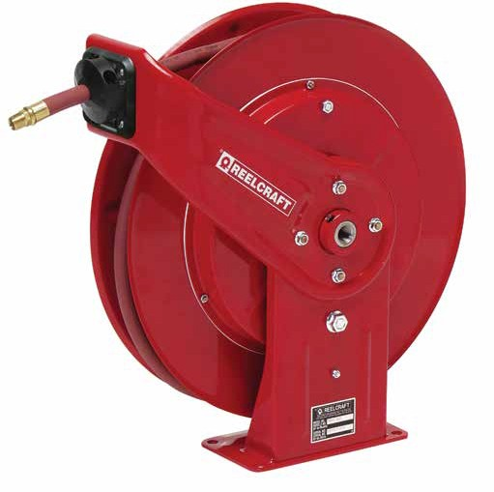Reinforced Steel
The steel-stamped guide arm is reinforced to reduce bending
due to angular pull.

Improved Connection
The elongated brass connec- tor and proprietary adhesion process provide a better crimp to the hose.
Stress-Free Swivel
Our full-flow design combines
the highest grade seal design with supporting bearing surfaces to insure the longest possible life.

Corrosion-Resistant
Steel components are individually powder coated to virtually eliminate corrosion.

Long Service Life
Field-proven swivel assures long service life.

Kinkless Hose
High quality PVC hose is specially blended for use on reels

Sealed Connection Points
Swivel and hose inlet con- nections seal against leaks

Adjustable Guide Arm Multiple guide arm positions provide versatile uses and easier field adjustment

Trouble-Free Performance
Fewer components increase the service life of the reel and improve performance

Shown: 7850 OLP
Long Life Drive Spring
Drive mechanism is enclosed for protection against the environment. Declutching arbor virtually eliminates possibility
of spring damage due to reverse winding of reel spool.
Robust Latch
Wide profile combined with special spring assures maximum service life.
Structural Strength
Welded heavy gauge steel frame includes a robotically welded base with stiffening ribs for lighter weight, yet stronger components for ease of handling and installation.

Easy to Mount
Attaches to most structurally sound surfaces. Edges are curved for safety.
Finish with Quality
Our components undergo a special five- stage cleaning process and are individually powder-coated for the highest quality paint adhesion. Excess powder is reclaimed to be environmentally friendly.

To place an order, please advise:
- Model number.
- Product to be handled such as air, oil, water, etc.
- Maximum operating pressure in P.S.I.
- Maximum operating temperature in degrees Fahrenheit.
- Hose inside and outside diameters and length.

- Installation height, especially if more than 16 feet.
- Desired guide arm position by add- ing one of the suffixes to the model number. Example: 5635 OLPSW for side wind.
Additional Considerations:
A flexible connection between the reel and the source of supply is required to prevent possible misalignment and bind- ing. Non-flexible connections will void the warranty. The pressure rating of inlet hose must be equal or greater than the rating of the reel.
Accessories
Reels ordered with hose and bumper are assembled complete and ready to
install. Order bumpers separately for reels without hoses.
Additional questions? Please visit our website or call for assistance. For more than 45 years, our specialty is offering hose handling solutions.

COPYRIGHT NOTICE
All rights reserved. No part of the material protected by this copyright may be reproduced or utilized in any form or by any means, electronic or mechanical, including photocopying, record- ing, broadcasting or by any other information storage and retrieval
system without written permission from Reelcraft Industries, Inc. Reelcraft, Work Smarter, Nordic, Hose Boss, Safe-T-Reel, Better by Design, Built Better to Perform Better, and Rely on Reelcraft are the trademarks and service marks of Reelcraft Industries, Inc.
registered in the United States and/or other jurisdictions. You shall
not display, disparage, dilute or taint our trademarks and service marks, or use our marks in such a way that would misrepresent the identity of the owner.
All other trademarks, service marks or registered trademarks appearing on these pages are the trademarks or service marks of
their respective owners. Super Swivel, Full Circle swivel, Viton, Quiet Speed, Buna, Push Lok, Stubby and Stubby II are not owned by Reelcraft Industries, Inc.

Customer Service: 1.855.634.9109 3

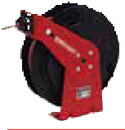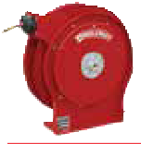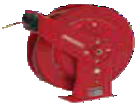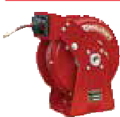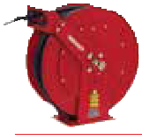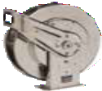Table of Contents

Reel Series | Page |  | Reel Series |  | Page
 |  |  | Fuel & Grounding | 3/4", 1", 11/4",
Series RT 1/4", 3/8", 1/2" I.D. | 8 |  | Reels | 11/2" I.D. | 18
Series 4000,  5000 & 5005 1/4", 3/8", 1/2" I.D. | 9 |  | Stainless Steel Reels | 1/4", 3/8", 1/2",  3/4", 1" I.D. | 19
1/4", 3/8", 1/2", |  |  | Pre-Rinse, Potable
Series 7000 3/4" I.D. | 10 |  | Water Reels | 3/8", 1/2" I.D. | 20
Series DP5000 1/4", 3/8",  & DP7000 1/2" I.D. | 11 |  | Series S | 1/4", 3/8", 1/2",  5/8" I.D. | 21 | 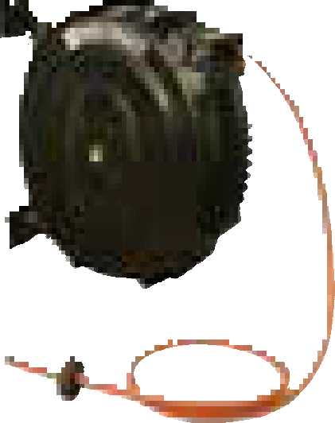
Series 3/8", 1/2",  HD70000 3/4" I.D. | 12 |  | Pressure Wash Reels | 1/4", 3/8", 1/2" I.D. | 22 | 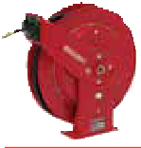
Series 80000 3/8", 1/2", 3/4",  & D80000 1" I.D. | 13 |  | Series CU, CT & CM | 3/8", 1/2" I.D. | 23 | 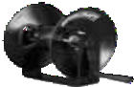
Series  SD10000 3/4", 1" I.D. | 14 |  | Series H | 3/8", 1/2", 3/4" I.D. | 24 | 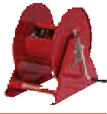
3/8", 1/2", 3/4", 1",  Series 9000 11/4", 11/2" I.D. | 15 |  | Series 30000 | 1/2", 3/4", 1" I.D. | 24-26 | 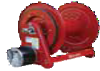

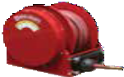
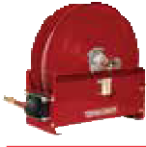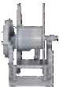Guide Arm Positions and Suffix Codes

Series 3100
& 4800
1/2", 3/4", 1",
11/4", 11/2" I.D. 16
The suffix codes (BW, TW and SW) must be added after the model number to specify desired guide arm position. For example, 5635 OLPSW designates side wind guide arm position. NOTE: Series 9000 reels
are shipped in the BW position and Series
80000 is shipped in the SW position. All other series reels are shipped in the TW position unless otherwise specified.
Series 4000 and 5000 reels ordered in the BW position are available in constant tension only.

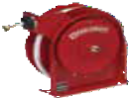
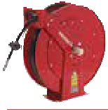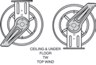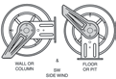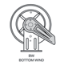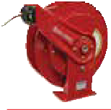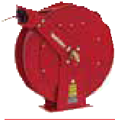

Series TH 1/4", 3/8", 1/2" I.D. 17
TW SW BW

Customer Service: 1.855.634.9109
4
All Other Calls: 1.800.444.3134

 |  |  |  |  |  |  | Table of Contents
 | Reel Series |  | Page |  |  | Reel Series | Page
 |  |  |  |  |  |  | 13/8", 11/2", 2",
 | Series 1200 | 1/2", 3/4", 1" I.D. | 29 |  |  | Series 6000 | 21/2", 3" I.D. 35
 |  |  |  |  |  |  | Light and medium duty
 | Series 2400 | 1/2", 3/4", 1" I.D. | 30 |  |  | Series LD, LG & LH | cord reels 36
 |  |  |  |  |  | Series L 4000,
 |  | 1", 11/4", 13/8", |  |  |  | L 5000, L 7000,  L 70000, L NM400
 | Series 3900 | 11/2" I.D. | 31 |  |  | & LS 5000 | Heavy duty cord reels 37-41
 | Liquid | 1/2", 3/4", 1", 11/4",
 | Propane Reels | 11/2", 2" I.D. | 32 |  |  | Series CR | High capacity cable reels 42
 | Series | 11/2", 2", 21/2", |  |  |  |  | Heavy duty cord
 | 3700 & 5900 | 3", 4" I.D. | 33 |  |  | Series 30000 | and cable reels 43
 |  | 11/4", 13/8", 11/2",
 | Series 3800 | 2" I.D. | 34 |  |  | Series TW & BA | Welding hose reels 44-45

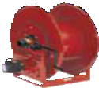
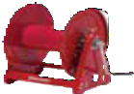
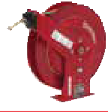Display stands
Three reel tabletop display S602155
Four reel tabletop display S602155-1
Six reel display S602037-2
Eight reel display S602037-1 Conveniently displays up to eight reels and features removable universal brackets for ease of mounting. It is easily assembled
and disassembled. Reels sold separately.

Safe-T-Reels

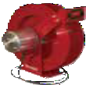Multiple configurations 47
Series WC & CEA
Welding
cable reels
46

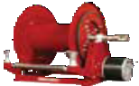
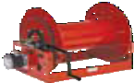
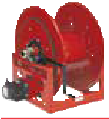
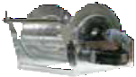
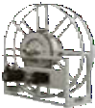
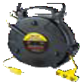
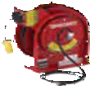
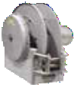
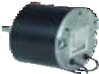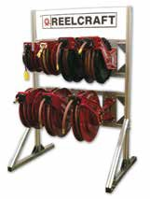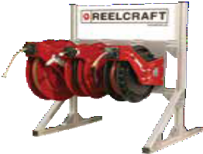
Three reel tabletop
display stand S602155
Parts &
Accessories
Brackets, motors,
switches, etc. 49-50
Eight reel display
stand S602037-1
Customer Service: 1.855.634.9109
All Other Calls: 1.800.444.3134
5
Series TB & TBL
Tool balancers
48

Custom Built Reels

Custom Built Reels
Reelcraft’s engineered products group custom builds reels to your specifica- tions. Our special engineered products are developed for demanding applications in areas such as marine, military, aviation, hydroseeding, sewer and well cleaning, offshore oil rigs, robotic cable and much

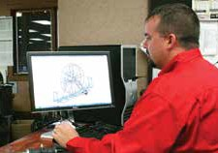more. We offer flexibility, competitive pricing and a lasting committment to excellence. For more than 25 years, Reelcraft’s engineered products group has produced custom products to meet individualized requirements.
Custom Reels
Built to your specs

Reelcraft’s Capabilities
Very few size and weight constraints
We build to meet most extreme size and weight constraints.
Special finishes/paint options
Options include CARC paint, marine grade epoxy, stainless steel, liquid enamel coat paint and powder coat paint in any color.
Various drive types
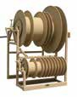
Manual crank, motorized, spring driven, hand-over-hand and more.

Wide range of pressures
A wide variety of pressure ranges available from 50 to 10,000.
Unique options
Hose Boss rewind assist, tensioning bars, multiple fluid paths, level rewinds and much more.
No minimum quantities
Order from 1 to as many as you need.

6
Customer Service: 1.855.634.9109
All Other Calls: 1.800.444.3134

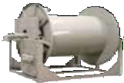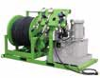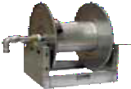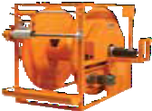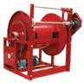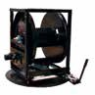

Marine grade | Multiple | Turn-key solutions | Stainless steel | Multiple fluid | Fiber optic cable | Sewer/jetter
epoxy | spools |  |  | paths

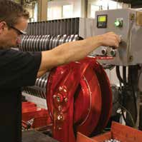

Reelcraft’s product quality starts with modern engineering techniques for maximum strength through better design, better materials and tested and proven products. We are committed to superior manufacturing processes by producing our steel com- ponents from hard tooling (dies) that increase product strength and reliability com- pared with simply bending metal in press breaks. In addition, we offer more levels of industrial products: Good, Better, Best and Ultimate. Our customers report that superior value is why they choose Reelcraft reels. All of these qualities and more add up to make "The Reelcraft Difference."

Special Powder Coat Paint Colors

Special Powder Coat Paint Colors

Customize your reel color with special paint options

Reelcraft is most well-known for its bright red reels, but we also paint secondary colors and special order colors. Reelcraft uses a rigorous cleaning process on raw parts prior to paint. After this process is complete, parts are then coated with a high quality, durable polyester powder coat paint for a uniform, corrosion resistant finish that will last through years of service.
Reelcraft frequently paints secondary colors - white, black, blue and gray. There is no set-up charge for secondary colors, only a variable per unit charge. We thoroughly clean our booths and tools prior to painting special order colors therefore require a one-time set-up charge in addition to the variable per unit charge.

Customer Service: 1.855.634.9109
All Other Calls: 1.800.444.3134
7

Green
20GN

Burgundy
12BG
RAL 3003

Green
20GN

Burgundy
12BG
RAL 3003
High Gloss Black 43BK
RAL 9005
Special Order Colors
We thoroughly clean our booths/tools prior to painting special order colors and thus require a set-up charge in addition to the variable per unit charge. Contact Reelcraft for additional colors not listed. Be aware that special paint may add to lead time.
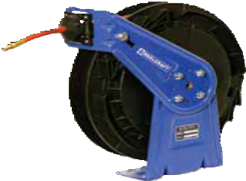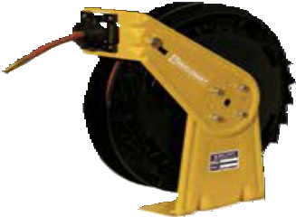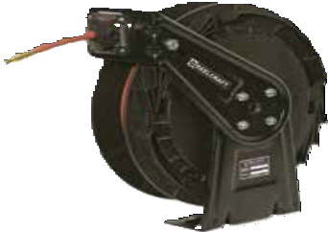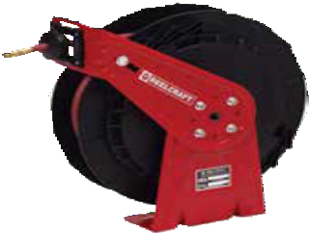
RT625-OLP-40BL RT625-OLP-42YE RT650-OLP-35BK RT850-OLP

Large Frame Reels Small Frame Reels

Reelcraft Red

Gray
39GY

Reelcraft Red
Secondary Colors
Reelcraft frequently paints secondary colors. There is no set-up charge for secondary colors, only a variable per unit charge and a possible increase in lead time.
Primary Colors - NO CHARGE Reelcraft is most well-known for its bright red reels, but we also paint gray on large
frame reels at no extra charge. Gray must be specified at time of order.

Large Frame Reels Small Frame Reels

White
17WH
RAL 9003

Black
35BK

White
17WH
RAL 9003

Black
35BK

Blue
40BL
RAL 5005

Silver
37SR

Blue
40BL
RAL 5005

Gray
39GY

Large Frame Reels Small Frame Reels

Gray Primer
26GY
Sunshine Yellow 42YE
RAL 1023

Bronze
47BZ

Silver
37SR

Gray Primer
26GY
Sunshine Yellow 42YE
RAL 1023

Bronze
47BZ

Hunter Green |  | Orange |  | Forrest Green |  | High Gloss Black |  | Hunter Green |  | Orange |  | Forrest Green
45GN |  | 55OR |  | 48GN |  | 43BK |  | 45GN |  | 55OR |  | 48GN
RAL 6004 |  | RAL 2009 |  | RAL 6006 |  | RAL 9005 |  | RAL 6004 |  | RAL 2009 |  | RAL 6006

Lightweight, Economical Reels | Series RT

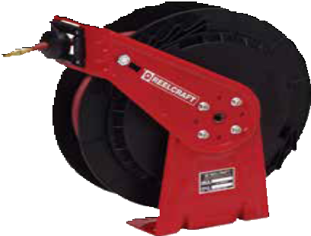Made in USA

RT650-OLP
Patent No. 7,150,425

Medium Duty Spring Retractable Reels
Air/Water/Oil/Grease - 1/4", 3/8", 1/2" I.D.
Series RT is an economical choice for a medium duty, light weight, spring driven hose reel for applications that are less demanding, yet require a product that can withstand industrial and commercial use. The industrial-grade drive spring is protected from the environment in a polypropylene spool for longer service life. Guide arm adjusts to seven positions.

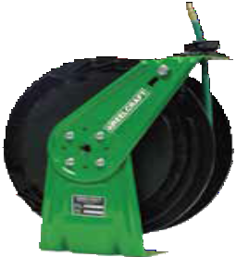
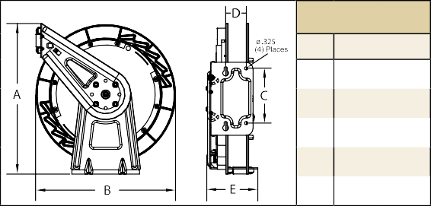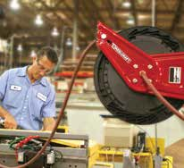Nitrogen Reels
Dimensions
E See Chart
 | in | mm
A | 177/8 | 454
B | 161/2 | 419
C | 6 | 152
D | 21/4 | 57

RT650-OLPG-20GN

Model with Hose | Shipping Weight |  | Hose I.D. |  | Hose O.D. |  | Hose Length |  | **Max Pressure |  | NPT(M)  Hose Outlet | NPT(F)  Reel Inlet | Model without hose or bumper | Shipping Weight |  | Pressure |  | E
 | lbs | kg | in | mm | in mm |  | ft | m | psi | bar | in | in |  | lbs | kg | psi | bar | in | mm
Low Pressure Air/Water Reels Maximum Temperature 150 °F (65 °C) **Maximum working pressure at 70 °F (20 °C)
RT425-OLP | 19 | 9 | 1/4 | 6 | .475 | 12 | 25 | 8 | 300 | 21 | 1/4 | 3/8 | RT402-OLP | 19 | 9 | 300 | 21 | 53/4 | 146
RT435-OLP | 21 | 10 | 1/4 | 6 | .475 | 12 | 35 | 11 | 300 | 21 | 1/4 | 3/8 | RT403-OLP | 19 | 9 | 300 | 21 | 53/4 | 146
RT450-OLP | 24 | 11 | 1/4 | 6 | .475 | 12 | 50 | 15 | 300 | 21 | 1/4 | 3/8 | RT405-OLP | 21 | 10 | 300 | 21 | 53/4 | 146
RT465-OLP | 25 | 11 | 1/4 | 6 | .475 | 12 | 65 | 20 | 300 | 21 | 1/4 | 3/8 | RT406-OLP | 21 | 10 | 300 | 21 | 53/4 | 146
RT625-OLP | 20 | 9 | 3/8 | 10 | .600 | 15 | 25 | 8 | 300 | 21 | 1/4 | 3/8 | RT602-OLP | 19 | 9 | 300 | 21 | 53/4 | 146
RT635-OLP | 21 | 10 | 3/8 | 10 | .600 | 15 | 35 | 11 | 300 | 21 | 1/4 | 3/8 | RT603-OLP | 19 | 9 | 300 | 21 | 53/4 | 146
RT650-OLP | 27 | 12 | 3/8 | 10 | .600 | 15 | 50 | 15 | 300 | 21 | 1/4 | 1/2 | RT605-OLP | 22 | 10 | 300 | 21 | 61/4 | 159
RT825-OLP | 26 | 12 | 1/2 | 13 | .750 | 19 | 25 | 8 | 300 | 21 | 1/2 | 1/2 | RT802-OLP | 23 | 10 | 300 | 21 | 61/4 | 159
RT835-OLP | 27 | 12 | 1/2 | 13 | .750 | 19 | 35 | 11 | 300 | 21 | 1/2 | 1/2 | RT803-OLP | 23 | 10 | 300 | 21 | 61/4 | 159
RT850-OLP | 37 | 17 | 1/2 | 13 | .750 | 19 | 50 | 15 | 300 | 21 | 1/2 | 1/2 | RT805-OLP | 25 | 11 | 300 | 21 | 73/4 | 197
Medium Pressure Oil Reels Maximum Temperature 150 °F (65 °C)
RT625-OMP | 27 | 12 | 3/8 | 10 | .710 | 18 | 25 | 8 | 1000 | 69 | 3/8 | 3/8 | RT602-OMP | 22 | 10 | 1000 | 69 | 53/4 | 146
RT635-OMP | 30 | 14 | 3/8 | 10 | .710 | 18 | 35 | 11 | 1000 | 69 | 3/8 | 3/8 | RT603-OMP | 22 | 10 | 1000 | 69 | 53/4 | 146
RT650-OMP | 35 | 16 | 3/8 | 10 | .710 | 18 | 50 | 15 | 1000 | 69 | 3/8 | 1/2 | RT605-OMP | 25 | 11 | 1000 | 69 | 73/4 | 197
RT825-OMP | 31 | 14 | 1/2 | 13 | .820 | 21 | 25 | 8 | 1000 | 69 | 1/2 | 1/2 | RT802-OMP | 23 | 10 | 1000 | 69 | 61/4 | 159
RT835-OMP | 32 | 15 | 1/2 | 13 | .820 | 21 | 35 | 11 | 1000 | 69 | 1/2 | 1/2 | RT803-OMP | 23 | 10 | 1000 | 69 | 61/4 | 159
High Pressure Grease Reels Maximum Temperature 150 °F (65 °C)
RT425-OHP | 28 | 13 | 1/4 | 6 | .580 | 15 | 25 | 8 | 5000 | 345 | 1/4 | 3/8 | RT402-OHP | 22 | 10 | 5000 | 345 | 53/4 | 146
RT435-OHP | 30 | 14 | 1/4 | 6 | .580 | 15 | 35 | 11 | 5000 | 345 | 1/4 | 3/8 | RT403-OHP | 22 | 10 | 5000 | 345 | 53/4 | 146
RT625-OHP | 30 | 14 | 3/8 | 10 | .730 | 19 | 25 | 8 | 4800 | 331 | 3/8 | 3/8 | RT602-OHP | 22 | 10 | 5000 | 345 | 53/4 | 146
RT635-OHP | 34 | 15 | 3/8 | 10 | .730 | 19 | 35 | 11 | 4800 | 331 | 3/8 | 1/2 | RT603-OHP | 22 | 10 | 5000 | 345 | 61/4 | 159
RT650-OHP | 46 | 21 | 3/8 | 10 | .730 | 19 | 50 | 15 | 4800 | 331 | 3/8 | 1/2 | RT605-OHP | 25 | 11 | 5000 | 345 | 73/4 | 197
Low pressure reels furnished standard with PVC hose. Medium pressure reels furnished standard with S.A.E. 100R1-AT (3/8") or S.A.E. 100R17 (1/2") one wire braid hose or equivalent. High pressure reels furnished standard with S.A.E. 100 R2T two wire braid hose. Reference page 4 for guide arm positions.

Prop 65: WARNING:
Cancer and Reproductive Harm www.P65Warnings.ca.gov.
Models listed with an icon can ship same day upon request when the order is received by 1:00 PM Eastern Time for quantities of 10 or fewer.
Indiana Warehouse California Warehouse
Interactive Reel Catalog
Visit www.reelcraft.com/catalog for complete product specifications, available parts and accessories.

8 Customer Service: 1.855.634.9109
Indiana & California Warehouses
Canadian Warehouse

Compact, Versatile Reels | Series 4000 / 5000 / 5005

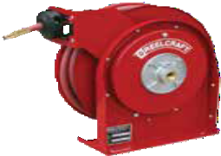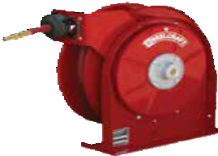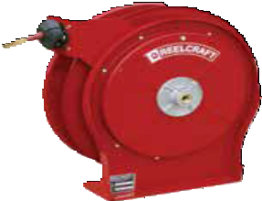Premium Duty Spring Retractable Reels
Air/Water/Oil/Grease - 1/4", 3/8", 1/2" I.D.
Series 4000, 5000 and 5005 reels are all-steel construction and compact for a wide range of applications with critical space requirements. A full flow shaft and swivel assures maximum product delivery. Guide arm adjusts to two positions.

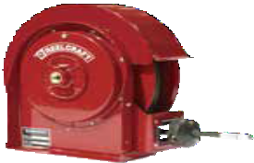
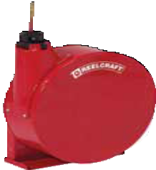Made in USA
Enclosed Reels
535 ELP

4625 OLP

5635 OLP

5650 OLP

Air Vend Reels
AV4425 OLPBWR
Enclosed Models: Series 5000 E reels are the same as 5000 O reels except E Series reels are fully enclosed. To order, change the model number suffix letter O to E, Example: 5430 OHP becomes 5430 EHP. Add 8 lbs. to open reel weight. Enclosed version is only available for Series 5000 reels (size index 2 reels). Refer to reelcraft.com for dimensional information.

NOTE: See operating instructions for optimum mounting configuration.
 | B |  | Dimensions - Size Index
 |  |  |  | 1 |  | 2 |  | 3 |  | 4
 |  |  |  | in | mm | in | mm | in | mm | in | mm
A
 |  |  | A | 127/8 327 |  | 143/8 365 |  | 175/8 448 |  | 175/8 448
 |  |  | B | 125/8 321 |  | 141/4 362 |  | 163/4 425 |  | 163/4 425
 | C |  | C | 8 | 203 | 93/4 | 248 | 93/4 | 248 | 93/4 | 248
 |  |  | D | 21/2 | 64 | 21/2 | 64 | 21/2 | 64 | 21/2 | 64
D |  | E
 |  |  | E | 55/8 | 143 | 61/8 | 156 | 57/8 | 149 | 71/4 | 184

Quiet latch with Hose | Ratchet latch with Hose | Shipping Weight | Hose I.D. | Hose O.D. | Hose Length | **Max Pressure | NPT(M)  Hose Outlet | NPT(F)  Reel Inlet | Quiet latch without hose or bumper | Shipping Weight | Pressure | Size Index #
 |  | lbs kg | in mm | in mm | ft m | psi bar | in | in |  | lbs kg | psi bar
Low Pressure Air/Water Reels Maximum temperature 150 °F (65 °C) w/hose / 210 °F (99 °C) w/o hose **Maximum working pressure at 70 °F (20 °C)
4420 OLP | ------------- | 18 8 | 1/4 6 | .475 12 | 20 6 | 300 21 | 1/4 | 3/8 | 4400 OLP | 17 8 | 500 35 | 1
4425 OLP | B4425 OLP | 19 9 | 1/4 6 | .475 12 | 25 8 | 300 21 | 1/4 | 3/8 | 4400 OLP | 17 8 | 500 35 | 1
4435 OLP | B4435 OLP | 19 9 | 1/4 6 | .475 12 | 35 11 | 300 21 | 1/4 | 3/8 | 4400 OLP | 17 8 | 500 35 | 1
5450 OLP | B5450 OLP | 26 12 | 1/4 6 | .475 12 | 50 15 | 300 21 | 1/4 | 3/8 | 5400 OLP | 20 9 | 500 35 | 2
4617 OLP | ------------- | 19 9 | 3/8 10 | .600 15 | 17 5 | 300 21 | 1/4 | 3/8 | 4600 OLP | 17 8 | 500 35 | 1
4625 OLP | B4625 OLP | 20 9 | 3/8 10 | .600 15 | 25 8 | 300 21 | 1/4 | 3/8 | 4600 OLP | 17 8 | 500 35 | 1
5635 OLP | B5635 OLP | 25 11 | 3/8 10 | .600 15 | 35 11 | 300 21 | 1/4 | 3/8 | 5600 OLP | 21 10 | 500 35 | 2
5650 OLP | B5650 OLP | 36 16 | 3/8 10 | .600 15 | 50 15 | 300 21 | 1/4 | 3/8 | 5605 OLP | 31 14 | 500 35 | 3
A5825 OLP | B5825 OLP | 27 12 | 1/2 13 | .750 19 | 25 8 | 300 21 | 1/2 | 3/8 | A5800 OLP | 22 10 | 500 35 | 2
A5835 OLP | B5835 OLP | 39 18 | 1/2 13 | .750 19 | 35 11 | 300 21 | 1/2 | 3/8 | A5805 OLP | 32 15 | 500 35 | 3
A5850 OLP | B5850 OLP | 41 19 | 1/2 13 | .750 19 | 50 15 | 300 21 | 1/2 | 3/8 | A5806 OLP | 35 16 | 500 35 | 4
Medium Pressure Oil Reels Maximum temperature 210 °F (99 °C)
5435 OMP | B5435 OMP | 31 14 | 1/4 6 | .530 13 | 35 11 | 2750 190 | 1/4 | 3/8 | 5400 OMP | 23 10 | 3000 207 | 2
5630 OMP | B5630 OMP | 31 14 | 3/8 10 | .690 18 | 30 9 | 2600 179 | 3/8 | 3/8 | 5600 OMP | 24 11 | 3000 207 | 2
A5825 OMP* | B5825 OMP* | 34 15 | 1/2 13 | .820 21 | 25 8 | 3000 207 | 1/2 | 3/8 | A5800 OMP | 24 11 | 3000 207 | 2
A5835 OMP | B5835 OMP | 42 19 | 1/2 13 | .820 21 | 35 11 | 3000 207 | 1/2 | 3/8 | A5805 OMP | 32 15 | 3000 207 | 3
High Pressure Grease Reels Maximum temperature 210 °F (99 °C)
5430 OHP | ------------- | 30 14 | 1/4 6 | .580 15 | 30 9 | 5000 345 | 1/4 | 1/4 | 5400 OHP | 23 10 | 5000 345 | 2
5435 OHP | B5435 OHP | 39 18 | 1/4 6 | .580 15 | 35 11 | 5000 345 | 1/4 | 1/4 | 5405 OHP | 33 15 | 5000 345 | 3
5625 OHP | B5625 OHP | 32 15 | 3/8 10 | .730 19 | 25 8 | 4800 331 | 1/4 | 1/4 | 5600 OHP | 26 12 | 5000 345 | 2
*Floor tank mount only - do not mount on ceiling. Low pressure reels furnished standard with PVC hose. Compressed air hoses should not be converted to oxygen service - may cause explosion when O mixes with fuel. Medium pressure reels furnished standard with S.A.E. 100R1-AT (1/4" and 3/8") or S.A.E. 100R17 (1/2") one wire braid hose. High pressure reels furnished standard with S.A.E. 100
2
R2T two wire braid hose. Reference page 4 for guide arm positions.

Models listed with an icon can ship same day upon request when the order is received by 1:00 PM Eastern Time for quantities of 10 or fewer.
Indiana Warehouse California Warehouse
Prop 65: WARNING:
Cancer and Reproductive Harm www.P65Warnings.ca.gov.
Interactive Reel Catalog
Visit www.reelcraft.com/catalog for complete product specifications, available parts and accessories.

Indiana & California Warehouses
Canadian Warehouse
Customer Service: 1.855.634.9109 9

Heavy Duty Hose Reels | Series 7000

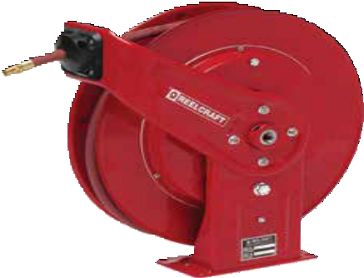Heavy Duty Spring Retractable Hose Reels
Made
7850 OLP
in USA
Air/Water/Oil/Grease - 1/4", 3/8", 1/2", 3/4" I.D.
Series 7000 is very robust and ideal for the most demanding applications. The reel’s base and guide arm are formed from high- grade steel and engineered with structural forms and gussets to yield the greatest amount of strength. The standard low pressure hose is for air or water service only. The basic reel without hose can be used for air, water or oil. Consult Reelcraft for other products and hoses. Guide arm adjusts to 7 positions.

 | in | mm | in | mm
A | 201/4 | 514 | 207/8 | 530
B | 193/4 | 502 | 211/8 | 537
C | 713/16 | 198 | 713/16 | 198

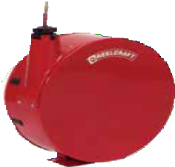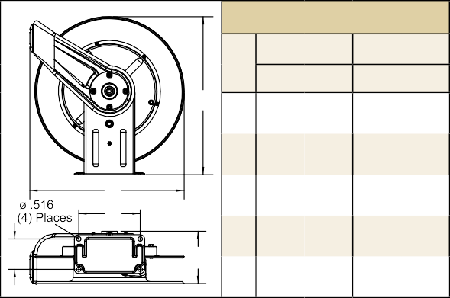For all metric thread connections over 1/2" add the suffix number 70 to indicate BSPT threads - example 7900 OLP70.
Enclosed Reels
7650 ELP

Series 7000 E reels are the same as 7000 O reels except E Series reels are fully enclosed. To order, change the model number suffix letter O to E. Example, 7650 OHP becomes 7650 EHP. Add 17 lbs. to open reel weight.
Dimensions
7000 0 7000 E
A
B
C
D 37/8 98 37/8 98
D
E
E 7 178 75/8 194
Applications
- Industrial
- Automotive service centers
- Transmission shops
- Fleet maintenance facilities
- Pneumatic tools
- Aircraft maintenance
- Tire stores
- Agriculture
- Service trucks
- Wash down

Model with Hose | Shipping Weight |  | Hose I.D. |  | Hose O.D. |  | Hose Length |  | **Max Pressure |  | NPT(M)  Hose Outlet | NPT(F)  Reel Inlet | Model without hose & bumper | Shipping Weight |  | Pressure
 | lbs | kg | in | mm | in | mm | ft | m | psi | bar | in | in |  | lbs | kg | psi | bar
Low Pressure Air/Water Reels Maximum temperature 150 °F (65 °C) w/hose / 210 °F (99 °C) w/o hose **Maximum working pressure at 70 °F (20 °C)
7650 OLP | 43 | 20 | 3/8 | 10 | .600 | 15 | 50 | 15 | 300 | 21 | 1/4 | 1/2 | 7600 OLP | 40 | 18 | 500 | 35
7670 OLP | 47 | 21 | 3/8 | 10 | .600 | 15 | 70 | 22 | 300 | 21 | 1/4 | 1/2 | 7607 OLP | 40 | 18 | 500 | 35
7850 OLP | 47 | 21 | 1/2 | 13 | .750 | 19 | 50 | 15 | 300 | 21 | 3/8 | 1/2 | 7800 OLP | 41 | 19 | 500 | 35
7850 OLP121 | 47 | 21 | 1/2 | 13 | .750 | 19 | 50 | 15 | 300 | 21 | 1/2 | 1/2 | 7800 OLP | 41 | 19 | 500 | 35
7850 OLPSW57 | 47 | 21 | 1/2 | 13 | .750 | 19 | 50 | 15 | 300 | 21 | 3/4 NH | 1/2 | 7800 OLP | 41 | 19 | 500 | 35
7925 OLP | 47 | 21 | 3/4 | 19 | 1.075 27 |  | 25 | 8 | 250 | 17 | 3/4 | 3/4 | 7900 OLP | 44 | 20 | 500 | 35
F7925 OLP* | 47 | 21 | 3/4 | 19 | 1.075 27 |  | 25 | 8 | 50 | 3 | 3/4 | 3/4 | F7900 OLP | 45 | 20 | 500 | 35
Medium Pressure Oil Reels Maximum temperature 210 °F (99 °C)
7650 OMP | 55 | 25 | 3/8 | 10 | .690 | 18 | 50 | 15 | 2600 | 179 | 3/8 | 1/2 | 7600 OMP | 43 | 20 | 3000 | 207
7850 OMP | 57 | 26 | 1/2 | 13 | .820 | 21 | 50 | 15 | 3000 | 207 | 1/2 | 1/2 | 7800 OMP | 43 | 20 | 3000 | 207
High Pressure Grease Reels Maximum temperature 210 °F (99 °C)
7450 OHP | 55 | 25 | 1/4 | 6 | .580 | 15 | 50 | 15 | 5000 | 345 | 1/4 | 1/2 | 7400 OHP | 43 | 20 | 5000 | 345
7650 OHP | 60 | 27 | 3/8 | 10 | .730 | 19 | 50 | 15 | 4800 | 331 | 1/4 | 1/2 | 7600 OHP | 46 | 21 | 5000 | 345
Low pressure reels furnished standard with PVC hose. Medium pressure reels furnished standard with S.A.E. 100R1-AT (3/8") or S.A.E. 100R17 (1/2") one wire braid hose. High pressure reels furnished standard with S.A.E. 100 R2T two wire braid hose. For hydraulic or other applications please consult manufacturer. *Series F7925 OLP supplied with UL330 and UCL approved fuel grade hose with a 250 psi (17 bar) minimum burst. Reference page 4 for guide arm positions.

Prop 65: WARNING:
Cancer and Reproductive Harm www.P65Warnings.ca.gov.
Models listed with an icon can ship same day upon request when the order is received by 1:00 PM Eastern Time for quantities of 10 or fewer.
Indiana Warehouse California Warehouse
Interactive Reel Catalog
Visit www.reelcraft.com/catalog for complete product specifications, available parts and accessories.

10 Customer Service: 1.855.634.9109
Indiana & California Warehouses
Canadian Warehouse

Compact, Dual Pedestal Reels | Series DP5000 / DP7000

Heavy Duty Spring Retractable Hose Reels
Air/Water/Oil/Grease - 1/4", 3/8", 1/2" I.D.
Reelcraft’s new compact dual pedestal Series DP5000 and DP7000 feature an innovative, non-welded, interlocking base. Independent testing to military
standards has proven the reel stand up to heavy vibration, which makes them especially strong and ideal for truck- mounted applications. Superbly engineered dual pedestal base and guide arm are structurally reinforced. All-steel construction and a baked-on powder coat finish combine to produce a rugged corrosion-resistant product suitable for a wide variety of heavy duty applications.

Meets or exceeds military vibration for Truck Transport test
MIL-STD-810F
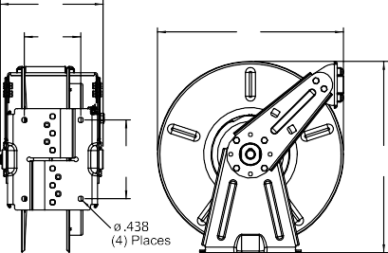
500,000 mile equivalent
DP5835 OLP Made
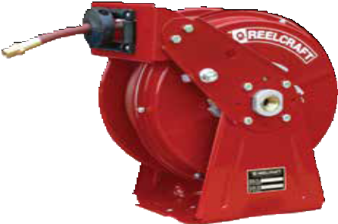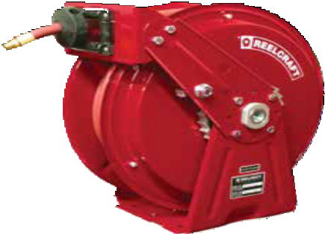in USA

DP7850 OLP

- Superior corrosion-resistance A double adhesive gasket seals the spring case.
- Ease of operation - The latch pawl is mounted on the guide arm to prevent latch out at full extension.
E D | C | B | A | Dimensions - Size Index
 |  |  |  |  | 1 | 2 | 3 | 4
 |  |  |  |  | in mm | in mm | in mm | in mm
 |  |  |  | A | 163/8 416 | 163/8 416 | 17 432 | 17 432
 |  |  |  | B | 143/8 365 | 143/8 365 | 161/2 419 | 161/2 419
 |  |  |  | C | 7 178 | 7 178 | 7 178 | 7 178
 |  |  |  | D | 4 102 | 5 127 | 4 102 | 5 127
 |  |  |  | E | 8 203 | 9 229 | 8 203 | 9 229

Model with Hose | Shipping Weight |  | Hose I.D. |  | Hose O.D. |  | Hose Length |  | **Max Pressure |  | NPT(M)  Hose Outlet | NPT(F)  Reel Inlet | Model without hose &  bumper | Shipping Weight |  | Pressure |  | Size Index #
 | lbs | kg | in | mm | in | mm | ft | m | psi | bar | in | in |  | lbs | kg | psi | bar
Low Pressure Air/Water Reels Maximum temperature 150 °F (65 °C) w/hose / 210 °F (99 °C) w/o hose **Maximum working pressure at 70 °F (20 °C)
DP5435 OLP | 34 | 15 | 1/4 | 6 | .475 | 12 | 35 | 11 | 300 | 21 | 1/4 | 1/2 | DP5400 OLP | 29 | 13 | 500 | 35 | 1
DP5450 OLP | 37 | 17 | 1/4 | 6 | .475 | 12 | 50 | 15 | 300 | 21 | 1/4 | 1/2 | DP5400 OLP | 29 | 13 | 500 | 35 | 1
DP7450 OLP | 46 | 21 | 1/4 | 6 | .475 | 12 | 50 | 15 | 300 | 21 | 1/4 | 1/2 | DP7400 OLP | 44 | 20 | 500 | 35 | 3
DP5635 OLP | 41 | 19 | 3/8 | 10 | .600 | 15 | 35 | 11 | 300 | 21 | 1/4 | 1/2 | DP5600 OLP | 37 | 17 | 500 | 35 | 1
DP5650 OLP | 44 | 20 | 3/8 | 10 | .600 | 15 | 50 | 15 | 300 | 21 | 1/4 | 1/2 | DP5605 OLP | 38 | 17 | 500 | 35 | 2
DP7650 OLP | 50 | 23 | 3/8 | 10 | .600 | 15 | 50 | 15 | 300 | 21 | 1/4 | 1/2 | DP7600 OLP | 44 | 20 | 500 | 35 | 3
DP5835 OLP | 52 | 24 | 1/2 | 13 | .750 | 19 | 35 | 11 | 300 | 21 | 3/8 | 1/2 | DP5800 OLP | 38 | 17 | 500 | 35 | 2
DP7850 OLP | 53 | 24 | 1/2 | 13 | .750 | 19 | 50 | 15 | 300 | 21 | 3/8 | 1/2 | DP7800 OLP | 45 | 20 | 500 | 35 | 4
DP7850 OLP121 | 53 | 24 | 1/2 | 13 | .750 | 19 | 50 | 15 | 300 | 21 | 1/2 | 1/2 | DP7800 OLP | 45 | 20 | 500 | 35 | 4
Medium Pressure Oil Reels Maximum temperature 210 °F (99 °C)
DP7650 OMP | 55 | 25 | 3/8 | 10 | .690 | 18 | 50 | 15 | 2600 | 179 | 3/8 | 1/2 | DP7600 OMP | 45 | 20 | 3000 | 207 | 3
DP5835 OMP | 54 | 24 | 1/2 | 13 | .820 | 21 | 35 | 11 | 3000 | 207 | 1/2 | 1/2 | DP5800 OMP | 40 | 18 | 3000 | 207 | 2
DP7850 OMP | 64 | 29 | 1/2 | 13 | .820 | 21 | 50 | 15 | 3000 | 207 | 1/2 | 1/2 | DP7800 OMP | 45 | 20 | 3000 | 207 | 4
High Pressure Grease Reels Maximum temperature 210 °F (99 °C)
DP7450 OHP | 59 | 27 | 1/4 | 6 | .580 | 15 | 50 | 15 | 5000 | 345 | 1/4 | 1/2 | DP7400 OHP | 44 | 20 | 5000 | 345 | 3
DP5635 OHP | 43 | 20 | 3/8 | 10 | .730 | 19 | 35 | 11 | 4800 | 331 | 3/8 | 1/2 | DP5600 OHP | 40 | 18 | 5000 | 345 | 2
DP7650 OHP | 65 | 29 | 3/8 | 10 | .730 | 19 | 50 | 15 | 4800 | 331 | 1/4 | 1/2 | DP7600 OHP | 46 | 21 | 5000 | 345 | 3
Low pressure reels furnished standard with PVC hose. Medium pressure reels furnished standard with S.A.E. 100R1-AT (3/8") or S.A.E. 100R17 (1/2") one wire braid hose. High pressure reels furnished standard with S.A.E. 100 R2T two wire braid hose. Reference page 4 for guide arm positions.

Models listed with an icon can ship same day upon request when the order is received by 1:00 PM Eastern Time for quantities of 10 or fewer.
Interactive Reel Catalog
Visit www.reelcraft.com/catalog for complete product specifications, available parts and accessories.
Indiana Warehouse California Warehouse
Prop 65: WARNING:
Cancer and Reproductive Harm www.P65Warnings.ca.gov.

Indiana & California Warehouses
Canadian Warehouse
Customer Service: 1.855.634.9109 11

Heavy Duty Mobile Base Hose Reels | Series HD70000

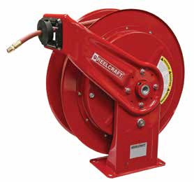Heavy Duty Spring Retractable Reels
HD76100 OLP
Air/Water/Oil/Grease - 1/4", 3/8", 1/2", 3/4" I.D.
Reelcraft’s new Series HD70000 hose reels are designed to accommodate up to 100’ of 3/8” I.D. hose or 75’ of 1/2” I.D. hose. The heavy duty base design, all steel construction and a baked-on powder coat finish combine to produce a rugged, corrosion-resis- tant product. A newly redesigned latching mechanism provides longer service life of the latch components. The one piece guide roller design and stainless steel pins offer greater strength and easier serviceability. The high quality, die cast aluminum hub and two sealed ball bearings produce a smoother spool rotation
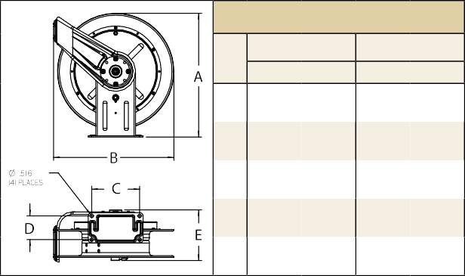and easier operation.
Compact design - Reels are 25% smaller than our heavy
duty Series 80000 reels.

Drive spring - The containerized drive spring offers easier handling during maintenance (size index 2 models only).

Versatility - The guide arm adjusts to seven different
positions for versatile mounting and a
wide range of applications.
Made in USA
D

Dimensions - Size Index |  |  |  |  |  |  | •
 | in | 1 | mm | in | 2 | mm
A | 201/4 |  | 514 | 201/4 |  | 514 | •
B | 193/4 |  | 502 | 193/4 |  | 502
C | 713/16 |  | 198 | 713/16 |  | 198 | •
D | 37/8 |  | 98 | 37/8 |  | 98
E | 7 |  | 178 | 81/4 |  | 210

Model with Hose | Shipping Weight |  | Hose I.D. |  | Hose O.D. |  | Hose Length |  | **Max Pressure |  | NPT(M)  Hose Outlet | NPT(F)  Reel Inlet | Model without hose & bumper | Shipping Weight |  | Pressure |  | Size Index #
 | lbs | kg | in | mm | in | mm | ft | m | psi | bar | in | in |  | lbs | kg | psi | bar
Low Pressure Air/Water Reels Maximum temperature 150 °F (65 °C) w/hose / 210 °F (99 °C) w/o hose **Maximum working pressure at 70 °F (20 °C)
HD76050 OLP | 45 | 20 | 3/8 | 10 | .600 | 15 | 50 | 15 | 300 | 21 | 1/4 | 1/2 | HD76000 OLP | 42 | 19 | 500 | 35 | 1
HD76070 OLP | 49 | 22 | 3/8 | 10 | .600 | 15 | 70 | 21 | 300 | 21 | 1/4 | 1/2 | HD76000 OLP | 42 | 19 | 500 | 35 | 1
HD76075 OLP | 65 | 29 | 3/8 | 10 | .600 | 15 | 75 | 23 | 300 | 21 | 1/4 | 1/2 | HD76005 OLP | 56 | 25 | 500 | 35 | 2
HD76100 OLP | 75 | 34 | 3/8 | 10 | .600 | 15 | 100 | 30 | 300 | 21 | 1/4 | 1/2 | HD76005 OLP | 56 | 25 | 500 | 35 | 2
HD78050 OLP | 49 | 22 | 1/2 | 13 | .750 | 19 | 50 | 15 | 300 | 21 | 3/8 | 1/2 | HD78000 OLP | 43 | 20 | 500 | 35 | 1
HD78075 OLP | 73 | 33 | 1/2 | 13 | .750 | 19 | 75 | 23 | 300 | 21 | 3/8 | 1/2 | HD78005 OLP | 58 | 26 | 500 | 35 | 2
HD79025 OLP | 49 | 27 | 3/4 | 19 | 1.075 27 |  | 25 | 8 | 250 | 17 | 3/4 | 3/4 | HD79000 OLP | 46 | 21 | 500 | 35 | 1
Medium Pressure Oil Reels Maximum temperature 210 °F (99 °C)
HD76050 OMP | 57 | 26 | 3/8 | 10 | .690 | 18 | 50 | 15 | 2600 | 179 | 3/8 | 1/2 | HD76000 OMP | 45 | 20 | 3000 207 |  | 1
HD76075 OMP | 85 | 39 | 3/8 | 10 | .690 | 18 | 75 | 23 | 2600 | 179 | 3/8 | 1/2 | HD76005 OMP | 60 | 27 | 3000 207 |  | 2
HD78050 OMP | 59 | 27 | 1/2 | 13 | .820 | 21 | 50 | 15 | 3000 | 207 | 1/2 | 1/2 | HD78000 OMP | 43 | 20 | 3000 207 |  | 1
HD78065 OMP | 78 | 35 | 1/2 | 13 | .820 | 21 | 65 | 20 | 3000 | 207 | 1/2 | 1/2 | HD78005 OMP | 60 | 27 | 3000 207 |  | 2
High Pressure Grease Reels Maximum temperature 210 °F (99 °C)
HD74050 OHP | 57 | 26 | 1/4 | 6 | .580 | 15 | 50 | 15 | 5000 | 345 | 1/4 | 1/2 | HD74000 OHP | 45 | 20 | 5000 345 |  | 1
HD74075 OHP | 80 | 36 | 1/4 | 6 | .580 | 15 | 75 | 23 | 5000 | 345 | 1/4 | 1/2 | HD74005 OHP | 60 | 27 | 5000 345 |  | 2
HD74100 OHP | 86 | 39 | 1/4 | 6 | .580 | 15 | 100 | 30 | 5000 | 345 | 1/4 | 1/2 | HD74005 OHP | 60 | 27 | 5000 345 |  | 2
HD76050 OHP | 62 | 28 | 3/8 | 10 | .730 | 19 | 50 | 15 | 4800 | 331 | 1/4 | 1/2 | HD76000 OHP | 48 | 22 | 5000 345 |  | 1
HD76075 OHP | 90 | 41 | 3/8 | 10 | .730 | 19 | 75 | 23 | 4800 | 331 | 1/4 | 1/2 | HD76005 OHP | 60 | 27 | 5000 345 |  | 2
Low pressure reels furnished standard with PVC hose. Medium pressure reels furnished standard with S.A.E. 100R1-AT (3/8") or S.A.E. 100R17 (1/2") one wire braid hose. High pressure reels furnished standard with S.A.E. 100 R2T two wire braid hose. Reference page 4 for guide arm positions.

Prop 65: WARNING:
Cancer and Reproductive Harm www.P65Warnings.ca.gov.
Models listed with an icon can ship same day upon request when the order is received by 1:00 PM Eastern Time for quantities of 10 or fewer.
Indiana Warehouse California Warehouse
Interactive Reel Catalog
Visit www.reelcraft.com/catalog for complete product specifications, available parts and accessories.

12 Customer Service: 1.855.634.9109
Indiana & California Warehouses
Canadian Warehouse

Dual Pedestal Hose Reels | Series 80000 / D80000

Heavy Duty Spring Retractable Reels
Air/Water/Oil/Grease - 3/8", 1/2", 3/4", 1" I.D.
Reelcraft’s Series 80000 and D80000 spring retractable reels incorporate the most current design and manufacturing techniques to increase service life and performance. The all-steel construction and a baked-on powder coat finish combine to produce a rugged, corrosion-resistant product suitable for a wide variety of heavy duty applications. Series D80000 reels are also supplied with Reelcraft’s ball-bearing style swivel.

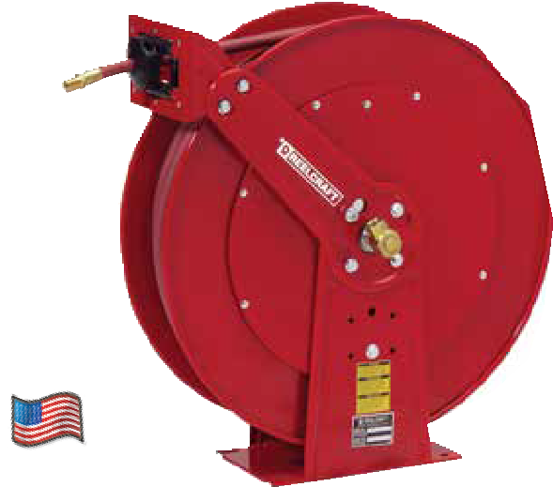
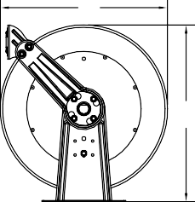
Made in USA
Features
P Guide arm is field adjustable for wall, ceiling, or truck mounting positions.
P Dual pedestal base and guide arm design are structurally reinforced.
P Five-in-one, heat-treated aluminium casting incorporates main shaft, ratchet, spring arbor and inlet/outlet plumbing in one-piece casting.
P Containerized spring assembly provides safer and easier handling during maintenance.
P Two sealed ball bearings for smooth rotation of main shaft.
 | B | Dimensions - Size Index
 |  |  | 1 |  | 2 |  | 3
 |  |  | in | mm | in | mm | in | mm
 | A | A | 253/8 | 645 | 253/8 | 645 | 253/8 | 645
 |  | B | 24 | 610 | 24 | 610 | 24 | 610
 |  | C | 10 | 254 | 101/2 | 267 | 101/2 | 267
 | C | D | 6 | 152 | 77/8 | 200 | 77/8 | 200
D | F E | E | 101/2 | 267 | 13 | 330 | 153/4 | 400
 |  | F | 81/8 | 206 | 103/8 | 264 | 103/8 | 264

82100 OLP

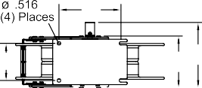

Model with Hose | Shipping Weight |  | Hose I.D. |  | Hose O.D. |  | Hose Length |  | **Max Pressure |  | NPT(M)  Hose Outlet | NPT(F)  Reel Inlet | Model without hose & bumper | Shipping Weight |  | Pressure |  | Size Index #
 | lbs | kg | in | mm | in | mm | ft | m | psi | bar | in | in |  | lbs | kg | psi | bar
Low Pressure Air/Water Reels Maximum temperature 150 °F (65 °C) w/hose / 210 °F (99 °C) w/o hose **Maximum working pressure at 70 °F (20 °C)
81075 OLP | 76 | 34 | 3/8 | 10 | .600 | 15 | 75 | 23 | 300 | 21 | 3/8 | 1/2 | 81000 OLP | 77 | 35 | 500 | 35 | 1
81100 OLP | 82 | 37 | 3/8 | 10 | .600 | 15 | 100 | 30 | 300 | 21 | 3/8 | 1/2 | 81000 OLP | 77 | 35 | 500 | 35 | 1
82075 OLP | 87 | 39 | 1/2 | 13 | .750 | 19 | 75 | 23 | 300 | 21 | 1/2 | 1/2 | 82000 OLP | 82 | 37 | 500 | 35 | 1
82100 OLP | 95 | 43 | 1/2 | 13 | .750 | 19 | 100 | 30 | 300 | 21 | 1/2 | 1/2 | 82000 OLP | 82 | 37 | 500 | 35 | 1
83050 OLP | 88 | 40 | 3/4 | 19 | 1.075 27 |  | 50 | 15 | 250 | 17 | 3/4 | 3/4 | 83000 OLP | 77 | 35 | 500 | 35 | 1
F83050 OLP* | 89 | 41 | 3/4 | 19 | 1.075 27 |  | 50 | 15 | 50 | 3 | 3/4 | 3/4 | F83000 OLP | 74 | 34 | 500 | 35 | 1
D83075 OLP | 102 | 46 | 3/4 | 19 | 1.075 27 |  | 75 | 23 | 250 | 17 | 3/4 | 3/4 | D83000 OLP | 83 | 38 | 500 | 35 | 2
D84035 OLP | 97 | 44 | 1 | 25 | 1.375 35 |  | 35 | 11 | 250 | 17 | 3/4 | 1 | D84000 OLP | 91 | 41 | 500 | 35 | 3
D84050 OLP | 103 | 47 | 1 | 25 | 1.375 35 |  | 50 | 15 | 250 | 17 | 3/4 | 1 | D84000 OLP | 91 | 41 | 500 | 35 | 3
Medium Pressure Oil Reels Maximum temperature 210 °F (99 °C)
82075 OMP | 101 | 46 | 1/2 | 13 | .850 | 22 | 75 | 23 | 2000 | 138 | 1/2 | 1/2 | 82000 OMP | 82 | 37 | 3000 | 207 | 1
82100 OMP | 109 | 49 | 1/2 | 13 | .850 | 22 | 100 | 30 | 3000 | 207 | 1/2 | 1/2 | 82000 OMP | 82 | 37 | 3000 | 207 | 1
83050 OMP | 98 | 44 | 3/4 | 19 | 1.188 30 |  | 50 | 15 | 1250 | 86 | 3/4 | 3/4 | 83000 OMP | 84 | 38 | 1500 | 103 | 1
D84050 OMP | 122 | 55 | 1 | 25 | 1.400 36 |  | 50 | 15 | 1275 | 88 | 1 | 1 | D84000 OMP | 86 | 39 | 1500 | 103 | 3
High Pressure Grease Reels Maximum temperature 210 °F (99 °C)
81075 OHP | 111 | 50 | 3/8 | 10 | .730 | 19 | 75 | 23 | 4800 | 331 | 3/8 | 3/8 | 81000 OHP | 85 | 39 | 5000 | 345 | 1
81100 OHP | 127 | 58 | 3/8 | 10 | .730 | 19 | 100 | 30 | 4800 | 331 | 3/8 | 3/8 | 81000 OHP | 85 | 39 | 5000 | 345 | 1
*Model F83050 OLP equipped with UL330 and ULC approved fuel grade hose. 250 psi (17 bar) minimum burst. For all metric thread connections over 1/2” add the suffix number 70 to indicate BSPT threads - example 83050 OLP70. Low pressure reels furnished standard with PVC hose. Medium pressure reels are furnished standard with S.A.E. 100R17 (1/2"), S.A.E. 100R1-AT (3/4"), or S.A.E. 100R1 (1") one wire braid hose. High pressure reels furnished standard with SAE 100 R2T two wire braid hose. See page 18 for gasoline and diesel fuel models. Reference page 4 for guide arm positions.

Models listed with an icon can ship same day upon request when the order is received by 1:00 PM Eastern Time for quantities of 10 or fewer.
Indiana Warehouse California Warehouse
Prop 65: WARNING:
Cancer and Reproductive Harm www.P65Warnings.ca.gov.
Interactive Reel Catalog
Visit www.reelcraft.com/catalog for complete product specifications, available parts and accessories.

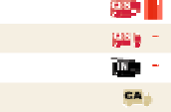
Indiana & California Warehouses
Canadian Warehouse

Customer Service: 1.855.634.9109
All Other Calls: 1.800.444.3134 13

Low Profile Hose Reels | Series SD10000

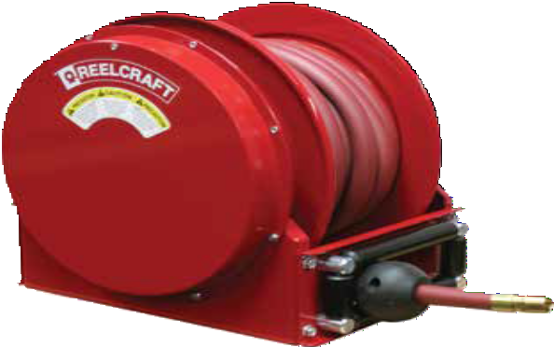Spring Retractable Low Profile Reels
SD13050 OLP
Air/Water/Oil/Vacuum Recovery - 3/4", 1" I.D.
Series SD10000 hose reels are designed to facilitate larger diameter 3/4" and 1" hose up to 50 ft. They feature a high quality external drive spring and a heavy gauge all-bolted together frame. The containerized external drive spring assem- bly offers easier handling during maintenance. This is the most compact reel in its class, making it ideal for mounting in truck cabinets or other areas where space is limited.

Made in USA
Specifications
- High impact UHMW guide rollers
- Corrosion resistant powder coat paint
- 13/8” solid main shaft
- Four 5/8” tie rods maintain reel integrity and provide added support
- Ultra low profile design for mounting in cabinetry
- Ductile iron fluid path parts
- Stainless latch spring and widened aluminum ratchet/pawl
- Torsion spring for longer service life
Features
P Reel features extreme space saving design, ideal for applications with minimal space constraints.
P Reel is built with high quality industrial grade components for superior strength and design.

E |  |  | Size Index
F
 |  |  |  | 1 |  | 2
 |  |  |  | in | mm | in | mm
 |  |  | A | 181/4 | 464 | 181/4 | 464
 |  |  | B | 191/8 | 486 | 191/8 | 486
 | A
 |  |  | C | 14 | 356 | 14 | 356
 |  |  | D | 111/4 | 286 | 131/4 | 337
D |  | C | E | 183/4 | 476 | 203/4 | 527
 |  |  | F | 8 | 203 | 10 | 254
 |  | B
All models are bottom wind unless otherwise specified. Additional bracket required for other guide arm positions.

Model with Hose | Shipping Weight |  | Hose I.D. |  | Hose O.D. | Hose Length |  | **Max Pressure |  | NPT(M)  Hose Outlet | NPT(F)  Reel Inlet | Model without hose & bumper | Shipping Weight |  | Pressure |  | Size Index #
 | lbs | kg | in | mm | in mm | ft | m | psi | bar | in | in |  | lbs | kg | psi | bar
Low Pressure Air/Water Reels Maximum temperature 150 °F (65 °C) w/hose / 210 °F (99 °C) w/o hose **Maximum working pressure at 70 °F (20 °C)
SD13035 OLP | 95 | 43 | 3/4 | 19 | 1.188 30 | 35 | 11 | 250 | 17 | 3/4 | 1 | SD13000 OLP | 85 | 39 | 500 | 35 | 1
SD13050 OLP | 105 | 48 | 3/4 | 19 | 1.188 30 | 50 | 15 | 250 | 17 | 3/4 | 1 | SD13000 OLP | 85 | 39 | 500 | 35 | 1
SD14035 OLP | 102 | 46 | 1 | 25 | 1.375 35 | 35 | 11 | 250 | 17 | 3/4 | 1 | SD14000 OLP | 85 | 39 | 500 | 35 | 1
SD14050 OLP | 125 | 57 | 1 | 25 | 1.375 35 | 50 | 15 | 250 | 17 | 3/4 | 1 | SD14005 OLP | 92 | 42 | 500 | 35 | 2
Medium Pressure Oil Reels Maximum temperature 210 °F (99 °C)
SD13035 OMP | 95 | 43 | 3/4 | 19 | 1.188 30 | 35 | 11 | 1250 | 86 | 3/4 | 1 | SD13000 OMP | 85 | 39 | 3000 | 207 | 1
SD13050 OMP | 105 | 48 | 3/4 | 19 | 1.188 30 | 50 | 15 | 1250 | 86 | 3/4 | 1 | SD13000 OMP | 85 | 39 | 3000 | 207 | 1
Vacuum Recovery Reels Maximum temperature 210 °F (99 °C)
SD13035 OVP | 95 | 43 | 3/4 | 19 | 1.260 32 | 35 | 11 | 28 Hg~300 psi |  | 3/4 | 1 | SD13000 OVP | 85 | 39 | 28 Hg~300 psi |  | 1
SD13050 OVP | 105 | 48 | 3/4 | 19 | 1.260 32 | 50 | 15 | 28 Hg~300 psi |  | 3/4 | 1 | SD13000 OVP | 85 | 39 | 28 Hg~300 psi |  | 1
SD14035 OVP | 102 | 46 | 1 | 25 | 1.496 38 | 35 | 11 | 28 Hg~250 psi |  | 1 | 1 | SD14000 OVP | 85 | 39 | 28 Hg~300 psi |  | 1
SD14050 OVP | 125 | 57 | 1 | 25 | 1.496 38 | 50 | 15 | 28 Hg~250 psi |  | 1 | 1 | SD14005 OVP | 92 | 42 | 28 Hg~300 psi |  | 2
NOTE: Vacuum recovery reel capacities based on using SAE 100 R4 hose or equivelant. Maximum O.D. is 1.500".

Prop 65: WARNING:
Cancer and Reproductive Harm www.P65Warnings.ca.gov.
Models listed with an icon can ship same day upon request when the order is received by 1:00 PM Eastern Time for quantities of 10 or fewer.
Indiana Warehouse California Warehouse
Interactive Reel Catalog
Visit www.reelcraft.com/catalog for complete product specifications, available parts and accessories.

14 Customer Service: 1.855.634.9109
Indiana & California Warehouses
Canadian Warehouse

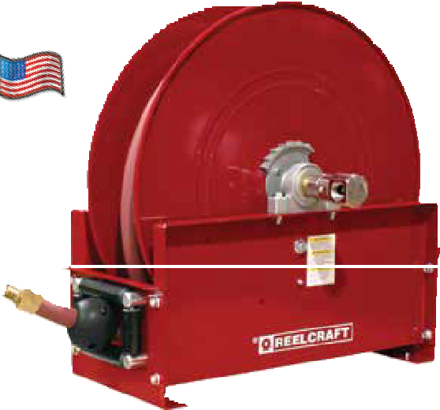
Vehicle-Mount Hose Reels | Series 9000

Ultimate Duty Spring Retractable Reels
Air/Water/Oil/Grease - 3/8", 1/2", 3/4", 1", 11/4", 11/2" I.D.
Series 9000 mobile base reels offer the greatest amount of stability for high volume air, water, diesel fuel and gasoline. Ideal for portable service trucks, permanent service or plant work areas. A durable baked-on powder coat finish produces a rugged corrosion resistant product suitable for
a wide variety of heavy duty applications. Basic reels without hose will handle air, water or oil; consult Reelcraft for other applications.

Made in USA

D9350 OLPBW

Hose Guide Roller Position
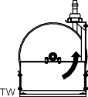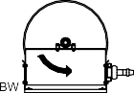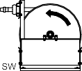

A suffix code (see diagram) must be added after the model number to specify desired position. Reels are shipped in the BW position unless specified otherwise. FF9500/9600 in BW only.
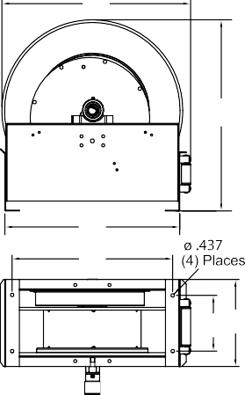*Series G9000 reels have an external drive spring and a removable gooseneck.
B |  | Dimensions - Size Index
 |  |  | 1 |  | 2 |  | 3 |  | 4
 |  |  | in | mm | in | mm | in | mm | in | mm
 | A | A | 263/8 | 670 | 263/8 | 670 | 263/8 | 670 | 261/4 | 667
 |  | B | 261/4 | 667 | 261/4 | 667 | 261/4 | 667 | 25 | 635
F |  | C | 221/4 | 565 | 221/4 | 565 | 221/4 | 565 | 22 | 559
 |  | D | 73/4 | 197 | 131/2 | 343 | 73/4 | 197 | 91/2 | 241
C
 |  | E | 12 | 305 | 173/4 | 451 | 133/8 | 340 | 171/4 | 438
 | D E
 |  | F | 241/8 | 613 | 241/8 | 613 | 241/8 | 613 | 241/4 | 616
G |  | G | 43/4 | 121 | 37/8 | 98 | 41/2 | 114 | 37/8 | 98

Model with Hose | Shipping Weight | Hose I.D. | Hose O.D. | Hose Length | **Max Pressure | NPT(M)  Hose Outlet | NPT(F)  Reel Inlet | Model without hose | Shipping Weight | Pressure | Size Index #
 | lbs kg | in mm | in mm | ft m | psi bar | in | in | & bumper | lbs kg | psi bar
Low Pressure Air/Water Reels Maximum temperature 150 °F (65 °C) w/hose / 210 °F (99 °C) w/o hose **Maximum working pressure at 70 °F (20 °C)
D9275 OLP | 122 55 | 1/2 13 | .750 19 | 75 23 | 300 21 | 1/2 | 1/2 | D9200 OLP | 115 52 | 500 35 | 1
D9299 OLP | 127 58 | 1/2 13 | .750 19 | 100 30 | 300 21 | 1/2 | 1/2 | D9205 OLP | 115 52 | 500 35 | 1
D9350 OLP | 140 64 | 3/4 19 | 1.075 27 | 50 15 | 250 17 | 3/4 | 3/4 | D9300 OLP | 115 52 | 500 35 | 1
D9375 OLP | 152 69 | 3/4 19 | 1.075 27 | 75 23 | 250 17 | 3/4 | 3/4 | D9300 OLP | 115 52 | 500 35 | 1
D9399 OLPBW | 143 65 | 3/4 19 | 1.075 27 | 100 30 | 250 17 | 3/4 | 3/4 | D9305 OLPBW | 115 52 | 500 35 | 3
D9450 OLP | 157 71 | 1 25 | 1.375 35 | 50 15 | 250 17 | 3/4 | 1 | D9400 OLP | 115 52 | 500 35 | 1
D9465 OLPBW | 164 74 | 1 25 | 1.375 35 | 65 20 | 250 17 | 3/4 | 1 | D9405 OLPBW | 115 52 | 500 35 | 3
Not available with hose |  | 1 1/4 32 | 1.750 44 | 50 15 | --- --- | ------ | 1 1/2 | FF9500 OLPBW 125 57 |  | 600 41 | 2
Not available with hose |  | 1 1/2 38 | 2.000 51 | 50 15 | --- --- | ------ | 1 1/2 | FF9600 OLPBW | 135 61 | 600 41 | 2
Medium Pressure Oil Reels Maximum temperature 210 °F (99 °C)
D9275 OMP | 131 59 | 1/2 13 | .820 21 | 75 23 | 3000 207 | 1/2 | 1/2 | D9200 OMP | 117 53 | 3000 207 | 1
D9350 OMP | 142 64 | 3/4 19 | 1.188 30 | 50 15 | 1250 86 | 3/4 | 3/4 | D9300 OMP | 117 53 | 3000 207 | 1
Not available with hose |  | 3/4 19 | 1.188 30 | 75 23 | --- --- | ------ | 3/4 | G9300 OMPBW* | 160 73 | 3000 207 | 4
E9450 OMP | 160 73 | 1 25 | 1.480 38 | 50 15 | 3000 207 | 1 | 1 | E9400 OMP | 120 54 | 3000 207 | 1
Not available with hose |  | 1 25 | 1.480 38 | 75 23 | --- --- | ------ | 1 | G9400 OMPBW* | 159 72 | 3000 207 | 4
High Pressure Grease Reels Maximum temperature 210 °F (99 °C)
D9175 OHP | 153 69 | 3/8 10 | .730 19 | 75 23 | 4800 331 | 3/8 | 1/2 | D9100 OHP | 118 54 | 5000 345 | 1
Low pressure reels furnished standard with PVC hose. Medium pressure reels are furnished standard with S.A.E. 100R17 (1/2" and 1") or S.A.E. 100R1-AT (3/4") one wire braid hose. High pressure reels furnished standard with S.A.E. 100 R2T two wire braid hose. Note: Change prefix from D to E to specify our heavy duty model with larger spring capacity, needle style bearings, addi- tional seals and grease fittings. Not available on FF9000 or G9000.

Models listed with an icon can ship same day upon request when the order is received by 1:00 PM Eastern Time for quantities of 10 or fewer.
Indiana Warehouse California Warehouse
Prop 65: WARNING:
Cancer and Reproductive Harm www.P65Warnings.ca.gov.
Interactive Reel Catalog
Visit www.reelcraft.com/catalog for complete product specifications, available parts and accessories.

Indiana & California Warehouses
Canadian Warehouse
Customer Service: 1.855.634.9109 15

Large Frame Hose Reels | Series 3100 / 4800

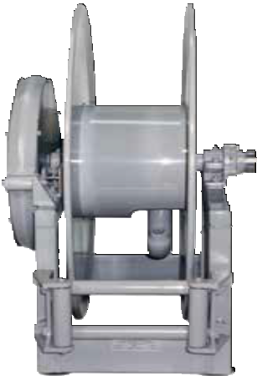
Twin hose models are available as standard.

Made in USA
Nordic
Series 4800

Spring Driven Large Frame Reels

Nordic Series 3100 & 4800
1/2", 3/4", 1" or 11/2" Fluid Path for 1/2" through 11/2" I.D. Hose
Inlet: 1/2" up to 1" female/male NPT 90° swivel joint.
Gooseneck: 1/2" up to 1" female/male NPT. Series 3100 reels handle hose from 1/4" through 1" I.D. Series 4830 reels handle hose from 1/2" through 1" I.D. Inlet is 1/2" up to 1" female/male NPT 90° swivel joint.
Gooseneck is 1/2" up to 1" female/male NPT. Series 4800 reels handle hose from 1" through 11/2" I.D. 2" straight grooved fitting x 11/2" NPT female inlet is standard. Gooseneck is 1" to 11/2" female/male NPT.
Roller position: You must specify roller position BW, SW or TW. If roller position is not specified, reels will be shipped with rollers in position BW, see page 15.

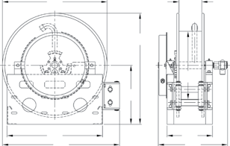
Series 3100 / 4830 product temperatures from -50 °F to +225 °F and standard pressures to 3000 psi. Series 4800 product temperatures from -50 °F to +225 °F at standard pressures to
Dimensions Diagram
B |  |  |  | F
 |  |  | A
 |  |  |  | G
 |  | H
C |  |  |  | D
 | J |  |  | E

300 psi for 2" and 600 psi for 11/2" I.D. hose. Reels to operate at other temperatures or pressures can be furnished at extra cost.
Consult manufacturer. The standard color for this series is red or gray.
Hose stop: A hose stop should be used to prevent damage to rollers and nozzles and to permit adjustment of free hose length. Hose stops are available at extra cost.
Note: Other sizes and/or threads can be furnished for gooseneck when specified.

Prop 65: WARNING:
Cancer and Reproductive Harm - www.P65Warnings.ca.gov.
Model numbers are representative.
Final part number assigned upon quote.
16
Customer Service: 1.855.634.9109
All Other Calls: 1.800.444.3134
Hose I.D. | in | 1/2 | 3/4 | 1 | 1 1/4 | 1 1/2 | Specification - Hose Capacity and Reel Dimensions  *20" (508 mm) diameter drum on Model #4830-31-10 for ½" and ¾" hose
 | mm | 13 | 19 | 25 | 32 | 38
Hose O.D. | in | 7/8 | 1 9/32 | 1 9/16 | 1 13/16 | 2 1/16
 | mm | 22 | 33 | 40 | 46 | 52
Model | Hose Length |  |  |  |  |  | Est. Weight |  | A | B | C | D | E | F | G | H | J
3101-19-4 | ft | 30 | 25 | 15 |  |  | 90 LB | in | 22.5 | 19 | 21 | 9 | 15.5 | 4 | 11.25 | 13 | 25
 | m | 9 | 8 | 5 |  |  | 41 KG | mm | 572 | 483 | 533 | 229 | 394 | 102 | 286 | 330 | 635
3101-23-4 | ft | 60 | 40 | 25 |  |  | 93 LB | in | 24.5 | 23 | 21 | 9 | 15.5 | 4 | 11.25 | 13 | 26
 | m | 18 | 12 | 8 |  |  | 42 KG | mm | 622 | 584 | 533 | 229 | 394 | 102 | 286 | 330 | 660
3101-23-6 | ft | 100 | 65 | 60 |  |  | 95 LB | in | 24.5 | 23 | 21 | 11 | 17.5 | 6 | 11.25 | 13 | 26
 | m | 30 | 20 | 18 |  |  | 43 KG | mm | 622 | 584 | 533 | 279 | 445 | 152 | 286 | 330 | 660
3101-23-8 | ft | 100 | 65 | 60 |  |  | 97 LB | in | 24.5 | 23 | 21 | 13 | 19.5 | 8 | 11.25 | 13 | 26
 | m | 30 | 20 | 18 |  |  | 44 KG | mm | 622 | 584 | 533 | 330 | 495 | 203 | 286 | 330 | 660
4830-31-5X | ft | 75 | 75 | 65 |  |  | 122 LB | in | 33 | 31 | 30 | 10.5 | 17 | 5.5 | 20 | 17.5 | 34.5
 | m | 23 | 23 | 20 |  |  | 55 KG | mm | 838 | 787 | 762 | 267 | 432 | 140 | 508 | 445 | 876
4830-31-8 | ft | 80 | 80 | 90 |  |  | 125 LB | in | 33 | 31 | 30 | 13 | 19.5 | 8 | 15 | 17.5 | 34.5
 | m | 24 | 24 | 27 |  |  | 57 KG | mm | 838 | 787 | 762 | 330 | 495 | 203 | 381 | 445 | 876
4830-31-10 | ft | *90 | *100 | 100 |  |  | 128 LB | in | 33 | 31 | 30 | 15 | 21.5 | 10 | *15 | 17.5 | 34.5
 | m | *27 | *30 | 30 |  |  | 58 KG | mm | 838 | 787 | 762 | 381 | 546 | 254 | *381 | 445 | 876
4800-31-6 | ft |  |  | 70 | 50 | 40 | 122 LB | in | 33 | 31 | 30 | 11.44 | 17 | 6 | 11.25 | 17.5 | 34.5
 | m |  |  | 21 | 15 | 12 | 55 KG | mm | 838 | 787 | 762 | 291 | 432 | 152 | 286 | 445 | 876
4800-31-8 | ft |  |  | 75 | 75 | 50 | 125 LB | in | 33 | 31 | 30 | 13.44 | 19 | 8 | 11.25 | 17.5 | 34.5
 | m |  |  | 23 | 23 | 15 | 57 KG | mm | 838 | 787 | 762 | 341 | 483 | 203 | 286 | 445 | 876

Twin Hydraulic Hose Reels | Series TH

Twin Hose, Spring Retractable Reels
Dual Hydraulic - 1/4", 3/8", 1/2" I.D.
Reelcraft’s hydraulic reels are used for medium pressure dual hydraulic hose applications and are ideal for operating hydraulic cylinders, tools and equipment. All twin hydraulic models include a full flow, high volume swivel for maximum product delivery.
Series TH reels incorporate contemporary engineering and manufacturing techniques for high quality performance. Reels are all-steel construction and compact for applications with critical space requirements.

Made in USA

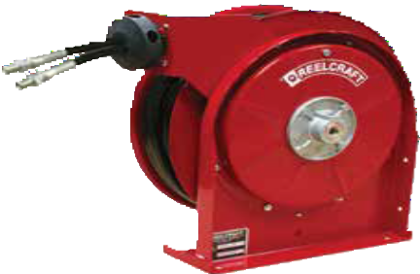
TH5425 OMP

- Cranes

Applications
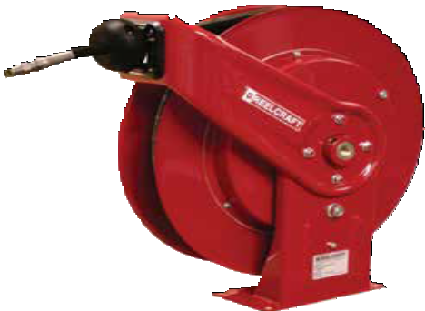
  - Hydraulic cylinders

- Construction equipment
- Hydraulic tools
- Vehicle extraction tools
- Aerial device
- Tree cutters
- Digger derricks
- Railroad maintenance tools

TH7445 OMP

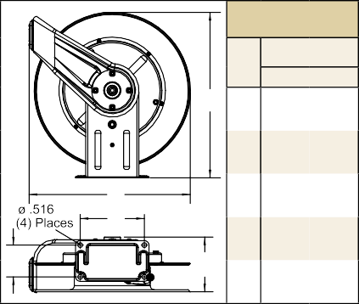
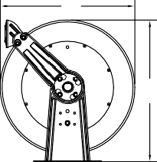
Size Index
1
in mm
A A 201/4 514
193/
B Size Index
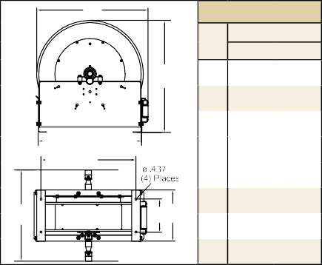
3
 | B | Size Index
 |  |  | 2
 |  |  | in | mm
 | A | A | 253/8 | 645
 |  | B | 24 | 610
 |  | C | 10 | 254
 | C | D | 6 | 152
D | F E | E | 127/8 | 327
 |  | F | 81/8 | 206

in mm
A A 263/8 670
B 261/4 667
 | C | 221/4 | 556
 | D | 73/4 | 195

B 4 502 F
C

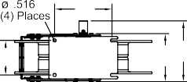
B C 77/8 200
C
D 37/8 98
D E
E 73/4 197

H D E

G
E 12 305
F 241/8 613
G 43/4 121
H 211/2 546

Model with Hose | Shipping Weight |  | Hose I.D. |  | Hose O.D. |  | Hose Length |  | Pressure |  | NPT(M)  Hose Outlet | NPT(F)  Reel Inlet | Model without hose & bumper | Shipping Weight |  | Pressure |  | Size Index #
 | lbs | kg | in | mm | in | mm | ft | m | psi | bar | in | in |  | lbs | kg | psi | bar
Medium Pressure Hydraulic Hose Reels Maximum temperature 210 °F (99 °C)
TH5425 OMP | 34 | 15 | 1/4 | 6 | .530 | 13 | 25 | 8 | 2000 | 138 | 1/4 | 1/4 | TH5400 OMP | 24 | 11 | 3000 | 207 | pg. 9
TH7445 OMP | 60 | 27 | 1/4 | 6 | .530 | 13 | 45 | 14 | 2000 | 138 | 1/4 | 1/4 | TH7400 OMP | 44 | 20 | 3000 | 207 | 1
THA7630 OMP | 53 | 24 | 3/8 | 10 | .660 | 17 | 30 | 9 | 2000 | 138 | 3/8 | 3/8 | THA7600 OMP | 44 | 20 | 3000 | 207 | 1
TH86050 OMP | 99 | 45 | 3/8 | 10 | .710 | 18 | 50 | 15 | 2000 | 138 | 3/8 | 3/8 | TH86000 OMP | 88 | 40 | 3000 | 207 | 2
THA7825 OMP | 57 | 26 | 1/2 | 13 | .850 | 22 | 25 | 8 | 2000 | 138 | 3/4 JIC(F) | 1/2 | THA7800 OMP | 50 | 23 | 3000 | 207 | 1
TH88050 OMP | 104 | 47 | 1/2 | 13 | .850 | 22 | 50 | 15 | 2000 | 138 | 1/2 | 1/2 | TH88000 OMP | 88 | 40 | 3000 | 207 | 2
TH9265 OMPBW | 155 | 70 | 1/2 | 13 | .910 | 24 | 65 | 20 | 2000 | 138 | 1/2 | 1/2 | TH9200 OMPBW | 120 | 54 | 3000 | 207 | 3
Reference page 4 for guide arm positions.

Models listed with an icon can ship same day upon request when the order is received by 1:00 PM Eastern Time for quantities of 10 or fewer.
Indiana Warehouse California Warehouse
Prop 65: WARNING:
Cancer and Reproductive Harm www.P65Warnings.ca.gov.
Interactive Reel Catalog
Visit www.reelcraft.com/catalog for complete product specifications, available parts and accessories.

Indiana & California Warehouses
Canadian Warehouse

Customer Service: 1.855.634.9109
All Other Calls: 1.800.444.3134 17

Fuel Delivery Reels | Series F7000 / FE/FD/FF9000 / F/FD80000 / G

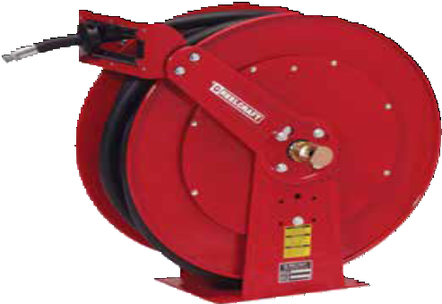Spring Retractable Fuel Reels
FD83075 OLP
F7000 - 3/4" I.D. / FF9000 - 11/4", 11/2" I.D.
FE9000, FD9000 - 3/4", 1" I.D. F80000, FD80000 - 3/4", 1" I.D. FSD10000 - 3/4", 1" I.D.
Reelcraft’s spring retractable fuel delivery reels, equipped with fuel com- patible seals, incorporate metal forms to insure the greatest possible strength and are ideal for mobile and permanent-mount applications.
These rugged, corrosion-resistant reels are suitable for a wide variety of fuel applications including E85. Series F/FD/FE/FSD reels are all sup- plied with our ball-bearing style swivel.

Model with Hose | Shipping Weight | Hose I.D. | Hose O.D. | Hose Length | Pressure | NPT(M)  Hose Outlet | NPT(F)  Reel Inlet | Model without hose & bumper | Shipping Weight | Pressure | Size Index Page | Size Index #
 | lbs kg | in mm | in mm | ft m | psi bar | in | in |  | lbs kg | psi bar
Low Pressure Fuel Reels Maximum temperature 150 °F (65 °C) w/hose / 210 °F (99 °C) w/o hose
F7925 OLP | 47 21 | 3/4 19 | 1.188 30 | 25 8 | *50 3 | 3/4 | 3/4 | F7900 OLP | 45 20 | 500 35 | 10 | ----
F83050 OLP | 89 40 | 3/4 19 | 1.188 30 | 50 15 | *50 3 | 3/4 | 3/4 | F83000 OLP | 74 34 | 500 35 | 13 | 1
FD83075 OLP | 115 52 | 3/4 19 | 1.188 30 | 75 23 | *50 3 | 3/4 | 3/4 | FD83000 OLP | 82 37 | 500 35 | 13 | 2
FD84035 OLP | 94 43 | 1 25 | 1.500 38 | 35 11 | *50 3 | 1 | 1 | FD84000 OLP | 84 38 | 500 35 | 13 | 3
FD84050 OLP | 115 52 | 1 25 | 1.500 38 | 50 15 | *50 3 | 1 | 1 | FD84000 OLP | 84 38 | 500 35 | 13 | 3
FE9350 OLP | 140 64 | 3/4 19 | 1.188 30 | 50 15 | *50 3 | 3/4 | 3/4 | FE9300 OLP | 115 52 | 500 35 | 15 | 1
FE9450 OLP | 157 71 | 1 25 | 1.500 38 | 50 15 | *50 3 | 1 | 1 | FE9400 OLP | 115 52 | 500 35 | 15 | 1
FD9350 OLP | 140 64 | 3/4 19 | 1.188 30 | 50 15 | *50 3 | 3/4 | 3/4 | FD9300 OLP | 114 52 | 500 35 | 15 | 1
FD9450 OLP | 157 71 | 1 25 | 1.500 38 | 50 15 | *50 3 | 1 | 1 | FD9400 OLP | 113 51 | 500 35 | 15 | 1
Not available with hose |  | 1 1/4 32 | 1.750 44 | 50 15 | -- -- | 1 1/4 | 1 1/2 | FF9500 OLPBW 125 57 |  | 600 41 | 15 | 2
Not available with hose |  | 1 1/2 38 | 2.000 51 | 50 15 | -- -- | 1 1/2 | 1 1/2 | FF9600 OLPBW | 135 61 | 600 41 | 15 | 2
FSD13035 OLP | 102 46 | 3/4 19 | 1.188 30 | 35 11 | *50 3 | 3/4 | 1 | FSD13000 OLP | 85 39 | 500 35 | 14 | 1
FSD13050 OLP | 110 50 | 3/4 19 | 1.188 30 | 50 15 | *50 3 | 3/4 | 1 | FSD13000 OLP | 85 39 | 500 35 | 14 | 1
FSD14035 OLP | 105 48 | 1 25 | 1.500 38 | 35 11 | *50 3 | 1 | 1 | FSD14000 OLP | 85 39 | 500 35 | 14 | 1
FSD14050 OLP | 127 58 | 1 25 | 1.500 38 | 50 15 | *50 3 | 1 | 1 | FSD14005 OLP | 92 42 | 500 35 | 14 | 2
*Models equipped with UL330 and ULC approved fuel grade hose. 250 psi minimum burst (17 Bar). Flow rates of fuel hose are reduced by 30% with addition of internal spring type bend restrictors. For example, flow rate of F7925 OLP with internal bend restrictors is 9.0 GPM at 40 psi; flow without internal bend restrictors is 13.0 GPM at 40 psi. See page 4 for guide arm positions.

Prop 65: WARNING:
Cancer and Reproductive Harm www.P65Warnings.ca.gov.

Static Discharge / Grounding Reels

Series G 3000

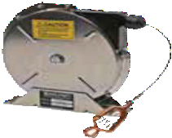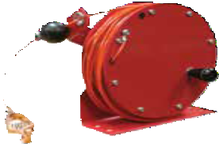
Static discharge reels are used to ground equipment operating in hazardous atmospheres.
When properly clamped to ground, the static discharge reel dissipates static electrical buildup, reducing the chances of sparking and the potential for explosion.
GHC3100 N
NEW!
GS3050
Models listed with an icon can ship same day upon request when the order is received by 1:00 PM Eastern Time for quantities of 10 or fewer.
Indiana Warehouse
Indiana & California Warehouses
California Warehouse
Canadian Warehouse
18
Customer Service: 1.855.634.9109
All Other Calls: 1.800.444.3134

Model | Cable Extended | Clamp Rating | Max Temp | Cable Notes | Shipping Weight
 | ft m |  | °F °C |  | lbs kg
G 3050 | 50 15 | 100 AMP | 150 66 | Single 7 x 7 stranded steel* | 12 5
GS3050** | 50 15 | 100 AMP | 150 66 | Single 7 x 7 stranded stainless steel* | 12 5
G 3050 Y | 50 15 | 100 AMP | 150 66 | 35’ (9.2m) plus dual 15’ (4.6m) for Y* Total extension 50’ (15m) | 12 5
G 3050 N | 50 15 | 100 AMP | 150 66 | Hi-vis orange nylon covered cable^ | 12 5
GA3100 N | 100 30 | 100 AMP | 125 52 | Hi-vis orange nylon covered cable^ | 16 7
GHC3100 N | 100 30 | 100 AMP | 125 52 | Hi-vis orange nylon covered cable^ | 12 5
*3/32" OD aircraft cable. DC resistance is approximately one ohm per 50 ft. of cable. **304 stainless steel model.
^Nylon covered cable (1/8" O.D.). Refer to reelcraft.com for dimensions.

Corrosion Resistant Reels | Stainless Steel Series

Stainless Steel Spring Retractable Reels
Air/Water/Oil - 3/8", 1/2", 3/4", 1" I.D.
Reelcraft’s stainless steel hose reels are ideal for food processing, pre-rinse, wash down, chemical transfer and industrial-solvent handling. Also suitable for coastal, off- shore and on-board ship in marine applications where the harsh environment of salt water spray requires the use of stainless steel hose reels. Swivels include Viton® O-rings. Buna seals are available for water applications by adding a -B at the end of the model number.
Note: Standard latch parts are made from aluminium. Series 80000 and D80000 stainless reels have an aluminum fluid path. Stainless latch parts and fluid path are available as a standard option by placing a -S at the end (example: OLS-S). Carbon steel reels with stainless steel fluid path are available as standard.

LC607 OLS

Made in USA

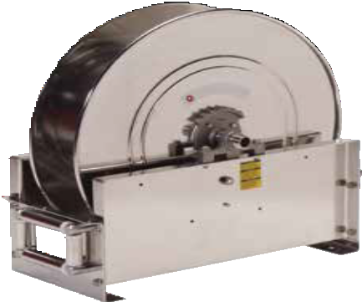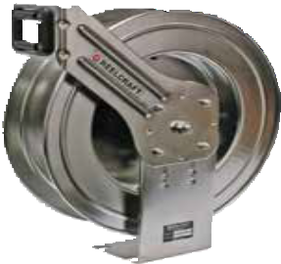D9300 OLSBW

Features
P Full-flow stainless steel shaft and swivel assures maximum product delivery. Exception: Series 80000 only on OLS-S models.
P Heavy duty brackets eliminate bending due to angular hose pull.
P Nylon guide rollers reduce hose drag and abrasion.
P Vibration-proof self- locking fasteners assures assembly integrity.
P 304L stainless steel
Model without hose & bumper | Model without hose & bumper SS Latch Parts | Shipping Weight | Hose I.D. | Hose O.D. | Hose Length | Pressure | NPT(F)  Outlet | NPT(F)  Inlet | Size Index Page | Size Index #
 |  | lbs kg | in mm | in mm | ft m | psi bar | in | in
Low and Medium Pressure Reels Maximum temperature 210 °F (99 °C)
5600 OLS | 5600 OLS-S | 22 10 | 3/8 10 | .600 15 | 35 11 | 500 35 | 3/8 | 3/8 | 9 | 2
5600 OMS | 5600 OMS-S | 24 11 | 3/8 10 | .710 18 | 30 9 | 3000 207 | 3/8 | 3/8 | 9 | 2
LC607 OLS* | --------------- | 35 16 | 3/8 10 | .600 15 | 70 21 | 300 21 | 1/4 | 1/4 | refer to reelcraft.com
LC800 OLS* | --------------- | 33 15 | 1/2 13 | .750 19 | 50 15 | 300 21 | 1/2 | 1/2
7800 OLS | 7800 OLS-S | 41 19 | 1/2 13 | .750 19 | 50 15 | 500 35 | 1/2 | 1/2 | 10 | ----
7600 OMS55 | 7600 OMS-S55 | 42 19 | 3/8 10 | .710 18 | 66 20 | 3000 207 | 3/8 | 3/8 | 10 | ----
7800 OMS | 7800 OMS-S | 43 20 | 1/2 13 | .850 22 | 50 15 | 3000 207 | 1/2 | 1/2 | 10 | ----
82000 OLS | 82000 OLS-S | 81 37 | 1/2 13 | .750 19 | 100 30 | 500 35 | 1/2 | 1/2 | 13 | 1
82000 OMS | 82000 OMS-S | 83 38 | 1/2 13 | .850 22 | 75 23 | 1500 103 | 1/2 | 1/2 | 13 | 1
83000 OLS | 83000 OLS-S | 81 37 | 3/4 19 | 1.188 30 | 50 15 | 500 35 | 3/4 | 3/4 | 13 | 1
83000 OMS | 83000 OMS-S | 83 38 | 3/4 19 | 1.188 30 | 50 15 | 1250 86 | 3/4 | 3/4 | 13 | 1
D83000 OLS | D83000 OLS-S | 84 38 | 3/4 19 | 1.188 30 | 75 23 | 500 35 | 3/4 | 3/4 | 13 | 2
D84000 OLS | D84000 OLS-S | 92 42 | 1 25 | 1.375 35 | 50 15 | 500 35 | 1 | 1 | 13 | 3
D9200 OLSBW | D9200 OLSBW-S | 115 52 | 1/2 13 | .750 19 | 75 23 | 500 35 | 1/2 | 1/2 | 15 | 1
D9300 OLSBW | D9300 OLSBW-S | 116 53 | 3/4 19 | 1.188 30 | 75 23 | 500 35 | 3/4 | 3/4 | 15 | 1
D9400 OLSBW | D9400 OLSBW-S | 117 53 | 1 25 | 1.375 35 | 50 15 | 500 35 | 1 | 1 | 15 | 1
D9200 OMSBW | D9200 OMSBW-S | 118 54 | 1/2 13 | .850 22 | 75 23 | 3000 207 | 1/2 | 1/2 | 15 | 1
D9300 OMSBW | D9300 OMSBW-S | 118 54 | 3/4 19 | 1.188 30 | 50 15 | 3000 207 | 3/4 | 3/4 | 15 | 1
For all metric thread connections over 1/2" add the suffix number 70 to indicate BSPT threads - example D83000 OLS70. Reference page 4 for guide arm positions. *Maximum temperature 150 °F (65 °C); includes Buna seals.

Model without Hose | Shipping Weight | Pressure | NPT(F)  Outlet | NPT(F)  Inlet | I.D. | 1/4 6 | 3/8 10 | 1/2 13 | 3/4 19 | 1 25 | Size Index #  (see pg. 24)
 | lbs kg | psi bar | in | in | O.D. | .530 13 | .710 18 | .850 22 | 1.188 30 | 1.375 35
Manual Crank Medium Pressure Reels Maximum temperature 210 °F (99 °C)
HS18000 M | 36 16 | 3000 207 | 1/2 | 1/2 | Hose Length | 425 130 | 300 91 | 200 61 | --- --- | --- --- | 1
HS28000 M | 35 16 | 3000 207 | 1/2 | 1/2 |  | 625 191 | 450 137 | 300 91 | --- --- | --- --- | 2
HS19000 M | 38 17 | 3000 207 | 3/4 | 3/4 |  | 425 130 | 300 91 | 200 61 | 75 23 | --- --- | 1
HS29000 M | 36 16 | 3000 207 | 3/4 | 3/4 |  | 625 191 | 450 137 | 300 91 | 125 38 | --- --- | 2
HS37000 L | 47 21 | 500 35 | 1 (M) | 1 |  | --- --- | --- --- | --- --- | --- --- | 100 30 | refer to reelcraft.com

Models listed with an icon can ship same day upon request when the order is received by 1:00 PM Eastern Time for quantities of 10 or fewer.
Indiana Warehouse California Warehouse
Prop 65: WARNING:
Cancer and Reproductive Harm www.P65Warnings.ca.gov.
Interactive Reel Catalog
Visit www.reelcraft.com/catalog for complete product specifications, available parts and accessories.

Indiana & California Warehouses
Canadian Warehouse
Customer Service: 1.855.634.9109 19

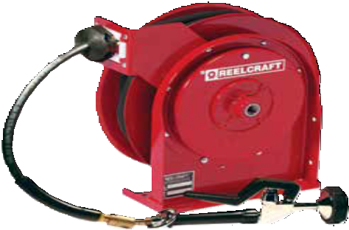Pre-Rinse and Potable Water | Series 4000 / 5000
Pre-Rinse Reel Features
P Lever-operated spray valve is included
P Optional 360° rotating swivel (600248) offers 20° of angular motion
P Push-Lok, field replaceable, hose-end fittings
P Reels can be mounted on the wall, ceiling, or under a counter,
making water conveniently available
P Latching mechanism holds hose at desired length
Spring Retractable Pre-Rinse Reels - 3/8" I.D.
Engineered for use in highly corrosive environments such as restaurants, institutions, and home and garden applications. Reelcraft’s pre-rinse reels include a standard lever-operated spray valve.
Available in stainless or powder-coat finish. Rated for hot water up to
180 °F (82 °C).

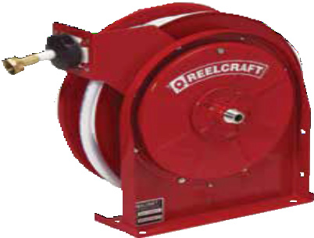
4625 OLPSW5

Made in USA

Optional 360° Swivel S600248

Spray Valve
S600080

A5835 OLBSW23
Hot water washdown and food prep
Commercial use, restaurants, schools, home/garden and more
Potable Water Reel Features
P Stainless steel, full flow shaft and PVC swivel
P Convenient fast hook-up and disconnect
P Drain and standard female garden hose outlet fitting are standard
P Maximum operating temperature 73 °F (23 °C)

Spring Retractable Potable (Drinking) Water Reel - 1/2" I.D.
Designed for potable water systems, the A5835 OLBSW23 is suitable for use as a drinking water system component though does not include the NSF/ANSI 61 Certification. Fluid path is stainless steel and CPVC material.
Dimensions - Size Index
B D

A C

E
 | 1 | 2 | 3
 | in mm | in mm | in mm
A | 127/8 327 | 143/8 365 | 15 381
B | 125/8 321 | 141/4 362 | 161/4 413
C | 8 203 | 93/4 248 | 93/4 248
D | 21/2 64 | 21/2 64 | 21/2 64
E | 55/8 143 | 61/8 156 | 7 178

Drinking Water
Boats, RVs, buses and much more

Model with Hose | Shipping Weight |  | Hose I.D. |  | Hose O.D. |  | Hose Length |  | Pressure |  | NPT(F)  Reel Inlet | Size Index #
 | lbs | kg | in | mm | in | mm | ft | m | psi | bar | in
Pre-Rinse Hose Reels Maximum temperature 180 °F (82 °C)
4625 OLPSW5 | 22 | 10 | 3/8 | 10 | .640 | 16 | 25 | 8 | 125 | 9 | 3/8 | 1
5635 OLPSW5 | 27 | 12 | 3/8 | 10 | .640 | 16 | 35 | 11 | 125 | 9 | 3/8 | 2
5635 ELPSW5 | 37 | 17 | 3/8 | 10 | .640 | 16 | 35 | 11 | 125 | 9 | 3/8 | 3
Pre-Rinse Stainless Steel Hose Reels Maximum temperature 180 °F (82 °C)
5635 OLSSW5 | 28 | 13 | 3/8 | 10 | .640 | 16 | 35 | 11 | 125 | 9 | 3/8 | 2
5635 ELSSW5 | 38 | 17 | 3/8 | 10 | .640 | 16 | 35 | 11 | 125 | 9 | 3/8 | 3
Potable (Drinking) Water Hose Reels Garden hose fitting 3/4” N/H threads (F)
A5835 OLBSW23* | 28 | 13 | 1/2 | 13 | .781 | 20 | 35 | 11 | 150 | 10 | 1/2 male | 2
Pressure rating for reel without spray valve is 250 psi (17 bar). *Maximum operating temperature is 73 °F (23 °C). Reference page 4 for guide arm positions.

Prop 65: WARNING:
Cancer and Reproductive Harm www.P65Warnings.ca.gov.
Models listed with an icon can ship same day upon request when the order is received by 1:00 PM Eastern Time for quantities of 10 or fewer.
Indiana Warehouse California Warehouse
Interactive Reel Catalog
Visit www.reelcraft.com/catalog for complete product specifications, available parts and accessories.

20 Customer Service: 1.855.634.9109
Indiana & California Warehouses
Canadian Warehouse

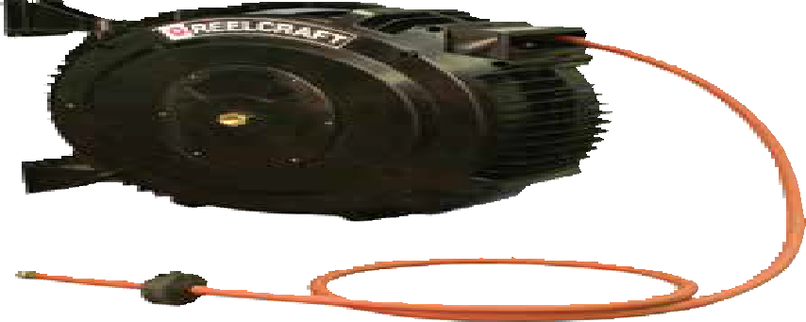
Medium Duty, Durable Reels | Series S

Spring Retractable Composite Reels

Air/Water/Chemical Delivery/Welding
1/4", 3/8", 1/2", 5/8" I.D.
Series S reels are economical, lighter weight, easy to handle and meet the demands of a medium-duty industrial grade reel for continuous operation. Made of corrosion-proof, tough polypropylene, extensive tests have shown it to be highly resistant to the vast majority of acids, alkalis and UV rays. The design protects the hose and allows easy cleaning of both hose and reel. Wall, ceiling or floor mount.

Arbor Farms Nursery, Fort Wayne, Indiana

SGA3650 OLP

Suitable for all position mounting.

A unique combination of composites and metals
The tough composite polypropyl- ene outer case houses solid brass swivel and fluid path, a steel main shaft and high quality spring steel motor.
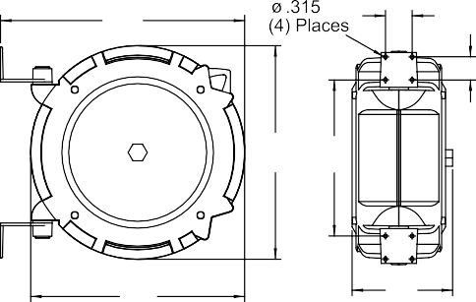
Corrosion-resistant, durable The tough composite polypropyl- ene outer case is UV stabilized and resistant to most acids and alkalis with excellent impact resistance.
Positive latching system
The design of the latching system ensures positive latching in any mounting position.
Unique mounting
The bracket supplied with the reel allows mounting in any position.
Lighter weight
The Series S offers distinct weight advantages due to the composite case construction.
Series S reels are made in Australia.

Models listed with an icon can ship same day upon request when the order is received by 1:00 PM Eastern Time for quantities of 10 or fewer.
Indiana Warehouse
Indiana & California Warehouses
California Warehouse Canadian Warehouse
Customer Service: 1.855.634.9109
All Other Calls: 1.800.444.3134
21
G |  |  |  | C |  | Dimensions
 |  |  |  |  |  |  | S Series
 |  |  |  |  | D |  | in | mm
 |  |  |  |  |  | A | 193/8 | 492
 |  | A | F |  |  | B | 191/4 | 489
 |  |  |  |  |  | C | 21/2 | 64
 |  |  |  |  |  | D | 21/8 | 54
 |  |  |  |  |  | E | 91/8 | 232
 | B |  |  | E |  | F | 141/8 | 359
 |  |  |  |  |  | G | 22 | 559

- Chemical delivery
- Oxygen acetylene
Applications
- Combination air/water
- Water service
- Hot water wash

Prop 65: WARNING:

Interactive Reel Catalog
Visit us at www.reelcraft.com/catalog for complete product specifications, available parts and accessories.
Model with Hose | Shipping Weight | Hose I.D. | Hose O.D. | Hose Length | **Max Pressure | NPT(M)  Hose Outlet | NPT(F)  Reel Inlet
 | lbs kg | in mm | in mm | ft m | psi bar | in | in
Air* & Water* Hose Reels Working temperature 150 °F (65 °C)
SGA3650 OLP | 21 10 | 3/8 10 | .621 16 | 50 15 | 240 17 | 3/8 | 3/8
SGA3665 OLP | 25 11 | 3/8 10 | .621 16 | 65 20 | 240 17 | 3/8 | 3/8
SGA3850 OLP | 23 10 | 1/2 13 | .781 20 | 50 15 | 240 17 | 1/2 | 1/2
Water Hose Reel Garden-style hose end. Working temperature 150 °F (65 °C)
SWA3850 OLP | 23 10 | 5/8 16 | .750 19 | 50 15 | 100 7 | 3/4 NH | 1/2
Hot Water Wash Reel Working temperature 185 °F (85 °C). **Maximum working pressure at 86 °F (30 °C)
SHA3850 OLP | 22 10 | 1/2 13 | .781 20 | 50 15 | 240 17 | 1/2 | 1/2
Chemical Delivery Hose Reel Working temperature 140 °F (60 °C)
SCA3650 OLP | 19 9 | 3/8 10 | .621 16 | 50 15 | 240 17 | 3/8 | 3/8
SCA3850 OLP | 22 10 | 1/2 13 | .781 20 | 50 15 | 240 17 | 1/2 | 1/2
Oxygen/Acetylene Hose Reel Working temperature 150 °F (65 °C)
STW3450 OLP | 27 12 | 1/4 6 | .530 13 | 50 15 | 300 21 | 9/16" 18(F) LH-RH | 9/16" 18(F) LH-RH
STW3450 OLP E dimension = 11.25" / 286 mm. *Air hose can be used for water on these models.

Cancer and Reproductive Harm www.P65Warnings.ca.gov.

Pressure Wash Reels | Series PW / H18006 / 30000
Prop 65: WARNING:
Cancer and Reproductive Harm www.P65Warnings.ca.gov.
Models listed with an icon can ship same day upon request
when the order is received by 1:00 PM Eastern Time for quantities of 10 or fewer.
Indiana Warehouse California Warehouse
Indiana & California Canadian Warehouse Warehouses
22
Customer Service: 1.855.634.9109
All Other Calls: 1.800.444.3134
Interactive Reel Catalog
Visit www.reelcraft.com/catalog for complete product specifications, available parts and accessories.

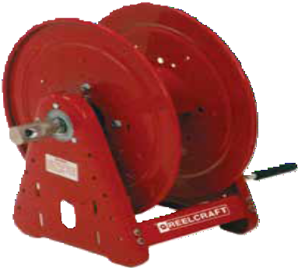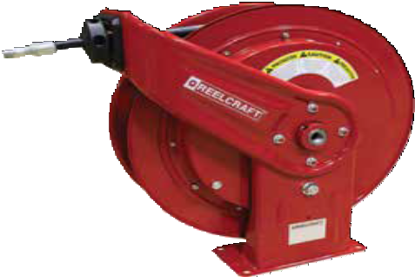Spring Retractable, Hand Crank, Motor Driven
PWD76075 OHP
CA38106 M
Made in USA
Air/Water - 1/4", 3/8", 1/2" I.D.
Compact design and quality steel construction are incorporated into Reelcraft’s full line of pressure wash reels, rated up to 5000 psi.
Series PW, H18006 and 30000 reels are able to carry 50 to 425 feet of tangle-free hose and are complete with a high pressure water
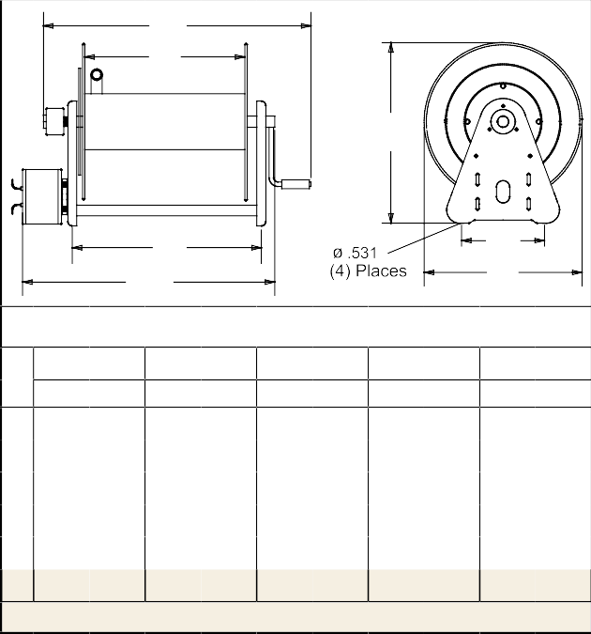swivel for maximum product delivery. The high pressure water swivel is designed to handle a broad range of pressures, temperatures and chemicals; perfect for agricultural/marine, equipment cleaning and pressure washing applications.
- Equipment cleaning
- Pressure washing
Applications
- Agriculture
- Marine
E
F
A
D
E
C
B
Dimensions - Series H & 30000
1 2 3 4
5
"B" is overall length.

 | in | mm | in | mm | in | mm | Shipping Weight |  | Size Index #
Hose I.D. | 1/4 | 6 | 3/8 | 10 | 1/2 | 13
Hose O.D. | .530 | 13 | .730 | 19 | .850 | 22
Model without hose & bumper | Hose Length
 | ft | m | ft | m | ft | m | lbs | kg
Hand Crank Pressure 5000 psi / 345 bar
H18006 M | 150 | 46 | 100 | 30 | --- | --- | 31 | 14 | 1
CA38106 M | 200 | 61 | 140 | 43 | 100 | 30 | 41 | 19 | 2
CA38112 M | 425 | 130 | 300 | 91 | 200 | 61 | 46 | 21 | 3
Electric Motor Driven Pressure 5000 psi / 345 bar
EA38106 M12D | 200 | 61 | 140 | 43 | 100 | 30 | 63 | 29 | 4
EA38112 M12D | 425 | 130 | 300 | 91 | 200 | 61 | 71 | 32 | 5
Max temperature 212 °F (100 °C). PSI rating based upon 2.4 to 1 safety factor.

 | in |  | mm | in |  | mm | in |  | mm | in |  | mm | in |  | mm
A | 201/8 |  | 413 | 201/4 |  | 514 | 201/4 |  | 514 | 201/4 |  | 514 | 201/4 |  | 514
B | 173/4 |  | 425 | 173/4 |  | 425 | 173/4 |  | 425 | 173/4 |  | 425 | 173/4 |  | 425
C | 10 |  | 254 | 9 |  | 229 | 9 |  | 229 | 9 |  | 229 | 9 |  | 229
D | 63/8 |  | 162 | 93/4 |  | 248 | 153/4 |  | 400 | 93/4 |  | 248 | 153/4 |  | 400
E | 133/4 |  | 349 | 193/4 |  | 502 | 253/4 |  | 654 | 177/8 |  | 454 | 237/8 |  | 606
F | 5 |  | 127 | 6 |  | 152 | 12 |  | 305 | 6 |  | 152 | 12 |  | 305

Model with Hose | Shipping Weight |  | Hose I.D. | Hose O.D. | Hose Length |  | Pressure |  | NPT(M)  Hose Outlet | NPT(F)  Reel Inlet | Model without hose & bumper | Shipping Weight |  | Pressure |  | Size Index Page | Size Index #
 | lbs | kg | in mm | in mm | ft | m | psi | bar | in | in |  | lbs | kg | psi | bar
Spring Driven Reels Maximum temperature 210 °F (99 °C)
PW7650 OHP | 60 | 27 | 3/8 10 | .730 19 | 50 | 15 | 4800 | 331 | 1/4 | 1/2 | PW7600 OHP | 43 | 20 | 5000 | 345 | 10 | ---
PWD76075 OHP | 90 | 41 | 3/8 10 | .730 19 | 75 | 23 | 4800 | 331 | 1/4 | 1/2 | PWD76005 OHP | 60 | 27 | 5000 | 345 | 12 | 2
PW81100 OHP | 119 | 54 | 3/8 10 | .730 19 | 100 30 |  | 4800 | 331 | 3/8 | 1/2 | PW81000 OHP | 86 | 39 | 5000 | 345 | 13 | 1
PSI rating based upon 2.4 to 1 safety factor. Reference page 4 for guide arm positions.

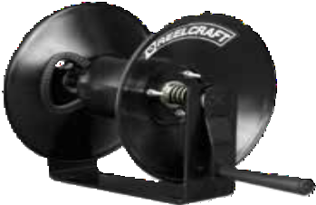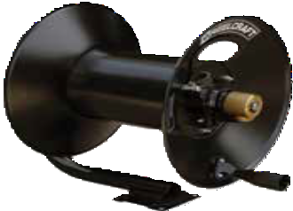General Use Hand Crank Hose Reels | Series C
Light Industrial Hand Crank Hose Reels
Reelcraft’s Series C hose reels are designed for lighter-duty applications that require longer lengths of hose. The Series C incorporates a balanced brass swivel, brass inlet, lighter weight components and forward-thinking design. Reels in this family benefit from a tough, corrosion-resistant powder coat paint. All reels feature a drag break to prevent
de-spooling when reel is not in use.
Series CU Air/Water - 3/8", 1/2" I.D.
Series CU features our most rigid base design in this series and supports the reel on either side.
Series CT Air/Water/Pressure Wash - 3/8", 1/2" I.D.
CU6050LN
CT6100HN
The Series CT frame features a tubular design. The inlet
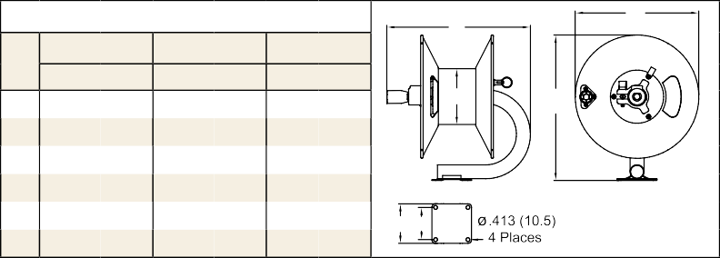is fed through the center of the tube frame, protecting the inlet hose and creating a cleaner look over all.
Dimensions - Series CT
E
B
5 6 7
F
A
D C
 | in | mm | in | mm | in | mm
A | 155/8 | 397 | 155/8 | 397 | 197/8 | 505
B | 131/4 | 337 | 131/4 | 337 | 16 | 406
C | 31/2 | 89 | 31/2 | 89 | 5 | 127
D | 41/4 | 108 | 41/4 | 108 | 6 | 152
E | 151/2 | 394 | 191/2 | 495 | 197/8 | 505
F | 6 | 152 | 6 | 152 | 6 | 152

Series CM Pressure Wash - 3/8" I.D. Series CM reels offer the greatest amount of flexibility in this series by featuring a modular mounting platform. Reelcraft can configure custom mounts upon request or the customer may
choose to supply their own.
Dimensions - Series CU |  |  |  |  |  |  |  |  | H C | F  G D | E | A | B
 | 1 |  | 2 |  | 3 |  | 4
 | in | mm | in | mm | in | mm | in | mm
A | 111/2 | 292 | 111/2 | 292 | 143/8 | 365 | 143/8 | 365
B | 101/2 | 267 | 101/2 | 267 | 131/4 | 337 | 131/4 | 337
C | 2 | 51 | 2 | 51 | 23/8 | 60 | 23/8 | 60
D | 65/8 | 168 | 111/8 | 283 | 61/4 | 159 | 101/4 | 260
E | 163/4 | 425 | 211/8 | 537 | 163/4 | 425 | 207/8 | 530
F | 4 | 102 | 4 | 102 | 6 | 152 | 6 | 152
G | 93/8 | 238 | 137/8 | 352 | 91/4 | 235 | 131/4 | 337
H | 33/8 | 86 | 33/8 | 86 | 4 | 102 | 4 | 102

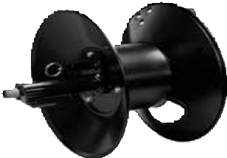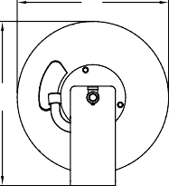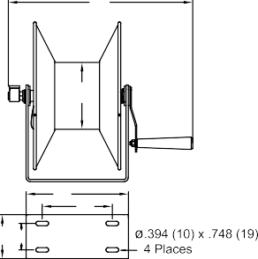
CM6050HN

 | in | 8 | mm | in | 9 | mm
B | 143/8 |  | 365 | 183/8 |  | 467
C | 21/2 |  | 64 | 21/2 |  | 64
D | 31/2 |  | 89 | 31/2 |  | 89
E | 163/8 |  | 416  B | 201/2 |  | 521

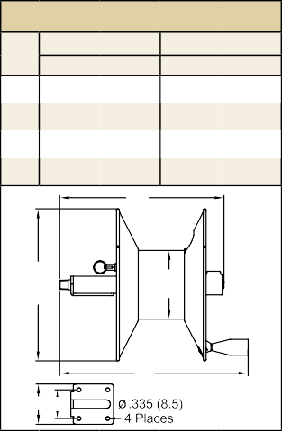Models listed with an icon can ship same day upon request when the order is received by 1:00 PM Eastern Time for quantities of 10 or fewer.
Dimensions - Series CM
131/4"
(337)
6"
(152)
E
D C

Prop 65: WARNING:
Model w/o hose | Shipping Weight |  | Hose I.D. |  | Hose O.D. |  | Hose Length |  | Pressure |  | NPT(F)  Reel Outlet | NPT(F)  Reel Inlet | Size Index #
 | lbs | kg | in | mm | in | mm | ft | m | psi | bar | in | in
Low Pressure Air/Water Reels Maximum temperature 150 °F (65 °C)
CU6050LN | 12 | 5 | 3/8 | 10 | .600 | 15 | 50 | 15 | 300 | 21 | 3/8 | 3/8 | 1
CU6100LN | 16 | 7 | 3/8 | 10 | .600 | 15 | 100 | 30 | 300 | 21 | 3/8 | 3/8 | 2
CU8050LN | 13 | 6 | 1/2 | 13 | .750 | 19 | 50 | 15 | 300 | 21 | 1/2 | 1/2 | 3
CU8100LN | 20 | 9 | 1/2 | 13 | .750 | 19 | 100 | 30 | 300 | 21 | 1/2 | 1/2 | 4
CT6050LN | 13 | 6 | 3/8 | 10 | .600 | 15 | 50 | 15 | 300 | 21 | 1/2 | 1/2 | 5
CT6100LN | 17 | 7.5 | 3/8 | 10 | .600 | 15 | 100 | 30 | 300 | 21 | 1/2 | 1/2 | 6
CT8050LN | 13 | 6 | 1/2 | 13 | .750 | 19 | 50 | 15 | 300 | 21 | 1/2 | 1/2 | 5
CT8100LN | 17 | 7.5 | 1/2 | 13 | .750 | 19 | 100 | 30 | 300 | 21 | 1/2 | 1/2 | 6
High Pressure Wash Reels Maximum temperature 210 °F (99 °C)
CT6050HN | 13 | 6 | 3/8 | 10 | .730 | 19 | 50 | 15 | 5000 | 345 | 3/8 | 1/2 | 5
CT6100HN | 17 | 7.5 | 3/8 | 10 | .730 | 19 | 100 | 30 | 5000 | 345 | 3/8 | 1/2 | 6
CTJ6200HN | 28 | 13 | 3/8 | 10 | .730 | 19 | 200 | 61 | 5000 | 345 | 3/8 | 1/2 | 7
CM6050HN | 14 | 6.5 | 3/8 | 10 | .730 | 19 | 50 | 15 | 5000 | 345 | 3/8 | 1/2 (M) | 8
CM6100HN | 18 | 8 | 3/8 | 10 | .730 | 19 | 100 | 30 | 5000 | 345 | 3/8 | 1/2 (M) | 9
Reels are supplied without hose; assemblies will be quoted upon request.

Cancer and Reproductive Harm www.P65Warnings.ca.gov.

Indiana Warehouse
Indiana & California Warehouses
California Warehouse
Canadian Warehouse

Customer Service: 1.855.634.9109
All Other Calls: 1.800.444.3134 23

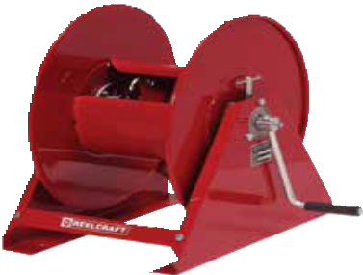Hand Crank / Motor Driven Reels | Series H / 30000
A
Medium duty
H16000

Medium Duty Hand Crank Reels
Series H - Air/Water/Oil/Grease - 3/8", 1/2", 3/4" I.D.
Series H is an economical reel designed for medium duty applications requiring long lengths of hose. It is equally suited for plant or field use such as turf care, pest control, steam cleaning and more.
Shipped completely assembled, ready to install.

Made in US

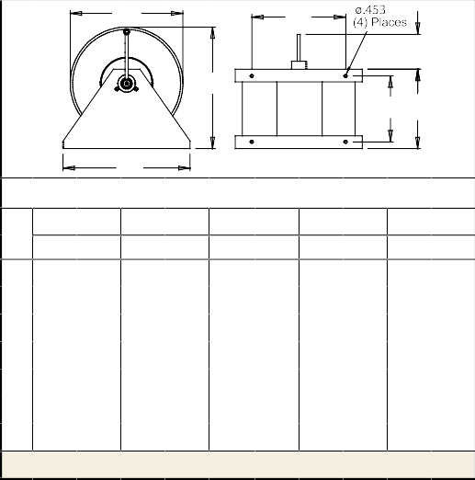
Model without hose | Shipping Weight |  | Hose I.D. |  | Hose O.D. |  | Hose Length |  | Pressure |  | NPT(F)  Reel Outlet | NPT(F)  Reel Inlet | Size Index #
 | lbs | kg | in | mm | in | mm | ft | m | psi | bar | in | in
Low Pressure Air/Water Hose Reels Max temperature 150 °F (65 °C)
H16000 | 32 | 15 | 3/8 | 10 | .600 | 15 | 300 | 91 | 500 | 35 | 1/4 | 3/8 | 1
H26000 | 34 | 15 | 3/8 | 10 | .600 | 15 | 450 137 |  | 500 | 35 | 1/4 | 3/8 | 2
H18005 | 33 | 15 | 1/2 | 13 | .750 | 19 | 175 | 53 | 1000 | 69 | 1/2 | 1/2 | 5
H18000 | 34 | 15 | 1/2 | 13 | .750 | 19 | 200 | 61 | 1000 | 69 | 1/2 | 1/2 | 1
H28005 | 34 | 15 | 1/2 | 13 | .750 | 19 | 300 | 91 | 1000 | 69 | 1/2 | 1/2 | 4
H28000 | 37 | 17 | 1/2 | 13 | .750 | 19 | 300 | 91 | 1000 | 69 | 1/2 | 1/2 | 2
H19000 | 33 | 15 | 3/4 | 19 | 1.075 27 |  | 105 | 32 | 1000 | 69 | 3/4 | 3/4 | 1
H29005 | 36 | 16 | 3/4 | 19 | 1.075 27 |  | 100 | 30 | 1000 | 69 | 3/4 | 3/4 | 3
H29000 | 41 | 19 | 3/4 | 19 | 1.075 27 |  | 150 | 46 | 1000 | 69 | 3/4 | 3/4 | 2
Medium Pressure Oil Hose Reels Max temperature 210 °F (99 °C)
H16000 M | 32 | 15 | 3/8 | 10 | .710 | 18 | 300 | 91 | 3000 | 207 | 3/8 | 1/2 | 1
H18000 M | 34 | 15 | 1/2 | 13 | .850 | 22 | 200 | 61 | 3000 | 207 | 1/2 | 1/2 | 1
H19000 M | 38 | 17 | 3/4 | 19 | 1.188 30 |  | 80 | 24 | 3000 | 207 | 3/4 | 3/4 | 1
H29000 M | 35 | 16 | 3/4 | 19 | 1.188 30 |  | 150 | 46 | 3000 | 207 | 3/4 | 3/4 | 2
High Pressure Grease Hose Reels Max temperature 210 °F (99 °C)
H16000 H | 35 | 16 | 3/8 | 10 | .730 | 19 | 250 | 76 | 5000 | 345 | 3/8 | 3/8 | 1
Hose assemblies can be quoted upon request. CAUTION: To prevent drum damage fully extend and pressurize hose and rewind on the reel. Stainless models available, see page 19.

G
C
F
A
D E
B
Dimensions - Size Index
1 2 3 4
5
in mm in mm in mm in mm in mm
A 19 483 19 483 187/8 479 201/8 512 201/8 512
B 20 508 20 508 14 356 14 356 14 356
C 15 381 15 381 10 254 10 254 10 254
D 10 254 16 407 16 407 16 407 10 254
E 121/2 318 181/2 470 181/2 470 181/2 470 121/2 318
F 53/4 146 53/4 146 53/4 146 53/4 146 53/4 146
G 173/4 451 173/4 451 153/16 386 173/4 451 173/4 451
Drum diameter 8".

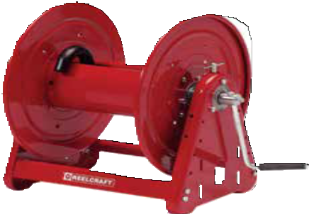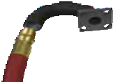Heavy Duty Hand Crank and Motor Driven Reels
Made in USA
Hand Crank
CA32112 L
Series 30000 - Air/Water/Oil - 1/4",1/2", 3/4", 1" I.D.
Reelcraft’s Series 30000 reels are designed for rugged, heavy duty applications requiring long lengths of hose and large storage capac- ity. All-bolted unitized construction with no welds to fatigue, full flow swivel and heavy gauge steel frame, spool and drum ensure longest service life. Series 30000’s vibration-proof, self-locking fasteners are ideal for industrial or field use such as turf care or pest control.

Prop 65: WARNING:
Cancer and Reproductive Harm www.P65Warnings.ca.gov.
Models listed with an icon can ship same day upon request
when the order is received by 1:00 PM Eastern Time for quantities of 10 or fewer.
Indiana Warehouse California Warehouse
Indiana & California Canadian Warehouse Warehouses
24
Customer Service: 1.855.634.9109
All Other Calls: 1.800.444.3134
Interactive Reel Catalog
Visit www.reelcraft.com/catalog for complete product specifications, available parts and accessories.

Hose Installation: The Series 30000 gooseneck is easily removed from the reel for hose attachment. Simply remove the four fasteners attaching gooseneck to reel, connect hose to the gooseneck and re-connect to the reel. NOTE: Do not discard the O-ring; insure that the O-ring is properly fitted into the grooves when replacing the gooseneck.
P Adjustable spool rotation drag that eliminates hose backlash
P Nickel-plated swivel with four O-ring options: AFLAS (standard), Buna, Viton® or
-EPR* seals *Standard swivel
P Motor mounting at either end of reel
P Optional lock pin to prevent spool rotation when the reel is not in use, S600874

Long Hose Lengths | Series 30000

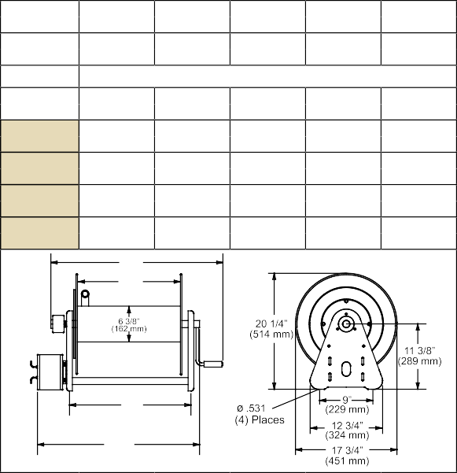E A 3 2 1 06 L 12D X
Hose I.D.
(6.4 mm) (9.5 mm) (12.7 mm) (19.1 mm) (25.4 mm)
Hose O.D. .530" .710" .850" 1.188" 1.375"
(13 mm) (18 mm) (22 mm) (30 mm) (35.0 mm)
"F" Width Hose Capacity
6"
(152 mm)
12"
(305 mm)
18"
(457 mm)
22"
(559 mm)
27"
(686 mm)
200'
(61 m)
425'
(130 m)
625'
(191 m)
780'
(238 m)
140' 100' 50'
(43 m) (30 m) (15 m)
300' 200' 100'
(91 m) (61 m) (30 m)
450' 325' 175'
(137 m) (99 m) (54 m)
550' 400' 225'
(168 m) (122 m) (69 m)
N/A
50'
(15 m)
100'
(31 m)
125'
(38 m)
(305 m)
E F
(213 m)
(152 m) (84 m) (46 m)
D
E
1/4" 3/8" 1/2" 3/4" 1"
1000' 700' 500' 275' 150'

Drive Type A - Air motor B - Bevel crank C - Hand crank
E - Electric motor
H - Hydraulic motor

Fluid Path Type
A - Gooseneck
B - No gooseneck (1" only)
H - Heavy duty gooseneck (1" only)

NOTE: This chart is for reference purposes only. Please see selec- tion chart or consult manufacturer for additional models not listed or for any questions about option combinations.
Width of Spool See “F” Dimension 06 - 6" (152 mm)
12 - 12" (305 mm)
18 - 18" (457 mm)
22 - 22" (559 mm)
28 - 27" (686 mm)

Swivel Size
0 - No swivel
2 - 1/2” (13 mm) I.D.
3 - 3/4” (19 mm) I.D.
4 - 1/2” (13 mm) Dual
5 - 3/4” (19 mm) Dual
6 - 1/4" (6 mm) Dual
7 - 1” (25 mm) I.D.
8 - 1/2" (13 mm) I.D.
pressure wash
Motor Type
Blank
X - Explosion proof electric motor

Power Source
Blank
12D - 12 V DC
24D - 24 V DC
10A - 115 V AC
4A - 1 ½ HP air motor 6A - 4 HP air motor

Pressure
L - 1000 PSI (69 bar)
M - 3000 PSI (207 bar)

Model without hose | Shipping Weight | Hose I.D. | Hose O.D. | Capacity | Pressure | NPT(F)  Reel Outlet | NPT(F)  Reel Inlet | D | E | F
 | lbs kg | in mm | in mm | ft m | psi bar | in | in | in mm | in mm | in mm
Hand Crank Hose Reels Maximum temperature 210 °F (99 °C)
CA32106 L | 40 18 | 1/2 13 | .750 19 | 100 30 | 1000 69 | 1/2 | 1/2 | 93/4 248 | 193/4 502 | 6 152
CA32112 L | 46 21 | 1/2 13 | .750 19 | 200 61 | 1000 69 | 1/2 | 1/2 | 153/4 400 | 253/4 654 | 12 305
CA32118 L | 51 23 | 1/2 13 | .750 19 | 325 99 | 1000 69 | 1/2 | 1/2 | 213/4 552 | 313/4 806 | 18 457
CA32122 L | 65 29 | 1/2 13 | .750 19 | 400 122 | 1000 69 | 1/2 | 1/2 | 253/4 654 | 353/4 908 | 22 559
CA32128 L | 69 31 | 1/2 13 | .750 19 | 500 152 | 1000 69 | 1/2 | 1/2 | 303/4 781 | 403/4 1035 | 27 686
CA32106 M | 42 19 | 1/2 13 | .850 22 | 100 30 | 3000 207 | 1/2 | 1/2 | 93/4 248 | 193/4 502 | 6 152
CA32112 M | 46 21 | 1/2 13 | .850 22 | 200 61 | 3000 207 | 1/2 | 1/2 | 153/4 400 | 253/4 654 | 12 305
CA32118 M | 52 24 | 1/2 13 | .850 22 | 325 99 | 3000 207 | 1/2 | 1/2 | 213/4 552 | 313/4 806 | 18 457
CA33106 L | 41 19 | 3/4 19 | 1.075 27 | 50 15 | 1000 69 | 3/4 | 3/4 | 93/4 248 | 193/4 502 | 6 152
CA33112 L | 46 21 | 3/4 19 | 1.075 27 | 100 30 | 1000 69 | 3/4 | 3/4 | 153/4 400 | 253/4 654 | 12 305
CA33118 L | 51 23 | 3/4 19 | 1.075 27 | 175 53 | 1000 69 | 3/4 | 3/4 | 213/4 552 | 313/4 806 | 18 457
CA33112 M | 47 21 | 3/4 19 | 1.188 30 | 100 30 | 3000 207 | 3/4 | 3/4 | 153/4 400 | 253/4 654 | 12 305
CA33118 M | 51 23 | 3/4 19 | 1.188 30 | 175 53 | 3000 207 | 3/4 | 3/4 | 213/4 552 | 313/4 806 | 18 457
CH37118 L* | 64 29 | 1 25 | 1.375 35 | 100 30 | 1000 69 | 1 | 1 | 213/4 552 | 313/4 806 | 18 457
CH37122 L* | 73 33 | 1 25 | 1.375 35 | 125 38 | 1000 69 | 1 | 1 | 253/4 654 | 353/4 908 | 22 559
CH37128 L* | 77 35 | 1 25 | 1.375 35 | 150 46 | 1000 69 | 1 | 1 | 303/4 781 | 403/4 1035 | 27 686
Bevel Crank Hose Reels Maximum temperature 210 °F (99 °C)
BA36112 L | 57 26 | 1/4 6 | Twin Welding | 250 76 | 200 14 | 1/4 | 1/4 | 153/4 400 | 253/4 654 | 12 305
BA34112 M | 54 24 | 1/2 13 | Twin Hydraulic | 100 30 | 3000 207 | 1/2 | 1/2 | 153/4 400 | 253/4 654 | 12 305
Electric Motor Driven Hose Reels Maximum temperature 210 °F (99 °C)
EA32106 L10A | 61 28 | 1/2 13 | .750 19 | 100 30 | 1000 69 | 1/2 | 1/2 | 93/4 248 | 195/8 498 | 6 152
EA32112 L12D | 64 29 | 1/2 13 | .750 19 | 200 61 | 1000 69 | 1/2 | 1/2 | 153/4 400 | 237/8 606 | 12 305
EA32118 L12D | 68 31 | 1/2 13 | .750 19 | 325 99 | 1000 69 | 1/2 | 1/2 | 213/4 552 | 295/8 752 | 18 457
EA33112 L12D | 68 31 | 3/4 19 | 1.075 27 | 100 30 | 1000 69 | 3/4 | 3/4 | 153/4 400 | 237/8 606 | 12 305
EA33118 L12D | 68 31 | 3/4 19 | 1.075 27 | 175 53 | 1000 69 | 3/4 | 3/4 | 213/4 552 | 295/8 752 | 18 457
EA33112 M12D | 71 32 | 3/4 19 | 1.188 30 | 100 30 | 3000 207 | 3/4 | 3/4 | 153/4 400 | 237/8 606 | 12 305
EA33128 M12D | 91 41 | 3/4 19 | 1.188 30 | 275 84 | 3000 207 | 3/4 | 3/4 | 303/4 781 | 385/8 981 | 27 686
EA33112 M24D | 71 32 | 3/4 19 | 1.188 30 | 100 30 | 3000 207 | 3/4 | 3/4 | 153/4 400 | 237/8 606 | 12 305
EH37118 L12D* | 82 37 | 1 25 | 1.375 35 | 100 30 | 300 21 | 1 | 1 | 213/4 552 | 31 787 | 18 457
Air Motor Driven Hose Reels Filter, regulator, lubricator required. Maximum temperature 210 °F (99 °C)
AA32112 L4A | 62 28 | 1/2 13 | .750 19 | 200 61 | 1000 69 | 1/2 | 1/2 | 153/4 400 | 231/4 591 | 12 305
AA33106 L4A | 59 27 | 3/4 19 | 1.075 27 | 50 15 | 1000 69 | 3/4 | 3/4 | 93/4 248 | 171/4 438 | 6 152
AA33112 L6A | 68 31 | 3/4 19 | 1.075 27 | 100 30 | 1000 69 | 3/4 | 3/4 | 153/4 400 | 231/4 591 | 12 305
Hose assemblies can be quoted upon request. CAUTION: To prevent drum damage, fully extend and pressurize hose and rewind on the reel. For metric thread connections over 1/2" add the suffix number 70 to indicate BSPT threads - example CA33112 M70. *All 1" reel models have an 8" (203 mm) diameter drum.

Many more reel models available in addition to chart. Please contact manufacturer for details.
Prop 65: WARNING:
Cancer and Reproductive Harm - www.P65Warnings.ca.gov.

Customer Service: 1.855.634.9109
All Other Calls: 1.800.444.3134 25

Hose Reel Cart and Trailer | Series 30000

Portable Hose Reel and Cart Hose Reel and Trailer
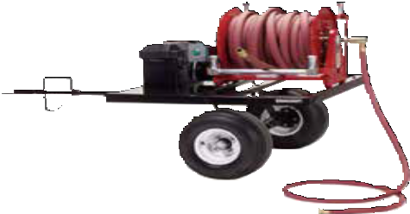
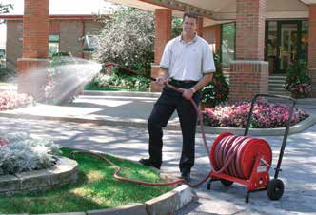Reelcraft’s rugged, self-contained hose reel trailer easily attaches to most off-road vehicles or carts and is pre-drilled
Hose Reel and Cart Package
600968
12" or 18" for Series 30000 hose reels. Reels hold up to 100’ of 1" I.D.
water hose.
Makes spot watering
easier, quicker and more convenient. Applications include golf courses,
athletic fields, sports turfs, grounds main-

Made in USA

600910

tenance, parks and rec, agriculture and nurseries.
Hose Reel and Trailer Packages
Package | Items Included
600911 | Trailer (600810); Hand rewind hose reel (CB37118 L); 10’ lead hose (S600982-10); Roller bracket, top wind (S602133-3)
600910 | Trailer (600810); 12 V DC Motor driven hose reel (EB37118 L12D); Switch, complete (S600808); Battery box, battery not included (S600812); Chain guard (S600518); Roller bracket, top wind (S602133-3); Roller bracket, bottom wind (S602132-3); 10’ lead hose with 1" I.D. (S600982-10)
600810 | Trailer only - does not include hose or reel. Reels designed for trailer include motor driven EB37118 L12D and hand crank CB37118 L. Trailer weight 154 lbs / 70 kg.

Hose Reel and Cart Packages
Package | Items Included
600965 | 12" hand crank hose reel (CA32112 L); 12" hand cart with pneumatic tires (600741-1); 10’ inlet hose (600962)
600966 | 12" hand crank hose reel (CA32112 L); 12" hand cart with semi-pneumatic tires (600741-2); 10’ inlet hose (600962)
600967 | 12" hand crank hose reel (CA33112 L); 12" hand cart with pneumatic tires (600741-1); 10’ inlet hose (600963)
600968 | 18" hand crank hose reel (CB37118 L); 18" hand cart with pneumatic tires (600885-1); 10’ inlet hose (S600982-10)

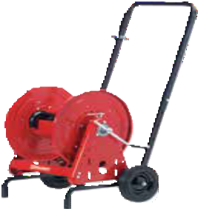Additional Accessories
Battery box (battery not included): S600812 Battery cable connector: 600814
Chain guard: S600518

Made in USA

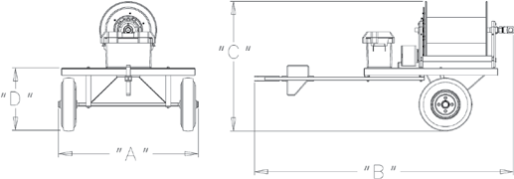Hose: 1" ID x 100’, 1" NPT x 1" NPSH: S600982-100 Hose: 3/4" ID x 150’, 3/4" NPT x 1" NPSH: 601044-150 Inlet hose: 1" ID x 10’, 1" NPT x 1" NPSH: S600982-10
Prop 65: WARNING:
Cancer and Reproductive Harm - www.P65Warnings.ca.gov.
26
Customer Service: 1.855.634.9109
All Other Calls: 1.800.444.3134
Trailer Dimensions
39”
990 mm
19”
482 mm
78”
1981 mm

Trailer designed for off-road use only, not for passenger transport. Maximum weight capacity 400 pounds. Maximum speed 15 miles per hour. Trailer, reel and accessories sold separately.
44”
1066 mm
Operating switch: S600808
Garden Fitting Conversion Kit
1/2" NPTM x 3/4" NH: 260729
3/4" NPTM x 3/4" NH: 261702

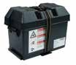
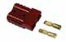
600965
Note: Refer to pages 24 and 25 for Series 30000 hose reel dimensions and specifications.
27" | C | A | B | Pneumatic | 600741-1 |  | 600885-1
 |  |  |  | Semi-Pneumatic | 600741-2 |  | 600885-2
 |  |  |  | Reel Size | 12" |  | 18"
 |  |  |  |  | in | mm | in | mm
 |  |  |  | A | Adjustable*
 |  |  |  | B | 233/4 | 603 | 283/4 | 730
 |  |  |  | C | 181/4 | 464 | 181/4 | 464
*Handle height of cart is adjustable to 355/8", 385/8", 411/2" or 441/2". Eight 5/16" (8mm) diameter mounting holes.

 |  | Additional Series 30000 Accessories
S600812 Battery Box
Battery not included. Supplied with mounting hardware.
Inside dimensions = 9" height x 14" width x 71/2" depth
 | S600812
600814 Battery Cable Connector
Battery not included.
600814 |  | See page 50 for switches, motors and chain guards; refer to reelcraft.com for replacement hoses.

Large Frame Reels | Reel Configurator

Reelcraft’s Reel Configurator

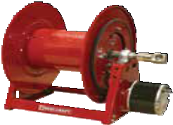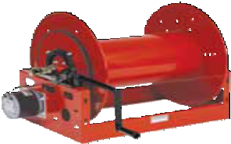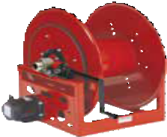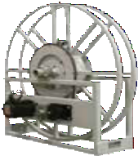Large Frame Reels

Series 1200 - 1/2”, 3/4”, 1” I.D.

Series 2400 - 1/2”, 3/4”, 1” I.D.

Series 3900 - 1”, 11/4”, 11/2” I.D.
Series 3700 / 5900 - 2”, 3" I.D.

Series 6000 - 11/2”, 2”, 21/2”, 3" I.D.
1/2" to 3" I.D.; hose lengths to 610' and more
Reelcraft’s new reel configurator quickly and accurately quotes large frame reels. Simply answer a few questions about your reel needs and the configurator can instantly quote your reel. It will also create a 3D model from which a sales drawing and bill of
material can be generated that can be sent out for your review. The new configurator allows for shorter lead times for large frame reels and increases the accuracy of the available combinations of reel options.

Improved response time
The configurator has greatly improved our response time to the customer. The traditional 2-3 day quote time has been reduced to only 20 minutes.

More accurate quotes
The configurator’s rules based sys- tem eliminates incompatibilities and increases the accuracy of the available combinations of reel options. It will also create a 3D model from which a sales drawing and bill of material can be generated that can be sent out for your review.

Reduced product lead time
The improved response time and quote procedure have also decreased the product lead time. The standard 4-6 week product lead time can be reduced to a mere 2-3 weeks with most configured products.

Current capacity
The configurator currently covers 85% of the standard large frame reels sold and manufactured by Reelcraft with hose I.D.’s ranging from 1/2” to 3”.
More sizes will become available as released.

For an accurate quote, please advise:

- Product to be handled such as air, oil, water, etc.
- Maximum operating pressure in PSI.
- Hose inside diameter (I.D.) and length.
- Desired drive type such as hand crank, electric motor, air motor, etc.
- Any special or additional accessories needed.

NOTE: Not all options are available in every combination. All large frame reels are supplied without hose. Reelcraft's configured reels and custom reels are built to order and not returnable.

Custom Capabilities
Don’t see what you need? Reelcraft’s engineered products group custom builds to your specifications.

- Very few size and weight constraints
- Special finishes / paint options
- Various drive types
- Wide range of pressures
- No minimum quantities

Customer Service: 1.855.634.9109
All Other Calls: 1.800.444.3134 27

Large Frame Reels | Nordic Heavy Duty Solutions

Reelcraft’s Engineered Product Solutions

Full Flow Design
The goose neck is contoured to match the drum diameter, which allows smooth hose wrapping and unimpeded flow.

Long Service Life
Swivel incorporates a permanently lubricated ball bearing.

Adjustable Hose Tension
The brake can be adjusted to suit the application requirements.

Trouble-Free Rewinding
Chain and sprocket drive ensures smooth and consistent operation.
Meets or Exceeds Military Vibration for Truck Transport test.
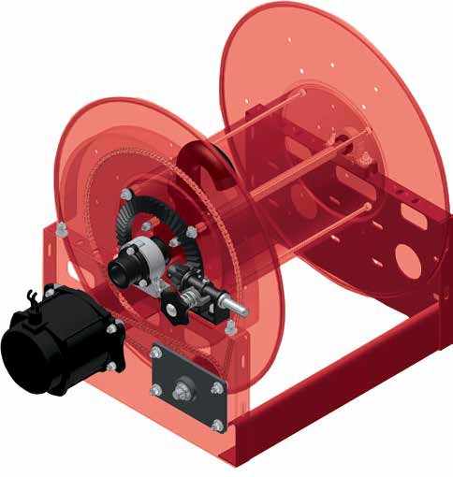MIL-STD-810F
500,000 mile equivalent
Long Service Life
The spool axial is supported by independent self-aligning bearing.

Free Rotation While Pressurized
The swing joint and spindle allows reel to freely rotate while fluid is pressurized.

Precise Rigid Construction
Proprietary unitized tie rods are zinc plated offering greater strength and resistance to vibration and corrosion.

Ultimate Corrosion Resistance
Individually powder coated components insure maximum coverage and resistance to corrosion.
Stainless steel fasteners are standard.

- - - -
6"-36"
in 2" increments
Drum Length
Drive Options |  | Series
E | 12 V DC | 1200
NJ | 24 V DC | 2400
EP | *12 V DC Exp | 3900
EA | *115 V AC Exp | 3700
EX | *230 V AC Exp | 5900
EJ | *24 V DC Exp
HD | Hydraulic
AF | 11/2 HP Air
AR | 4 HP Air
BC | Bevel Crank
HC | Hand Crank
S | Storage
CR | Cable Reel
*Exp=Explosion proof motor
Material Options/ Drive Size
1/2" Pitch Chain |  | ###5
5/8" Pitch Chain |  | ###6
3/4" Pitch Chain |  | ###7
Gear Driven |  | ###9
Alum. Frame/Spool |  | ##5#
304 S.S. Frame/Spool |  | ##9#
316 S.S. Frame/Spool |  | ##8#
Sewer Cleaning Reel |  | ##15
Twin Hose |  | ####T

Head
Dia.
19
21
23
25
28
31
36
39
46

Thread Size |  | Inlet/Outlet Thread |  | Thread Style |  | Fluid Path Material |  | Pressure |  | Inlet Style |  | Fluid Path Location/ Direction
50 | 1/2" | FM | Female In/ Male Out | NP | NPT | A | Aluminum | LP | 0-600 | 1 | Straight | 1 | Left Hand Top Wind
75 | 3/4" |  |  | BP | BSPP | D | Ductile Iron | 1K | 600-1000 | 2 | 90° | 2 | Left Hand Bottom Wind
10 | 1" | FF | Female In/Out | BT | BSPT | S | Stainless | 3K | 1000-3000 | 5 | 1" LPG | 3 | Right Hand Top Wind
12 | 11/4" | MF | Male In/ Female Out |  |  |  |  | 5K | 3001-5000 | 6 | 11/2" LPG | 4 | Right Hand Bottom Wind
15 | 11/2" |  |  |  |  |  |  | 6K | 5001-6000 | Additional Options
20 | 2" | MM | Male In/Out |  |  |  |  | 10K | 10,000
25 | 21/2" | VM | Grooved fitting In/Male Out |  |  |  |  | 15K | 15,000
30 | 3"
40 | 4" | VF | Grooved fitting In/ Female Out

Color Code
R | Red
B | Black
W | White
G | Grey
S | Silver

Part No. Example: EP3900-23-28-15FFNPALP21-R00
Idler
Chain Guard
Roller Bracket (Top)
Roller Bracket (Bottom)
Inboard Motor
Brake
Auxiliary Bevel Crank
Hose Boss (Guide)
Junction Box
Explosion Proof Switch
Solenoid
Circuit Breaker
Control Valve

EP(12VDC Electric Explosion Proof Motor)
3900(Series 3900 Hose Reel)
-23(23” Head Dia.) -28(28” Drum Length)
-15(1-1/2” Thread Size) FF(Female In/Out Thread Type)
NP(NPT Thread Style) A(Aluminum Fluid Path)
LP(0-600 PSI) 2(90° Inlet)
1(Left Hand Top Wind Fluid Path Location/Direction)
R(Red)
NOTE: Not all options available in every combination. Actual assigned part numbers will vary. Please contact manufacturer for price and availability.

Customer Service: 1.855.634.9109
28
All Other Calls: 1.800.444.3134

Large Frame Hose Reels | Nordic Series 1200

Heavy Duty Large Frame Reels

Nordic Series 1200
1" fluid path for 1/2" through 1" I.D. hose
Rewind: Direct crank rewind or chain and sprocket drive powered by A.C. or D.C. electric motor, compressed air motor or hydraulic motor. Crank is not supplied on power rewind models. A pin lock assembly is optional on manual rewind reels. A 3/8" pitch chain is standard.
Inlet: 1/2" up to 1" female/male NPT 90° swivel joint. Straight swivel joint may be specified at extra cost.
Gooseneck: 1/2", 3/4", 1" female NPT. Other sizes and/or threads, including garden hose thread, can be furnished when specified.
The standard color for this series is red.

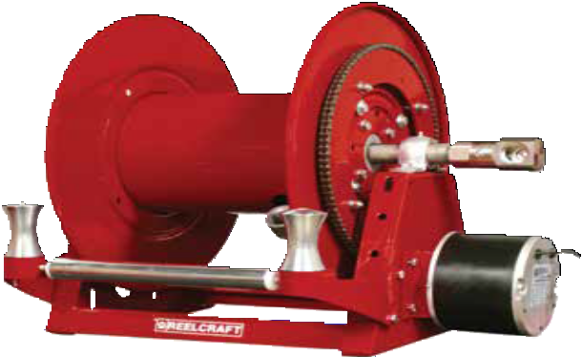
Shown with optional three-way roller bracket.

Nonexplosion-proof motor is standard “E” (pictured). Explosion proof (EP) motor is available upon request.
Dimensions Diagram
B |  | F | B |  | F
 | A | G |  | A | G
 | H |  |  | H
9"-10" |  | D-1.5" | 9"-10" |  | D-1.5"
C |  | D | C |  | D
 |  | E |  |  | E
 | Motor Driven |  |  | Hand Crank

Made in USA

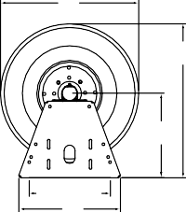
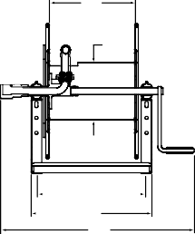
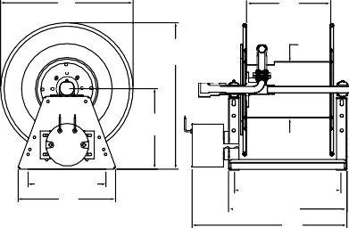
Built to order, not returnable.
Product temperatures range from
-20 °F to +225 °F and standard pres- sures to 3000 psi. Other temperatures or pressures can be furnished at extra cost; consult manufacturer.

Hose I.D. | in | 1/2 | 3/4 | 1 | Specification - Hose Capacity and Reel Dimensions  KEY: CRK = hand crank; “E” = nonexplosion-proof electric motor; EP = explosion-proof motor; AIR = air moter; BEVEL = bevel crank
 | mm | 13 | 19 | 25
Hose O.D. | in | 0.875 | 1.28 | 1.563
 | mm | 22 | 33 | 40
Model | Hose Length |  |  |  | Weight Crank* | Weight Motor* | Weight Bevel* |  | A | B | C | D | E CRK | E “E” | E EP | E AIR | E BEVEL | F | G | H
1200-19-6 | ft | 120 | 40 | 35 | 41 LB | 58 LB | 48 LB | in | 21.1 | 19 | 14 | 11 | 22 | 16.5 | 18.5 | 16 | 24 | 6 | 8 | 11.6
 | m | 37 | 12 | 11 | 19 KG | 26 KG | 22 KG | mm | 536 | 483 | 356 | 279 | 559 | 419 | 470 | 406 | 610 | 152 | 203 | 295
1200-19-12 | ft | 255 | 95 | 80 | 43 LB | 60 LB | 50 LB | in | 21.1 | 19 | 14 | 17 | 28 | 22.5 | 24.5 | 22 | 30 | 12 | 8 | 11.6
 | m | 78 | 29 | 24 | 20 KG | 27 KG | 23 KG | mm | 536 | 483 | 356 | 432 | 711 | 572 | 622 | 559 | 762 | 305 | 203 | 295
1200-19-18 | ft | 395 | 145 | 125 | 44 LB | 61 LB | 51 LB | in | 21.1 | 19 | 14 | 23 | 34 | 28.5 | 30.5 | 28 | 36 | 18 | 8 | 11.6
 | m | 120 | 44 | 38 | 20 KG | 28 KG | 23 KG | mm | 536 | 483 | 356 | 584 | 864 | 724 | 775 | 711 | 914 | 457 | 203 | 295
1200-19-22 | ft | 490 | 180 | 160 | 45 LB | 62 LB | 52 LB | in | 21.1 | 19 | 14 | 27 | 38 | 32.5 | 34.5 | 32 | 40 | 22 | 8 | 11.6
 | m | 149 | 55 | 49 | 20 KG | 28 KG | 24 KG | mm | 536 | 483 | 356 | 686 | 965 | 826 | 876 | 813 | 1016 | 559 | 203 | 295
1200-19-28 | ft | 630 | 220 | 190 | 46 LB | 63 LB | 53 LB | in | 21.1 | 19 | 14 | 33 | 44 | 38.5 | 40.5 | 38 | 46 | 28 | 8 | 11.6
 | m | 192 | 67 | 58 | 21 KG | 29 KG | 24 KG | mm | 536 | 483 | 356 | 838 | 1118 | 978 | 1029 | 965 | 1168 | 711 | 203 | 295
1200-23-6 | ft | 145 | 70 | 40 | 49 LB | 66 LB | 56 LB | in | 25.1 | 23 | 15.25 | 11 | 22 | 16.5 | 18.5 | 16 | 24 | 6 | 11.25 | 13.6
 | m | 44 | 21 | 12 | 22 KG | 30 KG | 25 KG | mm | 638 | 584 | 387 | 279 | 559 | 419 | 470 | 406 | 610 | 152 | 286 | 345
1200-23-12 | ft | 315 | 160 | 100 | 51 LB | 68 LB | 58 LB | in | 25.1 | 23 | 15.25 | 17 | 28 | 22.5 | 24.5 | 22 | 30 | 12 | 11.25 | 13.6
 | m | 96 | 49 | 30 | 23 KG | 31 KG | 26 KG | mm | 638 | 584 | 387 | 432 | 711 | 572 | 622 | 559 | 762 | 305 | 286 | 345
1200-23-18 | ft | 490 | 250 | 155 | 52 LB | 69 LB | 59 LB | in | 25.1 | 23 | 15.25 | 23 | 34 | 28.5 | 30.5 | 28 | 36 | 18 | 11.25 | 13.6
 | m | 149 | 76 | 47 | 24 KG | 31 KG | 27 KG | mm | 638 | 584 | 387 | 584 | 864 | 724 | 775 | 711 | 914 | 457 | 286 | 345
1200-23-22 | ft | 610 | 300 | 195 | 53 LB | 70 LB | 60 LB | in | 25.1 | 23 | 15.25 | 27 | 38 | 32.5 | 34.5 | 32 | 40 | 22 | 11.25 | 13.6
 | m | 186 | 91 | 59 | 24 KG | 32 KG | 27 KG | mm | 638 | 584 | 387 | 686 | 965 | 826 | 876 | 813 | 1016 | 559 | 286 | 345
1200-23-28 | ft | 780 | 370 | 240 | 54 LB | 71 LB | 61 LB | in | 25.1 | 23 | 15.25 | 33 | 44 | 38.5 | 40.5 | 38 | 46 | 28 | 11.25 | 13.6
 | m | 238 | 113 | 73 | 24 KG | 32 KG | 28 KG | mm | 638 | 584 | 387 | 838 | 1118 | 978 | 1029 | 965 | 1168 | 711 | 286 | 345

Reelcraft's reel configurator can quickly and accurately quote standard large frame reels.
Refer to page 27 for more information. Refer to page 28 to build a representative model number. Final part number assigned upon quote. Refer to chart on page 31 for weight adders.
Prop 65: WARNING:
Cancer and Reproductive Harm www.P65Warnings.ca.gov.

Customer Service: 1.855.634.9109 29

Large Frame Hose Reels | Nordic Series 2400

Heavy Duty Large Frame Reels

Nordic Series 2400
1/2", 3/4" or 1" fluid path for 1/2" through 1" I.D. hose
Rewind: Gear-drive rewind or chain and sprocket drive powered by A.C. or D.C. electric motor, compressed air motor or hydraulic motor.
Inlet: 1/2" up to 1" female/male NPT 90° swivel joint. Straight swivel joint may be specified at extra cost.
Gooseneck: 1/2" up to 1" female/male NPT. Other sizes and/or threads, including male NST and male garden hose thread, can be furnished when specified.
Product temperatures from -20 °F to +225 °F and standard pressures to 3000 psi. Reels to operate at other temperatures or pressures can be furnished at extra cost, consult manufacturer. The standard color for this series is red or gray. Add 12" to B dimension when crank is in rewind position.

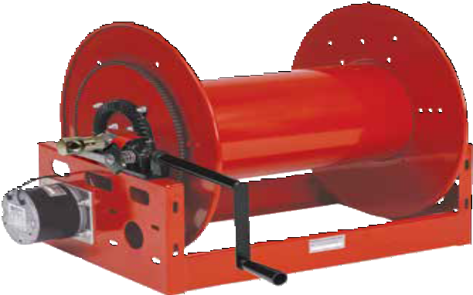
1/2” pitch chain now standard

Shown with optional bevel crank.

Made

Fire Service / Booster Reels
Dimensions Diagram
B |  |  |  | F
 |  | A
 |  |  |  |  | G
 | H
C |  |  |  | D
 |  |  | E

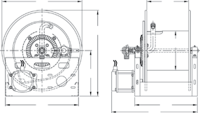
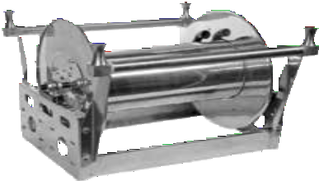
The aluminum Series 2450 reel for booster hose is corrosion-resistant and weighs up to
50% less than standard steel booster reels. Features include an aluminum spool and frame assembly, plated steel fluid path and plated sprocket and fasteners. No painting
or finishing is required.
Built to order, not returnable.

in USA

Hose I.D. | in | 1/2 | 3/4 | 1 | Specification - Hose Capacity and Reel Dimensions  KEY: CRK = hand crank; ELC = electric motor; HYD = hydraulic motor; AIR = air motor
 | mm | 13 | 19 | 25
Hose O.D. | in | .875 | 1.281 | 1.563
 | mm | 22 | 33 | 40
Model | Hose Length  (other std. lengths available) |  |  |  | Est. Weight |  | A | B CRK | B ELC | B AIR | B HYD | C | D | E CRK | E ELC | E AIR | E HYD | F | G | H
2400-19-16 | ft | 285 | 110 | 60 | 70 LB | in | 22.5 | 21 | 21 | 21 | 21 | 21 | 22 | 26 | 29 | 28 | 28 | 16 | 11.25 | 13
 | m | 87 | 34 | 18 | 32 KG | mm | 572 | 533 | 533 | 533 | 533 | 533 | 559 | 660 | 737 | 711 | 711 | 406 | 286 | 330
2400-23-14 | ft | 390 | 175 | 110 | 74 LB | in | 24.5 | 23 | 23 | 23 | 23 | 21 | 20 | 24 | 27 | 26 | 26 | 14 | 11.25 | 13
 | m | 119 | 53 | 34 | 34 KG | mm | 622 | 584 | 584 | 584 | 584 | 533 | 508 | 610 | 686 | 660 | 660 | 356 | 286 | 330
2400-23-18 | ft | 490 | 250 | 155 | 78 LB | in | 24.5 | 23 | 23 | 23 | 23 | 21 | 24 | 28 | 31 | 30 | 30 | 18 | 11.25 | 13
 | m | 149 | 76 | 47 | 35 KG | mm | 622 | 584 | 584 | 584 | 584 | 533 | 610 | 711 | 787 | 762 | 762 | 457 | 286 | 330
2400-23-20 | ft | 535 | 265 | 170 | 80 LB | in | 24.5 | 23 | 23 | 23 | 23 | 21 | 26 | 30 | 33 | 32 | 32 | 20 | 11.25 | 13
 | m | 163 | 81 | 52 | 36 KG | mm | 622 | 584 | 584 | 584 | 584 | 533 | 660 | 762 | 838 | 813 | 813 | 508 | 286 | 330
2400-23-24 | ft | 660 | 320 | 210 | 84 LB | in | 24.5 | 23 | 23 | 23 | 23 | 21 | 30 | 34 | 37 | 36 | 36 | 24 | 11.25 | 13
 | m | 201 | 98 | 64 | 38 KG | mm | 622 | 584 | 584 | 584 | 584 | 533 | 762 | 864 | 940 | 914 | 914 | 610 | 286 | 330
2400-25-8 | ft | 265 | 135 | 95 | 72 LB | in | 26.5 | 25 | 25 | 25 | 25 | 21 | 14 | 18 | 21 | 20 | 20 | 8 | 11.25 | 14
 | m | 81 | 41 | 29 | 33 KG | mm | 673 | 635 | 635 | 635 | 635 | 533 | 356 | 457 | 533 | 508 | 508 | 203 | 286 | 356
2400-25-14 | ft | 465 | 225 | 150 | 74 LB | in | 26.5 | 25 | 25 | 25 | 25 | 21 | 20 | 24 | 27 | 26 | 26 | 14 | 11.25 | 14
 | m | 142 | 69 | 46 | 34 KG | mm | 673 | 635 | 635 | 635 | 635 | 533 | 508 | 610 | 686 | 660 | 660 | 356 | 286 | 356
2400-31-8 | ft | 465 | 205 | 155 | 74 LB | in | 32.5 | 31 | 31 | 31 | 31 | 24 | 14 | 18 | 21 | 20 | 20 | 8 | 11.25 | 17
 | m | 142 | 62 | 47 | 34 KG | mm | 826 | 787 | 787 | 787 | 787 | 610 | 356 | 457 | 533 | 508 | 508 | 203 | 286 | 432
2400-31-10 | ft | 565 | 240 | 185 | 76 LB | in | 32.5 | 31 | 31 | 31 | 31 | 24 | 16 | 20 | 23 | 22 | 22 | 10 | 11.25 | 17
 | m | 172 | 73 | 56 | 34 KG | mm | 826 | 787 | 787 | 787 | 787 | 610 | 406 | 508 | 584 | 559 | 559 | 254 | 286 | 432
2400-31-16 | ft | 925 | 410 | 305 | 80 LB | in | 32.5 | 31 | 31 | 31 | 31 | 24 | 22 | 26 | 29 | 28 | 28 | 16 | 11.25 | 17
 | m | 282 | 125 | 93 | 36 KG | mm | 826 | 787 | 787 | 787 | 787 | 610 | 559 | 660 | 737 | 711 | 711 | 406 | 286 | 432

Prop 65: WARNING:
Cancer and Reproductive Harm www.P65Warnings.ca.gov.
Reelcraft's reel configurator can quickly and accurately quote standard large frame reels. Refer to page 27 for more information. Refer to page 28 to build a representative model number. Final part number assigned upon quote. Refer to chart on page 31 for weight adders.

30 Customer Service: 1.855.634.9109

Large Frame Hose Reels | Nordic Series 3900

Heavy Duty Large Frame Reels

Nordic Series 3900
11/2" fluid path for 1" through 11/2" I.D. hose
Rewind: Gear-drive rewind or chain and sprocket drive powered by A.C. or D.C. electric motor, compressed air motor or hydraulic motor.
Inlet: 2" straight grooved fitting with 11/2" female NPT straight swivel joint is standard. 2" 90° grooved fitting with 11/2" NPT female available at extra cost.
Gooseneck: 1", 11/4" and 11/2" female/male NPT outlet. Other sizes and/or threads can be furnished and must be specified.
Add 12" to B dimension when crank is in rewind position.

Made in USA

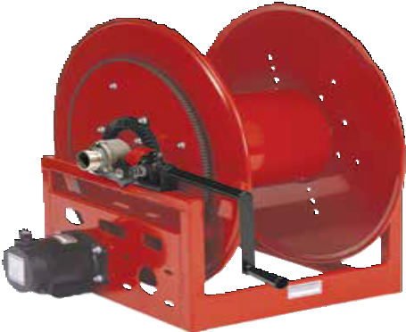1/2” pitch chain now standard
Shown with optional bevel crank.

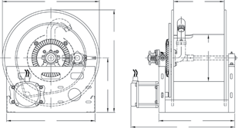
The standard color for this series is red or gray.
Hose I.D. | in | 1 | 1 1/4 | 1 3/8 | 1 1/2 | Specification - Hose Capacity and Reel Dimensions  KEY: CRK = hand crank; ELC = electric motor; HYD = hydraulic motor; AIR = air motor
 | mm | 25 | 32 | 35 | 38
Hose O.D. | in | 1.563 | 1.813 | 2.000 | 2.063
 | mm | 40 | 46 | 51 | 52
Model | Hose Length |  |  |  |  | Est. Weight |  | A | B CRK | B ELC | B AIR | B HYD | C | D | E CRK | E ELC | E AIR | E HYD | F | G | H
3900-19-16 | ft | 60 | 50 | 50 | 45 | 90 LB | in | 22.5 | 21 | 21 | 21 | 21 | 21 | 22 | 26 | 29 | 28 | 28 | 16 | 11.25 | 13
 | m | 18 | 15 | 15 | 14 | 41 KG | mm | 572 | 533 | 533 | 533 | 533 | 533 | 559 | 660 | 737 | 711 | 711 | 406 | 286 | 330
3900-19-20 | ft | 70 | 65 | 60 | 55 | 93 LB | in | 22.5 | 21 | 21 | 21 | 21 | 21 | 26 | 30 | 33 | 32 | 32 | 20 | 11.25 | 13
 | m | 21 | 20 | 18 | 17 | 42 KG | mm | 572 | 533 | 533 | 533 | 533 | 533 | 660 | 762 | 838 | 813 | 813 | 508 | 286 | 330
3900-23-12 | ft | 100 | 60 | 60 | 50 | 87 LB | in | 24.5 | 23 | 23 | 23 | 23 | 21 | 18 | 22 | 25 | 24 | 24 | 12 | 11.25 | 13
 | m | 30 | 18 | 18 | 15 | 39 KG | mm | 622 | 584 | 584 | 584 | 584 | 533 | 457 | 559 | 635 | 610 | 610 | 305 | 286 | 330
3900-23-18 | ft | 155 | 90 | 95 | 85 | 93 LB | in | 24.5 | 23 | 23 | 23 | 23 | 21 | 24 | 28 | 31 | 30 | 30 | 18 | 11.25 | 13
 | m | 47 | 27 | 29 | 26 | 42 KG | mm | 622 | 584 | 584 | 584 | 584 | 533 | 610 | 711 | 787 | 762 | 762 | 457 | 286 | 330
3900-23-20 | ft | 170 | 110 | 105 | 95 | 95 LB | in | 24.5 | 23 | 23 | 23 | 23 | 21 | 26 | 30 | 33 | 32 | 32 | 20 | 11.25 | 13
 | m | 52 | 34 | 32 | 29 | 42 KG | mm | 622 | 584 | 584 | 584 | 584 | 533 | 660 | 762 | 838 | 813 | 813 | 508 | 286 | 330
3900-23-26 | ft | 225 | 140 | 135 | 125 | 100 LB | in | 24.5 | 23 | 23 | 23 | 23 | 21 | 32 | 36 | 39 | 38 | 38 | 26 | 11.25 | 13
 | m | 69 | 43 | 41 | 38 | 45 KG | mm | 622 | 584 | 584 | 584 | 584 | 533 | 813 | 914 | 991 | 965 | 965 | 660 | 286 | 330
3900-23-28 | ft | 240 | 150 | 145 | 135 | 103 LB | in | 24.5 | 23 | 23 | 23 | 23 | 21 | 34 | 38 | 41 | 40 | 40 | 28 | 11.25 | 13
 | m | 73 | 46 | 44 | 41 | 47 KG | mm | 622 | 584 | 584 | 584 | 584 | 533 | 864 | 965 | 1041 | 1016 | 1016 | 711 | 286 | 330
3900-23-36 | ft | 325 | 190 | 185 | 180 | 111 LB | in | 24.5 | 23 | 23 | 23 | 23 | 21 | 42 | 46 | 49 | 48 | 48 | 36 | 11.25 | 13
 | m | 99 | 58 | 56 | 55 | 50 KG | mm | 622 | 584 | 584 | 584 | 584 | 533 | 1067 | 1168 | 1245 | 1219 | 1219 | 914 | 286 | 330
3900-25-12 | ft | 135 | 90 | 60 | 50 | 89 LB | in | 26.5 | 25 | 25 | 25 | 25 | 21 | 18 | 22 | 25 | 24 | 24 | 12 | 11.25 | 14
 | m | 41 | 27 | 18 | 15 | 40 KG | mm | 673 | 635 | 635 | 635 | 635 | 533 | 457 | 559 | 635 | 610 | 610 | 305 | 286 | 356
3900-25-20 | ft | 230 | 160 | 105 | 95 | 97 LB | in | 26.5 | 25 | 25 | 25 | 25 | 21 | 26 | 30 | 33 | 32 | 32 | 20 | 11.25 | 14
 | m | 70 | 49 | 32 | 29 | 44 KG | mm | 673 | 635 | 635 | 635 | 635 | 533 | 660 | 762 | 838 | 813 | 813 | 508 | 286 | 356
3900-31-12 | ft | 215 | 155 | 125 | 105 | 92 LB | in | 32.5 | 31 | 31 | 31 | 31 | 24 | 18 | 22 | 25 | 24 | 24 | 12 | 11.25 | 17
 | m | 66 | 47 | 38 | 32 | 42 KG | mm | 826 | 787 | 787 | 787 | 787 | 610 | 457 | 559 | 635 | 610 | 610 | 305 | 286 | 432
3900-31-16 | ft | 305 | 210 | 170 | 150 | 96 LB | in | 32.5 | 31 | 31 | 31 | 31 | 24 | 22 | 26 | 29 | 28 | 28 | 16 | 11.25 | 17
 | m | 93 | 64 | 52 | 46 | 44 KG | mm | 826 | 787 | 787 | 787 | 787 | 610 | 559 | 660 | 737 | 711 | 711 | 406 | 286 | 432
3900-31-20 | ft | 365 | 290 | 210 | 190 | 100 LB | in | 32.5 | 31 | 31 | 31 | 31 | 24 | 26 | 30 | 33 | 32 | 32 | 20 | 11.25 | 17
 | m | 111 | 88 | 64 | 58 | 45 KG | mm | 826 | 787 | 787 | 787 | 787 | 610 | 660 | 762 | 838 | 813 | 813 | 508 | 286 | 432

Dimensions Diagram
B |  |  | F
 | A
 |  |  |  | G
 | H
C |  | E | D

Reelcraft's reel configurator can quickly and accurately quote standard large frame reels. Refer to page 27 for more information. Refer to page 28 to build a representative model number. Final part number assigned upon quote.
Built to order, not returnable.
Standard seals maximum temperature 174 °F (79 °C) and minimum temperature -20 °F (-29 °C). Extreme temperature seals maximum temperature 400 °F (204 °C) and minimum temperature -50 °F
(-45 °C) and standard pressures to 600 psi. Other temperatures or pressures can be furnished at extra cost, consult manufacturer.
Note: Weights shown in chart are for crank rewind models.
Add these amounts and model number prefix for power rewind models.

Prefix | Type | LB / KG
EP | Electric | 42 / 19
A | Air | 26 / 12
H | Hyd | 26 / 12

Prop 65: WARNING:
Cancer and Reproductive Harm - www.P65Warnings.ca.gov.

Customer Service: 1.855.634.9109 31

Liquid Propane Reels | Nordic Series 3900 LPG / 80000 / D80000

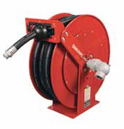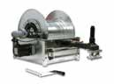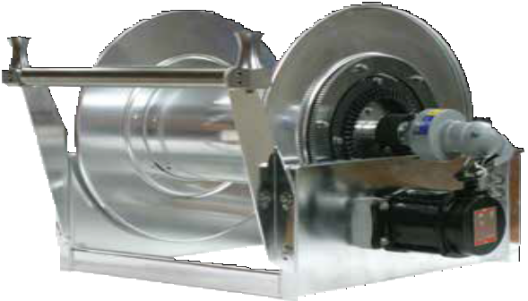Heavy Duty Large Frame Reels

Nordic Series 3900 LPG
11/2" or 2" fluid path for 1" through 2" I.D. hose
Rewind: Gear-drive or chain and sprocket drive powered by explosion proof A.C. or D.C. electric motor, compressed air motor or hydraulic motor.

Inlet: Full Circle® UL approved swivels available in 1", 11/2" and 2" as standard.
Hose Boss (optional accessory)

Now available in polished aluminum

The Hose Boss Rewind Assist consists of a rewind switch mounted in an extended arm with two hose rollers. Assists in efficiently and safely unwinding and rewinding hose.

Heavy Duty Spring Retractable Reels
Series 80000/D80000 - 1/2", 3/4", 1" I.D.
OPTIONS
Choose a reel model from the chart below, then use the suffix codes below to choose a flange/end plate material.
L P 8 2 0 0 0 O L

Flange/End Plate Material
S | Stainess Steel
P | Carbon Steel
Made in USA

Hose not included

Series 80000 Carbon steel
With Full Circle® swivel

Inset: Nordic Series 3900 LPG with optional Hose Boss

Hose Boss

Model without hose | Hose I.D. | Hose O.D. | Capacity | Pressure | Weight | A | B | C | D | E | F
 | in mm | in mm | ft m | psi bar | lbs kg | in mm | in mm | in mm | in mm | in mm | in mm
Series 80000 / D80000: Spring Driven Reels
LP82000 OL * | 1/2 13 | .845 21 | 100 30 | 300 21 | 82 37 | 253/8 645 | 24 610 | 10 254 | 6 152 | 153/8 391 | 81/8 206
LP83000 OL * | 3/4 19 | 1.188 30 | 50 15 | 350 24 | 82 37 | 253/8 645 | 24 610 | 10 254 | 6 152 | 153/8 391 | 81/8 206
LPD83000 OL * | 3/4 19 | 1.188 30 | 75 23 | 350 24 | 77 35 | 253/8 645 | 24 610 | 101/2 267 | 77/8 200 | 173/4 451 | 103/8 264
LPD84000 OL * | 1 25 | 1.500 38 | 50 15 | 350 24 | 77 35 | 253/8 645 | 24 610 | 101/2 267 | 77/8 200 | 177/8 454 | 103/8 264
*Choose flange/end plate material from charts above. Refer to page 13 for dimension chart.

Hose I.D. | in | 1 | 1 1/4 | 1 1/2 | 2 | Specification - Hose Capacity and Reel Dimensions  Refer to chart on page 31 for Series 3900 LPG dimensions.
 | mm | 25 | 32 | 38 | 51
Hose O.D. | in | 1.563 | 1.813 | 2.063 | 2.563
 | mm | 40 | 46 | 52 | 65
Model | Hose Length |  |  |  |  | Est. Weight |  | A | B | C | D | E | F | G | H
3900-19-20 | ft | 70 | 65 | 55 |  | 103 LB | in | 22.5 | 21 | 21 | 26 | 33 | 20 | 11.25 | 13
 | m | 21 | 20 | 17 |  | 47 KG | mm | 572 | 533 | 533 | 660 | 838 | 508 | 286 | 330
3900-23-16 | ft | 140 | 80 | 75 |  | 100 LB | in | 24.5 | 23 | 21 | 22 | 29 | 16 | 11.25 | 13
 | m | 43 | 24 | 23 |  | 45 KG | mm | 622 | 584 | 533 | 559 | 737 | 406 | 286 | 330
3900-23-20 | ft | 170 | 110 | 95 |  | 105 LB | in | 24.5 | 23 | 21 | 26 | 33 | 20 | 11.25 | 13
 | m | 52 | 34 | 29 |  | 48 KG | mm | 622 | 584 | 533 | 660 | 838 | 508 | 286 | 330
3900-23-24 | ft | 210 | 130 | 115 |  | 110 LB | in | 24.5 | 23 | 21 | 30 | 37 | 24 | 11.25 | 13
 | m | 64 | 40 | 35 |  | 50 KG | mm | 622 | 584 | 533 | 762 | 940 | 610 | 286 | 330
3900-25-14 | ft | 150 | 105 | 65 |  | 102 LB | in | 26.5 | 25 | 21 | 20 | 27 | 14 | 11.25 | 14
 | m | 46 | 32 | 20 |  | 46 KG | mm | 673 | 635 | 533 | 508 | 686 | 356 | 286 | 356
3900-25-18 | ft | 210 | 135 | 85 |  | 105 LB | in | 26.5 | 25 | 21 | 24 | 31 | 18 | 11.25 | 14
 | m | 64 | 41 | 26 |  | 48 KG | mm | 673 | 635 | 533 | 610 | 787 | 457 | 286 | 356
3900-23-26 | ft |  |  | 95 | 35 | 112 LB | in | 24.5 | 23 | 21 | 32 | 39 | 26 | 15 | 13
 | m |  |  | 29 | 11 | 51 LG | mm | 622 | 584 | 533 | 813 | 991 | 660 | 381 | 330
3900-31-12 | ft |  |  | 95 | 55 | 102 LB | in | 32.5 | 31 | 24 | 18 | 25 | 12 | 15 | 17
 | m |  |  | 29 | 17 | 46 KG | mm | 826 | 787 | 610 | 457 | 635 | 305 | 381 | 432
3900-31-22 | ft |  |  | 185 | 110 | 115 LB | in | 32.5 | 31 | 24 | 28 | 35 | 22 | 15 | 17
 | m |  |  | 56 | 34 | 52 KG | mm | 826 | 787 | 610 | 711 | 889 | 559 | 381 | 432

Prop 65: WARNING:
Cancer and Reproductive Harm - www.P65Warnings.ca.gov.
Refer to page 28 to build a representative model number including LPG swivel. Refer to charts on page 13 and 31 for dimensions.
Built to order, not returnable.

32 Customer Service: 1.855.634.9109

Large Frame Hose Reels | Nordic Series 3700 / 5900

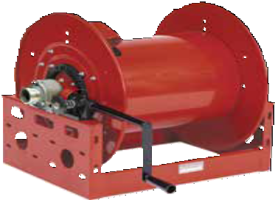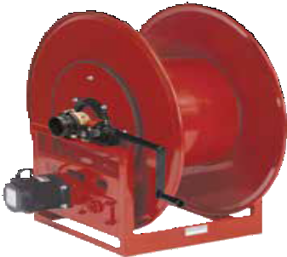Heavy Duty Large Frame Reels

Nordic Series 3700 & 5900
2", 3" or 4" fluid path for 11/2" through 4" I.D. hose
Rewind: Gear-drive crank rewind or chain and sprocket drive powered by A.C. or D.C. electric motor, compressed air motor or hydraulic motor.
Inlet: 2" (Series 3700) / 3" (Series 5900) straight grooved
fitting is standard. 4" (Series 5900) 90° grooved fitting and 24" diameter drum is standard. 90° grooved fitting swivel joint available at extra cost.
Gooseneck: 2" (Series 3700) / 3" (Series 5900) / 4" (Series 5900) female NPT. Other sizes and/or threads can be furnished and must be specified.
Series 5900 product temperatures from -50 °F to +400 °F and standard pressures to 300 psi. Series 3700 standard

1/2” pitch chain now standard

Nordic Series 5900 Shown with optional bevel crank.

Nordic Series 3700 Shown with optional bevel crank.

Made

in USA

seals maximum temperature 174 °F (79 °C) and minimum temperature -20 °F (-29 °C). Extreme temperature seals maximum temperature 400 °F (204 °C) and minimum
Standard pressures to 300 psi. Other temperatures or pressures can be furnished at extra cost, consult manufacturer. The standard color for this series is red or gray. Add 12" to B dimension when crank is

temperature -50 °F (-45 °C).
in rewind position.
Built to order, not returnable.

Hose I.D. | in | 1 1/2 | 2 | 2 1/2 | 3 | 4 | Specification - Hose Capacity and Reel Dimensions  KEY: CRK = hand crank; ELC = electric motor; HYD = hydraulic motor; AIR = air motor
 | mm | 38 | 51 | 64 | 76 | 102
Hose O.D. | in | 2.063 | 2.563 | 3.188 | 3.75 | 4.75
 | mm | 52 | 65 | 81 | 95 | 121
Model | Hose Length |  |  |  |  |  | Est. Weight |  | A | B CRK | B ELC | B AIR | B HYD | C | D | E CRK | E ELC | E AIR | E HYD | F | G | H
3700-23-20 | ft | 70 | 25 |  |  |  | 114 LB | in | 24.5 | 23 | 23 | 23 | 23 | 21 | 26 | 30 | 33 | 32 | 32 | 20 | 15 | 13
 | m | 21 | 8 |  |  |  | 52 KG | mm | 622 | 584 | 584 | 584 | 584 | 533 | 660 | 762 | 838 | 813 | 813 | 508 | 381 | 330
3700-25-20 | ft | 70 | 55 |  |  |  | 124 LB | in | 26.5 | 25 | 25 | 25 | 25 | 21 | 26 | 30 | 33 | 32 | 32 | 20 | 15 | 14
 | m | 21 | 17 |  |  |  | 56 KG | mm | 673 | 635 | 635 | 635 | 635 | 533 | 660 | 762 | 838 | 813 | 813 | 508 | 381 | 356
3700-25-24 | ft | 85 | 75 |  |  |  | 128 LB | in | 26.5 | 25 | 25 | 25 | 25 | 21 | 30 | 34 | 37 | 36 | 36 | 24 | 15 | 14
 | m | 26 | 23 |  |  |  | 58 KG | mm | 673 | 635 | 635 | 635 | 635 | 533 | 762 | 864 | 940 | 914 | 914 | 610 | 381 | 356
3700-25-32 | ft | 115 | 100 |  |  |  | 136 LB | in | 26.5 | 25 | 25 | 25 | 25 | 21 | 38 | 42 | 45 | 44 | 44 | 32 | 15 | 14
 | m | 35 | 30 |  |  |  | 62 KG | mm | 673 | 635 | 635 | 635 | 635 | 533 | 965 | 1067 | 1143 | 1118 | 1118 | 813 | 381 | 356
3700-31-12 | ft | 95 | 55 |  |  |  | 134 LB | in | 32.5 | 31 | 31 | 31 | 31 | 24 | 18 | 22 | 25 | 24 | 24 | 12 | 15 | 17
 | m | 29 | 17 |  |  |  | 61 KG | mm | 826 | 787 | 787 | 787 | 787 | 610 | 457 | 559 | 635 | 610 | 610 | 305 | 381 | 432
3700-31-20 | ft | 170 | 95 |  |  |  | 142 LB | in | 32.5 | 31 | 31 | 31 | 31 | 24 | 26 | 30 | 33 | 32 | 32 | 20 | 15 | 17
 | m | 52 | 29 |  |  |  | 64 KG | mm | 826 | 787 | 787 | 787 | 787 | 610 | 660 | 762 | 838 | 813 | 813 | 508 | 381 | 432
3700-31-26 | ft | 225 | 135 |  |  |  | 148 LB | in | 32.5 | 31 | 31 | 31 | 31 | 24 | 32 | 36 | 39 | 38 | 38 | 26 | 15 | 17
 | m | 69 | 41 |  |  |  | 67 KG | mm | 826 | 787 | 787 | 787 | 787 | 610 | 813 | 914 | 991 | 965 | 965 | 660 | 381 | 432
3700-39-16 | ft | 230 | 165 |  |  |  | 182 LB | in | 40.5 | 39 | 39 | 39 | 39 | 24 | 22 | 26 | 29 | 28 | 28 | 16 | 15 | 21
 | m | 70 | 50 |  |  |  | 83 KG | mm | 1029 | 991 | 991 | 991 | 991 | 610 | 559 | 660 | 737 | 711 | 711 | 406 | 381 | 533
3700-39-24 | ft | 360 | 250 |  |  |  | 190 LB | in | 40.5 | 39 | 39 | 39 | 39 | 24 | 30 | 34 | 37 | 36 | 36 | 24 | 15 | 21
 | m | 110 | 76 |  |  |  | 86 KG | mm | 1029 | 991 | 991 | 991 | 991 | 610 | 762 | 864 | 940 | 914 | 914 | 610 | 381 | 533
5900-31-16 | ft |  | 60 | 25 | 20 |  | 140 LB | in | 32.5 | 31 | 31 | 31 | 31 | 24 | 22 | 26 | 29 | 28 | 28 | 16 | 20 | 17
 | m |  | 18 | 8 | 6 |  | 64 KG | mm | 826 | 787 | 787 | 787 | 787 | 610 | 559 | 660 | 737 | 711 | 711 | 406 | 508 | 432
5900-31-24 | ft |  | 90 | 35 | 30 |  | 150 LB | in | 32.5 | 31 | 31 | 31 | 31 | 24 | 30 | 34 | 37 | 36 | 36 | 24 | 20 | 17
 | m |  | 27 | 11 | 9 |  | 68 KG | mm | 826 | 787 | 787 | 787 | 787 | 610 | 762 | 864 | 940 | 914 | 914 | 610 | 508 | 432
5900-31-32 | ft |  | 125 | 50 | 40 |  | 160 LB | in | 32.5 | 31 | 31 | 31 | 31 | 24 | 38 | 42 | 45 | 44 | 44 | 32 | 20 | 17
 | m |  | 38 | 15 | 12 |  | 73 KG | mm | 826 | 787 | 787 | 787 | 787 | 610 | 965 | 1067 | 1143 | 1118 | 1118 | 813 | 508 | 432
5900-36-12 | ft |  | 65 | 30 | 35 |  | 146 LB | in | 37.5 | 36 | 36 | 36 | 36 | 24 | 18 | 22 | 25 | 24 | 24 | 12 | 20 | 21
 | m |  | 20 | 9 | 11 |  | 66 KG | mm | 953 | 914 | 914 | 914 | 914 | 610 | 457 | 559 | 635 | 610 | 610 | 305 | 508 | 533
5900-36-16 | ft |  | 100 | 55 | 45 | 15 | 150 LB | in | 37.5 | 36 | 36 | 36 | 36 | 24 | 22 | 26 | 29 | 28 | 28 | 16 | 20 | 21
 | m |  | 30 | 17 | 14 | 5 | 68 KG | mm | 953 | 914 | 914 | 914 | 914 | 610 | 559 | 660 | 737 | 711 | 711 | 406 | 508 | 533
5900-39-12 | ft |  | 95 | 55 | 35 | 25 | 180 LB | in | 40.5 | 39 | 39 | 39 | 39 | 24 | 18 | 22 | 25 | 24 | 24 | 12 | 20 | 21
 | m |  | 29 | 17 | 11 | 8 | 82 KG | mm | 1029 | 991 | 991 | 991 | 991 | 610 | 457 | 559 | 635 | 610 | 610 | 305 | 508 | 533
5900-39-16 | ft |  | 145 | 90 | 45 | 35 | 200 LB | in | 40.5 | 39 | 39 | 39 | 39 | 24 | 22 | 26 | 29 | 28 | 28 | 16 | 20 | 21
 | m |  | 44 | 27 | 14 | 11 | 91 KG | mm | 1029 | 991 | 991 | 991 | 991 | 610 | 559 | 660 | 737 | 711 | 711 | 406 | 508 | 533
5900-39-24 | ft |  | 220 | 125 | 65 | 60 | 210 LB | in | 40.5 | 39 | 39 | 39 | 39 | 24 | 30 | 34 | 37 | 36 | 36 | 24 | 20 | 21
 | m |  | 67 | 38 | 20 | 18 | 95 KG | mm | 1029 | 991 | 991 | 991 | 991 | 610 | 762 | 864 | 940 | 914 | 914 | 610 | 508 | 533

Reelcraft's reel configurator can quickly and accurately quote standard large frame reels. Refer to page 27 for more information. Refer to page 28 to build a representative model number. Final part number assigned upon quote. Refer to chart on page 31 for weight adders and dimensions.
Prop 65: WARNING:
Cancer and Reproductive Harm www.P65Warnings.ca.gov.

Customer Service: 1.855.634.9109 33

Large Frame Hose Reels | Nordic Series 3800

Heavy Duty Large Frame Reels

Petroleum Service
11/2" or 2" fluid path for 11/4" through 2" I.D. hose
Rewind: Chain and sprocket drive powered by A.C. or D.C. electric motor, compressed air motor or hydraulic motor.
30° manual rewind assembly available at extra cost.
Inlet: 90° 2" grooved fitting is standard. Straight swivel joints may be specified at no extra cost.
Gooseneck: 11/4", 11/2" or 2" female/male NPT is available. Specify male or female fitting and hose size when ordering.
Brakes and locks: Manual friction brake and air operated caliper brake are standard.

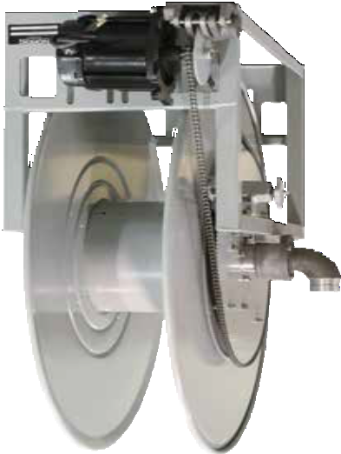

Made in USA

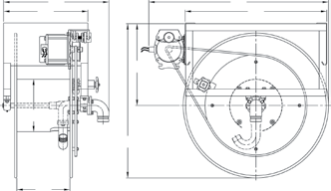
Standard seals maximum temperature 174 °F (79 °C) and minimum temperature -20 °F (-29 °C). Extreme temperature seals maximum temperature 400 °F (204 °C) and minimum tem- perature -50 °F (-45 °C). Standard pressures to 300 psi. Other temperatures or pressures can be furnished at extra cost; consult manufacturer. The standard color for this series is red or gray.
Dimensions Diagram
 |  | E |  |  | B
 | D |  |  |  |  | C
 |  |  |  | H
G
 |  |  | A
 | F

Hose I.D. | in | 1 1/4 | 1 3/8 | 1 1/2 | 2 | Specification - Hose Capacity and Reel Dimensions
 | mm | 32 | 35 | 38 | 51
Hose O.D. | in | 1.813 | 2.000 | 2.063 | 2.563
 | mm | 46 | 51 | 52 | 65
Model | Hose Length |  |  |  |  | Est. Weight |  | A | B | C | D | E | F | G | H
3800-31-10 | ft | 130 | 105 | 85 |  | 174 LB | in | 33 | 38.5 | 30 | 16 | 20.25 | 10 | 11.25 | 17.5
 | m | 40 | 32 | 26 |  | 79 KG | mm | 838 | 978 | 762 | 406 | 514 | 254 | 286 | 445
3800-31-12 | ft | 155 | 125 | 105 |  | 176 LB | in | 33 | 38.5 | 30 | 18 | 22.25 | 12 | 11.25 | 17.5
 | m | 47 | 38 | 32 |  | 80 KG | mm | 838 | 978 | 762 | 457 | 565 | 305 | 286 | 445
3800-31-16 | ft | 210 | 170 | 150 |  | 180 LB | in | 33 | 38.5 | 30 | 22 | 26.25 | 16 | 11.25 | 17.5
 | m | 64 | 52 | 46 |  | 82 KG | mm | 838 | 978 | 762 | 559 | 667 | 406 | 286 | 445
3800-39-7 | ft | 120 | 105 | 105 |  | 212 LB | in | 41 | 43.5 | 32 | 13 | 17.25 | 17 | 11.25 | 21.5
 | m | 37 | 32 | 32 |  | 96 KG | mm | 1041 | 1105 | 813 | 330 | 438 | 432 | 286 | 546
3800-39-9 | ft | 160 | 140 | 140 |  | 214 LB | in | 41 | 43.5 | 32 | 15 | 19.25 | 9 | 11.25 | 21.5
 | m | 49 | 43 | 43 |  | 97 KG | mm | 1041 | 1105 | 813 | 381 | 489 | 229 | 286 | 546
3800-39-11 | ft | 240 | 175 | 175 |  | 216 LB | in | 41 | 43.5 | 32 | 17 | 21.25 | 11 | 11.25 | 21.5
 | m | 73 | 53 | 53 |  | 98 KG | mm | 1041 | 1105 | 813 | 432 | 540 | 279 | 286 | 546
3800-31-13 | ft | 170 | 110 | 110 | 70 | 178 LB | in | 33 | 38.5 | 30 | 19 | 24.5 | 13 | 15 | 17.5
 | m | 52 | 34 | 34 | 21 | 81 KG | mm | 838 | 978 | 762 | 483 | 622 | 330 | 381 | 445
3800-39-12 | ft | 230 | 195 | 165 | 110 | 218 LB | in | 41 | 43.5 | 32 | 18 | 23.5 | 12 | 15 | 21.5
 | m | 70 | 59 | 50 | 34 | 99 KG | mm | 1041 | 1105 | 813 | 457 | 597 | 305 | 381 | 546
3800-39-16 | ft | 305 | 255 | 230 | 165 | 224 LB | in | 41 | 43.5 | 32 | 22 | 27.5 | 16 | 15 | 21.5
 | m | 93 | 78 | 70 | 50 | 102 KG | mm | 1041 | 1105 | 813 | 559 | 699 | 406 | 381 | 546

Prop 65: WARNING:
Cancer and Reproductive Harm - www.P65Warnings.ca.gov.
Refer to page 28 to build a representative model number. Final part number assigned upon quote. Built to order, not returnable.

34 Customer Service: 1.855.634.9109

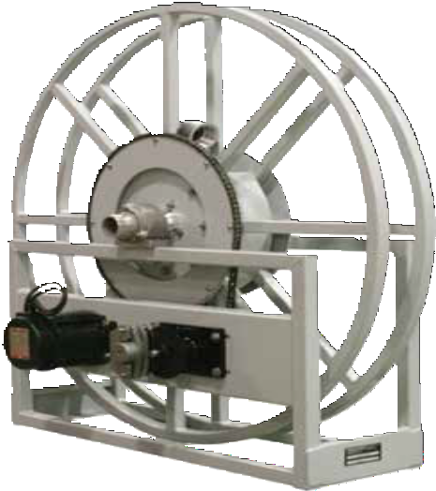
Large Frame Hose Reels | Nordic Series 6000

Heavy Duty Single Wrap Reels

Petroleum / Aviation Fuel Service
11/2", 2" or 3" fluid path for 13/8" through 3" I.D. hose
Rewind: Chain and sprocket drive powered by A.C. or D.C. electric motor, compressed air motor or hydraulic motor.
Inlet: 2" grooved fitting is standard for 1" through 2" ID hose. 3" grooved fitting is standard for 21/2" and 3" ID hose. 11/2", 2" and 3" NPT or BSPP available. 90° inlets available.
Gooseneck: 11/2", 2" and 3" NPT or BSPP. Specify male or female threads for gooseneck.
Brakes and locks: Air operated caliper brake and idler assembly is standard. Manual friction brake optional.
Materials: Standard frame and spool assembly are made of heavy duty steel construction. Also available in aluminum.
The standard color for this series is red or gray.
Operating pressure: 300 psi maximum. Reels to operate
at other pressure ratings available at extra cost. Consult manufacturer.
Operating temperatures: Maximum 400 °F (204 °C) /
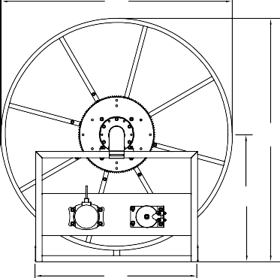
minimum -50 °F (-46 °C). Reels that are to operate at other temperature ratings are available at extra cost, consult manufacturer.

Made in USA

Hose I.D. | in | 1 3/8 | 1 1/2 | 2 | 2 1/2 | 3
 | mm | 35 | 38 | 51 | 64 | 76
Hose O.D. | in | 2.000 | 2.063 | 2.563 | 3.063 | 3.750
 | mm | 51 | 52 | 65 | 81 | 95
Model | Hose Length |  |  |  |  |  |  | A | B | C | H
6000-47 | ft | 55 | 50 | 30 | 25 | 20 | in | 48.5 | 47 | 38.5 | 25
 | m | 17 | 15 | 9 | 8 | 6 | mm | 1232 | 1194 | 978 | 635
6000-55 | ft | 80 | 75 | 50 | 40 | 35 | in | 55.75 | 55 | 38.5 | 28.25
 | m | 24 | 23 | 15 | 12 | 11 | mm | 1416 | 1397 | 978 | 718
6000-62 | ft | 100 | 100 | 70 | 50 | 50 | in | 62.75 | 62 | 38.5 | 31.75
 | m | 30 | 30 | 21 | 15 | 15 | mm | 1594 | 1575 | 978 | 806
6000-68 | ft | 125 | 120 | 85 | 70 | 60 | in | 68.75 | 68 | 38.5 | 34.75
 | m | 38 | 37 | 26 | 21 | 18 | mm | 1746 | 1727 | 978 | 883
6000-72 | ft | 150 | 140 | 100 | 80 | 70 | in | 72.75 | 72 | 38.5 | 36.75
 | m | 46 | 43 | 30 | 24 | 21 | mm | 1848 | 1829 | 978 | 933

Hose I.D. | Dimensions
 | D | E | F | G*
 | in mm | in mm | in mm | in mm
1 3/8” | 12 305 | 18.5 470 | 2.5 64 | 18 457
1 1/2” | 12 305 | 18.5 470 | 2.5 64 | 18 457
2" | 12 305 | 18.5 470 | 3.5 89 | 24 610
2 1/2” | 13 330 | 19.5 495 | 3.5 89 | 24 610
3” | 14 356 | 20.5 521 | 4.5 114 | 24 610

*Drum diameter conforms to API 1529 Appendix A.

Model numbers are representative.

Prop 65: WARNING:
Dimensions Diagram
B
A
H
C
F
G
D
E

Final part number assigned upon quote.
Built to order, not returnable.
Cancer and Reproductive Harm - www.P65Warnings.ca.gov.

Customer Service: 1.855.634.9109
All Other Calls: 1.800.444.3134 35

Light/Medium Duty Cord Reels | Series LD / LG / LH

Cord Options

Light/Medium Duty Cord Reels

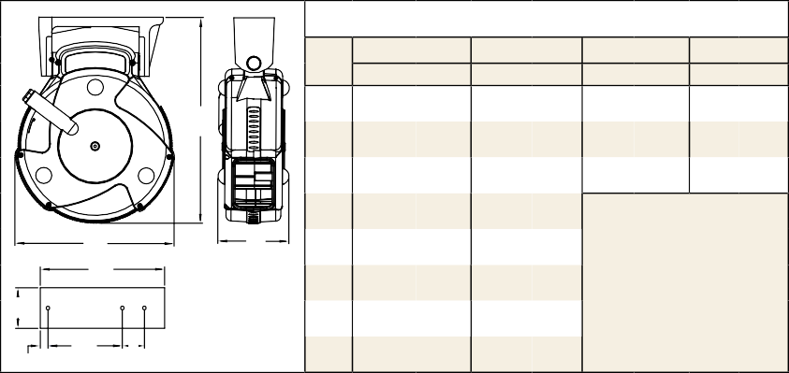
Dimensions - Size Index
1 2 3
B
D
C
E
in
117/8
91/4
33/4
23/4
2
17/8
7/16
mm
302
235
95
98
51
48
11
4
in mm in mm in mm
A
G
F
H
A
B C D E F G
H
151/4 387 133/4 349 173/4 451
111/2 292
11 279 171/4 438
83/4 222 111/8 283
N/A
5
93/16
3
51/2
9/16
15/8
127
233
76
139
14
41
1/4” mounting holes.
If reels are to be mounted more than 15’ overhead, consult manufacturer.
Series LD Cord Reels
Designed for overhead mounting, these reels are compact, feature a powder coated steel housing, adjustable cable stop and a resettable circuit breaker.

Model with Cord | Cord Ending | Cord Specifications |  |  |  | Volts | Amps | Weight | Size Index  #
 |  | AWG mm | # Cond | ft m | Type |  |  | lbs kg
LD2040 163 2* #2 |  | 16 1.33 | 3 | 40 12 | SJTW | 120 | 0.3 | 11 5 | 1
LD2030 163 9 #9 |  | 16 1.33 | 3 | 30 9 | SJTW | 125 | 10 | 8 4 | 1
LD2030 143 9 | #9 | 14 2.08 | 3 | 30 9 | SJTW | 125 | 13 | 9 4 | 1
*Requires a minimum of 5' hanging cable (outside reel). Designed for ceiling mount. 2' pigtail with 3 prong plug included.

Series LG Cord Reels
The medium duty Series LG cord reels are constructed from high-impact resistant composite materials to be lighter and compact. They feature an adjustable cable stop, detachable mounting bracket, and a circuit breaker that can be reset.

Model with Cord | Cord Ending | Cord Specifications |  |  |  | Volts | Amps | Weight | Size Index  #
 |  | AWG mm | # Cond | ft m | Type |  |  | lbs kg
LG3050 163 8* | #8 | 16 1.33 | 3 | 50 15 | SJTW | 120 | 10 | 13 6 | 2
LG3050 143 10 | #10 | 14 2.08 | 3 | 50 15 | SJTOW | 125 | 12 | 13 6 | 2
LG3050 143 9 | #9 | 14 2.08 | 3 | 50 15 | SJTW | 125 | 13 | 14 6 | 2
LG3075 143 9Q #9Q |  | 14 2.08 | 3 | 75 23 | SJTOW | 125 | 10 | 20 9 | 2
LG3040 123 9 | #9 | 12 3.32 | 3 | 40 12 | SJTW | 125 | 15 | 14 6 | 2
LG3065 123 9Q | #9Q | 12 3.32 | 3 | 65 20 | SJTOW | 125 | 15 | 24 11 | 2
*Requires a minimum of five feet hanging cable (outside reel). 3' pigtail with 3 prong plug included.
NEW models coming soon!

Series LH Hand Crank Reels
Designed with the contractor in mind, Series LH medium duty hand crank reels are portable and deliver power where and when it is necessary. They feature four circuit breaker protected outlets and a corrosion resistant powder coating.

#2 - Fluorescent Light
13 watt fluorescent light with shock-resistant lamp holder and shatter-resistant tube with switch. (models are UL listed in United States)
#8 - Fluorescent Light
13 watt fluorescent light features an on/off switch on the handle and an outlet. (models are UL listed in United States)
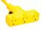 | #9 - Triple Outlet  Triple outlet with grounded receptacles. For maximum ratings, consult manufacturer. (models are UL listed in United States and Canada)
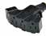 | #9Q - Quad Outlet  Circuit breaker protected, fanned quad 4 ground- ed NEMA5-15 outlets with LED power "on" indicator light. (models are ETL listed)
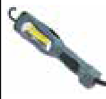 | #10 - LED Light  1300 Lumen LED with bright COB illumination; grounded 12 amp outlet and on-off switch on handle. (models are ETL listed)
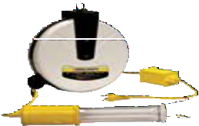
LD2040 163 2

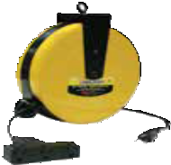
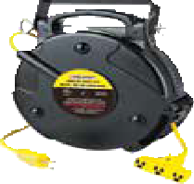
LD2030 163 9

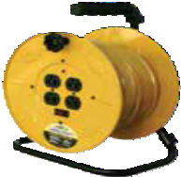
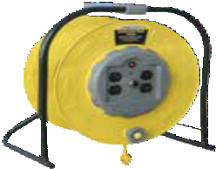LG3050 143 9
LH3100

LH2080 143

Products on this page are warranted for 1 year.
Prop 65: WARNING:
Cancer and Reproductive Harm - www.P65Warnings.ca.gov.
Models listed with an icon can ship same day upon request when the order is received by 1:00 PM Eastern Time for quantities of 10 or fewer.
Indiana Warehouse
Indiana & California Warehouses
California Warehouse
Canadian Warehouse
36
Customer Service: 1.855.634.9109
All Other Calls: 1.800.444.3134
Model with Cord* | Cord Ending | Cord Specifications |  |  |  | Volts | Amps | Weight | Size Index  #
 |  | AWG mm | # Cond | ft m | Type |  |  | lbs kg
LH2080 143 | 4 Outlets | 14 2.08 | 3 | 80 24 | SJTW | 125 | 10 | 15 7 | 3
LH3100* | 4 Outlets | 10 5.37 | 3 | 100 30 | STW | 125 | 15 | 13 6 | 4
*Does not include cord.

Power and Light Cord Reels | Series L 4000 / L 5000 / L 7000 / L 70000
- All models supplied with cord are complete with a 4-5 foot pigtail and three-prong plug (flying lead reels supplied with conduit box)
- Adjustable cord stop supplied on models with cord
Better by Design

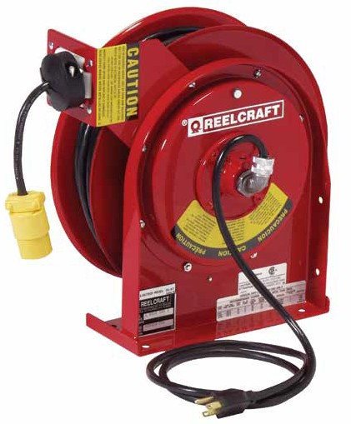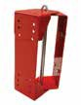Adjustable Bumper Stop
Allows any desired length of cord to be maintained outside the reel.

Corrosion-Resistant
Steel components are individually powder coated to virtually eliminate corrosion.

Reelcraft offers
many styles of outlets and lamps
- Single receptacle
- Duplex outlet box
- Triple tap
- R.V. plug
- Fluorescent
- Incandescent
- LED
- Flying lead

Adjustable Guide Arm
Multiple guide arm positions for versatile uses and easier field adjustment.

Enclosed Drive Spring
Drive mechanism is enclosed for protection against the environment.

Long Life Drive Spring
Declutching arbor virtually eliminates possibility of spring damage due to reverse winding
of reel spool.

Easy to Mount
Attaches to most structurally sound surfaces. Edges are curved for safety. Note: Swing brackets should be used if cords are pulled at more than 45°, see page 49.

600993

Structural Strength
Robotically welded heavy gauge steel frame.

Made in USA

L 4 0 5 0 1 6 3
Model Number Significance
This chart is for reference purposes only. Reels cannot be ordered by selecting from this chart. Please refer to selection charts on pages 38-39 or consult manufacturer for any questions about option combinations.
REEL SERIES
40 = 4000 SERIES
45 = 4500 SERIES
55 = 5500 SERIES
57 = 5700 SERIES
70 = 7000 SERIES
or 70000 SERIES
LENGTH OF CORD
00 = W/O CORD
35 = 35 FEET
45 = 45 FEET
50 = 50 FEET
75 = 75 FEET
100 = 100 FEET
FOR REFERENCE
ONLY
NO. OF CONDUCTORS
2 = TWO CONDUCTOR
3 = THREE CONDUCTOR
4 = FOUR CONDUCTOR
3
STYLE NUMBERS
NONE = OPEN END
1 = INCANDESCENT LAMP
2 = FLUORESCENT LAMP
3 = SINGLE RECEPTACLE
4 = R.V. PLUG (M)
5 = INCANDESCENT NON-SPARKING
6x = FLUORESCENT EXPLOSION PROOF
7 = DUPLEX OUTLET BOX (F)
8 = FLUORESCENT WITH OUTLET
9 = TRI TAP
10 = LED LAMP
X = FLYING LEAD
Customer Service: 1.855.634.9109
All Other Calls: 1.800.444.3134
37
WIRE SIZE
10 = 10 GAUGE
12 = 12 GAUGE
16 = 16 GAUGE

Model | Outside Diameter of Cord | Cord Specifications
 |  | AWG mm² | # Cond. | Type
600193 | .320” - .530” | 16 1.33 | 3 | SJO
1-HR1004-A | .438” - .624” | 12 3.32 | 3 | SJO
600267 | .645” | 10 5.37 | 3 | SO
1-HR1004 | .625” - .749” | 12 3.32 | 3 | SO
3-HR1004-3 | 1.06” - 1.30” | 6 8.00 | 3 | SO

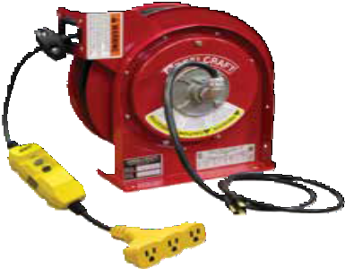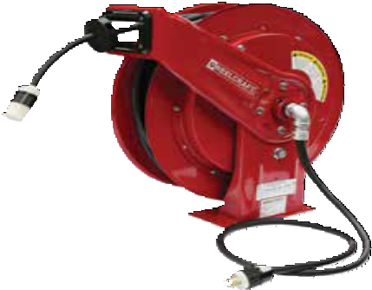Power and Light Cord Reels | Series L 4000 / L 5000 / L 7000 / L 70000
L 70100 123 3A
Made in USA
L 4545 123 9G
Model with Cord | Cord Ending | Cord Specifications |  |  |  | Volts | Amps | Shipping Weight | Size Index #
 |  | AWG mm2 | #  Cond. | ft m | Type |  |  | lbs kg
L 4035 163 3 | Single Receptacle | 16 1.33 | 3 | 35 11 | SJTOW | 125 | 13 | 25 11 | 1
L 4050 163 3 | Single Receptacle | 16 1.33 | 3 | 50 15 | SJTOW | 125 | 13 | 26 12 | 1
L 4545 123 3 | Single Receptacle | 12 3.32 | 3 | 45 14 | SJEOOW | 125 | 15 | 27 12 | 1
L 5550 123 3 | Single Receptacle | 12 3.32 | 3 | 50 15 | SJEOOW | 125 | 15 | 44 20 | 3
L 70075 123 3 | Single Receptacle | 12 3.32 | 3 | 75 23 | SEOOW | 125 | 15 | 70 32 | 5
L 70100 123 3 | Single Receptacle | 12 3.32 | 3 | 100 30 | SEOOW | 125 | 15 | 74 34 | 5
L 4545 123 3A* | Single Receptacle | 12 3.32 | 3 | 45 14 | SJEOOW | 125 | 20 | 28 13 | 1
L 5550 123 3A* | Single Receptacle | 12 3.32 | 3 | 50 15 | SJEOOW | 125 | 20 | 44 20 | 3
L 70075 123 3A* | Single Receptacle | 12 3.32 | 3 | 75 23 | SEOOW | 125 | 20 | 70 32 | 5
L 70100 123 3A* | Single Receptacle | 12 3.32 | 3 | 100 30 | SEOOW | 125 | 20 | 74 34 | 5
L 4545 123 3B* | Twist Lock Connector | 12 3.32 | 3 | 45 14 | SJEOOW | 125 | 20 | 28 13 | 1
L 5550 123 3B* | Twist Lock Connector | 12 3.32 | 3 | 50 15 | SJEOOW | 125 | 20 | 44 20 | 3
L 70075 123 3B* | Twist Lock Connector | 12 3.32 | 3 | 75 23 | SEOOW | 125 | 20 | 70 32 | 5
L 70100 123 3B* | Twist Lock Connector | 12 3.32 | 3 | 100 30 | SEOOW | 125 | 20 | 74 34 | 5
L 5750 103 4 | R.V. Plug | 10 5.37 | 3 | 50 15 | SOOW | 125 | 30 | 50 23 | 4
L 4545 123 7 | Duplex Outlet Box  w/GFCI (F)** | 12 3.32 | 3 | 45 14 | SJEOOW | 125 | 15 | 29 13 | 1
L 5550 123 7 | Duplex Outlet Box  w/GFCI (F)** | 12 3.32 | 3 | 50 15 | SEOOW | 125 | 15 | 45 20 | 3
L 70075 123 7 | Duplex Outlet Box  w/GFCI (F)** | 12 3.32 | 3 | 75 23 | SEOOW | 125 | 15 | 72 33 | 5
L 70100 123 7 | Duplex Outlet Box  w/GFCI (F)** | 12 3.32 | 3 | 100 30 | SEOOW | 125 | 15 | 76 34 | 5
L 4545 123 7A | Duplex Outlet Box  w/GFCI (F)** | 12 3.32 | 3 | 45 14 | SJEOOW | 125 | 20 | 29 13 | 1
L 5550 123 7A | Duplex Outlet Box  w/GFCI (F)** | 12 3.32 | 3 | 50 15 | SEOOW | 125 | 20 | 45 20 | 3
L 70075 123 7A | Duplex Outlet Box  w/GFCI (F)** | 12 3.32 | 3 | 75 23 | SEOOW | 125 | 20 | 72 33 | 5
L 70100 123 7A | Duplex Outlet Box  w/GFCI (F)** | 12 3.32 | 3 | 100 30 | SEOOW | 125 | 20 | 76 34 | 5
L 4545 123 7B | Duplex Outlet Box | 12 3.32 | 3 | 45 14 | SJEOOW | 125 | 20 | 29 13 | 1
L 4050 163 9 | Triple Tap | 16 1.33 | 3 | 50 15 | SJEOOW | 125 | 13 | 26 12 | 1
L 4545 123 9 | Triple Tap | 12 3.32 | 3 | 45 14 | SJEOOW | 125 | 15 | 28 13 | 1
L 70075 123 9 | Triple Tap | 12 3.32 | 3 | 75 23 | SEOOW | 125 | 15 | 71 32 | 5
L 70100 123 9 | Triple Tap | 12 3.32 | 3 | 100 30 | SEOOW | 125 | 15 | 75 34 | 5
L 4545 123 9G | Triple Tap w/GFCI(F) | 12 3.32 | 3 | 45 14 | SJEOOW | 125 | 15 | 29 13 | 1
L 70075 123 9G | Triple Tap w/GFCI(F) | 12 3.32 | 3 | 75 23 | SEOOW | 125 | 15 | 72 33 | 5
L 70100 123 9G | Triple Tap w/GFCI(F) | 12 3.32 | 3 | 100 30 | SEOOW | 125 | 15 | 76 34 | 5
For indoor non-weather tight applications only. All models UL listed at 125 Volt 60 HZ single phase. *Add a "C" to the end of the part number to specify twist lock inlet plug. **The GFCI Receptacle is designed to protect from line-to-ground shock hazards. The Ground Fault Circuit Interrupter does not protect against short circuits or overloads; this is the function of the fuse or circuit breaker. Reference page 4 for guide arm positions. NOTE: Swing brackets should be used if cords are pulled at more than 45°, see page 49.

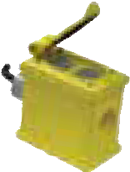Cord Options
Flying Lead Model  with Cord | Model No Cord | Cord Specifications |  |  |  | Volts/ Amps | Volts/ Amps | Shipping Weight* | Size Index #
 |  | AWG mm2 | #  Cond | ft m | Type |  |  | lbs kg
L 4050 163 X | L 4000 | 16 1.33 | 3 | 50 15 | SJEOOW | 125 / 13 | 220 / 6.5 | 22 10 | 1
--------- | L 4100 | 16 1.33 | 4 | 50 15 | SJEOOW | 125 / 10 | 220 / 5 | 22 10 | 1
L 4545 123 X | L 4500 | 12 3.32 | 3 | 45 14 | SJEOOW | 125 / 20 | 220 / 10 | 22 10 | 1
--------- | L 5000 | 10 5.27 | 3 | 35 11 | SO | 125 / 30 | 220 / 15 | 29 13 | 2
--------- | L 5400 | 12 3.32 | 3 | 35 11 | SJEOOW | 125 / 13 | 220 / 6.5 | 25 11 | 2
L 5550 123 X | L 5500 | 12 3.32 | 3 | 50 15 | SJEOOW | 125 / 20 | 220 / 10 | 35 16 | 3
L 70075 123 X | L 70075 | 12 3.32 | 3 | 75 23 | SEOOW | 125 / 20 | 220 / 10 | 69 31 | 6
L 70100 123 X | L 70100 | 12 3.32 | 3 | 100 30 | SEOOW | 125 / 20 | 220 / 10 | 73 33 | 6
L 5550 124 X | L 5500 124 | 12 3.32 | 4 | 50 15 | SEOOW | -------- | 600 / 16 | 43 20 | 3
L 70100 124 X | L 70100 124 | 12 3.32 | 4 | 100 30 | SEOOW | -------- | 600 / 16 | 75 34 | 6
L 5750 103 X | L 5700 | 10 5.27 | 3 | 50 15 | SEOOW | 125 / 30 | 220 / 15 | 37 17 | 4
--------- | L 7000 | 6 13.3 | 4 | 35 11 | SOOW | -------- | 220 / 45 | 41 19 | **
L 7050 104 X | -------- | 10 5.27 | 4 | 50 15 | SEOOW | -------- | 600 / 20 | 65 29 | **
For indoor non-weather tight applications only. All models UL listed at 125 Volt 60 HZ single phase. *Weight of model without cord.
**Refer to reelcraft.com. Reference page 4 for guide arm positions.

#3 - Single Receptacle Single 15 AMP with clamp type strain relief for both 16 AWG and 12 AWG cord. NEMA 5-15R
#3A - Single Receptacle
Single 20 AMP. NEMA 5-20R
#3B - Twist Lock Connector Single 20 AMP with twist lock connector. NEMA L5-20R
#4 - R.V. Plug
Male rubber plug used with recreational vehicles (RV’s).
#7/7A/7B - Duplex Outlet Box Duplex outlet box with flip-top lid. GFCI protection on #7 and 7A.
#9/9G - Triple Tap
Molded triple tap. GFCI protection on #9G only.
X - Flying Lead
Bare cord or cable endings and conduit box.
Prop 65: WARNING:
Cancer and Reproductive Harm www.P65Warnings.ca.gov.

Customer Service: 1.855.634.9109
38
All Other Calls: 1.800.444.3134

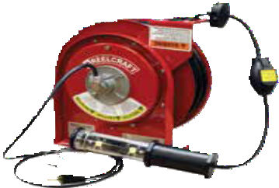
Power and Light Cord Reels | Series L 4000 / L 5000 / L 7000 / L 70000
Model with Cord | Cord Ending | Cord Specifications |  |  |  |  |  | Volts | Amps | Shipping Weight |  | Size Index #
 |  | AWG | mm2 | #  Cond | ft | m | Type |  |  | lbs | kg
L 4035 163 1 | *Incandescent | 16 | 1.33 | 3 | 35 | 11 | SJTOW | 125 | 10 | 23 | 10 | 1
L 4050 163 1 | *Incandescent | 16 | 1.33 | 3 | 50 | 15 | SJTOW | 125 | 10 | 27 | 12 | 1
L 4050 A 163 5** | *Incandescent | 16 | 1.33 | 3 | 50 | 15 | SJEOOW | 125 | 13 | 28 | 13 | 1
L 5245 A 163 6X** | Fluorescent | 16 | 1.33 | 3 | 45 | 14 | SEOOW | 125 | 0.13 | 39 | 18 | 2
L 4035 162 2 | Fluorescent | 16 | 1.33 | 2 | 35 | 11 | SJTOW | 125 | 0.3 | 25 | 11 | 1
L 4050 162 2 | Fluorescent | 16 | 1.33 | 2 | 50 | 15 | SJTOW | 125 | 0.3 | 26 | 12 | 1
L 4035 163 8 | Fluorescent Light and Outlet | 16 | 1.33 | 3 | 35 | 11 | SJTO | 125 | 10 | 25 | 11 | 1
L 4050 163 8 | Fluorescent Light and Outlet | 16 | 1.33 | 3 | 50 | 15 | SJTO | 125 | 10 | 27 | 12 | 1
L 4035 163 10 | LED | 16 | 1.33 | 3 | 35 | 11 | SJTOW | 125 | 13 | 26 | 12 | 1
L 4050 163 10 | LED | 16 | 1.33 | 3 | 50 | 15 | SJTOW | 125 | 13 | 28 | 13 | 1
For indoor non-weather tight applications only. *Incandescent bulb 75 watt max. All models UL listed at 125 Volt 60 HZ single phase. **Models equipped with automatic on/off switch that activates power. NOTE: Swing brackets should be used if cords are pulled at more than 45°, see page 49. Reference page 4 for guide arm positions.

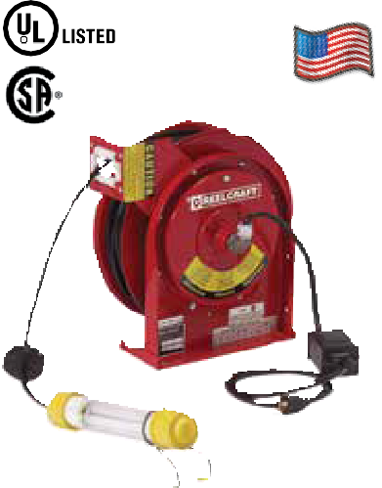
L 4050 163 10

Made in USA

P Compact for critical space requirements
P Durable abrasion and corrosion resistant baked- on powder coat finish

P All models supplied with cord are complete with a 4-5 foot pigtail and three- prong plug (except flying lead reels)

P Wall, ceiling or bench mount
P Adjustable cord stop
P Engineered for industrial use

L 4050 162 2

Cord Options

#1 - Incandescent Light (100 watt max)
- Single receptacle tool tap
- Push-through switch, metal grounded guard
#2 - Fluorescent Light (825 lumens)
- Durable shock absorbing lamp holder
- Shatter-resistant tube with switch
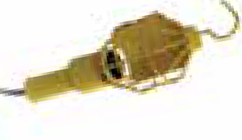 | #5 - Incandescent Light (100 watt max)  - Rubber handle with vinyl-coated cage w/o switch or receptacle  - Automatic on/off switch at reel guide arm  - Complies with NEC #511-3, f., portable lighting equipment; meets OSHA requirements
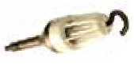 | #6 - Fluorescent Light  - Explosion proof 13 watt fluorescent hand lamp  - Automatic on/off switch at reel guide arm  - Suitable for Class 1, Div 1 group C and D locations Note: Reel is not explosion-proof.
#8 - Fluorescent Light (825 lumens)
- 120 V - 10 amp receptacle in-line on lamp handle
- Scratch guard protects lamp cover
#10 - LED Light (930 lumens)
- Two ultra high intensity 4-watt LEDs; single 3-watt end spot light
- Polycarbonate shatter-resistant light tube
- In-line tool tap, NEMA 5-15R configuration maximum 12 amp draw
Models listed with an icon can ship same day upon request when the order is received by 1:00 PM Eastern Time for quantities of 10 or fewer.
Interactive Reel Catalog
Visit www.reelcraft.com/catalog for complete product specifications, available parts and accessories.
Indiana Warehouse California Warehouse

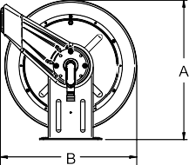 | Dimensions - Size Index
 |  | 5 | 6
 |  | in mm | in mm
 | A | 201/4 514 | 201/4 514
 | B | 193/4 502 | 193/4 502
 | C | 713/16 198 | 713/16 198
 | D | 37/8 98 | 37/8 98
 | E | 113/4 298 | 121/2 318

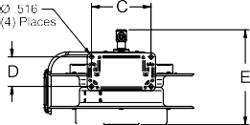
Dimensions - Size Index

 | 1  in | mm | 2  in | mm | 3  in | mm | 4  in | mm
A | 127/8 | 327 | 143/8 | 365 | 175/8 | 448 | 175/8 | 448
B | 125/8 | 321 | 141/4 | 362 | 163/4 | 425 | 163/4 | 425
C | 8 | 203 | 93/4 | 248 | 93/4 | 248 | 93/4 | 248
D | 21/2 | 64 | 21/2 | 64 | 21/2 | 64 | 21/2 | 64
E | 93/8 | 239 | 101/2 | 267 | 101/2 | 267 | 121/2 | 318
F | 13/4 | 44 | 21/8 | 54 | 21/8 | 54 | 21/8 | 54

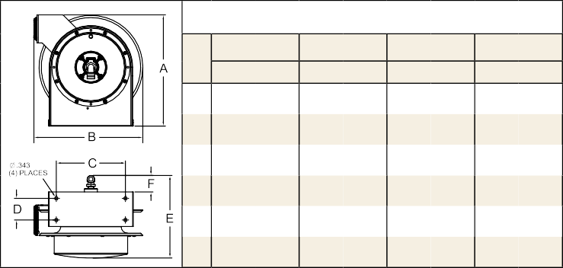
Prop 65: WARNING:
Cancer and Reproductive Harm www.P65Warnings.ca.gov.

Indiana & California Warehouses
Canadian Warehouse
Customer Service: 1.855.634.9109 39

NEMA 4 Power Cord Reels | Series L NM400

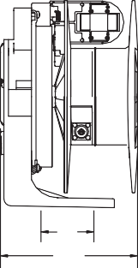
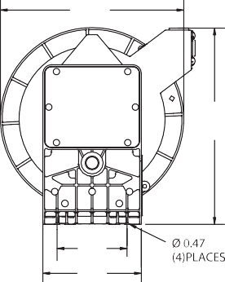
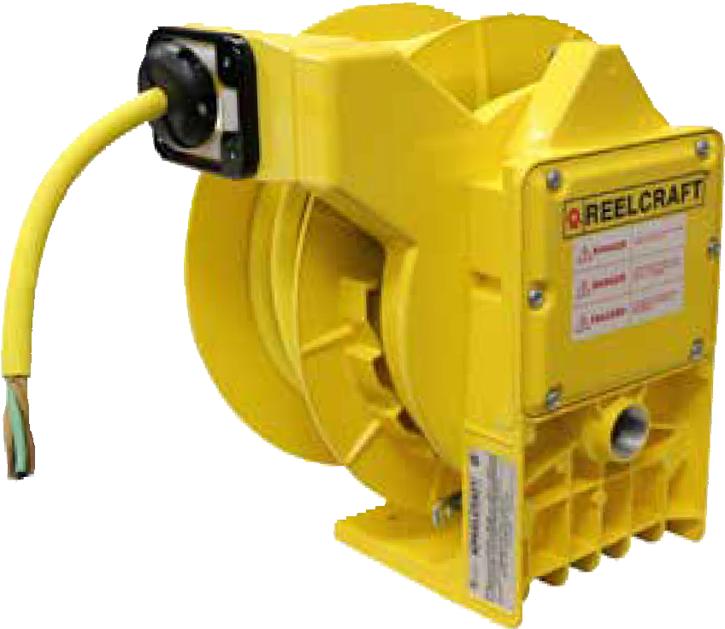
NEW!

L NM440 103 X
Features
P NEMA 4 rating provides protection to water or dust, indoor and out
P Large, easy to access junction box
P Cast aluminum construction with yellow powder coat finish
P Reel design prohibits latch-out when cable is fully extended
P Containerized drive spring allows for safer, easier handling during maintenance
P All models are UL and CSA approved

Heavy Duty Spring Retractable Cord Reels
Reelcraft’s new Series L NM400 cord reels are NEMA 4 rated and designed for protection against water or dust, indoor and outdoor. The guide arm is adjustable every 5° over a 270° arc allowing for the exact configuration to suit a wide range of applications. The containerized drive spring allows for safer, easier handling during mainte-
nance. The heavy duty cast aluminum design and powder coat finish combine to produce a rugged, corrosion- resistant product.

B |  |  | Dimensions
 |  |  |  | in | mm
 |  |  | A | 141/2 | 368
 | A |  | B | 131/2 | 343
 |  |  | C | 47/16 | 113
 |  |  | D | 31/16 | 78
C |  | D | E | 95/8 | 244
 |  |  | F | 71/4 | 184
F |  | E

Model with Cord | Cord Ending | Cord Specifications |  |  |  |  |  | Volts | Amps | Shipping Weight
 |  | AWG | mm2 | # Cond. | ft | m | Type |  |  | lbs | kg
L NM450 163 X | Flying Lead | 16 | 1.31 | 3 | 50 | 15 | SOW | 600 | 9 | 43 | 20
L NM450 143 X | Flying Lead | 14 | 2.08 | 3 | 50 | 15 | SOW | 600 | 13 | 48 | 22
L NM445 144 X | Flying Lead | 14 | 2.08 | 4 | 45 | 14 | SOW | 600 | 11 | 50 | 23
L NM425 123 X | Flying Lead | 12 | 3.31 | 3 | 25 | 8 | SOW | 600 | 18 | 44 | 20
L NM450 123 X | Flying Lead | 12 | 3.31 | 3 | 50 | 15 | SOW | 600 | 18 | 50 | 23
L NM440 124 X | Flying Lead | 12 | 3.31 | 4 | 40 | 12 | SOW | 600 | 14 | 50 | 23
L NM440 103 X | Flying Lead | 10 | 5.26 | 3 | 40 | 12 | SOW | 600 | 22 | 50 | 23
L NM430 104 X | Flying Lead | 10 | 5.26 | 4 | 30 | 9 | SOW | 600 | 16 | 50 | 23
All models UL listed at 125 Volt 60 HZ single phase.

Prop 65: WARNING:
Interactive Reel Catalog
Visit www.reelcraft.com/catalog for complete product specifications, available parts and accessories.
Cancer and Reproductive Harm www.P65Warnings.ca.gov.
Models listed with an icon can ship same day upon request when the order is received by 1:00 PM Eastern Time for quantities of 10 or fewer.
Indiana Warehouse California Warehouse

40 Customer Service: 1.855.634.9109
Indiana & California Warehouses
Canadian Warehouse

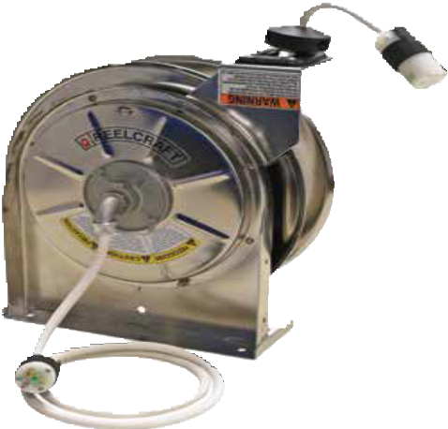Stainless Steel Cord Reels | Series LS 5000
LS 5445 123 3MWC

Heavy Duty Stainless Steel Cord Reels
Reelcraft's new stainless steel power cord reels are designed for applications where corrosion or sanitation are a concern. The heavy gauge 304L stainless steel provides an easy to clean finish and superior corrosion resistance. A robust collector ring assures maximum conductivity current flow. All reels listed include a 4-5’ pigtail, multi- positional guide arm, and adjustable cord stop. Models listed are for indoor, non-weather-tight applications only.

NEW!

Made in USA
Features
P Quiet - These reels utilize a cam latching system, making them much quieter and smother than other reels in their class.
P Compact - A space saving design makes them ideal for minimum space requirements.
P Superior strength - A robotically welded base, engineered structural supports and high-grade industrial 304L stainless steel combine to give this reel superior strength and stability.
P Long life drive spring - Declutching arbor virtually eliminates possibility of spring damage due to reverse winding. Only the highest quality spring steel is used and conditioned to insure there are no imperfections offering maximum service life.
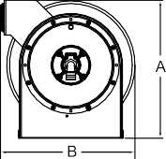 | Dimensions
 |  | in | mm
 | A | 143/8 | 365
 | B | 141/4 | 362
 | C | 93/4 | 248
 | D | 21/2 | 64
 | E | 101/2 | 267
 | F | 21/8 | 54

Model with Cord | Cord Ending | Cord Specifications |  |  |  |  |  | Volts | Amps | Shipping Weight
 |  | AWG | mm2 | # Cond. | ft | m | Type |  |  | lbs | kg
LS 5445 123 3 | Single Receptacle | 12 | 3.32 | 3 | 45 | 14 | SJEOOW | 125 | 15 | 31 | 14
LS 5445 123 3A | Single Receptacle | 12 | 3.32 | 3 | 45 | 14 | SJEOOW | 125 | 20 | 32 | 15
LS 5425 123 3MWC* | Single Medical Grade Receptacle | 12 | 3.32 | 3 | 25 | 8 | SJEOOW | 125 | 15 | 30 | 14
LS 5445 123 3MWC* | Single Medical Grade Receptacle | 12 | 3.32 | 3 | 45 | 14 | SJEOOW | 125 | 15 | 32 | 15
LS 5415 123 3M | Single Medical Grade Receptacle | 12 | 3.32 | 3 | 15 | 5 | SJEOOW | 125 | 15 | 28 | 13
LS 5425 123 3M | Single Medical Grade Receptacle | 12 | 3.32 | 3 | 25 | 8 | SJEOOW | 125 | 15 | 29 | 13
LS 5445 123 3M | Single Medical Grade Receptacle | 12 | 3.32 | 3 | 45 | 14 | SJEOOW | 125 | 15 | 31 | 14
LS 5445 123 7 | Duplex Outlet Box w/GFCI (F)** | 12 | 3.32 | 3 | 45 | 14 | SJEOOW | 125 | 15 | 33 | 15
LS 5445 123 7A | Duplex Outlet Box w/GFCI (F)** | 12 | 3.32 | 3 | 45 | 14 | SJEOOW | 125 | 20 | 33 | 15
LS 5445 123 7B | Duplex Outlet Box | 12 | 3.32 | 3 | 45 | 14 | SJEOOW | 125 | 20 | 33 | 15
LS 5445 123 9 | Triple Tap | 12 | 3.32 | 3 | 45 | 14 | SJEOOW | 125 | 15 | 32 | 15
LS 5445 123 9G | Triple Tap w/GFCI (F)** | 12 | 3.32 | 3 | 45 | 14 | SJEOOW | 125 | 15 | 33 | 15
LS 5400 | Bare Reel | 12 | 3.32 | 3 | 35 | 11 | SJEOOW | 125 | 20 | 24 | 11
LS 5425 123 X | Flying Lead | 12 | 3.32 | 3 | 25 | 8 | SJEOOW | 125 | 20 | 27 | 12
LS 5445 123 X | Flying Lead | 12 | 3.32 | 3 | 45 | 14 | SJEOOW | 125 | 20 | 29 | 13
For indoor non-weather tight applications only. *Reel includes white cord and white electrical enclosure. **The GFCI Receptacle is designed to protect from line-to-ground shock hazards. The Ground Fault Circuit Interrupter does not protect against short circuits or overloads; this is the function of the fuse or circuit breaker.

Models listed with an icon can ship same day upon request when the order is received by 1:00 PM Eastern Time for quantities of 10 or fewer.
Indiana Warehouse California Warehouse
Prop 65: WARNING:
Cancer and Reproductive Harm www.P65Warnings.ca.gov.
Interactive Reel Catalog
Visit www.reelcraft.com/catalog for complete product specifications, available parts and accessories.

Indiana & California Warehouses
Canadian Warehouse
Customer Service: 1.855.634.9109 41

Large Frame Cable Reels | Nordic Series CR

High Capacity Cable Reels

Nordic Series CR2400/CR3100
for 3-conductor service
Series CR2400 - Direct crank rewind or chain and sprocket drive powered by A.C. or D.C. electric motor or compressed air motor. An adjustable spring drag device is used to brake the reel.

Series CR3100 - Powered by a rugged spring protected by a tamperproof housing, a rachet mechanism locks on payout of cable, but is easily disengaged with a pull to provide rewind.

Cable rollers: Series CR3100 models supplied with a 4-way roller guide assembly. Roller guide supplied with Series CR2400 models at extra cost. Roller position must be specified. If not specified, bottom wind will be supplied. Can be supplied or installed, consult manufacturer.

Note: A cable stop should be used to prevent damage to rollers and to permit adjustment of free cable length.

Made in USA

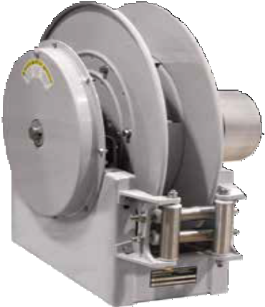
Nordic
Series CR3100

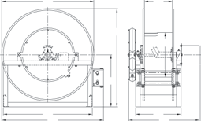
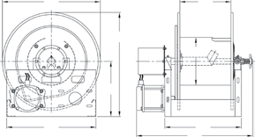
Many more sizes, from standard components, available on request. Consult manufacturer.

Dimensions Diagram
CR3100 | B  C J | H | A | F  D | G  E | CR2400 | B  C | H | A | F  G  D  E

Gauge / No. of Conductors |  | 16/3 | 14/3 | 12/3 | 10/3 | 8/3 |  |  |  | Specifications - Cable Capacity and Reel Dimensions  “E” dimension based on three conductor slip ring
Cable O.D. | in | .375 | .530 | .580 | .705 | .750 | 1.000 | 1.250 | 1.500
 | mm | 10 | 13 | 15 | 18 | 19 | 25 | 32 | 38
Model | Cable Length |  |  |  |  |  |  |  |  | Est. Weight |  | A | B | B PWR | C | D | E | E PWR | F | G | H | J
Spring Driven Reels
CR3100-23-4 | ft m | 85  26 | 85  26 | 100  30 | 100  30 | 90  27 |  |  |  | 92 LB  42 KG | in mm | 24.5  622 | 23  584 |  | 21  533 | 9  229 | 18  457 |  | 4  102 | 15  381 | 13  330 | 26  660
CR3100-25-4 | ft m | 95  29 | 100  30 | 100  30 | 100  30 | 100  30 |  |  |  | 97 LB  44 KG | in  mm | 26.5  673 | 25  635 |  | 21  533 | 9  229 | 18  457 |  | 4  102 | 15  381 | 14  356 | 27  686
CR3100-31-4 | ft m | 120  37 | 120  37 | 130  40 | 130  40 | 130  40 |  |  |  | 118 LB  54 KG | in  mm | 33  838 | 31  787 |  | 30  762 | 9.25  235 | 19  483 |  | 4  102 | 20  508 | 17.5  445 | 34.5  876
Hand Crank / Motor Driven Reels
CR2400-23-12 | ft m | 1900  579 | 930  283 | 775  236 | 520  158 | 430  131 | 240  73 | 155  47 | 105  32 | 72 LB  33 KG | in mm | 24.5  622 | 23  584 | 23  584 | 21  533 | 18  457 | 29  737 | 29  737 | 12  305 | 11.25  286 | 13  330
CR2400-31-8 | ft m | 2700  823 | 1350  411 | 1100  335 | 750  229 | 660  201 | 360  110 | 185  56 | 135  41 | 79 LB  36 KG | in  mm | 32.5  826 | 31  787 | 31  787 | 24  610 | 14  356 | 25  635 | 25  635 | 8  203 | 11.25  286 | 17  432

Prop 65: WARNING:
Cancer and Reproductive Harm - www.P65Warnings.ca.gov.
Model numbers are representative. Final part number assigned upon quote. Built to order, not returnable.

42 Customer Service: 1.855.634.9109

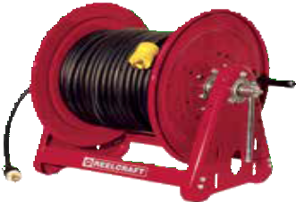
Heavy Duty Cord Reels | Series 30000

Heavy Duty Cord and Cable Storage Reels

Hand Crank, Bevel Crank & Motor Driven
Keep long lengths of expensive electrical cord off the ground and out of harm’s way with Reelcraft’s expanded Series 30000 line, which includes cable storage reels and live power cord. The reels are designed to handle long lengths of 10/3, 12/3 and 16/3 cable.

Reelcraft’s Series 30000 storage reels and live power cord reels are constructed of heavy gauge steel and are assembled with vibration-
proof, self-locking fasteners to ensure assembly integrity. They undergo a five-stage cleaning process and are individually powder-coated for the highest quality, corrosion-resistant paint adhesion. Suited for indoor, non weather-tight applications only.
Cord/Cable Storage Reels
Cord and cable storage reels are used for storage, unwinding, and winding of conductive cord/cable. The reel is not intended to be live and the power source must be disconnected while reeling/de-reeling to avoid twisting the wires. Series 30000 cable storage reels are available in hand crank only.

Live Power Cord Reels
Live power cord reels have collector rings that allow the reel to wind/unwind the cord/cable with live current without twisting the wires.
Live reels offer the advantage of using a reel as an effective piece of operating equipment rather than a simple device for the storage of cable or cord. Series 30000 live power cord reels are available in direct hand crank, bevel gear crank or electric motor-driven rewind.

CA30112-CS
Cable not included

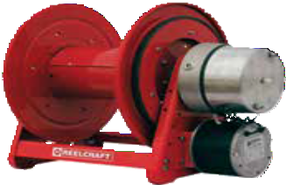
LE312 123 12D

Made in USA

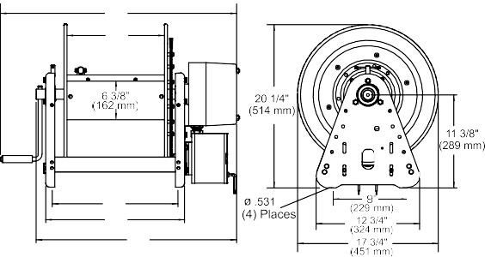

Model without Cable | Drive Type | Cord Specifications |  |  | Volts | Amps | Shipping Weight | Size Index #
 |  | AWG mm² | # Cond. | ft m |  |  | lbs kg
CA30106-CS* | Hand Crank | 10 5.211  12 3.131  16 1.0524 | 3  3  3 | 140 43  175 53  425 130 | This reel is for storage only. Not intended to be live. |  | 37 17 | 1
CA30112-CS* | Hand Crank | 10 5.211  12 3.131  16 1.0524 | 3  3  3 | 280 86  350 106  850 260 | This reel is for storage only. Not intended to be live. |  | 46 21 | 2
LB312 123 | Bevel Crank | 12 3.131 | 3 | 200 61 | 600 | 25 | 51 23 | 3
LB312 103 | Bevel Crank | 10 5.211 | 3 | 200 61 | 600 | 30 | 52 24 | 3
LC312 123 | Hand Crank | 12 3.131 | 3 | 200 61 | 600 | 25 | 50 23 | 4
LC312 103 | Hand Crank | 10 5.211 | 3 | 200 61 | 600 | 30 | 51 23 | 4
LE312 123 12D | Motor Driven** | 12 3.131 | 3 | 200 61 | 600 | 25 | 68 31 | 5
LE312 103 12D | Motor Driven** | 10 5.211 | 3 | 200 61 | 600 | 30 | 69 31 | 5
NOTE: Cord must be fully unspooled before use. Actual fill capacities vary with cord O.D. and jacket type. Consult manufacturer for applications requiring cord types other than SO, SOW, or SJO. Reel suited for indoor, non-weather tight applications only. *Power source must be disconnected while reeling/de-reeling. Through shaft on cable storage reels facilitates cable sizes up to .969” O.D. for other sizes, consult manufacturer. **All motor driven models are 12 V DC non- explosion proof. Other motor options available upon request.

Models listed with an icon can ship same day upon request when the order is received by 1:00 PM Eastern Time for quantities of 10 or fewer.
A B  D E | C | Dimensions - Size Index
 |  |  | 1 |  | 2 |  | 3 |  | 4 |  | 5
 |  |  | in | mm | in | mm | in | mm | in | mm | in | mm
 |  | A | 181/4 | 464 | 241/4 | 616 | 293/8 | 746 | 293/8 | 746 | 25 | 635
 |  | B | 6 | 152 | 12 | 305 | 12 | 305 | 12 | 305 | 12 | 305
 |  | C | N/A |  | N/A |  | 233/4 | 603 | 233/4 | 603 | 233/4 | 603
 |  | D | 93/4 | 248 | 153/4 | 400 | 153/4 | 400 | 153/4 | 400 | 153/4 | 400
 |  | E | 11 | 280 | 17 | 432 | 17 | 432 | 17 | 432 | 17 | 432

Interactive Reel Catalog
Visit us at www.reelcraft.com/catalog for complete product specifications, available parts and accessories.

Prop 65: WARNING:
Cancer and Reproductive Harm www.P65Warnings.ca.gov.

Indiana Warehouse
Indiana & California Warehouses
California Warehouse
Canadian Warehouse

Customer Service: 1.855.634.9109 43

Complete Welding Series | Series TW / STW / BA

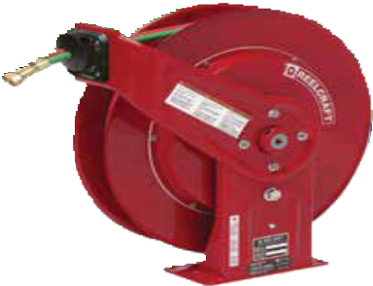
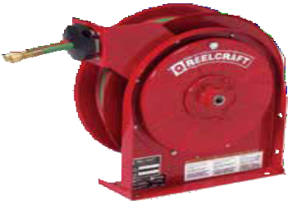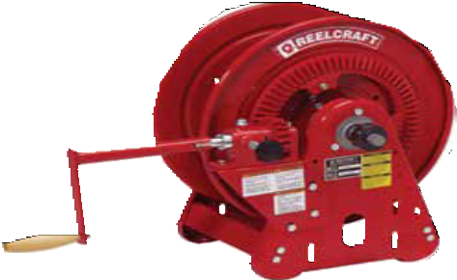Spring driven for hose lengths up to 60’

Ideal for locations where space is limited

Made in USA

TW5425 OLP

BA36106 L

TW7450 OLP

NOTE: Reels without hose, Series TW5400 OLP(T), TW7400 OLP(T), TW84000 OLPT
and TW86000 OLPT are U/L listed #70H2.

Model with Hose | Shipping Weight | Hose I.D. | Hose O.D. | Hose Length | Pressure | Hose Outlet | Reel Inlet | Model without hose & bumper | Shipping Weight | Size Index #
 | lbs kg | in mm | in mm | ft m | psi bar | in | in |  | lbs kg
Oxygen / Acetylene (only) Hose Reels
TW5425 OLP | 26 12 | 1/4 6 | .530 13 | 25 8 | 200 14 | 9/16 - 18(F) | 1/4 NPT(F) | TW5400 OLP | 21 10 | 1
STW3450 OLP | 29 13 | 1/4 6 | .530 13 | 50 15 | 300 21 | 9/16 - 18(F) | 9/16 - 18(M) | ---------------- | ---------- | See pg. 21
TW7450 OLP | 50 23 | 1/4 6 | .530 13 | 50 15 | 200 14 | 9/16 - 18(F) | 1/4 NPT(F) | TW7400 OLP | 42 19 | 2
TW7460 OLP | 55 25 | 1/4 6 | .530 13 | 60 18 | 200 14 | 9/16 - 18(F) | 1/4 NPT(F) | TW7400 OLP | 42 19 | 2
Series 30000 Hand Crank |  | 1/4 6 | .530 13 | 125 38 | 200 14 | 9/16 - 18(M) | 1/4 NPT(F) | BA36106 L | 50 23 | 4
Series 30000 Hand Crank |  | 1/4 6 | .530 13 | 250 76 | 200 14 | 9/16 - 18(M) | 1/4 NPT(F) | BA36112 L | 57 26 | 5
Welding Gas - Oxygen / Acetylene, Mapp, Propane, Natural and Fuel Gas (T-Grade) Hose Reels
TW5425 OLPT | 26 12 | 1/4 6 | .530 13 | 25 8 | 200 14 | 9/16 - 18(F) | 1/4 NPT(F) | TW5400 OLPT | 22 10 | 1
TW7450 OLPT | 50 23 | 1/4 6 | .530 13 | 50 15 | 200 14 | 9/16 - 18(F) | 1/4 NPT(F) | TW7400 OLPT | 43 20 | 2
TW7460 OLPT | 55 25 | 1/4 6 | .530 13 | 60 18 | 200 14 | 9/16 - 18(F) | 1/4 NPT(F) | TW7400 OLPT | 43 20 | 2
TW84100 OLPT | 101 46 | 1/4 6 | .530 13 | 100 30 | 200 14 | 9/16 - 18(F) | 9/16 - 18(M) | TW84000 OLPT | 81 37 | 3
TW86050 OLPT | 90 41 | 3/8 10 | .625 16 | 50 15 | 200 14 | 9/16 - 18(F) | 9/16 - 18(M) | TW86000 OLPT | 86 39 | 3
TW86075 OLPT | 99 45 | 3/8 10 | .625 16 | 75 23 | 200 14 | 9/16 - 18(F) | 9/16 - 18(M) | TW86000 OLPT | 86 39 | 3
Acetylene and fuel gas (red) inlet 1/4" FPT / oxygen (green) inlet 1/4" FPT. 9/16-18 models above are B size. Acetylene/fuel gas side has a LH thread and the oxygen side has a RH thread. Models supplied less hose have male outlets. Maximum temperature 150 °F (65 °C). Reference page 4 for guide arm positions.

Inlet Hose Assemblies Hose Assemblies
Part Number | Hose I.D. | Length | End Fittings | Pressure | Weight
 | in mm | ft m | in | psi bar | lbs kg
Twin Welding Oxygen/acetylene only (RM grade)
S600100-2 | 1/4 dual 6 | 2 .61 | 9/16-18 LH/RH(M/F) | 200 14 | .70 .32
S600100-4 | 1/4 dual 6 | 4 1.22 | 9/16-18 LH/RH(M/F) | 200 14 | 1.12 .51
S600100-6 | 1/4 dual 6 | 6 1.83 | 9/16-18 LH/RH(M/F) | 200 14 | 1.90 .86
Twin Welding Mapp, propane, natural and fuel gas (T-grade)
S601031-2 | 1/4 dual 6 | 2 .61 | 9/16-18 LH/RH(F) | 200 14 | .70 .32
S601031-4 | 1/4 dual 6 | 4 1.22 | 9/16-18 LH/RH(F) | 200 14 | 1.12 .51
S601031-6 | 1/4 dual 6 | 6 1.83 | 9/16-18 LH/RH(F) | 200 14 | 1.90 .86

Part Number | I.D. & O.D. | Length | Pressure | End Fittings | Weight
 | in mm | ft m | psi bar | in | lbs kg
Twin Welding Oxygen/acetylene only (RM grade) - LH/RH(F)
601032-25 | 1/4 6 | 25 8 | 200 14 | 9/16-18 | 6.5 3.0
601032-50 | 1/4 6 | 50 15 | 200 14 | 9/16-18 | 12.1 5.5
601032-60 | 1/4 6 | 60 18 | 200 14 | 9/16-18 | 13.3 6.0
601032-100 | 1/4 6 | 100 30 | 200 14 | 9/16-18 | 24.2 11.0
Twin Welding Mapp, propane, natural and fuel gas (T-grade) - LH/RH(F)
601031-25 | 1/4 6 | 25 8 | 200 14 | 9/16-18 | 6.5 3.0
601031-50 | 1/4 6 | 50 15 | 200 14 | 9/16-18 | 12.1 5.5
601031-60 | 1/4 6 | 60 18 | 200 14 | 9/16-18 | 14.4 6.50
601031-100 | 1/4 6 | 100 30 | 200 14 | 9/16-18 | 24.2 11.0
Advise product to be handled, maximum temperature and pressure fitting size when order- ing. Caution: Be sure working pressure required does not exceed above ratings.

Prop 65: WARNING:
Cancer and Reproductive Harm - www.P65Warnings.ca.gov.
Models listed with an icon can ship same day upon request when the order is received by 1:00 PM Eastern Time for quantities of 10 or fewer.
Indiana Warehouse California Warehouse
Hose Inlet Connecting Fittings - Optional
Model No. |  | Inlet Connection Fittings
90° | S300090 | ACETYLENE B size 9/16 - 18 LH (M) x 1/4" NPT (M)
 | S300091 | OXYGEN B size 9/16 - 18 RH (M) x 1/4" NPT (M)
Straight | 261371 | OXYGEN B size 9/16 - 18 RH (M) x 3/8" NPT (M)
 | 261372 | ACETYLENE/fuel gas - B size 9/16 - 18 LH (M) x 3/8" NPT (M)
Hose supplied on oxygen/acetylene reels is twin-Siamese type meeting R.M.A. and C.G.A. type V.D., grade RM specifications.

44 Customer Service: 1.855.634.9109
Indiana & California Warehouses
Canadian Warehouse

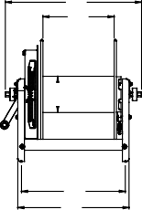
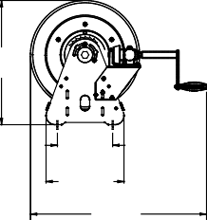
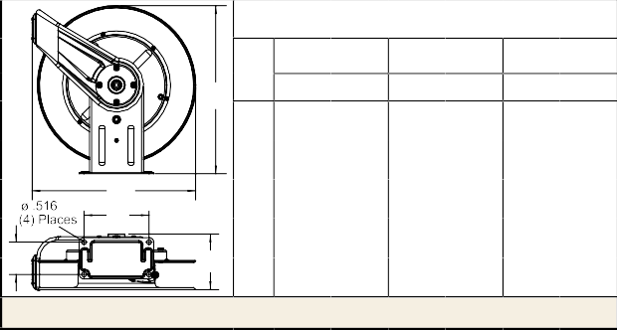Complete Welding Series | Series TW / STW / BA
Models listed with an icon can ship same day upon request
when the order is received by 1:00 PM Eastern Time for quantities of 10 or fewer.
Indiana Warehouse California Warehouse
Indiana & California Canadian Warehouse Warehouses
Customer Service: 1.855.634.9109
All Other Calls: 1.800.444.3134
45
Interactive Reel Catalog
Visit www.reelcraft.com/catalog for complete product specifications, available parts and accessories.
Series 5000 / 7000 / 80000
A
B C
D
E
Series 5000 reels have four 5/16" (8 mm) diameter mounting holes.

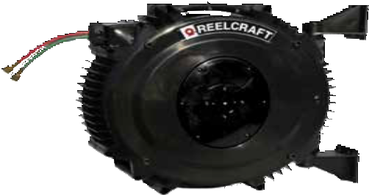
Lighter weight for hose lengths up to 50’
Features
P Designed to improve safety in the work area with an increase in productivity and efficiency
P Full flow shaft swivels
P Independent dual swivel body manufactured from aluminum and hard-coated for wear resistance assures positive separation of gases due to its unique design
P Double-sealed, O-rings prevent leakage
P Swivel body and inlet are both permanently identified with machined groves on the acetylene side to assure proper installation
P Durable abrasion and corrosion resistant baked-on red powder-coated finish
P Reel frame, spool and drum are fabricated of heavy gauge steel

STW3450 OLP
*See page 21 for additional details.
Made in Australia

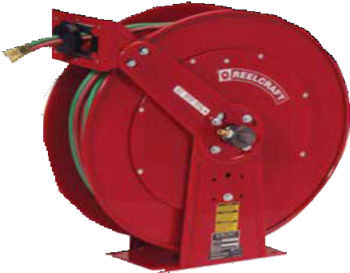
Dual welding, spring driven for high volume of gas

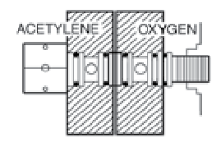TW84100 OLPT
Dual swivel is an exclusive Reelcraft design
Independent dual swivel body
manufactured from aluminum and hard coated for wear resistance. Assures positive separation of gases due to its unique design.

Double-sealed, special molded O-rings prevent leakage. Swivel body and inlet are both permanently identified with machined grooves on the acetylene side to assure proper installation. Available with TW5000 and TW7000 series reels.
Available in T grade only

Made in USA

“T” Grade Fuel Gas Reels
“T” grade hose reels are used for a wide variety of gases such as mapp gas, propane gas, natural gas and fuel gases. When ordering any welding hose reels you must specify the type of gas being used.
To order “T” grade reels, add a suffix “T” to the TW models. Example - TW5425 OLPT.
1  in mm |  |  | 2  in mm |  | 3  in mm
A | 143/8 | 365 | 201/4 | 514 | 253/8 | 645
B | 125/8 | 321 | 193/4 | 502 | 24 | 610
C | 93/4 | 248 | 77/8 | 200 | 10 | 254
D | 21/2 | 64 | 37/8 | 98 | 6 | 152
E | 6 | 152 | 73/8 | 187 | 121/4 | 311

A B |  |  | Series 30000
 |  |  |  | 4 |  | 5
 |  |  |  | in | mm | in | mm
6 5/8”  170 mm | 20 1/2”  514 mm |  | A | 155/8 | 397 | 215/8 | 550
 |  |  | B | 6 | 152 | 12 | 305
C D |  | 9”  229 mm  12 11/16”  320 mm  28 5/8”  727 mm | C | 93/4 | 248 | 153/4 | 400
 |  |  | D | 11 | 280 | 17 | 432
 |  |  | Four 1/2" (12.7 mm) mounting holes. Overall length with crank handle removed is 173/4" (451 mm).

Welding Cable Reels | Series CEA / WC

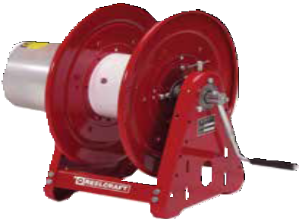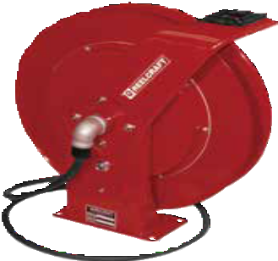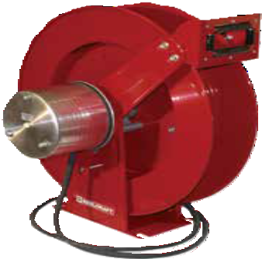Hand Crank / Spring Retractable Cable Welding Reels

Series CEA / WC

CEA30006
- Designed to improve safety in the work area with an increase in efficiency and productivity
- Cable reels have a current path through a continuous 400 or
700 AMP, 90 V DC (maximum) rated enclosed slip ring

Made in USA
- Welding cable reels store work lead or electrode lead, up to #4/0, safely and effectively when not in use. Each lead requires a separate reel. When welding also refer to ANSI/Asc Z 49.1
- Stores cable when not in use, elimi- nating tangled, kinked welding cables
- Maintains proper bend radius of cables, providing longer cable life
- Keeps work area and vehicles better organized, resulting in better space utilization

WC7000
Features - Hand Crank Reels
P All-bolted heavy gauge steel construction provides long life and ease of use and maintenance.
P Manual drum lock prevents spool from turning when not in use preventing unwanted pay out of cable.

WC80001

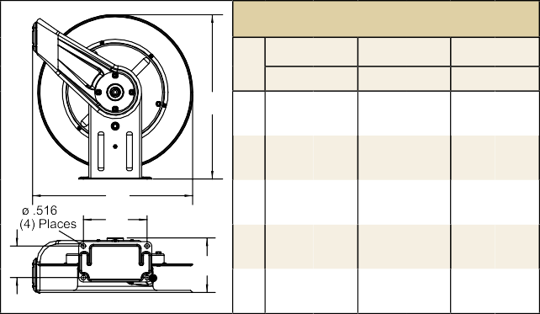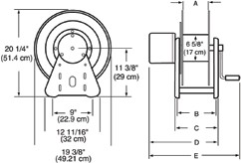Caution: If cable reels are to be used for extended periods of time, unwind all cable from reel to prevent heat build-up. For indoor non weather-tight applications only.
Size Index
1 2
3
in mm in mm in mm
A
A 201/4 514 201/4 514 253/8 645
B
C
D
E
E 131/4 337 14 356 155/8 397

Models listed with an icon can ship same day upon request when the order is received by 1:00 PM Eastern Time for quantities of 10 or fewer.
Indiana Warehouse
Indiana & California Warehouses
California Warehouse
Canadian Warehouse
46
Customer Service: 1.855.634.9109
All Other Calls: 1.800.444.3134
B | 193/4 | 502 | 193/4 | 502 | 24 | 610
C | 77/8 | 200 | 77/8 | 200 | 10 | 254
D | 37/8 | 98 | 37/8 | 98 | 6 | 152

A  B C D E | Size Index
 |  | 4 | 5
 |  | in mm | in mm
 | A | 6 152 | 12 305
 | B | 93/4 248 | 153/4 400
 | C | 11 279 | 17 432
 | D | 15 381 | 21 533
 | E | 21 533 | 27 686
Four 1/2" (12.7 mm) diameter mounting holes.

Interactive Reel Catalog
Visit www.reelcraft.com/catalog for complete product specifications, available parts and accessories.
Prop 65: WARNING:
Cancer and Reproductive Harm - www.P65Warnings.ca.gov.
Model without cable & bumper | Cable Size |  |  |  |  |  |  |  |  |  |  |  | Amps | Shipping Weight |  | Size Index #
 | #2  (34mm²) |  | #1  (42mm²) |  | #1/0  (54mm²) |  | #2/0  (67mm²) |  | #3/0  (85mm²) |  | #4/0  (107mm²)
 | ft | m | ft | m | ft | m | ft | m | ft | m | ft | m |  | lbs | kg
CEA30006 | 300 | 91 | 250 | 76 | 200 | 61 | 150 46 |  | --------- |  | --------- |  | 400 | 46 | 21 | 4
CEA30012 | 500* 152 |  | 500* 152 |  | 400 122 |  | 300 91 |  | --------- |  | --------- |  | 400 | 54 | 24 | 5
WC7000 | --------- |  | 50 | 15 | 50 | 15 | 50 | 15 | --------- |  | --------- |  | 400 | 58 | 26 | 1
WCH7000 | --------- |  | --------- |  | --------- |  | --------- |  | 50 | 15 | 50 | 15 | 700 | 58 | 26 | 2
WC80001 | --------- |  | 75 | 23 | 75 | 23 | 75 | 23 | --------- |  | --------- |  | 400 | 102 | 46 | 3
WC80002 | --------- |  | 100 | 30 | --------- |  | --------- |  | --------- |  | --------- |  | 400 | 104 | 47 | 3
WCH80001 | --------- |  | --------- |  | --------- |  | --------- |  | 75 | 23 | 75 | 23 | 700 | 102 | 46 | 3
*May exceed maximum cable length allowable for most welding applications. NOTE: Each cable requires separate reel. Reference page 4 for guide arm positions.

Cable Size | Bumper
#2, #1 | 1-HR1004-A
#1/0, #2/0, #3/0 | 1-HR1004
#4/0 | 2-HR1004-3

Hand Crank Reels
Up to 150’ fuel gas Up to 200’ 12/3 cable

in USA
Made
Multiple Configurations | Safe-T-Reel Series

Ideal for applications where space, weight and flexibility are key, these reels are designed for manual winding of air/water/fuel gases hose, electric cord and welding cable.
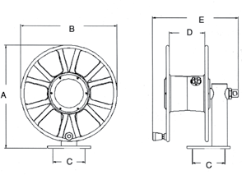Versatile in function, select configurations to suit specific needs. Safe-T-Reels offer trouble-free management of large capacities of hose or cord.

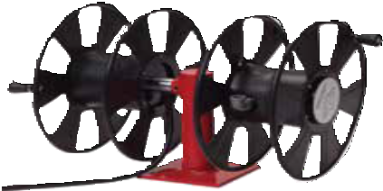
Side-by-side combinations
T-2462-0
Stacked combinations
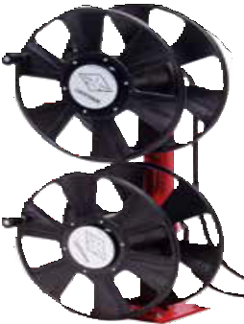
T-2464-0

Model without cable | AMP | Reel Capacity |  | Cable |  | Shipping Weight |  | Size Index #
 |  | ft | m | AWG | Cond | lbs | kg
Single Power Cable - 3 Conductor
T-1535-003 | 30 | 150 | 45 | 8 | 3 | 18.5 5 |  | 1
T-1535-083-100* | 33 | 100 | 30 | 8 | 3 | 50 | 23 | 1
T-1535-103-200* | 24 | 200 | 61 | 10 | 3 | 81 | 37 | 1
T-1535-123-100* | 25 | 100 | 30 | 12 | 3 | 46 | 21 | 1
T-1535-123-200* | 20 | 200 | 61 | 12 | 3 | 71 | 32 | 1
*Includes cable.

 | B |  | E | Dimensions - Size Index
 |  |  |  |  | 1 |  | 2 |  | 3
 |  | D
 |  |  |  |  | in | mm | in | mm | in | mm
 |  |  |  | A | 19 | 483 | 19 | 483 | 19 | 483
A |  |  |  | B | 18 | 457 | 18 | 457 | 18 | 457
 |  |  |  | C | 6 | 152 | 6 | 152 | 6 | 152
 |  |  |  | D | 61/2 | 165 | 61/2 | 165 | 121/2 | 165
 | C |  | C | E | 153/4 | 401 | 161/4 | 412 | 213/4 | 552
 |  |  |  | Four 1/2" (12.7 mm) diameter mounting holes.

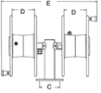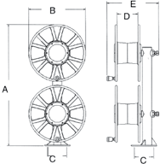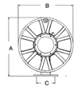Caution: Compressed air hoses should not be converted to oxygen service. Compressed air hoses are often con- taminated with an oil coating, which can react explosively when oxygen is introduced. Oxygen/Acetylene cannot be combined with welding cable or power cord. Note: Models listed are without hose and/or cable except where listed. Weights listed above are actual product weight without packaging materials. Safe-T-Reels are available with cable or hose and in various combinations. Please consult Reelcraft customer service for additional information.
Model without cable | AMP | Reel Capacity |  | Shipping Weight |  | Size Index #
 |  | ft | m | lbs | kg
Single Welding Cable 600 V, 2/0 Cable
T-1460-0 | 250 | 200 | 61 | 32 | 15 | 2
Dual Side-by-Side Welding Cable (2) 600 V, 2/0 Cable
T-2462-0 | 250 | 200 | 61 | 51 | 23 | 5
Dual Stacked Welding Cable (2) 600 V, 2/0 Cable
T-2464-0 | 250 | 200 | 61 | 62 | 28 | 4
Dual Side-by-Side Power Cable/Air Hose
T-2735-2-0* | 35 | 200  150 | 61  45 | 40 | 18 | 5
*Air hose side has 1/2" (12.7mm) inlet.

Dimensions - Size Index
 | B | E |  | 4 |  |  |  | B |  | 5
 |  |  |  | in | mm |  |  |  |  | in | mm
 |  | D
 |  |  | A | 38 | 965 | A |  |  |  | 19 | 483
A |  |  | B | 18 | 457 |  |  | C |  | 18 | 457
 |  |  | C | 6 | 152 |  |  |  |  | 6 | 152
 |  |  |  |  |  |  | D | E | D
 |  |  | D | 61/2 | 165 |  |  |  |  | 61/2 | 165
 | C | C | E | 161/4 | 737 |  |  |  |  | 29 | 737
Four 1/2" (12.7 mm) diameter mounting holes. |  |  |  |  |  |  |  | C

Models listed with an icon can ship same day upon request when the order is received by 1:00 PM Eastern Time for quantities of 10 or fewer.

Prop 65: WARNING:
Cancer and Reproductive Harm www.P65Warnings.ca.gov.

Indiana Warehouse
Indiana & California Warehouses
California Warehouse
Canadian Warehouse

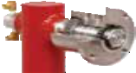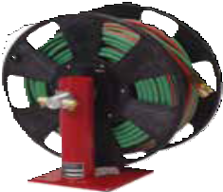
Detail of heavy duty shaft
with tapered roller bearing for high rigidity
Shaft sizes are 1" to 1.25" in diameter, sup- ported by tapered roller bearings with 2" to 2.3" housings.
T-1225-04-100T
Model without hose | Hose I.D. |  | Hose O.D. |  | Reel Capacity |  | Pressure |  | Shipping Weight |  | Size Index #
 | in | mm | in | mm | ft | m | psi | bar | lbs | kg
Single Spool Air/Water Hose Reels Maximum temperature 150 °F (65 °C)
T-1115-08 | 1/2 | 13 | .844 | 21 | 150 | 46 | 300 | 21 | 18 | 8 | 1
T-1116-08 | 1/2 | 13 | .844 | 21 | 250 | 76 | 300 | 21 | 22 | 10 | 3
T-1117-12 | 3/4 | 19 | 1.188 30 |  | 50 | 15 | 250 | 17 | 18 | 8 | 1
T-1118-12 | 3/4 | 19 | 1.188 30 |  | 75 | 23 | 250 | 17 | 22 | 10 | 3
Single Spool Oxygen/Acetylene T-Grade Seals Maximum temperature 150 °F (65 °C)
T-1225-04 | 1/4 | 6 | .530 | 13 | 150 | 45 | 200 | 14 | 19 | 9 | 2
T-1225-04-100T* | 1/4 | 6 | .530 | 13 | 100 | 30 | 200 | 14 | 44 | 20 | 2
T-1226-06 | 3/8 | 10 | .625 | 16 | 100 | 30 | 200 | 14 | 19 | 9 | 2
*Includes hose.

Customer Service: 1.855.634.9109
All Other Calls: 1.800.444.3134 47

Tool Balancers | Series TB / TBL

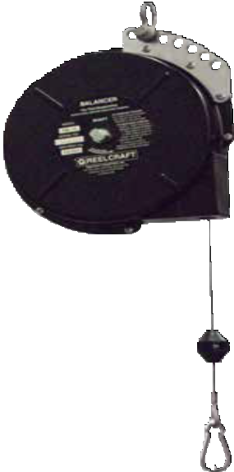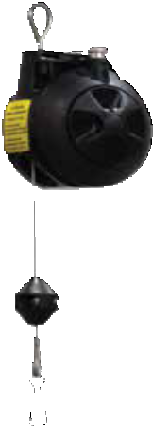Medium Duty TB 05
Top Five Benefits
- Balances the weight of assembly tools, making them nearly weightless
- Reduces operator fatigue
- Improves safety and ergonomics
- Increases productivity by keeping tools positioned for immediate use with minimal operator motion
- Reduces tool damage by preventing tools from being accidentally dropped

Bumper - S602413 Safety Clip - 261241
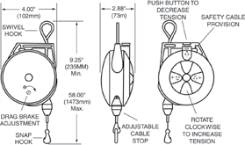Bright zinc plated steel cable and safety latch for tool attachment and other uses. Measures 2.375" (60 mm) long. Included with each model.
TB 1-5 Dimensions

Tool balancers make tools nearly weightless, reduce fatigue
Heavy Duty TBL 10

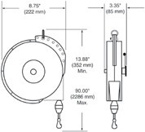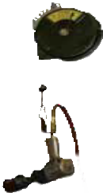
Model | Min - Max Load | Cable Length* | Shipping Weight
 | lbs kg | ft m | lbs kg
TB 01 0.0 - 1.5 0.0 - 0.7 |  | 6 1.8 | 1.0 0.5
TB 03 1.5 - 3.0 0.7 - 1.4 |  | 6 1.8 | 1.0 0.5
TB 05 | 3.0 - 5.0 1.4 - 2.3 | 6 1.8 | 1.5 1
*Cable lengths listed are "active" or "working" cable. Safety tool clip and cable stop included. Maximum temperature 150 °F (65 °C).

TB 10-23 Dimensions
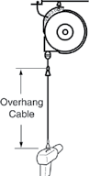Optional Accessories
Model | Min - Max Load | Cable Length* | Shipping Weight | Ratchet Lock
 | lbs kg | ft m | lbs kg
Constant Pull Reels - may be adjusted to balance through 6-18 in (152-457 mm) range.
TB 10 | 5.0 - 10 2.3 - 4.5 | 8 2.4 | 9 4 | NO
TB 12 | 8.0 - 12 3.6 - 5.4 | 8 2.4 | 10 4.5 | NO
TB 15 | 10 - 15 4.5 - 6.8 | 8 2.4 | 10 4.5 | NO
TB 23 | 16 - 23 7.2 - 10.4 | 8 2.4 | 10 4.5 | NO
Reels with Ratchet Lock - retract tool upward when manually released.
TBL 10 | 5.0 - 10 2.3 - 4.5 | 8 2.4 | 9 4 | YES
TBL 12 8.0 - 12 3.6 - 5.4 |  | 8 2.4 | 10 4.5 | YES
TBL 15 10 - 15 4.5 - 6.8 |  | 8 2.4 | 10 4.5 | YES
TBL 23 | 16 - 23 7.2 - 10.4 | 8 2.4 | 10 4.5 | YES
*Cable lengths listed are "active" or "working" cable. Safety tool clip and cable stop included. Maximum temperature 150 °F (65 °C).

Cables can be combined for added length
Overhang Cable
Model No. | Length
600605-3 | 3.0 ft / 91.5 cm
600605-5 | 5.0 ft / 152.4 cm
Safety Cable/Chain
600603* | 1.0 ft / 30.5 cm
600604** | 1.0 ft / 30.5 cm
*Nylon covered steel cable (1 to 6 lbs models)
**Steel link chain (10 to 23 lbs models)

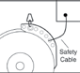Strongly recommended, second- ary steel cable or steel link chain. Prevents balancer from accidental fall. Balancers have extra holes for cable or chain.
Prop 65: WARNING:
Cancer and Reproductive Harm - www.P65Warnings.ca.gov.
Models listed with an icon can ship same day upon request when the order is received by 1:00 PM Eastern Time for quantities of 10 or fewer.
Indiana Warehouse
Indiana & California Warehouses
California Warehouse
Canadian Warehouse
48
Customer Service: 1.855.634.9109
All Other Calls: 1.800.444.3134

Nylon covered steel cable with safety clip. Brings tools closer to work area without unwinding cable from reel or mounting reel at lower height.

Reel Accessories | Roller Guides / Mounting Brackets

HR1057 / HR1059
HR1145
S270109 / 600168
Roller Hose Guide Assemblies

Model | Accommodates | Weight | Dimensions
 | Hose O.D. |  | A | B | C | D | E | F
 | in (mm) | lbs kg | in mm | in mm | in mm | in mm | in mm | in mm
HR1057 | .603 (16) - .906 (23) | .25 .12 | 0.875 22.3 | N/A | 3.125 79.4 | 3.125 79.4 | 1.6875 42.9 | 1.6875 42.9
HR1059 | .250 (6.4) - .625 (15.9) | .25 .12 | 0.625 15.9 | N/A | 3.125 79.4 | 3.125 79.4 | 1.6875 42.9 | 1.6875 42.9
HR1145 | .603 (16) - .906 (23) | .34 .15 | 2 50.8 | 1 25.4 | 3.75 95.3 | 2.75 69.9 | 2.125 54.1 | 3.125 79.4
S270109 | .900 (23) - 2.00 (50.8) | 5.39 2.44 | 5.25 133.4 | 2.375 60.4 | 12 305 | 8 204 | 5 127 | 10.5 267
600168 | .900 (23) - 1.38 (35) | 1.75 .34 | 1.75 44.5 | 2.0625 27 | 5.125 130 | 5.125 130 | 4 102 | 4 102
These four-way roller guide assemblies are for use with reels on cabinet door openings and for similar locations where sharp edges may cut or damage the hose. The four-way design permits pulling or retracting hose at any angle. Model S270109 has nylon rollers mounted on an 11 gauge steel frame with pre-drilled mounting holes.
 |  |  | Note: A hose bumper should be used with the four-way roller hose guide assemblies to prevent damage to rollers and nozzles.

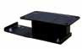Additional Accessories
Cancer and Reproductive Harm - www.P65Warnings.ca.gov.
Customer Service: 1.855.634.9109
All Other Calls: 1.800.444.3134
49
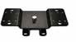  S600608  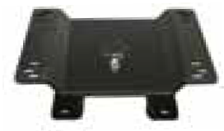 | 340° Pivot Base  Aligns reel to the direction of hose or cord run. May be mounted with reel upright or hanging. Weight 10 lbs (5 kg). Note: Use if hoses or cords are pulled at more than 45°. Refer to www.reelcraft.com/  accessories for dimensional | For Reel Series | Part #
 |  | RT / 4000 / 5000  / 5005 / 7000 / HD70000 | S600608
 |  | 80000 / D80000  / 30006 | 600801
 |  | 30012 | 600801-12
600801 | information.
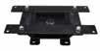 | 330° Pivot Base  Aligns reel to the direction of cord run. Use if cords are pulled at | L NM400 | 263109
600801-12 | more than 45°.
600992  600626 | Wall-Mounted Universal Swing Bracket  Bracket will pivot approximately 180°. All steel construction with a durable baked on powder coat finish. Weight 6 lbs (3 kg).  Note: Use if hoses or cords are pulled at more than 45°.  Note: Not for overhead mounting. Refer to www.reelcraft.com/ accessories for dimensional information. | For Reel Series | Part #
 |  | RT | 600992
 |  | 4000 / 5000 | 600993
 |  | RT / 4000 / 5000  / 5005 / 7000 / HD70000 | 600626
 |  | 80000 / D80000  / DP5000 / DP7000 | 600980
600295 | Top Mounting Channels and Beam Clamps  600370 Top channel and beam clamps - for one reel 600295 Top channel and beam clamps - for two reels For mounting Series 7000 reels to an I-beam or overhead support. Mounting channels can be mounted end to end to mount three or more reels. To permit the mounting of Reelcraft Series RT, 4000, 5000, 5005 and electric cord reels on mounting channel, an adaptor assembly must be used (#600230).
600230 | 600230 Adaptor Assembly  Used with top channels and beam clamps only.

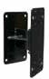
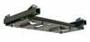
Roller Guide Assemblies
Three-way rollers |  | Four- way rollers  (multi-position)
Spools and blocks are chrome-plated to resist corrosion and abrasion. Rollers speed handling and reduce wear on hose. All painted parts are finished with durable abrasion resistant baked-on powder coat. Delrin bearing surfaces give a quiet operation with minimum wear and all features combine to give trouble-free maximum service life.
For the special UHMW composite rollers, add a "U" at the end of the part number. (Example: S600693-1U)
Hose Reel Spool Size | Bottom Wind Roller bracket assembly model number | Top Wind Roller bracket assembly model number | Multi Position Roller bracket assembly model number
in mm
Series 30000 - Four Way Rollers
6 152 | S600693-1 | S600692-1 | S600533-1
12 305 | S600693-2 | S600692-2 | S600533-2
18 457 | S600693-3 | S600692-3 | S600533-3
22 559 | S600693-4 | S600692-4 | S600533-4
28 711 | S600693-5 | S600692-5 | S600533-5
Series 30000 - Three Way Rollers
6 152 | S602132-1 | S602133-1
12 305 | S602132-2 | S602133-2
18 457 | S602132-3 | S602133-3
22 559 | S602132-4 | S602133-4
28 711 | S602132-5 | S602133-5
Bottom wind and top wind may be used with all models except bevel crank. Multi position may not be used on models with a chain guard or Series 37000 reels.
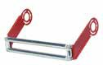
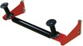
Prop 65: WARNING:

Reel Accessories | Motors / Switches

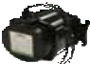
Rewind Motors

Part No. | Specification
Electric Motors
S260409 | Reversible type, 12 V DC 1/3 HP | 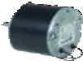
260450 | Reversible type, 24 V DC 1/4 HP
Explosion Proof Electric Motors
S260430 | Reversible type, single phase, explosion proof, Class 1 Group D Division 1, 115 V AC 0.40 HP.
S260626 | 24 V DC 2/3 HP. Electric motor reversible type. Explosion proof. | 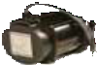
S260583 | 12 V DC 2/3 HP. Electric motor reversible type. Explosion proof.
Air Motors
260428 | 4 AM delivers up to 11/2 HP, 1/4" NPTF (F) inlet | 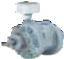
260429 | 6 AM delivers up to 4 HP, 1/2" NPTF (F) inlet
Hydraulic Motor
370066 | 1021 RPM, 668 lb-in, 2400 psi,  2.2 in³ intermittent 1800 psi continuous

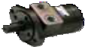
Additional Accessories

Part No. | Specification | Use with Motor
Control Valves
260454 | Pneumatic on/off flow control valve assembly, 1/4" NPTF (F) inlet for 4 AM compressed air motors. Recommend using a filter, regulator, and lubricator with compressed air motors. | 260428
260455 | Same as above with 3/8" NPTF (F) inlet and outlet for 6 AM motors. | 260429
Circuit Breaker
S260422 | 40 AMP, manual reset button must be pressed firmly to reset | S260409 260450
Starting Solenoid
S260426 | 12 V DC for activation of motor | S260409 S260583
370018 | 24 V DC for activation of motor | 260450  S260626
Mounting Bracket
260532 | Combination for circuit breaker, solenoid and starting switch
Operating Switches and Accessories

Part No. | Specification |  | Use with Motor
Push Button Switch
S600870 | 115/230 V AC, 10 AMP  fuse |  | S260430
600811 | 12/24 V DC, up to 1/3 HP, breaker and relay |  | S260409 260450
S600808 | 600811 switch with bracket, 12/24 V DC |  | S260409 260450
600869 | 12/24 V DC, up to 2/3 HP |  | S260626 S260583
260424 | Momentary contact with rubber cap, 12/24 V DC, non-explosion proof |  | Any DC motor
260425 | Momentary contact, class 1 group D, 115/230 V AC. May also be used with solenoid for 12 or 24 V DC. |  | Any explosion proof motor
Speed Control Switch
600871 | 115/230 V AC, 10 AMP |  | S260430
600866 | 12/24 V DC |  | Any DC motor
Push Button Switch with Speed Control
S600872 | 115/230 V AC, 10 AMP  fuse, adjustable speed control |  | S260430
600873 | 115/230 V AC, 10 AMP  fuse, forward/reverse adjustable speed control |  | S260430
600867 | DC, 25 AMP, up to 1/3 HP |  | S260409
600868 | DC, 40 AMP circuit break- er, up to 2/3 HP |  | S260583
Junction Box
370200 | For explosion proof motor |  | Any explosion proof motor
Chain Shrouds
S600518 | Optional chain shroud for Series 30000 and Series 1200 reels. | 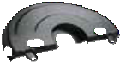
S261746 | Optional chain shroud for Series 2400, 3700, and 3900 reels.
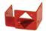
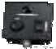
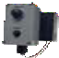
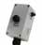
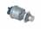
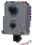
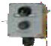
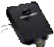*Reference reelcraft.com for detailed specifications.
Prop 65: WARNING:
Cancer and Reproductive Harm - www.P65Warnings.ca.gov.

50 Customer Service: 1.855.634.9109

Online Interactive Catalog
Reelcraft’s Online Interactive Catalog

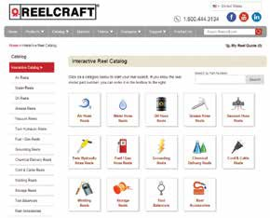Complete Online Catalog of Products Reelcraft's interactive catalog gives users the ability to self- select the product they need for their specific application. The products are grouped into categories by application such as air, water, oil, grease, fuel, and welding. Each
individual category of products gives the user the choice to narrow their search by filters such as hose/cord length, drive type, reel grade, in stock items, etc. The individual product pages include all the available information for each product including:

- Product specifications and dimensions
- Service manuals
- Tech bulletins
- Videos
- Available inventory

Parts and Accessories
- CAD drawings
- FAQs
- Quote request form
- Available parts and accessories
- 360° images

Easy to use!

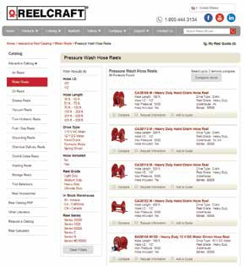The interactive catalog also contains an extensive listing of parts and accessories. Search the catalog of over 200 hose assemblies by hose I.D., length, pressure rating, or end fitting size. The catalog also contains information for the following items:

  - Replacement hose assemblies
  - Inlet hose assemblies
  - Bumper stop assemblies
- Roller guide assemblies
- Swing brackets
- Pivot bases
- Swivel assemblies

Visit www.reelcraft.com/catalog to start your search!

Custom Capabilities
Don’t see what you need? Reelcraft’s engineered products group custom builds to your specifications.

  - Very few size and weight constraints
  - Special finishes / paint options
- Various drive types
- Wide range of pressures
- No minimum quantities

Customer Service: 1.855.634.9109 51

North America and Corporate Headquarters
2842 E. Business Hwy 30 Columbia City, IN 46725
Customer Service: 855-634-9109
Ph: 800-444-3134 • Fax: 800-444-4587
Ph: 260-248-8188 • Fax: 260-248-2605
reelcraft@reelcraft.com
www.reelcraft.com

Latin America and the Middle East
Thompson International, Inc.
P.O. Box 12958, Ft. Wayne, IN 46866 Ph: 260-489-1685 • Fax: 260-489-0203 info@t-i-i.com www.reelcraft.com/latinamerica

Pacific Rim
P.O. Box 53776, Clark Freeport Zone Philippines 2023
Ph: +63 (45) 625-6624
Fax: +63 (45) 321-0643
rap@comclark.com
www.reelcraft.com/asia

Europe
Unit 17 • Cronin Courtyard Weldon South Industrial Estate
Corby • Northamptonshire NN18 8AG United Kingdom
Ph: +44 (0) 1536 406999
Fax: +44 (0) 1536 406777
europe@reelcraft.com
www.reelcraft.com/europe

China
Reelcraft Changzhou Co., Ltd. Building C, No. 229 HeHai West Road Changzhou, Jiangsu, China 213022 Ph: +86 (519) 8512 2391 ext. 8002
Fax: +86 (519) 8512 9309
rco@reelcraftchina.com
www.reelcraftchina.com

Australia
PO Box 6463 BC, Blacktown NSW 2148, Australia
Ph: +61 (2) 9621 8988
Fax: +61 (2) 9621 7688
sales@recoila.com
www.reelcraft.com

Form # 917-1097 3/2018
reelcraft.com

